SAVA AND DRINA RIVER CORRIDORS INTEGRATED DEVELOPMENT PROJECT (SDIP)

RESETTLEMENT POLICY FRAMEWORK (RPF) FOR SERBIA

December 2019

Table of Contents
Acronyms 3
Definitions glossary 4
Executive summary 6
1. Introduction 7
1.1 Brief description of the Project 7
1.2 Estimated displacement impacts and justification of RPF 9
1.3 Objectives of this RPF 9
1.4 Fundamental principles guiding resettlement 10
2. Legal framework 12
2.1 National legal framework guiding resettlement 12
2.2 Expropriation process in Serbia 14
2.2.1 Key provisions of the Law 14
2.2.2 The expropriation process 15
2.3 WB standards on Land Acquisition, Restrictions on Land Use and Involuntary Resettlement (ESS5) 16
2.4 Gap analysis 17
3. Resettlement strategies applicable to the Project 24
3.1 Key principles 24
3.2 Estimated displacement impacts 24
3.3 The Cut-off date 24
3.4 Eligibility criteria 25
3.5 Entitlement matrix 25
4. Resettlement instruments 33
4.1 Social analysis of sub-projects for land acquisition, restriction on land use and involuntary resettlement impacts 33
4.2 Resettlement plan (RP) 34
4.2.1 Minimum elements of the RP 34
4.2.2 Process of development and approval of RPs 35
4.2.3 RP implementation 37
5. Consultation and disclosure 38
5.1 Public consultations 38
5.2 Disclosure of documents 38
5.3 Stakeholder Engagement Log (SEL) 38
6. Grievance mechanism 39
6.1 Raising grievances 39
6.2 Grievance administration 40
6.3 Grievances and beneficiary feedback reporting 40
6.4 Grievance log 40
6.5 Grievance admission channels 41
6.6 Monitoring and reporting on Grievances 41
6.7 World Bank Grievance Redress Service 42
7. Monitoring and evaluation 43
7.1 Institutional monitoring 43
7.2 Monitoring of resettlement process 43
8. Institutional arrangements 44
8.1 Institutions responsible for Project implementation 44
8.2 Key institutions in the process of resettlement 45
9. Budget and funding of resettlement 47
Annex 1 - Grievance registration form 48
Annex 2 - Social analysis template 49
Annex 3 - Record keeping template 51

Table of Figures

Table 1 - Gap analysis 18
Table 2 - Entitlement matrix 26
Table 3 - Institutional responsibilities 43
Table 4 - Institutions involved in expropriation / resettlement 46

Figure 1 - The Sava and Drina rivers basin; Source: UNECE (2016) 7
Figure 2 - RP approval flow chart 37
Figure 3 - Proposed governance arrangements for the Project 45

Acronyms

BoE | Beneficiary of Expropriation
CC | Constitution Court of Serbia
CFD | Central Feedback Desk
DfW | Directorate for Water of Republic of Serbia
ESS | Environmental and Social Standards of World Bank
ESS5 | ESS on Land Acquisition, Restrictions on Land Use and Involuntary Resettlement
GoRoS | Government of Republic of Serbia
GM | Grievance Mechanism
GRS | Grievance Redress Service
ISRBC | The International Sava River Basin Commission
LM | Local Municipalities
LGD | Local Grievance Desk(s)
MoAFWM | Ministry of Agriculture, Forestry and Water Management of Republic of Serbia
MoF | Ministry of Finance of Republic of Serbia
PAP | Project Affected People
PMU | Project Management Unit
RPF | Resettlement Policy Framework (this document)
RP | Resettlement Plan
RoS | Republic of Serbia
SDIP | Sava and Drina river corridors integrated development project (this Project)
SEL | Stakeholder Engagement Log
SSS | Social Safeguard Specialist
WB | World Bank

Definitions glossary

Cut-off date | Date of beginning of the census of persons and inventory of assets affected by the (sub)-project, if any. If a person(s) should occupy the project area after the Cut-off date, they will not be eligible for compensation and/or resettlement assistance. Similarly, fixed assets (such as built structures, crops, fruit trees, and woodlots) established after the Cut-off date will not be compensated. Before the census, the PIU will publish an information about the Cut-off date in local newspapers, informing all owners and users of the initiation of the expropriation process. The Cut-off date will also be publicly disclosed on notice boards in local communities and relevant municipalities and at consultation meetings, with an accompanying explanation. The public announcement will also be posted, as necessary, on frequently visited locations throughout the affected areas. This information will include posted warnings that persons settling in the project area after the cut-off date may be subject to removal.
Economic displacement | Includes all loss of income sources or means of livelihood as a result of land acquisition or restricted access to resources (land, water, or forest) as a result of Project implementation, regardless whether affected persons must move to another location or not.
Entitlement | Compensation and other forms of assistance that PAPs have the right to receive in accordance with this RPF in the respective eligibility category.
Expropriation | It refers to a dispossession or a limitation of ownership rights on property with a compensation pursuant to market value of the property and is based on the Governments eminent domain power, regulated by the Law on Expropriation.
Involuntary resettlement | Refers to Project-related impacts of resettlement where the person affected has no possibility to decline land acquisition or restrictions on land use, physical displacement (relocation, loss of residential land or loss of shelter), economic displacement (loss of land, assets or access to assets, leading to loss of income sources or other means of livelihood), or both.
Land Acquisition | Refers to all methods of obtaining land for project purposes, which may include outright purchase, expropriation of property and acquisition of access rights, such as easements or rights of way. Land acquisition may also include: (a) acquisition of unoccupied or unutilized land whether or not the landholder relies upon such land for income or livelihood purposes; (b) repossession of public land that is used or occupied by individuals or households; and (c) project impacts that result in land being submerged or otherwise rendered unusable or inaccessible. “Land” includes anything growing on or permanently affixed to land, such as crops, buildings and other improvements, and appurtenant water bodies.
Livelihood | Refers to the full range of means that individuals, families and communities utilize to make a living, such as wage-based income, agriculture, fishing, foraging, other natural resource-based livelihoods, petty trade and bartering.
Moving allowance | The cash compensation for expenses directly associated to moving/relocation of the household or business.
Physical displacement | Loss of shelter and assets resulting from the property acquisition associated with the Project that requires PAPs to move from home, work place or business premises to another location.
Project Affected Person (PAP) | PAP is any person who, as a result of the implementation of the (sub)-project suffers impacts.
Replacement cost | Replacement cost is defined as a method of valuation yielding compensation sufficient to replace assets, plus necessary transaction costs associated with asset replacement. Where functioning markets exist, replacement cost is the market value as established through independent and competent real estate valuation, plus transaction costs. Where functioning markets do not exist, replacement cost may be determined through alternative means, such as calculation of output value for land or productive assets, or the undepreciated value of replacement material and labor for construction of structures or other fixed assets, plus transaction costs. In all instances where physical displacement results in loss of shelter, replacement cost must at least be sufficient to enable purchase or construction of housing that meets acceptable minimum community standards of quality and safety. The valuation method for determining replacement cost should be documented and included in relevant resettlement planning documents. Transaction costs include administrative charges, registration or title fees, reasonable moving expenses, and any similar costs imposed on affected persons.
Restrictions on land use | Refers to limitations or prohibitions on the use of agricultural, residential, commercial or other land that are directly introduced and put into effect as part of the project. These may include restrictions on access to legally designated parks and protected areas, restrictions on access to other common property resources, and restrictions on land use within utility easements or safety zones.
Stakeholders | Any and all individuals, groups, organizations, and institutions interested in and potentially affected by a Project, or having the ability to influence the Project.
Transitional allowance | Describes one-off cash compensation as an additional financial assistance to facilitate PAP adjustment in the area to which they are relocated.
Vulnerable group/individuals | Refers to people below the poverty line, the landless, the elderly, women and children, and those who by virtue of gender, ethnicity, age, physical or mental disability, economic disadvantage, or social status may be more adversely affected by resettlement than others or who may be limited in their ability to claim or take advantage of resettlement assistance and related development benefits.

Executive summary

The development objective of the SDIP is to strengthen capacity for integrated river basin management and development through improved transport connectivity, flood protection, and landscape management in selected catchment areas of the Sava and Drina river corridors. The Project consists of three components, will be implemented over a period of 10 years, organized in two phases. This Project will include of approximately 40 sub-projects with high relevance to the program objectives. In Serbia, SDIP will support rehabilitation and stabilization of Sava River dykes, flood protection measures along the Drina River and its tributaries, modernization and capacity expansion at the port of Sremska Mitrovica, and dredging, river training, and navigability enhancing works alongside the berths of the port and in the main fairway to/from the port.
The proposed Project activities, due to planned nature and extend of civil works, especially in Component 1 of the Project, are possible to have displacement impacts. At this Project planning phase the likely nature or magnitude of the impacts related to the Project is impossible to estimate, this RPF is prepared to clarify resettlement principles, organizational arrangements, and design criteria to be applied to sub-projects, and to mitigate potential resettlement impacts. This RPF has been prepared in accordance with the legal system, laws and procedures of Republic of Serbia, and in conformity with ESS5 and good international practices. The objective of this RPF is to define overarching principles, procedures, actions, organizational structures and capacity requirements during resettlement, if such should be required, and its impact attributable to Project implementation. It also provides the framework for individual RPs that may need to be prepared under the sub-projects, should the need arise.
To achieve proclaimed objectives, in line with WB ESS5 standards on Land acquisition, restriction on land use and involuntary resettlement, this RPF covers the following elements:
- a brief description of the project and components for which land acquisition and resettlement are required, and an explanation of why a resettlement policy framework rather than a resettlement plan is being prepared - Chapter 1.1 and 1.2;
- principles and objectives governing resettlement preparation and implementation - Chapters 1.3 and 1.4;
- a description of the process for preparing and approving resettlement plans - Chapter 4;
- estimated displacement impacts and estimated numbers and categories of displaced persons, to the extent feasible - Chapter 3.2;
- eligibility criteria for defining various categories of displaced persons - Chapter 3.4 and 3.5;
- a legal framework reviewing the fit between borrower laws and regulations and Bank policy requirements and measures proposed to bridge any gaps between them - Chapter 2;
- methods of valuing affected assets - Chapter 3.1 and 3.5;
- organizational procedures for delivery of compensation and other resettlement assistance - Chapter 8.2;
- a description of the implementation process, linking resettlement implementation to civil works - Chapter 4.2.3;
- a description of grievance redress mechanisms - Chapter 6;
- a description of the arrangements for funding resettlement, including the preparation and review of cost estimates, the flow of funds, and contingency arrangements - Chapter 9;
- a description of mechanisms for consultations with, and participation of, displaced persons in planning, implementation, and monitoring - Chapter 5; and
- arrangements for monitoring by the implementing agency and, if required, by third-party monitors - Chapter 7.

1. Introduction

1.1 Brief description of the Project

A pivotal feature of the Western Balkans region is the Sava River Basin, one of Europe’s largest transboundary basins. It covers over one third of the Western Balkans in area and population, and connects five of the eight Western Balkan countries (i.e., Slovenia, Croatia, Bosnia and Herzegovina [BiH], Serbia, and Montenegro). The Drina is the Sava’s largest tributary, draining a mountainous area half the size of Switzerland.

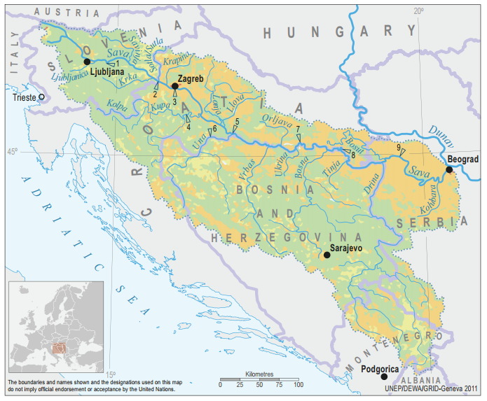
Figure 1 - The Sava and Drina rivers basin; Source: UNECE (2016)
The Sava and Drina have a proclivity for both dry spells and devastating floods—most recently occurring in 2010 and 2014. Current climate change projections for the Sava River Basin foresee a rise of flood peaks of up to 8 percent, while droughts are also anticipated to become more frequent. Floods and droughts create risks for livelihoods and impose constraints on trade, food security, and productive investment.
Deeper integration of water management is necessary across national borders as well as across water-dependent sectors to lower investment costs, capture synergies and economies of scale, and minimize negative externalities. The Sava-Drina River Corridor still possesses substantial rehabilitation and development potential that, with an integrated approach, could pave the way for further development in the water sector and beyond. A regional program on the Sava-Drina Corridor focused on integrated water resources development can facilitate a transition from fragmented, country-specific actions to joint decisions and concrete investments in infrastructure and complementary measures.
The development objective of the SDIP is to strengthen capacity for integrated river basin management and development through improved transport connectivity, flood protection, and landscape management in selected catchment areas of the Sava and Drina river corridors. This Project will implement approximately 40 sub-projects with high relevance to the program objectives. Sub-projects will be implemented at national level and will have cumulative regional benefits. Sub-projects related to environmental and flood management were prioritized based on potential for climate change adaptation.
The Project consists of four components as described below:

Component 1: Integrated Management and Development of the Sava River Corridor;
Component 2: Integrated Management and Development of the Drina River Corridor;
Component 3: Project preparation and management;
Component 4: Regional activities .

The program will be implemented over a period of 10 years, organized in two phases. Phase 1 will focus on flood protection and river basin management activities in the Sava and Drina River Corridors. It will start with Brčko District (BiH), Serbia and Montenegro while other entities and countries can join as they become ready. Phase 2 will build on Phase 1 and strengthen river port connectivity and environmental management. The estimated program cost for both phases is US$298 million.
In Serbia, SDIP will support rehabilitation and stabilization of Sava River dykes, flood protection measures along the Drina River and its tributaries, modernization and capacity expansion at the port of Sremska Mitrovica, and dredging, river training, and navigability enhancing works alongside the berths of the port and in the main fairway to/from the port. Also, the designs for reconstruction and upgrading of dykes at Kolubara and New Belgrade are underway and will be completed by March 2020, including the safeguard assessments and tender documentation. The procurement process for the preparation of preliminary engineering design, feasibility study, environmental impact assessment, and other preparation documentation for the navigation and port-related subprojects is ongoing and the consultants are being mobilized. So far two Sub-Projects have been identified as mature, the Flood Protection Works On the left River Bank of Sava in Popova Bara and Jarak. Within the RP prepared for these two Projects details on the GM will be provided.

1.2 Estimated displacement impacts and justification of RPF

The proposed Project activities, due to planned nature and extend of civil works, especially in Component 1 of the Project, are possible to have displacement impacts, maybe including land acquisition, other private property acquisition and/or relocation (i.e. structures built either on private or public land, crops, orchards, etc), physical relocation, economic displacement, temporary occupation of land and restricted access to economic resources for local communities due to changes in access and resource use. However, at this phase of Project planning since the size, number, scale and location of all subprojects cannot be determined, the likely nature or magnitude of the land acquisition or restrictions on land use related to a project with potential to cause physical and/or economic displacement is unknown and as it is impossible to estimate displacement impacts, number and categories of displaced persons, this RPF is prepared to clarify resettlement principles, organizational arrangements, and design criteria to be applied to subprojects, and to mitigate potential resettlement impacts. This RPF has been prepared in accordance with the legal system, laws and procedures of Republic of Serbia, and in conformity with ESS5 and good international practices.
Therefore, this RPF, rather than a RP is being prepared at this time. Once the individual project components are defined and the necessary information becomes available, such a framework will be expanded into specific plans proportionate to potential risks and impacts. No physical and/or economic displacement will occur until plans required by this ESS have been finalized and approved by the WB. Once the sites of the sub-projects are known, a two-tiered due diligence approach will be undertaken as outlined in this RPF, and individual RPs will be prepared that are compliant with this RPF. This RPF also provides the mandatory basis for developing site specific resettlement instruments as appropriate during implementation of those Project activities that lead to resettlement.

1.3 Objectives of this RPF

The objective of this RPF is to define overarching principles, procedures, actions, organizational structures and capacity requirements during resettlement, if such should be required, and its impact attributable to Project implementation. It also provides the framework for individual RPs that may need to be prepared under the sub-projects, should the need arise.
Its specific objectives are as follows:
- provide procedures for due diligence and screening for applicability of ESS5;
- classify RoS legal solutions in main events of involuntary resettlement, relocation and loss of assets, including legal and administrative procedures and assessment of compensation to be paid for loss of assets;
- compare them to ESS resettlement policies and international good practices; and provide the way to bridge the gaps, if any;
- identify key institutions besides the PIU, involved during the SDIP Project implementation, including especially legally authorized state institutions implementing the procedures and safeguards of involuntary resettlement process;
- design monitoring and evaluation criteria to provide compliance with ESS5 international good practices, this RPF and any subsequent RPs;
- present PAP's eligibility criteria and compensation entitlement matrix according to type of loss assets;
- define the basic process of identification and evaluation of affected assets and the value of compensation to replace the loss of assets;
- provide instruments for prompt and effective compensation at full replacement cost for loss of assets or access to assets;
- describe mitigation principles, including fundamentals in order to minimize impacts on PAPs during Project implementation, including mitigation guidelines measures provided for vulnerable groups and women;
- describe and provide directions for preparation, approval procedure, outlines and implementation process of RPs or other involuntary resettlement instruments in accordance with ESS5, as relevant;
- specify requirement of public disclosure, disclosure of documents, public and local community involvement in all phases of the Project preparation, including RPF and RPs disclosure and process;
- include public consultation guidelines in the PAP community during process of involuntary resettlement and Project implementation that may result in loss of assets;
- establish a gender-sensitive guidelines framework for resettlement in order to determine differential impacts since economic and social disruption do not result in equal hardship for women and men;
- specify internal monitoring activities during all phases of Project implementation, especially regarding resettlement issues, safeguarding legal and under this RPF defined process, including reporting and evaluation of the resettlement process and external monitoring and evaluation;
- specify the process of keeping a project Stakeholder Engagement Log (SEL) by the PIU;
- present a Project Grievance Mechanism (GM) to provide people who believe are adversely affected by the Project and sub-projects, an avenue to raise issues and concerns free of charge, define grievance process and complaint rights, process, bodies and procedures available to PAPs during the whole course of Project implementation, including feedback reporting.

1.4 Fundamental principles guiding resettlement

This RPF provides overarching and binding principles to be applied in all cases of physical resettlement, economic displacement and all other adverse social impacts caused throughout all phases of the Project implementation. These principles shall govern all actions of the PIU and its representatives, their subsidiaries if any, contractors, all other state and local institutions involved in the Project’s implementation.
The fundamental principles guiding resettlement in the SDIP are as follows:
- If possible, all resettlement should be avoided by exploring all viable alternatives or, when unavoidable, minimize involuntary resettlement by exploring Project design alternatives with the goal that adverse effects should be rendered to the bare unavoidable minimum.
- When unavoidable, adverse effects and social impact occurs, all loss of property shall be mitigated by providing timely compensation for loss of assets at least at the value of replacement costs.
- PAPs will be assisted in their efforts to improve, or at least restore, their livelihoods and living standards, in real terms, to pre-displacement levels or to levels prevailing prior to the beginning of Project implementation, whichever is higher.
- Negotiated settlements with affected persons are encouraged by this RPF prior to associated formal expropriation with the goal to help avoid administrative or judicial delays, and to the extent possible to reduce the impacts on affected persons.
- All resettlement needs to be managed in accordance with Serbia national laws, ESS5 and accepted international good practices. Where gaps exist between them, more stringent provisions will be applied. As a fundamental rule, under this RPF, during the Project’s implementation, policy that is most beneficial to the PAPs will always prevail.
- The Project’s PIU will be involved in all resettlement activities and at the earliest stage possible in the project design, in order to provide cost-effective, efficient and timely implementation of principles and objectives set by this RPF, as well to promote innovative approaches for improving the livelihoods and standards of living of those affected by involuntary resettlement.
- The Project will improve living conditions of poor or vulnerable persons who are physically displaced, through provision of adequate housing, access to services and facilities, and security of tenure.
- Additional special support will be provided to vulnerable groups and/or infividuals affected by the Project, during resettlement process, as well as during implementation of all phases of the Project according to their specific vulnerability.
- The Project will ensure a gender sensitive approach by inclusion of women, part of affected households, in all public consultation and discussions on specific mitigation measures. All activities in this RPF will aim to be gender tailored, with the goal to empower women and provide with the possibility to participate in mitigation measures provided for resettlement impact. The documentation for ownership or occupancy, such as title deeds and lease agreements (including the bank accounts established for payment of compensation), will be issued in the names of both spouses, if the expropriated assets are part of marital property of both spouses. Other resettlement assistance, such as skills training, access to credit and job opportunities will be made equally available to men and women and adapted to their needs.
- All resettlement activities are planned and implemented with appropriate disclosure of information, meaningful consultation, and the informed participation of those affected.
- In accordance with this RPF, RPs, and other resettlement instruments as appropriate, will be prepared. This RPF, the RPs and other resettlement instrument, is any, will be publicly disclosed during public consultations held prior to its final approval and prior to start of works that cause physical or economic displacement, to allow affected persons and stakeholders to participate in Project development, planning and implementation of resettlement programs.
- Accessible GM will be developed for affected people grievances before start of any civil works that can cause relevant physical or economic displacement per this RPF. During the Project implementation and resettlement cycle, stakeholders will be provided with full information about their grievance rights, possibilities and procedures. All grievances will be considered during Project implementation and resettlement activities.
- All resettlement activities should be conceived and conducted as sustainable projects by providing sufficient investment resources to enable principles and goals of resettlement defined by this RPF and RPs to be fully achieved.

2. Legal framework

2.1 National legal framework guiding resettlement

Constitution of Republic of Serbia
Passed in 2006 (the constitution was approved in the constitutional referendum of 2006, held from the 28-29th of October. It was officially proclaimed by the National Assembly of Serbia on November 8, 2006), Constitution of RoS proclaims the rule of law and social justice, principles of civil democracy, human and minority rights and freedoms, and commitment to European principles and values.
Article 58 generally acknowledges guarantees of peaceful tenure of a person’s property and other property rights acquired by law. It states that property rights may be revoked or restricted only when in public interest, established by law and with compensation equaling the market value at the minimum. It is to be emphasized that the Constitution of RoS sets payment of compensation at the level defined not less than the "market value". As such, this is an important provision for bridging gaps between Serbian laws and WB resettlement standards embodied in ESS5, as it will be presented later in this document. The provisions of the Constitution do not differentiate formal from informal properties relevant from the perspective of the structures constructed without a construction permit, a practice common for the past 30 years in Serbia. The Constitution further proclaims that all human rights (including the right of property) and minority rights guaranteed by the Constitution shall be implemented directly.
Of equal relevance is Article 16 stating that all general accepted rules of international law and ratified international treaties shall be an integral part of the legal system in the Republic of Serbia and applied directly. This provision allows direct implementation of ESS resettlement standards and policies, provisions of this RPF and individual RPs next to existing Serbian laws, and most important ways of bridging gaps between them if those WB resettlement policies and this RPF is considered to be an integral part of any future Loan agreement with the WB, once approved, signed and ratified by the Parliament.

The Law on Public property
Published in "Official Gazette of the RoS, No 72/2011, 88/2013, 105/2014, 104/2016 - other law, 108/2016, 113/2017 and 95/2018, it stipulates fundamental provisions on public ownership and other proprietary rights of the State, autonomous provinces and local self-government units.

The Law on foundations of property law relations
The Law on foundations of property law relations ("Official Gazette of the SFRY", No. 6/80, 36/90,"Official Gazette of the FRY", No. 29/96 and "Official Gazette of the RoS", No.115/2005) stipulates fundamental provisions of property relations, including ownership rights substance, subjects of ownership rights, co-ownership and joint ownership rights, acquiring the right of ownership, right on yields emanating from owned thing, possession rights, ownership acquired by adverse possession, ownership relations deriving in situations when structures was built on someone else's land, protection of ownership rights, protection of possession, cessation of ownership rights, etc. Most important provisions of this Law that are of considerable influence on the resettlement process and application of WB standards are the provisions regarding ownership rights acquired by construction (for informally constructed structures), provisions on the legal institute of joint spouse property on property acquired during marriage etc.

The Planning and construction law
The planning and construction law was published in "Official Gazette of the RoS", No. 72/09 of September 3, 2009, corrected "Official Gazette No. 81/09 (Corrigendum), changed by Constitution Court of RoS ruling 64/10 (CC), 24/11, 121/12, 42/13 (CC), 50/13 (CC), 98/13 (CC), 132/14 145/14, 83/2018, 31/2019 and 37/2019 (CC) and it governs the following issues: the conditions and modalities of spatial planning and development, the development of general and detailed regulation plans, the development and use of construction land and the construction of facilities, predominant use of land when the land has multiple uses, public use of land and other issues of significance in the development of space, landscaping and use of construction land and the construction of facilities.

Building legalization law
Building legalization law, published in "Official Gazette of the RoS ", No. 96/15 dated November 26, 2015 and 83/18 regulates the conditions, procedure and manner for legalizing buildings, parts of buildings, auxiliary buildings and other buildings constructed without a building or construction permit. The custom of constructing complete buildings (houses, shops, even apartment buildings), or adding auxiliary buildings to existing, legal building (garage, additional floors on houses or rooms) without a construction permit became quite usual during the past 30 years. The governments over the years always maintained the intention to legalize all illegally constructed buildings, if constructed on own land and/or with consent of the owner, but most of the buildings have not yet been legalized. It is without any doubt that if the Project will have any resettlement impact, some of the assets will be buildings without building permits so provisions of this law can be important, but in those cases, the RPF, in terms of eligibility, shall prevail if more stringent. This law now imposes restrictions to title transfer for structures constructed without building permits. In line with Article 28, all structures subject to the formal process of legalization shall within 6 months be registered as such by the relevant cadastral authority together with the note that any commercial transaction in terms of transfer of title is forbidden. This SSS experience on FERP WB financed project proves that the practice of building structures or part of structures is very common on publicly owned plots that are part of riversides and riverbeds in urban communities, so it can be expected that these kind of cases of impacts arise in this Project too, on river Sava and Drina.

The Law on Extra-Judicial Proceedings
The Law on Extra-Judicial Proceedings ("Official Gazette of SRoS", No. 25/82 and 48/88, amended "Official Gazette of the RoS" No 46/95, 18/2005, 85/2012, 45/2013, 55/2014, 6/2015 and 106/2015) defines the rules by which courts decide on personal, family, property-related and other rights and legal interests, which are resolved in extra-judicial proceedings, pursuant to the Law. In accordance with this Law, the court in extra-judicial proceedings determines compensation for an expropriated property after it establishes the important facts and approves a decision which defines the type and amount of compensation. According to this Law, participants may conclude an Agreement about type and amount of compensation, and the court will then base its decision on their agreement, if the court finds that the agreement is not contrary to mandatory regulations. Following ESS5 proclaimed standards and principles of resettlement, endorsed by this RPF in Chapter 1.4, RoS institution in charge of the land acquisition process will be obliged to strive to reach a negotiated settlement with previous owners of property, in accordance with the Expropriation law prior to the administrative proceedings (as will be described in the next Chapter 2.2) or pursuant to this Law.

The Law on Administrative procedures
The law in effect was adopted in 2016 ("Official Gazette of RoS No18/16 and authentic interpretation of the law - 95/2018”) defines the rules and procedures to be applied by government authorities when deciding on rights, obligations or legal interests of individuals, legal persons or other parties, within the framework of administrative procedures. Decisions by administration bodies are approved in form of a decree, after completing the procedure as prescribed by this Law. The party has the right to appeal against the decision approved in first instance. This Law administratively governs the expropriation process.

The Law on State Survey and Cadastre
The Law on State Survey and Cadastre ("Official Gazette of the RoS" No 72/2009, amended on 18/2010, 65/2013, 15/2015, 47/17, 113/17, 27/18, 41/18 ) regulates the professional activities and affairs of the state administration related to land, buildings and other structures survey, real estate cadastre, records and registration of property, registration of possession, registration of illegal buildings and buildings legalized according to provision of the latest Building Legalization Law of RoS, utilities cadastre, basic geodetic works, address register, topographic and cartographic activities, valuation of real estate, geodetic and cadastral information system.

2.2 Expropriation process in Serbia

The Law on Expropriation (passed in 1995 and enacted on January 1, 1996, amended in March 2001, March 2009, 2013 by the Constitutional Court ruling, and in 2016 – with the authentic interpretation) enables government institutions to acquire property for projects that are deemed to be of public interest, while protecting the interests of all persons with legal title, whose assets are to be expropriated. The Law on expropriation does not use the term "involuntary resettlement”, but instead uses the term "expropriation" and is based on the Governments eminent domain power. The law also enshrines the principle of compensation at "market price" of the property instead of the "replacement cost" used in ESS5.

2.2.1 Key provisions of the Law

These are key provisions of the Law of Expropriation:
- Immovable assets (defined as land, buildings and other structures including perennial plants, crops, logging forest etc) can be expropriated only once the public interest is declared either by law, or individual decision of the Government of RoS. Public interest can be declared if construction of facility is intended for public utility infrastructure, education, public health, social welfare, culture, water management, sports, transport, power, national defense, local/national government needs, environmental protection, protection from weather-related damage, exploration for, or exploitation of, minerals, land needed for resettlement of people holding mineral-rich lands, property required for certain joint ventures, and housing construction for the socially disadvantaged.
- As the potential Beneficiary of Expropriation (BoE) the law recognizes the Republic of Serbia, autonomous province Vojvodina, cities, the city of Belgrade, municipalities, public funds, public companies, companies that are established by public companies, as well as for companies with majority state capital founded by the above-mentioned state institutions.
- Expropriation can be either complete or incomplete. Complete expropriation allows the BoE to obtain ownership over the expropriated property, while the ownership by the owner and other rights cease to exist. Incomplete expropriation provides the BoE with specific easement rights on the land and structures, as well as the lease of the land for a definite period of time (not longer than three years in both cases). At the end of the easement or lease period full ownership rights over property are returned to the owner, and must be restored to condition prior to expropriation.
- Owners of immovable property partially expropriated are entitled to request expropriation of the remaining property and receive corresponding compensation, in case when the expropriation has deteriorated their economic situation, or the remaining part of the property has become unviable. The final submission date for such a request is two years after the construction of the facility that induced expropriation has been completed or within two years from the completion of construction works.
- As a general rule, compensation is cash based, unless the Law stipulates otherwise. When agricultural land is subject to expropriation for construction of linear infrastructure facilities (roads, highways, pipelines, etc.), suitable agricultural land of the same type and quality, or the corresponding value in the area or its surroundings shall be offered as a primary type of compensation. If such land is not available, the compensation shall then be offered cash based.
- To lessee of socially or state-owned flats, or to persons with occupancy rights in residential building or apartment subject to expropriation, tenure rights (use, lease or occupancy rights) of same kind of another equivalent, social or state-owned property in the vicinity shall be provided.
- Taking of the Expropriated property is not be allowed prior to the day the decision on compensation becomes legally valid, or before the date of conclusion of an agreement on compensation for expropriated property, unless the Law stipulates otherwise. This does not apply in cases of physical resettlement. There are exceptional cases allowing the BoE to take possession of the expropriated property immediately upon the final decision on expropriation, provided that the BoE has defined the basis for compensation under the provisions of the Law.

2.2.2 The expropriation process

This is a step-by-step presentation of the expropriation process, as defined by the Expropriation law:
- Declaration of the public interest: The General assembly of RoS by enacting a law, or GoRoS by its decision declares within 90 days the public interest for a certain development project thus enabling the use of eminent domain power of the government to acquire land and assets. The Expropriation law lists institutions, entities and bodies eligible to act as BoE.
- Commencement of the process: The process starts by submission of expropriation request to the relevant administrative authority (Municipality administration where the property is located) by the BoE. The request, amongst other data, must contain exact specification of owners and properties for which expropriation is proposed, and evidence on adequate funds available for compensation either through secured funds within the budget, or a bank guarantee, securing the payment of compensation, in accordance with the regulations governing public finances.
- Stakeholder engagement: Prior to deciding on the request, the relevant authority shall hold a hearing allowing the owners of immovable property to be informed on all facts of importance for the expropriation of property. If all conditions are met, the expropriation decision will be issued.
- Compensation: The BoE shall submit written compensation offers within 15 days of the legal validity of expropriation decision based on evaluation of assets made by proper authority.
- The municipal authority will without delay supply the owner with a copy of the offer and will collect information that may be of importance for the compensation from administrative and other institutions and organizations. The compensation agreement cannot be in contradiction to the Law on Expropriation provisions.
- Competence of the Judicial system. If the agreement is not reached within two months upon the date of legal validity of the Expropriation decision, the municipal administration shall ex officio refer such case without delay to the competent municipal court to determine and decide on the compensation. This process is, as mentioned, guided by the Law on Extra-Judicial proceedings.

2.3 WB standards on Land Acquisition, Restrictions on Land Use and Involuntary Resettlement (ESS5)

All WB financed projects involving Land Acquisition, Restrictions on Land Use and Involuntary Resettlement involuntary resettlement are subject to ESS5. The applicability of ESS5 is established during the environmental and social assessment described in ESS1. The ESS requires the Borrower to produce a Social Analysis to identify significant social issues in the existing project or activities, and assess their current status, specifically in terms of meeting the requirements of the ESSs, including social impacts that includes Land Acquisition, Restrictions on Land Use and Involuntary Resettlement involuntary resettlement.
The SA will also include facilities or activities that are not funded as part of the project, to determine if the WB ESS should apply to such activities equally as Associated Facilities in the meaning assigned to that term by the ESS. For the purpose of ESS and Bank projects, the term “Associated Facilities” means facilities or activities that are not funded as part of the project and, in the judgment of the Bank, if they are: (a) directly and significantly related to the project; and (b) carried out, or planned to be carried out, contemporaneously with the project; and (c) necessary for the project to be viable and would not have been constructed, expanded or conducted if the project did not exist.
The policy describes the procedures and instruments for mitigating negative economic and social issues that may arise. ESS5 is triggered in all cases when land acquisition or restrictions on land use that may cause physical displacement (relocation, loss of residential land or loss of shelter), economic displacement (loss of land, assets or access to assets, leading to loss of income sources or other means of livelihood), or both.
The overall objectives of ESS5 are the following:
- To avoid involuntary resettlement or, when unavoidable, minimize involuntary resettlement by exploring project design alternatives.
- To avoid forced eviction.
- To mitigate unavoidable adverse social and economic impacts from land acquisition or restrictions on land use by: (a) providing timely compensation for loss of assets at replacement cost and (b) assisting displaced persons in their efforts to improve, or at least restore, their livelihoods and living standards, in real terms, to pre-displacement levels or to levels prevailing prior to the beginning of project implementation, whichever is higher.
- To improve living conditions of poor or vulnerable persons who are physically displaced, through provision of adequate housing, access to services and facilities, and security of tenure.
- To conceive and execute resettlement activities as sustainable development programs, providing sufficient investment resources to enable displaced persons to benefit directly from the project, as the nature of the project may warrant.
- To ensure that resettlement activities are planned and implemented with appropriate disclosure of information, meaningful consultation, and the informed participation of those affected.

2.4 Gap analysis

The objectives of ESS5 are clear in their aim to avoid involuntary resettlement caused by land acquisition measures wherever feasible, and if this is not possible, to apply such compensation principles for impacts on all PAPs and to restore their livelihoods at least to pre-project level. In general, the institutional framework for expropriation in Serbia is not completely in compliance with the ESS5, and the most evident differences relate to the requirements to compensate at replacement cost for land vis-à-vis the national requirement of compensating land at market value without payment of taxes and fees as part of compensation package. Additionally, the national law includes decrease of value for structures by depreciation and it does not recognize informal users, occupiers and settlements. It also does not require a project specific grievance mechanism, a social impact assessment, gender disaggregated data, has a limited public consultation process and no assistance to vulnerable persons or groups are provided.
The table below provides an overview of specific gaps between the national expropriation law vis-à-vis ESS5 and the recommendations for remedy and/or mitigation in order to comply with the ESS5 requirements.

Table 1 - Gap analysis
Subject | National legislation | WB ESS5 and good international resettlement standards | Gaps and measures for bridging the gaps
Resettlement instruments, census and social impact assessment | The only documents prepared are part of construction plans, the Expropriation study is an inventory of land impacted and formal owners without tackling socio-economic issues. | Resettlement Plan is prepared proportionate to the risks and impacts associated with the (sub)projects. Where the likely nature or magnitude of the land acquisition or restrictions on land use is unknown, RPF is prepared. Census and socioeconomic survey must be conducted to identify PAPs, their demographic and socioeconomic characteristics, inventory of assets affected, magnitude of losses and extent of displacement, information on vulnerable groups or persons and additional studies the Bank may deem relevant. | This RPF and a site-specific RPs, if necessary, will be developed per ESS5, in addition to national legal requirements. Census and socioeconomic survey conducted according to WB requirement in addition to requirements under national legislation
Avoidance and minimization of involuntary resettlement | There are no specific requirements to minimize involuntary resettlement apart mentioned | Involuntary resettlement should be avoided where feasible, or minimized, exploring all viable alternative project designs.  The Borrower will consider feasible alternative project designs to avoid or at least minimize displacement. | The PIU will seek to minimize physical and/or economic displacement. All alternatives and measures explored to avoid or minimize negative impact will be recorded in the internal periodical (monthly or quarterly) report required by the WB.
Public consultations on resettlement instruments | The formal owners are contacted only at the very process of expropriation there is no requirements for public consultation apart from the spatial planning phase under the Planning and construction law. | Meaningful consultations with affected persons and communities, local authorities, and other stakeholders need to be carried out during the preparation and implementation of resettlement instruments and throughout all phases of the Project. | National legislation does not require public consultation with affected persons and communities at the extent and reach of those envisaged by ESS. The PIU shall disclose RPF and RP (if applicable) to PAPs and stakeholders and conduct consultation meetings as described in this RPF throughout all phases of the Project.
Cut-off date for eligibility and census | The RoS Expropriation Law stipulates that after the date of submission of the proposal for expropriation by the expropriation beneficiary to the relevant municipality, all investments made by owners after receiving information about the Expropriation proposal will not be compensated, except the necessary expenses. | Normally, the cut-off date is when census begins but could also be the date the project area was delineated, prior to the census, provided that there has been an effective public dissemination of information on the area delineated, and systematic and continuous dissemination subsequent to the delineation to prevent further population influx. | The cut-off will be date of beginning of the census. This will be publicly announced and published by the BoE in local newspapers, informing all owners and users of the initiation of the expropriation process, the cut-off date and the contact persons who may be contacted by PAPs for further information. This information will include posted warnings that persons settling in the project area after the cut-off date may be subject to removal.
Eligibility for compensation | The Expropriation Law recognizes only formal title holders and holders of rights recognizable under national laws (factual ownership). | Besides formal owners, ESS5 also recognizes those who have no recognizable legal right or claim to the land they are occupying on Cut-off-Date as eligible for relocation and rehabilitation assistance and compensation for loss of non-land assets at replacement value. | Compensation and assistance to PAPs without legal right or claims will be made per principles and entitlements provided in the entitlement matrix of this RPF, if they are present in the project affected area at the time of the cut-off date. Asset inventory and valuations of their affected properties will be conducted and all measures will be recorded in the internal periodical (monthly or quarterly) project progress report.
Valuation methodology for compensation for property | Compensation for loss of properties and assets should be at least equal to the market price.  Depreciation are deducted from compensation (or included by decreasing the market price value appraisal). The Expropriation Law does not specifically mention compensation for the costs of any registration fees and transfer taxes. | Compensation should be equal to full replacement cost without depreciation. | Compensation and assistance to PAPs will be at least equal to replacement value as provided in the entitlement matrix of this RPF.
Escrow accounts | There is no requirement to have an escrow account. However, the BoE is required to submit proof of financial funds for compensation prior to start of expropriation. If there is a court process about the compensation value, court can order funds to be deposited in court deposit account. | If there are significant difficulties related to the payment of compensation to particular affected persons, on an exceptional basis, with prior agreement of the Bank, the PIU may deposit compensation (plus contingencies) into an interest-bearing escrow or other deposit account. | Compensation funds as required by the RP/RPF including contingencies, can be deposited into interest-bearing accounts, if necessary, however only under exceptional circumstances and with prior approval from the WB. Compensation placed in escrow will be made available to eligible persons in a timely manner as issues are resolved.
Taking possession of land and related assets | The expropriated land and related assets can be taken into possession when the agreement on compensation is signed or the decision on compensation, when determined by the judicial authorities becomes legally binding. However, if BoE can prove urgency needs or damages if possession is not allowed, administrative authority in charge of expropriation can allow taking possession prior to compensation payment, which in practice happens often. | Taking possession of assets only after full payment of compensation is a rule. In certain cases there may be significant difficulties related to the payment of compensation to particular affected persons, for example, where repeated efforts to contact absentee owners have failed, where project-affected persons have rejected compensation that has been offered to them in accordance with the approved plan, or where competing claims to the ownership of lands or assets are subject to lengthy legal proceedings, Borrower may be allowed to take possession of the property but only with prior consent of the WB and after showing adequate funds has been placed in the escrow account. | Taking of land and related assets after payment of compensation shall apply as a rule. If the offer is rejected, the land and related assets can be taken once the funds equal to the offered amount plus 10% have been secured and earmarked in a designated account, and with prior approval of WB, and the MoF has endorsed such taking by rendering case to case based decisions in compliance with the Law.
Transitional Support | The Expropriation Law doesn't recognize any form of transitional allowance. | Transitional support will be provided as necessary to all economically displaced persons, based on a reasonable estimate of the time required to restore their income-earning capacity, production levels, and standards of living. This may include payment for lost crops and lost natural resources, payment of lost profits for businesses, or payment of lost wages for employees affected by business relocation. | The PIU will ensure that displaced persons receive transitional support per entitlement of this RPF.
Loss of benefits and income for workers and employees | No particular legal provision | In addition to compensation at full replacement cost and transitional support, displaced persons must be assisted in their efforts to improve, or at least restore, their livelihoods and living standards. | Each site-specific RP shall include measures and design adequate support and assistance commensurate to the impact, as a way to bridge the gap, and all measures must be demonstrated and documented to the satisfaction of the WB.
Gender aspects | Men and women have equal rights in the Republic of Serbia, including the right to be title holders. | Women’s perspectives must be obtained through consultation and their interests factored into all aspects.  Documentation of ownership or occupancy and compensation should be issued in the names of both spouses wherever possible, and other resettlement assistance, such as skills training, access to credit, and job opportunities, should be equally available to women and adapted to their needs. | Particularly in some rural areas, women’s participation in consultations may be limited. Women only consultation may be held as relevant.  Documentation of ownership or occupancy and compensation should be issued in the names of both spouses, and other resettlement assistance, such as skills training, access to credit, and job opportunities, should be equally available to women and adapted to their needs.
Grievance  Mechanism (GM) | There is no requirement to have project specific grievance mechanism, apart from the institutional one. | The Borrower will ensure that a grievance mechanism for the project is in place, in accordance with ESS10 as early as possible in project development to address specific concerns about compensation, relocation or livelihood restoration measures raised by displaced persons (or others) in a timely fashion. | The PIU shall establish a Project Grievance Mechanism as described in the RPF scaled to the risks and adverse impacts of the project. Appropriate, affordable (free) and accessible procedures to address concerns and grievances will be established; such grievance mechanisms should consider the availability of judicial recourse and community and traditional dispute settlement mechanisms.
Monitoring & Evaluation | No specific monitoring procedures are required by RoS laws to be implemented by the BoE. | The Borrower will establish procedures to monitor and evaluate the implementation of the plan and will take corrective action as necessary during implementation to achieve the objectives of this ESS. The extent of monitoring activities will be proportionate to the project’s risks and impacts. For all projects with significant involuntary resettlement impacts, the Borrower will retain competent resettlement professionals to monitor the implementation of resettlement plans, design corrective actions as necessary, provide advice on compliance with this ESS and produce periodic monitoring reports. | The PIU will be responsible for monitoring in line with the requirements set out in the ESS, this RPF and any subsequent RPs. All monitoring and evaluation measures must be demonstrated and documented to the satisfaction of the WB, and will be recorded in the internal periodical (monthly or quarterly) project progress report. Affected persons will be consulted during the monitoring process as described in the Chapter of this RPF about the SEL.

3. Resettlement strategies applicable to the Project

3.1 Key principles

Key principles which will govern all resettlement activities by the PIU or conducted on behalf of the PIU, or Associated Facilities (in the meaning as assigned in this RPF) will be incorporated into all site-specific RP(s). These are summarized as follows:
- Involuntary resettlement will be avoided, or if not possible, minimized by exploring feasible alternatives in Sub-project designs.
- Resettlement and compensation of Project-Affected People will be carried out in compliance with Serbian legislation and World Bank’s ESS5, were the more stringent (more beneficial to PAPs) requirement will take precedence.
- All PAPs will be compensated for their losses at replacement cost and additional assistance will be provided appropriate to individual impact and suited to individual needs of PAP, in order to allow restoration to at least pre-displacement level.
- Differentiated measures will be adopted and carried out so that adverse impacts do not fall disproportionately on the disadvantaged or vulnerable groups/individuals, if any.
- Besides mandatory stakeholder engagement and public consultations, PIU will keep an open dialog channels through-out the full life of the (sub-)projects with stakeholders, PAPs and the impacted local communities.
- The RP implementation and outcomes will be monitored and evaluated by the PIU, and all measures must be demonstrated and documented to the satisfaction of the WB, and be recorded in the internal periodical (monthly or quarterly) report required by the financing institution.

3.2 Estimated displacement impacts

As sub-projects are currently under planning and review, it is not feasible to estimate displacement impacts and number and categories of displaced persons. When sub-projects are known, PIU will conduct an Social analysis that will be used to identify and assess the potential social risks and impacts of the proposed sub-projects. The Social analysis process and its findings, as well as proposed mitigation measures will be documented as part of the project/subproject package, as described in the Chapter 4.1 of this RPF.
However, two sub-projects have already been accepted (Jarak and Popova Bara) and RPs are being prepared simultaneously as this RPF. Some of the information on potential impacts have already been recognized and further details will be known and presented in the process of RP development.

3.3 The Cut-off date

The date of beginning of the Census for the RPs preparation serves as the Cut-off date. Persons who encroach on the project area after the cut-off date are not entitled to compensation or any other form of resettlement assistance. Similarly, fixed assets (such as built structures, crops, fruit trees, and woodlots) constructed after the cut-off date will not be compensated.
A Moratorium notice informing the general and local public of the declaration shall be made to serve as the Cut–off date for eligibility to entitlements. The date of the notice shall correspond to the commencement date of the Census. This information will include posted warnings that persons settling in the sub-project areas after the Cut-off date may be subject to removal without compensation. In addition, at the beginning of the Census, every individual surveyed shall be informed about the moratorium date and the respective consequences of commencing activities after the date of beginning the Census.

3.4 Eligibility criteria

The unit of entitlement is any individual eligible to receive compensation or rehabilitation benefits. The determination of Eligibility criteria is in lieu with developing and identifying the Census and inventory of all assets impacted by the Project to allow full compensation in line with the Entitlement Matrix. All PAPs identified prior to the Cut-off date shall be entitled to compensation, according to the compensation principles of the law, this RPF and ESS5, whereas the more stringent (more beneficial to the PAPs) requirements shall prevail.
Project Affected Persons are defined to include the following categories:
- PAPs with formal title ownership on the land, that lose all or part of their land;
- PAPs with formal title ownership, who have immovable property with or without building permissions on the land to be expropriated;
- PAPs with formal title over businesses that are affected by the loss of all or part of the land on which businesses are located;
- Project affected persons with formal title over animal husbandries and agricultural processors that are affected by the loss of all or part of the land on which they are based;
- Project affected persons with formal title of tenancy on private or public land;
- Project affected persons with formal title over land that will be needed during construction on a temporary basis;
- Project affected persons without formal title on affected land or businesses but their livelihoods are directly dependent on the affected land or businesses (e.g., those working on affected agricultural land or working in the affected businesses);
- Project affected persons without formal title of ownership or use but who have established usage of public or private land by investing in immovable objects, crops, woods, trees, fruit bearing trees, vineyards, the age of crops, and the time needed to reproduce them;
- Persons without any formal or recognisable legal right to the property they are occupying prior to the Cut-off date; and
- Any affected community facilities will also be reconstructed or necessary support will be provided.

3.5 Entitlement matrix

The entitlements for different categories of impact and PAPs shall be as per the Entitlement Matrix as adopted in this RPF. As a general rule, in case of:
- Physical displacement PAPs will be offered choices among feasible resettlement options, including adequate replacement housing or cash compensation at replacement cost and provided with relocation assistance suited to the needs of each group of displaced persons and appropriate to their loss of assets;
- In all cases of economic displacement, when sub-projects affect livelihoods or income generation, measures will be to allow affected persons to improve, or at least restore, their incomes or livelihoods
All entitlements, eligibility for compensation and compensation evaluation methods for resettlement under this RPF are summarized in the Table 2 below.

Table 2 - Entitlement matrix
Type of loss | Person with rights | Compensation policy
Economic displacement
Land
Agricultural land regardless to severity of loss (whether partial or complete loss) | Owner with formal property title (including owner with legally recognisable claim) | Replacement land of equal or higher value and similar productivity in direct proximity or in the surroundings of the expropriated land together with all costs of resettlement and administrative fees needed for transfer of ownership rights, if any.  Or, Cash compensation at replacement costs;  +  Transitional allowance and assistance, if needed.
 | Lessee with valid documents of the right of lease who cultivates agricultural land pursuant to agreement | Compensation for all improvements on land (such as irrigation). Compensation will be paid at replacement cost.  +  Costs of equipment relocation and installation  +  Offer replacement land for lease, if land was leased from state, or  compensation for the cost of identifying a viable alternative location,  +  Lost net income during the period of transition  +  Transitional allowance and assistance, if needed.
 | PAPs without formal title (users of agricultural land and livelihood is land based) | PAPs without a formal title who were in possession of the cultivated land on Cut-off date will not receive compensation for the land but will be compensated for all investments made on land at replacement cost and will be offered use of other land with safe and long-term agricultural use (lease of state land), or  compensation for the cost of identifying a viable alternative location,  +  Costs of equipment relocation and installation  +  Lost net income during the period of transition  +  Transitional allowance and assistance, if needed.
Construction land used for business enterprise, regardless to severity of loss (whether partial or complete loss) | Owner with formal or recognisable title, or users of publicly/state owned construction land, and pre-nationalization owners | Cash compensation at replacement costs, or  At property owner demand, if legal terms are met, replacement land of equal or higher value and similar value in direct proximity or in the surroundings of the expropriated land together with all costs of resettlement and administrative fees needed for transfer of ownership rights, if any,  +  Compensation for all investments on land Compensation will be paid at replacement cost  +  Costs of equipment relocation and installation  +  Lost net income during the period of transition  +  Transitional allowance and assistance, if needed.
 | Lessee with valid documents of the right of lease | Compensation for all investments on land Compensation will be paid at replacement cost  +  Costs of equipment relocation and installation  +  Lost net income during the period of transition  +  Replacement land for lease, if land was leased from state, or  compensation for the cost of identifying a viable alternative location,  +  Compensation for all rent paid in advance, for the period not expired
 | PAPs without formal title | PAPs without a formal title who were in possession of the land on Cut-off date will not receive compensation for the land, but will:  be compensated for all investments made on land at replacement cost.
Unviable land, agricultural or construction | Property owners, or users of publicly/state owned construction land | In case the remaining area of land is not viable, it can be expropriated upon PAPs request and compensated according to type of property
PLANTS AND STRUCTURES ON AGRICULTURAL LAND (but not houses)
Loss of annual crops, that could not have been harvested prior to land repossession | Owners of crops (it is not of importance if the owner of crops is owner of land, or lessee, or informal owner/user of land providing that they bore costs of planting crops | Cash compensation at replacement cost
Loss of perennial plants and trees (fruit bearing trees, vineyards and fruit bearing plants) | Owners of plants (it is not of importance if the owner of plants is owner of land, or lessee, or informal owner/user of land providing that they bore costs of planting | The right to collect fruits  +  Cash compensation at replacement cost on the basis of sort, year and productive value, including the value of time needed to produce such crop and net income loss, as well as costs of investment (work and labour force), to plant a new vineyard, orchard or similar, till the moment it reaches the full fructuous potential.
Affected vineyards and orchards not yet fruit bearing |  | Cash compensation for the investment in planting a new vineyard or orchard (labour, seedlings), including the value of time needed to reproduce a replacement vineyard or orchard and net income loss.
Wood mass (mature or nearly mature) |  | The replacement cost determined based on the value of the “wood on the stump” at market value
Forests without mature wood mass |  | Cash compensation for the investment in planting a new forest, including the value of time needed to reproduce a replacement forest and net income loss.
Nursery not yet yielding |  | Cash compensation for the investment in planting material (nursery and other reproductive material).
Buildings used for keeping and raising livestock (sheds, stables, etc.) | Owners of structures used for keeping livestock | Cash compensation at replacement costs, or;  At property owner demand, if legal terms are met, appropriate replacement property + costs of resettlement and administrative fees needed for transfer of ownership rights, if any;  +  Compensation for the cost of identifying a viable alternative location, if owner doesn't own alternative location  +  Lost net income during the period of transition  +  Transitional allowance and assistance, if needed.
Impact on agricultural employees, or processors | Workers, employees | In case of disturbance of income source compensation on a one-time basis will be paid commensurate to income loss;  +  Training for alternative jobs if possible and if needed;  +  Priority in employment on the Project, if possible and on a case by case basis (In accordance with social assessment processed in RPs)
BUSINESS (but not agriculture)
Business structures (shops, offices buildings) etc. | Owners with formal title (including owner with legally recognisable claim) | Cash compensation at replacement costs, including taxes  +  Costs of equipment and inventory relocation and re-installation  +  Compensation for the cost of identifying a viable alternative location,  +  Cash compensation on a one time basis (transitional allowance) to be determined on a case to case basis during social survey by obtaining relevant data on income and livelihood. Transitional allowance shall then be determined commensurate with the loss.  or;  At property owner demand, if legal terms are met, replacement property of equal or higher value and similar feature, in direct proximity or in the surroundings of the expropriated building together with all costs of resettlement and administrative fees needed for transfer of ownership rights, if any
 | Lessee with valid documents of the right of lease who uses premises according to agreement | Compensation for all improvements on premises (such as reconstruction, refurbishment etc.). Compensation will be paid at replacement cost.  +  Costs of equipment and inventory relocation and re-installation,  +  Cash compensation on a one time basis (transitional allowance) to be determined on a case to case basis during social survey by obtaining relevant data on income and livelihood. Transitional allowance shall then be determined commensurate with the loss.  +  Replacement premises for lease, if premises was leased from state, or  +  Compensation for the cost of identifying a viable alternative location,
 | PAPs, owners without formal title (building constructed without building permit on one’s own plot of land, or on somebody else's land - usually state owned) | Cash compensation for the building at replacement cost of the structure, including taxes  +  Costs of equipment and inventory relocation and re-installation  +  Compensation for the cost of identifying a viable alternative location,  +  Cash compensation on a one off basis (transitional allowance) to be determined on a case to case basis during social survey by obtaining relevant data on income and livelihood. Transitional allowance shall then be determined commensurate with the loss, and assistance.
Loss of any non-agricultural business | Owner of business (regardless of the fact if the business is properly registered as long as it is a legal activity) | Cash compensation for relocating the business, including compensation for immovable inventory and replacement cost of investment.  +  Compensation for the cost of identifying a viable alternative location  +  Lost net income during the period of transition  +  Cash compensation on a one-time basis (transitional allowance) and transitional assistance  +  Any registration taxes.  +  Appropriate level of support for improving the skills if necessary to perform restoration of income source (livelihood).
Loss of non-agricultural businesses | Workers, employees | In case of disturbance of income source compensation on a one-time basis will be paid commensurate with income loss.  +  Training for alternative jobs if possible.  +  Priority in employment on the Project, if possible and on a case by case basis (In accordance with social assessment processed in RPs)
Living premises (houses, flats) used for lease as source of livelihood | Owner of property | Cash compensation for building at full replacement cost  +  Compensation for costs of relocation (moving allowance) and cash compensation on a one time basis (transitional allowance, if rent was a source of livelihood).
PHYSICAL RESETTLEMENT
Buildings (residential, houses, flats etc.) | Owner with formal title (including owner with legally recognisable claim) | Cash compensation at replacement costs, or;  replacement property of equal or higher value, in direct proximity or in the surroundings of the expropriated property together with all costs of resettlement and administrative fees needed for transfer of ownership rights, if any;  +  Payment for relocation costs (moving allowance) and compensation for other costs during relocation and cash compensation on a one time basis (transitional allowance).  +  Transitional assistance suited to the needs of each group of displaced persons.
 | Informal owner - building constructed without building permit on one’s own plot of land if subject to legalization
 | Informal owner - building constructed without building permit on one’s own plot of land or constructed without building permit on someone else’s or state-owned - not eligible for legalization | Cash compensation for the building at replacement cost of the structure  +  Provide arrangements to allow them to obtain adequate housing with security of tenure (if they don't own other structures)  +  Payment for relocation costs (moving allowance) and compensation for other costs during relocation and cash compensation on a one time basis (transitional allowance)  +  Transitional assistance suited to the needs of each group of displaced persons.
 | Lessee of the affected property | Payment of resettlement costs and compensation for other costs caused by relocation and cash compensation on a one-time basis (transitional allowance)  +  Transitional assistance suited to the needs of each group of displaced persons.
 | Lessee or person with occupancy right to state owned flat | Provide lease or occupancy rights of same kind of another equivalent, social or state owned property in the vicinity.  If equivalent state or socially owned flat is not available in the vicinity, PAP will be offered state or social owned flat more remote from the area of expropriated flat,  +  Payment for relocation costs (moving allowance) and compensation for other costs during relocation and cash compensation on a one time basis (transitional allowance). evaluated based on potential extra costs incurred by increased commuting costs  +  Transitional assistance suited to the needs of each group of displaced persons.
Unviable buildings | Owner of building | In case that the remaining building is not viable or under a physical impediment for physical use can be expropriated upon PAP’s request.  Compensation is provided in the way as prescribed for that type of building in accordance with this matrix.
Other resettlement situations
Publicly or state owned buildings, or part of buildings | Informal users, squatters | Provide arrangements to allow them to obtain adequate housing with security of tenure (if they don't own other structures)  +  Payment for relocation costs (moving allowance) and compensation for other costs during relocation and cash compensation on a one time basis (transitional allowance).  +  Transitional assistance suited to the needs of each group of displaced persons.
Loss of access to usual natural resources and buildings | Communities, businesses, individuals or households | Replacement of public ownership or conveniences (roads and similar) and provide access to equal conveniences or services. Measures will be implemented to either allow continued access to affected resources or to provide access to alternative resources with equivalent livelihood-earning potential and accessibility. Where common property resources are affected, benefits and compensation associated with restrictions on natural resource usage may be collective in nature
Impacts caused by temporary occupancy of land and any damages to the property | Property owner (including owner with legally recognisable claim) | Market price of lease for duration of the occupancy. The land must be returned to original condition. Improved quality of the land due to top soiling work should not be removed, except if agreed differently with PAP.  +  Replacement cost in accordance with this matrix for affected crops, orchards, nurseries etc.  +  Compensation for any damages to the property evaluated at replacement costs.
Established permanent easement rights on the property (i.e. right of way over land or property) | Property owner (including owner with legally recognisable claim) | Compensation for decrease of market value of land or building due to easement rights implementation  +  Replacement cost in accordance with this matrix for affected crops, orchards, nurseries etc.  +  Compensation for any permanent loss of income due to easement evaluated at replacement costs.
Impact on vulnerable groups | Vulnerable PAPs: persons below the poverty line in accordance with national laws, households led by women, single parent,  elderly, disabled person or those with long-term health problems. | On top of all rights defined in this matrix, vulnerable PAPs will be provided additional assistance including legal assistance and help. Any additional support required for any affected vulnerable households will be determined on case-to-case basis during socio-economic survey.  These PAPs are given priority of employment on  the project if that is possible.
Undetermined impact | Owner or formal beneficiary | Any undetermined impact will be mitigated in accordance with principles and aims of this RPF

4. Resettlement instruments

4.1 Social analysis of sub-projects for land acquisition, restriction on land use and involuntary resettlement impacts

In consultation with the Bank, identification and use of appropriate methods and tools, including scoping, social analyses, investigations, audits, surveys and studies, will be used to identify and assess the potential social risks and impacts of the proposed sub-projects that will be part of the SDIP. These methods and tools will reflect the nature and scale of the sub-project land acquisition, restriction on land use and involuntary resettlement impacts. This process will be referred to, in this RPF, as Social analysis and is conducted prior to other resettlement instruments.
The PIU will receive preliminary information from local Municipalities once the locations of proposed sub-projects are known. The required information shall include a description of the nature, scope and location of the proposed sub-project, accompanied by location maps and any other details as may be required. By using the resettlement screening checklist provided in Annex 2 of this RPF, the PIU (MAFWM) will then go on site and verify the information provided in cooperation with local authorities, to confirm whether the project has potential involuntary resettlement which might result in physical displacement of persons, loss of assets, loss of livelihood or restriction of resource use. If there are enumerated impacts present, then this RPF is triggered and a RP needs to be prepared. Screening for potential involuntary displacement is done by PIU staff using the resettlement-screening checklist provided in Annex 2 which includes triggers for providing a RPs. If the answer is ‘yes’ to any of the questions, a RP will be prepared. Appropriate screening training will be provided by the SSS.
The Social analysis process and its findings, as well as proposed mitigation measures will be documented as part of the project/subproject package. The following guidelines, codes of practice and requirements will be followed in the selection, design and implementation of any operations financed under the activities of the Project. Screening of activities will be carried out by the PIU’s Social Safeguard Specialist. The screening reports will be endorsed by the Head of the PIU and submitted to the World Bank.
The screening will rely on the following criteria and will aim to faithfully identify whether the proposed sub-projects will have adverse impacts on:
- loss of shelter, physical displacement;
- assets/resources or access to assets/resources;
- loss of income sources or means of livelihood;
- land, and require land acquisition;
- business and economic displacement;
- access to education and health of the community;
- vulnerable persons and households.
The Social analysis will identify persons with formal rights to land and assets (including customary and traditional rights recognized under the laws of the country). The analysis will also identify persons who do not have formal rights to land but have a claim to such land and assets. It will not only rely only on the use and analysis of secondary data that is readily available, but will also require a walk-over survey to validate that the secondary data provides a true, reliable and accurate accounting of the social environment. In cases where no conclusive decisions can be drawn from the walkover survey, further efforts will be made to acquire and verify information through key informant interviews, focus group discussions and other adequate methodology. If the analysis finds that such impacts as described above are present on sub-project affected land, a RP and other resettlement instruments as applicable will be prepared based on the principles and guidance provided by the RPF.

4.2 Resettlement plan (RP)

4.2.1 Minimum elements of the RP

The scope of requirements and level of detail of the RP vary with the magnitude and complexity of resettlement caused by the sub-project. The plan is based on up-to-date and reliable information about (a) the proposed sub-project and its potential impacts on the displaced persons and other adversely affected groups, (b) appropriate and feasible mitigation measures, and (c) the legal and institutional arrangements required for effective implementation of resettlement measures.
A site-specific RP shall include the following at the minimum, as specified in the ESS5:
- Description of the project: General description of the project and identification of the project area;
- Potential impacts identification: activities that give rise to displacement, scope and scale of land acquisition and impacts on structures and other fixed assets, or imposed restriction of use, alternatives considered to avoid or minimize displacement, mechanisms to minimize displacement during project implementation etc;
- Objectives: The main objectives of the resettlement program;
- Census survey and baseline socioeconomic studies;
- Legal framework: compulsory acquisition and imposition of land use restriction and the nature of compensation associated with it, in terms of both the valuation methodology and the timing of payment, applicable legal and administrative procedures, including a description of the remedies available to displaced persons in the judicial process, laws and regulations relating to the agencies responsible for implementing resettlement activities, gaps, if any, between local laws and practices and ESS5, and the mechanisms to bridge such gaps etc;
- Institutional framework: identification of agencies responsible for resettlement activities, assessment of the institutional capacity of such agencies, steps that are proposed to enhance the institutional capacity of agencies etc;
- Eligibility: Definition of displaced persons and criteria for determining their eligibility for compensation and other resettlement assistance, including relevant cutoff dates;
- Valuation of and compensation for losses: methodology to be used in valuing losses to determine their replacement cost; and a description of the proposed types and levels of compensation under local law and supplementary measures as are necessary to achieve replacement cost value;
- Community participation: Involvement of displaced persons (including host communities, where relevant), strategy for consultation with, and participation of, displaced persons in the design and implementation of the resettlement activities, summary of the views expressed and how these views were taken into account, resettlement alternatives presented and the choices made by displaced persons, institutionalized arrangements by which displaced people can communicate their concerns to project authorities, and measures to ensure that vulnerable groups are adequately represented;
- Implementation schedule: providing anticipated dates for displacement, and estimated initiation and completion dates for all resettlement plan activities;
- Costs and budget: showing categorized cost estimates for all resettlement activities;
- Grievance mechanism: sub-project specific affordable and accessible procedures for third-party settlement of disputes arising from displacement or resettlement;
- Monitoring and evaluation: Arrangements for monitoring of displacement and resettlement activities by the implementing agency, supplemented by third-party monitors, performance monitoring indicators to measure inputs, outputs, and outcomes for resettlement activities, involvement of the displaced persons in the monitoring process, etc;
- Arrangements for adaptive management: provisions for adapting resettlement implementation in response to unanticipated changes in project conditions, or unanticipated obstacles to achieving satisfactory resettlement outcomes.
When project circumstances require the physical relocation of residents (or businesses), resettlement plans require additional information and planning elements. Additional requirements include:
- Transitional assistance: describes forms of assistance to be provided for relocation of household members and their possessions and in transitional period;
- Site selection, site preparation, and relocation: When planned relocation sites are to be prepared, the RP includes describes the alternative relocation site preparation, technical, institutional, social, legal arrangements etc;
- Housing, infrastructure, and social services: Plans to provide or to finance local housing, infrastructure (e.g., water supply, feeder roads), and social services (e.g., schools, health services);
- Environmental protection and management of the planned relocation sites;
- Consultation on relocation arrangements: describes process of consultation with physically displaced persons on their preferences regarding relocation alternatives, choices related to forms of compensation and transitional assistance etc;
- Integration with host populations: measures to mitigate the impact of planned relocation sites on any host communities.
If land acquisition or restrictions on use of, or access to, land or natural resources cause significant economic displacement, arrangements to provide displaced persons with sufficient opportunity to improve, or at least restore, their livelihoods are also incorporated into the RP, or into a separate livelihoods improvement plan. These include:
- Direct land replacement: for agricultural livelihood based PAPs, the RP provides for an option to receive replacement land of equivalent productive value or demonstrates that sufficient land of equivalent value is unavailable, etc;
- Loss of access to land or resources: describes means to obtain substitutes or alternative resources, or otherwise provides support for alternative livelihoods;
- Support for alternative livelihoods: describes feasible arrangements for obtaining employment or for establishing a business, including provision of relevant supplemental assistance including skills training, credit, licenses or permits, or specialized equipment. As warranted, livelihood planning provides special assistance to women, minorities or vulnerable groups who may be disadvantaged in securing alternative livelihoods;
- Consideration of economic development opportunities: identifies and assesses any feasible opportunities to promote improved livelihoods as a result of resettlement processes. This may include, for example, preferential project employment arrangements, support for development of specialized products or markets, preferential commercial zoning and trading arrangements etc;
- Transitional support: describes transitional support to those whose livelihoods will be disrupted.

4.2.2 Process of development and approval of RPs

Activities on the preparation of site-specific, sub-project RPs will be disclosed in the way to enable significant participation of PAPs. That assumes the phase of preliminary preparations will include disclosure of preparations for population census, disclosure of census results while respecting privacy of personal information, disclosure of socio-economic baseline assessment, as well as disclosure of RP drafts. The purpose of public disclosure and discussions is to ensure meaningful participation of PAPs in the process of preparation, implementation and monitoring of resettlement instruments.
As mentioned, amongst other elements of RP, census survey and baseline socioeconomic studies will be prepared. The purpose of a household-level census is to identify and enumerate PAPs, and to make an inventory of affected assets. The census survey also serves other essential functions:
- identifying characteristics of displaced households, including a description of production systems, labor, and household organization;
- provide baseline information on PAPs livelihoods (including, as relevant, production levels and income derived from both formal and informal economic activities) and standards of living (including health status) of the displaced population;
- provide information on vulnerable groups or persons for whom special provisions may have to be made;
- identify public or community infrastructure, property or services that may be affected;
- provide a basis for the design of and budgeting for the resettlement program;
- in conjunction with establishment of a Cut-off date, provide a basis for excluding ineligible people from compensation and resettlement assistance; and
- establish baseline conditions for monitoring and evaluation purposes.
As the WB may deem relevant, additional studies on the following subjects may be required to supplement or inform the census survey:
- land tenure and transfer systems, including an inventory of common property natural resources from which people derive their livelihoods and sustenance, etc;
- the patterns of social interaction in the affected communities, including social networks and social support systems, and how they will be affected by the project; and
- social and cultural characteristics of displaced communities, including a description of formal and informal institutions (e.g., community organizations, ritual groups, nongovernmental organizations (NGOs)) that may be relevant to the consultation strategy and to designing and implementing the resettlement activities.
Questionnaire template survey for carrying out the socio-economic census is provided in Annex 2 to this document.
The first draft of RP shall be submitted to the World Bank for review and clearance. After it has been cleared, it will be disclosed (in English and in Serbian language) by the PIU in areas accessible to affected people, local newspapers in the community(s) affected by the relevant sub-project and on internet portal of the PIU, followed by public consultation with local communities and stakeholders. PIU shall also issue a summarized information on the RP for public disclosure to ensure that affected people understand the compensation procedures and know what to expect at the various stages of the sub-project (for example, when an offer will be made to them, how long they will have to respond, grievance procedures, legal procedures to be followed if negotiations fail etc). Public consultation outcome shall be documented and reported with the final document of the RP and sent to WB for "No Objection". Upon receiving the "No Objection", final RP will again be disclosed in areas accessible to affected people, published in local newspapers in the community(s) affected by the relevant sub-project and on internet portal of the PIU, and made available throughout the sub-project life cycle, RP implementation and process of resettlement.

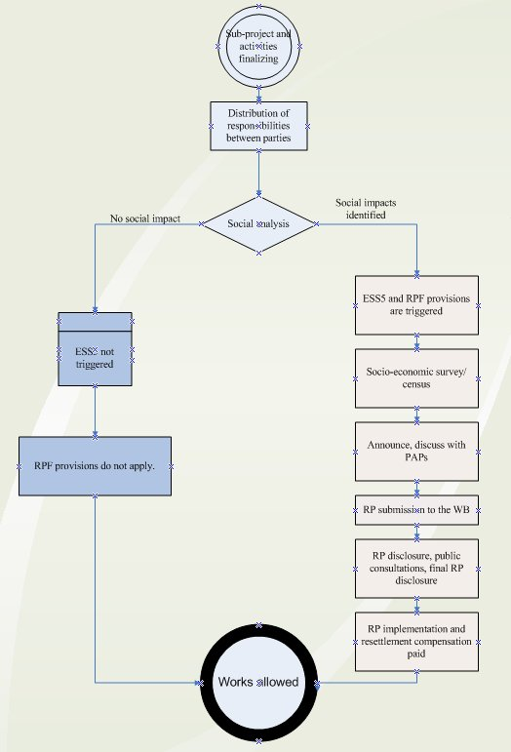
Figure 2 - RP approval flow chart

4.2.3 RP implementation

No activities on construction works can commence until and unless compensation has been paid, or appropriate compensation set aside on an escrow or similar account, or replacement property administered to PAPs, or court procedure initiated to determine the compensation in case no amicable settlement is reached, as outlined in the Entitlement Matrix
Implementation of RPs is an obligation of the Borrower through the PIU. The PIU shall monitor overall implementation, collaborate with the municipalities in which territory the constructions are taking place, collaborate with contractors and disclose information to PAPs and communities.

5. Consultation and disclosure

5.1 Public consultations

The PIU will establish an ongoing relationship with affected communities, from as early as possible in the sub-project planning process, and throughout the life of the Project. The engagement process will ensure their meaningful consultation in order to facilitate a common understanding of the nature and duration of the impacts; informed participation on matters that affect them directly; proposed mitigation measures; the sharing of development benefits and opportunities; and implementation issues. Individual meetings may be held with PAPs regarding specific cases, including upon request by PAPs. All documents prepared as part of the implementation of this RPF, i.e. the RPF, any subsequent sub-project RP, will be disclosed in Serbian and English languages, and made available for a public feedback no later than 5 days prior to public consultations and sufficient time shall be provided for submitting remarks after public consultations. All public consultations shall be announced through local newspapers and on the PIU’s internet portal. Project information, and Information about the GM will be disseminated in Serbian and English.

5.1.1. Public consultation on this RPF

After the WB approve draft of the RPF, public consultation on RPF will be held (may be held in the same time as public consultation for approved drafts of other Project documents). The RPF will be disclosed (on PIU and Project website) and available for a public insight at least 10 days prior to public consultations and sufficient time must be given for submitting comments and questions. The public consultation invite will be sent to institutional stakeholders and published in national and local newspapers of communities that are known to be, or may be, affected by the Project (in local municipalities that are affected by nominated sub-projects and along Sava Drina corridor). Public consultation will be announced in other media, as available (websites, social media, TV and radio stations).
List of invitees will include at least representatives of:
- Governmental institutions (Ministry of construction, traffic and infrastructure, Ministry of environmental protection, Ministry of labor, Ministry of Health and other relevant governmental bodies)
- Nongovernmental institutions (national river Sava and Drina commission members, national and regional conservation societies, relevant Belgrade and Novi Sad University experts, Initiative for Drina river protection and other relevant nongovernmental organisations)
- Representatives of known to be affected local municipalities, and that may be affected.
- National and local media.
- General public.
The public consultation will commence by short overview of the Project, followed by the presentation of document(s) that will include introduction remarks about the key objective and features of the RPF, a detailed presentation of the document's key features, including an overview of gaps between the national framework and ESS, identified measures for bridging the gaps, eligibility criteria and detailed features of the Entitlement Matrix.
Report and comments from public consultation, with the list of participants will be added to this RPF and sent to WB for final review.

5.2 Disclosure of documents

All documents will be disclosed in Serbian and English languages. Documents must be available to the public throughout duration of the sub-project, including its evaluation. Versions in Serbian (or/and additional languages of the local community) will be published on the web-site of the PIU and of relevant local municipalities. All documents shall be presented to PAPs in the process of land acquisition, particularly to vulnerable groups, and project’s impact on their property and their rights must be explained. Hard copies of the documentation shall be available in the affected Municipalities. The PIU is responsible for all disclosures of the documents.

5.3 Stakeholder Engagement Log (SEL)

The PIU will maintain and disclose a stakeholder engagement log as documented record of all stakeholder engagement activities, including group and individual meetings, planned or spontaneous meetings, formal or informal, phone conversations, written exchanges etc. Each log entry shall contain details of stakeholders engaged, date, time and place of meeting/method of communication, short description of the topics discussed, information gathered, a summary of the feedback received, if any, and a brief explanation of how the feedback was taken into account, or the reasons why it was not. The log may be supported by multimedia (photo, video) records of the meetings if available, and written documents that were discussed or issued in relations to the engagement.
The SEL will be a valuable tool providing an overview of key engagement phases, and actions within, facilitating monitoring of SEP, Sub-Project and RP implementation, resettlement process feedback, evaluation of empowerment of PAPs while agreeing the compensation packages as designed in the RPF and Sub-Project Specific Plans. The SEL shall be managed by the Social Specialist of the PIU.

6. Grievance mechanism

A Project level grievance mechanism (GM) will consist of a Central Feedback Desk (CFD) administered by the PIU and Sub-Project specific Local Grievance Desks (LGD) (collectively referred to as Grievance Mechanism (GM)) established and administered by the local Governments with representatives from the key three stakeholders PIU representative, Municipal representative and representative of the PAPs.
To ensure GM access, potential beneficiaries, communities and other stakeholders may submit grievances through channels as outlined below. The GM will provide the opportunity for continued feedback on the Sub-Projects and resolution of individual grievances during implementation. Procedures related to complaints handling will be posted on the MoAFWM website to ensure full transparency.
The GM shall serve as both Project level information center and grievance mechanism, available to those affected by implementation of all Project sub-components and be applicable to all Project activities and relevant to all local communities affected by project activities. The GM shall be responsible for receiving and responding to grievances and comments of the following four groups:
- A person/legal entity directly affected by the project, potential beneficiaries of the Project,
- A person/legal entity directly affected by the project through land acquisition and resettlement,
- Stakeholders - people with interest in the project, and
- Residents/communities interested in and/or affected by project activities.

The Central Feedback Desk (CFD) shall be effective immediately after appraisal of the Project, in order to manage and appropriately answer complaints during its different phases while the LGD shall be effective upon decision on each new Sub-Project has been taken. In addition to the GM, legal remedies available under the national legislation are also available (courts, inspections, administrative authorities etc.).
MoAFWM and the Local Governments respectively are responsible for establishing functioning GM and informing stakeholders about the GM role and function, the contact persons and the procedures to submit a complaint in the affected areas. Information on the GM will be available:
- on the website of the MAFWM (http://www.minpolj.gov.rs/)
- on the notice boards and websites of LMs
- through social media campaigns.

6.1 Raising grievances

Effective grievance administration strongly relies on a set fundamental principle designed to promote the fairness of the process and its outcomes. The grievance procedure shall be designed to be accessible, effective, easy, understandable and without costs to the complainant. Any grievance can be brought to the attention of the GM personally or by telephone or in writing by filling in the grievance form by phone, e-mail, post, fax or personal delivery to the addresses/numbers to be determined. The access points and details on local entry points shall be publicized and shall be part of the awareness building once further micro locations of the Sub-Projects are known. So far two Sub-Projects have been identified as mature, the Flood Protection Works On the left River Bank of Sava in Popova Bara and Jarak. Within the RP prepared for these two Projects details on the GM shall be provided.

6.2 Grievance administration

Any grievance shall follow the path of the following mandatory steps: receive, assess and assign, acknowledge, investigate, respond, follow up and close out.
Once logged, the GM shall conduct a rapid assessment to verify the nature of grievances and determine on the severity. Within 3 days from logging it will acknowledge that the case is registered and provide the grievant with the basic next step information. It will then investigate by trying to understand the issue from the perspective of the complainant and understand what action he/she requires. The GM will investigate the facts and circumstances and articulate an answer. The final agreement should be issued and grievant be informed about the final decision not later than 30 days after the logging of the grievance. Closing out the grievance occurs after the implementation of the resolution has been verified. Even when an agreement is not reached, or the grievance was rejected, the results will be documented, actions and effort put into the resolution. If the grievance could not be resolved in amicable endeavor, the grievant can resort to the formal judicial procedures, as made available under the Serbian national legal framework. Logging a grievance with the GM does not preclude or prevent seeking resolution from an official authority, judicial or other at any time (including during the grievance process) provided by the Serbian legal framework.
In case of anonymous grievance, after acknowledgment of the grievance within three days from logging, the GM will investigate the grievance and within 30 days from logging the grievance, issue the final decision that will be disclosed on the PIU’s website.
The GM shall keep a grievance register log, which will include grievances received through all admission channels, containing all necessary elements to disaggregate the grievance by gender of the person logging it as well as by type of grievance. However, the personal data of each Grievant shall be protected under the Data Protection Law. Each grievance will be recorded in the register with the following information at minimum:
- description of grievance,
- date of receipt acknowledgement returned to the complainant,
- description of actions taken (investigation, corrective measures),
- date of resolution / provision of feedback to the complainant,
- verification of implementation, and
- closure.
To avoid multiple Grievances by the same person on the same matter, simply because different admission channels exist, the LGD and the CGD shall weekly exchange information on grievances received and compare the Grievance logs. The centralized log at the level of the CGD will contain notes on potentially duplicated submissions. Multiple submissions, on same events, by same grievant shall be resolved by one decision, which will be stated and the grievant appropriately informed.

6.3 Grievances and beneficiary feedback reporting

The role of the GM, in addition to addressing grievances, shall be to keep and store comments/grievances received and keep the Central grievance log administered by the MoAFWM/PIU. In order to allow full knowledge of this tool and its results, quarterly updates from the GM shall be available on the MoAFWM website. The updates shall be disaggregated by gender, type of grievances /complaints and updated regularly.

6.4 Grievance log

The PIU will maintain grievance log to ensure that each complaint has an individual reference number and is appropriately tracked and recorded actions are completed. When receiving feedback, including grievances, the following is defined:
- Type,
- Category,
- Deadline for resolving the appeal, and
- Agreed action plan.
Each complaint should be assigned with an individual reference number and is appropriately tracked and recorded actions are completed. The log should contain the following information:
- Name of the grievant, location and details of the grievance,
- Date of submission,
- Date when the Grievance Log was uploaded onto the project database,
- Details of corrective action proposed,
- Date when the proposed corrective action was sent to the complainant (if appropriate),
- Date when the grievance was closed out,
- Date when the response was sent to the grievant.

6.5 Grievance admission channels

Any grievance can be brought to the attention of the GM by filling the grievance form in hard copy or on-line, or in any other format as chosen by the grievant. The Grievance form is provided in Annex 1 of this RPF.
Any type of grievance can be submitted by mail, fax, phone, e-mail or in person using the below access details:

Ministry of Agriculture, Forestry and Water Management
Directorate for Water
To the attention of the CGD
Address: Bulevar umetnosti 2a11070 Beograd

Local access details to be known and disseminated at later stages.

6.6 Monitoring and reporting on Grievances

The CFD will be responsible for:
- Collecting data from LGD serving as local admission points on the number, substance and status of complaints and uploading them into the single regional database;
- Maintaining the grievance logs on the complaints received at the regional and local level;
- Monitoring outstanding issues and proposing measures to resolve them;
- Disclosing quarterly reports on GM mechanisms;
- Summarizing and analyzing the qualitative data received from the local Grievance Admission points on the number, substance and status of complaints and uploading them into the single project database;
- Monitoring outstanding issues and proposing measures to resolve them.

The monthly social monitoring reports to the WB shall be submitted through the PIU, which shall include a section related to GM which provides updated information on the following:
- Status of GM implementation (procedures, training, public awareness campaigns, budgeting etc.);
- Qualitative data on number of received grievances (applications, suggestions, complaints, requests, positive feedback) and number of resolved grievances;
- Quantitative data on the type of grievances and responses, issues provided and grievances that remain unresolved;
- Level of satisfaction by the measures (response) taken;
- Any corrective measures taken.

6.7 World Bank Grievance Redress Service

Communities and individuals who believe that they are adversely affected by a World Bank (WB) supported project may submit complaints to existing project-level grievance redress mechanisms or the WB’s Grievance Redress Service (GRS). The GRS ensures that complaints received are promptly reviewed in order to address project-related concerns. Project affected communities and individuals may submit their complaint to the WB’s independent Inspection Panel which determines whether harm occurred, or could occur, as a result of WB non-compliance with its policies and procedures. Complaints may be submitted at any time after concerns have been brought directly to the World Bank’s attention, and Bank Management has been given an opportunity to respond. For information on how to submit complaints to the World Bank’s corporate Grievance Redress Service (GRS), please visit:

http://www.worldbank.org/en/projects-operations/products-and-services/grievance-redress-service.

For information on how to submit complaints to the World Bank Inspection Panel, please visit www.inspectionpanel.org.

7. Monitoring and evaluation

7.1 Institutional monitoring

The PIU will keep a resettlement and expropriation database with a minimum of following information: volume of land required, land acquisition completed, inventory of persons and property affected, inventory of expropriation cases disaggregated by different phases of the process (submission of proposal, decision on expropriation, valuation, compensation offer, settlement agreement, payment of compensation, payment of assistance during relocation, judicial processes etc.). A suggested template for monitoring is presented in Annex 3
In addition to the above activities, the table below presents a list of institutional responsibilities during the land acquisition & resettlement process:
Table 3 - Institutional responsibilities
Task: | Responsibility:
Disclosure and arranging public consultations on the RPF | MAFWM (PIU)
Information disclosure to all PAPs about the procedure of the beginning of expropriation and during all phases of expropriation | PIU and Local Municipalities (LM)
Communication and consultation with PAPs | PIU and LM
Activities prior to commencement of works | PIU and LM
Providing assistance during resettlement | PIU and LM
Compensation payment | BoE
Grievances management | PIU
Monitoring and reporting on expropriation and resettlement | PIU / SSS
Monitoring and reporting after commencement of works | Contractor

7.2 Monitoring of resettlement process

The PIU will conduct internal periodical (monthly or quarterly depending on the length of land acquisition processes) monitoring so that efficiency of the expropriation process and level of satisfaction of PAPs can be assessed.
Indicators for implementation of monitoring are as follows:
- Number of PAPs by categories;
- Number of public meetings with affected persons;
- Number and percentage of negotiated settlements signed;
- Number of physical resettlement cases;
- Number of economical resettlement cases;
- Number of completed land acquisition cases compared to expected total number;
- Number of PAPs compensated compared to the expected total, disaggregated by types and reason for compensation;
- Amount of compensation paid compared to the expected total;
- Number of temporary occupied private property land plots by the contractor for construction;
- Comparison of data on livelihood of affected persons before and after the (sub)-Project
- Number and type of assistances provided to vulnerable groups compared to total; and
- Number and type of grievances, including legal actions arising from expropriation and resettlement (submitted cases, resolved cases, time needed for their resolution).
The PIU shall monitor the implementation of the resettlement process both through internal, official institutional arrangements, as well as periodically by an independent external consultant, to be appointed. The external monitoring and evaluation consultant may be appointed during RP preparation, if necessary, based on consultation with the World Bank. A RP Completion report will be prepared and submitted to the World Bank within 2 months of the RP completion. The report should verify that all entitlements have been delivered in line with the site-specific RPs. In addition, the report should evaluate whether the mitigation actions prescribed have had the desired effect. The socioeconomic status of the affected population should be measured against the baseline conditions of the population before displacement, as established through the census and socioeconomic baseline studies.

8. Institutional arrangements

8.1 Institutions responsible for Project implementation

SDIP will be implemented through a sequential and simultaneous multiphase programmatic approach with five participating countries: Serbia, BiH, Montenegro, Croatia, and Slovenia. Slovenia will be the only non-borrowing program beneficiary; it will participate in the regional studies, regional dialogue, capacity building tools, and related activities under Component 3. Sub-projects will be implemented at national level and will have cumulative regional benefits.
SDIP will be implemented by participating countries in a coordinated manner through two levels of coordination. At the regional level, a regional committee consisting of the existing ISRBC members and senior officials from key sectors such as water, transport, energy and tourism will facilitate dialogue and cooperation in the region. This committee will also provide strategic oversight and guidance for the implementation of regional activities in addition to national subprojects, ensuring stronger dialogue, integration and knowledge sharing. During implementation, other sectors will be included as and when the need arises.
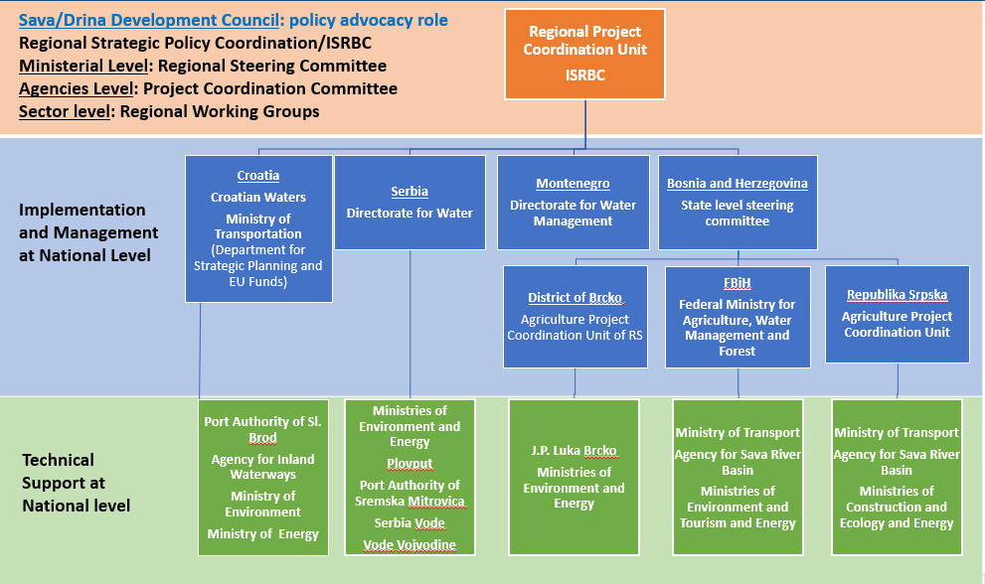
Figure 3 - Proposed governance arrangements for the Project
At the Serbian national level, implementation will be undertaken by project implementation units within line ministries of each country/entity. In each country/entity, PIUs will be established comprising of the required technical and managerial expertise to support project implementation. In Serbia, the borrower will be MoF, and the role of PIU will be assigned to external experienced team engaged by the DfW, which is a part of MoAFWM. Technical support agencies will be set up in Plovput, Port Authority of Sremska Mitrovica, PC Serbia Vode, PC Vode Vojvodine and Ministry of Environment for program implementation.
The MAFWM /PIU will be responsible for the day-to-day management and implementation of the Project and sub-projects. Implementation arrangements are designed to ensure cross-departmental coordination with the MoF and other stakeholders covering high level policy and strategic direction, external coordination and accountability, project management functions, and the management of specific project activities. The PIU will also include one SSS to support compliance with the World Bank safeguards requirements, as well as technical experts (change management advisor, ICT adviser and other experts) on a part-time basis. Fiduciary management including procurement and financial management shall be within the responsibility of the Central Fiduciary Unit - CFU (responsible for procurement and financial management) housed under the MoF. The Social Safeguard Specialist will be responsible for the Social analysis, and for ensuring that the GM is functional.

8.2 Key institutions in the process of resettlement

The resettlement process involves the Government of RoS, the Beneficiary of Expropriation, the tax authority, accredited valuation experts, the local Governments and the Relevant Courts in cases there is a dispute. An overview of all institutions is presented below. The in-depth assigned responsibilities and arrangements for implementing the requirements of this RPF and each site-specific RP shall be covered in the RPs itself.

Table 4 - Institutions involved in expropriation / resettlement
Institution: | Key responsibility during resettlement:
General assembly of RoS | Declares public interest by law
Government of RoS (GoRoS) | Declares public interest for expropriation (if not done by law as above)
MAFWM/PIU | Coordinates all resettlement activities under this RPF and individual RPs  Appoints a Social Safeguard Specialist to assist and monitor the implementation and report on social components of the (sub)-project, particularly implementation of RPF  Discloses the Cut-off date in public announcement  Prepares and discloses RPF, RPs and all other documents  Holds public consultations in all Project phases  Engages with relevant stakeholders  Establishes and administers the grievance mechanism of PAPs and stakeholders;  Monitors and evaluates process of resettlement reports to WB on all issues under this RPF  Monitors the process of temporary land occupation until the land is given back to their owners in accordance with this RPF
Ministry of Finance (MoF) | Borrower
Tax administration offices (decentralized to municipality units, but under MoF) | Provides assessment of market value of agricultural or construction land
Local-Self Governments, including its administration | Local municipalities govern the expropriation process (Department of property affairs)
MoAFWM | Provides information about available replacement land
Republic Geodetic Authority, State Cadastre of immovable property, decentralized units | Provides official information on all immovables, including land, structures, houses, etc.  Provides official legal information on owners of immovables  Provides information on possessors of immovable property  Annotation of expropriation process  Executes legal title changes of immovable property owners after land acquisition, expropriation etc.
Relevant municipal courts | Determines fair compensation if amicable agreement has not been reached

9. Budget and funding of resettlement

As a rule, the cost burden of compensation will be borne by the Government of Serbia and budgeted within the Budget for the upcoming fiscal years. Costs for the implementation of this RPF include categories: (a) administrative costs including cost associated with expropriation (if necessary), and (b) compensation for land acquisition, and asset loss, including transitional and any other allowance as necessary.
At this point it is not possible even roughly to estimate the costs for compensation for different types of losses as per the Entitlement Matrix.
The overall responsibility for resettlement and expropriation for the Project is under the PIU established within STA. The financial responsibility for the land acquisition, including the compensation to be paid, resettlement costs, etc., lies with the Serbia Government, based on this RPF and, the Loan Agreement signed between the WB and the Government of Serbia. This RPF and the Loan Agreement stands above the law on expropriations and will define measures that will be applied when there exist gaps between the ESS5 and relevant laws.

Annex 1 - Grievance registration form
Reference No:
Full Name
Note: you can remain anonymous if you prefer, or request not to disclose your identity to the third parties without your consent. In case of anonymous grievances, the decision will be disclosed at the Projects website www.minpolj.rs
First name _____________________________________

Last name _____________________________________

❏ I wish to raise my grievance anonymously
❏ I request not to disclose my identity without my consent Contact Information Please mark how you wish to be contacted (mail, telephone, e-mail).
❏ By Post: Please provide mailing address: _________________________________________________________________ ________________________________________________________________ __________________________________________
❏ By Telephone: _______________________________________________
❏ By E-mail _______________________________________________
❏ I will follow up o the resolution at the website as I want to remain anonymous
Preferred Language for communication ❏ Serbian ❏ Other (indicate)
Description of Incident or Grievance (What happened? Where did it happen? Who did it happen to? What is the result of the problem? Date of Incident/ Grievance)

❏ One-time incident/grievance (date _______________)
❏ Happened more than once (how many times? _____)
❏ On-going (currently experiencing problem) What would you like to see happen to resolve the problem?

Signature: _______________________________ Date: _______________________________
Please return this form to: The Ministry of Agriculture Forestry and Water Management, PIU,

Annex 2 - Social analysis template
SOCIAL SCREENING FORM AND TRIGGERS FOR SUB PROJECTS
This screening report shall comprise of the screening form, ownership evidence and pictures from the walkover survey.

Name of Sub project:
Location:
Type of Activity and Procurement Package as assigned in the Procurement Plan:
Nature of Project:
Size/Scale:
Project Implementing Agency:
Description of Project Surroundings:
Screening indicators related to Land acquisition, assets and access to resources
 |  | YES | NO
 | Type of activity – Will the sub project:
1 | Require that land (private) to be acquired (temporarily or permanently) for its development
2 | Affect more than 200 persons
3 | Use land that is currently occupied or regularly used for productive purposes (e.g. gardening, farming, pasture, fishing locations, forests
4 | Physically displace individuals, families or businesses
5 | Result in the temporary or permanent loss of crops, fruit trees or household infrastructure
6 | Result in the involuntary restriction of access by people to legally designated parks and protected areas
7 | Result in loss of livelihood
8 | Have negative impact to any vulnerable individuals or groups
9 | Have negative impact to informal side road shops, traders or any nomadic type of commercial activity
10 | Provide the opportunities to improve the informal side road shops, traders or nomadic type of commercial activity
11 | Impact to community Health & Safety
12 | Impact internally displaced persons or refugees
13 | Disrupt access to health care and education
If any of the boxes 1 through 9 are ticked YES the ESS5 will be triggered and site specific instruments in line with this RPF will be prepared.

If any of the boxes 10 through 13 are ticked YES commensurate mitigation measures shall be designed through the site specific ESMP

CERTIFICATION

We hereby certify that we have thoroughly examined all the potential adverse effects of this sub project. To the best of our knowledge, the sub project does not avoid /avoids all adverse social impacts.

________________________________________ ___________________________________
For the PIU Social Safeguard Specialist

Annex 3 - Record keeping template
The World Bank
Serbia: SDI Project
-General information-
No | Site | Land acquisition required | Land acquisition completed | No. of landowners (cases) | No. of landowners received compensation | No. of landowners (cases) on courts | No. landowners yet to be offered compensation | No. of landowners who did not receive compensation | No. of physically displaced households | Duration of expropriation based on sample
 |  | (in ha) | (in ha)
1 | To be added once selected | 0.00 | 0.00 | 0 | 0 | 0 | 0 | 0 | 0 | 0
TOTAL |  | 0.00

Annex 4 – Public Consultation Report

Republic of Serbia
Ministry of Agriculture, Forestry
and Water Management
Nemanjina 22-26, 11000 Belgrade

SAVA AND DRINA RIVER CORRIDORS INTEGRATED DEVELOPMENT PROGRAM (SDIP)

REPORT ON PUBLIC CONSULTATIONS
held for:
Environmental and Social Management Framework (ESMF)
Environmental and Social Commitment Plan (ESCP)
Resettlement Policy Framework (RPF)
Stakeholder Engagement Plan (SEP) and
Labour Management Plan (LMP)

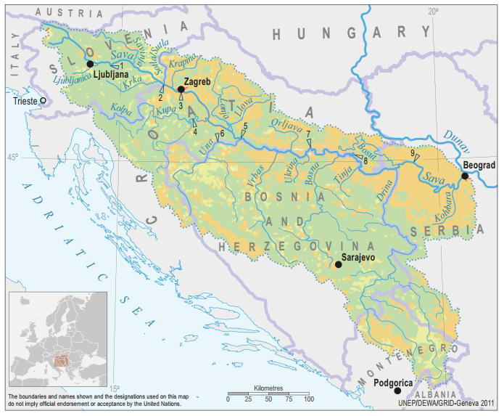

FINAL DOCUMENT
B E L G R A D E, January 2020

Table of contents

1. REPORT ON PUBLIC DISCLOSURE AND PUBLIC CONSULTATION 3
2. LIST OF PARTICIPANTS - PRELIMINARY CONSULTATIONS WITH KEY STAKEHOLDERS, 30 DEC 2019 8
3. DOCUMENTATION 11

REPORT ON PUBLIC DISCLOSURE AND PUBLIC CONSULTATION

As required by WB Environmental and Social Standard 10 (ESS10) – Stakeholder Engagement and Information disclosure, during preparation of Draft ESMF, ESCP, RPF, SEP and LMP documents the Borrower carried out public consultations with relevant stakeholders.
Starting from 19 December 2019, MAFWM disclosed the Draft ESMF, ESCP, RPF, SEP and LMP documents on its web site and announced invitation for Public Consultations for the public, bodies and organizations interested in subject documents prepared for SDIP Project. Same announcement was published in the daily newspaper with national coverage “Politika” on 26 December 2019. Public and other interested parties and organizations were invited to participate in process of public consultation on draft ESMF, ESCP, RPF, SEP and LMP documents.
Draft documents and invitation to the Public Consultations were also available on the web site of the MAFWM: http://www.rdvode.gov.rs/aktuelno.php.
On 30 December 2019, at 12:00 AM (local time), public consultations and presentation of the Draft ESMF, ESCP, RPF, SEP and LMP documents were organized at the premises of the Ministry of Agriculture, Forestry and Water Management - Serbian Directorate for Water Management, Room 301, III floor, Bulevar umetnosti 2a, 11000 Belgrade. The meeting was attended by a diverse group of 21 stakeholders, namely representatives of MAFWM – Directorate for water management, Public Water Management Company “Srbijavode”, Citizen Association “Akademija inzenjerskih nauka Srbije - The Academy of Engineering Sciences of Serbia”, non-formal Citizen Group “Pravo na vodu – Right2water” and NGO Coalition “Save the Blue Heart of Europe” and Association “Jugo Cikling Kampanja – Yugo Cycling Campaign”.
The attendees were:
- Mr. Milan Boric Citizen Association “Jugo Cikling Kampanja”
- Ms. Ana Petrovic Serbian Directorate for Water Management
- Mr. Branislav Djordjevic Citizen Association “Akademija inzenjerskih nauka Srbije”
- Ms. Aleksandra Smiljanic Citizen Association “Akademija inzenjerskih nauka Srbije”
- Mr. Zoran Bukvic UZB
- Mr. Dmitar Zakula Serbian Directorate for Water Management
- Mr. Zoran Kresojevic Serbian Directorate for Water Management - PIU
- Ms. Milica Pavlovic Serbian Directorate for Water Management
- Ms. Jasmina Pejcic Serbian Directorate for Water Management
- Ms. Mila Udarevic Serbian Directorate for Water Management
- Ms. Maja Jeremic Serbian Directorate for Water Management
- Mr. Uros Suberic Serbian Directorate for Water Management
- Ms. Zorica Jankovic Serbian Directorate for Water Management
- Ms. Milica Mrenkolic Serbian Directorate for Water Management
- Ms. Dijana Ivanov Serbian Directorate for Water Management
- Mr. Milan Njegovan Serbian Directorate for Water Management
- Ms. Biljana Vasic Public Water Management Company “Srbijavode”
- Mr. Oliver Ilic Non-formal Citizen Group “Savski Nasip”
- Mr. Sasa Petrovic Citizen Group “Pravo na vodu”
- Mr. Sasa Kulic Serbian Directorate for Water Management
- Ms. Iva Markovic NGO Coalition “Save the Blue Heart of Europe”

The consultation consisted of two parts. The first presentational were participants were informed in general of the ESF and the purpose of ESMF, ESCP, RPF, SEP and LMP documents during implementation. In addition, it was emphasized that all activities supported under the Project shall be environmentally and socially sound, sustainable, and consistent with WB ESS and Serbian national legislation.
Project screening procedure and risk classification are explained, as well as legal and administrative framework for Project.
The meeting started according to schedule at 12:00 AM. The Social Specialist Ms. Nina Valcic presented all project documents in details to the interested attendees.

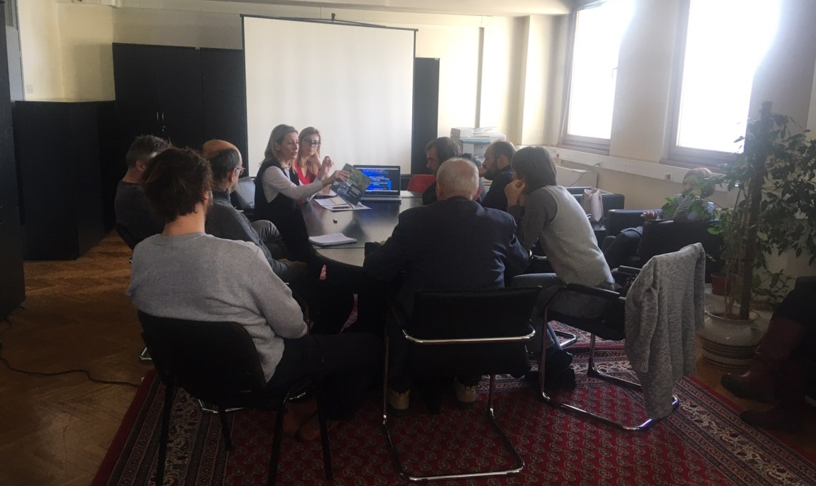
Picture 1: Public consultation in Belgrade, 30 December 2019
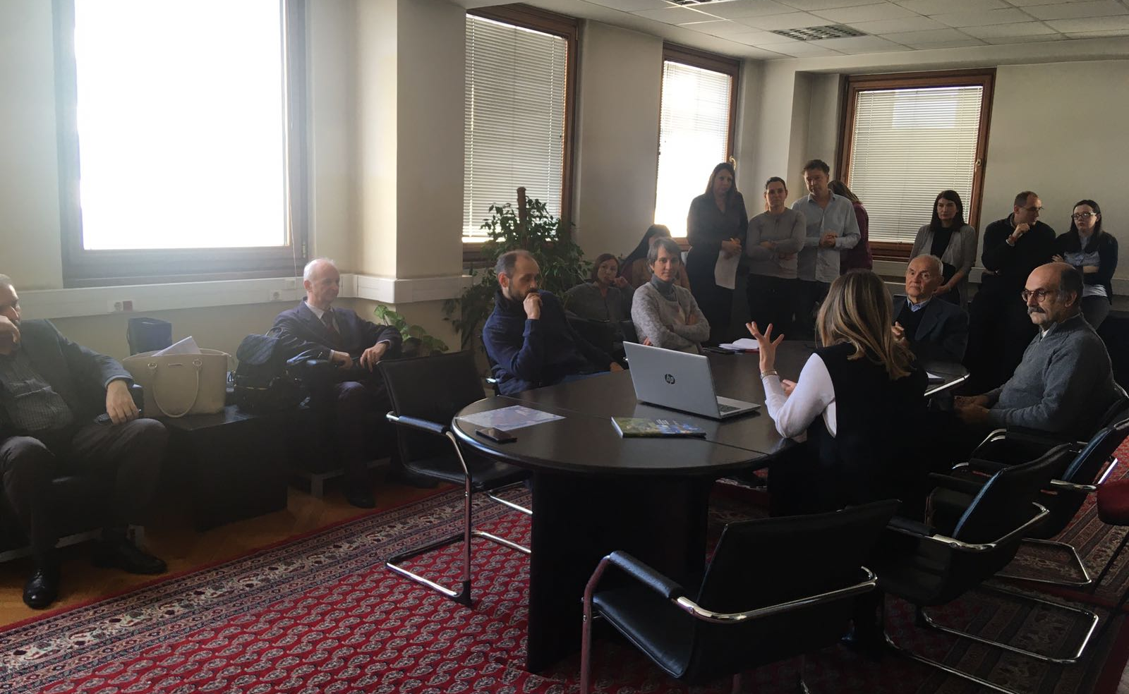
Picture 2: Public consultation in Belgrade, 30 December 2019
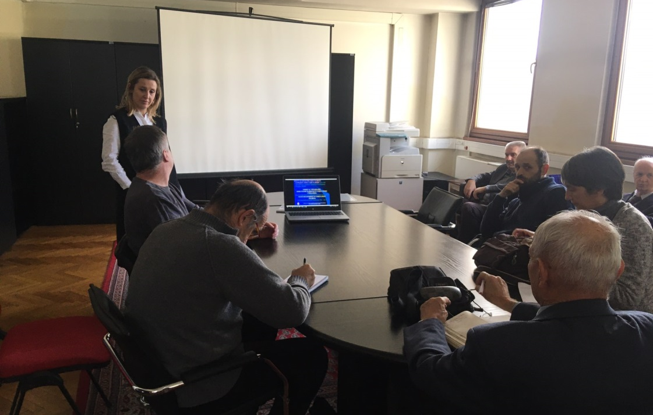
Picture 3: Public consultation in Belgrade, 30 December 2019
Special focus was given to project description, implementation arrangements, potential environmental and social impacts, grievance redress procedures, labor management, screening forms and development of environmental and social management plans during Project implementation.
The importance of Labor management and most important provisions of WB Environmental and Social Standard ESS2 (Labor and Working Conditions) are also explained to the public during presentation of ESMF document.
Before starting with questions of participants, institutional responsibilities and monitoring and reporting procedure on Project were presented and explained. However, the whole consultation have taken a participatory form and turned into a very interactive discussion with participation of all present Stakeholders very early before the moderator handed over the floor to the participants. This
Consultation started at 12:00 AM and ended at 3:30 PM, local time.

Questions and Answers during public presentation and consultations:

Q1: Has the MAFWM and/or the Government defined all Sub-projects at this stage?
A1 Nina Valcic, Social Specialist: Only a couple of Sub-project were identified at the preparation stage. These are Sub-projects Jarak, Popova Bara and Surcin Warehouse. One of the aims of these public consultations and the whole Stakeholder engagement activities relate inter alia to better understand the needs and provide the Stakeholders with an opportunity to directly contribute to the project architecture.
.................................................
Q2: What is the rationale of the World Bank to support compensation even for informal structures constructed without valid permits on land designated as river protection belt?
A1 Nina Valcic, Social Specialist: Any Project developed with financial support of the World Bank, here and anywhere in the World are subjected to the Banks social standards. As already highlighted as of October 2018 any new Project is subject to the Environmental and Social Framework =. Adverse impacts attributable to the Project stemming from Land acquisition are in detailed covered by the ESS 5 on Land Acquisition, Restrictions on Land Use and Involuntary Resettlement. The requirements of these standards are very specific when it comes to informal owners and users and formal and informal economic activities and between these two categories there are no differences in their eligibility. In the aim to prevent opportunistic claims, which indeed, are not eligible the Borrow is requested to announce the Cut-off date.
.................................................
Q3: How are the specific Stakeholder engagement activities designed? What will the methods of engagement be and what frequency will they take?
A1 Nina Valcic, Social Specialist: .As presented today this Project has a standalone Stakeholder Engagement Plan (SEP) applicable throughout the Project lifecycle, to be updated as needed following the procedure set out in the plan itself. The method of engagement is phase sensitive and will be continued and ongoing carefully following the development of the Project and the need to consult and inform the identified Stakeholders. Stakeholders are encouraged to follow announcements on the website of the MAFWM and newspapers as the Project information will be available there. Following these consultations and the Appraisal by the World Bank the engagement shall be intensified as outlined in the plan. For more details please again refer to the disclosed Stakeholder Engagement plan.
.................................................
Q4: Will the Project have a specific Grievance Mechanism? As we understand this is a requirement of many IFIs?
A1 Nina Valcic, Social Specialist: This as all other Projects financially supported by the World bank will have a Project Specific Grievance Mechanism to serve both persons directly affected by land acquisition and persons affected by other Project`s activities ( throughout the cycle). At this moment given the preparation phase of the project the Central mechanism within the MAFWM is operational to be followed by local entry points. Subsequently as the selection of Sub-projects continues and progresses. This points and function of the GM shall be locally publicized and information material distributed.

Opinions and remarks provided in written form:

O1 Branislav Djordjevic, Citizen Association “Akademija inzenjerskih nauka Srbije”, by his letter dated 03 January 2020:
- All hydro technical project activities on the rivers and in the Sava and Drina corridors should be done exclusively with new hydrological studies and with new hydrological analyzes, since the previously prepared studies are obsolete. Recommended experts to be involved in the new design team.
- Detailed environmental impact analysis is required. The Ramsar Convention on the Protection of Wetlands should also be kept in mind.
- In the case of construction of a new embankment on the left bank of the Sava River in the New Belgrade area, a Spatial Plan of Detailed Regulation with clearly defined Land use should be developed.
- The planned settlements in the remaining Sava river bank areas of New Belgrade, in the hinterland of the regulated part of the river banks, should be carefully reviewed in sense of the population density of that particular city zone (density of buildings, floors), as it is already extremely densely populated, which is reflected in very difficult traffic, as well as to air pollution resulting from excessive occupancy of remaining land.
- Since the Program also includes the Drina corridor, regardless of which facilities will be financed in that corridor, the integral solution of the water management system on that river, which is now official, should be mentioned, as it is in the Water Management Base of Serbia and the Spatial Plan of the Republic of Serbia , as well as in the Republika Srpska Water Management Strategy.
- During the consultation, I and several other attendees were unpleasantly surprised by the explanation of the World Bank's position that all facilities for which displacement and demolition are needed - are in the same legal position in terms of compensation, regardless of when and how investors built the property to be removed. Therefore, in view of the legal regulations relating to water land, as well as the zone of protection of springs, the World Bank in Serbia must use the only possible - selective approach. He implies that the position on the legal position of those whose property will be expropriated and compensated for the construction of shorelines does not apply to those owners who have committed the crime of building in prohibited zones.
- It would be completely illogical and dangerous to require a high degree of flood protection in the new coastal zones regulated under this Program, while allowing the already existing embankment upstream of the settlement in block 45 to be physically destroyed by unintended use as a road, even for the heaviest traffic. Such loads have a very unfavorable effect on the deformations of the foundation zone of the embankment, which therefore becomes unsafe and prone to collapse. The World Bank should therefore explicitly restrict its loan for the construction of new fortifications on the left bank of the Sava by requiring that physical barriers be completely prevented from accessing motor vehicles on the embankment, in all places where it occurs, and preventing the opening of some new approaches.
- In order to re-design the New Belgrade embankment project, it should be borne in mind that the owners of illegally constructed houses in the river side area have constructed transverse embankments to block the large water (river inundation) trough so that they can reach their homes, not only by cars, but by heavy construction machines. These transverse structures during periods of high Sava waters completely impede the flow in the high water trough and drastically aggravate the modes of propagation of large water waves, drastically increasing the risk of breakage of the embankment. Therefore, it is necessary for the World Bank to make the loan for new works in the Sava Corridor conditional on the removal of these transverse structures (access roads to residential buildings, rem.aut.), as well as all other facilities in the large water basin and to enable unhindered mode of transmission of large-water waves. Here, too, the principle must be that these works should be done at the expense of those persons who performed those dangerous works.
- Raft owners cut deep embankments through deep trenches to push plumbing to their rafts. The embankment is thus damaged in several places, which compromises its safety. Therefore, as one of the priorities of this Program, the World Bank should require the rehabilitation of an already existing embankment and prevent its further damage by enforcing a traffic ban on it, except for the official purpose of maintaining the embankment.
- The World Bank should also be aware of the very serious endangering of Belgrade Water Supply springs by illegal construction in the protection zones of the springs.

O2 Aleksandra Smiljanic, Citizen Association “Akademija inzenjerskih nauka Srbije”, by her letter dated 03 January 2020, related to SDIP Project Potential Procurement Packages - : Nr. 1.1.14 Design and Raising dykes in Novi Beograd to protect Belgrade City from flood:
- Several hundred illegal cottages between the embankment and the water were built on the Sava embankment. They threaten the embankment itself, which protects New Belgrade with over 200,000 inhabitants from flooding, as well as Belgrade's water supply, because they are located in the middle of Belgrade's water source
- The owners of illegal cottages drive cars along an embankment that is not designed for traffic but only for service vehicles
- The owners of illegal rafts along the Sava Quay have drilled the embankment in several places with water pipes to bring water to their rafts.
- Although no funds have been allocated for specific projects, investment is being considered for coastal fortification along the planned settlement in New Belgrade, downstream of Block 70a, on land owned by the private companies Comtrade and Zepter. The owners of these companies benefit most from such a project, which is not in line with the World Bank policy that everyone has equal access to World Bank funds
- New planned settlements along the Sava River in New Belgrade do not need to be built, because New Belgrade is already too densely populated and traffic congestion is unbearable.
- If the World Bank wants to provide embankments on the Sava River, it must first start with the existing, already built part of the embankment, which is most vulnerable to the misuse of infrastructure by irresponsible citizens.
- I request that my statement and the accompanying articles be forwarded to the World Bank:
- http://savskinasip.com/analize/group-of-irresponsible-people-endanger-belgrade/1469/
- http://savskinasip.com/analize/stance-of-serbian-academy-of-engineering-sciences/1463/
- http://savskinasip.com/analize/story-about-insolent-people-and-powerless-system/1439/

LIST OF PARTICIPANTS - PRELIMINARY CONSULTATIONS WITH KEY STAKEHOLDERS, 30 DEC 2019

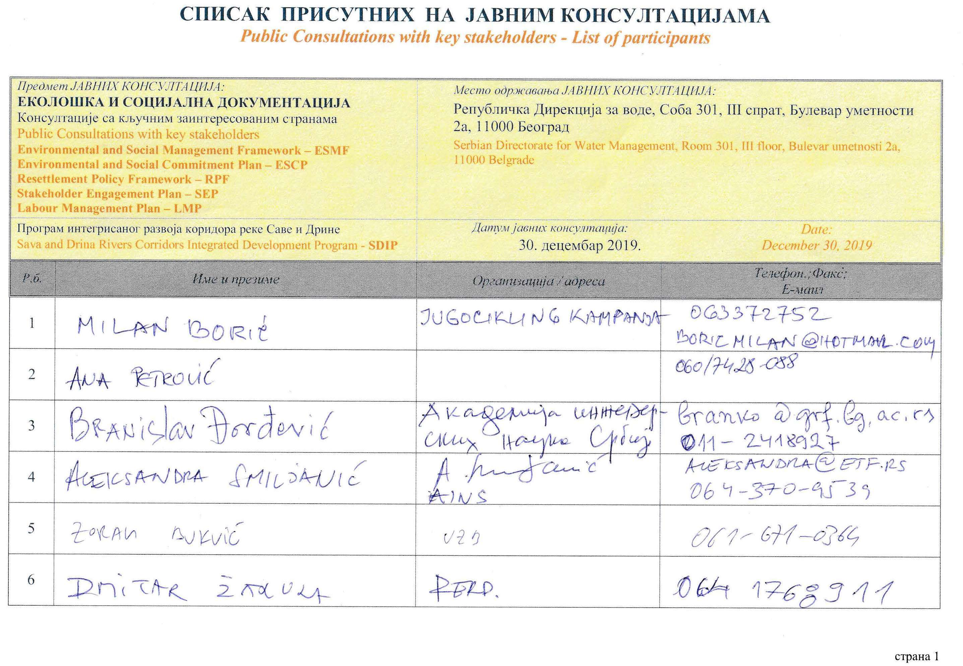
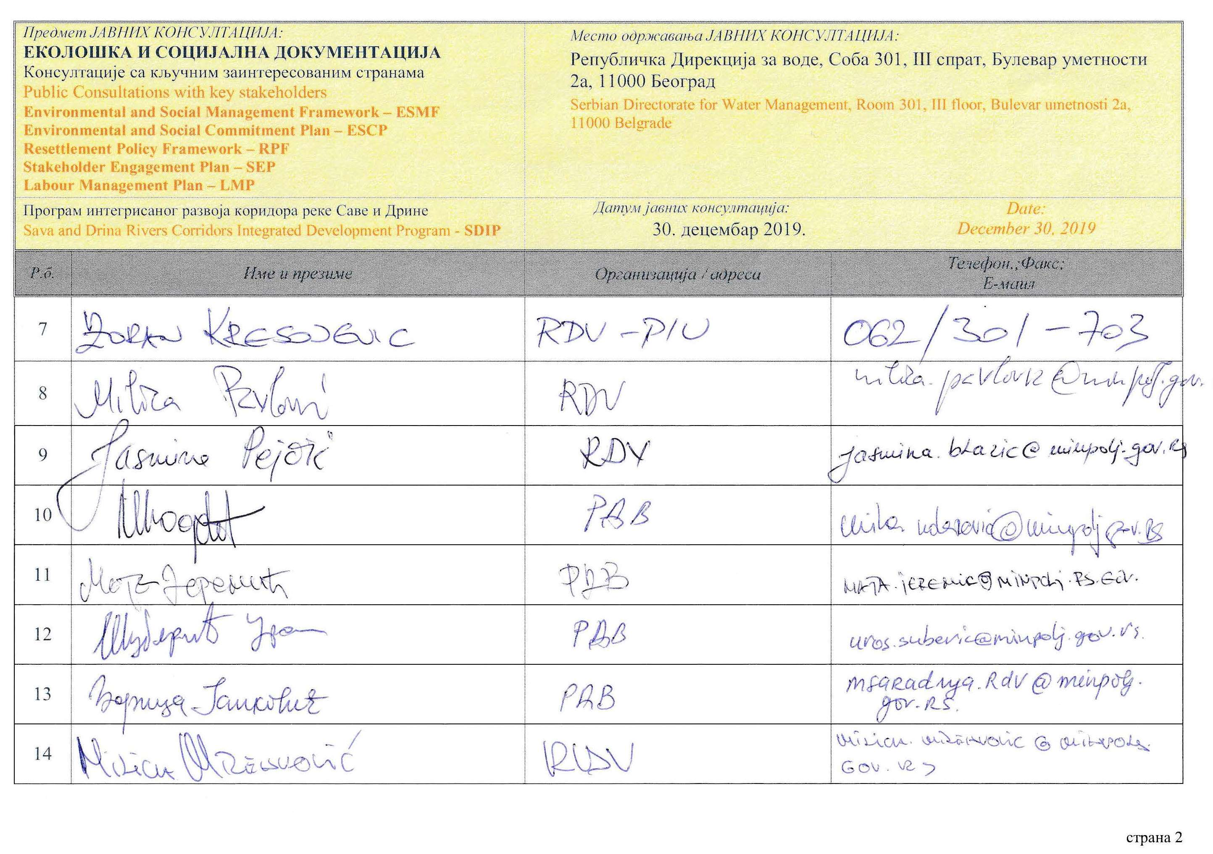
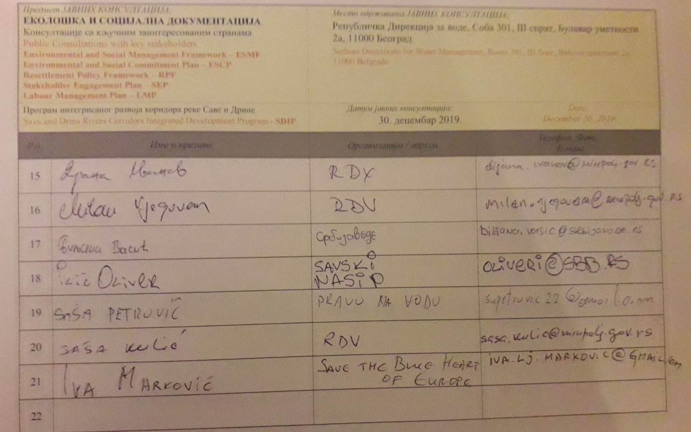

DOCUMENTATION

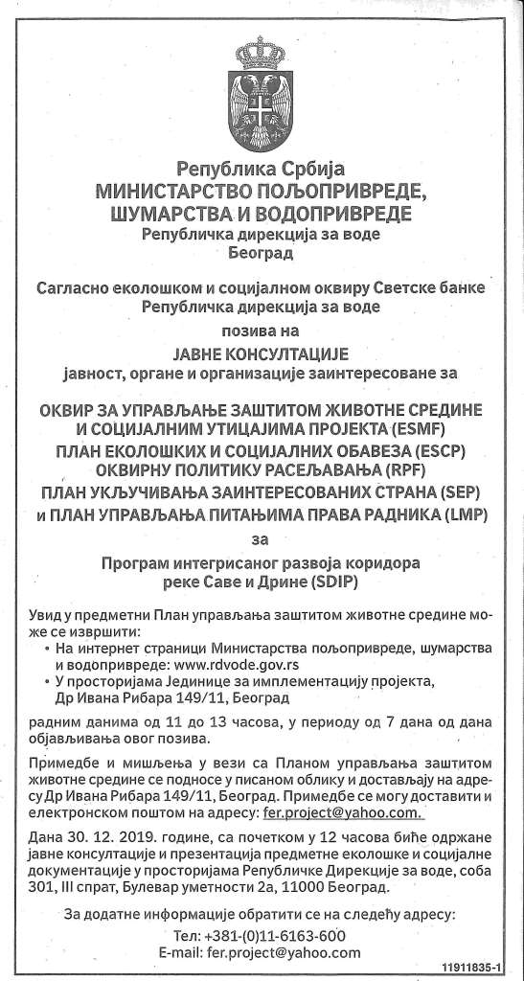
Picture 4: Announcement of public consultation in daily newspaper, (“Politika”, 26 Dec 2019)

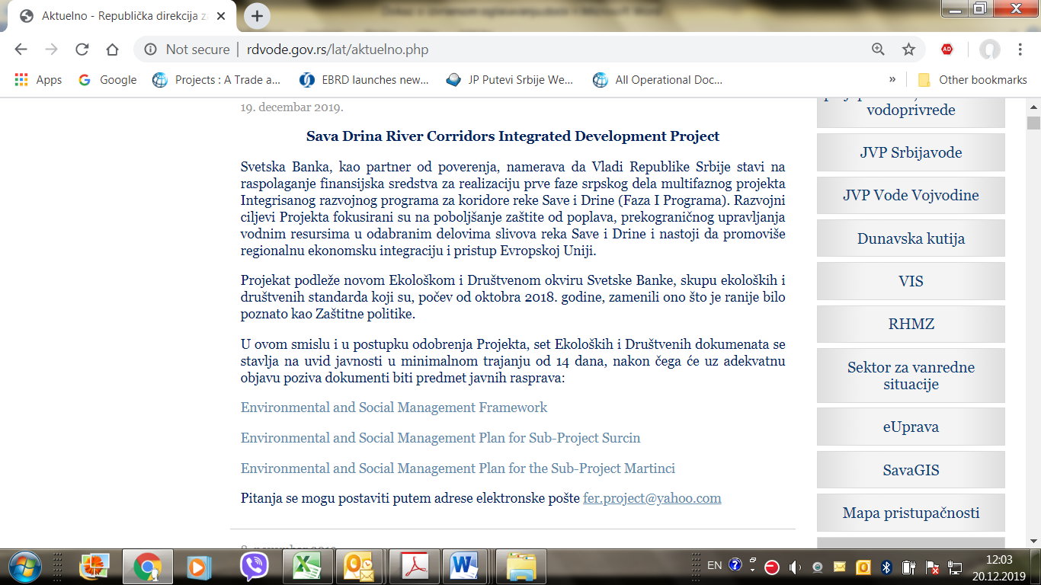
Picture 5: Announcement of public consultation on SDIP Environmental documents on Ministry web site

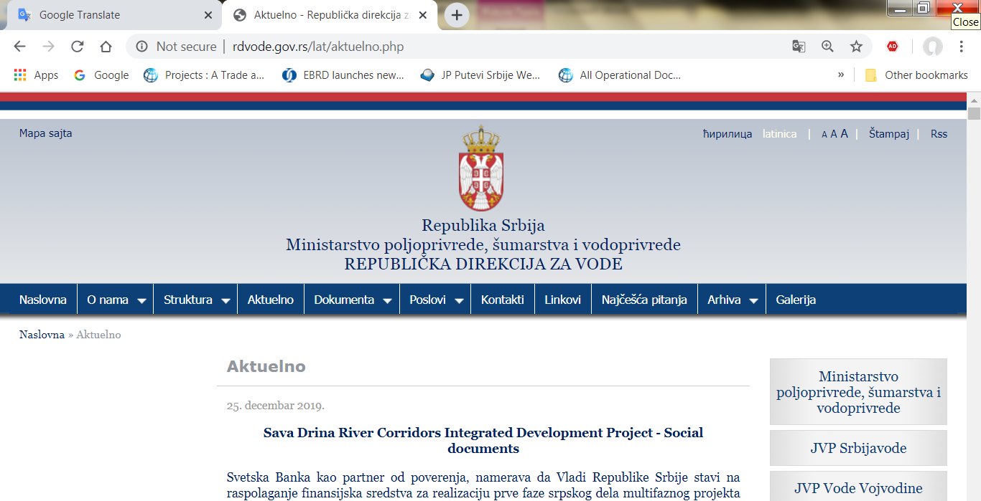
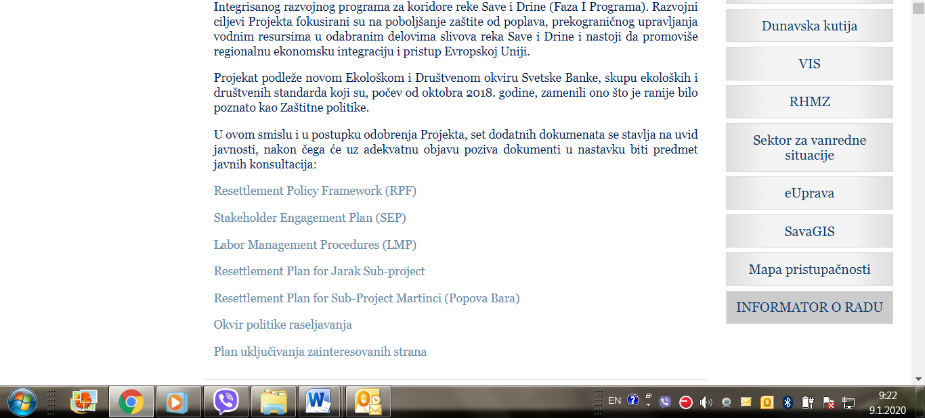
Picture 6: Announcement of public consultation on SDIP Social documents on Ministry web site

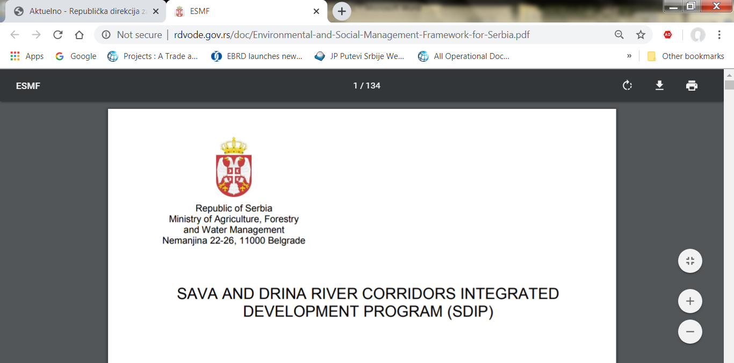
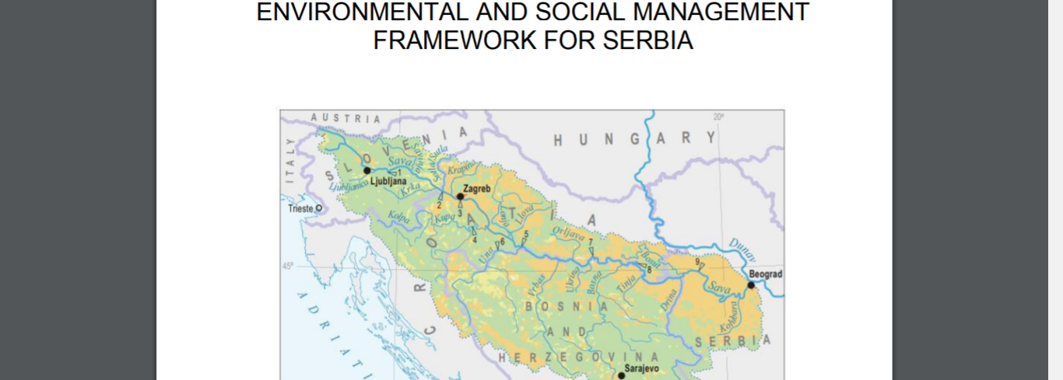
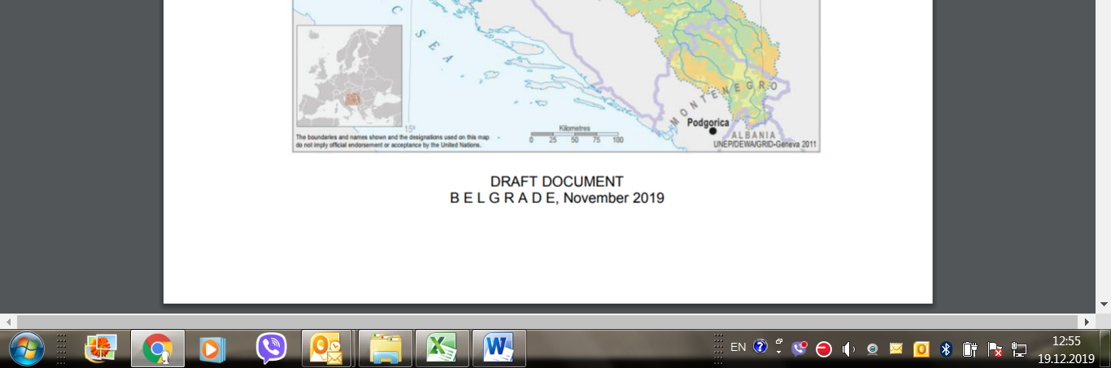
Picture 7: Public disclosure of DRAFT ESMF document, English language, Ministry web site

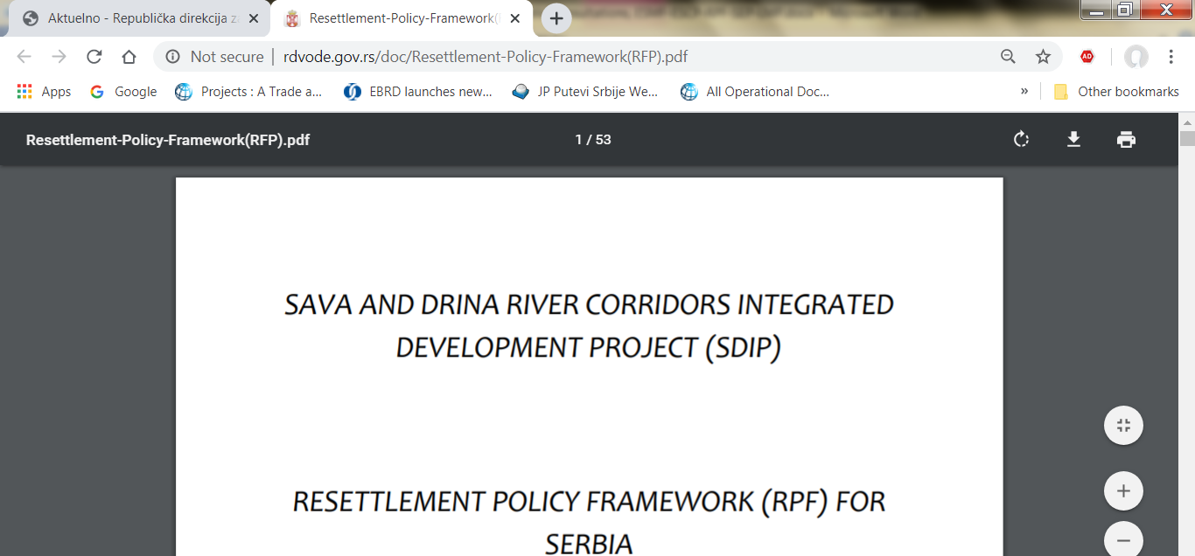
Picture 8: Public disclosure of DRAFT RPF document, English language, Ministry web site

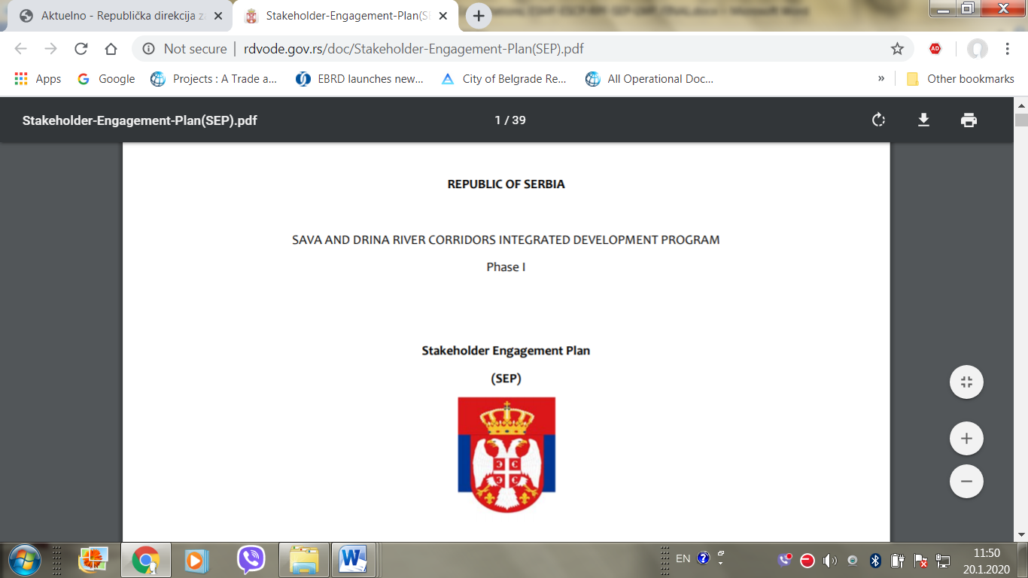
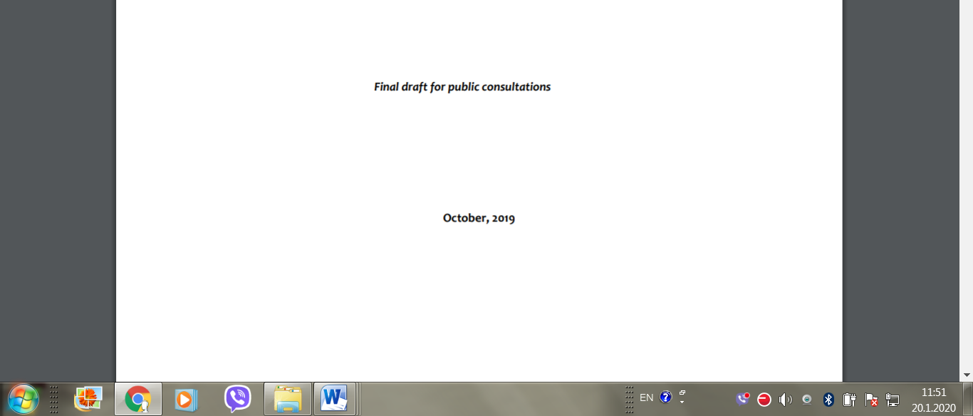
Picture 9: Public disclosure of DRAFT SEP document, English language, Ministry web site

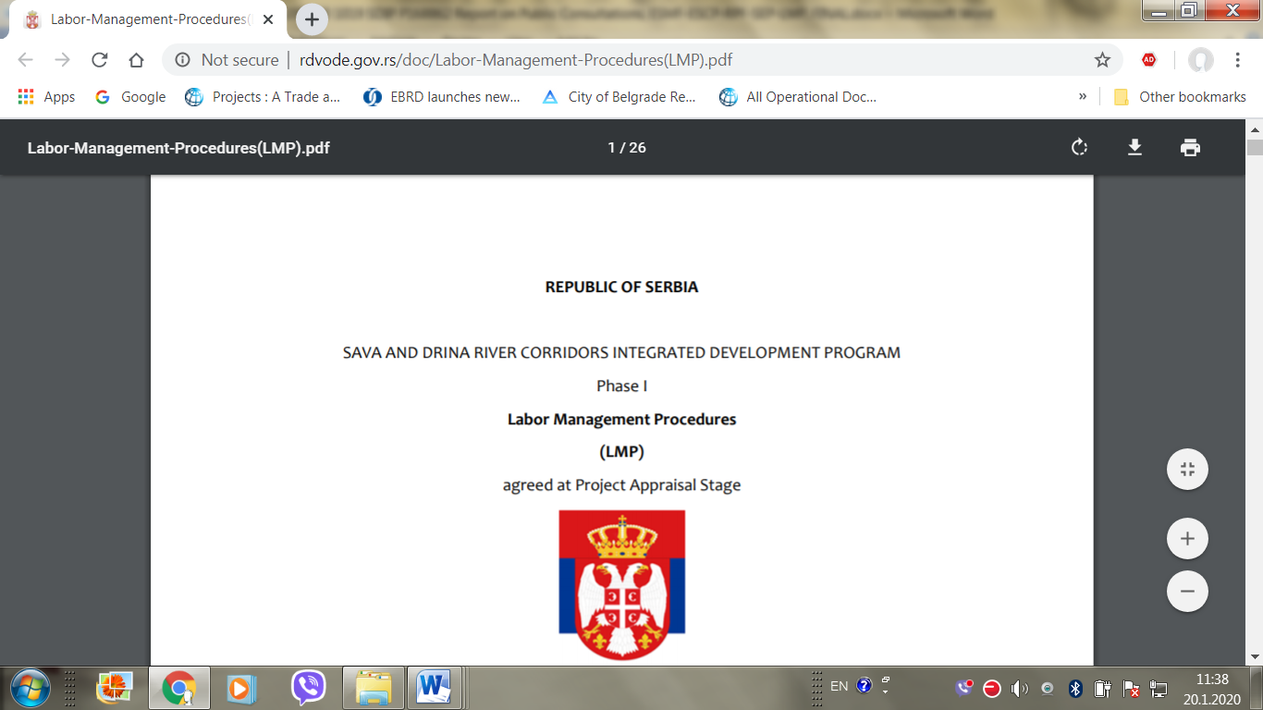
Picture 10: Public disclosure of DRAFT LMP document, English language, Ministry web site

https://www.ilo.org/dyn/natlex/docs/ELECTRONIC/74694/119555/F838981147/SRB74694%20Eng.pdf provides English version for review, last accessed October 9, 2019.
https://www.paragraf.rs/propisi/zakon_o_javnoj_svojini.html, last accessed October 9, 2019
https://www.paragraf.rs/propisi/zakon_o_osnovama_svojinskopravnih_odnosa.html, ibid
https://www.paragraf.rs/propisi/zakon_o_planiranju_i_izgradnji.html, ibid
https://www.paragraf.rs/propisi/zakon_o_ozakonjenju_objekata.html, last accessed October 9, 2019
Serbia Flood Emergency and Recovery Project
https://www.paragraf.rs/propisi/zakon_o_vanparnicnom_postupku.html, last accessed October 9, 2019
https://www.paragraf.rs/propisi/zakon-o-opstem-upravnom-postupku.html, ibid
https://www.paragraf.rs/propisi/zakon_o_drzavnom_premeru_i_katastru.html, last accessed October 9, 2019
https://www.paragraf.rs/propisi/zakon_o_eksproprijaciji.html, ibid
http://pubdocs.worldbank.org/en/837721522762050108/Environmental-and-Social-Framework.pdf#page=29&zoom=80

