REPUBLIC OF SERBIA

SAVA AND DRINA RIVER CORRIDORS INTEGRATED DEVELOPMENT PROGRAM
Phase I

Stakeholder Engagement Plan
(SEP)

Final draft for public consultations

October, 2019
CONTENT
Contents
Glossary 4
List of Abbreviations & Acronyms 5
1. Introduction 6
1.1 Purpose of the SEP 6
1.2 The Project and its Components 6
1.3 Scope and Structure of the SEP 7
1.4 Summary of potential environmental and social impacts 8
2. Policy and Regulatory Framework for Citizen Engagement in Serbia 9
3. World Bank Environmental and Social Standard on Stakeholder Engagement 9
4. Summary of previous stakeholder engagement activities 10
4.1 Lessons Learned on Stakeholder Engagement from Previous Flood Protection Projects 11
5. Engagement during Project Preparation - Stakeholder Identification Mapping and Analyses 11
5.1 Stakeholder Identification and Mapping 11
5.2 Disadvantaged / Vulnerable individuals or groups 13
5.3 Stakeholder Analysis 14
5.4 Gender analysis, actions and indicators 18
5.5 Stakeholder expansion 18
5.1 Planned stakeholder engagement activities 19
6. Stakeholder engagement activities 25
6.1 Detail on engagement methods to be used 25
6.1.1 Project outreach methods 25
6.1.2 Mass/social media communication 25
6.1.3 Communication materials 25
6.2 Grievance mechanism 25
6.3 Information Desks 26
6.4 Citizen/PAP perception survey and feedback 26
6.5 Trainings, workshops 26
6.6 Proposed strategy to incorporate the view of vulnerable groups 26
6.7 Information disclosure 27
7.4 Transboundary communication 28
8. Implementation Arrangements and Institutional analysis for Stakeholder Engagement 29
8.1 Project enabling efforts from lessons learned 29
8.2 Roles and Responsibilities 29
8.3. Stakeholder Engagement Methods Error! Bookmark not defined.
9.1 Raising grievances 31
9.2 Grievances administration 31
9.3 Grievance and beneficiary feedback reporting 32
9.4 Constitution of GM Error! Bookmark not defined.
9.5 Grievance Log Error! Bookmark not defined.
9.6 Grievance admission channels 33
9.7 Monitoring and Reporting on Grievances 33
9.8 World Bank Grievance Redress System 34
10. Monitoring and Reporting of the SEP 34
A.1.1 Reporting frequency 36
A.1.2 Six Monthly E&S Compliance Reports to the World Bank Error! Bookmark not defined.
A.1.3 Involvement of stakeholders in monitoring activities 36
A.1.4 Reporting back to stakeholder groups 36
11. Disclosure and Consultation requirements 36
12. Estimated Budget 37
ANNEX 1 – GRIEVANCE REGISTRATION FORM 38

Glossary

Consultation: The process of sharing information and getting feedback and/or advice from stakeholders and taking these views into account when making project decisions and/or setting targets and defining strategies.

Environmental and Social Standards (ESSs): The 10 Environmental and Social Standards (ESSs) set out the requirements that apply to all new World Bank investment project financing enabling the World Bank and the Borrower to manage environmental and social risks of projects.

Project: Refers to the Sava Drina River Corridor.

Stakeholders: Refers to individuals or groups who: (a) are affected or likely to be affected by the project (project-affected parties); and (b) may have an interest in the project (other interested parties).

Stakeholder engagement: A continuous process in which the Project builds and maintains constructive and sustainable relationships with stakeholders impacted over the life of a project. It includes a range of activities and interactions over the life of the project such as stakeholder identification and analysis, information disclosure, stakeholder consultation, negotiations and partnerships, grievance management, and reporting to stakeholders and management functions.
Stakeholder Engagement Plan (SEP): A plan which assists the Borrower to effectively engage with stakeholders throughout the life of the project and specifying activities that will be implemented to manage or enhance engagement.

List of Abbreviations & Acronyms
CMU | Country Management Unit of the WB
CPF | Country Partnership Framework
EHS | Environmental, Health and Safety
ESF | Environmental and Social Framework
ESMF | Environmental and Social Management Framework
ESS | Environmental and Social Standards
EU | European Union
FAO | Food and Agriculture Organization of the United Nations
FY | Fiscal Year
GM | Grievance Mechanism
GoRoS | Government of Republic of Serbia
GRS | Grievance Redress System
IDA | International Development Association/ World Bank
IFIs | International Financial Institutions
LMP | Labor Management Procedures
M&E | Monitoring and Evaluation
MAFWM | Ministry of Agriculture, Forestry and Water Management of the Republic of Serbia
MCTI | Ministry of Construction, Transport and Infrastructure
MoF | Ministry of Finance of the Republic of Serbia
NGO | Non-Governmental Organization
PDO | Project Development Objective
PMU | Project Management Unit

1. Introduction

The World Bank (WB) as a trusted partner on the Western Balkans aims to provide financing through a multiphase program approach to the Government of Serbia (GoRoS) for the implementation of the Serbian part of the first phase of the Sava and Drina river corridors integrated development program (hereinafter referred to as: The Project). The Development Objective of the Sava Drina River Corridors Integrated Development Project (Phase 1 of the Program) is to improve flood protection, and transboundary water resources management in selected catchment areas of the Sava and Drina river corridors and aims to promote regional economic integration and EU accession within a challenging political environment.

The Project is aligned with Serbia CPF 2016-2020 and with the World Bank’s twin goals, with the priorities set out by the national governments of the program’s beneficiaries, and with EU policy goals for the region.

The project is designed as an Investment Project Financing (IPF) and as such needs to comply with the World Bank’s Environmental and Social Standards (ESS). In response to the commitment of the GOS to comply with the ESF, the Ministry of Agriculture, Forestry and Water Management (MAFWM) has developed this Stakeholder Engagement Plan (SEP) for the two Sub-Projects known at this stage and as a framework approach for Sub-Projects where the design and location of the project since it has multiple subprojects that will only be designed during project implementation, to guide the project’s stakeholder engagement in line with ESS 10 - Stakeholder Engagement and Information Disclosure, from the early stages and throughout the Project cycle focusing on gender gaps and tailored approaches.

1.1 Purpose of the SEP
The purpose of the present Stakeholder Engagement Plan (SEP) is to outline the target groups and methods of stakeholder engagement and the responsibilities in the implementation of stakeholder engagement activities. The intention of the SEP is to activate the engagement of stakeholders in a timely manner during project preparation and throughout implementation. Specifically, SEP serves the following purposes: i) stakeholder identification and analysis; (ii) planning engagement modalities and effective communication tools for consultations and disclosure; (iii) defining role and responsibilities of different actors in implementing the Plan; (iv) defining the Project’s Grievance Mechanism (GM) and (v) providing feedback to stakeholders.

1.2 The Project and its Components
The program has been organized into four components, as follows:

Component 1: Integrated Management and Development of the Sava River Corridor
This component will finance investments in renovation and upgrading of flood protection infrastructures to address the increasing risk of flooding due to climate change. These activities will reduce the risk and impact of floods, thereby increasing the resilience of the riparian countries to these climate change-related threats. The component will also finance activities needed to enable improved navigation. Requested GEF funding will support the prioritization and preparation of some activities.
Sub-component 1.1: Flood protection and environmental management. This sub-component will finance construction and rehabilitation of embankments at selected priority areas along the Sava River Corridor as well as nature-based solutions to re-vitalize selected protected areas of ecological significance to the Western Balkans. For example, this sub-component will finance reconstruction of Kolubara dykes that will protect Obrenovac City in Serbia, dykes in Novi Beograde that will protect Belgrade City from flood hazards, and reforestation in Vrbanja, Vrbas and the Sava River basin in BiH, which will mitigate the threat of droughts. Upgraded flood protection capacity (at or above 1 in 100-year event) also enhance climate adaptation capacity of protected areas.
Sub-component 1.2: Waterway Improvements. Under this sub-component, grant financing will be mobilized to finance demining activities along the Sava’s right bank within BiH, as a pre-requisite to the execution of civil works—planned for Phase II of the program—to increase the navigational capacity of the Sava river. The preparatory documentation for these Phase II works (engineering designs, environmental and social safeguards instruments, expected climate change impacts on navigability, bidding documents) will also be finalized during the project. The project-supported demining efforts are also an operational pre-requisite to the planned improvements to Sava river ports under Phase II. Demining activities are proposed as a no-regret investment that will help unlock the river’s economic potential for generations to come.
Demining of the right bank of the Sava river in BiH will be conducted following the Standard Operating Procedures (SOP) for humanitarian demining developed and adopted by the Bosnia and Herzegovina Mine Action Center (BiHMAC). These country-specific procedures are based on the principles of the International Mine Action Standards (IMAS) endorsed by the UN Inter-Agency Coordination Group on Mine Action. They comprise, inter alia, the actions of general surveying, technical surveying, equipment pre-testing and testing, professional supervision of demining operations, systematic surveying, and integrated planning. The BiH State Ministry of Communications and Transport will be the lead implementing agency for demining, with BiHMAC participating as technical lead, with the collaboration of the respective Entity level Ministry of Transport and Brcko District Government. BiHMAC has already produced detailed engineering designs for the demining activities, which will be updated as needed prior to commencement of civil works. The demining civil works will be conducted by one or more experienced contractors to be competitively selected during implementation in accordance with the World Bank Procurement Framework. In addition, expert supervision services will be provided for the duration of the works, to ensure SOP and IMAS compliance. Completion of demining of the right bank of the Sava is consistent with the goals of the BiH Council of Ministers Mine Action Strategy 2018-2025, and it will contribute to the attainment of international obligations to which BiH is a signatory, most notably including the Mine Ban Convention, which BiH ratified in September 1998.

Component 2: Integrated Management and Development of the Drina River Corridor
This component will support multipurpose investments along the Drina to reduce the risk and potential impact of floods. It may also support preparatory interventions that will optimize reservoir operation and protect environmental assets of global value to be implemented in Phase II. This component will facilitate the implementation of actions, management measures and investments identified by the Drina Strategic Action Plan being prepared under the ongoing Western Balkans GEF-SCCF Drina River Basin Management Project and investments identified through the ESMAP Integrated Water and Hydropower Development Project. The above measures will contribute to increased resilience of the riparian countries to floods and droughts. Requested GEF funding will support the prioritization and preparation of these activities.
Sub-component 2.1: Flood protection and environmental management. This sub-component will finance infrastructure works (for example, flood protection in Gorazde City, FBiH), studies, surveys, consultations and preparation of detailed design of interventions related to the management of environmental assets (the protection of local ecosystems that act as carbon sinks) along the Drina Corridor. The on-going GEF-SCCF-financed Drina River Basin Management project as well as the ESMAP technical assistance, are conducting studies that will identify the additional actions needed for flood protection, bank stabilization, drainage and river training works, and reservoir management in the Drina Corridor. Upgraded flood protection capacity (at or above 1 in 100-year event) also enhance climate adaptation capacity of protected areas.
Sub-component 2.2: Integrated development of Drina watershed. This sub-component will finance improved watershed management in the Lim and Grncar River basins of Montenegro, as well as works related to flood protection, drainage and irrigation measures within the Lim River Basin (a tributary of the Drina River) to mitigate flood risks and promote sustainable use of natural resources. These measures include: river bank stabilization; river training works; flood protection embankments and dykes. The detailed designs of these investments are under preparation through the ongoing GEF-SCCF project. This sub-component will further finance the preparation of selected priority investments in line with the project development objective.

Component 3: Project preparation and management

This component will support: 1) preparation of Phase II regional activities; and 2) operational costs, consultancies, non-consultancy services, and goods required for the establishment and operation of the Regional Implementation Unit and national PMUs. Sub-component 3.1: Project preparation. This sub-component will either finance or provide technical support for the preparation of project documentation for Phase II of the program, including environmental and social safeguard assessments. Sub-component 3.2: Institutional strengthening and project management. This sub-component will finance activities to increase institutional capacity and inter-sectoral coordination in the participating countries to ensure more efficient decision making and program management at regional level. This sub-component will promote joint action and decision making in river basin management and flood risk management among riparian countries, thus enhance the climate adaptation capacity of the region.

Component 4: Regional activities
This component will support policy dialogue, consultations, preparation of plans and studies, and investments to strengthen the nexus between water services and connectivity with the regional development and economic cooperation objectives of the Sava and Drina Corridor. Examples include the Sava River Basin Management Plan and Hydrological assessments, Climate Change Adaptation Strategy for the Sava River Basin, planning and development of tourism in the Sava and Drina Rivers corridors including the designing of Master Plans for Nautical tourism and Ecotourism. River Basin Management Plans and Hydrological assessments will ultimately support integrated water resources management, thereby indirectly increasing the resilience of riparian countries to climate change; requested GEF funding will co-finance measures related to river basin planning and management, flood monitoring network, institutional capacity building, and studies that inform or prepare future investments.

1.3 Scope and Structure of the SEP
The SEP shall be applicable to all activities planned under the Project in Phase I, while the adequacy of this SEP shall be assessed and update as the case may be prior to commencement of Phase II. The stakeholder engagement will be an integral part of the project’s environmental and social performance and project design and implementation.

The document comprises 12 chapters. Chapter 1 introduces the Project and its objectives, followed by Chapter 2 listing the regulatory framework for citizen engagement in Serbia, which provides the framework for SEP in addition to the World Bank ESS10 presented in Chapter 3. A summary of stakeholder engagement held so far is presented in Chapter 4. Stakeholder Identification, Mapping and Analysis is described in Chapter 5. Institutional analysis is provided in Chapter 6. The Stakeholder Engagement Activities are presented in Chapter 7. Implementation Arrangements for implementing the SEP are presented in Chapter 8. Description of the Project’s Grievance Mechanism (GM) follows in Chapter 9. Monitoring, documentation and reporting are presented in Chapter 10, disclosure and consultation requirements in Chapter 11, while the budget needed for implementation of the SEP is discussed in Chapter 12.

1.4 Summary of potential environmental and social impacts
Potential environmental and social impacts of the project, as identified in the ESMF based on the environmental and social assessment thereunder, which need to be the focus of stakeholder engagement activities, include:

- Potential impacts on landscapes and views due to construction and maintenance activities,
- Permanent and temporary acquisition of land,
- Temporary restriction to access to land,
- Labor influx and Gender based violence stemming from the influx,
- Temporary diversions and closure of routes and roads,
- Erosion and topsoil loss due to land clearing and vegetation removal and/or excavation, machinery operations, excavations of material,
- Potential impacts on air quality due to movement of vehicles and equipment, earthworks, open piles of topsoil and spoil, and the operation of combustion engines and/or,
- Noise, dust, waste generation and traffic disturbance from construction vehicles and machinery,
- Physical or economic displacement, loss of assets, loss of livelihood and related compensation procedures,
- Generation of local income through the recruitment of workers from local communities to the project.
- The Project`s added value and community benefits and support.

1.5 Project Locations
This project will be implemented through a number of Sub-Projects with majority of locations yet to be defined. However, two Sub-projects are sufficiently mature with high implementation readiness and relevance to the program objectives, with detail designs and tender documents likely to ready by Effectiveness.
Detailed engineering designs are available for: (i) Rehabilitation of the left Sava riverbank in Jarak (Municipality of Sremska Mitrovica) and (ii) Embankments stabilization of left Sava river dyke in Martinci -Popova Bara (Municipality of Sremska Mitrovica). For these two Sub-Projects site specific Resettlement Plans (RP) are under preparation for which engagement activities and methods as designed in this SEP and supplemented with resettlement specific engagements standards will be used.

2. Policy and Regulatory Framework for Citizen Engagement in Serbia
The Republic of Serbia citizen engagement commitments do not reside under a single self-standing law or regulation. However, the recognition of importance of citizen engagement is embedded in the legal system and clearly recognized by the mandatory procedures provided by individual laws. From the Constitution as the highest legal act down to an ample normative framework comprising the Serbian legislative ground, there is a strong commitment to stakeholder engagement. The Constitution of the Republic of Serbia (2006) proclaims the rule of law and social justice, principles of civil democracy, human and minority rights and freedoms, and commitment to European principles and values. Article 74 proclaims the right to healthy environment and grants the right to timely and comprehensive information on the state of the environment.

On May 12, 2009, the Republic of Serbia ratified the Aarhus Convention on Access to information, public participation in decision-making and access to justice in environmental matters („Official Gazette – International Contracts “, No. 38/09) and it links environmental and human rights and is based on the belief that it is a basic right of present and future generations to live in an environment adequate to health and wellbeing. The convention is focused on achieving this through the implementation of three pillars: rights of access to information, access to decision-making, and access to justice.
Other stakeholder engagement, disclosure and transparency requirements within certain topics and sectors are embedded in the applicable laws regulating each of the treated subject (i.e. Expropriation, Environmental impact assessment). These are overall compliant to the requirements of ESS10 but have certain shortcomings when it comes to active outreach and continuous engagement strategies.

3. World Bank Environmental and Social Standard on Stakeholder Engagement
The new World Bank’s Environmental and Social Framework (ESF) came into effect on October 1, 2018. The Environmental and Social Standard (ESS) 10 is on “Stakeholder Engagement and Information Disclosure”. The provisions of the Standards are to be read in conjunction with other applicable ESSs. The specific requirements set out by ESS10 are highlighted below:
- Borrowers will commence with stakeholder engagement as early as possible in the project development process and in a timeframe that enables meaningful consultations with stakeholders on project design and shall maintain such engagement throughout the Project cycle. The nature, scope and frequency of stakeholder engagement will be proportionate to the nature and scale of the project and its potential risks and impacts.
- Borrowers will engage in meaningful consultations with all stakeholders. Borrowers will provide stakeholders with timely, relevant, understandable and accessible information, and consult with them in a culturally appropriate manner, which is free of manipulation, interference, coercion, discrimination and intimidation.
- The process of stakeholder engagement will involve the following: (i) stakeholder identification and analysis; (ii) planning on ways to engage; (iii) disclosure of information; (iv) consultation with stakeholders; (v) addressing and responding to grievances; and (vi) reporting to stakeholders.
- The Borrower will maintain and disclose a stakeholder engagement log as documented record of stakeholder engagement, including a description of the stakeholders consulted, a summary of the feedback received and a brief explanation of how the feedback was taken into account, or the reasons why it was not.
- The Borrower should also propose and implement a grievance mechanism to receive and facilitate the resolution of concerns and grievances of project-affected parties related to the environmental and social performance of the project in a timely manner.
The SEP is a living document, potential changes are driven by any changes in the Project during its implementation. Should the project be subject to significant changes, such updates will be reflected in the SEP and the document will be re-disclosed.

4. Summary of previous stakeholder engagement activities
The Project’s financial intervention is targeted towards flood protection, reconstruction of water infrastructure and facilities. The specific nature of the Project yet leaning on to completed and on-going sector interventions within the water agenda required a broad engagement with various project stakeholders and is ongoing since early 2019. The specific stakeholder engagement activities that have taken place during Project preparation include:

- Numerous dialogues with government agencies at the national, regional and local level;
- Consultations with potential beneficiary groups, including agri-businesses, and their representatives;
- Detailed discussions with relevant ministries and implementation agencies in each country, in joint meetings with stakeholders from multiple sectors including water, transportation, environment, and energy, and agreed to the completeness and readiness of the subproject list as well as the proposed implementation arrangements,
- Review of project preparation status with representatives from the Ministry of Construction, Transport and Infrastructure, PWC Serbia Water, PWC Vode Vojvodina and Directorate for Water of the MAFWM, including safeguard documentation,
- Meeting with the secretariat of the International Sava River Basin Commission (ISRBC) and agreed to the regional activities.
- Meeting with Project Affected Persons and citizens from Martinci, where the river Sava poses threat to the settlement in its entirety but more explicit and imminent danger to private assets placed at the very edge of the steep river banks.

Obviously the process of engagement until now was steered prevalently towards the governmental authorities as well as those responsible for water management and transport, environment and infrastructure as they are best placed at the moment to help erect the architecture of the Project given the regional importance and programme structure. However, the importance of the Project and willingness and readiness to move forward with preparation of relevant documents, strategies and continued dialogue including preparation of detailed designs for individual sub-project are some of the highlights.

On the other hand, the early stakeholder engagement during the meeting in Martincy surfaced the expectations of the citizens that protection from damages the river Sava persistently is causing, delayed for years now will finally be considered. The expectations are high, the detailed design almost finalized and a draft Resettlement Plan was prepared for this sub-project.
Further details shall be added when other beneficiaries are also consulted.

4.1 Lessons Learned on Stakeholder Engagement from Previous Flood Protection Projects
Lessons from previous investment operations in Serbia: Previous World Bank support has been provided in a fragmented manner to the sector and mainly at national level without transboundary effects. The World Bank has been a long-standing partner in this region contributing immensely to the knowledge and decision support agenda. There has been extensive work covering a wide range of studies and policy dialogue activities, at different levels, with the Sava and Drina riparian countries, as well as technical assistance provision in different sectors, since 2007. However, these fragmented engagements failed to create the much needed enabling platform for collaborative sustainable management and development of the shared natural resources across the basin. Project visibility matters for uptake and adaptive design. For effective implementation, project activities need to be discussed with stakeholders at preparation and launch, lessons learned during implementation of each phase need to be shared.

5. Engagement during Project Preparation - Stakeholder Identification Mapping and Analyses
ESS 10 recognizes two broad categories of stakeholders: 1) Project Affected Parties and 2) Other Interested parties. Project-affected parties includes those likely to be affected by the project because of actual impacts (positive and negative) or potential risks to their physical environment, health, security, cultural practices, well-being, or livelihoods. These stakeholders may include individuals or groups, including direct project beneficiaries and local communities. They are the individuals or households most likely to observe/feel changes from environmental and social impacts of the project. The term “Other interested parties” (OIPs) refers to: individuals, groups, or organizations with an interest in the project, which may be because of the project location, its characteristics, its impacts, or matters related to public interest. For example, these parties may include regulators, government officials, the private sector, the scientific community, academics, unions, women’s organizations, other civil society organizations, and cultural groups.

5.1 Stakeholder Identification and Mapping
Stakeholder mapping is done vertically (across the administrative space) and horizontally (within an individual space). The first step involves universal mapping. Each stakeholder group is rated for their relative importance and influence - starting from rating from 1 to 5, the weighting derived from cross-referencing interest and power of the stakeholders. The stakeholders of high (5*) and substantial significance (4*) are stakeholders to be included into all engagement activities and require continuous and undisrupted engagement. This helps in assigning importance for further analysis. The universal mapping, interest and the relative importance are presented below.
Table 1. Stakeholder Segmentation by their Areas of Influence
National / Country Level*****
Stakeholders  National level | Area of Influence | Significance  *****
Ministry of Finance | Loan Agreement oversight | *****
World Bank | Loan Approval, Loan implementation support and monitoring of compliance to covenants | ****
Ministry of Agriculture Forestry and Water Management | Main counterpart of the WB for Project implementation | *****
Ministry of Construction, Transport, and Infrastructure (MCTI) | Main counterpart of the WB for Project implementation for component related to | *****
Ministry of environmental protection at National level | Main authority for environmental protection and permitting | *****
Provincial Secretariat for Urban Planning and Environmental Protection of Vojvodina | Main authority for environmental protection and permitting at the level of the Autonomous Province of Vojvodina | *****
PMU housed by the Directorate for Water within the Ministry of Agriculture Forestry and Water Management | Project management and implementation, oversight, reporting, implementation program, environmental and social risk management, grievance management, SEP implementation and coordination | *****
CFU housed by the Ministry of Finance | Procurement and financial management activities | *****
PWMC Srbijavode | Main authority for water management in Serbia (except the AP Vojvodina) | *****
PWMC Vode Vojvodine | Main authority for water management the level of the Autonomous Province of Vojvodina | *****
National media (Radio, TV, Newspaper) | Enables wide and regular dissemination of information related to the Project, ensures its visibility and facilitates stakeholder engagement | ****
Social media (Twitter, Facebook etc.) | Enables wide and regular dissemination of information related to the Project, ensures its visibility and facilitates stakeholder engagement | ****
Local and Community Level
People affected by land acquisition | Affected by loss of assets attributable to the implementation needs of the Sub-projects | *****
People residing in the project areas | Individuals and household likely to observe changes from the environmental and social impacts of the Sub-Projects during their implementation stemming from civil works These PAPs are likely to be affected by disturbances caused by the Project’s heavy vehicles traffic, construction impacts, etc., but may also benefit from project-related employment opportunities. | *****
Local Governments (including line departments: land management, economic development, environment, Mesne zajednice) | Serve as first point of contact, conduct field outreach, disseminate project related materials, facilitate public meetings and consultations, liaison between targeted groups and MAFWM /PMU.  Administratively manage the land acquisition process. Responsible for Sub-Project GM set up, management and monitoring. | *****
Local media (radio, TV, Newspaper) | Enable wide and regular dissemination of information related to the Project to ensure its visibility, facilitate stakeholder engagement on the local level, regional and national level | *****
Education and research institutions, community organizations | Provide knowledge and research on the latest developments in the agricultural sector | ***
Low-skilled, semi-skilled and high-skilled workers | Positive externalities beneficiaries through potential employment | ***

5.2 Disadvantaged / Vulnerable individuals or groups
Disadvantaged / vulnerable individuals or groups are potentially disproportionally affected and less able to benefit from opportunities offered by the project due to specific difficulties to access and/or understand information about the project and its environmental and social impacts and mitigation strategies. The project area includes villages often affected by floods in the recent past and are classified as vulnerable due to flood risks. Additional disadvantaged / vulnerable individuals or groups in the project area include “those registered as poor with the local social services; women-headed households; elder-headed households (≥ pension age) without any other household member bringing in income; and households headed by disabled people. For each Sub-Project a vulnerability assessment will be conducted as part of the project preparation and shall inform both the RP if needed and the need to adapt the engagement methods and approaches as designed in this SEP bridge any engagement barriers stemming from vulnerability.

5.3 Stakeholder Analysis
The stakeholders of high and substantial significance (ranked 5* and 4* during universal mapping) are analyzed in the Table below. The analysis includes the current status of the stakeholder, concerns and issues raised during consultations, their expectations from the project, significance of the risk of unmet expectations and enabling conditions required to mitigate those risks. The stakeholder risk is moderate due to the need to coordinate with multiple stakeholders throughout the Project period.

Table 4: Stakeholder Analysis by the Level of Engagement
National Level
1. Subgroup | 2. Current Status | 3. Concerns and issues | 4. Expectations | 5. Risks | 6. Enabling Qualifiers
Ministry of Finance (MoF) | State budget financial management, inclusion of state guarantees, authorized persons for disbursement | Potential disbursement cap | Maintain the state guarantees, and execute the Loan Agreement as per condition of the finance contract | Moderate | Disclosure of draft budgetary documents and analysis of final docs on financial performance
World Bank | Loan Approval, Loan implementation support and monitoring of compliance to covenants and achievement of Project Development Objectives | Implementation readiness, effectiveness and disbursement delays | Meeting the timelines for Project Approval and implementation in line with goals as set forth in the Project documents. | Low | Approval of Loan, Project Operations Manual and 0ther project specific documents prepared by the Borrower i.e. PMU
MAFWM/PMU | Has experience in WB projects including flood protection Projects and is experienced in implementing the WB ESF | PMU to be adequately staffed to manage large-scale projects and subprojects with ESF. | Maintain institutional capacity in implementing World Bank funded project in the flood protection and prevention sector, hiring competent staff to manage the project at all levels | Moderate | Within MAFWM a PMU with relevant expertise in staff in project management, procurement, financial management, environmental and social safeguards, M&E, capacity building for MAFWM/PMU throughout Project implementation
MCTI/PMU | Has experience in WB projects s and is experienced in implementing the WB ESF | PMU to be adequately staffed to manage large-scale projects and subprojects with ESF. | Adequate institutional capacities in implementing World Bank funded project in the, hiring competent staff to manage the project at all levels | Moderate | Within MCTI a PMU with relevant expertise in staff in project management, procurement, financial management, environmental and social safeguards, M&E, capacity building for MCTI/PMU throughout Project implementation
Ministry of Environmental Protection | Experienced in permitting and EIA procedures | Delays in issuing permits due to changes after elections | Maintain efficiency and cooperation level during permitting and EIA procedures to avoid delays | Moderate | Reasonable time for appointment of new Government
Provincial Secretariat for Urban Planning and Environmental Protection of Vojvodina | Experienced in permitting and EIA procedures | Delays in issuing permits due to changes after elections | Maintain efficiency and cooperation level during permitting and EIA procedures to avoid delays | Moderate | Reasonable time for appointment of new Government
CFU in the Ministry of Finance | Procurement and financial management activities housed in CFU, experience in in implementing WB financed Projects | Potentially insufficient number of staff to manage multiple WB Projects | Establish and maintain excellent communication and coordination with MAFWM/PMU and MCTI/PMU and other relevant stakeholders | Moderate | Project will strengthen CFU capacity by hiring additional fiduciary staff as needed
Community level
1. Subgroup | 2. Current Status | 3. Concerns and issues | 4. Expectations | 5. Risks | 6. Enabling Qualifiers
Local Governments (including line departments: land management, economic development, environment, Mesne zajednice) | Variable experience in WB projects in implementing the WB ESF | Adequate and timely response to requests for implementation of measures designed in the ESMF, SEP RPF, RP etc. | maintain excellent communication and coordination with MAFWM/PMU | Moderate | Timely commencement of engagement and integration into the Project processes by the MFWM /PMU

5.4 Gender analysis, actions and indicators
The Projects proposed interventions will not deliver their intended economic and social returns in full unless all members of the target populations and end-user beneficiaries, irrespective of gender, can participate in the decision-making process and access improved facilities. The sub-project consultation will actively involve community members, irrespective of gender, to ensure effective public participation. At the same time, enterprise surveys have shown that women-headed businesses incur higher logistics costs than male-headed businesses. The nature of this gap as it relates to the Sava River Basin will be further explored during Phase 2 preparation, to better understand the needs and risk exposure of women-headed businesses and to promote intera0ction between these businesses and the river port authorities of the Sava corridor. In the CPF 2015-2020 some gender gaps have been highlighted that could be addressed commensurate to the force of the Project. Serbia female labor participation has been assessed as low and the Project will promote access to employment and service provision opportunities. On the objective area of supporting development of more efficient land and property markets it is noted that properties are almost invariably registered to males, making it difficult for female household members to participate in the benefit sharing and decision making related to displacement. The project Development Indicators (PDOs) include the number of people benefiting from enhanced flood protection measures disaggregated by gender.

5.5 Stakeholder expansion
This Project will have prevalent number of groups of people and economically differentiated groups who are interested in the project on different levels. The Project may need to revisit the list of stakeholders and verify if there is a need to expand the list and engage with other stakeholders in course of the Project. This will be facilitated by filling out the stakeholder expansion questionnaire below at critical points during Project implementation (e.g. after first call for proposal, mid-term, substantial project design changes, etc). A potential update will be part of the Monitoring & Evaluation (M&E) segment of the Project.
Table 2: Expansion and update questionnaire
STAKEHOLDER EXPANSION AND UPDATE NEED QUESTIONNAIRE
□ YES  □ NO  If No the Project needs to expand the Stakeholder list | Is our current list focused on relevant stakeholders who are important to our current and future efforts?  (Answers should be based on knowledge of the Project, feedback received and grievances registered tackling inadequate outreach, and feedback from Extension Services and TA during their Engagement)
□ Yes  □ No  If No the Needs assessment should be revisited or a supplementary conducted and Stakeholder list revisited | Do we have a good understanding of where stakeholders are coming from, what they may want, whether they would be interested in engaging with the Project, and why?  (The answers should be based on the frequency of stakeholders approaching through communication channels other than the Projects, with suggestion for inclusion of groups or eligible activities etc.)
□ Yes  □ No  If No the Stakeholder list should be revisited as well as admission and evaluation criteria should be revisited | Does the current engagement strategy focus adequately on potential beneficiaries of the Project from vulnerable groups?  (Answers should be based on the Stakeholder engagement log relative to the gender aspects and grievances received by women focusing on insufficient inclusion and/or access to Project benefits)

  - Planned stakeholder engagement activities
Stakeholder engagement activities need to provide specific stakeholder groups with relevant information and opportunities to voice their views on topics that matter to them. The table below presents the stakeholder engagement activities envisaged under the project. The activity types and their frequency are adapted to the three main project stages (RPP preparation, implementation and project design; construction; post-construction and operation phase). A more detailed explanation of the stakeholder engagement methods used is included in section 6.

Table 3: Planned stakeholder engagement activities by project phase
Project stage | Target stakeholders | Topic(s) of engagement | Method(s) used | Location/frequency | Responsibilities
RP, SEP, LMP and ESMP preparation and implementation; Detailed Design | Project Affected Parties -  People affected by land acquisition;  People residing in project area;  Vulnerable households  Community members | Land acquisition process;  Assistance in gathering officials documents for early land registration;  Compensation rates and methodology; Project scope and rationale;  Project E&S principles;  Resettlement and livelihood restoration options;  Grievance mechanism process  Potential Labor influx stemming from construction works  Awareness raising on Gender Based Violence (GBV)  Community Health and Safety  Environmental and Social risks (other then resettlement) and mitigation measures  Labor Management Procedures (applicable to the Project) for potential job-seekers | Public meetings, trainings/workshops, separate meetings specifically for women and vulnerable;  Mass/Social Media Communication - Facebook, WhatsApp;  Disclosure of written information - Brochures, posters, flyers, website  Information desks - In Municipalities and HQ;  Grievance mechanism  PAP survey - Upon completion of resettlement | Project launch meetings in municipalities;  Monthly meetings in affected municipalities and villages;  Survey of PAPs in affected villages;  Communication through mass/social media (as needed);  Information desks with brochures/posters in affected municipalities (continuous) | PMU (Environment & Social Consultants , land acquisition department of Municiaplities  E/S Consultant;  Municipal grievance committee
 | Other Interested Parties (External);  Municipalities  Cadaster offices National and local | Land acquisition process;  Registration of land plots;  Resettlement and livelihood restoration options;  Project scope, rationale and E&S principles;  Grievance mechanism process | Face-to-face meetings;  Joint public/community meetings with PAPs | Weekly (as needed) | PMU (E&S team, CLOs, land acquisition RP consultant
 | Other Interested Parties (External)  Press and media; NGOs;  Businesses and business organizations;  Workers' organizations;  Academic institutions;  National Government Ministries;  Local Government Departments;  General public, tourists, jobseekers | Land acquisition process;  Grievance mechanism process;  Project scope, rationale and E&S principles | Public meetings, trainings/workshops;  Mass/Social Media Communication - Facebook, WhatsApp;  Disclosure of written information - Brochures, posters, flyers, public relations kits, website;  Information desks - In Municipalities and HQ;  Grievance mechanism;  Project tours for media, local representatives | Project launch meetings;  Monthly meetings in affected municipalities and villages;  Communication through mass/social media (as needed);  Information desks with brochures/posters in affected municipalities (continuous) | PMU (E&S team, CLOs, land acquisition department)
 | Other Interested Parties (External)  Other Government Departments from which permissions/clearances are required;  Other project developers reliant on or in the vicinity of the Project and their financiers | Project information - scope and rationale and E&S principles;  Coordination activities;  Land acquisition process;  Grievance mechanism process | Face-to-face meetings;  Invitations to public/community meetings | As needed | PMU (E&S team, CLOs, land acquisition department)
 | Other Interested Parties (Internal)  Other PMU Staff;  Supervision Consultants;  Contractor, sub-contractors, service providers, suppliers and their workers | Project information - scope and rationale and E&S principles;  Training on ESIA and other sub-management plans;  Grievance mechanism process | Face-to-face meetings;  Trainings/workshops;  Invitations to public/community meetings | As needed | PMU (E&S team, CLOs, land acquisition department)
Construction (mobilization, construction, demobilization) | Project Affected Parties -  People affected by land acquisition;  People residing in project area;  Vulnerable households | Land acquisition process (land registration; compensation rates and methodology; livelihood restoration)  Grievance mechanism process;  Health and safety impacts (EMF, Construction-related safety measures);  Employment opportunities;  Environmental concerns;  GBV awareness-raising | Public meetings, trainings/workshops, separate meetings specifically for women and vulnerable; individual outreach to PAPs  Mass/Social Media Communication - Facebook, WhatsApp;  Disclosure of written information - Brochures, posters, flyers, website  Information desks - In Municipalities and HQ;  Grievance mechanism  Citizen/PAP survey - Upon completion of resettlement and/or construction | Monthly/quarterly meetings in all affected municipalities and villages with ongoing construction;  Communication through mass/social media (as needed);  Information desks with brochures/posters in affected municipalities (continuous) | PMU (E&S team, CLOs, land acquisition department);  Supervision and RP consultants;  Contractor/sub-contractors;  NGOs/trainers;  Municipal grievance committee
 | Other Interested Parties (External)  National Agency of Public Registry;  Municipalities (including Mayor's representatives in villages) | Land acquisition process;  Registration of land plots;  Resettlement and livelihood restoration options;  Project scope, rationale and E&S principles;  Grievance mechanism process | Face-to-face meetings;  Joint public/community meetings with PAPs | Weekly (as needed) | PMU (E&S team, CLOs, land acquisition department);  Supervision and RP consultants;  Contractor/sub-contractors;
 | Other Interested Parties (External)  Press and media; NGOs;  Businesses and business organizations;  Workers' organizations;  Academic institutions;  National Government Ministries;  Local Government Departments;  General public, tourists, jobseekers | Project information - scope and rationale and E&S principles;  Coordination activities;  Land acquisition process;  Health and safety impacts;  Employment opportunities;  Environmental concerns;  Grievance mechanism process | Public meetings, trainings/workshops;  Mass/Social Media Communication - Facebook, WhatsApp;  Disclosure of written information - Brochures, posters, flyers, public relations kits, website;  Information desks - In Municipalities and HQ;  Grievance mechanism;  Project tours for media, local representatives | Monthly/quarterly meetings in all affected municipalities with ongoing construction and headquarters;  Communication through mass/social media (as needed);  Information desks with brochures/posters in affected municipalities (continuous) | PMU (E&S team, CLOs, land acquisition department)
 | Other Interested Parties (Internal)  Other PMU Staff;  Supervision Consultants;  Contractor, sub-contractors, service providers, suppliers and their workers | Project information - scope, rationale and E&S Principles;  Training on ESIA and other sub-management plans;  Grievance mechanism process | Face-to-face meetings;  Trainings/workshops;  Invitations to public/community meetings | As needed | PMU (E&S team, CLOs, land acquisition department);  Supervision and RP consultants;  Contractor/sub-contractors;
Post-construction and Operation phase  (within life of the Project and defect liability period) | Project Affected Parties -  People affected by land acquisition;  People residing in project area;  Vulnerable households | Satisfaction with engagement activities and GRM;  Grievance mechanism process;  Electro-magnetic fields;  Community health and safety measures during TL operation;  Accessing resettlement compensation and completing land transfer (for PAPs who have not yet received it, if any) | Public meetings, trainings/workshops, individual outreach to PAPs  Mass/Social Media Communication - Facebook, WhatsApp;  Disclosure of written information - Brochures, posters, flyers, website  Information desks - In Municipalities and HQ;  Grievance mechanism  PAP survey - Upon completion of resettlement | Meetings in affected municipalities and villages (six-monthly);  Survey of citizens/PAPs in affected villages;  Communication through mass/social media (as needed);  Information desks with brochures/posters in affected municipalities (continuous) | PMU (E&S team, CLOs, land acquisition department)
 | Other Interested Parties (External)  Press and media; NGOs;  Businesses and business organizations;  Workers' organizations;  Academic institutions;  National Government Ministries;  Local Government Departments;  General public, tourists, jobseekers | Grievance mechanism process;  Electro-magnetic fields;  Community health and safety measures during TL operation; | Public meetings, trainings/workshops;  Mass/Social Media Communication - Facebook, WhatsApp;  Disclosure of written information - Brochures, posters, flyers, public relations kits, website;  Information desks - In Municipalities and HQ;  Grievance mechanism;  Project tours for media, local representatives | Meetings in affected municipalities (six-monthly);  Communication through mass/social media (as needed);  Information desks with brochures/posters in affected municipalities (continuous) | PMU (E&S team, CLOs, land acquisition department)

6. Stakeholder engagement activities
Various stakeholder engagement activities are proposed to ensure awareness and meaningful consultations about Project activities. The outreach and stakeholder engagement will be gender appropriate, taking into consideration the after-hour chores of women. Targeted messaging will encourage the participation of women, those living in areas with risks from flooding and highlight Project characteristics that are designed to respond to their needs and increase their access to Project benefits.

Detail on engagement methods to be used

6.1.1 Project outreach methods
At the start of the project, MFWM/PMU will organize project launch meetings in each of the 2 municipalities Jarak and Sremska Mitrovica where the Sub-Projects identified at appraisal stage are located. Such engagement will then continue whenever new Sub-Projects are agreed to be developed. The PMU will rely on the support from the respective Municipalities to help organize community meetings/sensitization sessions in all settlements throughout the project’s lifecycle. Launch meetings shall be the first step in the Sub-Project preparatory activities. The Project will include targeted outreach to women and disadvantaged groups ahead of these meetings to ensure their integration in the engagement activities.

Mass/social media communication
The PMU shall engage a social expert who shall be inter alia responsible to assist the PMU in disclosure, dissemination of information and communication with the local population. The media for communication shall be as seen fit for each community taking into consideration the type and sensitivity of stakeholders.

Communication materials
Written information will be disclosed to the public via a variety of communication materials including brochures, flyers, posters, etc. A public relations kit will be designed specifically and distributed both in print and online form. PMU will also update its website regularly (at least on a quarterly basis) with key project updates and reports on the project’s environmental and social performance both in English and Serbian. The website will also provide information about the grievance mechanism for the project (see next sub-section).

Grievance mechanism
In compliance with the World Bank’s ESS10 requirement, a specific grievance mechanism will be set-up for the project. Dedicated communication materials (GM pamphlets, posters) will be created to help local residents familiarize themselves with the grievance redress channels and procedures. A GM guidebook/manual will also be developed and suggestion boxes installed in each affected municipality and village. In order to capture and track grievances received under the project, a dedicated GM Management Information System/database is planned. GM committees at the municipal level will benefit from training on how to receive, respond to, address and close grievances in line with best international practices. Internal GM training will also take place for Municipal and contractor staff. The PMU`s website will include clear information on how feedback, questions, comments, concerns and grievances can be submitted by any stakeholder and will include the possibility to submit grievances electronically. It will also provide information on the way the GM committee works, both in terms of process and deadlines.
    - Information Desks
Information Desks in each municipality will provide local residents with information on stakeholder engagement activities, construction updates, contact details of the PMU. The PMU will set up at affected municipalities information desks, in the premises of each affected Municiaplity where they can meet and share information about the project with PAPs and other stakeholders. Brochures and fliers on various project related social and environmental issues will be made available at these information desks.
    - Citizen/PAP perception survey and feedback
Six months after each launch meeting the PMU will conduct sample-based stakeholder satisfaction surveys to collect feedback on: i) engagement process and the quality and effectiveness of methods ii) level of inclusiveness in the engagement process, iv) quality of the communication and dialogue with the internal stakeholders (PMU, Contractor, GM etc) during construction works. The survey results will be soliciting feedback on the effectiveness of the project activities that will be used for communication level improvements. This will allow the PMT to identify potential design issues related to access and implementation of the matching grant program and the effectiveness of advisory services. The survey data will be disaggregated by age, gender and location). Survey results with proposed corrective measures will be published on Ministry website and discussed at consultation meetings.
    - Trainings, workshops
Trainings on a variety of social and environmental issues will be provided to each contractor staff and possibly relevant local government stakeholder. Issues covered will include a sensitization to gender-based violence risks.
    - Proposed strategy to incorporate the view of vulnerable groups
The project will take special measures to ensure that disadvantaged and vulnerable groups have equal opportunity to access information, provide feedback, or submit grievances. The deployment of social specialist will help to ensure proactive outreach to all population groups. Training and awareness raising sessions will be conducted in villages rather than municipal centers to ensure higher participation of targeted population. Focus groups dedicated specifically to vulnerable groups will be conducted with vulnerable groups including groups will be conducted to gauge their views and concerns including for Roma communities, households and individual to identify any cumulative vulnerability stemming from their unintegrated status in the community and the project attributable impacts.

  - Information disclosure
The website of MAFWM will be used (http://www.minpolj.gov.rs/) and any respective local Municipality will be used to disclose project documents, including those on environmental and social performance in both Serbian and English. PMU will create a webpage on the Project on its existing website. All future project related environmental and social monitoring reports, listed in the above sections will be disclosed on this webpage. Project updates (including news on construction activities and relevant environmental and social data) will also be posted on the homepage of the MAFWM website. An easy-to-understand guide to the terminology used in the environmental and social reports or documents will also be provided on the website. All information brochures/fliers will be posted on the website. Details about the Project Grievance Mechanism will be posted on the website including the electronic grievance submission form will also be made available on PMU’s website. Contact details of the PMU, the Contractor(s) as appointed, the Supervision Consultant as appointed, the GM will also be made available on the website. PMU will update and maintain the website regularly (at least once a quarterly basis). Further, PMU will create a dedicated project Facebook page for Hoced

6.8. The Stakeholder Engagement log (SEL)

The PMU will maintain and disclose a stakeholder engagement log as documented record of all stakeholder engagement activities, including group and individual meetings, planned or spontaneous meetings, formal or informal, phone conversations, written exchanges etc. Each log entry shall contain details of stakeholders engaged, date, time and place of meeting/method of communication, short description of the topics discussed, information gathered, a summary of the feedback received, if any, and a brief explanation of how the feedback was taken into account, or the reasons why it was not. The log may be supported by multimedia (photo, video) records of the meetings if available, and written documents that were discussed or issued in relations to the engagement.

The SEL will be a valuable tool providing an overview of key engagement phases, and actions within, facilitating monitoring of SEP, Sub-Project and RP implementation, resettlement process feedback, evaluation of empowerment of PAPs while agreeing the compensation packages as designed in the RPF and Sub-Project Specific Plans.
The SEL shall be managed by the Social Specialist of the PMU.

Transboundary communication
The Higher-level Objective of the Sava and Drina River Corridors Integrated Development Program (SDIP) is to facilitate integrated transboundary water resources management and development along the Sava and Drina River Corridors. Governmental bodies of each country part of the reparian countries will agree and develop River basin management plan, Integrated data management system operational and provides information for decision making and agree on a Platform for transboundary collaboration established /operational.

8. Implementation Arrangements and Institutional analysis for Stakeholder Engagement

8.1 Project enabling efforts from lessons learned
The Project recognizes that the stakeholder profile is quite diverse their expectations and orientation as well as capacity to interface with the project might be different. The project design and institutional arrangements have been drawn such as to enable mitigation of social exclusion risks and come up with types of activities and approaches to address the likely impediments arising therefrom.

Early engagement and maintenance of dialog. The FER Project supported by the Bank, which closed on October 31, 2019 is a role model overall and in engagement with local communities in particular during preparation and implementation of site-specific resettlement plans

8.2 Roles and Responsibilities
Stakeholder engagement will be coordinated and led by the MAFWM/ PMU supported by the social and environmental specialist. The PMU will closely coordinate with other key stakeholders –Local Governments (line departments included), Extension Services, and local NGOs. The roles and responsibilities of these actors/stakeholders are summarized in the Table below.
Figure 1. Responsibilities of key actors/stakeholders in SEP Implementation
Actor/Stakeholder | Responsibilities
MAFWM/PMU | - Plan, implement and monitor SEP activities;  Lead and coordinate stakeholder engagement activities;  - Collect stakeholder feedback through regional workshops, satisfaction surveys and bilateral meetings,  - Manage the grievance mechanism at Project level, communicate grievances regularly through monitoring reports,  - Build capacity of implementing partners – Local Governments and GM on ESF stakeholder engagement standard and its implications;  - Manage national GM database and submit quarterly reports on the substance and quantity of grievances; and  - Supervise/monitor Sub-Projects and engage with stakeholders.
Local Governments | - Lead stakeholder engagement activities at the municipal and community level during land acquisition and construction works;  - Coordinate with the PMU on the outreach activities;  - Local focal points for GM  - Administers the Grievance  - Discloses all documents, distributes outreach material as needed  - Facilitate the organization of regional stakeholder workshops to present project progress and collect feedback about project services  - Facilitate information requests and grievances by transfer to the PMU
Line departments in Municipalities | - Update spatial plans and issue permits (as required)  - Respond to E&S risk management requests  - Facilitate information requests and grievances by transfer to the PMU  - Discloses all documents, distributes outreach material as needed  - Administers land acquisition process

9. Grievance Mechanism
A Project level grievance mechanism (GM) will consist of a Central Feedback Desk (CFD) administered by the PMU and Sub-Project specific Grievance Desks (LGD) (collectively referred to as Grievance Mechanism (GM)) established and administered by the local Governments with representatives from the key three stakeholders PMU representative, Municipal representative and representative of the PAPs.
The To ensure GM access, potential beneficiaries, communities and other stakeholders may submit grievances through channels as outlined below. The GM will provide the opportunity for continued feedback on the Sub-Projects and resolution of individual grievances during implementation. Procedures related to complaints handling will be posted on the MAFWM’s website to ensure full transparency.

The GM shall serve as both Project level information center and grievance mechanism, available to those affected by implementation of all Project sub-components and be applicable to all Project activities and relevant to all local communities affected by project activities. The GM shall be responsible for receiving and responding to grievances and comments of the following two groups:
- A person/legal entity directly affected by the project, potential beneficiaries of the Project,
- A person/legal entity directly affected by the project through land acquisition and resettlement,
- Stakeholders - people with interest in the project, and
- Residents/communities interested in and/or affected by project activities.
The Central Feedback Desk (CFD) shall be effective immediately after appraisal of the Project, in order to manage and appropriately answer complaints during its different phases while the LGD shall be effective upon decision on each new Sub-Project has been taken. In addition to the GM, legal remedies available under the national legislation are also available (courts, inspections, administrative authorities etc.).

However, the grievance mechanism for project workers required under ESS2 will be provided separately with details to be provided in the Labour Management Procedures.

MAFWM and the Local Governments respectively are responsible for establishing functioning GM and informing stakeholders about the GM role and function, the contact persons and the procedures to submit a complaint in the affected areas. Information on the GM will be available:

- on the website of the MAFWM (http://www.minpolj.gov.rs/.)
- on the notice boards and websites of Local Governments
- through social media campaigns.

9.1 Raising grievances
Effective grievance administration strongly relies on a set fundamental principle designed to promote the fairness of the process and its outcomes. The grievance procedure shall be designed to be accessible, effective, easy, understandable and without costs to the complainant. Any grievance can be brought to the attention of the GM personally or by telephone or in writing by filling in the grievance form by phone, e-mail, post, fax or personal delivery to the addresses/numbers to be determined. The access points and details on local entry points shall be publicized and shall be part of the awareness building once further micro locations of the Sub-Projects are known. So far two Sub-Projects have been identified as mature, the Flood Protection Works On the left River Bank of Sava in Popova Bara, Jarak. Within the RP prepared for these two Sub-Projects details on the GM shall be provided.

9.2 Grievances administration
Any grievance shall follow the path of the following mandatory steps: receive, assess and assign, acknowledge, investigate, respond, follow up and close out.
Once logged, the GM shall conduct a rapid assessment to verify the nature of grievances and determine on the severity. Within 3 days from logging it will acknowledge that the case is registered and provide the grievant with the basic next step information. It will then investigate by trying to understand the issue from the perspective of the complainant and understand what action he/she requires. The GM will investigate the facts and circumstances and articulate an answer. The final agreement should be issued and grievant be informed about the final decision not later than 30 days after the logging of the grievance. Closing out the grievance occurs after the implementation of the resolution has been verified. Even when an agreement is not reached, or the grievance was rejected, is the results will be documented, actions and effort put into the resolution. If the grievance could not be resolved in amicable endeavor, the grievant can resort to the formal judicial procedures, as made available under the Serbian national legal framework. Logging a grievance with the GM does not preclude or prevent seeking resolution from an official authority, judicial or other at any time (including during the grievance process) provided by the Serbian legal framework.
In case of anonymous grievance, after acknowledgment of the grievance within three days from logging, the GM will investigate the grievance and within 30 days from logging the grievance, issue the final decision that will be disclosed on the PMU’s website.
Each GM shall keep a grievance register log, which will include grievances received through all admission channels, containing all necessary elements to disaggregate the grievance by gender of the person logging it as well as by type of grievance. However, the personal data of each Grievant shall be protected under the Data Protection Law. Each grievance will be recorded in the register with the following information at minimum:
- description of grievance,
- date of receipt acknowledgement returned to the complainant,
- description of actions taken (investigation, corrective measures),
- date of resolution / provision of feedback to the complainant,
- verification of implementation, and
- closure.
To avoid multiple Grievances by the same person on the same subject simply because different admission channels exist, the LGD and the CGD shall weekly exchange information on grievances received and compare the Grievance logs. The centralized log at the level of the CGD will contain notes on potentially duplicated submissions. Multiple submissions, on same events, by same grievant shall be resolved by one decision, which will be stated and the grievant appropriately informed.

9.3 Grievance and beneficiary feedback reporting
The role of the GM, in addition to addressing grievances, shall be to keep and store comments/grievances received and keep the Central grievance log administered by the MAFWM/PMU. In order to allow full knowledge of this tool and its results, quarterly updates from the GM shall be available on the MAFWM website. The updates shall be disaggregated by gender, type of grievances /complaints and updated regularly.

Grievance Log
The PMU will maintain grievance log to ensure that each complaint has an individual reference number and is appropriately tracked and recorded actions are completed. When receiving feedback, including grievances, the following is defined:
- Type,
- Category,
- Deadline for resolving the appeal, and
- Agreed action plan.
Each complaint should be assigned with an individual reference number and is appropriately tracked and recorded actions are completed. The log should contain the following information:

- Name of the grievant, location and details of the grievance.
- Date of submission.
- Date when the Grievance Log was uploaded onto the project database.
- Details of corrective action proposed,
- Date when the proposed corrective action was sent to the complainant (if appropriate).
- Date when the grievance was closed out.
- Date when the response was sent to the grievant.

Grievance admission channels
Any grievance can be brought to the attention of the GM by filling the grievance form in hard copy or on-line, or in any other format as chosen by the grievant. The Grievance form is provided in Annex 1.
Any type of grievance can be submitted by mail, fax, phone, e-mail or in person using the below access details:

Ministry of Agriculture, Forestry and Water Management
PMU
To the attention of the CGD
Address Dr. Ivana Ribara 149
11070 Beograd
Telephone: +381 11 6163-600
And
Access details of each LGD to be known at later stages and to be disseminated at later stages

Monitoring and Reporting on Grievances

The CFD will be responsible for:
  - Collecting data from LGD serving as local admission points on the number, substance and status of complaints and uploading them into the single regional database;
  - Maintaining the grievance logs on the complaints received at the regional and local level
  - Monitoring outstanding issues and proposing measures to resolve them;
  - Disclosing quarterly reports on GM mechanisms.
  - Summarizing and analyzing the qualitative data received from the local Grievance Admission points on the number, substance and status of complaints and uploading them into the single project database;
  - Monitoring outstanding issues and proposing measures to resolve them;

The monthly social monitoring reports to the WB shall be submitted through the PMU, which shall include a section related to GM which provides updated information on the following:
- Status of GM implementation (procedures, training, public awareness campaigns, budgeting etc.);
- Qualitative data on number of received grievances (applications, suggestions, complaints, requests, positive feedback) and number of resolved grievances;
- Quantitative data on the type of grievances and responses, issues provided and grievances that remain unresolved;
- Level of satisfaction by the measures (response) taken;
- Any corrective measures taken.

World Bank Grievance Redress System
Communities and individuals who believe that they are adversely affected by a World Bank (WB) supported project may submit complaints to existing project-level grievance redress mechanisms or the WB’s Grievance Redress Service (GRS). The GRS ensures that complaints received are promptly reviewed in order to address project-related concerns. Project affected communities and individuals may submit their complaint to the WB’s independent Inspection Panel which determines whether harm occurred, or could occur, as a result of WB non-compliance with its policies and procedures. Complaints may be submitted at any time after concerns have been brought directly to the World Bank’s attention, and Bank Management has been given an opportunity to respond. For information on how to submit complaints to the World Bank’s corporate Grievance Redress Service (GRS), please visit http://www.worldbank.org/en/projects-operations/products-and-services/grievance-redress-service. For information on how to submit complaints to the World Bank Inspection Panel, please visit www.inspectionpanel.org.

10. Monitoring and Reporting of the SEP
The PMU will document, and communicate the progress and results of the project, including monitoring of the Stakeholder Engagement Plan. The PMU will be responsible for overall compilation of progress and results. Feedback and grievances received through the project GM will be aggregated and included in the social progress monitoring reports and other report at frequency as required by the WB.
10.1 Monitoring reports during construction
Monitoring reports documenting the environmental and social performance of the Project during construction will be prepared by the Social and Environmental specialists to be engaged by the PMU for the PMU and the World Bank. These reports will include a section regarding stakeholder engagement and grievance management. Table 4 proposes a comprehensive set of indicators related to SEP performance at this stage. The achievement of indicators shall rely on information from the SEL.
Table 4: SEP Indicators to Be Documented in Progress Reports
Engagement with PAPs
Number and location of formal meetings with PAPs
Number and location of informal meetings with PAPs
Number and location of community awareness raising or training meetings
Number of men and women that attended each of the meetings above
Number, location, attendance and documentation of the meetings held with the municipalities and communities or other stakeholders
For each meeting, number and nature of comments received, actions agreed during these meetings, status of those actions, and how the comments were included in the Project ESMP.
Minutes of meetings of formal meetings and summary note of informal meetings will be annexed to the report. They will summarize the view of attendees and distinguish between comments raised by men and women.
Engagement with other stakeholders
Number and nature of engagement activities with other stakeholders, disaggregated by category of stakeholder (Governmental departments, municipalities, NGOs)
Minutes of meetings will be annexed to the six-monthly report
Number and nature of Project documents publicly disclosed
Number and nature of updates of the Project website
Number and categories of comments received on the website
Grievance Resolution Mechanism
Number of grievances received, in total and at the local level, at Tbilisi headquarters, on the website, disaggregated by complainant’s gender and means of receipt (telephone, email, discussion)
Number of grievances received from affected people, external stakeholders
Number of grievances which have been (i) opened, (ii) opened for more than 30 days, (iii) those which have been resolved, (iv) closed, and (v) number of responses that satisfied the complainants, during the reporting period disaggregated by category of grievance, gender, age and location of complainant.
Average time of complaint’s resolution process, disaggregated by gender of complainants and categories of complaints
Number of LGD meetings, and outputs of these meetings (minutes of meetings signed by the attendees, including the complainants to be annexed to the report)
Trends in time and comparison of number, categories, and location of complaints with previous reporting periods
Workers Grievances
Number of grievances raised by workers, disaggregated by gender of workers and worksite
Number of workers grievances (i) opened, (ii) open during more than 30 days, (iii) resolved, (iv) closed, and (v) number of responses that satisfied the workers, during the reporting period disaggregated by category of grievance, gender, age of workers and worksite.
Profile of those who lodge a grievance (gender, age, worksite), by category of grievances.
Average time of complaint’s resolution process, disaggregated by gender of complainants and categories of complaints
Trend in time and comparison of number, categories, and location of complaints with previous reporting periods

The reporting on Environmental and Social activities conducted by PMU and the Supervision and ESMP and RP Monitoring will be the responsibility of the Social and Environmental Consultants during the construction phase will be undertaken in accordance with the requirements of the ESMP and RP.

Reporting frequency
During the Project development and construction phase, the Social and Environmental specialist will prepare monthly reports on E&S performance for the PMU and the WB which will include an update on implementation of the stakeholder engagement plan and include indicators as designed in Table 4. Monthly reports will be used to develop quarterly and annual reports reviewed. The quarterly and annual reports will be disclosed on the Project website and made available at the level of project affected Municipalities.

10.2 Involvement of stakeholders in monitoring activities
The Project provides several opportunities to stakeholders, especially Project Affected Parties to monitor certain aspects of Project performance and provide feedback. LGD at the level of each affected Municipality will allow PAPs to submit grievances and other types of feedback. Citizen/PAP surveys at the project mid-point and end stages will also allow PAPs to provide feedback on project performance. Furthermore, frequent and regular community meetings and interactions with PMU staff, will allow PAPs and other local stakeholders to be heard and engaged.

Reporting back to stakeholder groups
The PMU through the Social consultant will report back to PAPs and other stakeholder groups, primarily through public meetings in project affected Municipalities and/or Villages. Minutes of meetings will be shared during subsequent public meetings. Feedback received through the GM will be responded to in writing and verbally, to the extent possible. Sms’ and phone calls will be used to respond to stakeholders whose telephone numbers are available.

11. Disclosure and Consultation requirements
Following a 14 days two-week disclosure window once endorsed by MAFWM and the WB, the draft SEP, shall be subject to Public consultations. The SEP will be disclosed in Serbian and English at the website of the MAFWM together with invitations to the Public Consultations. The consultation meetings shall be supported by sign language interpreters and special support for stakeholder with sensory disabilities, as appropriate. Additional formats like location sketches, physical models, and film presentations will be considered to communicate relevant information. The Borrower should help the public to understand technical documents, for instance, through the publication of simplified summaries, nontechnical background explanations, or access to local experts. Given the importance of Project, its scale and geographical spread the Public invitation shall be announced in a reputable printed media with national coverage to allow a wide range of Stakeholders to be included in the Consultation process. This will provide the Stakeholders with opportunities to express their views on project risks, impacts, and mitigation measures and allow MAFWM to consider and respond to them.

The Invitation shall indicate how the document to be consulted on may be accessed, the Project details, date, time and venue of the consultations, and contact information details for feedback and /or questions.

The Public consultation shall solicit the following: (a) whether the list of identified stakeholders is accurate; (b) the proposed methods of notification and engagement (for example, where meetings and workshops may be held and how to communicate with disadvantaged or vulnerable groups); (c) the proposed extent and format of engagement (for example, the type of meetings and duration of the consultation period); and (d) the format and language of information to be provided. Stakeholder feedback on these aspects will be reviewed and incorporated in the SEP as appropriate

Once the Consultations have been completed, Minutes of the Meeting shall be prepared and annexed to the SEP. The Minutes shall reflect on the feedback received, questions raised and how these were incorporated into the final document. The attendance of Stakeholders shall be verified through a signed attendance log, preferable with contact details of the attendees and photographs with permission to disclose.

12. Estimated Budget
MAFWM/PMU will be responsible for planning and implementation of stakeholder engagement activities, as well as other relevant outreach, disclosure and consultation activities. Based on the needs of the SEP, the stakeholder engagement/communication budget will cover the following activities: (i) development of communication strategy, (v) printed outreach materials and project documents (leaflets, ads, manuals, brochures, posters, etc.). To ensure successful SEP implementation, the Project will hire an external Social Specialist to support the PMU in outreach and social performance.
ANNEX 1 – GRIEVANCE REGISTRATION FORM
Reference No:
Full Name
Note: you can remain anonymous if you prefer, or request not to disclose your identity to the third parties without your consent. In case of anonymous grievances, the decision will be disclosed at the Projects website www.minpolj.rs
First name _____________________________________

Last name _____________________________________

❏ I wish to raise my grievance anonymously
❏ I request not to disclose my identity without my consent Contact Information Please mark how you wish to be contacted (mail, telephone, e-mail).
❏ By Post: Please provide mailing address: _________________________________________________________________ ________________________________________________________________ __________________________________________
❏ By Telephone: _______________________________________________
❏ By E-mail _______________________________________________
❏ I will follow up on the resolution at the website as I want to remain anonymous
Preferred Language for communication ❏ Serbian ❏ Other (indicate)
Description of Incident or Grievance (What happened? Where did it happen? Who did it happen to? What is the result of the problem? Date of Incident/ Grievance)

❏ One-time incident/grievance (date _______________)
❏ Happened more than once (how many times? _____)
❏ On-going (currently experiencing problem) What would you like to see happen to resolve the problem?

Signature: _______________________________ Date: _______________________________
Please return this form to: The Ministry of Agriculture Forestry and Water Management, PMU,

ANNEX 2 – report on public consultations

Republic of Serbia
Ministry of Agriculture, Forestry
and Water Management
Nemanjina 22-26, 11000 Belgrade

SAVA AND DRINA RIVER CORRIDORS INTEGRATED DEVELOPMENT PROGRAM (SDIP)

REPORT ON PUBLIC CONSULTATIONS
held for:
Environmental and Social Management Framework (ESMF)
Environmental and Social Commitment Plan (ESCP)
Resettlement Policy Framework (RPF)
Stakeholder Engagement Plan (SEP) and
Labour Management Plan (LMP)

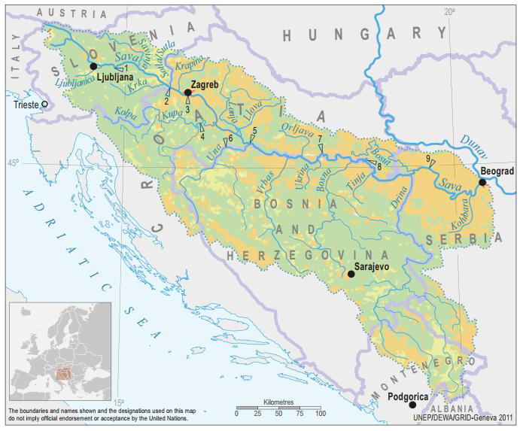

FINAL DOCUMENT
B E L G R A D E, January 2020

Table of contents

1. REPORT ON PUBLIC DISCLOSURE AND PUBLIC CONSULTATION 3
2. LIST OF PARTICIPANTS - PRELIMINARY CONSULTATIONS WITH KEY STAKEHOLDERS, 30 DEC 2019 8
3. DOCUMENTATION 11

REPORT ON PUBLIC DISCLOSURE AND PUBLIC CONSULTATION

As required by WB Environmental and Social Standard 10 (ESS10) – Stakeholder Engagement and Information disclosure, during preparation of Draft ESMF, ESCP, RPF, SEP and LMP documents the Borrower carried out public consultations with relevant stakeholders.
Starting from 19 December 2019, MAFWM disclosed the Draft ESMF, ESCP, RPF, SEP and LMP documents on its web site and announced invitation for Public Consultations for the public, bodies and organizations interested in subject documents prepared for SDIP Project. Same announcement was published in the daily newspaper with national coverage “Politika” on 26 December 2019. Public and other interested parties and organizations were invited to participate in process of public consultation on draft ESMF, ESCP, RPF, SEP and LMP documents.
Draft documents and invitation to the Public Consultations were also available on the web site of the MAFWM: http://www.rdvode.gov.rs/aktuelno.php.
On 30 December 2019, at 12:00 AM (local time), public consultations and presentation of the Draft ESMF, ESCP, RPF, SEP and LMP documents were organized at the premises of the Ministry of Agriculture, Forestry and Water Management - Serbian Directorate for Water Management, Room 301, III floor, Bulevar umetnosti 2a, 11000 Belgrade. The meeting was attended by a diverse group of 21 stakeholders, namely representatives of MAFWM – Directorate for water management, Public Water Management Company “Srbijavode”, Citizen Association “Akademija inzenjerskih nauka Srbije - The Academy of Engineering Sciences of Serbia”, non-formal Citizen Group “Pravo na vodu – Right2water” and NGO Coalition “Save the Blue Heart of Europe” and Association “Jugo Cikling Kampanja – Yugo Cycling Campaign”.
The attendees were:
- Mr. Milan Boric Citizen Association “Jugo Cikling Kampanja”
- Ms. Ana Petrovic Serbian Directorate for Water Management
- Mr. Branislav Djordjevic Citizen Association “Akademija inzenjerskih nauka Srbije”
- Ms. Aleksandra Smiljanic Citizen Association “Akademija inzenjerskih nauka Srbije”
- Mr. Zoran Bukvic UZB
- Mr. Dmitar Zakula Serbian Directorate for Water Management
- Mr. Zoran Kresojevic Serbian Directorate for Water Management - PIU
- Ms. Milica Pavlovic Serbian Directorate for Water Management
- Ms. Jasmina Pejcic Serbian Directorate for Water Management
- Ms. Mila Udarevic Serbian Directorate for Water Management
- Ms. Maja Jeremic Serbian Directorate for Water Management
- Mr. Uros Suberic Serbian Directorate for Water Management
- Ms. Zorica Jankovic Serbian Directorate for Water Management
- Ms. Milica Mrenkolic Serbian Directorate for Water Management
- Ms. Dijana Ivanov Serbian Directorate for Water Management
- Mr. Milan Njegovan Serbian Directorate for Water Management
- Ms. Biljana Vasic Public Water Management Company “Srbijavode”
- Mr. Oliver Ilic Non-formal Citizen Group “Savski Nasip”
- Mr. Sasa Petrovic Citizen Group “Pravo na vodu”
- Mr. Sasa Kulic Serbian Directorate for Water Management
- Ms. Iva Markovic NGO Coalition “Save the Blue Heart of Europe”

The consultation consisted of two parts. The first presentational were participants were informed in general of the ESF and the purpose of ESMF, ESCP, RPF, SEP and LMP documents during implementation. In addition, it was emphasized that all activities supported under the Project shall be environmentally and socially sound, sustainable, and consistent with WB ESS and Serbian national legislation.
Project screening procedure and risk classification are explained, as well as legal and administrative framework for Project.
The meeting started according to schedule at 12:00 AM. The Social Specialist Ms. Nina Valcic presented all project documents in details to the interested attendees.

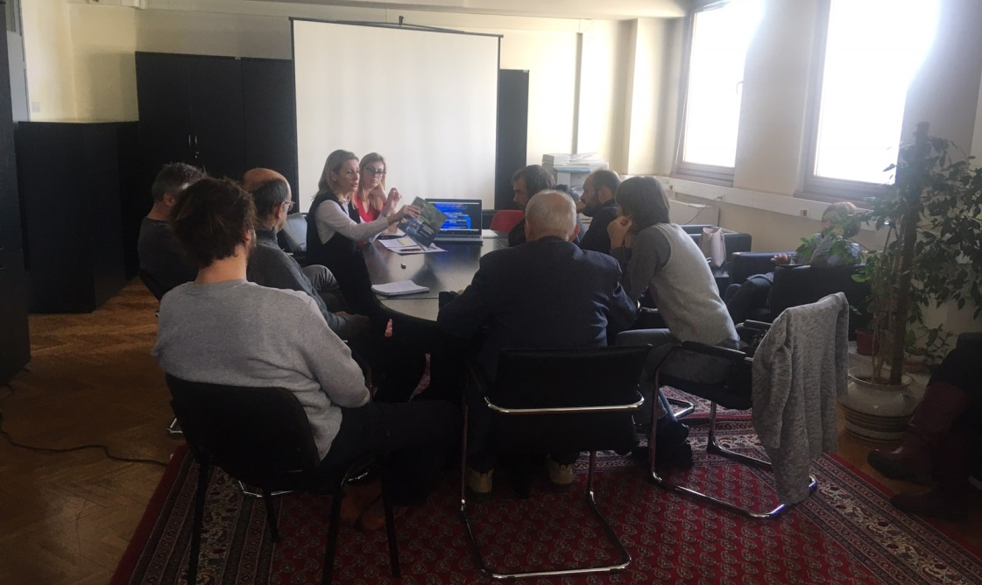
Picture 1: Public consultation in Belgrade, 30 December 2019
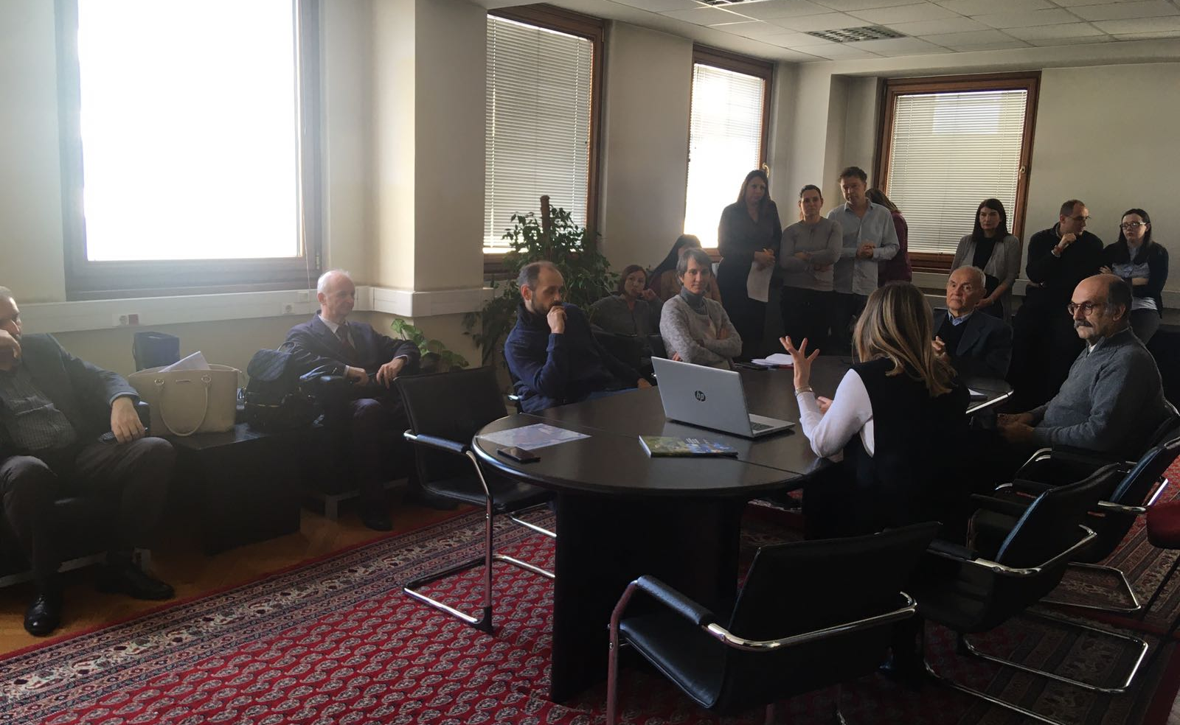
Picture 2: Public consultation in Belgrade, 30 December 2019
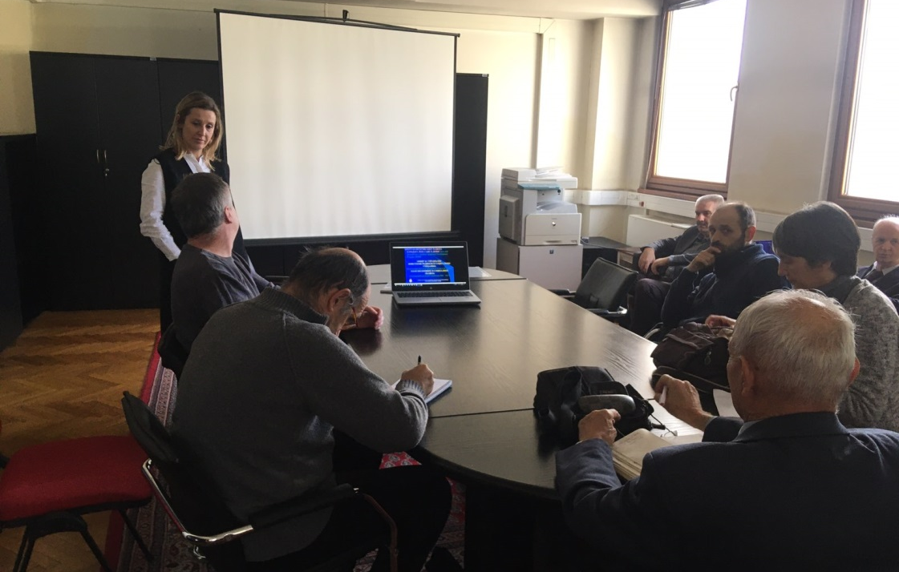
Picture 3: Public consultation in Belgrade, 30 December 2019
Special focus was given to project description, implementation arrangements, potential environmental and social impacts, grievance redress procedures, labor management, screening forms and development of environmental and social management plans during Project implementation.
The importance of Labor management and most important provisions of WB Environmental and Social Standard ESS2 (Labor and Working Conditions) are also explained to the public during presentation of ESMF document.
Before starting with questions of participants, institutional responsibilities and monitoring and reporting procedure on Project were presented and explained. However, the whole consultation have taken a participatory form and turned into a very interactive discussion with participation of all present Stakeholders very early before the moderator handed over the floor to the participants. This
Consultation started at 12:00 AM and ended at 3:30 PM, local time.

Questions and Answers during public presentation and consultations:

Q1: Has the MAFWM and/or the Government defined all Sub-projects at this stage?
A1 Nina Valcic, Social Specialist: Only a couple of Sub-project were identified at the preparation stage. These are Sub-projects Jarak, Popova Bara and Surcin Warehouse. One of the aims of these public consultations and the whole Stakeholder engagement activities relate inter alia to better understand the needs and provide the Stakeholders with an opportunity to directly contribute to the project architecture.
.................................................
Q2: What is the rationale of the World Bank to support compensation even for informal structures constructed without valid permits on land designated as river protection belt?
A1 Nina Valcic, Social Specialist: Any Project developed with financial support of the World Bank, here and anywhere in the World are subjected to the Banks social standards. As already highlighted as of October 2018 any new Project is subject to the Environmental and Social Framework =. Adverse impacts attributable to the Project stemming from Land acquisition are in detailed covered by the ESS 5 on Land Acquisition, Restrictions on Land Use and Involuntary Resettlement. The requirements of these standards are very specific when it comes to informal owners and users and formal and informal economic activities and between these two categories there are no differences in their eligibility. In the aim to prevent opportunistic claims, which indeed, are not eligible the Borrow is requested to announce the Cut-off date.
.................................................
Q3: How are the specific Stakeholder engagement activities designed? What will the methods of engagement be and what frequency will they take?
A1 Nina Valcic, Social Specialist: .As presented today this Project has a standalone Stakeholder Engagement Plan (SEP) applicable throughout the Project lifecycle, to be updated as needed following the procedure set out in the plan itself. The method of engagement is phase sensitive and will be continued and ongoing carefully following the development of the Project and the need to consult and inform the identified Stakeholders. Stakeholders are encouraged to follow announcements on the website of the MAFWM and newspapers as the Project information will be available there. Following these consultations and the Appraisal by the World Bank the engagement shall be intensified as outlined in the plan. For more details please again refer to the disclosed Stakeholder Engagement plan.
.................................................
Q4: Will the Project have a specific Grievance Mechanism? As we understand this is a requirement of many IFIs?
A1 Nina Valcic, Social Specialist: This as all other Projects financially supported by the World bank will have a Project Specific Grievance Mechanism to serve both persons directly affected by land acquisition and persons affected by other Project`s activities ( throughout the cycle). At this moment given the preparation phase of the project the Central mechanism within the MAFWM is operational to be followed by local entry points. Subsequently as the selection of Sub-projects continues and progresses. This points and function of the GM shall be locally publicized and information material distributed.

Opinions and remarks provided in written form:

O1 Branislav Djordjevic, Citizen Association “Akademija inzenjerskih nauka Srbije”, by his letter dated 03 January 2020:
- All hydro technical project activities on the rivers and in the Sava and Drina corridors should be done exclusively with new hydrological studies and with new hydrological analyzes, since the previously prepared studies are obsolete. Recommended experts to be involved in the new design team.
- Detailed environmental impact analysis is required. The Ramsar Convention on the Protection of Wetlands should also be kept in mind.
- In the case of construction of a new embankment on the left bank of the Sava River in the New Belgrade area, a Spatial Plan of Detailed Regulation with clearly defined Land use should be developed.
- The planned settlements in the remaining Sava river bank areas of New Belgrade, in the hinterland of the regulated part of the river banks, should be carefully reviewed in sense of the population density of that particular city zone (density of buildings, floors), as it is already extremely densely populated, which is reflected in very difficult traffic, as well as to air pollution resulting from excessive occupancy of remaining land.
- Since the Program also includes the Drina corridor, regardless of which facilities will be financed in that corridor, the integral solution of the water management system on that river, which is now official, should be mentioned, as it is in the Water Management Base of Serbia and the Spatial Plan of the Republic of Serbia , as well as in the Republika Srpska Water Management Strategy.
- During the consultation, I and several other attendees were unpleasantly surprised by the explanation of the World Bank's position that all facilities for which displacement and demolition are needed - are in the same legal position in terms of compensation, regardless of when and how investors built the property to be removed. Therefore, in view of the legal regulations relating to water land, as well as the zone of protection of springs, the World Bank in Serbia must use the only possible - selective approach. He implies that the position on the legal position of those whose property will be expropriated and compensated for the construction of shorelines does not apply to those owners who have committed the crime of building in prohibited zones.
- It would be completely illogical and dangerous to require a high degree of flood protection in the new coastal zones regulated under this Program, while allowing the already existing embankment upstream of the settlement in block 45 to be physically destroyed by unintended use as a road, even for the heaviest traffic. Such loads have a very unfavorable effect on the deformations of the foundation zone of the embankment, which therefore becomes unsafe and prone to collapse. The World Bank should therefore explicitly restrict its loan for the construction of new fortifications on the left bank of the Sava by requiring that physical barriers be completely prevented from accessing motor vehicles on the embankment, in all places where it occurs, and preventing the opening of some new approaches.
- In order to re-design the New Belgrade embankment project, it should be borne in mind that the owners of illegally constructed houses in the river side area have constructed transverse embankments to block the large water (river inundation) trough so that they can reach their homes, not only by cars, but by heavy construction machines. These transverse structures during periods of high Sava waters completely impede the flow in the high water trough and drastically aggravate the modes of propagation of large water waves, drastically increasing the risk of breakage of the embankment. Therefore, it is necessary for the World Bank to make the loan for new works in the Sava Corridor conditional on the removal of these transverse structures (access roads to residential buildings, rem.aut.), as well as all other facilities in the large water basin and to enable unhindered mode of transmission of large-water waves. Here, too, the principle must be that these works should be done at the expense of those persons who performed those dangerous works.
- Raft owners cut deep embankments through deep trenches to push plumbing to their rafts. The embankment is thus damaged in several places, which compromises its safety. Therefore, as one of the priorities of this Program, the World Bank should require the rehabilitation of an already existing embankment and prevent its further damage by enforcing a traffic ban on it, except for the official purpose of maintaining the embankment.
- The World Bank should also be aware of the very serious endangering of Belgrade Water Supply springs by illegal construction in the protection zones of the springs.

O2 Aleksandra Smiljanic, Citizen Association “Akademija inzenjerskih nauka Srbije”, by her letter dated 03 January 2020, related to SDIP Project Potential Procurement Packages - : Nr. 1.1.14 Design and Raising dykes in Novi Beograd to protect Belgrade City from flood:
- Several hundred illegal cottages between the embankment and the water were built on the Sava embankment. They threaten the embankment itself, which protects New Belgrade with over 200,000 inhabitants from flooding, as well as Belgrade's water supply, because they are located in the middle of Belgrade's water source
- The owners of illegal cottages drive cars along an embankment that is not designed for traffic but only for service vehicles
- The owners of illegal rafts along the Sava Quay have drilled the embankment in several places with water pipes to bring water to their rafts.
- Although no funds have been allocated for specific projects, investment is being considered for coastal fortification along the planned settlement in New Belgrade, downstream of Block 70a, on land owned by the private companies Comtrade and Zepter. The owners of these companies benefit most from such a project, which is not in line with the World Bank policy that everyone has equal access to World Bank funds
- New planned settlements along the Sava River in New Belgrade do not need to be built, because New Belgrade is already too densely populated and traffic congestion is unbearable.
- If the World Bank wants to provide embankments on the Sava River, it must first start with the existing, already built part of the embankment, which is most vulnerable to the misuse of infrastructure by irresponsible citizens.
- I request that my statement and the accompanying articles be forwarded to the World Bank:
- http://savskinasip.com/analize/group-of-irresponsible-people-endanger-belgrade/1469/
- http://savskinasip.com/analize/stance-of-serbian-academy-of-engineering-sciences/1463/
- http://savskinasip.com/analize/story-about-insolent-people-and-powerless-system/1439/

LIST OF PARTICIPANTS - PRELIMINARY CONSULTATIONS WITH KEY STAKEHOLDERS, 30 DEC 2019

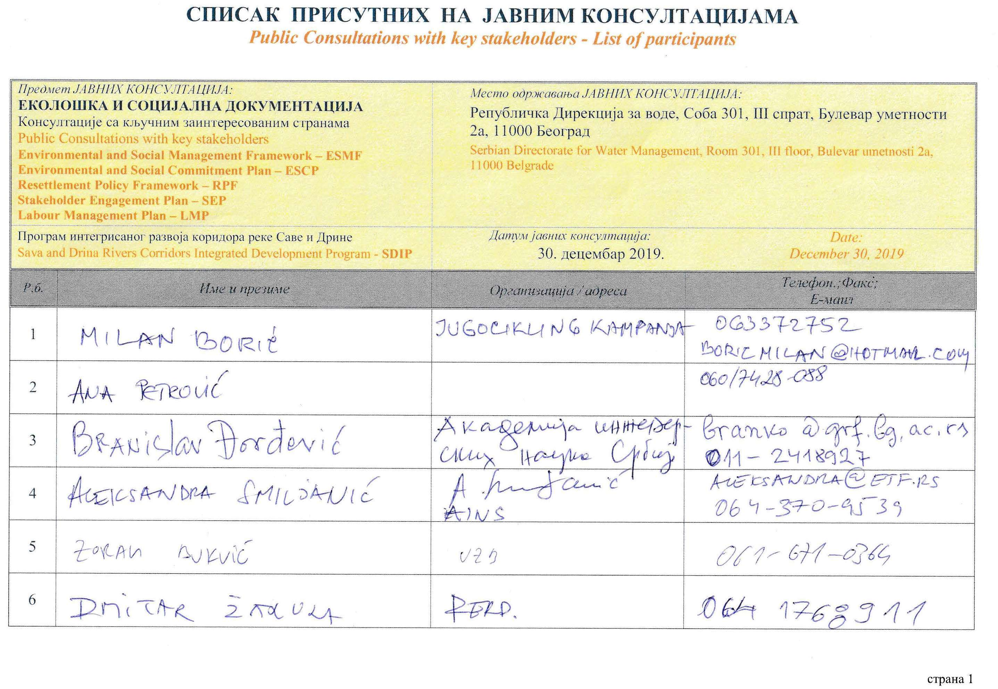
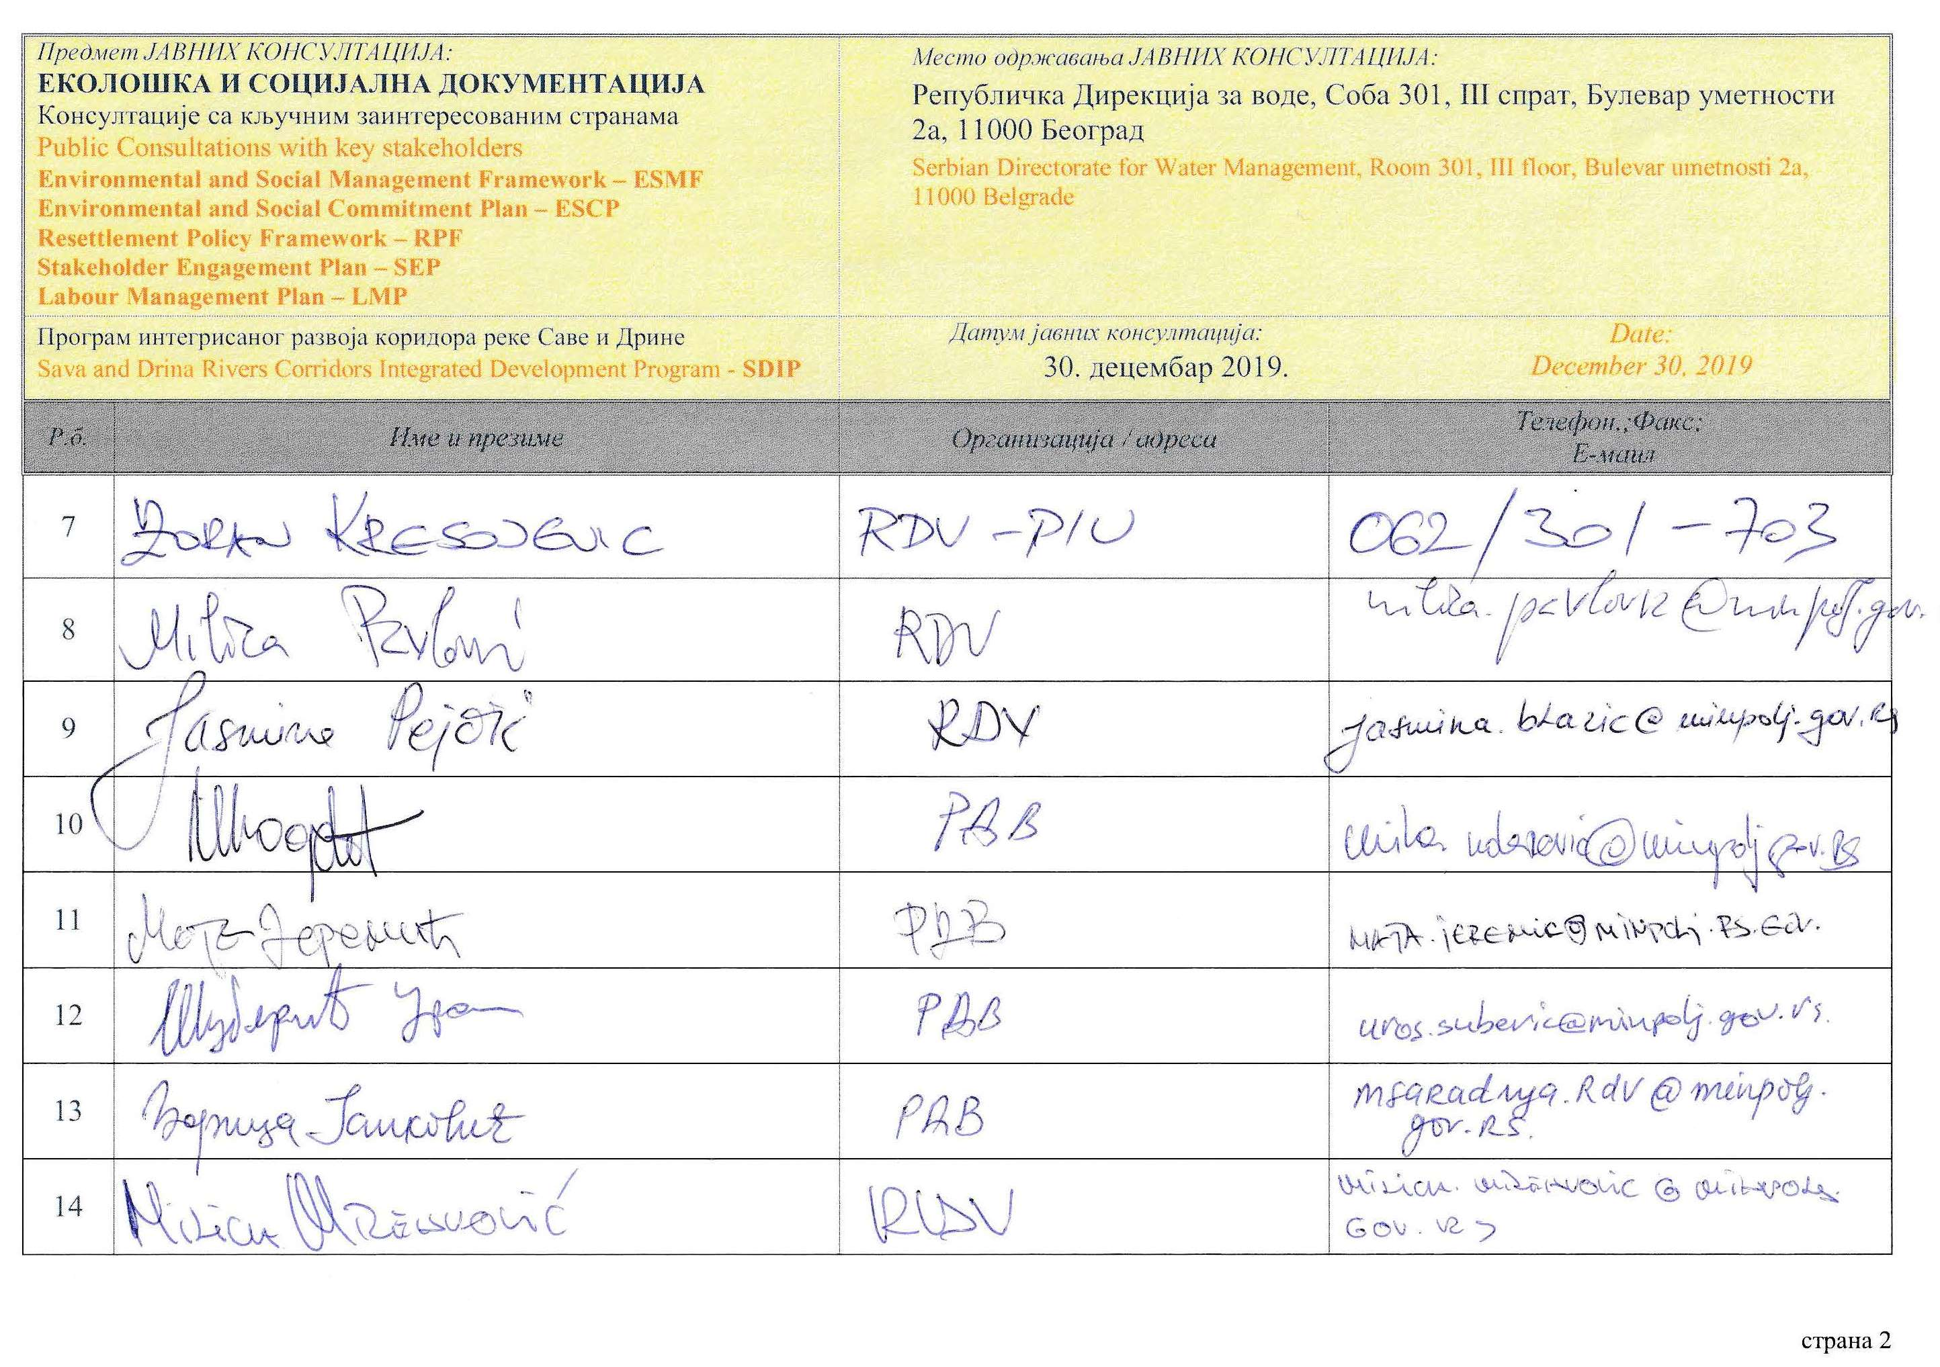
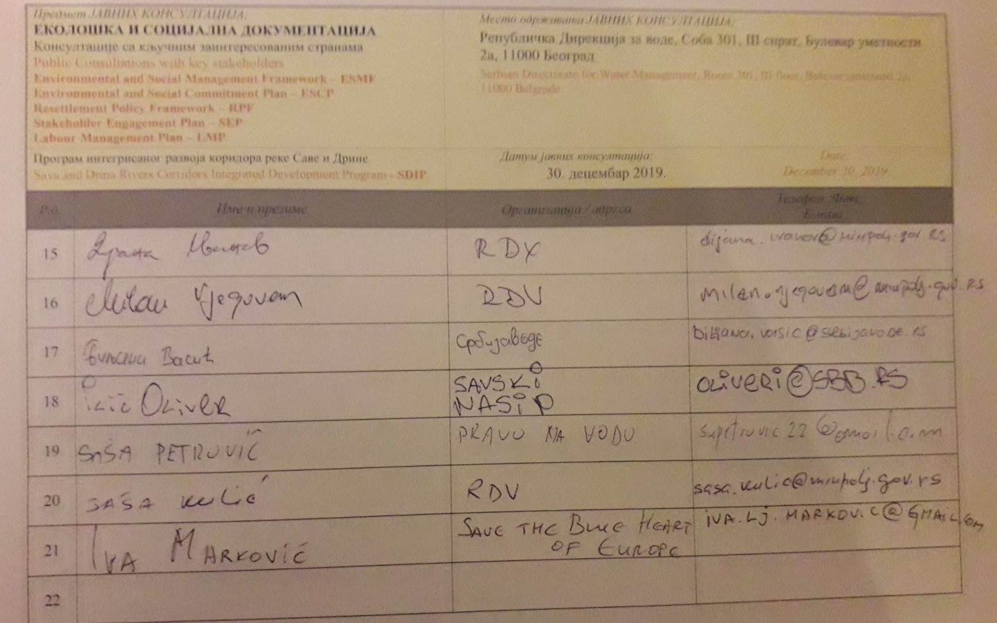

DOCUMENTATION

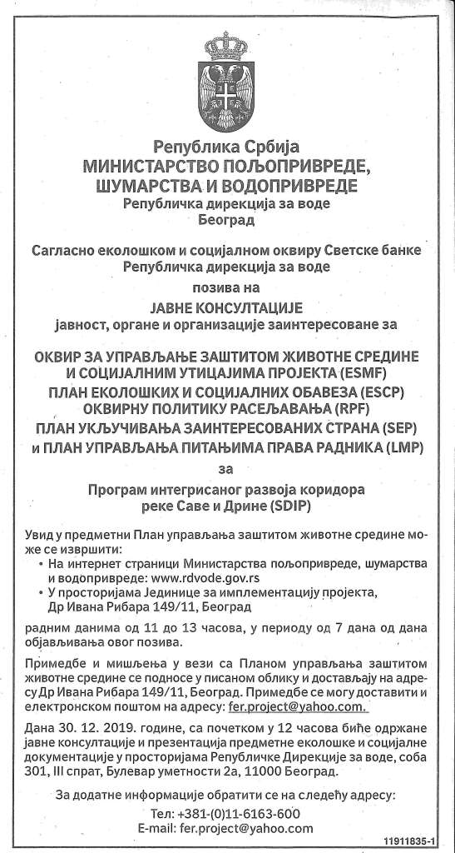
Picture 4: Announcement of public consultation in daily newspaper, (“Politika”, 26 Dec 2019)

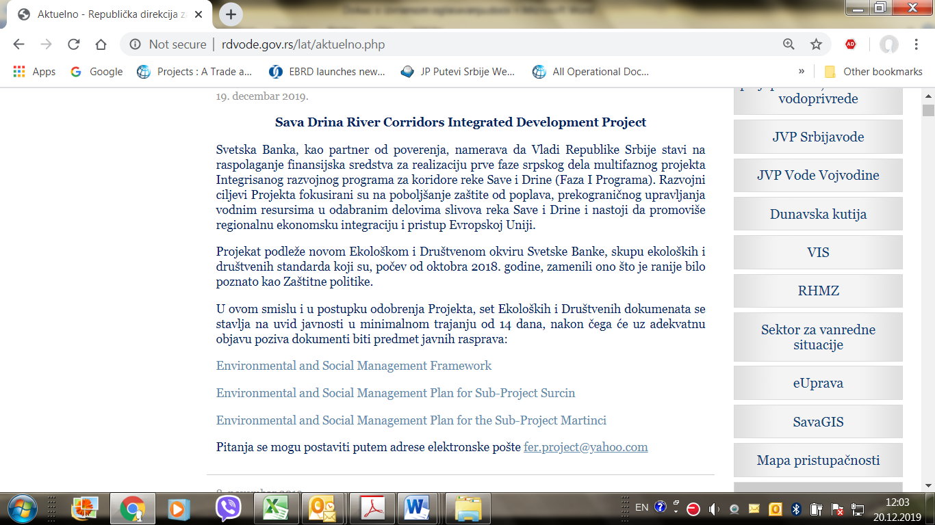
Picture 5: Announcement of public consultation on SDIP Environmental documents on Ministry web site

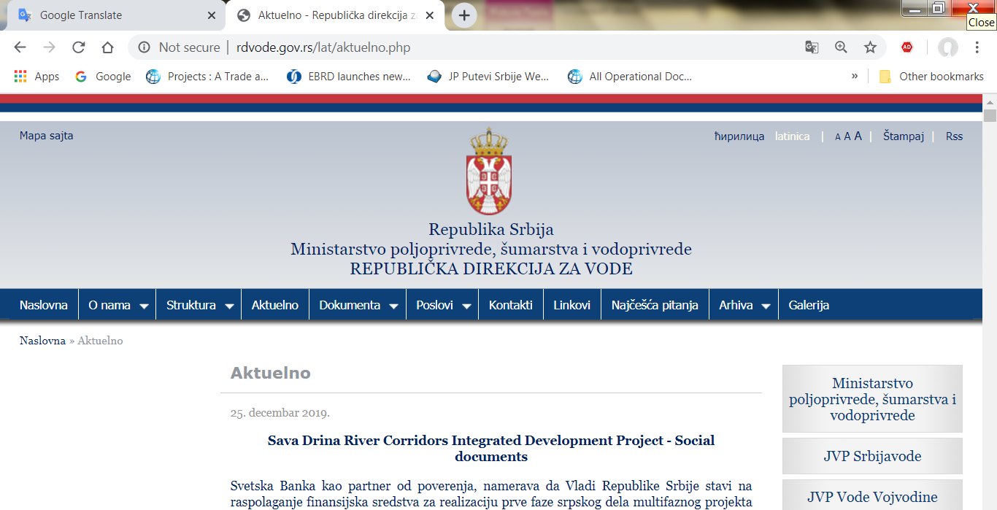
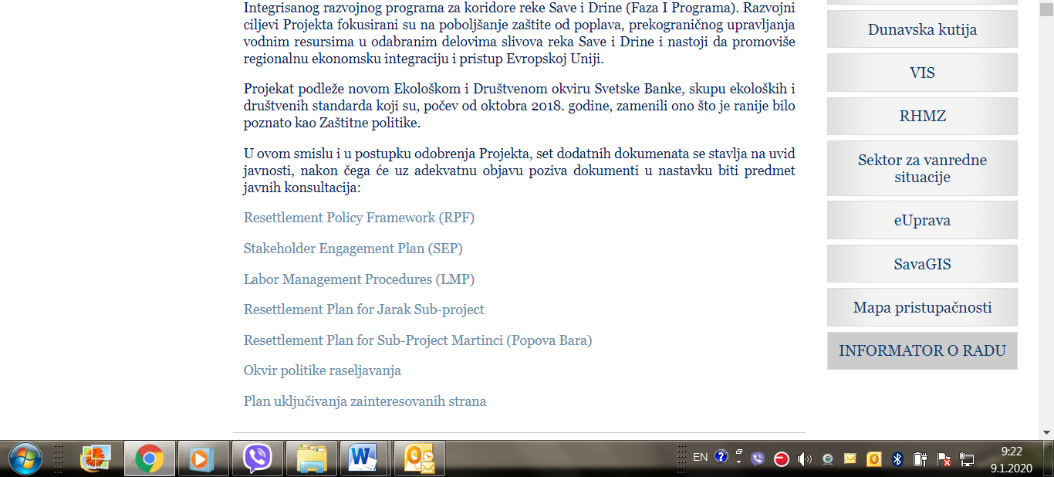
Picture 6: Announcement of public consultation on SDIP Social documents on Ministry web site

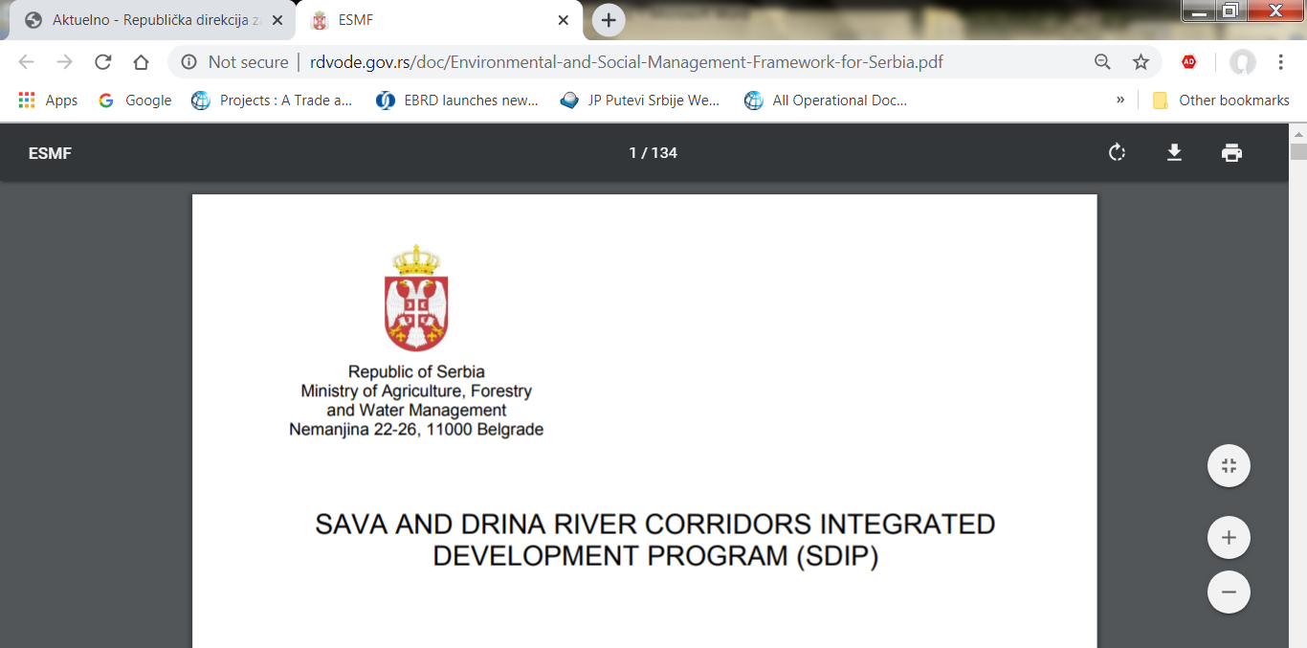
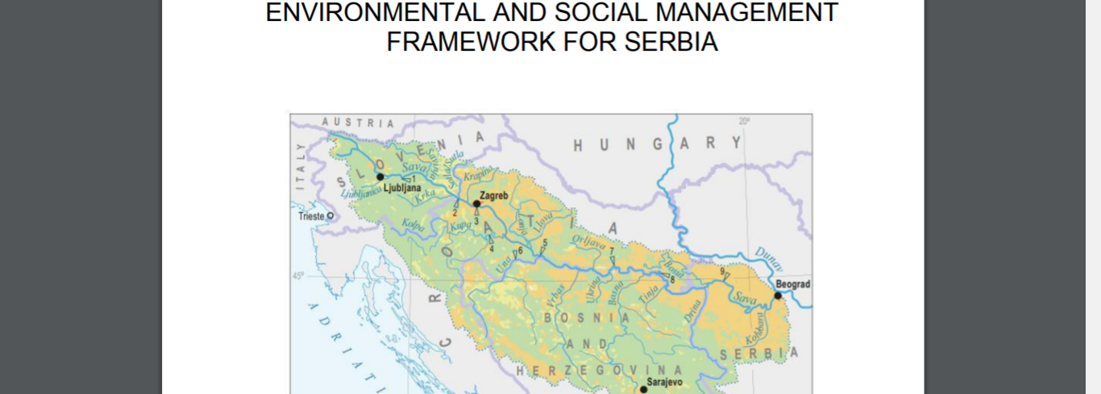
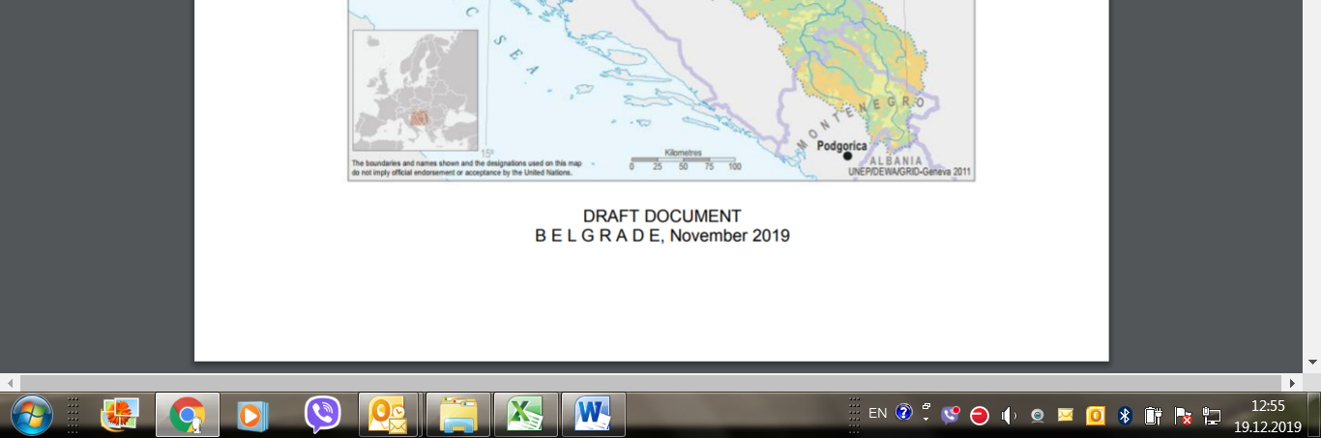
Picture 7: Public disclosure of DRAFT ESMF document, English language, Ministry web site

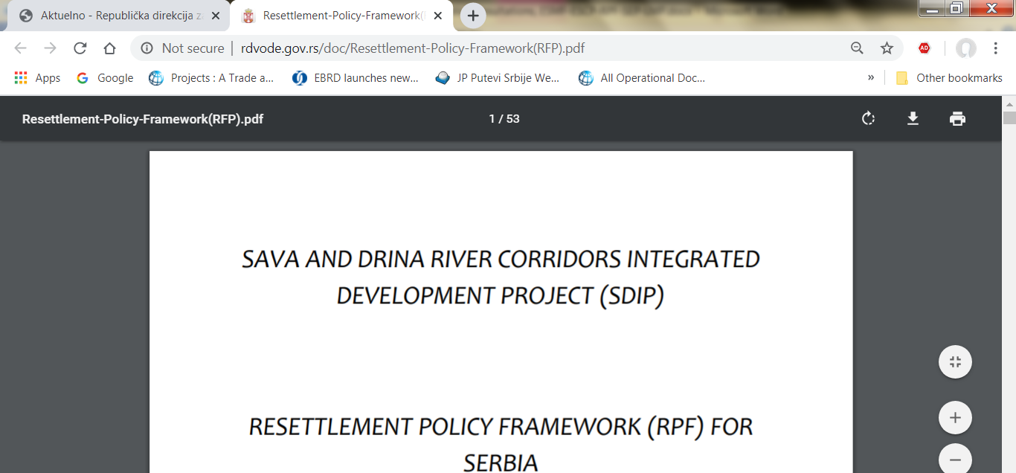
Picture 8: Public disclosure of DRAFT RPF document, English language, Ministry web site

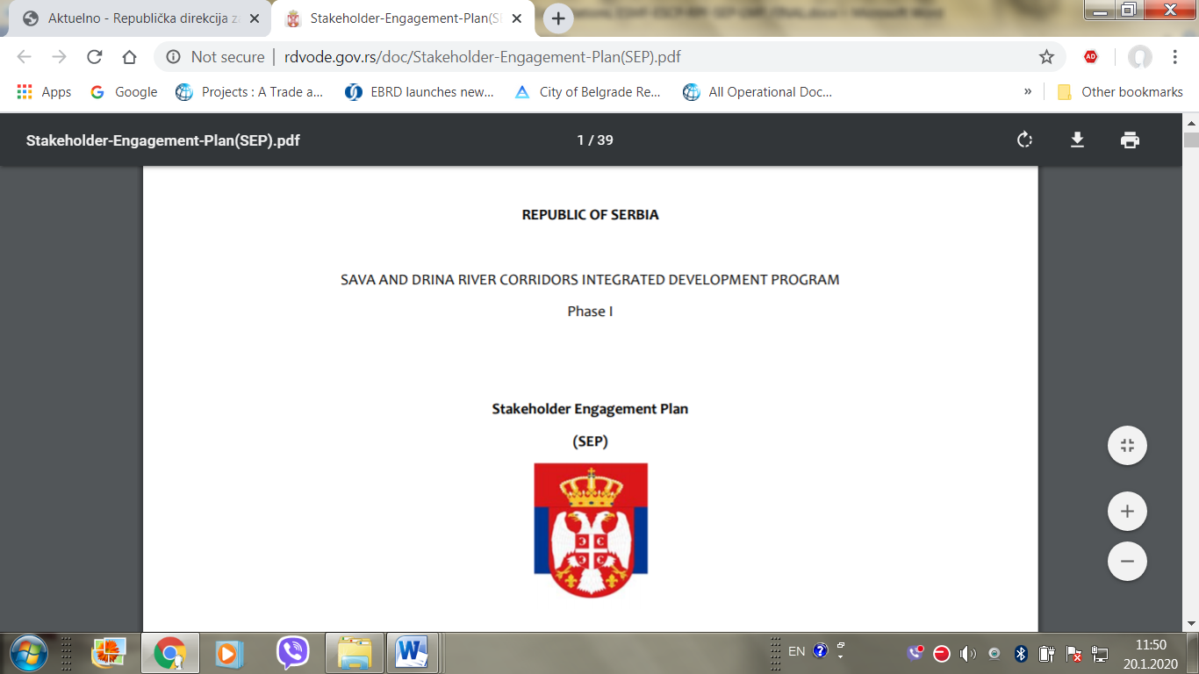
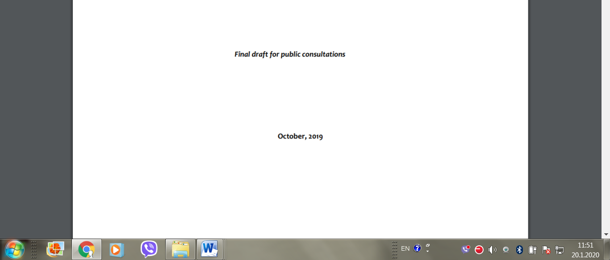
Picture 9: Public disclosure of DRAFT SEP document, English language, Ministry web site

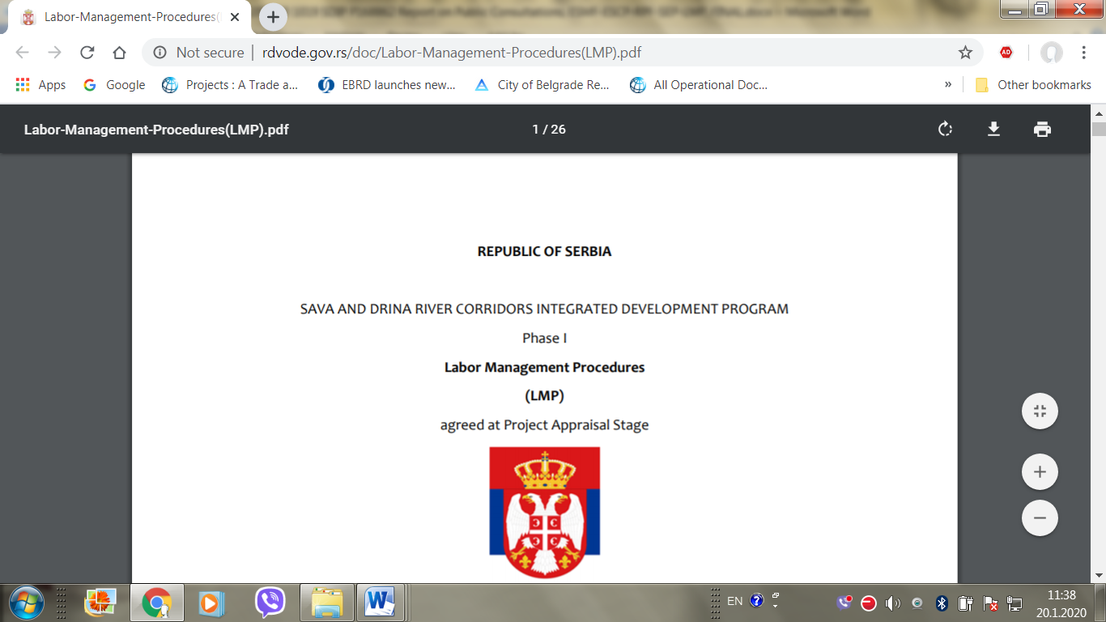
Picture 10: Public disclosure of DRAFT LMP document, English language, Ministry web site

This is part of a multiphase programmatic approach with an overall financing envelope of EUR225.4 million US$250.2 million equivalent ）
Sub-component 1.3 Enhancement of port facilities is omitted here as implementation of this sub-component is in Phase II. Preparation of activities within this sub-component will be included under sub-component 3.1 Project Preparation.
www.worldbank.org/en/projects-operations/environmental-and-social-framework/brief/environmental-and-social-standards
Sub-groups at community level are not exclusive and may have multiple overlaps (e.g. young women agri-food producers who lives in a disadvantaged area would receive extra points in the selection criteria for all three characteristics (gender, age and location).

