SERBIA FLOODS EMERGENCY AND RECOVERY PROJECT

(FERP)

Component 3

Abbreviated Resettlement Action Plan

(ARAP)

For Hrtkovci - Gomolava Flood Protection subproject



Republic of Serbia

Ministry of Agriculture, ForestryForestryryry and water management

Directorate for Water Management

Project Implementation Unit

*Draft document I*

May 2018

CURRENCY EQUIVALENTS

(Middle Exchange Rate of the National Bank of Serbia- Effective May 2018)

Currency Unit = RSD

97,7990 RSD = 1 USD

118,1901 RSD = 1 EUR

**ABREVIATIONS AND ACRONIMS**

RS - Republic of Serbia

BoE - Beneficiary of Expropriation

CE - Citizen Engagement

CC - Constitutional Court

CM - Cadastre Municipality

GC - Grievance Committee

IFIs - International Financial Institutions

OP - Operational policy of the World Bank

PAP - Project Affected Person

PIU - Project Implementation Unit

FERP - Serbia Floods Emergency and Recovery Project

RNA - Recovery Needs Assessment

ARAP - Abbreviated Resettlement Action Plan

RPF - Resettlement Policy Framework

WB - World Bank

OP 4.12 - Operational Policy on Involuntary Resettlement

MAFW - Ministry of Agriculture, Forestry and water management

MF - Ministry of Finance

PWMC - Public Water Management Company

RSD - Serbian Dinar

**LIST OF DEFINITIONS/GLOSSARY**

**COMPENSATION.** Payment in cash or in kind for an asset or a resource that is acquired or affected by a project. Compensation will be paid before taking possession of the land and assets in all cases, including where this is not possible due to the absence of the owners. In the case of absence of owners, the money will be deposited to an escrow account for 3 years.

**CUT-OFF DATE**. Date of socio-economic Survey determining the number of PAPs and the extent of impact on their structures and other assets. Persons who encroach on the area after the cut-off date are not entitled to compensation or any other form of resettlement assistance. Similarly, fixed assets (such as built structures, crops, fruit trees, and woodlots) established after the cut-off date will not be compensated.

**ECONOMIC DISPLACEMENT**. Loss of income streams or means of livelihood, resulting from land acquisition or obstructed access to resources (land, water or ForestryForestryry) resulting from the construction or operation of a project or its associated facilities.

**EXPROPRIATION**. Means deprivation or limitation of ownership rights of property with a compensation pursuant to market value of that property by use of the power of Eminent Domain.

**INVOLUNTARY RESETTLEMENT**. Resettlement is involuntary when land is acquired through the application of state powers. Actions may be taken without the displaced person’s informed consent or power of choice.

**LIVELIHOOD RESTORATION**. Measures that will be undertaken to assist physically and economically displaced PAPs to improve their livelihoods and standards of living or at least to restore them, in real terms, to pre-displacement levels or to levels prevailing prior to the beginning of project implementation, whichever is higher. Assistance must continue after displacement, for a transition period, based on a reasonable estimate of the time likely to be needed to restore their livelihood and standards of living.

**MOVING ALLOWANCE**. The moving allowance is a cash compensation for costs directly associated to moving/relocation of the household.

**PAP.** Project Affected Person is any person who, as a result of the implementation of a project, loses the right to own, use, or otherwise benefit from a built structure, land (residential, agricultural, or pasture), annual or perennial crops and trees, or any other fixed or moveable asset, either in full or in part, permanently or temporarily.

**PHYSICAL DISPLACMENT**. Loss of shelter or property caused by expropriation of land in connection with the project, which requires the physical shifting of a PAP from his/her pre-project place or residence, place for work or business premises.

**REPLACEMENT COST**. For agricultural land, replacement cost is the pre-project or pre-displacement, whichever is higher, market value of land of equal productive potential or use located in the vicinity of the affected land, plus the cost of preparing the land to levels similar to those of the affected land, plus the cost of any registration and transfer taxes. For land in urban areas, it is the pre-displacement market value of land of equal size and use, with similar or improved public infrastructure facilities and services and located in the vicinity of the affected land, plus the cost of any registration and transfer taxes. For houses and other structures, it is the market cost of the materials to build a replacement structure with an area and quality similar to or better than those of the affected structure, or to repair a partially affected structure, plus the cost of transporting building materials to the construction site, plus the cost of any labor and contractor's fees, plus the cost of any registration and transfer taxes. In determining the replacement cost, depreciation of the asset and the value of salvage materials are not taken into account, nor is the value of benefits to be derived from the project deducted from the valuation of an affected asset. It also includes costs for levelling or other preparation for new construction or use. Costs are calculated based on the time at which the asset is being replaced, if not, inflation is taken into account in calculating costs.

**ABBREVIATED RESETTLEMENT ACTION PLAN (ARAP).**The document specifying the procedures to be followed and the Actions to be taken consistent with the principles and objectives of OP 4.12 and with the RPF adopted for the FER Project. The goal is to mitigate adverse effects, compensate losses, and provide development benefits to persons and communities affected by an investment project in cases when less than 200 persons are affected by the Project or the resettlement impacts are minor.

**MINOR RESETTLEMENT IMPACTS.** To categorise resettlement as minor resettlement impacts all of the following conditions have to be met : all of the PAPs lose less than 10 percent of their land, regardless of the number of PAPs (b) the remainder of their land is economically viable; and (c) they have no need for physical relocation.

**RESETTLEMENT POLICY FRAMEWORK (RPF**). RPF is a Project level document meant to clarify resettlement principles, organizational arrangements, and design criteria to be applied to subprojects to be prepared during project implementation. It contains clear definitions of conditions under which the resettlement (for a specific project, a sector program or within a political entity like a state or a province) will be planned and implemented. It defines issues like entitlement, principles of compensation, grievance processes and other legal procedures. An RPF is required for projects with subprojects or multiple components that cannot be identified before project approval. The RPF for the FER Project was adopted in March 2015.

**STAKEHOLDERS**. Any and all individuals, groups, organizations, and institutions interested in and potentially affected by a project or having the ability to influence a project.

Contents

[EXECUTIVE SUMMARY - 11 -](#_Toc513490071)

[Project Background - 11 -](#_Toc513490072)

[Project Impacts - 11 -](#_Toc513490073)

[1. INTRODUCTION - 12 -](#_Toc513490074)

[1.1 Project description - 12 -](#_Toc513490075)

[1.2 Sub-Project Area Description, Local context and Key demographics - 12 -](#_Toc513490076)

[1.3 Sub-Project Objectives and Activities - 15 -](#_Toc513490077)

[1.4 Scope and Purpose of an Abbreviated Resettlement Action Plan - 16 -](#_Toc513490078)

[1.5 Objectives and Principles of the Abbreviated Resettlement Action Plan - 16 -](#_Toc513490079)

[1.6 Study methodology - 17 -](#_Toc513490080)

[2. LEGAL FRAMEWORK - 17 -](#_Toc513490081)

[2.1 The National Land Policy - The Republic of Serbia Expropriation Law - 17 -](#_Toc513490082)

[2.2 Public interest and purpose of expropriation - 18 -](#_Toc513490083)

[2.3 Expropriation process - 18 -](#_Toc513490084)

[2.4 Valuation - 19 -](#_Toc513490085)

[2.5 Information and consultation requirements - 19 -](#_Toc513490086)

[2. 6 Information of public interest - 20 -](#_Toc513490087)

[2.7 Other Applicable Laws and Provisions - 20 -](#_Toc513490088)

[3. THE WORLD BANK POLICY ON INVOLUNTARY RESETTLEMENT (OP/BP 4.12) - 20 -](#_Toc513490089)

[3.1 Gap analysis between relevant national legislation and World Bank OP. 4.12 - 21 -](#_Toc513490090)

[4. MINIMIZATION OF IMPACTS - 23 -](#_Toc513490091)

[5. Affected people and project impacts - 24 -](#_Toc513490092)

[5.1 Overview of Project Impacts - 24 -](#_Toc513490093)

[5.2. Census/Inventory - 25 -](#_Toc513490094)

[6. SOCIO-ECONOMIC SURVEY - 25 -](#_Toc513490095)

[6.1 Demographic features of the household - 25 -](#_Toc513490096)

[6.2 Sources of Livelihood for the affected person and monthly income - 26 -](#_Toc513490097)

[6.3 Place of Residence - 27 -](#_Toc513490098)

[6.4 Community Perception of the Project - 27 -](#_Toc513490099)

[7. RESETTLEMENT COMPENSATION STRATEGIES - 27 -](#_Toc513490100)

[7.1 Key Principles - 27 -](#_Toc513490101)

[7.2 Cut-Off Date - 27 -](#_Toc513490102)

[7.3 Eligibility - 27 -](#_Toc513490103)

[7.4 Valuation - 28 -](#_Toc513490104)

[8. GRIEVANCE MANAGEMENT & REDRESS - 29 -](#_Toc513490105)

[8.1 Organizational Arrangements for Grievance Management - 29 -](#_Toc513490106)

[8.2 Grievance Procedure - 30 -](#_Toc513490107)

[9. CONSULTATION AND PARTICIPATION - 31 -](#_Toc513490108)

[9.1 Disclosure and consultations requirements during preparation of draft and final ARAP - 32 -](#_Toc513490109)

[10 INSTITUTIONAL ARRANGEMENT AND IMPLEMENTATION TEAM - 32 -](#_Toc513490110)

[10.1 Responsibility for Implementation - 32 -](#_Toc513490111)

[10.2 Institutional Capacities - 33 -](#_Toc513490112)

[11. IMPLEMENTATION SCHEDULE - 34 -](#_Toc513490113)

[11.1 Monitoring, Evaluation and Reporting - 35 -](#_Toc513490114)

[11.2. Completion Report - 36 -](#_Toc513490115)

[12. COSTS AND BUDGET - 36 -](#_Toc513490116)

[Annexes - 38 -](#_Toc513490117)

[Annex 1 – Invitation for Public Consultation on ARAP Draft - 39 -](#_Toc513490118)

[Annex 2 – Request to For Access to Information of Public Importance - 40 -](#_Toc513490119)

[Annex 3 – Socio-economic Survey Questionnaire - 41 -](#_Toc513490120)

[Annex 4 – A copy of the real estate cadastre sheet - 44 -](#_Toc513490121)

[**** - 46 -](#_Toc513490122)

[Annex 5 – Grievance Commission brochure - 48 -](#_Toc513490123)

[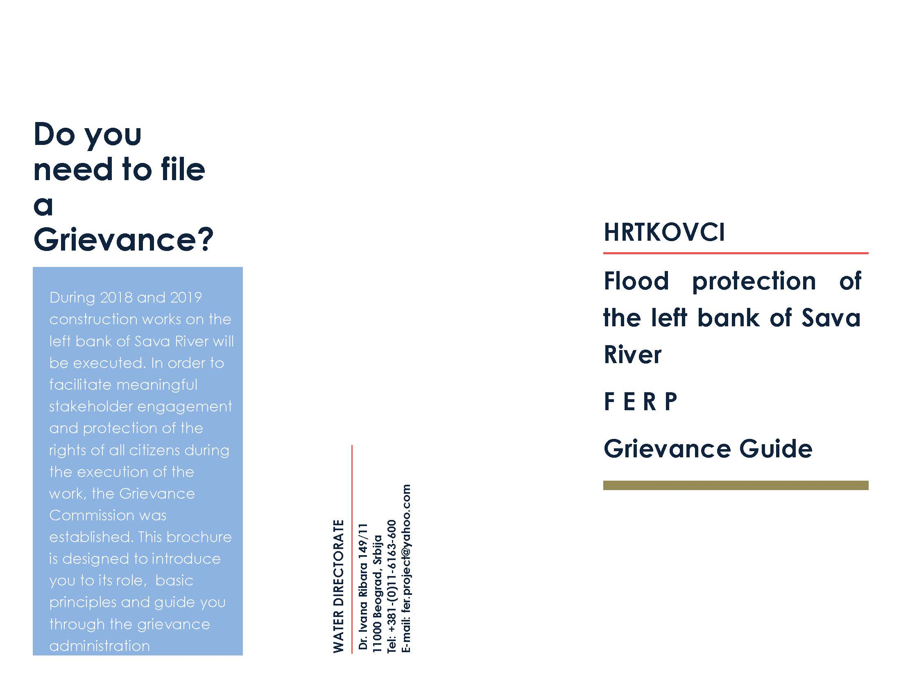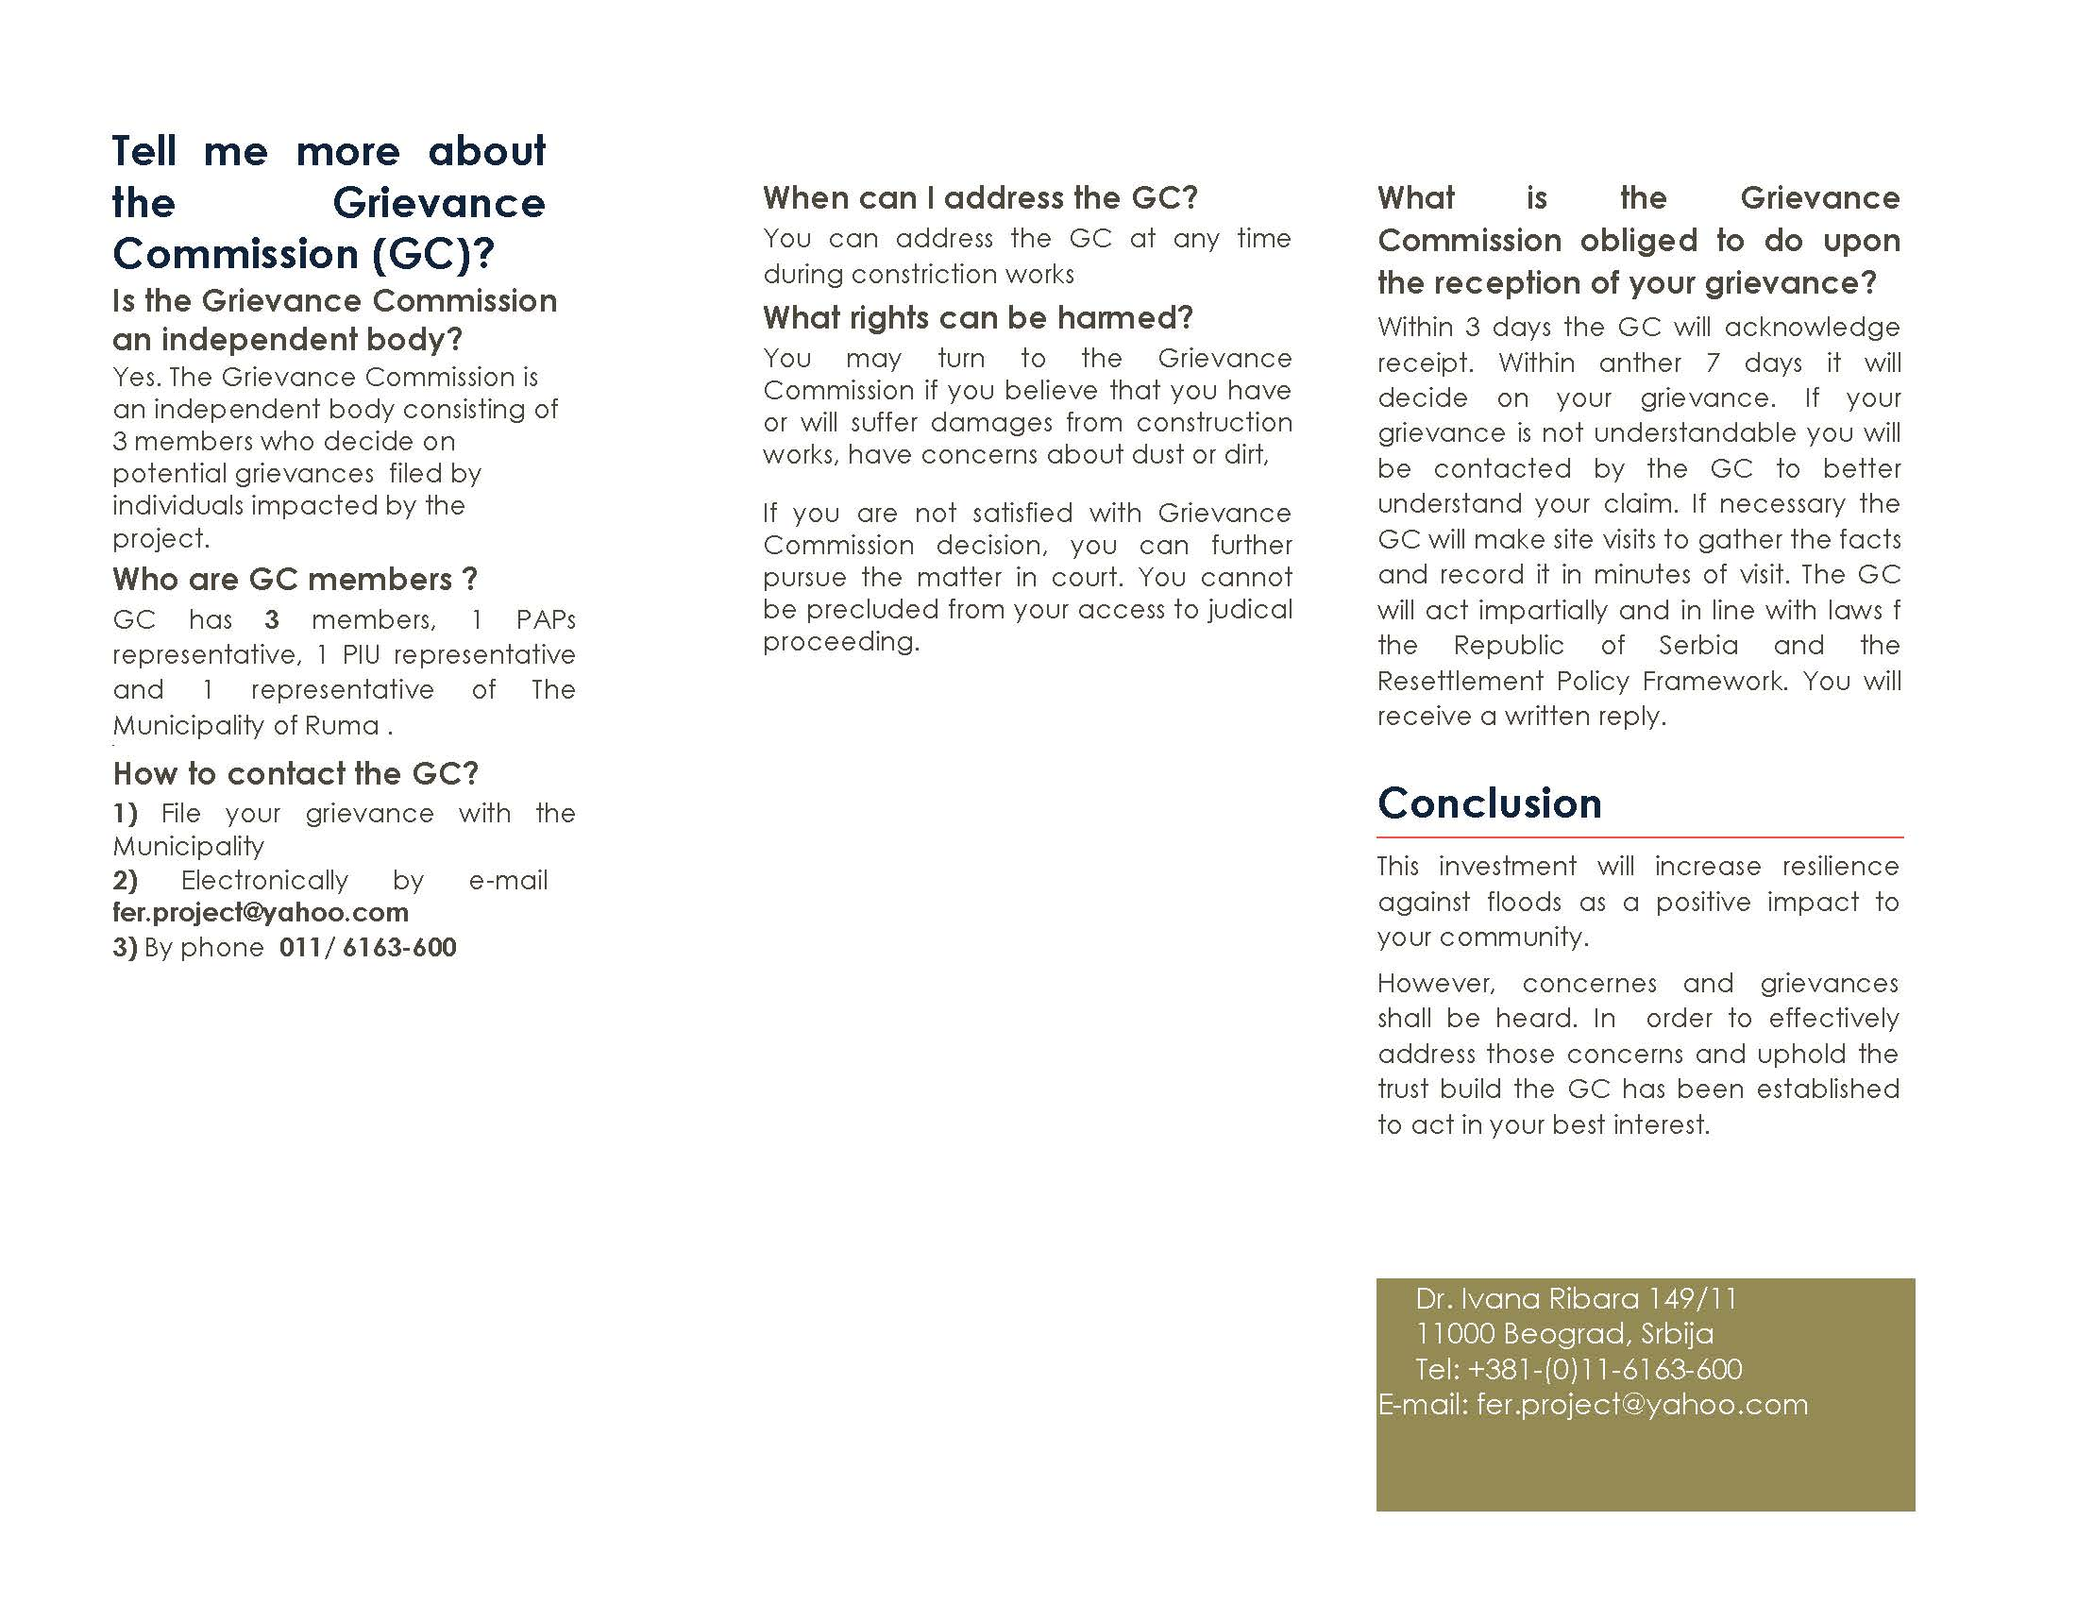 - 49 -](#_Toc513490124)

[Annex 6 – Grievance registration Form - 51 -](#_Toc513490125)

[Annex 7 - Signed and notarized lease agreement with owner Serbian - 52 -](#_Toc513490126)

[Annex 8 Social screening check list - 55 -](#_Toc513490127)

[Annex 9 Personal invitation to survey - 56 -](#_Toc513490128)

List of tables:

[Table 1: WB OP 4.12 and Serbian Law on Expropriation: GAP analysis - 19 -](#_Toc513490014)

[Table 2: Data on ownership of cadastre parcels affected by sub-project - 21 -](#_Toc513490015)

[Table 3: Demographics of the affected household - 23 -](#_Toc513490016)

[Table 4: Entitlement matrix for impacts identified - 25 -](#_Toc513490017)

[Table 5: Organizational Responsibilities and Arrangements - 30 -](#_Toc513490018)

[Table 6: Tentative Implementation Schedule for ARAP Hrtkovci - 31 -](#_Toc513490019)

# EXECUTIVE SUMMARY

## Project Background

During the third week of May 2014, exceptionally heavy rains fell on Serbia. This resulted in devastating floods causing significant economic hardship for much of the population in Serbia. The heavy rainfall with no precedent started in early/mid-May 2014 causing massive floods, destroying houses, bridges and sections of roads, resulting in the declaration of a national state of emergency on May 15, 2014 (pursuant to Article 32, Paragraph 3 of the Law on Emergency Situations, (Official Gazette of the Republic of Serbia, No. 111/2009, 92/2011 and 93/2012), across the country, which was in force until May 23rd.

The Government conducted a Recovery Needs Assessment (RNA)[[1]](#footnote-1) completed on July 10, 2014 with the objective of estimating disaster effects[[2]](#footnote-2). The RNA was presented at a donor’s Conference convened in Brussels on July 16, 2014 in the aftermath of the natural disaster, revealing that the energy sector was the hardest hit and significant infrastructure damaged.

On October 9, 2014 the World Bank approved an Emergency Loan in the amount of $300 million to support the Government of Republic of Serbia to remedy existing damages and prevent future flooding. The Project will bring evident benefit by avoided damages of agriculture production, land, assets, households, business etc. The Loan has been restructured by Amendment to the Loan Agreement and Supplemental Letter confirmed by the Serbian counterpart on June 1, 2017. The Project is implemented by the Ministry of Agriculture, Forestry and Water management namely it’s PIU.

The Impact of the Project to assets is minor, less than 200 persons are affected which is why an abbreviated Resettlement Action Plan is appropriate and acceptable.

The Sub-Project implementation in Hrtkovci will require only land acquisition of 1 privately owned land parcel in the total area of 3099 m2.

The Project will bring evident benefit by avoiding future damages on agriculture production, land, other assets including public road used by village Hrtkovci community, and avoid potential damages to households, business etc.

## Project Impacts

Hrtkovci Flood Protection sub-project will require land acquisition of only one land parcel. The parcel in question is marked in public cadastre as parcel number 3617/2 CM Hrtkovci[[3]](#footnote-3).

Beside required land acquisition, the extent and the severity of impacts are minor; there is no physical or economic displacement or impacts on livelihood, no loss of access to usual resources for households and local community

# 1. INTRODUCTION

## 1.1 Project description

Following devastating floods in 2014, the Government of Serbia requested to address some of the country's most pressing needs in the wake of this disaster. An emergency Recovery Loan to address some of the country's most pressing rehabilitation and flood protection needs. The Loan was approved and signed on October 9, 2014 in the amount of $300 million. The aim of the proposed investments is to reduce imminent risk of recurring floods by restoring and/or improving the function of existing infrastructure. The objectives of FERP are to help restore power system capability to reliably meet domestic demand; (ii) protect livelihoods of farmers in flood affected areas; (iii) protect people and assets from floods; and (iv) improve the Borrower’s capacity to respond effectively to disasters. The Project includes 4 components (1) Energy Sector Support; (2) Agricultural Sector Support; (3) Flood Protection; and (4) Contingent Emergency Response. The original amount assigned to the Component 3: Flood protection was EUR 16.72 million and has been increased by another EUR 17.34 million (total EUR 34.06 million) by virtue of the Amendment to the Loan Agreement signed and agreed by the Serbian counterpart on June 1, 2017.

Prior to the floods in 2014, the Government of the Republic of Serbia based on climate behaviour and rainfall statistics assessed the need to protect the most vulnerable locations i.e. cities, from any future floods. Based on repair/rehabilitation urgency and considering the extent of damage and risk of future impacts areas particularly vulnerable to floods were identified. Based on their vulnerability they have been chosen to be one of the sub-projects to be included in the Project’s Flood Protection Component. The sub-projects presented below were identified either at appraisal stage or by the Decision of the Government and under cover of the Restructured- Loan:

1. Flood Protection of Novi Pazar,
2. Flood Protection of Smederevska Palanka (including Jasenica),
3. Flood Protection of Negotin area
4. Flood Protection of Aleksinac,
5. Flood Protection of Vršac,
6. Flood protection of Valjevo,
7. Flood protection of Čačak,
8. Provo pump-station,
9. Construction of flood protection system for Donji Ljubes settlement,
10. Rehabilitation of Tamis dike,
11. Erosion protection and rehabilitation works on the left bank on the Sava River - Hrtkovci, Gomolava
12. Rehabilitation of the left bank embankment on the Danube River on section B. Palanka town and Smederevo town

This ARAP is prepared for the erosion protection and rehabilitation works on the left bank on the Sava River – Hrtkovci, sub-project which was added in mutual agreement between the World Bank and the Republic of Serbia, represented through the PIMO/ FERP PIU namely.

## 1.2 Sub-Project Area Description, Local context and Key demographics

During the 2014 floods, Sava River stream caused severe floods, also affecting left bank of Sava river at Hrtkovci village in municipality of Ruma, especially the 5.800 years old archaeological site of Gomalava. Hrtkovci is a small village located in the Sremski District of the autonomous province of Vojvodina. As of the 2011[[4]](#footnote-4) Census, the village of Hrtkovci is defined as rural or "other" settlement and has 3036 inhabitants, whereas both genders represents exactly 50% of all population or 1.518 inhabitants. The average age is 40, 2 years (38,5 in men and 42,0 in women), which is lower than the national and municipality average. There are 1,171 registered households in Hrtkovci with an average number of 2,39 members per household. The population disaggregated by ethnicity identify the majority to be Serbs (69,89%), followed by Hungarians, Croats, Romas, Ruthenians, Slovaks, Montenegrins, Germans and others and a number of 2,3% of undisclosed. Two main indicators of educational structure of the population, educational attainment and literacy, present the level of population education, also involving the achieved level of socio-economic development in general and was superficially explored to determine the adequate communication tool and method in the course of engagement of the PAPs in general. As statistical information for village Hrtkovci is not available, we will use relevant data for municipality of Ruma, especially its rural settlements. In the population aged 15 and over by computer literacy, Ruma in its rural communities has close to 20% computer literate persons ratio, 14% can be considered partially computer literate, while 66% are computer illiterate persons and that needs to be taken into account when choosing method of disclosure important Project documents, public announcements regarding Project, construction information etc. There are slightly more computer literate amongst male population, but the difference is not statistically significant. In terms of education nearly 4,5% of all population Ruma rural population, including Hrtkovce, doesn't have any kind of education (1,7% male and 7,2% female), 18.45% started but didn't finish elementary education (usually only four instead of eight years education - 14.28% male and female 22.66%) and 27.40% finished only primary school (27.83% male and 26.95% female). High school education is represented in 43.86% of population (mostly vocational schools, 50.51% males and 37.13% females) and only around 5% of population has some sort of high or higher education. The unemployment rate is at reasonable 9% of all population, but more than 50% of all population is considered economically inactive (retired, children, house-persons, people not looking for a job etc.)

The settlement of Hrtkovci is located along the left bank of the Sava River. Over time, the Sava River eroded the high coastline. During passing of stronger currents and higher waters, erosion processes are intensified, the coastline collapses, and the river flows threatens the left bank in the immediate vicinity of the arable land and the houses in the settlement of Hrtkovci.

The section includes 930m long Sava river bank, unstable in soil composition and exposed to the influence of the river flow. All of this causes continuous collapsing and erosions of soil and the shifting of the left bank towards the settlement and arable land. The process of erosion affects the coast and the river bed. The collapse of the coast consumed the road which is now in some sections partly below the water in the river bed. The coast along the entire section is almost vertical or with steep slopes. The slope stability is permanently endangered. The erosion of the coast is constant. Along the shores there are some less steep sections where low vegetation and trees can be seen, as shown in the photo below.



Photo - Sava river bank at Hrtkovci

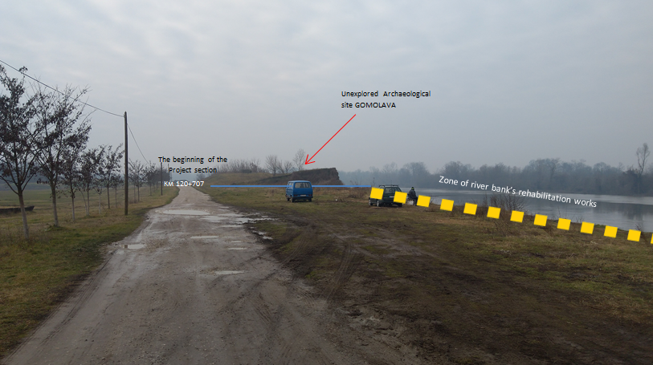

Photo - Overview of the Project area

In Hrtkovci, the current state of the coast requires urgent rehabilitation work on the protection of the left bank in order to stop the eroding and collapsing of the coast, which is also an integral part of the defence line from the large waters of the settlement Hrtkovci. This sub-project determines technical solutions and necessary works on the rehabilitation of the coast of Hrtkovci, in the Gomolava area, on the left bank of the Sava River from rkm 120 + 347 to rkm 121 + 277 in order to prevent further collapsing of the left bank due to river flow in the curve and poor resistance of the left bank, to rehabilitate existing damage and permanently stop the erosion process of the river shore. Targeted flood protection aim to reduce risk of potential losses to private and public property; including public infrastructure, agricultural and livestock production, as well as family household assets by construction of flood protection infrastructure.

The following are some of the expected benefits from the proposed flood control in the context of implementation of the Project and the sub-project :

* avoided damages of agriculture production on land likely to suffer frequent floods;
* avoided damages of assets (private houses; apartment houses; industrial facilities;

roads, electricity, schools, kindergartens, health facilities and other public buildings);

* avoided losses of business due to uninterrupted production, provision of services,

interrupted communications, traffic disruption, etc.;

* avoided human health costs due to reduction of pollution in the water supply

systems, reduced water borne diseases, and reduced risks of human life losses;

* increased recreation benefits including potential for tourism development;
* indirect economic development effects

## 1.3 Sub-Project Objectives and Activities

The overall objectives of the FERP are to help restore power system capability to reliably meet domestic demand; (ii) protect livelihoods of farmers in flood affected areas; (iii) protect people and assets from floods; and (iv) improve the Borrower’s capacity to respond effectively to disasters.

From 120 + 347 to the beginning of the archaeological site of Gomolava at km 120 + 567 works on the rehabilitation of the bank will be financed from the budget of the RS.

In accordance with the detailed regulation plan for the coastal area of the left bank of the Sava River as well as the obtained conditions of the competent Institute for the Protection of Cultural Monuments, works on the rehabilitation of the Sava river in the zone of the unexplored part of the archaeological site Gomolava from km 120 + 567 to km 120 + 707 will not be performed until the completion of protective archaeological excavations.

The scope of the Sub-Project envisages works from km 120 + 707 to km 121 + 277, in a total length of 570 m, and the works on the rehabilitation of the river bank will be financed from the World Bank loan, since protective archaeological excavations have been completed on this section, property legal issues have been resolved and there is an approved project under which works on the rehabilitation of the coastline will be carried out.

The activities to be implemented under the River Sava Hrtkovci sub-project include three phases of activities:

* Phase 1 from rkm 120 + 707 to rkm 120 + 947, L = 240m
* Phase 2 from rkm 120 + 947 to rkm 121 + 112, L = 165m
* Phase 3 from rkm 121 + 112 to rkm 121 + 277, L = 165m

The focus is on the left Embankment of the river Sava and four different types of works are proposed:

1. Construction of Flood Protection structures,
2. Reconstruction of the weak points on the embankment,
3. Upgrading sections of embankment from the 1:25 year flood to the 1:100 year flood, and
4. Bank armouring in locations where erosion of the riverbank may undercut the embankment.

## 1.4 Scope and Purpose of an Abbreviated Resettlement Action Plan

The Abbreviated Resettlement Action Plan (ARAP) is prepared in Bank assisted Projects, in cases were less than 200 persons are displaced and impacts are considered "minor". It is anticipated that the sub-project will require only one case of agricultural land acquisition, its implementation will not cause relocation or replacement of structures, perennial or annual crops and no other impact has been identified to private property, households, community or village amenities. The impacts identified above require the need to prepare this specific ARAP. Detailed description of impact is given in chapter 5 AFFECTED PEOPLE AND PROJECT IMPACTS.

The scope of work undertaken during the ARAP preparation included:

* Screening of project area,
* Survey of projected affected area, land and property there on;
* Walk through the project area i.e. field verification;
* Census of the PAPs including persons and their land, assets and property thereon;
* Socioeconomic assessment of the PAPs;
* Identification of land, assets and properties likely to be affected;
* Valuation of the land and assets and property thereon to be expropriated;
* Consultations with affected Project Affected Persons (PAPs)
* Analysis of the relevant legal framework;
* Analysis of institutional framework covering the identification of agencies responsible for
* Establishment of adequate Grievance mechanism.

In accordance to the Loan Agreement, an RPF[[5]](#footnote-5) consistent with the World Bank’s OP 4.12.was prepared for the Project, approved by the World Bank and relevant Serbian authorities, and publicly disclosed in 2015 and serves as the guiding document for preparation of this ARAP.

## 1.5 Objectives and Principles of the Abbreviated Resettlement Action Plan

This ARAP, and its detailed provision, is prepared according to the Laws and regulations of Republic of Serbia and the RPF. The objective of this ARAP is to assess the impacts, compensation compliance and shall set out actions on how to avoid and mitigate future impacts by sovereignty of right over occupied land and provide prompt and effective compensation for residual impacts to those eligible. The objectives are not dependent to the scope and scale of impact.

The RPF has outlined the key land acquisition and resettlement principles and objectives to be followed, the organizational arrangements and design criteria to be applied to subprojects to be prepared during Sub-Projects implementation to ensure adequate management of land acquisition where applicable, and access by sovereignty over occupied land required for the Project.

This ARAP specifies the following:

* Detailed procedures to be followed by Directorate for Water (DfW/PIU), Municipality of Ruma and local office of Hrtkovci in respect to consultation and disclosure;
* Provide baseline census of affected persons and asset information;
* Describes specific compensation rates and standards as per OP 4.12;
* Describes consultations with affected people about acceptable alternatives and mitigation measures;
* Describes institutional responsibility for implementation and procedures for grievance redress;
* Provides a timetable and budget; and
* Implementation and monitoring arrangements.

The RPF and subsequently this ARAP is in line with the local legislation and WB OP 4.12 and the more stringent requirements will prevail.

The preparation of this document has been guided by the WB Involuntary Resettlement Sourcebook: Planning and Implementation in Development Projects (2004) and good practice cases as well but mostly application of individual measures has been chosen based on consultation with PAPs and the in site needs.

This ARAP is tailored to cover identified direct social impacts that result from this Bank assisted investment projects and are caused by:

* the involuntary loss of assets or access to assets[[6]](#footnote-6);

## 1.6 Study methodology

The preparation of this ARAP was through a combination of desk review of secondary data and field study. The desk study involved review of project documents including available maps for the project sites, cadastral records, Municipal database on PAPs and their assets, expropriation records and preliminary technical designs. The desk study was supplemented with a survey of the project sites to establish the exact impact of the proposed subprojects in terms of affected property and creates an inventory of PAPs, and assets. The field survey consisted of a household census of identified PAP; social assessment of the subproject sites along the corridor of impact along the Sava river left bank at village of Htrkovci, socioeconomic study of the PAPs and their census. The Census was prepared on the basis of data available through the Cadastral Register and the database of the Municipality of Ruma and individual interview. Secondary data were used in addition to generated primary data obtained through the PAP and interviews with government officials and non-government officials about PAP and their assets. During analysis and interpretation of the gathered data equal weight was given to quantitative and qualitative aspects so that it reflects a balanced reality of the current situation of the PAP. The data generated shall serve as baseline conditions against which the living standards shall be compared to during the follow up survey in the Completion Report.

# 2. LEGAL FRAMEWORK

## 2.1 The National Land Policy - The Republic of Serbia Expropriation Law

The Republic of Serbia Expropriation Law (passed in 1995 and enacted on January 1, 1996, amended in March 2001, amended again on March 19, 2009) guides expropriation and serves as a general framework for expropriation in the Republic of Serbia. The law also enshrines the principle of compensation at market value.

The most important features of the Law on Expropriation are:

- It is intended to ensure simple, efficient process, reducing as far as possible the need for a lengthy judicial process to facilitate necessary expropriation. Under normal circumstances, the entire process of acquisition can be completed within six months;

- The fair value of the land affected by a particular scheme, or project, is determined by the Tax Administration, on behalf of the “Beneficiary of Expropriation”. The value is assessed on the basis of current market price;

- As a condition to start expropriation, the Beneficiary of Expropriation must arrange a Bank Guarantee with a Commercial Bank, in the assessed total sum for payment;

- In the case of privately owned agricultural land, if comparable land of the same type and quality, or the appropriate value, in the same area or vicinity (Article 15 of the Expropriation Law) can be identified, it is offered to the project affected person with formal title;

- The comparability of land is determined on the basis of an assessment of the available public land, by an accredited expert hired either by the Beneficiary of Expropriation, or the Ministry of Agriculture, Forestry and Water management (MAFW);

- In case of disagreement on the comparability of the land offered, a different accredited expert would be hired by the local municipality to determine the comparability of the land offered;

- Further disagreement would result in the project affected person resorting to the judicial process, where a decision would be made on the comparability of the land, or the payment of the assessed fair value in monetary terms;

- Where comparable land cannot be identified, the project-affected person with legal title is offered the assessed fair value as determined by the Tax Administration. If the project affected person wishes to challenge the assessment of “fair value” they can resort to the judicial process;

- For the project affected person, without formal title, there is no provision to pay compensation currently under the Law on Expropriation;

- In addition, after the passage of the Law on Planning and Construction (passed in 2009 and amended in 2011), it is a criminal offense to construct any structure without a building permit on either public or private land; and

- In the case of a project-affected person, with a formal title, who has constructed a permanent structure, without a formal building permit, compensation can be paid, if decided by a Court, under the Law on Fundamentals of Property Relations (1980, applicable from 1st September 1980, amended 1990, 1996 and 2005) at the investment cost– as determined by an accredited Expert to assess the value of the materials needed for replacement.

## 2.2 Public interest and purpose of expropriation

Property can only be expropriated upon the establishment of public interest for projects that bring greater benefit for the public (Art. 1).

Expropriation may be carried out for the needs of RS, cities, municipalities, public enterprises and public institutions, unless otherwise provided by the Law.

The Law on Expropriation requires the Beneficiary of Expropriation to justify the need for expropriation and to demonstrate that the scheme cannot occur without the proposed expropriation.

## 2.3 Expropriation process

A condition precedent to start expropriation is evidence that the required funds have been secured and made available. It is necessary for the Beneficiary of Expropriation arranging a Bank Guarantee with a Commercial Bank for the assessed fair value or in case of Local Governments is the Beneficiary of expropriation adequate appropriations within the Budget are made (Art. 24).

The procedure for expropriation starts by submitting a proposal by the Beneficiary of Expropriation to the relevant Municipality (“the expropriation authority”). A specific expropriation proposal is prepared for each land parcel and project-affected person that contains the amount of land impacted the justification of the need for the specific expropriation, together with the confirmation that the scheme is included in the relevant spatial development plan.

Once the proposal has been submitted with supporting documentation individual invitations to hearings on expropriation are sent to every PAP. The invitation specifies the purpose, time and date of hearing proposed and provides the PAPs with a list of documents to be made available for presentation and discussion at the agreed time.

After the hearing with the individual PAP has been finalized an Expropriation decision is issued.

## 2.4 Valuation

At the valuation stage, the Beneficiary of Expropriation contacts the Tax Administration to assess the value for land (all types of land, agricultural, urban, barren etc.) at market price. If impacts to agricultural land occur for construction of linear infrastructure, the Beneficiary of Expropriation contacts the MAFW, which provides an assessment of the availability of comparable agricultural land. In addition, the Beneficiary of Expropriation hires, at its own expense, an accredited expert(s) to assess the value of the land, agricultural output, businesses, and all immovable property and structures in accordance with paragraph 28(iii). At the request of the project-affected persons, they can be present during the valuation process.

In the event that the PAPs disagrees with the offered compensation in either form, they can resort to the judicial process, and the Beneficiary of Expropriation can request the Ministry of Finance, on an exceptional basis, to allow access to the site with assistance prior to payemt of compensation (Article 35). The decision is being issued on a case to case basis assessing all relevant facts of the individual case. Based on the objectives of the Project, works to be executed are considered as urgent and access to site could be allowed. So far no such claim has been made by the Beneficiary of expropriation. This provision can only be invoked in case of formal land acquisition by expropriation.

The Beneficiary of expropriation is not required to prepare a socio-economic study or a baseline census with regard to the project affected persons.

Once the decision cannot be disputed by legal remedies it becomes legally binding and the negotiations on the compensation is ready to commence. The Agreement has to include the timing and rate at which cash compensation will be paid or in kind compensation provided (Art. 26). If no agreement on compensation is reached within 2 months of the validity of the Decision on Expropriation (or less if the Municipal Administration decides as such), the Municipal Administration submits the case file together with relevant documents to the competent Court, at the territory of which the expropriated real property is located, for the purpose of determining the compensation. The competent court ex officio decides in non-contentious proceedings on the amount of compensation for the expropriated property

## 2.5 Information and consultation requirements

The Law on expropriation does require *per se neither* public dissemination nor consultation of information on the area delineated, nor systematic and continuous dissemination. Nevertheless it requires public disclosure of the determination of Public interest and the Municipal authority to invite individually every affected person with formal legal rights to a meeting to present any facts which may be relevant for expropriation. It additionally requires timely disclosure and information of every decision within the process flowchart. This dissemination has statutory limits wherever a legal remedy is provided.

## 2. 6 Information of public interest

Information of public importance is information held by a public authority body, created during or relating to the operation of a public authority body, which is contained in a document and concerns anything the public has a justified interest to know. The Law on information of public importance (Official Gazette RS", br. 120/2004, 54/2007, 104/2009 i 36/2010) requires any document publicly disclosed to have integrated guidance on how to access information of public importance.

This subject is governed by the Law On Free Access To Information Of Public Importance[[7]](#footnote-7) shall govern the rights of access to information of public importance held by public authorities, with a view to exercising and protecting the public interest to know and attaining a free democratic order and an open society.

By virtue of this Law access to information shall be granted to all stakeholders, including every natural person or legal entity upon written request unless otherwise regulated by the Law. Within 15 days of receipt of a request at the latest, the authority shall inform the applicant whether the requested information is held, and grant him/her access to the document containing the requested information or issue or send to the applicant a copy of the document, as the case may be. Annex 2 provides a template for access to information.

## 2.7 Other Applicable Laws and Provisions

Besides the Law on Expropriation, the following comprise the list of legal documents, policies and regulatory acts and frameworks dealing with expropriation and resettlement and other social impacts associated with flood protection works, representing basis of this ARAP:

1. Law on Fundamentals of Property Relations (adopted in 1980, amended 1990, 1996 and 2005)
2. Law of Planning and Construction (adopted and revised in 2009, and amended in 2011, 2013 and 2014)
3. Law on State Cadastre (adopted in 2009, amended in 2010)
4. Law on Spatial Planning of the Republic of Serbia from 2010 to 2020 (adopted in 2010)
5. Law on waters (adopted in 2010 amended in 2012 and 2016)
6. The Law on Elimination of the Consequences of Floods In Serbia (adopted in 2014 amended in 2015)

# 3. THE WORLD BANK POLICY ON INVOLUNTARY RESETTLEMENT (OP/BP 4.12)

All WB financed projects involving involuntary resettlement are subject to OP 4.12. The policy describes the procedures and instruments for eliminating negative economic, social and environmental issues that may arise OP 4.12 is triggered not only in cases of physical relocation, but any loss of land resulting in relocation or loss of shelter, loss of assets or access to assets and loss of income sources and means of livelihood.

The overall objectives of OP 4.12 are the following:

* (a)Involuntary resettlement should be avoided where feasible, or minimized, exploring all viable alternative project designs.
* (b) Where it is not feasible to avoid resettlement, resettlement activities should be conceived and executed as sustainable development programs, providing sufficient investment resources to enable the persons displaced by the project to share in project benefits. Displaced persons should be meaningfully consulted and should have opportunities to participate in planning and implementing resettlement programs.
* (c) Displaced persons should be assisted to improve their former livelihoods and standards of living or at least to restore them, in real terms, to pre-displacement levels or to levels prevailing prior to the beginning of project implementation, whichever is higher.

OP 4.12 distinguishes the following three categories of persons for eligibility for compensation and assistance:

a. Persons with formal rights to land (including customary and traditional rights recognized under the laws of the country).

b. Persons who do not have formal rights to land at the time the census begins but have a claim to such land and assets - provided that such claims are recognized under the country laws or become recognized through a process identified in the specific resettlement plans.

c. Persons without recognizable legal right or claim to the land they are occupying.

## 3.1 Gap analysis between relevant national legislation and World Bank OP. 4.12

The objectives of OP. 4.12 are clear in their aim to avoid involuntary resettlement caused by land acquisition measures wherever feasible and if not possible to apply such compensation principles for impacts on all PAPs and to restore their livelihoods at least to pre-project level. In general, the institutional framework for expropriation in Serbia is strong and broadly compatible with the OP. 4.12, but there are some exceptions, especially related to the requirements to compensate at replacement cost for land vis-à-vis the national requirement of compensating land at market value. Additionally, the national law does not recognize informal users, occupiers and settlements. It does not require a project specific grievance redress mechanism, a social impact assessment, payment of taxes and fees as part of compensation package, gender disaggregated data and assistance to vulnerable persons.

The table below provides an overview of specific gaps between the national expropriation law vis-à-vis OP 4.12 and the recommendations for remedy and/or mitigation in order to comply with the OP 4.12 requirements. **Only gaps relevant for impacts identified under this ARAP are presented.**

Table 1: WB OP 4.12 and Serbian Law on Expropriation: GAP analysis

| **Issue** | **Requirements of Serbian Law on Expropriation** | **World Bank OP 4.12 Requirements** | **Gaps and measures for bridging the gaps** |
| --- | --- | --- | --- |
| Census and Socioeconomic Survey  and  Abbreviated Resettlement Action Plan (ARAP) | No explicit requirement related with socio-economic studies or development of any kind of resettlement instrument regardless of the extent of impact. Nevertheless the Law requires a inventory of affected persons and assets without socio-economic baseline and indicators. | Census and socioeconomic survey to be made for ARAP. The study should include information on (i) current occupants in the affected area, (ii) characteristics of displaced households and their standards of living and livelihoods, (iii) magnitude of expected losses and extent of displacement, and (iv) information on vulnerable groups or persons. | Census and socioeconomic survey conducted according to WB requirement in addition to requirements under National Legislation |
| Cut-off Date for Eligibility | The Law stipulates that the cut-off date for eligibility is the date of submission of the proposal for expropriation by the expropriation beneficiary to the relevant municipality. | Normally, the cut-off date is the date the census begins. The cut-off date could also be the date the project area was delineated, prior to the census, provided that there has been an effective public dissemination of information on the area delineated, and systematic and continuous dissemination subsequent to the delineation to prevent further population influx. Persons who encroach on the area after the cut-off date are not entitled to compensation or any other form of resettlement assistance. | The cut-off date for purposes of eligibility shall be the date of beginning of the census.  PAPs will be explicitly informed about this cut- off date and its implications during the consultations on the draft ARAP.  PAPs were explicitly informed about the cut- off date and its implications by Newspaper Announcement on November 6, 2017 (Please refer to Annex 7 - Announcement of Cut-off date). |
| Eligibility for Compensation  (informal) | The Law only recognizes formal ownership and persons without formal right but have a claim to such land and assets - provided that such claims are recognized under the country laws or become recognized. | According to WB OP 4.12, there are 3 categories of persons in terms of compensation eligibility:  a) Those who have formal rights to land  b) Those who do not have formal rights to land at the time the census begins but have a claim to such land and assets, provided that such claims are recognized under the laws of Bosnia and Herzegovina or become recognized through a process identified in the ARAP  c) Those who have no recognizable legal right or claim to the land they are occupying | As per RPF, project affected persons who constructed buildings without permits, who have been using public or private land are entitled to compensation/assistance for any investment made on public and private land in the cost of structures and installations (under the Law on Fundamentals of Property Relations (1980, applicable from 1st September 1980, amended 1990, 1996 and 2005) in terms of the investment made – as determined by an accredited expert to assess the value of the materials used, crops, woods, trees, fruit bearing trees, vineyards, the age of crops and the time needed to reproduce them. These rights do not extend to individuals who commence activities, either in the form of cultivation or the construction of any immovable property, after the cut-off date |
| Compensation at replacement value | The valuation for auxiliary structures is the replacement cost taking into account the depreciation cost | With regard to structures, "replacement cost" is defined as follows; For houses and other structures, it is the market cost of the materials to build a replacement structure with an area and quality similar to or better than those of the affected structure, or to repair a partially affected structure, plus the cost of transporting building materials to the construction site, plus the cost of any labor and contractors' fees, | In determining the replacement cost of the affected asset, the cost of market value plus taxes and fees, if any, will be taken into account. In case of valuing the cost of affected structures, the depreciation cost of structures will not be taken into account and the estimation of costs will be assessed on how much it will cost for building a new one of the same quality. The valuation of affected structures will also take into account value of time invested in construction and applicable taxes, if any |
| Grievance Redress  (To serve for impacts incurred by exercising sovereignty and any other issues arising during construction.) | Besides officially recognized institutions and legal remedies for appeals no other procedure for settlement of Grievances is required | Appropriate, affordable and accessible procedures for third-party settlement of disputes arising from resettlement must be established; such grievance mechanisms should take into account the availability of judicial recourse and community and traditional dispute settlement mechanisms. | The Municipality of Vršac established an independent grievance committee on November 11, 2017 comprising of: PIU representative, municipality representative (delegated by the municipality), project affected persons representative delegated by the Project Affected Persons. |
| Monitoring | No specific monitoring procedures are required | The Borrower is responsible for adequate monitoring and evaluation of the activities set forth in the resettlement instruments. | The PIU will be responsible for monitoring in line with the requirements set out in the RPF and this ARAP. |

# 4. MINIMIZATION OF IMPACTS

An alternative route for the Project could not have been explored and the impact area itself could not have been avoided since the alignment is set as it follows the position of the river. It has been determined that sub-project design induces minimum negative impact to PAPs and the community, as planned works will evoke only one case of land acquisition, so no further mitigation measures are necessary. Nevertheless, PIU will have open communication with stakeholders and monitor the situation in the community during sub-project implementation in order to promptly discern any undetermined impact and apply mitigation measures in accordance with RPF and this ARAP.

# 5. Affected people and project impacts

## 5.1 Overview of Project Impacts

As already stated earlier, the Hrtkovci River Sava Flood protection sub-project will require acquisition of only one privately owned land parcel, in the total area of 3099 m2. Besides the privately owned parcel, six other parcels of land, located on the left Sava river bank will be needed for execution of the sub-project as shown in Table 2. Below. Three parcels are owned by PWMC and the remaining three by LM of Ruma.

Table : Data on ownership of cadastre parcels affected by sub-project

|  |  |  |
| --- | --- | --- |
| **Owned by** | **Cadastre parcel number** | **Area of land (m2)** |
| Public - LM Ruma | 2227 | 2028 |
| Private - Savic Jovan | 3617/2 | 3099 |
| Public - LM Ruma | 4386 | 6358 |
| Public - LM Ruma | 4387 | 900 |
| Public - PWMC | 4507/1 | 598150 |
| Public - PWMC | 4507/2 | 29313 |
| Public - PWMC | 4508 | 1255592 |

The analysis of the census inventory and walk through the project area has shown that there are no agricultural or other structures erected on private property, that the privately owned agricultural land is not being cultivated and that there are no crops, perennial plants, trees etc. Also, the identification of land affected process determined that there are no formal or informal users of the publicly owned land, no privately (or publicly) owned structures (regardless of type of ownership - formal or informal), no agricultural production taking place, no crops or plants planted, and no public amenities located on the publicly owned land that will be affected by the sub-project.

It has also been determined that the privately owned parcel (cadastre parcel number 3617/2) has been leased to PWMC on July 14, 2017, for a yearly rent of 84, 32 EUR. The rent has been dully paid. The land was leased by PWMC in order to prepare the sub-project, whereas within article 8. It is defined that the lease will be upheld until conclusion of expropriation of the subject property. The lease agreement is provided in this ARAP in Annex 7. PWMC is in possession of the land.

## 5.2. Census/Inventory

The Census/Inventory of PAP, household and asset was developed in order to gather and analyse data and information required to identify all categories of impacts, the Project Affected Person (PAP) directly affected by loss of assets caused by the implementation of the sub-project.

The Census contains data on the following:

(i) Location and Cadastral Municipality,

(ii) Land plot number,

(iii) Type of impact,

(iv) Name of PAP (owner or user),

(vii) Type of asset on land affected,

(viii ) Compensation assessed,

(ix) Other information relevant for individual case.

To comply with the extent of protection of personal data provided by the Protection of privacy and individual data Act of the Republic of Serbia[[8]](#footnote-8) the detailed excel file is kept as a separate file and at the PIU data base, available upon request with justified interest.

# 6. SOCIO-ECONOMIC SURVEY

The Socio-economic survey was conducted with the support of the Municipality of Ruma during April 2018.

The Socio-economic survey was conducted in the form of a door-to-door activity, facilitating the full inventory of persons and assets to be captured as well as the baseline conditions to the most reasonable expected extent.

The aim was to solicit the opinions of the PAP about the Project itself and its impacts, as well as to obtain specific data on current livelihoods and living conditions of PAP as well as to glance at the community perspective on flood protection plans.

The survey served to additionally present the details of the Project with relevant maps where all spots with mitigation measures were pinned.

The dataset gathered during the Socio-economic Survey provides a baseline of detailed socio, economic, household demographic and other relevant data for the Project Affected Population (see survey template (Annex 3).

Confidential information about individual persons and properties will not be publicly disclosed and all persons have been assigned with an ID number for purposes of identification in the publicly disclosed document.

## 6.1 Demographic features of the household

The interview in the affected household was conducted with the head of household, male, age 45. There are four other members of the household, with three generations living together (mother of the PAP, wife and two children). Household features are presented below.

Table : Demographics of the affected household

|  |  |  |  |
| --- | --- | --- | --- |
| Name | Year of birth | Gender | Education |
| Savić Jovan | 1972. | Male | Vocational high school |
| Savić Radmila | 1975 | Female | Higher vocational education |
| Savić Branko | 2000 | Male | Student |
| Savić Jovana | 1998 | Female | Student |
| Savić Danica | 1949 | Female | Elementary school |

## 6.2 Sources of Livelihood for the affected person and monthly income

It has been determined that two persons (husband and wife) in the Project Affected Household are employed, generating monthly income over 70.000 RSD (equivalent of 590 EUR per month). There is some minor agricultural activity (not on the affected property) and agricultural products are used for their own needs as food. No credit or additional informal income has been reported. The minimum wage in Serbia in January 2018 was set at 26.312 RSD for a 184 hour month (221,9 EUR or 269,8 $ equivalent) so when asked to self-assess their economic situation and financial status the answer was that they are neither satisfied not dissatisfied. This perception is easily explained by the reported incomes.

## 6.3 Place of Residence

The respondent reported their place of residence to be village of Hrtkovci.

## 6.4 Community Perception of the Project

The community is very devoted to the success of the Project since the floods are very common and patterned occurrences especially endangering those living at the very banks of the river. The constant fear during the heavy rains and snow melts has boosted the support of the community. community in Hrtkovci looks forward to successful completion of the sub-project.

# 7. RESETTLEMENT COMPENSATION STRATEGIES

## 7.1 Key Principles

The RPF committed key principles which are incorporated into this ARAP. The principles for the impacts identified could be briefly summarized as follows:

* Land acquisition and compensation of Project-Affected People will be carried out in compliance with Serbian legislation and World Bank’s Policies and Procedures on involuntary resettlement OP 4.12 were the more stringent requirement will take precedence
* Affected People will be compensated for their losses at replacement cost to allow restoration at pre-displacement level,
* The ARAP implementation and outcomes will be monitored and evaluated by the PIU

## 7.2 Cut-Off Date

The date of the Census shall be the Cut-off date. Persons who encroach on the area after the cut-off date are not entitled to compensation or any other form of resettlement assistance. Similarly, fixed assets (such as built structures, crops, fruit trees, and woodlots) constructed after the cut-off date will not be compensated.

The first information about the cut-off date PAP received through public disclosure of the RPF for the FERP.

## 7.3 Eligibility

The unit of entitlement is any individual eligible to receive compensation or rehabilitation benefits. Determination of unit of entitlement is in lieu with developing and identifying the census and inventory of all assets impacted by the Project to allow full compensation in line with the Entitlement Matrix. All PAPs identified prior to the cut-off date shall be entitled to compensation, according to the compensation principles of the Law on expropriation, Law on fundamental property rights, RPF and OP 4.12 whereas the more stringent in requirements shall prevail.

Project affected persons are defined to include the following categories:

* Project affected persons, with formal title, who lose all or part of their land;
* Project affected persons, with formal title, who have immovable property with or without building permissions on the land to be expropriated;
* Project affected persons with formal title over businesses that are affected by the loss of all or part of the land on which businesses are located
* Project affected persons with formal title over animal husbandries and agricultural processors that are affected by the loss of all or part of the land on which they are based;
* Project affected persons with formal title of tenancy on private or public land;
* Project affected persons with formal title over land that will be needed during construction on a temporary basis;
* Project affected persons without formal title on affected land or businesses but their livelihoods are directly dependent on the affected land or businesses (e.g., those working on affected agricultural land or working in the affected businesses);
* Project affected persons without formal title of ownership or use but who have established usage of public or private land by investing in immovable objects, crops, woods, trees, fruit bearing trees, vineyards, the age of crops, and the time needed to reproduce them; and
* Any affected community facilities will also be reconstructed or necessary support will be provide for their relation to the community loosing access to such common facilities

This sub-project affects following categories of PAPs under both categories of impact:

* Project affected persons, with formal title, who have property on agricultural land

The entitlements for different categories of impact and PAPs shall be as per the Entitlement Matrix[[9]](#footnote-9) as adopted in the RPF for the FER Project shown for ***impact categories relevant for the identified impacts only.***

Table : Entitlement matrix for impacts identified

| **Impact categories** | **E Entitlement** | **Compensation** |
| --- | --- | --- |

|  |  |  |
| --- | --- | --- |
| Agricultural land regardless to severity of loss ( whether partial or complete loss) | Owner with formal title | Cash compensation at replacement costs, or;  At property owner demand, if legal terms are met, replacement land of equal or higher value and similar productivity in direct proximity or in the surroundings of the expropriated land together with all costs of resettlement and administrative fees needed for transfer of ownership rights, if any |

Although there is one vulnerable person the impact is commensurate with the entitlements proposed and therefore no special entitlements nor additional assistance proposed.

## 7.4 Valuation

At the valuation stage, the Beneficiary of Expropriation contacts the Taxation Administration for the assessment of fair value for all land. In the specific case of agricultural land, the Beneficiary of Expropriation contacts the MAFW, which provides an assessment of the availability of comparable agricultural land. In addition, the Beneficiary of Expropriation can hire, at its own expense, through the relevant LM, an accredited expert(s) to assess the value of the land. At the request of the project-affected persons; they can be present during the valuation process. After the valuation, the Beneficiary of Expropriation presents the offer to the project- affected person. At this point, the project-affected person also agrees to transfer access to the land to the Beneficiary of Expropriation for the commencement of works. If the project-affected person does not accept the offer they can apply to the court, following the standard procedures set forth by Serbian law. The ruling of the court also determines who pays the cost of litigation.

# 8. GRIEVANCE MANAGEMENT & REDRESS

## 8.1 Organizational Arrangements for Grievance Management

The RPF has outlined the basic requirements for Grievance commission and management of its activities. After dully consideration, the grievance redress mechanism was tailored to fit the purpose and mirror the local needs, customs, habits and expectations of the community.

There are several complementary mechanism in place (e.g. the Property department of Municipality of Ruma, The Engineer (on Site (when appointed) and the PWMC, an official and formal Grievance Committee will be established as a forum for grievances and comments in relation to expropriation, temporary impact to any kind of property, damages in relation to execution of the works. The information about the Committee will be publicly disclosed and available on the notice board in LM of Ruma and local office in Hrtkovci. Since the small Scope of the Project and relatively small impact, the GC shall be a body of three members. This is deemed to be sufficient capacity to deal with grievances. One of the members is a representative of PAPs one a government official from the Municipality of Ruma not directly involved in the process of expropriation to ensure full impartiality and the third member is a representative of the PIU. The GC will meet as necessary, depending on the range and nature of grievances. The GC is responsible for receiving and responding to grievances/comments of the following two groups:

* Persons directly affected by the Project including land acquisition impacts & rights to be exercised over occupied land.
* Residents living in the Project area who are interested in and/or affected by the Project .

The GC is supported by the PIU and the Municipality of Ruma.

The PIU/DfW in cooperation with the Municipality of Ruma will distribute Grievance Brochures (presented in Annex 5 – Grievance Commission) to inform of the grievance mechanism, its function, the contact persons and the procedures to submit a complaint in the affected areas and made Information on the GC available at:

* the notice board and website of Municipality of Ruma (http://www.ruma.rs) , and the notice board of local office at Hrtkovci
* on the Construction Site in the Camp of the Engineer,

To allow easy access to the GC a printout of the grievance recording form will be available at the Municipality of Ruma and at local office at Hrtkovci, and for download on the website of the Municipality of Ruma and of MAFW. The grievance recording form template is presented in Annex 6 to this ARAP.

## 8.2 Grievance Procedure

The grievance procedure is designed to be effective, easy, understandable and without costs to the complainant. Any grievance can be brought to the attention of the GC personally or by telephone, or in writing by filling in the grievance form (by post, fax or personal delivery to the addresses/numbers given below:

Municipality of Ruma

Grievance Commission

Glavna 155

Ruma

Phone Number: 022/478-314

All grievances will be recorded in the Grievance Log register and assigned with a number, and acknowledged within 3 working days. The Grievance Log register will have all necessary elements to disaggregate the grievance by gender of the person logging it as well as by type of grievance. Each grievance will be recorded in the register with the following information:

* description of grievance,
* date of receipt acknowledgement returned to the complainant,
* description of actions taken (investigation, corrective measures), and
* date of resolution and closure / provision of feedback to the complainant.

The GC will make all reasonable efforts to address the complaint upon the acknowledgement of grievance. If the grievance/complaint is vague and not clear enough, the GC is obliged to help and provide counsel and even help in redrafting the submission, in order for the grievance/complaint to become clear, for purposes of an informed decision by the GC, in the best interests of persons affected by the Project. If the GC is not able to address the issues raised by immediate corrective action, a long-term corrective action will be identified. The decision of the GC shall give a clear assessment on the grievance/complaint, clear ruling and recommendations for fair remedy and propose measures to modify future conduct that caused the grievance as well as proposed measures to compensate if mitigation measures cannot remedy the harm or injury. The decision shall be in writing and shall be delivered to the person who filed the grievance as well as to any other person or entity to which the recommendation and measures shall apply or is under obligation by Law. The person who filed the grievance can express his/her personal satisfaction to the outcome of the grievance resolution procedure.

The complainant will be informed about the proposed corrective action and follow-up of corrective action within 7 working days upon the acknowledgement of grievance.

If the particular issue rose through the grievance mechanism cannot be addressed or if action is not required, a detailed explanation/ justification will be provided to the complainant on why the issue was not addressed. The response will also contain an explanation on how the person/ organization that raised the complaint can proceed with the grievance in case the outcome is not satisfactory.

The independent grievance commission has the possibility to hire, with costs covered by the Beneficiary of Expropriation, an accredited expert to review and assess the comparability of offered agricultural land. If the independent grievance commission determines that the offered agricultural land is not of comparable value, they can request the Beneficiary of Expropriation to pay the assessed fair value, as determined by the Taxation Administration. If after mediation, the project affected person, offered comparable agricultural land or assessed fair value for immovable property, disputes either the comparability or the assessment of fair value, they are free to enter the judicial process in a manner consistent with the current Law on Expropriation;

At all times, complainants may seek other legal remedies in accordance with the legal framework of Republic of Serbia at any time.

The GC will publish, and provide the GC with copies, one intermediate report on the number and type of grievances received, comments addressed and closed-out, disaggregated by gender and type of grievances/comments two months after establishment, another intermediate report during construction works and one final report after completion of works

# 9. CONSULTATION AND PARTICIPATION

The Project Implementation Unit (PIU), together with the representatives of Municipal departments in charge of expropriation, is responsible for communicating with affected communities, Project Affected People (PAPs) and representatives of Local Community Offices. The PIU will assist the Municipalities in understanding the requirements set out in the RPF and ARAP.

The PIU, together with the involved Municipalities, will carry out public consultations on the ARAP and information dissemination that will reflect main issues of relevance to the Project. Immediately after the official start of the Project, all stakeholders will be timely informed about the Project’s scope and contacts for further information inquiries, the available grievance mechanism and the disclosure of the publicly available Project documents through:

* + - * announcements in the local daily media,
* the website of http://www.ruma.rs
* noticeboard of Municipality of Ruma and local office of Hrtkovci

This ARAP will be disclosed in Serbian and English on the above mentioned websites, as well as made available as printed copies at the premises of Municipality of Ruma, local office in Hrtkovci and the premises of the PIU.

## 9.1 Disclosure and consultations requirements during preparation of draft and final ARAP

To allow the PAPs to be fully informed the draft ARAP will be disclosed minimum two weeks before public consultation on the website of the PIU and the Municipality of Ruma, and a public consultative meetings will be organized by the PIU in the local office of Hrtkovci (if possible) or in the LM of Ruma.

The public consultation shall be announced through the local radio station and given the limited number of PAPs under direct impact individual invitations will be served to their home addresses. The information leaflet to be distributed for attendance to consultation is presented in Annex 9.

During the public consultation all stakeholders will be able to raise their concerns views and express opinion either orally or in writing. During the meeting, the municipality informs the project affected persons about the project, presents them with all the information about the level of impact on their property with maps, their entitlement based on this ARAP (a brochure with copy of the entitlement matrix and the RPF will be given to the project affected persons in the first meeting), the steps which will be taken afterward, provides them with legal advice and informs them about their rights, including the role of the independent grievance commission. A separate brochure shall be distributed in respect of the role of the said grievance commission. . Stakeholders unable to attend the meeting will be able to raise their concerns, views and express opinion in writing.

The public consultation shall be documented and accompanied by a list of attendees, minutes of consultations, photographs. All issues shall be taken under advisement by the PIU, the draft shall then be updated with relevant data on consultations held, concerns raised and outcomes. The minutes of the meeting, including the date and list of participants will be incorporated in the form of an annex to the final ARAP. After approval by the World Bank and relevant national authorities the final ARAP shall be publicly disclosed in September 2018.The invitation to PAPs shall be such as to ensure adequate representation and presence of women from different socioeconomic groups. The aim is to ensure proportionate or 50% representation of women during consultation and specifically seek women’s opinion on it.

# 10 INSTITUTIONAL ARRANGEMENT AND IMPLEMENTATION TEAM

## 10.1 Responsibility for Implementation

The Abbreviated Resettlement Action Plan will be implemented by the DWM of MoAE, namely its Project Implementation Unit (PIU) as described in more details further through the document. The PIU will monitor the overall implementation of the subproject, cooperate with Vrsac Municipality, the Contractor to be elected for construction works. Other organizations and parties involved in the process of expropriation are the Ministry of Finance, Tax Administration, and accredited experts,

The table below provides an overview of the responsibilities and arrangements for implementing the requirements of this ARAP.

Table : Organizational Responsibilities and Arrangements

|  |  |
| --- | --- |
| **Task** | **Responsible Entity** |
| Disclosure of information and documents to all Project Affected People and communities, and organization of 3 public meetings at commencement, mid-term and Project completion | PIU |
| Keeping records of consultation activities | PIU |
| Direct communication with and, if needed, visits to owners and occupants | PIU |
| Valuation of property to be acquired | Municipality of Ruma Tax administration office and Accredited experts |
| Expropriation of property | Municipality of Ruma |
| Monitoring and reporting with respect to land acquisition | PIU |
| Monitoring and reporting with respect to temporary land occupation carried out during construction | PIU/Beneficiary of Expropriation, Municipality of Ruma , Contractor |
| Grievance management | PIU/GRM/Contractor |
| Completion Report | PIU |

## 10.2 Institutional Capacities

The implementation of the provisions and obligations under this ARAP shall be by the Ministry of Agriculture which assigned responsibility for implementation of FERP Sub-Component DWM. The DWM already has an established PIU for a World Bank financed Irrigation and Drainage Rehabilitation Project which closed on March 31, 2013. During preparation of investments and implementation of works, the PIU will work in close coordination with the relevant PWMC Vojvodinavode, as well as with the Municipality of Ruma.

The staff assigned for implementation of this ARAP and the Flood protection sub-project is deemed to be sufficient to carry out all tasks related to ARAP implementation.

The organization of the PIU is presented in the hierarchy chart below:

Figure : Organization of PIU

# 11. IMPLEMENTATION SCHEDULE

Table : Tentative Implementation Schedule for ARAP Hrtkovci

|  |  |  |  |  |  |  |  |  |  |
| --- | --- | --- | --- | --- | --- | --- | --- | --- | --- |
|  | Activity | Responsibility | 2018 | | | | | | 2019 |
| May | | June | July | August | September | April |
| *1* | Disclosure of ARAP draft | PIU | 7 |  |  |  |  |  |  |
| 2 | Public consultative meeting | PIU |  | 21 |  |  |  |  |  |
| 3 | Disclosure of final ARAP | PIU/Municipality of Ruma |  | 31 |  |  |  |  |  |
| 4 | Follow up Audit | PIU |  |  |  |  |  |  | 30 |
| 5 | Valuation of assets | LM of Ruma/Tax office | To be determined but prior to commencement of civil works | | | | | | |
| 6 | Compensation payment | Beneficiary of expropriation | To be determined but prior to commencement of civil works | | | | | | |
| 7 | Establishing Grievance Commission | LM of Ruma/PIU |  |  | 1 |  |  |  |  |

## 11.1 Monitoring, Evaluation and Reporting

Monitoring of the land acquisition and resettlement process will be conducted by the PIU to:

Ascertain whether activities are in progress as per schedule and the timelines are being met;

* assess whether the compensation / rehabilitation measures are sufficient;
* identify any potential issues(including monitoring of grievance management in terms of recording and responding to grievances within the specified timeframe); and
* Identify methods to mitigate any identified issues.
* Ascertain that the in-kind compensation has been adequately provided.

In addition the construction work supervision consultant will have a duty and obligation to monitor implementation of social requirements during the construction phase. The following shall be their duties:

* Supervision of the contractors in performance of their obligations and ARAP implementation;
* Preparation and submission to the Employer of regular reports on implementation of measures for social monitoring;
* Provision of service to the local community through receipt of feedback and proposals.
* The board on the site will include clearly visible information on contact persons on behalf of the supervision, as well as working hours for contacts with the public. All complaints, praises, proposals received by the supervision contractor, would be forwarded together with the Supervisor’s opinion to the Employer for further acting. The idea is that every reaction of the local population is provided with a timely response, while a unified records of the correspondence with the local population will be presented in regular reports to the financing institution; It is very important that local - The population shall be fully aware of complaint possibility and that mechanism for submission of complaints is very simple.
* Suspension of works causing a high level of noise in periods when such noise is not allowed;
* Suspension of the works if inadequate protection of local population and environment against dust and pollution is provided. It is planned that within the final phases of the works execution, the supervisor completes questionnaires with the local population on behalf of the Employer in order to assess the level of content of local population. The questionnaires would be sent to the mailboxes of locals, while ones completing these questionnaires could deliver them in person to the supervisor’s representative or send them by regular post to the Employer’s address. Experience gained during the realization of the different infrastructure rehabilitation projects in Serbia, funded by WB Loans, significantly contributed to preparation of bases for social monitoring and assessment subsequent mitigation of impacts produced by the project on local community. Related to positive practice, PIU representative will perform regular controls of measures taken by the contractor and supervision, and control will be performed by the checklist shown in Attachment 10.

The PIU maintains a land acquisition database, and the owners/users of properties that have been affected. The data/information will be updated periodically in order to keep track of the progress of such owners/user.

Hereby indicators to be used for monitoring of implementation of this ARAP are designed and shall include inter alia:

* Overall spending on expropriation and compensation
* Number of PAPs by categories and number of project affected households by categories
* Number of PAPs whose property has been damaged by construction works
* Number of PAPs compensated for damages
* Number of public meetings and consultations with affected people
* Number of auxiliary structures affected,
* Number of m2 expropriated,
* Number and percentage of individual compensation agreements signed before the beginning of construction activities,
* Number and type of grievances received by the GC related to land acquisition (number of grievances submitted, number and percentage of grievances resolved within the specified timeframe of 7 days, number and percentage of people satisfied with the outcome, i.e. the response provided to their grievances/comments, all disaggregated by gender of complainant), and number of legal actions initiated in relation to land acquisition)
* Number of grievances received by the GC related to construction works
* Number of engaged local workmanship for the purpose of the works execution

(person-month and number of actually employed persons disaggregated by gender);

* Number of contracts concluded by the contractor in local community (e.g. for accommodation of workers, lease of lots for storage of materials, etc.)

The PIU shall produce Monthly reports and send quarterly/semi-annual updates to the World Bank.

## 11.2. Completion Report

The Beneficiary of Expropriation (DfW/PIU) will monitor the implementation of the resettlement, relocation and in kind compensation processes, both through internal, official institutional arrangements, as well as by an independent, external consultant, to be appointed by implementing entity. The external monitoring and evaluation consultant will be appointed prior to construction starting on any subproject and will have obligation of reporting on semi-annual bases.

Based on the semi-annual report the PIU shall do an in –house completion report to summarize the implementation of the ARAP. The report should verify that all physical inputs committed in the ARAP have been delivered and all services provided. In addition, the report should evaluate whether the mitigation actions prescribed in the ARAP have had the desired effect. The socioeconomic status of the affected population should be measured against the baseline conditions of the population before displacement, as established through the census and socioeconomic studies. The internal completion report is considered appropriate in comparison to the extent of impact.

# 12. COSTS AND BUDGET

The Budget will envisage earmarked proceeds for land acquisition. As per national requirements the costs of clearance of land will be financed by the Beneficiary of expropriation i.e Municipality of Ruma. The resources required for losses of assets are secured and allocated in the in the Budget of the Municipality of Ruma for the year 2018.

# Annexes

## Annex 1 – Invitation for Public Consultation on ARAP Draft



**NOTE: This an unofficial translation only. Invitation will be written in Serbian**

In accordance with the WB Operational Policy (OP 4.12)

The Ministry of Ministry of Agriculture, Forestry and Water Management,

Directorate for Water Management, issues an invitation for

**PUBLIC CONSULTATIONS**

on

**ABBREVIATED RESETTLEMENT ACTION PLAN FOR (ARAP)**

**For Hrtkovci Flood Protection sub-project**

**Under the Serbia Floods Emergency and Recovery Project (FERP)**

**To be held on May 21, 2018 at 10:00 PM (Local time )at the Public Enterpise „Plan“, 27. October street No. 7а, 22400 Ruma**

The document subject to the consultation is made available in hard copies at the the following adresses:

* At the premises of The Ministry of Agriculture, ForestryForestry and Water management Directorate for Water Management, Belgrade, on the second floor, on working days from 11:00 AM to 01:00 PM (local time), within 14 days in regards to the date of public announcement of this invitation.
* the premises of Municipality of Ruma, during working hours, and in the premises of local office in Hrtkovci
* on the web site of the Ministry of Agriculture, ForestryForestryry and Water management Directorate for Water Management : www.rdvode.gov.rs
* On the website of the Municipality of Ruma: http://www.ruma.rs

Questions and concerns in respect to the provisions of the documents can be submitted in writing to the following address below as well as by e-mail and be submitted and stated directly during the consultation.

If you need any additional information, please contact:

|  |
| --- |
| Floods Emergency and Recovery Project (FERP)  Dr Ivana Ribara 149/11, Street  11000 Belgrade, Serbia  Tel: +381-(0)11-6163-600  E-mail: fer.project@yahoo.com |

## Annex 2 – Request to For Access to Information of Public Importance

**NOTE: This an unofficial translation only. Requests should be made in Serbian**

………………………………………………………………………………………………

name and head office of the addressed authority

**R E Q U E S T**

**For Access to Information of Public Importance**

On the basis of Article 15 section 1 of the Law on Free Access to Information of Public Importance (“Official Gazette of Republic of Serbia” No. 120/04, 54/07, 104/09 and 36/10), I hereby request that the authority first written above grant me the following:\*

* + ⁫ notification as to whether it is in possession of the requested information;
  + ⁫ insight into the document containing the requested information;
  + ⁫ copy of the document containing the requested information;
  + ⁫ sending of the document containing the requested information:\*\*
  + ⁫ by mail
  + ⁫ by electronic mail
  + ⁫ by fax
  + ⁫ by other means:\*\*\*\_\_\_\_\_\_\_\_\_\_\_\_\_\_\_\_\_\_\_\_\_\_\_\_\_\_\_\_\_\_\_\_\_\_\_\_\_\_\_\_\_\_

This request relates to the following information:

\_\_\_\_\_\_\_\_\_\_\_\_\_\_\_\_\_\_\_\_\_\_\_\_\_\_\_\_\_\_\_\_\_\_\_\_\_\_\_\_\_\_\_\_\_\_\_\_\_\_\_\_\_\_\_\_\_\_\_\_\_\_\_\_\_\_\_\_\_\_\_\_\_\_\_\_\_\_\_\_\_\_\_\_\_\_\_\_\_\_\_\_\_\_\_\_\_\_\_\_\_\_\_\_\_\_\_\_\_\_\_\_\_\_\_\_\_\_\_\_\_\_\_\_\_\_\_\_\_\_\_\_\_\_\_\_\_\_\_\_\_\_\_\_\_\_\_\_\_\_\_\_\_\_\_\_\_\_\_\_\_\_\_\_\_\_\_\_\_\_\_\_\_\_\_\_\_\_\_\_\_\_\_\_\_\_\_\_\_\_\_\_\_\_\_\_\_\_\_\_\_\_\_\_\_\_\_\_\_\_(please provide as detailed an account of the requested information as possible, as well as any other data that could facilitate information retrieval)

\_\_\_\_\_\_\_\_\_\_\_\_\_\_\_\_\_\_\_\_\_\_\_\_\_\_\_\_\_\_\_\_

Applicant / Name and Surname

In \_\_\_\_\_\_\_\_\_\_\_\_\_\_\_\_\_\_\_\_, \_\_\_\_\_\_\_\_\_\_\_\_\_\_\_\_\_\_\_\_\_\_\_\_\_\_\_\_\_\_\_\_ Address

On \_\_\_\_\_\_\_\_\_\_\_201\_\_\_ (date) \_\_\_\_\_\_\_\_\_\_\_\_\_\_\_\_\_\_\_\_\_\_\_\_\_\_\_\_\_\_\_\_

Other contact data

\_\_\_\_\_\_\_\_\_\_\_\_\_\_\_\_\_\_\_\_\_\_\_\_\_\_\_\_\_\_\_\_

Signature \_\_\_\_\_\_\_\_\_\_\_\_\_\_\_\_\_\_\_\_\_\_\_\_\_\_\_\_\_\_\_\_\_\_\_\_\_\_\_

\* Check the box next to the legal right to access to information that you wish to exercise.

\*\* Check the box next to the means by which the copy of the document is to be sent.

\*\*\* If you require the copy to be sent by other means, please indicate by which other means.

## Annex 3 – Socio-economic Survey Questionnaire

|  |  |
| --- | --- |
| Questionnaire number |  |

|  |  |
| --- | --- |
| Survey date: .2018 |  |

|  |  |
| --- | --- |
| Municipality: Ruma |  |
| Location: |  |
| Address: |  |
| Cadastral plot reference: |  |
| Whole plot affected: YES / NO |  |
| If no, specify the size of the non-affected part: m2 |  |

1. GENERAL INFORMATION ON THE RESPONDENT

|  |
| --- |
| 1.1. Respondent’s name and surname: |
| 1.2. Place of living: |
| 1.3. Owner or user of land plot: |
| 1.4. Ethnic group: |
| 1.5. Phone number: |

2. GENERAL INFORMATION ON AFFECTED PROPERTY (PLOT)

**2.1. Location of the plots, total number per location and cadastral reference**

|  |  |  |  |
| --- | --- | --- | --- |
| Location | Total number of plots | Cadastral plot reference | Current use  *Tick applicable use* |
| *1.* |  |  | Arable land  ForestryForestryry  Pasture  Unused |
| *2.* |  |  | Arable land  ForestryForestryry  Pasture  Unused |
| *3.* |  |  | Arable land  ForestryForestryry  Pasture  Unused |

3. OWNERSHIP ISSUES

3.1. Owner: Yes No

3.2. User: Yes No

|  |  |  |
| --- | --- | --- |
| **3.3. Ownership details** | | |
| With fully registered title |  |  |
| Legalization in progress |  | What stage is the legalization process in: |
| Formal lease of public property |  | Owner |
| Formal lease of private property |  | Owner (contact details): |
| Informal lease |  | Owner (contact details): |
| Fully informal |  | How did the owner take possession of the above mentioned plot? |
| Shared ownership  YES / NO |  | If yes, name other co-owners: |
| *Tick applicable box* | |  |

4. AGRICULTURAL ACTIVITIES

4.1. Perennial / annual species: \_\_\_\_\_\_\_\_\_\_\_\_\_\_\_\_\_\_\_\_\_\_\_\_\_\_\_\_\_\_\_\_\_\_\_\_\_\_\_\_\_\_\_\_\_\_\_\_\_\_\_\_\_\_\_\_\_\_\_\_\_\_\_\_\_\_\_\_\_\_\_\_\_\_\_\_

4.2. If perennial: Year of plantation: \_\_\_\_\_\_\_\_\_\_\_\_

4.3. Average yield on this plot according to farmer :\_\_\_\_\_\_\_\_\_\_\_\_\_\_\_\_\_\_\_\_\_\_\_\_\_\_\_\_\_\_\_\_\_\_\_\_\_\_\_\_\_\_\_\_\_ (specify measurement unit).

4.4. Overall land holdings of the farmer, including this plot and all others: \_\_\_\_\_\_\_\_\_\_\_\_\_\_\_\_\_\_\_\_ hectares

*Including farm lands, pastures, ForestryForestryrys, arid and unused land – Include all land available to the farmer regardless of ownership.*

4.5. Of which farmed this year: \_\_\_\_\_\_\_\_\_\_\_\_\_\_\_\_\_\_\_\_\_\_ hectares

5. AGRICULTURAL ACTIVITIES

5.1. Do you sell crops \_\_\_\_\_\_\_\_\_\_\_\_\_\_\_\_\_\_\_\_\_\_\_\_\_\_\_\_\_\_\_\_\_\_\_\_\_\_\_\_\_\_\_\_\_\_\_\_\_\_\_\_\_\_\_\_\_\_\_\_\_\_\_\_\_\_\_\_\_\_\_\_\_\_\_\_\_\_\_\_\_\_\_\_

5.2. If yes, what is your average annual income generated by selling crops:\_\_\_\_\_\_\_\_\_\_\_\_\_\_\_\_\_\_\_\_\_\_\_\_\_\_\_\_\_\_\_\_\_\_\_\_\_\_\_\_

5.3. Do you use crops to meet your own needs (consumption): \_\_\_\_\_\_\_\_\_\_\_\_\_\_\_\_\_\_\_\_\_\_\_\_\_\_\_\_\_\_\_\_\_\_\_\_\_\_\_\_\_\_\_\_\_\_\_\_\_\_

5.4. Did you have any plans with affected part of the land plot? YES / NO

5.5. If yes, what would you like to do with affected part of the land plot ?\_\_\_\_\_\_\_\_\_\_\_\_\_\_\_\_\_\_\_\_\_\_\_\_\_\_\_\_\_\_\_\_\_\_\_\_\_\_\_\_\_\_

6. GENERAL INFORMATION ON AFFECTED HOUSEHOLD MEMBERS

**6.1. Information on household members**

|  |  |  |  |  |  |  |  |
| --- | --- | --- | --- | --- | --- | --- | --- |
|  | Name and surname | Relationship with Head of Household | Year of Birth | Gender | | Occupation | Education  (degree of vocational education) |
| 1 | HH | HH |  | M | F |  |  |
| 2 |  |  |  | M | F |  |  |
| 3 |  |  |  | M | F |  |  |
| 4 |  |  |  | M | F |  |  |
| 5 |  |  |  | M | F |  |  |

7. SOCIO-ECONOMIC DETAILS ABOUT THE AFFECTED HOUSEHOLD

VULNERABILITY

|  |  |  |
| --- | --- | --- |
| **7.1 Is any of the household members suffering from one of the following problems:** | | **7.2. Social benefits (yes or no, if yes which kind of assistance)** |
| Physical handicap |  |  |
| Mental handicap |  |  |
| Chronic disease requiring regular medical attention |  |  |
| Chronic disease requiring hospitalization |  |  |
| unemployed or without regular income |  |  |
| Elderly and/or elderly and single |  |  |
| Member of ethnic minority (e.g. Roma) |  |  |
| Other problem (specify) |  |  |

*Indicate the number of affected household members in section 2 in the relevant table*

**7.1. Total household income**

|  |  |  |  |  |  |  |
| --- | --- | --- | --- | --- | --- | --- |
| Which of the following categories does the average total monthly income of your whole household fall in: | |  | Amongst the following, what are your main sources of income: | | | |
| Less than 10, 000 RSD |  |  | Salaries |  | Pensions |  |
| Between 10.000 and 40, 000RSD |  |  | Personal agricultural production |  | Government or other assistance |  |
| Between 40,000 and 70,000 RSD |  |  | Small business |  | Other (specify): |  |
| More than 70,000 RSD |  |  | Remittances |  | Other (specify): |  |
| *In case there are several household members earning the income, please consolidate them together* |  |  | *Tick appropriate box* | | | |

7.2 Total Monthly expenditure and categories

|  |  |  |  |  |
| --- | --- | --- | --- | --- |
| Which of the following categories does the average total monthly spending’s of your whole household fall in: | |  | Amongst the following, what are your main expenditure categories or assign a relevant range or amount | |
| Less than 10, 000 RSD |  |  | Food and non-alcoholic beverages |  |
| Between 10.000 and 40, 000RSD |  |  | Housing related expenses (rent, water, electricity, gas, fuels, etc.) |  |
| Between 40,000 and 70,000 RSD |  |  | Food |  |
| More than 70,000 RSD |  |  | Furniture, household equipment and routine maintenance of the house |  |
|  |  |  | Health |  |
|  |  |  | Education |  |
|  |  |  | Leisure and recreation |  |
| *In case there are several household members earning the income, please consolidate them together* |  |  | *Tick appropriate box* | |

7.2. Are you satisfied with your economic situation?

|  |  |
| --- | --- |
| Highly satisfied |  |
| Satisfied |  |
| Neither satisfied nor dissatisfied |  |
| Dissatisfied |  |
| Highly dissatisfied |  |

*Tick applicable box*

*Anything you wish to add not covered? -----------------------------------------------------------------*

*THANK YOU!*

## Annex 4 – A copy of the real estate cadastre sheet

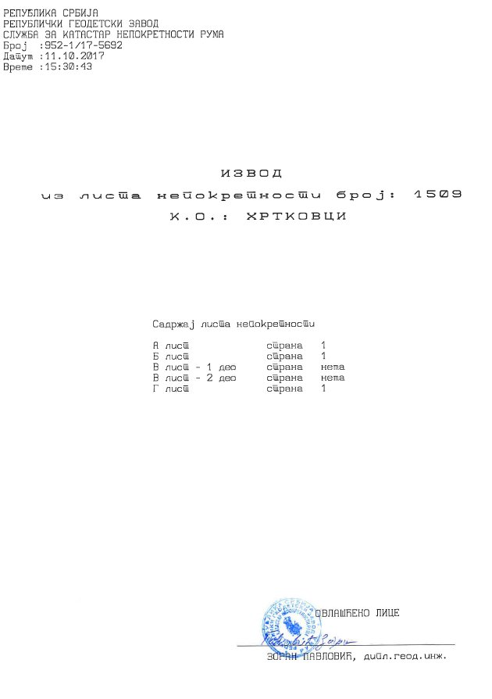

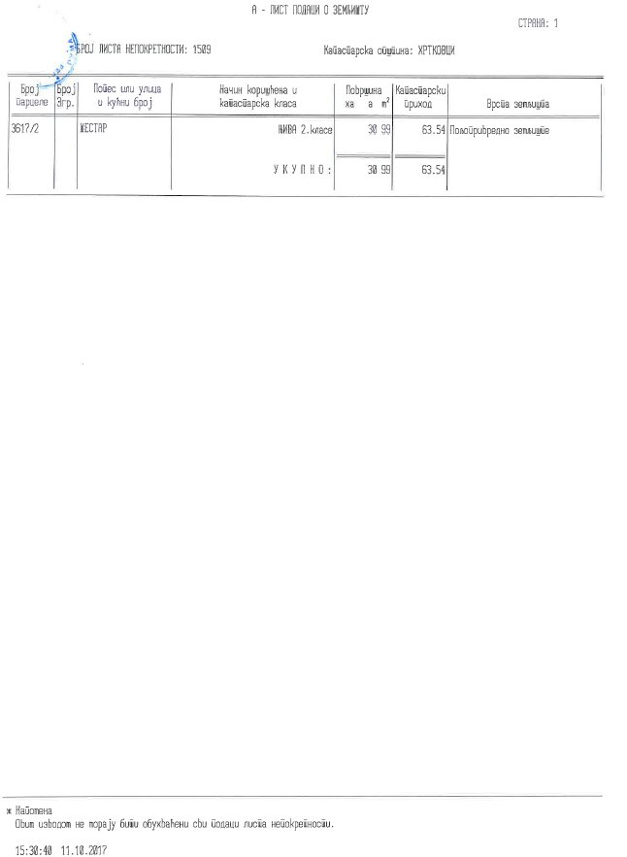

## Katastar str3.jpg

**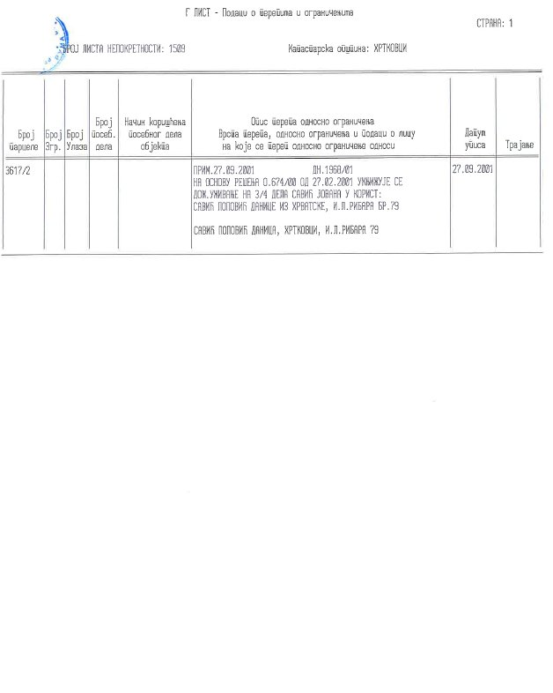**

## Annex 5 – Grievance Commission brochure

## C:\Users\n.valcic\Desktop\FERP\007 GOMOLOVO\07 GRIEVANCE COMMISSION\01 Brochure GC Gomolava eng_Page_1.jpgC:\Users\n.valcic\Desktop\FERP\007 GOMOLOVO\07 GRIEVANCE COMMISSION\01 Brochure GC Gomolava eng_Page_2.jpg

## Annex 6 – Grievance registration Form

|  |
| --- |
| SERBIA FLOODS EMERGENCY AND RECOVERY PROJECT (FERP) |
| **Component 3-Hrtkovci sub-project** |
|  |
| Reference number: |
| Full name: |
| Contact information: |
| Please mark how you wish to be contacted (mail, telephone, e-mail).   * By post: Please provide mailing address:   \_\_\_\_\_\_\_\_\_\_\_\_\_\_\_\_\_\_\_\_\_\_\_\_\_\_\_\_\_\_\_\_\_\_\_\_\_\_\_\_\_\_\_\_\_\_\_\_\_\_\_\_\_\_\_\_\_\_\_\_\_\_\_\_\_\_\_\_\_\_\_\_\_\_\_\_\_\_\_\_\_\_  \_\_\_\_\_\_\_\_\_\_\_\_\_\_\_\_\_\_\_\_\_\_\_\_\_\_\_\_\_\_\_\_\_\_\_\_\_\_\_\_\_\_\_\_\_\_\_\_\_\_\_\_\_\_\_\_\_\_\_\_\_\_\_\_\_\_\_\_\_\_\_\_\_\_\_\_\_\_\_\_\_\_   * By telephone: \_\_\_\_\_\_\_\_\_\_\_\_\_\_\_\_\_\_\_\_\_\_\_\_\_\_\_\_\_\_\_\_\_\_\_\_\_\_\_\_\_\_\_\_\_\_\_\_\_\_\_ * By e-mail: \_\_\_\_\_\_\_\_\_\_\_\_\_\_\_\_\_\_\_\_\_\_\_\_\_\_\_\_\_\_\_\_\_\_\_\_\_\_\_\_\_\_\_\_\_\_\_\_\_\_\_ |
| Description of the event giving rise to the grievance. What happened? Where did it happen? Who did it happen to? When did it happen? Main consequences of the event? Any other relevant information on the grievance |
| How do you see your case would be best resolved? |
| . .2018  Date and Place| Signature |

## Annex 7 - Signed and notarized lease agreement with owner Serbian

**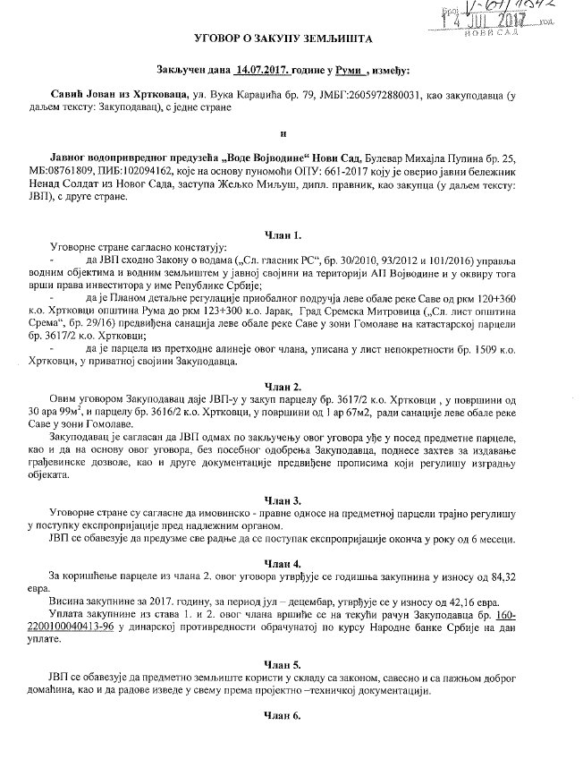**

**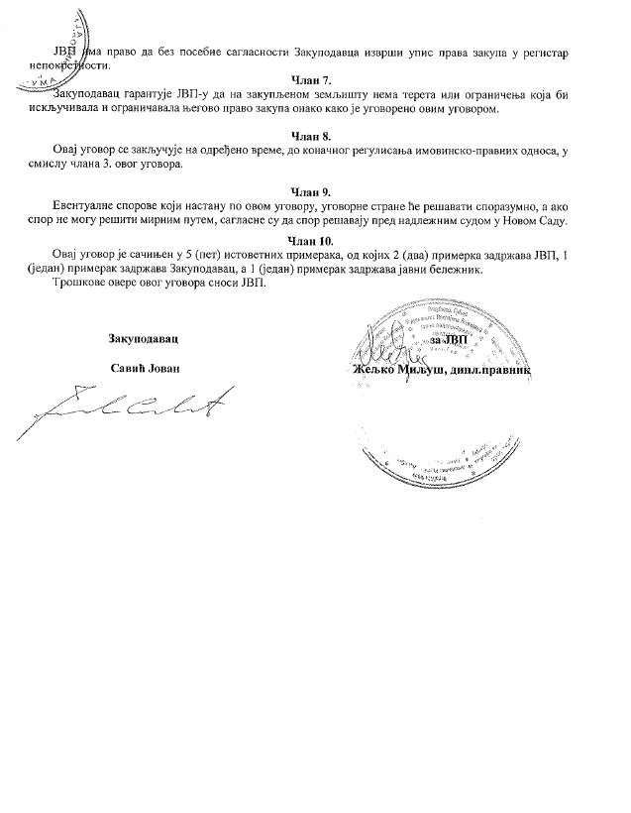**

**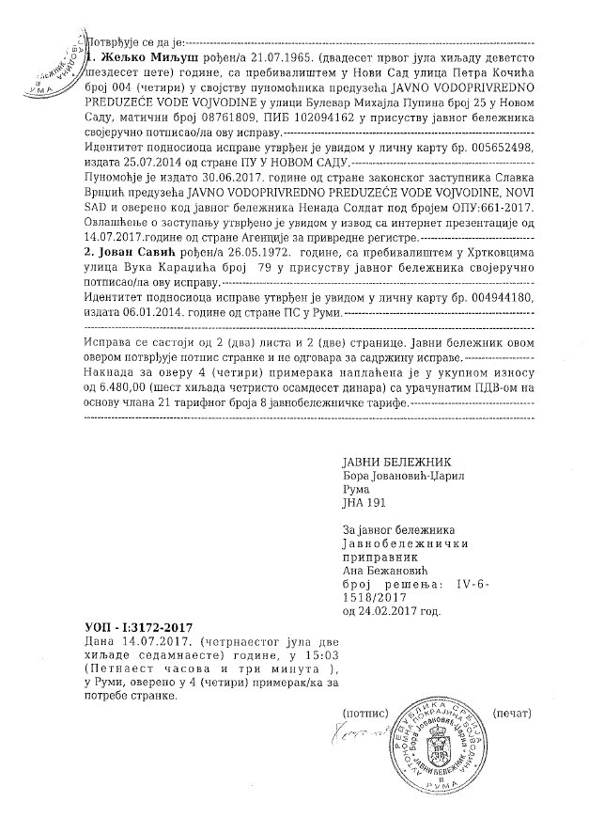**

## Annex 8 - Social screening check list

|  |  |  |  |  |  |  |  |  |
| --- | --- | --- | --- | --- | --- | --- | --- | --- |
| **SUB-PROJECT:** | | *(section name)* | | | | | | |
| **Screening team:** | | *(Names of team members performing screening)* | | | | | | |
| **Attachments:** | | *(Photos, additional docs, tables, etc.)* | | | **date:** | |  | |
| **No** | | **Item description** | | **Checked** | **Note for designer** | | **Screening comments** | |
| 1 | | Identification of section location  Start point  End point | |  |  | |  | |
| 2 | | Identification of lane width  Lane width  Lane no: | |  |  | |  | |
| 3 | | Shoulders width  Shoulders width  Shoulders condition | |  |  | |  | |
| 4 | | Identification of Settlements, and subsections with high intensity pedestrian traffic  Settlements  Type of settlements  High intensity pedestrian traffic | |  |  | |  | |
| 5 | | Identification of subsections with agricultural land next to the flood protection structure  - Agricultural area identification | |  |  | |  | |
| 6 | | Identification of subsections passing by the woods  Woods  Green areas | |  |  | |  | |
| 7 | | Identification of structures[[10]](#footnote-10)  Commercial objects (workshops, cafes, stores etc.)  Residential objects | |  |  | |  | |
| 8 | | Identification of places of great cultural heritage  Historical heritage  Cultural heritage  Nature preserved area  Weekend rest areas | |  |  | |  | |
| 11 | | Vulnerable categories needs  Access to road  Sidewalks  Cycle lane  Banquette  Underground passage | |  |  | |  | |
| 12 | | Identification of rivers  - Sources of drinking water | |  |  | |  | |
| 13 | | Identification of utilities  Electricity  Low-voltage cable  Overhead Installation | |  |  | |  | |
| 15 | | Identification of dangerous places (memorial stones and others) | |  |  | |  | |

## Annex 9 Personal invitation to survey



In accordance with the WB Operational Policy (OP 4.12)

The Ministry of Agriculture, Forestry and Water Management,

Directorate for Water Management, issues an invitation for

**PUBLIC CONSULTATIONS**

**To Mrs/Ms/Mr\_\_\_\_\_\_\_\_\_\_\_\_\_\_\_\_\_\_\_\_\_\_\_\_\_\_\_**

on

**ABBREVIATED RESETTLEMENT ACTION PLAN FOR (ARAP)**

**For Hrtkovci Flood Protection sub-project**

**Under the Serbia Floods Emergency and Recovery Project (FERP)**

**To be held on May X, 2018 at XX:XX PM (Local time ) at the XXXX**

The document subject to the consultation is made available in hard copies at the the following adresses:

* At the premises of The Ministry of Ministry of Agriculture, ForestryForestryry and Water management Directorate for Water Management, Belgrade, on the second floor, on working days from 11:00 AM to 01:00 PM (local time), within 14 days in regards to the date of public announcement of this invitation.
* the premises of Municipality of Ruma, during working hours, and on premises of local office of Hrtkovci
* on the web site of the Ministry of Agriculture, Forestry and Water management Directorate for Water Management : www.rdvode.gov.rs
* On the website of the Municipality of Ruma http://www.ruma.rs

Questions and concerns in respect to the provisions of the documents can be submitted in writing to the following address below as well as by e-mail and be submitted and stated directly during the consultation.

If you need any additional information, please contact:

|  |
| --- |
| Floods Emergency and Recovery Project (FERP)  Dr Ivana Ribara 149/11, Street  11000 Belgrade, Serbia  Tel: +381-(0)11-6163-600  E-mail: fer.project@yahoo.com |

1. Republic of Serbia, Recovery Needs Assessment, 2014 <http://www.obnova.gov.rs/uploads/useruploads/Documents/RNA-REPORT-140714.pdf>, last accessed on January 29,2018. [↑](#footnote-ref-1)
2. Disaster effects are classified under damages and losses. Damage refers to the total or partial destruction of physical assets existing in the affected area and losses refer to changes in economic flows arising from the disaster. [↑](#footnote-ref-2)
3. For copy from the real estate cadastre please see Annex 4 [↑](#footnote-ref-3)
4. These are the last available official data. The Census data from 2015 is still not published yet [↑](#footnote-ref-4)
5. See RPF for FERP, available at <http://www.rdvode.gov.rs/> accessed on January 17, 2018 [↑](#footnote-ref-5)
6. See World Bank OP 4.12 <http://web.worldbank.org/WBSITE/EXTERNAL/PROJECTS/EXTPOLICIES/EXTOPMANUAL> [↑](#footnote-ref-6)
7. Official Gazette of RS" No. 120/04, 54/07, 104/09 I 36/10 [↑](#footnote-ref-7)
8. "Official Gazette RS", No. 97/2008, 104/2009 – other law, 68/2012 – Decision of the CC 107/2012) [↑](#footnote-ref-8)
9. Only part of the Entitlement Matrix relevant for specific impacts identified under this Subcomponent has been presented. For access to full entitlement Matrix within RPF please see RPF for FERP available at <http://www.rdvode.gov.rs/>, accessed on January 17,2016 [↑](#footnote-ref-9)
10. [↑](#footnote-ref-10)