Ministry of Agriculture, Forestry and Water Management
Directorate for Water Management
11070 Belgrade,
Blvd. Umetnosti 2a

FLOODS EMERGENCY AND RECOVERY PROJECT (FERP)

ENVIRONMENTAL AND SOCIAL MANAGEMENT PLAN
for
works at pump station “Provo” at Sava River,
Provo settlement, municipality of Vladimirci

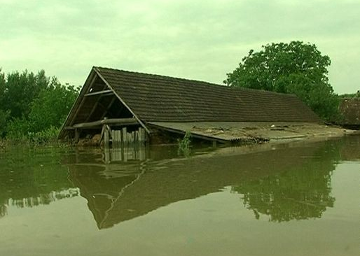

DRAFT DOCUMENT 01
B E L G R A D E, January 2019
Table of contents:

INTRODUCTION 4
1. FLOODS EMERGENCY RECOVERY PROJECT - DESCRIPTION 6
1.1. Background 6
1.2. Provo Project Description 6
1.2.1. Location description (baseline conditions) 6
1.2.1.1. Zone of works and its location in respect to natural and cultural protected areas 9
1.2.2. An overview of the Construction work on Provo sub-project 10
1.2.2.1. Brief summary of the works to be undertaken as a part of this sub-project: 10
4. LEGAL AND INSTITUTIONAL FRAMEWORK 11
4.1. Relevant Institutions 11
4.2. EIA procedure in the Republic of Serbia 11
4.3. Relevant Government Policies, Acts, Rules, Strategies and Guidelines 11
4.4. Applicable Safeguards 12
5. Potential Environmental AND SOCIAL Impacts 12
5.1. Potential environmental impacts of Provo Project 13
5.2. Potential social impacts of Provo Project 13
5.2.1. Community information and grievance mechanism 14
5.3. Other positive impacts of FERP Project 15
5.4. Potential negative Impacts and recommended Mitigation Measures 15
5.5. Potential water / wetland contamination 17
6. MITIGATION MEASURES AND ENVIRONMENTAL MONITORING ACTIVITIES 18
6.1. Mitigation Measures 18
6.1.1. General 18
6.1.2. Environmental Impacts and Respective Mitigation Measures 18
Potential air pollution - Dust 18
Potential water contamination 18
Potential contamination of soils due to pesticide usage and improper waste disposal 18
Equipment maintenance and fuelling 19
Occupational Health and Safety 19
Noise 19
6.2. Mitigation Plan for FERP Sub-Project PROVO 21
7. MONITORING ACTIVITIES 35
7.1. Monitoring Plan for FERP Sub-Projects PROVO 36
8. ENVIRONMENTAL MANAGEMENT RESPONSIBILITIES 43
8.1. Environmentally sound clauses for civil works contracts 43
9. IMPLEMENTATION ARRANGEMENTS 44
10. MONITORING AND REPORTING ARRANGEMENTS 44
10.1. FERP Project Monitoring 44
10.2. Environmental Monitoring Plans 44
10.3. Reporting Arrangements 44
10.3.1. Contractor to PIU 44
10.3.2. Project Supervision Consultant to PIU 45
10.3.3. PIU to MAFWM, WB, Semi-Annual Environmental & Social Report 45
11. PUBLIC CONSULTATIONS AND PUBLIC DISCLOSURE OF THE ESMP 45
12. REFERENCES 46

ANNEXES:
Annex 1: Relevant National Legislation as of January 2019
Annex 2: Construction Permit
Annex 3: Report on Public Disclosure and Public Consultation
Annex 4: Social Screening Form for Provo project

Abbreviations

DWM | Directorate for Water Management
DoEIA | Department of Environmental Impact Assessment within the Relevant Institution
EHS | Environmental, Health and Safety
EIA | Environmental Impact Assessment
ESMP | Environmental and Social Management Plan
ESMF | Environmental and Social Management Framework
ESSS | Environmental and Social Safeguard Specialist
FERP | Floods Emergency Recovery Project
INP | Institute for Nature Protection
MAFWM | Ministry of Agriculture, Forestry and Water Management
MEP | Ministry of Environmental Protection
PIU | Project Implementation Unit
PPE | Personal Protective Equipment
PSC | Project Supervision Consultant
PWMC | Public Water Management Company
RDNEIA | Request for decision about the need for EIA
SSIP | Site Specific Implementation Plan
WB | The World Bank Group
WMP | Waste Management Plan

INTRODUCTION

During the third week of May 2014, exceptionally heavy rains fell on Serbia. This resulted in devastating floods causing significant economic hardship for much of the population in Serbia. The heavy rainfall with no precedent started in early/mid-May 2014 causing During the third week of May 2014, exceptionally heavy rains fell on Serbia. This resulted in devastating floods causing significant economic hardship for much of the population in Serbia. The heavy rainfall with no precedent started in early/mid-May 2014 causing massive floods, destroying houses, bridges and sections of roads, resulting in the declaration of a national state of emergency on May 15, 2014 (pursuant to Article 32, Paragraph 3 of the Law on Emergency Situations, (Official Gazette of the Republic of Serbia, No. 111/2009, 92/2011 and 93/2012), across the country, which was in force until May 23rd.
The Government conducted a Recovery Needs Assessment (RNA) completed on July 10, 2014 with the objective of estimating disaster effects. The RNA was presented at a donor’s Conference convened in Brussels on July 16, 2014 in the aftermath of the natural disaster, revealing that the energy sector was the hardest hit and significant infrastructure damaged.
On October 9, 2014 the World Bank approved an Emergency Loan in the amount of $300 million to support the Government of Republic of Serbia to remedy existing damages and prevent future flooding. The Project will bring evident benefit by avoided damages of agriculture production, land, assets, households, business etc. The Loan has been restructured by Amendment to the Loan Agreement and Supplemental Letter confirmed by the Serbian counterpart on June 1, 2017. The Project is implemented by the Ministry of Agriculture, Forest and Water management namely it’s PIU. massive floods, destroying houses, bridges and sections of roads, resulting in the declaration of a national state of emergency on May 15, 2014 (pursuant to Article 32, Paragraph 3 of the Law on Emergency Situations, (Official Gazette of the Republic of Serbia, No. 111/2009, 92/2011 and 93/2012), across the country, which was in force until May 23rd.
The Government conducted a Recovery Needs Assessment (RNA) completed on July 10, 2014 with the objective of estimating disaster effects. The RNA was presented at a donor’s Conference convened in Brussels on July 16, 2014 in the aftermath of the natural disaster, revealing that the energy sector was the hardest hit and significant infrastructure damaged.
On October 9, 2014 the World Bank approved an Emergency Loan in the amount of $300 million to support the Government of Republic of Serbia to remedy existing damages and prevent future flooding. The Project will bring evident benefit by avoided damages of agriculture production, land, assets, households, business etc. The Loan has been restructured by Amendment to the Loan Agreement and Supplemental Letter confirmed by the Serbian counterpart on June 1, 2017. The Project is implemented by the Ministry of Agriculture, Forest and Water management namely it’s PIU.
This document presents the Environmental and Social Management Plan (ESMP), which has been prepared to ensure that the proposed Floods Emergency Recovery Project and associated works are implemented compliant with the World Bank Operational Policies and local legislation relate to environmental protection. The main objective of this ESMP is to provide a valuable tool for identifying possible key environmental and social impacts resulting from the project and proposing mitigation measures to address the most significant impacts. The ESMP presents the institutional and implementation responsibilities as distributed amongst the various stakeholders during project implementation.
Although no major adverse environmental issues are anticipated, and the project has been categorized as environmental Category B in according to the World bank OP/BP 4.01 on Environmental Assessment as the investments are directed on the reconstruction and replacement of existing water pumping station (WPS) with the new one exclusively, the ESMP identifies commensurate mitigation measures aimed at environment protection and maintenance of environmental conditions, mainly during execution of the civil works.

FLOODS EMERGENCY RECOVERY PROJECT - DESCRIPTION

Background

Unprecedented rainfall started in early/mid-May 2014 causing massive floods, resulting in the declaration of a national state of emergency in Serbia on May 15, 2014. The heavy rainfall, led to a rapid and substantial increase of water levels in eight of the main rivers in western, south-western, central and eastern Serbia. Flash floods destroyed houses, bridges and sections of roads, while rising water levels resulted in flooding of both urban and rural areas. The disaster resulted in 51 deaths, with approximately 32,000 people evacuated from their homes, and around 110,000 households cut off from the electricity supply. Overall, the floods affected some 1.6 million people, or about one fifth of the total population living in 49 municipalities. Adverse weather conditions have continued during next few months, causing further damage to harvest and energy infrastructure.
The Floods Emergency Recovery Project focuses on the priority sectors identified in the Recovery Needs Assessment including energy, agriculture, and flood protection. The project would help close the financing gap and ensure continued provision of electricity services, forestall a likely decline in direct support to farmers in affected areas at a time when the fiscal accounts are under severe stress and help improve resilience to disasters by financing investments in critical flood prevention infrastructure.

Provo Project Description
The subject sub-project of flood protection in the area of Provo includes Construction of the new water pumping station WPS “Provo” - replacing the existing old one.
The condition of the existing water pumping station and equipment is such that the many years of work and elapsed time make reconstruction and adaptation neither cost nor appropriate to the current technical and technological moment.
In order to ensure better response for future floods, Instead of existing WPS "Provo" it is necessary to build a new pumping station with a higher capacity: from 1000 l/s, which creates a reserve for normal conditions of exploitation, which the existing station does not have.

    - Location description (baseline conditions)

Provo sub-project is located in Macva, Municipality of Vladimirci, at the right hand side of the south bound river bank of Sava River.
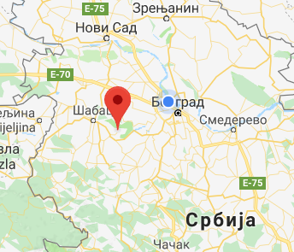
CACAK
BELGRADE
SABAC
PROVO
SMEDEREVO
Serbia
Picture 01: Project location, Provo, map of Serbia
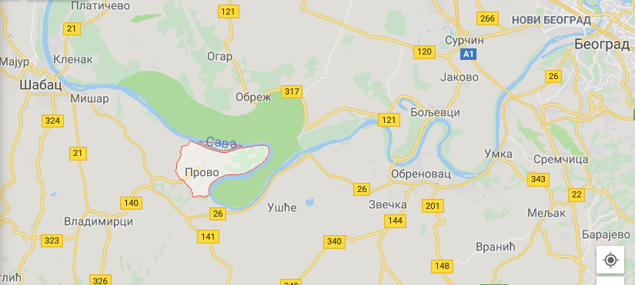
SABAC
VLADIMIRCI
PROVO
OBRENOVAC
BELGRADE
Picture 02: Project location, Provo, Vladimirci Municipality

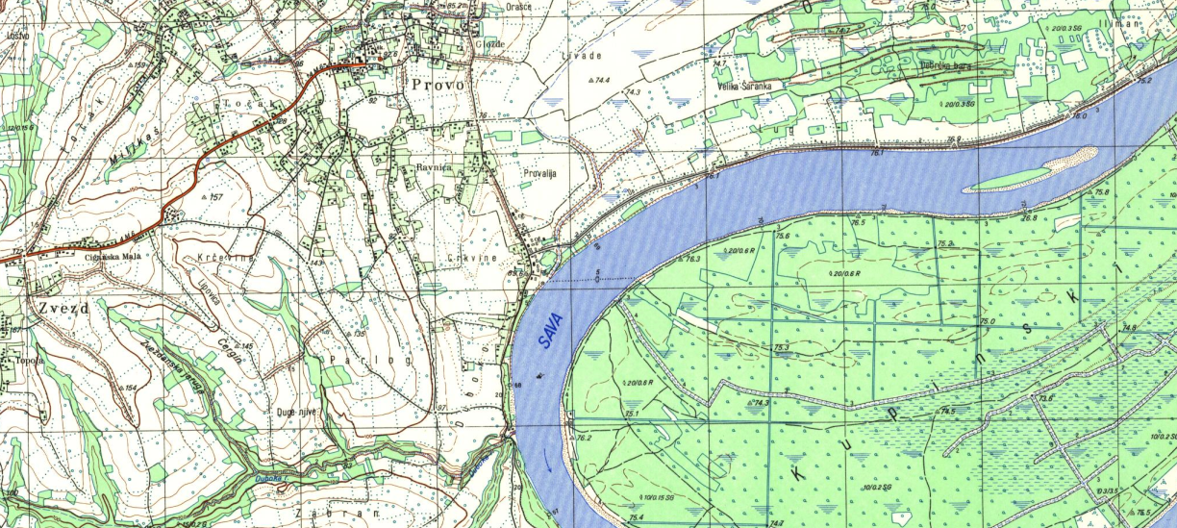
Picture 03: Project location, Provo Settlement, right bank of Sava River

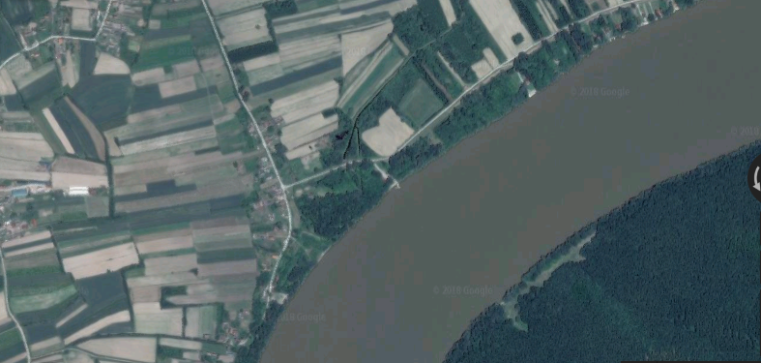
Picture 04: Project location, 150 m from the right bank of Sava River

During May's floods in 2014 this area has suffered great damage. Over 2000 ha was completely under water. There were no conditions for the permanent operation of the existing WPS because the main flow was external water and as the station itself was partially flooded.
The existing pumping station is accessed by a short and wide, paved secondary road. The road is linked with the Provo settlement. The surroundings of the pumping station are agricultural lands, mostly not cultivated. In the border of the road from Provo to the pumping station there are homes and some warehouses where families live or deal with their business. The wideness of the road is appropriate for trucks that will transport large equipment or building materials and the road has an easy access with the Provo settlement. This road is mostly without sidewalks and has a low transport intensity of motor vehicles.
Within the existing pumping station there is a mechanical building (prefabricated building made of wooden planks), which houses a 50 kW diesel engine and one propeller pump, which is outside the building (Picture 05).
Old water pumping station has no masonry facility, there is no spare generator or a place to install it, and in case of malfunction - there is no possibility of draining the excess water. Since the pumping station has been in use for 55 years and the installed equipment is obsolete, the conditions for delivery of fuel and safe storage are difficult, increased operating costs, it is necessary to project a new pumping station nearby or on the existing site.
Working with a diesel engine is not automatic and therefore require a permanent presence of the operator. The maintenance and consumption of energy are too expensive, or inappropriate for the XXI century. Security due to frequent breakdowns is also compromised. Consequently, the justification of the construction of a modern water pumping station from the associated catchment area should not be specifically proven.
At the site of the existing WPS "Provo" it is necessary to build a new pumping station with the same capacity of 500 l/s with a spare unit, which the existing station does not have.
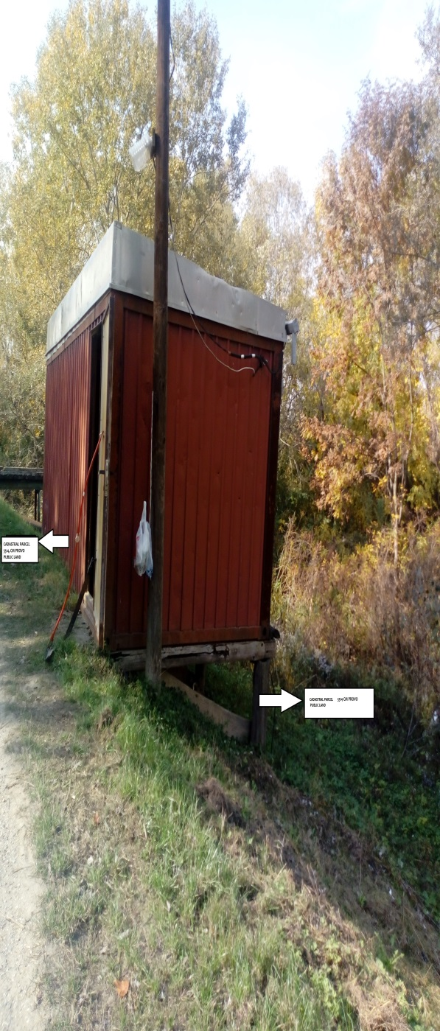 | 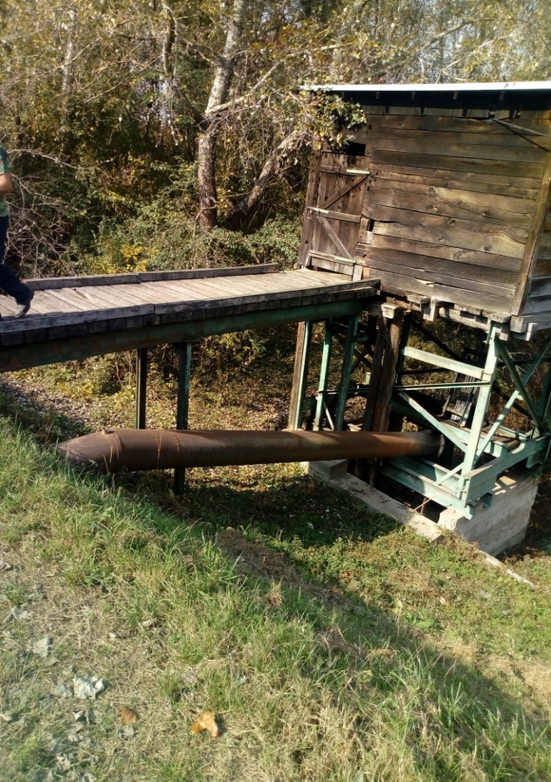
Picture 05: Existing water pumping station “Provo”

      - Zone of works and its location in respect to natural and cultural protected areas
According to the map of protected areas, and official list of nature protected areas prepared by Institute for Nature Protection of Serbia (INP), project area is not included in the ecological network, nor in the area of registered natural assets. Inside the wider area surrounding the project section there is only one protected natural asset, placed on the opposite side of Sava River (picture 06). This is a special nature reserve “Obedska pond” (orange area on picture 06). However, due to existing physical barrier (Sava River), ”Obedska bara” is completely spared from any negative project impact.
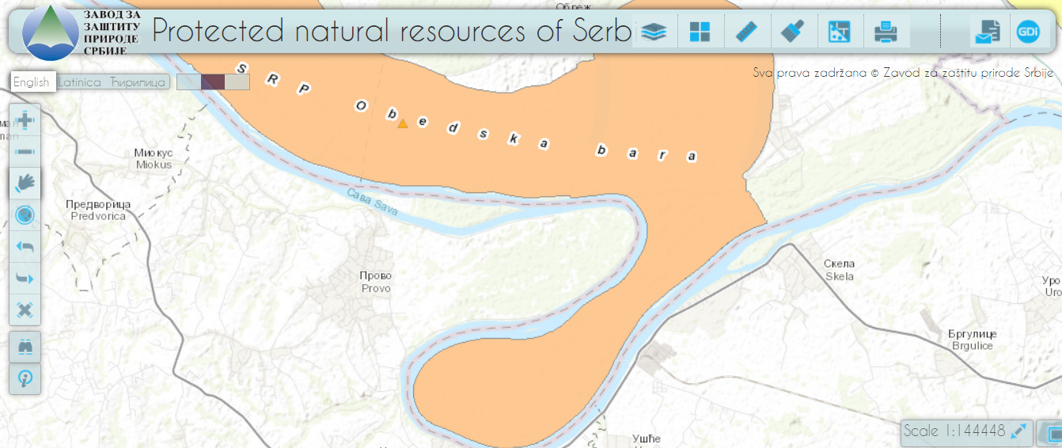
Picture 06: Location of project area in respect to protected areas
According to the another map also prepared by relevant Institution, which include all protected areas (picture 07), within the Project zone there are no registered archaeological finds or cultural monuments and there are no cultural protected areas in the close vicinity of project zone.
However, 3 previously protected areas (67-“Kljuc pond”, 68-“Saranica pond” and 69-“Gornje njive pond”) are still shown on map in the close vicinity of the project zone: All of them were recognised as nature reserve but status of protection for “Kljuc pond” and “Gornje njive pond” is cancelled by Municipality authorities during 2009. Status of protection for nature reserve “Saranica pond” is cancelled by Institute for nature protection in recent years.
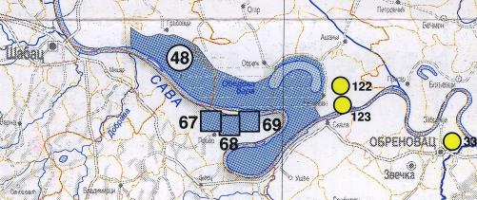
Picture 07: Location of project area in respect to protected areas

    - An overview of the Construction work on Provo sub-project
A new water pumping station “Provo” will replace the old one and will be constructed on area which dimensions are 10,50m х 4,75m + access plateau 5,75m х 2,00m + 5,75m х 1,00m+ 1,89m х 12,50m. It will have basement and ground floor, with gross area of 165,81m2, on cadastral parcel Nr. 5514 K.O. Provo, Provo settlement. All project activities will be undertaken within the Right of Way (RoW), on public land owned by PWC “Srbijavode”.
Crucial project activities are:
- Installation of new aggregates: pumps, electric motors and corresponding hydraulic equipment,
- adaptation of the building,
- power supply and
- electric motor drive.
Layout plan is presented on following picture:
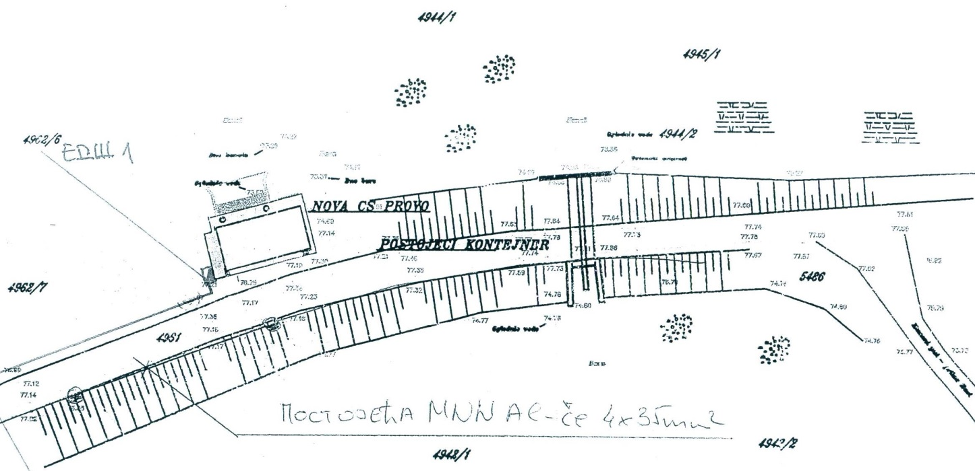
New WPS “Provo”

      - Brief summary of the works to be undertaken as a part of this sub-project:

- Construction works
  - Preparation works
Building construction site. Preparation of construction sites, installation of construction containers for the needs of temporary residence of the workers, arrangement of space near the site for the purpose of stocking materials and mechanization of accommodation and execution of infrastructure connections.
  - Earth works
  - Reinforced concrete and concrete works
  - Craft works
  - Other works

- Electrical works
- Electrical installation – purchase, transport and installation
Procurement, transport and installation of MRO cabinets for measuring electricity consumption

- Machine works
- Hydromachine equipment - purchase, transport and installation
Vertical single-stage propeller pump

LEGAL AND INSTITUTIONAL FRAMEWORK

Relevant Institutions

The Ministry of Agriculture, Forestry and Water Management (MAFWM) and the Ministry of Environmental Protection (MEP) are the key relevant institutions for environmental management including FERP related projects.
The other aspects of environmental management related to FERP projects are dealt with by several other institutions, among which are the Institute for Nature Protection of Serbia and the Institute for Protection of Cultural Monuments of the Republic of Serbia, and the Public Water Management Companies (PWMC) “Srbija Vode”, “Beograd Vode” and “Vode Vojvodine”.

EIA procedure in the Republic of Serbia

In the legal system of the Republic of Serbia, the Environmental Impact Assessment procedure is regulated by the Law on Environmental Impact Assessment, which is transposed the European EIA Directive (85/337/EEC, 97/11/EC, 2003/35/EC and COM 2009/378). According to that Law, preparation of the Environmental Impact Assessment is not required for the flood protection projects related to reconstruction of existing water pumping stations unless they are placed within or in the vicinity of the nature or culture protected areas. In such cases the Project Proponent is obliged to submit so-called “Request for Decision about Need for Environmental Impact Assessment” (RDNEIA) to the Ministry of Environmental Protection (MEP). Depending on the Ministry’s assessment of significance of potential environmental impacts of the project, it is decided if Request for opinion regarding necessity of EIA procedure for each sub-project which is found to be adjacent or within the nature/cultural protected area will be submitted to the Department of Environmental Impact Assessment within the Relevant Institution.

Relevant Government Policies, Acts, Rules, Strategies and Guidelines

Environmental protection in Republic of Serbia is regulated by several national and municipal laws and by-laws. The environmental legislation in force in Serbia is summarized in Annex 1.
The main legal documents are:
- The Constitution of Serbia (“Official Gazette of RS” No. 98/06).
- The National Strategy for Sustainable Development (“Official Gazette of RS” No. 72/09, 81/09)
- Law on Environmental Protection (“Official Gazette of RS” No. 135/04, 36/09, 72/09, 43/11, 14/16, 76/18)
- Law on Environmental Impact Assessment (“Official Gazette of RS” No. 135/04, 36/09)
- The Law on Waste Management (“Official Gazette of RS” No. 36/09, 88/10, 14/16)
- The Law on Water (“Official Gazette of RS” No. 30/10, 93/12, 101/16, 95/18)
- Law on noise protection (“Official Gazette of RS”, 36/09, 88/10)
- The Law on Occupational Safety and Health (“Official Gazette of RS” No. 101/05, 91/15, 113/17)
- Law on Planning and Construction (“Official Gazette of RS” No. 72/09, 81/09, 64/10, 24/11, 121/12, 42/13, 50/13, 98/13, 132/14, 145/14, 83/18)
- Law on Nature Protection, (“Official Gazette of RS” No. 36/09, 88/10, 91/10, 14/16)
- Agricultural Land Law, (“Official Gazette of RS” No. 62/06, 41/09, 112/15, 80/17)

Regulations established on the basis of the Law on EIA include the following:
- Decree on establishing the List of Projects for which the Impact Assessment is mandatory and the List of projects for which the EIA can be requested (“Official Gazette of RS” No. 114/08)
- Rulebook on the contents of requests for the necessity of Impact Assessment and on the contents of requests for specification of scope and contents of the EIA Study (“Official Gazette of RS” No. 69/05)

Applicable Safeguards

Safeguard Policies Triggered by the Provo Project | Yes | No
Environmental Assessment OP/BP 4.01 | X
Natural Habitats OP/BP 4.04 |  | X
Forests OP/BP 4.36 |  | X
Pest Management OP 4.09 |  | X
Physical Cultural Resources OP/BP 4.11 |  | X
Indigenous Peoples OP/BP 4.10 |  | X
Involuntary Resettlement OP/BP 4.12 |  | X
Safety of Dams OP/BP 4.37 |  | X
Projects on International Waterways OP/BP 7.50 |  | X
Projects in Disputed Areas OP/BP 7.60 |  | X

Potential Environmental AND SOCIAL Impacts

Since the existing infrastructure, facilities and equipment will be reconstructed, repaired and replaced during the realisation of the project, impacts on environment will be a consequence of human presence and construction machines, and the nature of construction works at a location, which are limited to the location of works or its surrounding vicinity.
The construction of new water pumping station in Provo would not pose significant risks to the environment. In addition, the project aim is only to improve the efficiency of flood control systems. As a consequence, the range of impacts is limited (impacts directly related to the construction activities) and their magnitude remains small (localized impacts and no significant effect on future operation). Considering the nature of the proposed project, it is anticipated that adverse environmental impacts can be expected in the construction phase mainly. The aspect of health and safety at work is also taken into consideration. It is to be noted that parts of the construction work are taking place in an urban environment, however in all parts in an environment already strongly influenced by human activities. Broadly, the impacts in the construction phase can be of the following types:
- Soil and Water Pollution: during construction activities, when using machinery, there is a possibility of soil contamination due to accidental spills of oils and fuel from construction machinery. In the area of construction works, construction waste is generated which, if not properly disposed of, may result in adverse impacts. The construction works carried out inside the river bed results in a temporary increase of turbidity of the watercourse.
- Flora and fauna: construction works in the river bed along with the temporary increase of turbidity in the watercourse threaten freshwater habitats. Impacts on other habitats are not expected.
- Disposal of excavated materials and construction wastes. Demolition debris and excessive soil are usually generated during the reconstruction works on drainage and flood control systems;
- Degradation of landscapes and soil erosion. The impacts on vegetative cover will be short-term, localized, and totally associated with reconstruction works;
- Impacts from temporary access roads and work areas. Establishment of temporary dirt roads to access work areas and temporary disposal sites for excavated materials can enhance soil erosion, and degrade the landscape;
- Noise and vibration disturbances during construction and temporary air pollution (dust) related to the transportation of construction materials and truck traffic. These impacts will occur during the construction works, but will be only short-term. Effects include dust from construction activities, noise during trench excavation, possible effect of vibration caused by operation of heavy machinery, increased traffic in some sections of roads, etc.;
- Safety hazards from construction activities. No major hazards are expected the construction of the proposed project elements, as long as proper construction practices and safety procedures are applied;
- Impacts on historic-cultural and archaeological monuments. No archaeological or cultural resources are expected to be encountered during project implementation.

Potential environmental impacts of Provo Project

In general, all negative impacts during the construction phase will be temporary and can be mitigated by applying good construction practices.

Significant negative impacts on natural environment in the operational phase are not expected. On the contrary, impacts in the operational phase are considered to be highly positive, as project aims at prevention of risks for environment, humans and civil infrastructure.

Project impacts by phases are shown in following table:
Phase | Type of impact
Construction phase | Soil compaction and erosion
 | Dust emission
 | Noise
 | Soil and water pollution.
 | Impact on aquatic ecosystem
 | Degradation of riparian vegetation caused by
 | construction work
 | Risk to people and/or animals of unfenced and
 | unlabelled construction site
 | Health and safety risk for workers on the construction
 | site due to the potential land sliding
Operational phase | Low impact on natural environment on the project
 | location
 | Positive impact in terms of prevention of risks for
 | environment, humans and property
Degree of negative impact | Minimal if mitigation measures are applied

Potential social impacts of Provo Project

Replacement of the old, existing pumping station in Provo, and Construction of the new one on same place is covered by the Project and will be carried on existing place and same cadastral parcel (KP 5514 KO Provo, Picture 08). The project neither requires land acquisition or involuntary resettlement, clearance of occupied public land, nor leads to loss of assets, access to assets or loss of livelihood or access to means of livelihood as defined by OP 4.12, nor long lasting disruptions to the natural environment and human settlements and activities.
Construction area is within the RoW, on public land owned by PWC Srbijavode. In course of preparation phase, the FERP PIU Social Specialist on October 18, 2017 had screened the Sub-Project area for social impacts through a desktop review of available documents complemented by site inspection to verify the authenticity and credibility of documents and to verify no occupation had occurred. .
The Social screening report comprises the screening form, ownership evidence and pictures from site visit. Completed Social screening form for Provo project is enclosed as Annex 04 of this ESMP document.
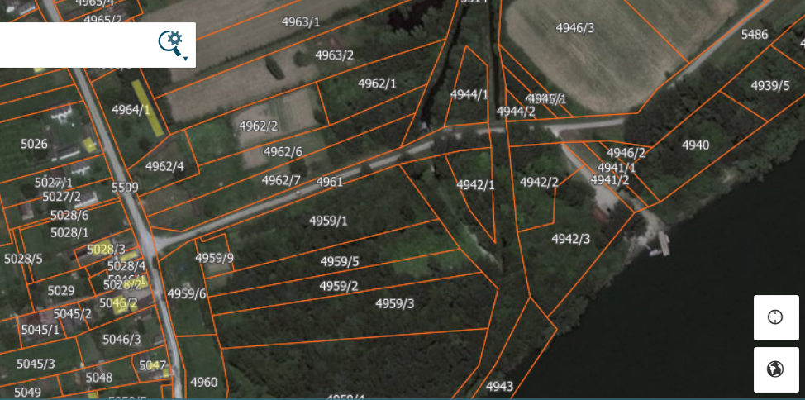
Picture 08 Project location, Provo settlement, State owned Cadastral parcel KP 5514

Construction permit is already obtained (no 351-154/14-IV/02 dated 15 Dec 2014, Annex 2), confirming that land on which a new pumping station will be constructed – cadastral parcel KP 5514 is place where a new pumping station will be constructed. Additionally, same document confirms that Location Information for subject cadastral parcel is obtained too (document Nr. 353-89/14-IV/02 dated 15.09.2014).

    - Community information and grievance mechanism

Before beginning of the works people located in close proximity of the areas will be informed about: nature of works, duration and contact information in case they have further questions or concerns.
A Sub-Project specific grievance mechanism will be available on this project. The grievance mechanism will be established by the PIU and the Municipality of Vladimirci in order to receive and address, in a timely manner, specific concerns about impacts during construction (e.g. noise, dust, vibration, etc.) and possible compensation and relocation claims that could be raised by directly or indirectly affected persons and/or members of host communities. A summary of complaints and the measures taken to resolve them will be publicly available.
The project proponent will ensure that during the project implementation phase the people who are directly affected by the project, particularly those residing in close proximity of the works receive information on ongoing basis and also have access to a contact person to voice any concerns or complaints.
Prior to commencing construction, the implementing agency should:
• Distribute a one-page information brochure to directly affected people with the following information: (i) the purpose, nature, and scale of the project; (ii) the duration of proposed project activities and working hours; (iii) any risks (e.g. landslides) to and potential impacts on such people and relevant mitigation measures; and (iv) contact information to receive further information of submit concerns or complaints.
• At the work site there should be a visible sign with the name of the project, planned duration and contact information.
Below is a brief description of the procedure and responsibilities for receiving, processing and responding to communication and complaints from the public regarding the project:
• Communications and complaints can be received directly by the contractor at the work site or by the Municipality through the contact information it provides to the public. It must be noted that the Municipality is the responsible for responding to any communication.
• Such communications are noted in a “communications log” to be maintained by the Municipality and the person sending the communication (verbally or on writing) receives an acknowledgement of receipt of his/her communication
• The communication should be processed and responded two in no more than 15 days.
• The response to the communication, and any corrective action required as a result of it, must also be registered in the “communication log”.

Other positive impacts of FERP Project

The construction of a new WPS “Provo” will bring social, health and ecological benefits, to population and local community in Provo, Vladimirci municipality. The sub-project is expected to create a short-term project depended employment opportunities as was the case on other FER Sub-projects).
In case of unemployment and poverty in the project area, manpower resources will not be reduced. If some of the unemployed are employed or if employment has impact on unemployment, the project creates social benefits due to decreased social support or aid to the unemployed. That is the case in the flood emergency response project.

Potential negative Impacts and recommended Mitigation Measures

Summary of key impacts during construction phase and recommended mitigation measures are described in following table:

Table 1: key impacts during construction phase and recommended mitigation measures
impact | significance | comment
impacts on land use/ settlements, | low | There will be no land acquisition as defined by WB OP 4.12 during the project implementation. In case of any land acquisition permanent or temporary– an Resettlement instrument shall be prepared in accordance with the RPF applicable for this Project
ground and surface water, | low | Due to low amount of drainage water that can be potentially drained into any river the consequential impact is expected to be minimal to negligible.  Also, improper disposal of excavated materials and construction wastes could adversely impact ground and surface water
air quality, | low | Temporary impact. Local air quality may experience some moderate and temporary deterioration due to dust from transportation of construction materials and truck traffic and elevated levels of nitrogen oxide (NOx) and sulphur oxide (SOx) from construction equipment exhausts. Impact can be mitigated by following GEMM procedures
flora and fauna (protected areas and species), | low | Minimal loss or damage of vegetation and loss and damage or disruption to fauna can occur during works. Impacts can be offset or mitigated by following GEMM procedures. There will be no negative impacts on protected areas due to nature of works.
noise and vibration, | low | Only limited temporary impact during the construction phase. Mitigation measures in form of noise deflecting shields will be placed where the work-scheduling activities cannot have desired effect. Impact can be mitigated by following GEMM procedures.
soil quality, | low | Soil contamination can occur from:  drainage of dredged materials, spillage of hazardous and toxic chemicals. Impact can be mitigated by following GEMM procedures
Loss of top soil | low/  negligible | Loss of top soil due to temporary access roads and work areas, Landscape degradation
waste, | low | Health hazards and environmental impacts can happen due to improper waste management practices. Impact can be mitigated by following GEMM procedures
cultural and religious issues, | no impact | There are no cultural or religious assets within the project zone. According to the INP map – no protected natural or cultural heritage exist within the project zone.
cumulative impacts etc. | medium/  moderate | Temporary, construction works may cause a slight increase of noise levels and air pollutants concentrations during the works only
Staff safety | low | Construction workers may be affected adversely due to hazardous working environments where high noise, dust, unsafe movement of machinery etc. may be present.

Table 2: Identification of Main Environmental and Social Negative Impacts
Activity | Possible expected impacts
Construction works | Indoor air pollution by dust, noises etc.  Contamination by un appropriate paints, lubricants etc.  Outdoor noises by electric generators, preparation of construction materials etc.  Outdoor air pollution by dusts during preparation of working materials and other working procedures.
Transport | Noise, dust and muddy.  Destruction of existing road.
Infrastructure | Temporary interruption of operation of pumping station  Increasing of traffic

Table 3: Identification of main risks
Activity | Possible Risks
Construction/rehabilitation works | Risk for contamination of the territory elements that can be dispersed at groundwater sources.  Risk on workers life if not respecting technical safety conditions. Risk by accidents caused by electrical power and humidity.  Risk on workers’ health in case of air pollution or other contamination by waste waters and materials to be used on contraction/rehabilitation
Transport | Risk of life of inhabitants, pedestrians and workers in the road from Pumping station to Provo.
Infrastructure | Road consummation and destruction of road pavement by passing of big transport vehicles.

Table 4: Identification of possible impacts and risks during operation phase
Activity | Possible impacts/risks
Using of un-appropriate raw materials for maintenance | Possible contamination of the territory

Possible adverse effects as a consequence of temporary construction activities shall, among other things, consist of: damages to access roads, noise, waste and dust; gaseous emissions; potential soil and water contamination; short-term disruptions to surrounding ecosystems; and momentary disruptions to neighbouring settlements through various project and operational activities.
Increasing the intensity of the road transport to the pumping station during the construction works, may increase the risk of accidents for pedestrians.
Of activities not present directly at the construction site, the following stand out: quarry and borrow pit operations which if not managed properly, may lead to temporary adverse impacts. Contractor's camp site may be a potential source of temporary adverse impacts.

Potential water / wetland contamination

During works in the vicinity of the Sava River in the Provo area, contamination of ground water may occur, as a consequence of water effluent from the construction site, spillage of fuels and oils from construction mechanization and uncontrolled flow of sanitary waters from the Construction site and the Contractor's camp.
Considering possible pollutions after works completion, they are limited to accidents only. In which case as defined by the Ministry of Interior and the Law on Water, procedures for incidental situations will be applied.
Spillage of fuels and oils may, in most cases, occur inside the Contractor's camp and on manipulative surfaces where equipment and construction mechanization are maintained and cleaned. Effluent dirty water should be treated in separators of adequate size before being discharged towards the recipient.
If any spillage occurs inside the project area, the Contractor is obligated to react by applying absorbing materials, such as absorbing carpets / linens, and/or sand, as well as remove the layer of contaminated soil and move it to an approved location, in accordance with the Law.

MITIGATION MEASURES AND ENVIRONMENTAL MONITORING ACTIVITIES

Each Sub-project of the FERP requires production of a site-specific ESMP document by the ESSS. The ESMP is an Action Plan indicating which of the Environmental Assessment report recommendations and alternatives will actually be adopted and implemented. ESMP could be produced as a part of Main Design or as a free-standing document. It will ensure incorporation of the relevant environmental factors into the overall project design and will identify linkages to other safeguard policies relating to the project.

Mitigation Measures

    - General
This section details out the potential environmental impacts by each FERP sub-projects including Provo Project.
    - Environmental Impacts and Respective Mitigation Measures

Potential air pollution - Dust
Impact - Possible sources of air pollution will be dust due to maintenance activities, movement of machinery and other sources. Construction works involve breaking up, digging, crushing, transporting, and disposal of small quantities of dry materials. Locally, the air quality may experience some moderate and temporary deterioration due to dust from construction traffic and elevated levels of nitrogen oxide (NOx) and sulphur oxide (SOx) from construction equipment exhausts. The dust may settle on vegetation, crops, structures and buildings.
Mitigation Measures - Spraying of water is the main way of controlling dust. Water is, in any case, required to be added to fill material during the construction works.

Potential water contamination
Impact - Water contamination may occur during the execution of the works from site run off, spills from the equipment maintenance areas and sanitary wastewater effluent from the work camps. As for the potential pollution during operation, these are mostly limited to accidents. In such a case, procedures for action in incidental situations, as defined by the Ministry of Interior and in the Water Law, will apply.
Mitigation Measures - Fuel and lubricant spills can occur at the Contractor’s work camp while maintaining and washing equipment and work vehicles. During the normal operations, these areas should be equipped with the adequately sized, gravity oil separator. Should spills occur, to mitigate the problem the Contractor should use absorbing materials, such as absorbent mats/fabrics, or sand and scrape off the contaminated soils and dispose them in approved facility, in accordance with the Water Law.

Potential contamination of soils due to pesticide usage and improper waste disposal
Impact - Potential contamination of soils due to increased use of pesticides during implementation of Farm Incentives Program (FERP – Component 2).
Mitigation Measures - Integrated Pest Management Approach (IPM) is mandatory during project execution. Ensuring appropriate selection and safe use of pesticides when they are needed by project demands related to safeguard OP 4.09 - Pest Management whilst avoiding the use of pesticides falling into WHO classes IA, IB or II.
Impact - Potential contamination of soils and watercourses as a result of improper disposal of liquid and solid wastes from construction activities.
Mitigation Measures - The mitigation measure to avoid contamination of soils and watercourses is to ensure that waste materials are properly disposed to the suitable locations. Partly, inert waste materials can be used as filling material.
Contractor should produce a Waste Management Plan for the Project. Mitigation measures should, among other requirement, contain contractor obligations to:
- locate the garbage pit/waste disposal site min 500 m away from the residential area so that people from Provo and surrounding settlements are not disturbed with the odour likely to be produced from anaerobic decomposition of wastes at the waste disposal places. Encompass the waste disposal place by fencing and tree plantation to prevent children to enter the area. All solid waste will be collected and removed from the work camps and disposed in approval waste disposal sites.
- In case oil and grease are trapped for reuse in a minimum 60cm thick lined pit, care shall be taken to ensure that the pit should be located at the lowest end of the site and away from the residential areas.
- In case of filling of low-lying areas with wastes, it needs to be ensured that the level matches with the surrounding areas. In this case care should be taken that these low-lying areas are not used for rainwater storage

Equipment maintenance and fuelling
Impact - equipment maintenance and fuelling may cause contamination of soils and watercourses, including groundwater, if handling of lubricants, fuels and solvents is improper or careless.
Mitigation Measures - To avoid damage to natural environment there is a need to ensure proper handling of lubricants, fuels and solvents while maintaining the equipment.

Occupational Health and Safety
Impacts - Construction workers may be affected adversely due to hazardous working environments where high noise, dust, unsafe movement of machinery etc. may be present.
Mitigation Measures - The Contractor shall instruct his workers in health and safety matters, and require from the workers to use the provided personal safety equipment. Contractor has to ensure that all operators of heavy or dangerous machinery are properly trained/certified, and also insured. He will have to provide first aid facilities, rapid availability of trained paramedical personnel, and emergency transport to nearest hospital with accident and emergency facilities.

Noise
Impact - Noise caused by the construction works will have only a temporary impact. Although temporary and mostly moderate, noise impacts in the vicinity of residential areas may cause negative health impact, if not mitigated.
Mitigation Measures - In sensitive areas (schools, nature parks, hospitals) special care regarding noise emission will be taken by the Contractor, strictly respecting the ESMP requirements. In case of noise disturbance with noise emissions which are above permitted level, temporary noise barriers should be considered as appropriate mitigation measure. Awareness building and administrative measures should be taken to ensure proper maintenance of vehicles. In case of exceeded noise limits for sensitive areas the Contractor should erect temporary shields to prevent a free noise spreading to the sensitive receptors.
Based on the preliminary assessment, key mitigation measures recommended under this Environmental and Social Management Plan (ESMP) are listed as follows:
- Identify and locate on project plans any sensitive natural resources in the project area including but not limited to patches of natural habitat, bird colonies, and wetlands, unique plant communities etc. (consult with local nature protection authorities).
- Identify local access routes through and around cultivated land and pasture.
- Minimize requirements for temporary or permanent alteration of lands outside the project zone.
- Provide for zones of preliminary accumulation of wastes that will cause no damage to the vegetation cover and other components of the environment.
- Transport and disposal of construction concrete rubbles, debris and spoils in approved paths and landfills/disposal sites.
- Delineate access roads/ work areas carefully and prevent their expansion.
- Rehabilitate access roads and work areas after work completion (scratch soil with special engine, put fertile topsoil in place, etc.).
- Use closed/covered trucks for transportation of construction materials.
- Clean the surrounding area from dust by water sprinkling, removal of excess materials and cleaning of sites upon completion of activities.
- Restoration to quasi-original conditions of landscape after completion of construction works.
- Arrange necessary preservation measures (establish protection zones, by-pass these areas during transportation and other).
- Cease the works as soon as historical and cultural monuments are encountered during earthworks and provide relevant information to the State Agency for Historical and Cultural Monuments Protection.
Conduct mid-term and end-of-project inspections to the sites during construction works.
Prior to commencement of works, the Contractors will be required to prepare and submit for approval Site-Specific Implementation Plans (SSIP) consisting of:

- Waste and wastewater management plan
- Oil and fuel storage management plan
- In-river works management plan
- Camp management plan
- Re-foresting plan
- Emergency response plan

The following table presents the Mitigation Plan is intended to serve as a checklist to ensure that relevant mitigation measures are implemented at appropriate project stages.

Mitigation Plan for FERP Sub-Project PROVO

Phase | Problem/activity impact | Mitigating measure | Institutional responsibility | Comment
PRE-CONSTRUCTION | EIA Procedure and Bid documents preparation
 | Bidding documents prepared with access to or use of the this ESMP in a translated version | No bid documents will be prepared without incorporated a (Serbian) copy of the mitigation and monitoring plan ESMP, which shall be included in the safeguard clauses of the Technical Specifications in the contracts and commitment to comply with Lender Requirements | PIU on behalf of the Investor PWMC “Srbijavode” – VPC “Sava – Dunav”
CONSTRUCTION | Material supply
 | Sand and gravel borrow pit. Disturbance of Sava River bed, water quality, ecosystem disturbance | Use existing borrow pits or buy material at licensed separations; requirement for official approval or valid operating license. | Sand and gravel Contractor or Separation  Construction Contractor | to be specified in bid documents -Conditions for selection of subcontractors for material supply
CONSTRUCTION | Material transport
 | Dust, fumes | All trucks are to be covered | Truck operator | a)-d) to be specified in bid documents-Technical Specifications for realization of works
 | Stone, Dust | wet or cover truck load | Truck operator
 | Sand and gravel,  Dust | wet or cover truck load | Truck operator
 | Dust emissions from the site may impact air quality and pose a health threat to workers and neighbours | In case of disposal of dredged or excavated materials the debris shall be kept in controlled area and sprayed with water mist to reduce debris dust  During pneumatic drilling/compaction dust shall be suppressed by ongoing water spraying and/or installing dust screen enclosures at site  The septic tank (in case of reconstruction of existing ones) installed at toilet should be enclosed in quite hermetic manner to avoid unpleasant smells.  The surrounding environment (side walks, roads) shall be kept free of debris to minimize dust  There will be no open burning of construction / waste material at the site  There will be no excessive idling of construction vehicles at sites  All materials will be supplied/transported in a manner which minimizes dust – including covered truck loads or closed off truck loads, with dust suppressing measures through water spraying | Construction Contractor
CONSTRUCTION | Construction site
 | Potential damage of cultural property during the earth works | If archaeological sites or artefacts are found during the execution of construction and other works, the Contractor is to immediately and without delay, cease the works and inform closest IPCM (Valjevo, Belgrade), as well as take necessary measures as to not destroy or damage the site and preserve it the same way as it was found. | Construction Contractor | Construction Supervision will be responsible on this project to prevent damage to cultural properties
 | Excavation works may  uncover archaeological or other significant findings | Stop all works on site in case of chance finding and notify proper authorities. | Construction Contractor | Project implementation delay
 | Potential water and soil pollution from improper material storage, management and usage | organize and cover material storage areas; isolate concrete, works from watercourse by using sealed formwork or covers; isolate wash down areas of concrete trucks and other equipment from watercourse by selecting areas for washing that are not free draining directly into watercourse | Construction Contractor
 | Water and soil pollution from improper disposal of waste materials | dispose waste material at location protected from washing out, should be marked in the site plan; if not on site, then at authorized landfill / depot | Construction Contractor
 | Water and soil pollution from improper disposal of waste materials | Storage of wastes according to international best practice (IFC EHS General Guideline). Apply additional measures for storage of hazardous wastes (such as use of secondary containment, access restriction, provision of PPE etc.) as necessary to prevent harm to construction staff, environment and public. Use and labelling of designated waste collection containers and storage areas for different kinds of wastes. | Construction Contractor
 | Potential contamination of soil and water from improper maintenance and fuelling of equipment | apply best engineering practice in safe storage and handling of lubricants, fuel and solvents by secured storage; ensure proper loading of fuel and maintenance of equipment; collect all waste and dispose to permitted waste recovery facility | Construction Contractor
 | Improper material storage and use may cause pollution of air, soil or water | Store all materials in original containers in adequate locations, which allow for leak-proof storage  Do not dispose of paint and other waste containers except through adequate handling procedures  Ensure workers are familiar with safety regulations and storage requirements for each product. | Construction Contractor
 | Water and soil pollution from improper disposal of waste materials | Transport of waste in marked vehicles designed to the type of waste to minimise the risk of release of materials (hazardous and non-hazardous materials) and windblown debris. Training of drivers in handling and disposal of their cargo and the documentation of the transport describing the nature of the waste and its degree of hazard. | Construction Contractor
 | Improper waste management may cause pollution of soil and groundwater or cause scattering by wind/animals and pose a health risk | Designated waste disposal areas will be allocated on site, including waste collection bins for smaller waste, and designated areas for bulkier waste  All waste, including construction debris and excavated materials will be regularly and timely transported off site and managed through an authorized agency or disposed of at a site that was officially designated by the local authorities – Vladimirci Municipality  Waste collection and disposal pathways and sites will be identified for all major waste types expected from demolition and construction activities.  Mineral construction and demolition wastes will be separated from general refuse, organic, liquid and chemical wastes by on-site sorting and stored in appropriate containers.  The records of waste disposal will be maintained as proof for proper management as designed.  Whenever feasible the contractor will reuse and recycle appropriate and viable materials  Removed vegetation may best be composted on site, at a designated and managed area.  All oily wastes will be separately collected, in bins which are leak- proof, and will be handled over to the authorized management and Disposal Company, receipts for which shall be kept. | Construction Contractor
 | Construction works on site may impact the quality of surface waters(small natural ponds) and subsequently ground water | The site will establish appropriate water and sediment control measures such as e.g. silt fences to prevent water sediment from moving off site and causing pollution.  Collectors will be provided to avoid surface water dispersion in case of watering of sand or gravel to control the dusts  The approach to handling sanitary wastes and wastewater from pumping station (installation or reconstruction) must be approved by the local authorities  Construction vehicles and machinery will be washed only in designated areas where runoff will not pollute natural surface water bodies, and will be adequately collected and managed  Before starting the painting activity, the bottom will be covered by plastic paper to ensure collection of colours drops in the soils. After finalization of work this plastic will be removed and disposed at places defined by local authorities. | Construction Contractor
 | Possibility of encountering an archaeological site | if an archaeological site is encountered, Contractor will immediately suspend the Works and inform IPCM | Construction Contractor (Periodical IPCM monitoring)
 | Workers safety | provide workers with safety instructions and protective equipment; safe organization of bypassing traffic | Construction Contractor
 | Community safety | regulate traffic and pedestrian circulation in instances of increased risk; put up signs visualizing construction site boundaries; | Construction Contractor
 | Contamination of territory or ground waters by using or treatment of un appropriate building materials | Prepare mixed cement etc. in isolated space. Pave with cement a surface of 20m2 in appropriate distance and into the territory of pumping station, avoiding penetration in ground layers of several building material components.  Avoid repair, refuelling or any interventions on equipment on unpaved areas with inadequate leak control trays.  Information of workers and operators in the importance of respecting the preventions to avoid possible contamination | Construction Contractor
 | The overall worker safety, and risks of unauthorized and un desired access to construction site | The inhabitants leaving close to pumping station will be notified of the works, objectives and temporary expected negative impacts through appropriate communication; public meetings, etc.  All legally required permits will be acquired for construction and/or rehabilitation. Contractor formally agrees that all work will be carried out in a safe and disciplined manner designed to minimize impacts on neighbouring residents and environment. Including organization of transport to minimize impacts on neighbourhood, and washing of vehicle tires to minimize spreading of debris on the roads.  Workers will comply with international good practice (always hardhats, as needed masks and safety glasses, harnesses etc.). Workers also will be contracted respecting Serbian legislation, and the developer should respect all hygienic and safety rules conditioned by Serbian legislation. Life insurance of workers etc. will be provided by the employer. Technical security measures will be provided by the employer.  Emergency safety kit should be placed close to the working place for intervention in case of accidents. Emergency contacts and numbers should be clearly posted on site.  In case of contact with polluted waters of channels or sediments the workers should have safety clothes.  Appropriate warning signposting of the working sites, visual barriers etc., will be used to prevent accidents. | Construction Contractor
 | Accidents during construction works may cause unintentional damage to the local infrastructure or power supply net | Ensure all adequate permits from local utilities have been obtained  Ensure familiarity with networks in the proximity of the site  In case of accidental disruption, immediately stop all works, notify proper authorities in Sabac and Vladimirovac and emergency remediation of damaged network in line with the legal requirements | Construction Contractor | Temporary delay the Project implementation
 | Use of raw materials may pose an additional stress on the natural environment | Use raw materials (sand, gravel, stone) only from suppliers that have valid licenses issued by the Relevant Institution. | Construction Contractor
 | Noise generated during works may pose a threat and risk to the workers on site, animals and neighbouring properties | Construction noise will be limited to restricted times agreed to in the permit in respect with Serbian Environmental Legislation  During operations the engine covers of generators, air compressors and other powered mechanical equipment shall be closed, and equipment placed at station territory. | Construction Contractor
 | Works done on site may  damage or permanently remove vegetation | Ensure no damage to vegetation occurs on site.  In case of unavoidable damage, re-plant same species on site.  Ensure visually the same appearance as before works started. | Construction Contractor | Temporary decrease of green cover efficiency
 | Use of heavy-duty  transport vehicles for materials on site can cause local traffic disturbances | Ensure local community is aware of any major transport requirements and disruptions to the regular traffic pattern.  Adequately manage traffic and use postings to warn others of possible congestion. | Construction Contractor | Temporary noise and dust generation
 | Improper material storage and use may cause pollution of air, soil or water | Store all materials in original containers in adequate locations, which allow for leak-proof storage  Do not dispose of paint and other waste containers except through adequate handling procedures  Ensure workers are familiar with safety regulations and storage requirements for each product. | Construction Contractor
MAINTENANCE | Construction site
 | Obligation of publishing the results of archaeological excavations | It is necessary to provide funding for storing, publishing and presenting for goods which will be discovered, archaeologically excavated and researched, documented and conserved for the sake of permanent scientific and professional presentation encompassed in an investment project | Investor PWMC “Srbijavode”
 | Possible air, water and soil pollution / dust, vehicle exhaust, fuel and lubricants spills | apply best engineering practice in safe storage and handling of lubricants, fuel and solvents by secured storage; ensure proper loading of fuel and maintenance of equipment; collect all waste and dispose in line with the Law on waste management (“Official Gazette of RS” No. 36/09, 88/10, 14/16);  Organize and cover material storage areas; selecting areas for washing that are not free draining directly or indirectly into watercourse (Sava River);  dispose waste material at location protected from washing out | Maintenance Contractor
Operation | Improper waste water management may cause contamination of ground waters | Avoid any activities that may leak hazardous constituents into the ground | Operator of pumping station and Provo / Vladimirci Municipality
Operation | Improper solid waste collection and management may pose a threat to soil and water quality | Set up proper waste management procedures, including separation of waste into oily and hazardous waste, regular municipal and green waste which can be composted  Ensure sufficient waste collection bins are available on site and that regular collection of wastes is ensured  Isolate the space of collection been and ensure frequent sanitation from authorized entities. | Operator of pumping station with local waste collection utility
Operation | Leaks and spills in station  can pollute the surface water | Have in place leak control action plan  Provide leak proof bins for collection of oily wastes or equipment which can drip oil  Ensure waste is adequately managed | Operator of pumping station and authorized company for management of such wastes
Planning/ Designing | Assure compliance with relevant construction field legislation | Acquire construction permit Provide Water management guidelines if subprojects are executed near surface watercourses. | Project applicant
Planning/ Designing | Potential damages to the existing infrastructure and facilities, especially underground installations (water supply and sewerage pipeline etc.) which cause obstacles in the provision of services to consumers. | Precisely situate the position of infrastructural facilities and underground installations at the location of works in cooperation with relevant institutions at all levels of authority. | Project applicant in cooperation with designers and representatives of relevant institutions of local authority.
Planning/ Designing | Increased possibility of employment and gaining income in the local community. | Prioritise qualified local population in employment. | Contractor | Problems should be regulated through tender documentation.
Reconstruction/ | Supply of material | Use the existing quarries and concrete bases for the supply of material.  Use licenced suppliers for other materials | Contractor | Borrow pits from which materials and concrete base are supplied must have valid environmental permits.
Reconstruction/ | Transport of material. | Using trucks with awning and special vehicles depending on the type of material. | Contractor | When transporting material, drivers must observe speed limitations
Reconstruction/ | Violation of vegetation cover | Replant or re-seed vegetation. Apply measures of good construction practice. | Contractor | Problems should be regulated through the Works execution contract.
Reconstruction/ | Emissions of dust from the landfill of earth material. due to vehicles' movement  on macadam roads and construction works execution. | Compact deposited earth material.  Sprinkle dust sources with water in order to reduce impacts on the surrounding population and vegetation. Control the speed of vehicles in order to reduce dust rising.  Prepare and implement a Plan for construction site organisation that includes good construction practices. | Contractor | Problems should be regulated through the Works execution contract.
Reconstruction/ | Emission of gases and particles from vehicles, mechanisation and generators. | Regular equipment maintenance.  The contractor is obliged to submit evidence of vehicle roadworthiness in line with the regulations on hazardous gases emission. Prepare and implement the Construction Site Organisation Plan that incorporates good construction practice measures. | Contractor | Problems should be regulated through the Works execution contract.
Reconstruction/ | Noise in the operation of heavy mechanisation and generators. | Observe law-defined working hours at the construction site.  Make the generator casings sound proof if they are located near residential units. Ensure mufflers for heavy machinery. Prepare and implement the Construction Site Organisation Plan that incorporates good construction practice measures. | Contractor | Problems should be regulated through the Works execution contract.
Reconstruction/ | Increased water turbidity as a consequence of the works. | Construction works should be executed in a way that surfaces and natural contents outside the project are not damaged and that works are performed so that watercourses are not unnecessarily made tumid and watercourses discontinued.  Works should be executed in dry weather. Prepare and implement a Construction Site Organisation | Contractor | Contractor
Reconstruction/ | Soil groundwater and surface water pollution.  with oils and lubricants  due to equipment poor maintenance and repairs and refuelling at the  Construction site. | Avoid servicing and refuelling at the site.  Use protective foils during possible vehicle refuelling and maintenance at the construction site. Provide absorbing material in case of fuel spills. Used oiled materials and agents should be managed in l line with the Waste management report. Procedure for actions in case of incidental oil and lubrication spills.  Prepare and implement the Construction Site Organisation Plan that incorporates good construction practice measures. Measures from water management documents and measures from the Waste management report. | Contractor | Problems should be regulated through the Works execution contract.
Reconstruction/ | Water and soil pollution due to inadequate disposal of communal, inert and hazardous waste. | Typical containers for solid Communal waste are placed at the construction site locations;  Acceptance of collected Communal waste and its disposal by authorised institutions;  Hazardous waste fractions (used waste oils, oiled packaging. bitumen agents waste, waste transformer oils, waste asbestos-cement pipes etc.) are separately collected into typical containers or metal barrels; they are to be consigned to entities authorised for hazardous waste management;  Re-usage and recycle of waste whenever possible.  It is prohibited to incinerate waste in the open and at the location.  Actions in line with the waste management report. | Contractor | Problems should be regulated through the Works execution contract.
Reconstruction/ | Reconstruction et  damaged brides | Avoid driving on the Sava River banks;  Ensure streambed and bank in the zone of bridges, upstream and downstream from bridges, as to ensure their protection from erosion processes. | Contractor | Problems should be regulated through the Works execution contract.
Reconstruction/ | Decommissioning and dismantling of old, existing water pumping station:  Dismantling and removing (in whole or in part) the existing structure together with salvaging,  cleaning, handling and storing of all usable or valuable parts and materials, and disposing of non-salvable  materials and debris; | The existing structure shall be dismantled and removed in a careful and workmanlike manner and the use of equipment or facilities that might damage portions of the structure to be salvaged shall not be permitted. Salvable material shall be cleaned, sorted and stored as to size and length for purposes of checking and preparing lists.  Removal and Disposal of Non-Salvable Materials:  Any debris that falls off the structures onto the underlying ground, roadway right-of-way shall be immediately cleaned up by the Contractor. The Contractor shall remove all non-salvable materials and debris from the site as soon as possible. All material shall be deemed non-salvable unless noted otherwise on the Drawings or Special Provisions. Demolition debris shall be properly disposed of at an approved location, in accordance with the applicable Regulations and Acts.  Storage of non-salvable materials and debris will not be allowed on site without the written approval of the Engineer. | Contractor  The Contractor shall submit to the Engineer, a detailed plan and schedule clearly illustrating the method and sequence by which the Contractor proposes to dismantle and remove the existing structures (in whole or in part), including a description of the measures that will be implemented to meet the environmental  requirements. | This requirements as part of ESMP document will become part of Works execution contract.
Reconstruction/ | Reduced mobility through the area where the works are executed. | Plan the relocation of equipment at times when daily traffic is not jammed; Provide alternative passage for pedestrians and vehicles in cooperation with local authorities or provide a safe passage through the construction site;  Avoid roads through inhabited areas especially near schools and hospitals; Prepare and implement the Construction Site Organisation Plan that incorporates good construction practice measures. | Contractor | Problems should be regulated through the Works execution contract.
Reconstruction/ | Potential pollution of soil and water due to the discharge of waste sanitary waters from the construction site | Installation of ecological toilettes for workers | Contractor | Problems should be regulated through the Works execution contract.
Reconstruction/ | Population at increased risks of traffic accidents and construction works to population. | Assure adequate warning signs, lighting, protective fencing etc.  Observe traffic rules.  Clean construction waste from the construction site both in the construction phase and after works completion, when closing the construction site.  Assure medical supplies and aid through institutional and administrative arrangements with municipal hospitals at the construction site.  Implement the Construction Site Organisation Plan. | Contractor | Problems should be regulated through the Works execution contract.
Reconstruction/ | Risk of injuries at work. | Demand from all workers to abide by the Protection at work measures;  Provide protective equipment;  Install warning signs at the construction site;  Prepare and implement the Construction Site Organisation Plan and Protection at work measures plan. | Contractor | Problems should be regulated through the Works execution contract.
Reconstruction/ | Construction material leftovers after the closure of temporary construction sites | All shivers and material that remain after the closure of temporary construction sites are to be removed from the location and reused/recycled where possible.  All remains are to be disposed of in a manner that will not be harmful to environment; this is to be done by companies that have permits to perform such works | Contractor | Problems should be regulated through the Works execution contract.

Summary of Potential Environmental Impacts and Mitigation Measures

POTENTIAL ENVIRONMENTAL IMPACTS | STAGE / MECHANISM |  | DURATION | SUGGESTED MITIGATION MEASURE |  | RESPONSIBILITY | TIMING
HYDROLOGY & HYDROGEOLOGY Changes to surface and ground water quantity and quality | Construction Activities |  | Construction Period | No mitigation measures required. |  | Not applicable. | -
 | Operation and Maintenance |  | Lifespan of water pumping station | No mitigation measures required. |  | Not applicable. | -
SOILS Erosion or compaction of soils | Construction Activities |  | Construction Period | • Salvage of topsoil and sod for reclamation following completion of the works. |  | Contractor & Local Water Authority | During and at completion of construction. Periodic monitoring until reclamation criteria achieved.
 | Operation and Maintenance |  | Lifespan of water pumping station | No mitigation measures required. |  | Local Water Authority | -
AQUATIC RESOURCES Disturbance of wetlands or fish habitat | Construction Activities |  | Construction Period | • Follow approved dredging practices. • Minimize disturbance to riparian wetlands. |  | (Ministry or Directorate responsible for fish management) Institute for Nature Conservation (in protected areas) | During dredging.
 | Operation and Maintenance |  | Lifespan of water pumping station | No mitigation measures required. |  | Not applicable. | -
VEGETATION Disturbance to vegetation communities, tree removal | Construction Activities |  | Construction Period | • Locate borrow pits and sand drainage areas to minimize new areas of disturbance. • Utilize existing disturbed areas whenever possible. |  | Tendering agency/ local water authority,  The Contractor,  “Srbijasume” | Detailed design (tender specification).
 | Operation and Maintenance |  | Lifespan of water pumping station | No mitigation measure required. |  | Not applicable. | -
WILDLIFE Disturbance and | Construction Activities |  | Construction Period | • Schedule construction to minimize disturbance to nesting birds. |  | Tendering agency. | Detailed design (tender specification)
dislocation from habitat | Operation and Maintenance |  | Lifespan of water pumping station | No mitigation measures required. |  | Not applicable. | -
POLLUTION Fuel spills or improper waste disposal | Construction Activities |  | Construction Period | • Equipment free from leaks and in good operating condition. • Refuel at least 15 m away from surface water. • Prompt clean-up of fuel spills. • Solid and human waste management plan for the construction site. |  | Tendering agency/ local water authority/ contractor | Construction start-up and construction period. (condition of tender)
 | Operation and Maintenance |  | Lifespan of water pumping station | No mitigation measures required. |  | Not applicable. | -

MONITORING ACTIVITIES

DWM/PIU and PSC will monitor overall environmental and social performance during project implementation.
For each of the environmental components, the monitoring plan specifies the parameters to be monitored; location of the monitoring sites and duration of monitoring. The monitoring plan also specifies the applicable standards, implementation and supervising responsibilities.
In addition to the critical locations selected during design stage, the environmental monitoring will also be done at the construction camp site and any other plant site as determined relevant during construction works stage.
World Bank guidance on the environmental aspects of project monitoring, including its health and socio-economic aspects, is provided in Environmental Assessment Sourcebook Update 14 Environmental Performance Monitoring and Supervision (June 1996).
The project’s monitoring program included surface and groundwater quality impacts, disturbance to important ecological habitats including riverside ecosystems, unscheduled environmental compliance inspections during construction, final inspection upon completion to ensure site condition is satisfactory, and assessment of sites prior to and after construction to ensure no loss of natural values.
Elements of an environmental performance-monitoring program:
Objectives
Indicators linked to project impacts and mitigation measures
Measured parameters
Institutional responsibilities, timing
Reporting arrangements
Cost and financing provisions

The following table presents the monitoring activities and responsibilities over the implementation of proposed mitigation measures, during execution of FERP sub-project Provo.

Monitoring Plan for FERP Sub-Projects PROVO

Phase | What is the parameter to be monitored? | Where the parameter should be monitored? | How the parameter should be monitored? / type of monitoring equipment | When the parameter should be monitored? (frequency of measurement or continuous) | Why the parameter should be monitored? (optional) | Institutional responsibility
 |  |  |  |  |  | Operate
CONSTRUCTION |  |  | Material transport
Stone | truck load covered or wetted | job site | supervision | unannounced inspections during work, at least once per week | and safety requirements and enable as | Supervision Contractor
Sand and gravel | truck load covered or wetted | job site | supervision | unannounced inspections during work, at least once per week | little disruption to traffic as it is possible | Supervision Contractor
Traffic management | hours and routes selected | job site | supervision | unannounced inspections during work, at least once per week |  | Supervision Contractor
CONSTRUCTION |  |  | Construction Site
Cultural goods and archaeological findings | Presence of archaeological findings in the soil | at and near the Construction site | Continuous supervision of earthworks | During earthworks. | For the sake of preservation of cultural heritage | Contractor Supervision (Monitoring).
During construction | Chance findings | On site | Through site log | Regularly through construction works | To ensure adequate management of chance findings | Contractor to implement, Supervisor to review and report on
Dust | air pollution (solid particles) | at and near job site | inspection and visual observation | unannounced inspections during material delivery and construction | health and safety requirements and enable as little disruption to traffic as it is possible | Supervision Contractor
During construction | Air and Soil quality | On construction site and surrounding areas | Visually inspect dust generation and control.  Inspect presence and if any smell is emitted from the septic tank on site. Visually inspect presence of clandestine waste on site and in surroundings.  Visually inspect for leaks of oily materials.  Keep proof of waste being collected by authorized company.  Visually inspect signs of open burning  of wastes. | Continuously during construction works | To ensure works are conducted as per the utmost safety and environmental protection standards | Contractor to implement, Supervisor to review and report on
Workers safety | protective equipment; organization of bypassing traffic | job site | inspection | Unannounced inspections during work. It is recommended to use H&S template for this purpose (next table) |  | Supervision Contractor
During construction | Notification, information of workers for the importance of environmental and hygienic protection, Worker and farmers safety and health | On construction site | Maintain a log of workers and neighbour notification, all information efforts, permits obtained, supervisor will provide regular reports on EMP compliance, worker safety, and on possible complaints  Appropriate signs will be inspected visually | Continuously during construction works | To ensure works are conducted as per the utmost safety and environmental protection standards | Contractor to implement, Supervisor to review and report on
During construction | Noise levels | On construction site and surrounding areas | Ensure compliance with permit as per Serbian law. Measurements on complaints from neighbours. | Continuously during construction works | To ensure noise levels do not exceed permissible | Contractor to implement, Supervisor to review and report on
During construction | Water Quality | On construction site and surrounding areas | Visually and upon complaints of increased turbidity, waste materials in small ponds, spills or leaks. | Continuously during construction works | To ensure there is no pollution caused to the waters | Contractor to implement, Supervisor to review and report
Before/during construction | Isolation of septic tank | On construction site | Visually or by penetration | In the reconstruction | To ensure there is not risk of contamination by waste waters | Contractor to implement, Supervisor to review and report on
During construction | Waste management | On construction site and surrounding areas | Visually for separation of wastes, review receipts from the collection company, or notification from the commune on the proper site of the disposal | Continuously during construction works | To ensure there is no risk of environmental pollution caused by construction works | Contractor to implement, Supervisor to review and report on
During construction | Damage to vegetation or other specific habitats | On construction site | Site log and visual inspection | Continuously during construction works | To ensure no damage to vegetation and specific habitats | Contractor to implement, Supervisor to review and report on
During construction | Storage of paint, oil or other hazardous materials | On site | Visually ensure proper storage, and no leaks or spills | Continuously during construction works | To minimize risks of pollution of hazardous materials | Contractor to implement, Supervisor to review and report on
OPERATION
Increased vehicle speed | condition of traffic signs; vehicle speed | Approach roads to the construction site | visual observation; speed detectors | unannounced | enable safe traffic flow | Traffic Police
Erosion, rockfall, hazardous conditions | section included in project | condition of hazard signs | visual observation | during maintenance activities |  | Contractor
During operation/  maintenance | Waste collection and management | On site- within pumping station | Visually for separation of wastes, review receipts from the collection company, or notification from the municipality on the proper site of the disposal | Continuously during construction works | To ensure there is no risk of environmental pollution from improper waste  management | Pumping station operator
During operation/  maintenance | Septic tank maintenance  – clearing and adequate disposal of wastes | On site- within pumping station | Visually, or through measuring flow. | Continuously | To ensure that no contamination occurs from waste waters | Pumping station operator
During operation/  maintenance | Respecting of worker safety measures | On site- within pumping station | Visually, and ensure compliance with plan | Continuously | No life risk for workers and operators | Pumping station operators
During operation/  maintenance | Leaks and spills in station | On site- within pumping station | Visually, and ensure compliance with plan | Continuously | To ensure no leaks of oils or other materials pollute the environment | Pumping station operator

Phase | Monitoring parameter | Location | How / equipment | When / frequency | Responsibility
Supply of material | Possession of environmental permits for plants of quarries and concrete bases from which material is supplied | Legal entities that own the plants | Insight into the documentation | During material supply | Supervision  body
Transport of material | If trucks are covered during powdered material transport | At the construction site and transport roads | Visual supervision | During material transport | Supervision  body
Reconstruction/ | Degradation and soil pollution | At the construction site and directly around the construction site | Visual supervision | Weekly | Supervision  body
Reconstruction/ | Does the construction site meet the criteria from the guidelines for good construction practice | At the construction site | Visual supervision. Insight into the documentation. | During the works execution | Supervision  body
Reconstruction/ | Occurrence of noise and air pollution | AI the works execution location | Standard air quality and noise level measurement equipment. | Upon receipt of grievances | Contractor - Company that has licence to perform environment monitoring works
Reconstruction/ | Destruction of crops, woods, meadows etc. | At the works execution location and in the vicinity | Visually | Upon receipt of grievances | Supervision  body
Reconstruction/ | Working hours control. | At the works execution location | Visually and comparison with the construction site organisation plan. | Upon receipt of grievances | Supervision  body
Reconstruction/ | Waste management during the works execution | At the cons1ruction site | Visually and by comparison with the waste management report. | Permanently | Supervision  body
Reconstruction/ | Number of registered accidents Existence of hygienic Conditions for workers, Protective equipment application | At the construction site | Visually and insight into the register | Permanently during the works execution | Contractor Supervision  body
Reconstruction/ | Impact on population due to the limitation of business activity and right to use land | Local community | Insight into the register | Upon receipt of grievances | Project applicant
Reconstruction/ | Quality of executed works Quality of material that is installed | At the construction site | Visual monitoring and through register | Permanently during the works execution and construction site removal | Supervision  body
Construction site closure | Waste remnants and soil degradation | At the project location | Visually | After the works completion | Contractor Supervision  body
Pollution of water and soil because of improper disposal of excavated materials and construction wastes | Existence of zones/sites for preliminary accumulation of wastes | At and near work site | Inspection | During construction works | Contractor, Supervisor Engineer
Loss of top soil due to temporary access roads and work areas, Landscape degradation | Clear delineation of access roads and work sites to prevent their expansion | At access roads and work sites | Inspection, Observation | During construction works | Contractor, Supervisor Engineer
 | Cleaning of access roads and work sites after construction works completion | At access roads and work sites | Inspection, Observation | After construction works | Contractor, Supervisor Engineer
 | Restoration of landscape to quasi-original condition after completion of works and after use of quarries | At work site and quarries | Unannounced Inspection | After works completion. | PIT Environmental Specialist
Temporary air pollution (dust) related to the transportation of construction materials and truck traffic | Sprinkling of water to suppress the dust | At access roads and work sites | Inspection, Observation | During construction works | Contractor, Supervisor Engineer
Noise and vibration disturbances | Termination of construction works at the established time (e.g. work on daylight hours) | At access roads and work sites | Inspection, Observation | During construction works | Contractor, Supervisor Engineer
 | Measure noise levels (Db) | At and near the work site | Inspection | During construction works | Contractor, Supervisor Engineer
Staff safety | Use of protective equipment, organization of by-passing traffic | At work site | Inspection | During construction works | Contractor, Supervisor Engineer

ENVIRONMENTAL MANAGEMENT RESPONSIBILITIES

For each potential impact the ESMP provides for:
- the proposed mitigation measure(s); and
- the parties or agencies charged with implementing those measures, separated into:
- Agencies responsible for implementation. For this specific assignment the executing agencies (e.g. contracted design institutes) shall ensure that all necessary agreements and permits (e.g. EIA conclusion, permits for water use and discharge and for the disposal of excavated materials, wastes, and demolition debris) are obtained from relevant state and local authorities before the construction works are tendered out. Construction contractors shall take the responsibility for physical implementation of mitigation measures provided under the ESMP during the construction phases according to the Bank’s policies and Serbia environmental legislation.
- Supervising agencies responsible for supervising the executing agencies to ensure that they execute the mitigation measures as planned. The Directorate of Water and Serbia Floods Emergency Recovery Project Implementation Team (PIT) will be responsible for supervising the timely, proper and reliable implementation of works and measures in the consequence provided by the ESMP. PIT will also ensure that all necessary agreements and permits are obtained by appropriate contractors from relevant state and local authorities before the construction works are tendered out. The World Bank during supervision missions may request randomly to check if such permits are issued and are valid (e.g., not expired) as well as if the ESMP mitigation and monitoring aspects are implemented on the ground during the construction phases according to the Bank’s policies and Serbia environmental legislation.
- Various Ministries give different permits. Ministry of Finance together with Ministry of Infrastructure and Ministry of Agriculture, Forestry and Water Management control License process for works. Ministry of Agriculture, Forestry and Water Management with Directorate of Water, The Public Water Resources Management Companies Srbijavode, Beogradvode and Vode Vojvodine providing preparation of water resources management technical documentation, different kind of license requested for works and supervise construction, organization and implementation of water pollution protection measures. Hydro meteorological Institute take water samples and monitoring quality of water.

Environmentally sound clauses for civil works contracts

Most construction phase impacts will be possible to mitigate by including appropriate clauses into the civil works contracts. Revisions of clauses should cover, but not limited to, the following issues:
- Compliance with general national environmental guidelines;
- Compliance with relevant World Bank Operational Policies;
- Protection of Historic-cultural monuments;
- Adequate disposal of construction and excavation wastes;
- Proper location of construction camps;
- Restoration of the quasi-original conditions of landscape in construction sites after works completion;
- Occupational Health&Safety requirements (Consultants and contractors working on the program will be required to adhere to all applicable laws and regulations controlling workplace health and safety), etc.
Construction works contracts shall absorb this ESMP with its Environmental Mitigation Plan and Environmental Monitoring Plan presented within the chapter 4 and chapter 5 ESMP as an integral part, and will be part of the Tender documents. This ESMP document will be a part of the bidding and contractual documents for which the contractor hired will be responsible to implement and to ensure that all works are completely conducted in a manner which will not generate negative impacts to the environment. The works Supervisor will ensure compliance with the EMP listed measures and provide reports on compliance.

IMPLEMENTATION ARRANGEMENTS

The Office for Reconstruction will be responsible for overseeing the overall project implementation. Project management functions and day to day operations will be the responsibility of EPS, the Directorate for Agrarian Payments (DAP) (with the support of Treasury), and the Project Implementation Unit (PIU) established under DWM.

MONITORING AND REPORTING ARRANGEMENTS

FERP Project Monitoring

The FERP project will be monitored by PIU under the DWM. Information and data collected at each of the implementation agencies will be fed into overall monitoring and evaluation (M&E). The Office for Reconstruction will oversee M&E activities regularly through the project reports, evaluate the results achieved and guide the implementing agencies on corrective management actions.
The Construction contractor is obliged to perform all monitoring activities (sampling, measurement, etc.) prescribed within the Monitoring Plan of ESMP document produced for project on which the Contractor is engaged.
Supervision Consultant is responsible to monitor all construction activities, including environmental protection during project implementation. PSC will be authorized to perform additional sampling in case he finds this needed.

Environmental Monitoring Plans

Monitoring plan for FERP projects should be in line with the bidding documents. The main components of the monitoring plans include:

- Environmental issue to be monitored and the means of verification
- Specific areas, locations and parameters to be monitored;
- Applicable standards and criteria;
- Monitoring of the procurement of materials (checks that valid permits are in place)
- Duration
- Institutional responsibilities for monitoring and supervision

Reporting Arrangements

    - Contractor to PIU
The Contractor will prepare his compliance reports in respect to ESMP and his SSIP as a Quarterly Progress Reports and submit them to PIU, in both Serbian and English language, in hard copy and electronic versions.
Construction Contractor will provide quarterly reports to PIU which document the environmental mitigation and protection measures, together with prescribed monitoring activities carried out during that quarter’s reporting period. Construction Contractor will take care of the environment quality according to the mitigation and monitoring plan which are part of ESMP.
The same applies to the Environmental Monitoring and Supervision Contractors for their part of mitigation and environmental monitoring activities.
If any kind of accident or endangerment of environment happens, reporting will be immediate. PIU and the Contractor have joint responsibility for reporting and investigating incidents. The Contractor is obliged to inform the project manager and local authorities about accident immediately after it happened.

    - Project Supervision Consultant to PIU
The findings of the regular monitoring activities, including activities specified in the Generic Monitoring Plan, carried by the Contractor will be included in the quarterly PSC progress reports.

    - PIU to MAFWM, WB, Semi-Annual Environmental & Social Report

Each Contractor is obliged to produce and deliver to the PIU a Semi-Annual Environmental and Social Report covering all project activities. PIU shall provide Semi-Annual reports to MAFWM and WB regarding the status of implementation of mitigation measures by the Contractors, additional mitigation measures that may need to be implemented, incidents of non-compliance with applicable environmental permits, complaints received from local residents, NGOs, etc. and how these were addressed. In case of fatalities or major incidents on site the PIU will immediately report to WB.
Monitoring and compliance in accordance with ESMF and site specific ESMPs, including monitoring of implementation of site-specific measures on each sub-project/section during project implementation will be undertaken by the PIU, and reported in writing to the Bank on semi-annual basis. An environmental specialist is appointed by PIU to monitor the comprehensiveness in the implementation of ESMPs.
In terms of social monitoring each Contractor shall keep records of grievances received (if any) directly and confirm they have been transmitted to the GRM. The Contractor shall keep monthly employment progress record per template to be provided by the Social Consultant of the PIU to monitor the enhancement of positive impacts of local employment created during the life of the Sub-Project.
Land acquisition shall be monitored weekly by the Social Consultant to inform the Monthly progress report which is already submitted at the end of each month to the World Bank to verify compliance with requirements set forth in the RPF, subsequent ARAP and this ESMP.

PUBLIC CONSULTATIONS AND PUBLIC DISCLOSURE OF THE ESMP

In accordance with WB OP4.01 a draft version of ESMP will be publicly disclosed at the websites of the Ministry of Agriculture, Forestry and Water Management, the Directorate of Water building and in the Provo municipality during February 2019, for a minimum period of two weeks. The invitation and the draft document shall be disclosed at the official web-sites of the Vladimirci Municipality and Local administration in Provo settlement, and the MoAEP respectively. The public consultation meeting will be held at the premises of the City administration in Vladimirci / Provo.

REFERENCES

1 Preliminary design for construction of pumping station "Provo", SZR "Branko Ivosevic", Kovin, 2014
2 Project for carrying out works at the pumping station "Provo", SZR "Branko Ivosevic", Kovin, February 2015
3 Information about the location for cadastral parcel no. 5514 К.О. Provo, no. 353-89114-T V / 02 from 15 .09.2014.
4 Layout plan kp.br. 5514 К.О. Provo, Geodetic Services Agency, “Geo Team Future", Smederevska Palanka, Vuka Karadzica 24
5 Cross-Border Program Croatia-Serbia 2007-2013, Annex 14: Protected Areas, May 2007 ( http://www.croatia-serbia.com/images/stories/OP_last_version.pdf )
6 Environmental and Social Management Framework ESMF for Rehabilitation Project of the Sava River Rehabilitation Road, AECOM, Institute for Hydrotechnics, Prism Research and Project, September 2013
http://europa.rs/upload/documents/3/cbc_hr_srb_annex2_c20076565_of_20122007_en.pdf
7 Summarized Environmental Management Plan and Environmental Specifications for Re-construction of Drinking Water pumping station in Dobrac, Center for Environmental Impact Assessment, Tirana, Albania, 2011
http://documents.worldbank.org/curated/en/367921468000880008/pdf/E14440v30Box360C00ECA0EMP0P096263v2.pdf
8 Environmental Assessment Sourcebook No 25, Environmental Management Plans, The World Bank Environment Department, January 1999
9 Project Appraisal Document, PAD1129, Serbia - Floods Emergency Recovery Project, September 2014
10 Integrated Safeguards Data Sheet, ISDSA1019, Integrated Safeguards Data Sheet (Appraisal Stage) - Floods Emergency Recovery Project - P152018, September 2014
11 Project Information Document, PIDA12087, Project Information Document (Appraisal Stage) - Floods Emergency Recovery Project - P152018, September 2014
12 Environmental and Social Management Framework, ESMF, Floods Emergency Recovery Project - P152018, February 2015
13 Resettlement Policy Framework, RPF, Floods Emergency Recovery Project - P152018, February 2015

Annex 1

LEGISLATION

MAIN SERBIAN LEGISLATION:

ANNEX 1: RELEVANT NATIONAL LEGISLATION AS OF JANUARY 2019

The main laws and regulations currently in force in Republic of Serbia which are relevant to the environmental protection during planning, design, construction and operating of this Project are listed below:

1. Law on planning and construction (“Official Gazette of RS” No. 72/2009, 81/2009, 64/2010, 24/2011, 121/2012, 42/2013, 50/2013, 98/2013, 132/2014, 145/2014, 83/2018)
2. Law on nature protection (“Official Gazette of RS”, 36/09, 88/10, 91/10, 14/16)
3. Law on environmental protection (“Official Gazette of RS” No. 135/04, 36/09, 72/09, 43/11, 14/16, 76/18)
4. Law on EIA (“Official Gazette of RS” No. 135/2004, 36/09)
5. Law on Strategic EIA (“Official Gazette of RS” No. 135/04, 88/10)
6. Law on waste management (“Official Gazette of RS”, 36/09, 88/10, 14/16)
7. Law on noise protection (“Official Gazette of RS”, 36/09, 88/10)
8. Law on water (“Official Gazette of RS”, 30/10, 93/12, 101/16, 95/18)
9. Law on forest (“Official Gazette of RS”, 30/10, 93/12, 89/15, 95/18)
10. Law on air protection (“Official Gazette of RS”, 36/09, 10/13)
11. Law on Safety and Health at Work (“Official Gazette of RS”, 101/05, 91/15, 113/17)
12. Agricultural Land Law, (“Official Gazette of RS” No. 62/06, 65/08, 41/09, 112/2015, 80/2017)

Regulations established on the basis of the Law on EIA include the following:

12. Decree on establishing the List of Projects for which the Impact Assessment is mandatory and the List of projects for which the EIA can be requested (“Official Gazette of RS” No. 114/08)
13. Rulebook on the contents of requests for the necessity of Impact Assessment and on the contents of requests for specification of scope and contents of the EIA Study (“Official Gazette of RS” No. 69/05)
14. Rulebook on the contents of the EIA Study (“Official Gazette of RS” No. 69/05)
15. Rulebook on the procedure of public inspection, presentation and public consultation about the EIA Study (“Official Gazette of RS” No. 69/05)
16. Rulebook on the work of the Technical Committee for the EIA Study (“Official Gazette of RS” No. 69/05)
17. Regulations on permitted noise level in the environment (“Official Gazette of RS” No. 72/10)
18. Decree on establishing class of water bodies (“Official Gazette of SRS” No. 5/68)
19. Regulations on dangers pollutants in waters (“Official Gazette of SRS” No. 31/82)

Other relevant Serbian legislation

20. Law on confirmation of convention on information disclosure, public involvement in process of decision making and legal protection in the environmental area (“Official Gazette of RS”, 38/09)
22. European Environment and Health Committee. Serbia. Copenhagen, WHO Regional Office for Europe, 2006 (http://www.euro.who.int/eehc/implementation/20061010_9 accessed 29 December 2009).
24. National Assembly. Law on Protection against Environmental Noise. Official Gazette of the Republic of Serbia, No. 36/09, 88/10.
25. National Assembly. Law on Waste Management. Official Gazette of the Republic of Serbia, 2009, No. 36/09.
26. National Assembly. Constitution of the Republic of Serbia. Official Gazette of the Republic of Serbia, 2006, No. 98/06.
27. National Assembly. Law on Environmental Protection. Official Gazette of the Republic of Serbia, 2004, No. 135/04.
28. National Assembly. Law on Air Protection. Official Gazette of the Republic of Serbia, 2009, No. 36/09.
29. National Assembly. Law on Management of Chemicals. Official Gazette of the Republic of Serbia, 2009, No. 36/09.
30. National Assembly. Law on Biocidal Products. Official Gazette of the Republic of Serbia, 2009, No. 36/09.
31. National Assembly. The Law on Environmental Protection. Official Gazette of the Republic of Serbia, 2009, No. 36/09.
32. National Assembly. Law on Occupational Safety and Health. Official Gazette of the Republic of Serbia, 2005, No. 101/05
33. National Assembly. Law on Environmental Impact Assessment. Official Gazette of the Republic of Serbia, 2004, No. 135/04 (http://www.basel.int/legalmatters/natleg/serbia-02e.pdf, accessed 11 January 2010).
39. Federal Assembly. Regulation on permitted level of noise in the environment. Official Gazette of the Republic of Serbia, 2010, No. 72/10.
40. National Assembly. Law on Integrated Pollution Prevention and Control. Official Gazette of the Republic of Serbia, No. 135/04 (http://www.basel.int/legalmatters/natleg/serbia-04e.pdf, accessed 11 January 2010).

Annex 2

CONSTRUCTION PERMIT

ANNEX 2: CONSTRUCTION PERMIT

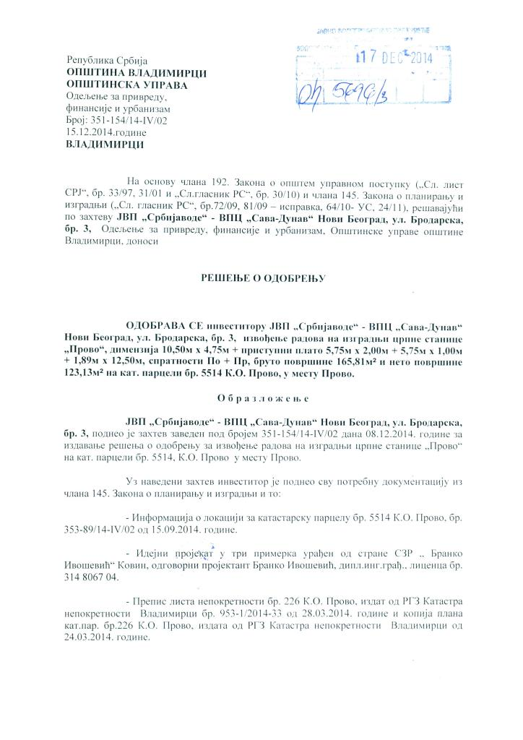

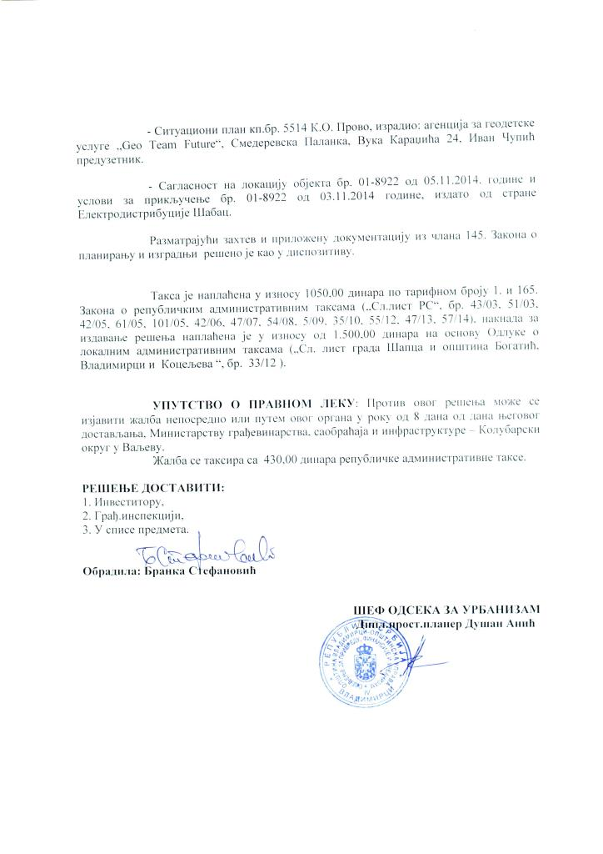

Annex 3

REPORT ON PUBLIC CONSULTATIONS

ANNEX 3: REPORT ON PUBLIC DISCLOSURE AND PUBLIC CONSULTATION

This section will be incorporated after the completion of public consultations.

Annex 4

SOCIAL SCREENING FORM FOR PROVO PROJECT

ANNEX 4: SOCIAL SCREENING FORM FOR PROVO PROJECT

SOCIAL SCREENING FORM AND TRIGGERS FOR SUB-PROJECTS
Land acquisition and access to resources
 |  | YES | NO
 | Type of activity – Will the sub-project:
1 | Require that land (public or private) be acquired (temporarily or permanently) for its development |  | √
2 | Use land that is currently occupied or regularly used for productive purposes (e.g. gardening, farming, pasture, fishing locations, forests |  | √
3 | Displace individuals, families or businesses |  | √
4 | Result in the temporary or permanent loss of crops, fruit trees or household infrastructure |  | √
5 | Result in the involuntary restriction of access by people to legally designated parks and protected areas |  | √
6 | Result in loss of livelihood |  | √
7 | Have impact to any vulnerable individuals or groups |  | √
8 | Be a government assisted resettlement |  | √
If any of the boxes attributed to the questions is ticked with the “YES”, an Abbreviated Resettlement Action Plan shall be prepared.
CERTIFICATION
We hereby certify that we have thoroughly examined all the potential adverse effects of this sub-project. To the best of our knowledge, the sub-project avoids all adverse social impacts.
Resettlement Consultant
Name: Nina Valcic
Name: Djuradj Surlan
Date: October 18, 2017

Republic of Serbia, Recovery Needs Assessment, 2014 http://www.obnova.gov.rs/uploads/useruploads/Documents/RNA-REPORT-140714.pdf, last accessed on January 29, 2018.
Disaster effects are classified under damages and losses. Damage refers to the total or partial destruction of physical assets existing in the affected area and losses refer to changes in economic flows arising from the disaster.
Republic of Serbia, Recovery Needs Assessment, 2014 http://www.obnova.gov.rs/uploads/useruploads/Documents/RNA-REPORT-140714.pdf, last accessed on January 29, 2018.
Disaster effects are classified under damages and losses. Damage refers to the total or partial destruction of physical assets existing in the affected area and losses refer to changes in economic flows arising from the disaster.
http://www.zzps.rs/novo/index.php?jezik=en&strana=zastita_prirode_zasticena_prirodna_dobra
“Kljuc pond” and “Gornje Njive pond”, which were declared protected areas in 1991, are no longer protected areas based on the official decision of the Municipal Council of Vladimirci, adopted in 2009. (Decision of the Municipal Council of Vladimirci 501-36 / 09-I, 2009 and Decision of the Municipal Council of Vladimirci 501-37 / 09-I, 2009

