Republic of Serbia
Ministry of Agriculture, Forestry
and Water Management
Ministry of Construction, Transport
and Infrastructure
Nemanjina 22-26, 11000 Belgrade

SAVA AND DRINA RIVER CORRIDORS INTEGRATED DEVELOPMENT PROGRAM (SDIP)

ENVIRONMENTAL AND SOCIAL MANAGEMENT FRAMEWORK FOR SERBIA

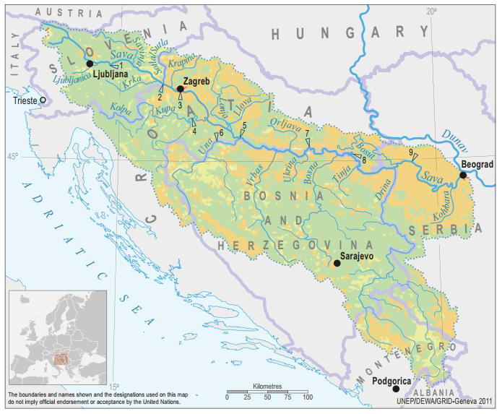

FINAL DOCUMENT
B E L G R A D E, March 2020

Table of contents

EXECUTIVE SUMMARY 8
1. INTRODUCTION 14
1.1. Context 14
1.2. Objectives of the Environmental and Social Management Framework 14
2. PROJECT DESCRIPTION 16
2.1. Program and Project Development Objective 16
2.2. Project Components 16
2.3. Project Beneficiaries 18
2.4. Contractors and Implementing Partners 18
2.5. Exclusions 18
3. ENVIRONMENTAL AND SOCIAL BASELINE 19
3.1. Baseline country and environmental information 19
3.2. Baseline information for Sava River basin 19
3.2.1. Relief and topography 19
3.2.2. Soils 20
3.2.3. Climate conditions 20
3.2.4. Sava River and its main tributaries in Serbia 20
3.2.5. Ramsar sites in Sava River Basin in Serbia 20
3.3. Nature protected areas within the Sava River basin 20
3.3.1. Obedska bara (S1) 20
3.3.2. Zasavica (S2) 21
3.3.3. Other nature protected areas within the Sava River Basin 22
3.4. Baseline information for Drina River basin 24
3.4.1. Geographic characterization 24
3.4.2. Climate and hydrology 24
3.4.3. Biodiversity 24
3.4.4. Natural resources 25
3.4.5. Demography 25
3.4.6. Cultural heritage and monuments 25
3.5. Nature protected areas within the Drina River basin 26
3.5.1. National Park Tara 27
3.6. Environmental and Social Baseline on national / state level 28
3.6.1. Water 28
3.6.2. Main environmental pressures in Sava River Basin and Drina River Basin in Serbia 28
3.6.2.1. Organic pollution 28
3.6.2.2. Nutrient pollution 29
3.6.2.3. Hazardous substances pollution 29
3.6.2.4. Hydromorphological alterations 29
3.6.2.5. Future Infrastructure projects 29
3.6.2.6. Invasive species 29
3.6.3. Climate change and Floods 30
3.6.4. Waste 31
3.6.5. Biodiversity, flora, fauna 31
3.6.6. Social baseline and background 32
4. POLICY, LEGAL AND ADMINISTRATIVE FRAMEWORK 35
4.1. Foreword 35
4.2. Reaching environmental standards in Serbia 35
4.3. Relevant Government Policies, Acts, Rules, Strategies and Guidelines 35
4.3.1. The Constitution of Serbia 35
4.3.2. The Law on Public property 35
4.3.3. The Law on foundations of property law relations 35
4.3.4. The National Strategy for Sustainable Development 36
4.3.5. Law on Water 36
4.3.6. Law on Environmental Protection 36
4.3.7. Law on Environmental Impact Assessment 36
4.3.8. The Law on Waste Management 36
4.3.9. The Law on Protection against Environmental Noise 37
4.3.10. The Law on Occupational Health and Safety 37
4.3.11. Regulation on Labor, Working Conditions and Gender equality 37
4.3.12. Planning and construction law 37
4.3.13. Building legalization law 37
4.3.14. The Law on Extra-Judicial Proceedings 38
4.3.15. The Law on Administrative procedures 38
4.3.16. The Law on State Survey and Cadastre 38
4.3.17. The Law on Expropriation 38
4.3.18. National Legal Framework guiding labor and Working Conditions 39
4.4. Relevant Institutions 39
4.4.1. The Ministry of Environmental Protection (MEP) 39
4.4.2. The Environmental Protection Agency – SEPA 40
4.4.3. The Ministry of Agriculture, Forestry and Water Management (MAFWM) 40
4.4.4. The Ministry of Construction, Transport and Infrastructure (MCTI) 40
4.4.5. The MAFWM - Water Directorate (DfWM), 40
4.4.6. Public Water management Company “Srbijavode” 41
4.4.7. The MAFWM - Forestry Directorate 41
4.4.8. Republic Hydro-Meteorological Service 41
4.4.9. Republic Geodetic Authority 41
4.4.10. Ministry of Health 41
4.4.11. The network of the institutes of public health 41
4.4.12. The Ministry of Health - Sanitary Inspection 42
4.4.13. Ministry of Finance - Customs Administration 42
4.4.14. The Institute for Nature Conservation in Serbia 42
4.4.15. Relevant Institutions on Provincial level 42
4.5. EIA procedure in the Republic of Serbia 43
5. RELEVANT WB ENVIRONMENTAL AND SOCIAL STANDARDS 44
5.1. Environmental and Social Management Framework 44
5.2. Risk Classification 44
5.3. Project Consisting of Multiple Smaller Subprojects 44
5.4. Overview of relevance Environmental and Social Standards for SDIP Project 45
5.4.1. ESS1 Assessment and Management of Environmental and Social Risks and Impacts 45
5.4.2. ESS2 Labor and Working Conditions 46
5.4.3. ESS3 Resource Efficiency and Pollution Prevention and Management 46
5.4.4. ESS4 Community Health and Safety 46
5.4.5. ESS5 Land Acquisition, Restrictions on Land Use and Involuntary Resettlement 47
5.4.7 ESS7 Indigenous Peoples/Sub-Saharan African Historically Underserved Traditional Local Communities 47
5.4.8 ESS8 Cultural Heritage 47
5.4.9 ESS9 Financial Intermediaries 47
5.4.10 ESS10 Stakeholder Engagement and Information Disclosure 47
5.5 Other Criteria and Guidelines 48
5.6 Comparison between ESF objectives and national requirements 49
6 LABOR MANAGEMENT PROCEDURES 53
6.1 Overview of labor use on the project 53
6.2 Grievance Mechanism for Workers 53
6.3 Third party’s management 54
6.4 Community workers 55
6.5 Primary supply workers 55
7 POTENTIAL ENVIRONMENTAL AND SOCIAL IMPACTS AND RISKS 56
7.1 Environmental and Social Impacts during Project implementation 57
7.1.1 Land acquisition, Restriction on land use and involuntary resettlement 57
7.1.2 The primary labor risk is the risk of informal work. 57
7.1.3 Pollution of soil and agricultural land 58
7.1.4 Water pollution 58
7.1.5 Waste 58
7.1.6 Oil Spills 59
7.1.7 Air 59
7.1.8 Noise levels 59
7.1.9 Flora and fauna 59
7.1.10 Impacts on habitats and biodiversity 59
7.1.11 Impacts on settlements and population 59
7.1.12 Impacts on cultural and historic heritage 59
7.1.13 Impacts on climate 60
7.2 Potential Negative Impacts and Recommended Mitigation Measures 60
8 ENVIRONMENTAL AND SOCIAL RISK MANAGEMENT 63
8.1 Risk classification according to the WB ESMF 63
8.2 World Bank Environmental and Social risk management 63
8.2.1 ESS 1 - Assessment and Management of Environmental and Social Risks and Impacts 63
8.2.2 ESS 2 – Labor and Working Conditions 64
8.2.3 ESS 3 – Recourse and Efficiency, Pollution Prevention and Management 64
8.2.4 ESS 4 – Community Health and Safety (CHS) 65
8.2.5 ESS 5 – Land Acquisition, Restrictions on Land Use, and Involuntary Resettlement 65
8.2.6 ESS 6 – Biodiversity Conservation and Sustainable Management of Living Natural Resources. 66
8.2.7 ESS7 Indigenous Peoples/Sub-Saharan African Historically Underserved Traditional Local Communities 66
8.2.8 ESS 8 – Cultural Heritage 66
8.2.9 ESS9 Financial Intermediaries 67
8.2.10 ESS 10 – Stakeholder Engagement and Information Disclosure 67
8.2.11 OP 7.50 – Projects on international waterways 67
8.3 Projects Consisting of Multiple Smaller Subprojects 68
8.4 Environmental and Social Screening and Project Approval 68
8.4.1 Environmental and Social Screening Process (Step-by-Step} 68
8.4.2 Environmental and Social Screening Checklists 69
8.7 Mitigation measures and environmental monitoring activities 72
8.7.1 Standardized Environmental and Social Management Plans (ESMP) 72
8.7.2 Disclosure and Public Consultations on ESMP document 73
8.7.3 Generic ESMP 73
8.7.4 Integration of the ESMPs into project documents 73
8.7.5 Monitoring and Reporting 73
9 ESMF IMPLEMENTATION ARRANGEMENTS 81
9.1 ESMF Process Flow at the Project Level 81
9.2 Results Monitoring and Evaluation Arrangements 82
9.3 Sustainability 82
9.4 Contractor’s Responsibility regarding environmental protection 82
9.5 Hiring Requirements - PMU’s Environmental & Social Safeguard Consultant 83
9.6 Project Supervision Consultants 83
10 PROJECT GRIEVANCE MANAGEMENT 85
10.1 Raising grievances 85
10.2 Grievances administration 85
10.3 Grievance and beneficiary feedback reporting 86
10.3.1 Grievance Log 86
10.3.2 Grievance admission channels 86
10.3.3 Monitoring and Reporting on Grievances 87
10.4 World Bank Grievance Redress System 87
11 STAKEHOLDER ENGAGEMENT 88
12 STAKEHOLDER CONSULTATIONS 88
REFERENCES: 88

ANNEX 01: PROJECT ACTIVITIES 89
ANNEX 02: DETAILED MPA PROGRAM FRAMRWORK FOR THE SDIP PROGRAM 90
ANNEX 03: EXCLUSION LIST OF PROJECT / ACTIVITIES 92
ANNEX 04: ESQ - ENVIRONMENTAL SCREENING QUESTIONNAIRE - TEMPLATE 93
ANNEX 05 LIST I – PROJECTS REQUIRING A MANDATORY ENVIRONMENTAL IMPACT ASSESSMENT 96
ANNEX 06 LIST II – PROJECTS FOR WHICH AN IMPACT ASSESSMENT MAY BE REQUIRED 99
ANNEX 07: RELEVANT NATIONAL LEGISLATION AS OF OCTOBER 2019 106
ANNEX 08 FORMAT FOR REPORT ON COMPLIANCE WITH CONDITIONS OF WORK WITH ESS2 108
ANNEX 09 STATEMENT OF LEGAL AND REGULATORY COMPLIANCE 110
ANNEX 10 SAMPLE MITIGATION PLAN AND MONITORING PLAN FOR ESMP 111
ANNEX 10A MITIGATION PLAN 111
ANNEX 10B MONITORING PLAN 111
ANNEX 11: SAMPLE FILLED OUT ESMP – MITIGATION PLAN 112
ANNEX 12: SAMPLE FILLED OUT ESMP – MONITORING PLAN 124
ANNEX 14: Sample ES Questionnaire to be used for regular reporting to PMU and WB 133
ANNEX 15: REPORT ON PUBLIC DISCLOSURE AND PUBLIC CONSULTATION ON ESMF 138
ANNEX 16: COMPLIANCE REPORT 153
ANNEX 17: Summary of potential land acquisition impacts stemming from development of Component 1.3 155

Abbreviations
a.s.l. | Above sea level
BOD | Biological Oxygen Demand
DfWM | Directorate for Water Management
DRB | Drina River Basin
E&S | Environmental and Social
EEA | European Environmental Agency
ESIA | Environmental and Social Impact Assessment
EHSG | World Bank Group Environmental, Health and Safety Guidelines
ESCP | Environmental and Social Commitment Plan
ESF | Environmental and Social Framework
ESMF | Environmental and Social Management Framework
ESMAP | Energy Sector Management Assistance Program
ESMP | Environmental and Social Management Plan
ESSs | Environmental and Social Standards
MoEP | Ministry of Environment Protection
ICPDR | The International Commission for the Protection of the Danube River
ISRBC | International Sava River Basin Commission
LMP | Labor Management Procedure
OP | Operational Procedure
O&M | Operation and Maintenance
PE | Population Equivalent
PMU | Project Management Unit
RoS | Republic of Serbia
RP | Resettlement Plan
RPF | Resettlement Policy Framework
SRB | Sava River Basin
MAFWM | Ministry of Agriculture, Forestry and Water Management
MCTI | Ministry of Construction, Transport and Infrastructure
SDIP | Sava-Drina River Corridor Integrated Development Program
SEP | Stakeholder Engagement Plan

EXECUTIVE SUMMARY

Project background. The World Bank (WB) as a trusted partner aims to provide financing through a multiphase program approach to the Government of Serbia (GoS) for the implementation of the Serbian part of the first phase of the Sava and Drina river corridors integrated development program (hereinafter referred to as: The Project). The Development Objective of the Sava Drina River Corridors Integrated Development Project (Phase I of the Program) is to improve flood protection, and transboundary water resources management in selected catchment areas of the Sava and Drina river corridors and aims to promote regional economic integration and EU accession within a challenging political environment. The Project is aligned with Serbia CPF 2016-2020 and with the World Bank’s twin goals (reduction of poverty and promotion of shared prosperity), with the priorities set out by the national government and with EU policy goals for the region.
The project is designed as an Investment Project Financing (IPF) and as such needs to comply with the World Bank’s Environmental and Social Framework (2016) (ESF) comprising, inter alia, the Environmental and Social Standards (ESS). In response to the commitment of the GOS to comply with the ESF, the Ministry of Agriculture, Forestry and Water Management (MAFWM) and Ministry of Construction, Transport and Infrastructure (MCTI) have developed this ESMF.
Context. Devastating floods occurred in the Sava and Drina catchments, most recently occurring in 2010 and 2014. The 2014 Sava flood—the largest flood in a century—caused 79 casualties and a damage of €1.5 billion in Serbia (4.7% of GDP), €2.0 billion in Bosnia and Herzegovina (15% of GDP) and €300 million in Croatia （0.5% of GDP）. In 2010 the Drina was flooded extensively—partly due to spilling hydropower reservoirs—and saw its highest levels in 100 years. The trends and changes in mean values of precipitation, evapotranspiration, and discharges in this basin indicate that climate change is expected to cause more intense flood and drought episodes, both in terms of scope and duration.
The hydraulic infrastructure in the Sava and Drina River Basin, while nominally extensive, has been poorly maintained and only partially modernized and expanded since the Balkans War of the 1990s and the breakup of Yugoslavia, hampering regional economic integration and suppressing growth. The 2014 floods have shown the importance of improved management and protection of its existing infrastructure.
Development Objectives. The Higher-level Objective of the Sava and Drina River Corridors Integrated Development Program (SDIP) is to facilitate integrated transboundary water resources management and development along the Sava and Drina River Corridors.
The Development Objective of the Sava Drina River Corridors Integrated Development Project (Phase 1 of the Program) is to improve flood protection, and transboundary water resources management in selected catchment areas of the Sava and Drina river corridors. The impact of project interventions will be tracked through key results indicators that will include the following:
- Flood risks reduced
- Number of people, male and female, benefiting from enhanced flood protection measures
- Flood Early Warning system operational and provides timely and accurate information
- Strengthened institutions and instruments for transboundary water management
- River basin management plan developed and agreed among member countries
- Integrated data management system operational and provides information for decision making
- Platform for transboundary collaboration established /operational
This project will implement subprojects with high implementation readiness and relevance to the program objectives, with detail designs and tender documents likely ready by Effectiveness, while simultaneously preparing subprojects that will be implemented during the second phase of the Regional Program.
Relevant ESF instruments will be developed during preparation of each subproject and will focus on ESIA/ESMP and RP, while the Project level ESF instruments, ready at Project Appraisal i.e. the RPF, ESMF, SEP, LMP shall apply and guide the development of each site specific instrument.
Phase I (this project) activities have been identified and prepared through ongoing Bank interventions in the region as well as other initiatives financed by national resources and other financiers. This project is intended as a trust-building and learning process with activities of limited complexity and interdependency. Preparation for Phase II will cover additional transformational, multi-purpose projects. Subprojects will be implemented at national level and will have cumulative regional benefits.
Project Components. The Project will be implemented through four components and sub-components:
Component 1: Integrated Management and Development of the Sava River Corridor
This component will finance investments in renovation and upgrading of flood protection infrastructures to address the increasing risk of flooding due to climate change. These activities will reduce the risk and impact of floods, thereby increasing the resilience of the riparian countries to these climate change-related threats. The component will also finance activities needed to enable improved navigation. Requested GEF funding will support the prioritization and preparation of some activities.
Sub-component 1.1: Flood protection and environmental management. This sub-component will finance construction and rehabilitation of embankments at selected priority areas along the Sava River Corridor as well as nature-based solutions to re-vitalize selected protected areas of ecological significance to the Western Balkans. For example, this sub-component will finance reconstruction of Kolubara dykes that will protect Obrenovac City in Serbia, dykes in Novi Beograd that will protect Belgrade City from flood hazards, and reforestation in Vrbanja, Vrbas and the Sava River basin in BiH, which will mitigate the threat of droughts. Upgraded flood protection capacity (at or above 1 in 100-year event) also enhance climate adaptation capacity of protected areas.
Sub-component 1.2: Waterway Improvements. Under this sub-component, grant financing will be mobilized to finance demining activities along the Sava’s right bank within BiH, as a pre-requisite to the execution of civil works—planned for Phase II of the program—to increase the navigational capacity of the Sava river. The preparatory documentation for these Phase II works (engineering designs, environmental and social safeguards instruments, expected climate change impacts on navigability, bidding documents) will also be finalized during the project. The project-supported demining efforts are also an operational pre-requisite to the planned improvements to Sava river ports under Phase II. Demining activities are proposed as a no-regret investment that will help unlock the river’s economic potential for generations to come.
Demining of the right bank of the Sava river in BiH will be conducted following the Standard Operating Procedures (SOP) for humanitarian demining developed and adopted by the Bosnia and Herzegovina Mine Action Center (BiHMAC). These country-specific procedures are based on the principles of the International Mine Action Standards (IMAS) endorsed by the UN Inter-Agency Coordination Group on Mine Action. They comprise, inter alia, the actions of general surveying, technical surveying, equipment pre-testing and testing, professional supervision of demining operations, systematic surveying, and integrated planning. The BiH State Ministry of Communications and Transport will be the lead implementing agency for demining, with BiHMAC participating as technical lead, with the collaboration of the respective Entity level Ministry of Transport and Brcko District Government. BiHMAC has already produced detailed engineering designs for the demining activities, which will be updated as needed prior to commencement of civil works. The demining civil works will be conducted by one or more experienced contractors to be competitively selected during implementation in accordance with the World Bank Procurement Framework. In addition, expert supervision services will be provided for the duration of the works, to ensure SOP and IMAS compliance. Completion of demining of the right bank of the Sava is consistent with the goals of the BiH Council of Ministers Mine Action Strategy 2018-2025, and it will contribute to the attainment of international obligations to which BiH is a signatory, most notably including the Mine Ban Convention, which BiH ratified in September 1998. Sub-component 1.3: Enhancement of ports facilities, services and logistics. The project will finance cargo handling capacity expansion, equipment modernization, multimodal links, and navigation channel improvements at the port of Sremska Mitrovica, to allow for the handling of up to 1.5 million tons of dry bulk, liquid bulk, and general cargo—including containers. The subproject will provide direct road and rail connections between the port and an adjacent inland rail intermodal terminal, thus promoting the use of combined transport with lower-emission, lower-cost modes like rail freight and inland waterway transport. It is expected that this intervention will improve the connectivity and market access of the immediate hinterland of the port of Sremska Mitrovica: the Srem and Macva districts primarily, as well as other parts of northwest and central Serbia. It will also contribute to improvements in logistics service delivery in the Sava corridor, including the facilitation of container transportation and handling, which are expected to result in greater tonnage capture by the port.

Component 2: Integrated Management and Development of the Drina River Corridor
This component will support multipurpose investments along the Drina to reduce the risk and potential impact of floods. It may also support preparatory interventions that will optimize reservoir operation and protect environmental assets of global value to be implemented in Phase II. This component will facilitate the implementation of actions, management measures and investments identified by the Drina Strategic Action Plan being prepared under the ongoing Western Balkans GEF-SCCF Drina River Basin Management Project and investments identified through the ESMAP Integrated Water and Hydropower Development Project. The above measures will contribute to increased resilience of the riparian countries to floods and droughts. Requested GEF funding will support the prioritization and preparation of these activities.
Sub-component 2.1: Flood protection and environmental management. This sub-component will finance infrastructure works (for example, flood protection in Gorazde City, FBiH), studies, surveys, consultations and preparation of detailed design of interventions related to the management of environmental assets (the protection of local ecosystems that act as carbon sinks) along the Drina Corridor. The on-going GEF-SCCF-financed Drina River Basin Management project as well as the ESMAP technical assistance, are conducting studies that will identify the additional actions needed for flood protection, bank stabilization, drainage and river training works, and reservoir management in the Drina Corridor. Upgraded flood protection capacity (at or above 1 in 100-year event) also enhance climate adaptation capacity of protected areas.
Sub-component 2.2: Integrated development of lower Lim watershed. This sub-component will finance improved watershed management in the Lim and Grncar River basins of Montenegro, as well as works related to flood protection, drainage and irrigation measures within the Lim River Basin (a tributary of the Drina River) to mitigate flood risks and promote sustainable use of natural resources. These measures include: river bank stabilization; river training works; flood protection embankments and dykes. The detailed designs of these investments are under preparation through the ongoing GEF-SCCF project. This sub-component will further finance the preparation of selected priority investments in line with the project development objective.

Component 3: Project preparation and management

This component will support: 1) preparation of Phase II regional activities; and 2) operational costs, consultancies, non-consultancy services, and goods required for the establishment and operation of the Regional Implementation Unit and national PMUs.
Sub-component 3.1: Project preparation. This sub-component will either finance or provide technical support for the preparation of project documentation for Phase II of the program, including environmental and social safeguard assessments.
Sub-component 3.2: Institutional strengthening and project management. This sub-component will finance activities to increase institutional capacity and inter-sectoral coordination in the participating countries to ensure more efficient in river basin management and flood risk management among riparian countries, thus enhance the decision making and program management at regional level. This sub-component will promote joint action and decision making climate adaptation capacity of the region.

Component 4: Regional activities
This component will support policy dialogue, consultations, preparation of plans and studies, and investments to strengthen the nexus between water services and connectivity with the regional development and economic cooperation objectives of the Sava and Drina Corridor. Examples include the Sava River Basin Management Plan and Hydrological assessments, Climate Change Adaptation Strategy for the Sava River Basin, planning and development of tourism in the Sava and Drina Rivers corridors including the designing of Master Plans for Nautical tourism and Ecotourism. River Basin Management Plans and Hydrological assessments will ultimately support integrated water resources management, thereby indirectly increasing the resilience of riparian countries to climate change; requested GEF funding will co-finance measures related to river basin planning and management, flood monitoring network, institutional capacity building, and studies that inform or prepare future investments.
Project Beneficiaries. Beneficiaries of Phase I include but are not limited to residents and businesses located within the flood prone areas along the Sava and Drina river corridors, and transport service providers. Government agencies across water, transport, energy, emergency response, and environmental sectors will benefit from improved information from regional studies and planning. In addition, aggregated effects from national level activities could benefit the broader river basins and region in terms of reduced flood risk exposure, new employment and business opportunities, and more cross-sector, cross-national coordination for integrated water resources management and development.
Project Duration. The financing instrument of the proposed Project is realized though Investment Project Financing. The program will be implemented over a period of 10 years, organized in two Phases. Phase I will focus on flood protection and river basin management activities in the Sava and Drina River Corridors. It will start with Brcko District (BiH), Serbia and Montenegro while other entities and countries can join as they become ready. Phase II will build on Phase I and strengthen river port connectivity and environmental management.
Purpose of the Environmental and Social Management Framework (ESMF). The project includes a number of subprojects that have not been identified at appraisal, which is why the Framework approach is deemed adequate. The ESMF provides guidance and procedures for managing potential environmental and social risks and impacts of unknown subprojects, guidance on how negative impacts will be avoided, minimized or mitigated. Through the ESMF screening procedures, once identified, subprojects will be assessed from environmental and social point of view to meet the WB’s applicable Standards, as well as any applicable Environmental and Social Law and Regulations of the Republic of Serbia for adequate mitigation of any residual and/or unavoidable impacts. The Framework serves as a guidance tool for the PMUs which will be established (one within the MCTI for subproject 1.3.1. “Expansion and modernization of port of Sremska Mitrovica” and the other in the Directorate for Water Management (DfWM) of the MAFWM for other subprojects), the implementing agencies, and any other stakeholder relevant to risk management, in identifying and assessing the potential environmental and social impacts of subprojects and ensuring necessary mitigation measures are implemented to minimize or prevent any adverse environment and social impacts. The Framework will also serve as guidance on environmental and social monitoring and reporting.
All subprojects to be financed under the Program would be subject to assessment of environmental and social risks by MAFWM’s Project Management Unit (PMU), except the subproject 1.3.1. “Expansion and modernization of port of Sremska Mitrovica” where subject assessment will be performed by MCTI’s PMU, following the procedures described in this Framework. For “high” risk subprojects an Environmental and Social Impact Assessment (ESIA) will be carried while for “substantial”, “moderate” and “low” risk subprojects the assessment will be carried out in line with the Serbian environmental laws (respective of the subproject location) and will include preparation of a site-specific Environmental and Social Management Plan, all in line with this ESMF and provisions set forth under the World Bank ESS1 and ESF. The other relevant ESSs and OPs are:
ESS/OP
ESS1 | Assessment and Management of Environmental and Social Risks and Impacts
ESS2 | Labor and Working Conditions
ESS3 | Resource Efficiency and Pollution Prevention and Management
ESS4 | Community Health and Safety
ESS5 | Land Acquisition, Restrictions on Land Use and Involuntary Resettlement
ESS6 | Biodiversity Conservation and Sustainable Management of Living Natural Resources
ESS8 | Cultural Heritage
ESS10 | Stakeholder Engagement and Information Disclosure
OP 7.50 | Projects on international waterways

This document outlines the project background & context, the policy and regulatory framework, a brief description of the environmental and social risks and impacts of possible subprojects, Environmental and Social Assessment (ESA) procedures & guidelines, institutional arrangements, consultations and disclosure procedures, and monitoring and evaluation procedures. The ESMF will provide generic Environmental and Social Management Plans (ESMPs) for some of the typical anticipated type of investments and impacts and it includes guidelines for proposed small to micro-scale construction subprojects in the form of an ESMP checklist.
Institutional capacities to manage environmental and social risks and impacts. The implementing agencies for the project will be the Ministry of Agriculture, Forestry and Water Management (MAFWM) through the Directorate for Water and Ministry of Construction, Transport and Infrastructure (MCTI), which will housed two PMUs (one in each Ministry). Each Ministry will house one PMU to support project implementation. This is the first project MAFWM and MCTI are preparing under the Bank’s new Environment and Social Framework (ESF). Hence, capacity building through engagement of experienced external consultants and training of the PMUs staff shall be implemented to enhance capacity for delivering the project compliant to the ESF but also manage adequately third parties, to the extent applicable. The PMU housed by the MAFWM will be responsible for implementation of all Components, Subcomponents and sub-projects except sub-project 1.3.1 which will be implemented by PMU housed by the MCTI. The roles and responsibilities, obligations and commitments throughout this ESMF apply to each PMU for the activities they implement respectively.
Potential environmental impacts. Impacts on the environment which will occur during the project implementation are a direct consequence of human presence and construction machines, as well as the execution of civil engineering, assembly, construction works at a location. Pollutions that occur in the phase of reconstruction, rehabilitation, and repair are temporary in their scope and limited in intensity although they can cause serious consequences in cases of individual breakdowns. No long term negative impacts are envisaged if the Project is implemented with due care and observing the relevant procedures. Project activities at this stage are not fully defined and environmental impacts identified at this stage are preliminary in nature and will need to be further elaborated specifically (subproject wise). Following requirement given in this ESMF document it can be anticipated that with adequate due diligence the associated impacts for all subprojects will be identified and mitigation measures proposed.
An ESMF and two section-specific Environmental Management Plans (EMPs) for Sample Subprojects (Popova bara and Warehouse in Surcin) have been prepared up to October 2019. These documents have been modeled on ESMF and EMPs already implemented by PMU on previous flood protection and river management projects. The work, which has been performed in close cooperation with the project team included collection of secondary data, related literatures, field surveys, public/stakeholder consultations, and desk studies.
Potential social impacts.
Positive impacts. The repair of flood-damaged infrastructure, expansion and modernization of ports and facilities will bring economic, social, health and ecological benefits, to population and local communities. Experiences of similar projects show that the project will have many positive effects on society through the creation of conditions for population's standard growth in almost all segments (education, health protection, additional employment, Increases in productive land area associated positively with reduced out migration due to direct and indirect increases in employment opportunities). The Number of people benefiting from enhanced flood protection measures with gender sensitive information, the Flood Early Warning system operational will provide timely and accurate information and serve flood preventions, River basin management plan developed and agreed among member countries Integrated data management system operational and provides information for decision making. Furthermore, the Project will facilitate trade and transport with lower emission, lower cost and improved connectivity and market access country wide between ports and adjacent inland.
- Integrated water resources management and development, can facilitate a transition from fragmented, country-specific actions to joint decisions and concrete investments in infrastructure and complementary measures. The regional program is a catalyst for several sector investments, particularly in the areas of:
- Market access. Inland waterway: Restoration of the navigability of the Sava waterway and modernizing ports along this corridor can improve market access, reduce transport costs to/from lagging regions and in the long run facilitate improved regional trade across countries;
- Environmental assets management and development: Simultaneously, the engineering design of the underlying navigation infrastructure interventions, such as dredging, river bank protection and river training, can be adapted to also protect floodplains and revitalize wetlands. Such multi-purpose interventions can: boost sustainable tourism (including eco-tourism), a sector with a large potential for job creation and enable investments in other sectors, such as irrigated agriculture and manufacturing.
- Flood protection: Critically, all these measures can be designed to also enhance protection against floods and other climate-related risks.
- Economy and employment. Investments in port capacity expansion and modernization at the Port of Sremska Mitrovica are expected to reduce operating costs for port operators, leading to lower handling fees, as well as in faster vessel turnaround times. Specifically, it was assumed that the proposed terminals will result in a net reduction in port handling fees of 20%, and that the time it takes to handle a ton of cargo will be reduced by 0.15 minutes per ton. Additionally, the Project will bring project dependent economic benefits from increased employment ( temporary engagement of local workforce) increase of services (restaurants, market) but long term social benefits due to increased social support generated through additional employment:
  - -Increase in the number of work positions during the investment implementation (temporary effect);
  - -Increase in the number of work positions due to needs for maintenance activities;
  - -New work positions as a consequence of economic development enabled by the investment implementation.
- Adverse impacts. The Project’s negative social impacts are few but easily mitigated. The project will target areas of the country characterized by the following socio-economic risks: (i) flooding (ii) damages to property and assets, (iii) impacts to livelihood due to loss of properties (especially underdeveloped municipalities in Southern and Eastern parts of Serbia. Among the targeted beneficiaries, the following groups have been identified as vulnerable to exclusion from project benefits or inadequate integration into the project activities: women (lack of land tenure, informality of women`s significant role in the agriculture business), youth (economic weaknesses, land tenure issues, access to market), the landless (economic weakness, quality and size of leased land), and those living in disadvantaged areas (remote & underdeveloped municipalities). To minimize the risk of exclusion, the Project will: i) conduct targeted outreach to vulnerable groups to encourage their awareness and participation in Project activities; ii) continue to adjust stakeholder engagement activities and project benefits sharing based on targeted beneficiary feedback (disaggregated by gender, age and location).
- Land acquisition, restriction on Land use and Involuntary resettlement and resettlement are expected under this Project which is why a Resettlement Policy Framework (RPF) in line with World Bank’s Environmental and Social Framework (2016) (ESF) comprising, inter alia, the Environmental and Social Standards (ESS) was prepared to guide land acquisition for subproject with physical footprint unknown at appraisal stage. For two subprojects, Jarak and Popova Bara, for which the civil engineering design is available adequate Resettlement Plans (RPs) have been prepared. It is unlikely that the development needs will require Physical displacement, and the impacts will be constraint to economic displacement with a limited impact to livelihoods The land potentially affected by the project activities is prevalently unused, or used with constraints as the rivers especially in case of Sava river has eroded private land over years not. This has not only prevented people from using their land, but has also made significant impacts in flooding and detaching large areas of land decreasing peoples land holdings. Notwithstanding, social screening and due diligence conducted for development activities proposed under Component 1.3 Enhancement of ports facilities, services and logistics, identified potential needs for land acquisition of private land hosting a number of residential and auxiliary structures.
- Labor risks (as defined by ESS 2) are expected given that major civil works/ labor involvement is envisaged and contracted workers (employees of firms that will be engaged directly by the project). The LMP applicable to project workers as defined by ESS2 is developed as a self-standing document in line with the National Law which has aligned with the ESS2 as Serbia is signatory to all main ILO conventions which have informed these standards. While many of the changes in cargo-handling methods in ports will resulted in significant improvements for the safety of port workers during the operation phase, labor risks related to the construction activities shall be mitigated by adequate enforcement of the LMP with focus on the elevated monitoring level based on specific circumstances of the port related type of construction activities and therewith associated risks with consideration of cumulative impacts stemming from the port day-to-day operations and activities ongoing during the construction works.
- Risk to community health and safety (ESS4). The major risks tied to Community health and Safety relate to potential traffic and road safety risks to workers, affected communities and road users throughout the project life. These risks mainly stem from increased traffic on haulage routes from and to potential borrow and deposit areas to be used by the Contractors during construction works. Increased risk from hazardous materials including UXOs, mines and mine-exploding devices might be found which shall adequately be addressed through development of “Unexploded ordnance and mines chance finds procedure. Health and safety risks posed by the influx of workers or people providing support services into an area are almost considered negligent, while Gender-Based Violence (GBV) or Sexual Exploitation and Abuse (SEA) of children, or communicable diseases are not anticipated in relation to the project. The ports development although will facilitate direct road and rail connections between the port and an adjacent inland rail intermodal terminal imposes the risk of increase of traffic accidents from traffic pattern changes and will require adequate avoidance and mitigation measures including but not limited to road user awareness raising with focus on most vulnerable road users. The area of impact will include the port areas , within and outside port limits including the shore side, access and transportation routes. There should be full and proper consultation with all interested parties during the preparation of site specific emergency plans, including those that have their own emergency plans. Port emergency plans should take into account the possibility of an event in the port affecting neighboring premises and an event in neighboring premises affecting the port premises thus harmonizing efforts to minimize the communities exposure to construction relate Health and Safety risks.

INTRODUCTION

Context
A pivotal feature of the Western Balkans region is the Sava River Basin, one of Europe’s largest transboundary basins. It covers over one third of the Western Balkans in area and population and connects five Western Balkan countries (Slovenia, Croatia, BiH, Serbia, and Montenegro). The Drina is the Sava’s largest tributary, draining over 20,000 km² mountainous area. The economy and jobs in the region depend heavily on these shared water resources, to transport goods, generate energy, grow food and fibers, sustain biodiversity, as well as provide for leisure and eco-tourism activities. The Sava River Basin has considerable untapped potential as an enabler of economic growth, regional connectivity, resilience and social cohesion, and job creation. Similarly, the Drina corridor has significant potential for food production, and tourism development.
At the same time, the Sava and Drina Rivers caused devastating floods in its catchments, most recently occurring in 2010 and 2014. The 2014 Sava flood—the largest flood in a century—caused 79 casualties and a damage of €1.5 billion in Serbia (4.7% of GDP), €2.0 billion in Bosnia and Herzegovina (15% of GDP) and €300 million in Croatia （0.5% of GDP）. In 2010 the Drina was flooded extensively—partly due to spilling hydropower reservoirs—and saw its highest levels in 100 years. The trends and changes in mean values of precipitation, evapotranspiration, and discharges in this basin indicate that climate change is expected to cause more intense flood and drought episodes, both in terms of scope and duration.
The hydraulic infrastructure in the Sava and Drina River Basin, while nominally extensive, has been poorly maintained and only partially modernized and expanded since the Balkans War of the 1990s and the breakup of Yugoslavia, hampering regional economic integration and suppressing growth. The 2014 floods have shown the importance of improved management and protection of its existing infrastructure.
The Sava and Drina river corridors integrated development (SDIP) program, focused on integrated water resources management and development, can facilitate a transition from fragmented, country-specific actions to joint decisions and concrete investments in infrastructure and complementary measures. The regional program is a catalyst for several sector investments, particularly in the areas of:
- Inland waterway: Restoration of the navigability of the Sava waterway and modernizing ports along this corridor can improve market access, reduce transport costs to/from lagging regions and in the long run facilitate improved regional trade across countries;
- Environmental assets management and development: Simultaneously, the engineering design of the underlying navigation infrastructure interventions, such as dredging, river bank protection and river training, can be adapted to also protect floodplains and revitalize wetlands. Such multi-purpose interventions can: boost sustainable tourism (including eco-tourism), a sector with a large potential for job creation and enable investments in other sectors, such as irrigated agriculture and manufacturing.
- Flood protection: Critically, all these measures can be designed to also enhance protection against floods and other climate-related risks.

Objectives of the Environmental and Social Management Framework
In order to address the potential impact of Sava and Drina River Corridors Integrated Development Project (SDIP), an Environmental and Social Management Framework (ESMF) has been developed, which contains the national and the World Bank’ s requirements on Environmental and Social Impact Assessment for the activities and subprojects to be financed. The document describes in a non-technical manner the proposed project and presents major findings of the Environmental and Social risk analysis of the proposed Sava Drina River Corridors Integrated Development Program (SDIP).
The document provides a summary of environmental and socioeconomic conditions and of the how the proposed subprojects could affect the environment and people. In addition, the ESMF describes what actions shall be taken to reduce the effects on the environment or people.
This Environmental Management Framework Document provides general policies, guidelines, codes of practice and procedures that will be in place during the implementation of the SDIP Project to meet requirements of the World Bank (WB) Environmental and Social Standards (ESS). It defines the steps, processes, and procedures for subproject screening, preparation and implementation, assessment, management and monitoring of environmental and social risks and impacts of the subprojects.
ESMF includes measures and plans for reduction, mitigation and/or compensation of unavoidable adverse risks and impacts, rules for estimating and budgeting costs of such measures, as well as information on the agency or agencies responsible to address project risks and impacts. It further includes adequate information on the area where the subprojects are expected to be implemented, including any potential environmental or social vulnerability of such area; as well as information on potential impacts and mitigation measures commensurate to the scale of the impacts.
All subprojects to be financed under the Project are subject to the project specific environmental and social screening which shall be conducted by the Project Management Unit, following the procedures laid out in this Framework. The screening aims at identifying potential impacts at the subprojects levels so adequate avoidance, minimization or offset measures as the case may be are applied.
This ESMF is intended to be used as a practical tool during program formulation, design, implementation, and monitoring in SDIP Project. The purpose of this framework is to specify the procedures that the Project will have in place during implementation, with the objective that all activities supported under the Project will be environmentally and socially sound and sustainable, consistent with WB Standards and Serbian national legislation.
ESMF also serves as a tool to screen the sub projects financed and based on the screening guides on the environmental due diligence procedures. ESMF shall guide SDIP project stakeholders to address, avoid, minimize or mitigate adverse environmental and social risks and impacts and enhance the environmental and social outcomes of the SDIP Project. ESMF document provides the responsibilities of different parties involved in the project implementation and presents sufficient guidance for the selection, preparation and implementation of subprojects.
Finally, the ESMF provide guidance for preparation of Environmental and Social Impact Assessment (ESIA) and Environmental and Social Management Plans (ESMPs) for all subprojects which will be implemented under the SDIP Project.

PROJECT DESCRIPTION

Program and Project Development Objective
The Higher-level Objective of the Sava and Drina River Corridors Integrated Development Program (SDIP) is to facilitate integrated transboundary water resources management and development along the Sava and Drina River Corridors.
 | 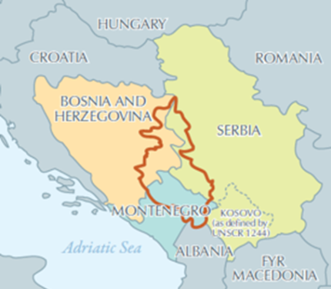
Picture 01: Sava River Corridor | Picture 02 Drina River Basin
The Development Objective of the Sava Drina River Corridors Integrated Development Project (Phase I of the Program) is to improve flood protection, and transboundary water resources management in selected catchment areas of the Sava and Drina river corridors.

Project Components
The Project will consist of the following three components and subcomponents:
Component 1: Integrated Management and Development of the Sava River Corridor
The component will finance investments in renovation and upgrading of flood protection infrastructure in Phase I and port rehabilitation and river training works to give more room for the Sava river in Phase II.
Phase I activities will reduce the risk and impact of floods, thereby increasing the resilience of the riparian countries to these climate-related threats. The component will also support upgrading of the freight carrying capacity of the Sava waterway consistent with Class IV standard at selected bottleneck sections that are currently constrained to Class III standard or lower; and cargo handling capacity expansion works at the Port of Sremska Mitrovica in Serbia. Further port expansion investments along the Sava river corridor may be financed under the program, and their economic viability will be assessed during preparation of SDIP’s Phase II
Sub-component 1.1: Flood protection and environmental management. This sub-component will also finance construction and rehabilitation of embankments at selected priority areas along the Sava River Corridor. This sub-component will finance works to clean up an old solid waste dump site in Brcko District located along the Sava River bank as well as nature-based solutions to re-vitalize selected protected areas of ecological significance to the Western Balkans.
Sub-component 1.2: Waterway Improvements. This sub-component will fund civil works in selected sites to address impediments to navigation along the Sava between the Port of Sremska Mitrovica (Serbia) and Slavonski Brod (Croatia) to bring these sections up to Class IV standard. Grant financing will be mobilized to finance demining activities along the Sava Right bank within BiH. Demining is a prerequisite for preparation of design documents and relevant ESF instruments for subprojects in the key waterway section between Jaruge (Croatia) and Novi Grad (Federation of Bosnia and Herzegovina)—considered the most pressing navigation bottleneck across the Sava at present. Demining activities are proposed as a no-regret investment that will help unlock the river’s economic potential for generations to come.
Sub-component 1.3: Enhancement of ports facilities, services and logistics. The project will finance cargo and vessel handling capacity expansion and modernization at the port of Sremska Mitrovica in Serbia. This investment will facilitate the handling of edible and non-edible dry bulk, liquid bulk, and general cargo freight, including the containers, and will enable a maximum handling capacity—to be delivered in stages over time—of 1.5 million tons per year. The expanded port will comprise infrastructure and superstructure for 4 terminals, as follows: a grain terminal (“Zone 1”); a gravel, sand, and aggregates terminal (“Zone 2”); a petroleum products and alternative fuels terminal (“Zone 3”); and a general cargo terminal within the existing operational port (“Zone 4”/Luka Leget). The expanded port will be consistent with serving vessels of waterway Class IV.
.
Component 2: Integrated Management and Development of the Drina River Corridor
This component will support multipurpose investments along the Drina to reduce the risk of flood and drought in Phase I. It will also support interventions that will optimize reservoir operation, and to protect environmental assets of global value in Phase II. This component will facilitate the implementation of actions, management measures and investments identified by the Drina Strategic Action Plan being prepared under the ongoing Western Balkans GEF-SCCF Drina River Basin Management Project and investments identified through the ESMAP Integrated Water and Hydropower Development Project. All the above measures will contribute to increased resilience of the riparian countries to floods and droughts. Requested GEF funding will support the prioritization and preparation of these activities.
Sub-component 2.1: Flood protection and environmental management. The sub-component will finance infrastructure works, studies, surveys, consultations and preparation of detailed design of interventions related to the management of environmental assets along the Drina Corridor. The on-going GEF-SCCF-financed Drina River Basin Management project as well as the ESMAP technical assistance, are conducting studies that will identify the additional actions needed for flood protection, bank stabilization, drainage and river training works, and reservoir management in the Drina Corridor. This sub-component will finance the preparation of selected priority investments in line with the project development objective including any further studies that may be needed.
Sub-component 2.2: Integrated development of lower Lim watershed. This project will finance improved watershed management in the Lim and Grncar River basins of Montenegro. This activity will finance works related to flood protection, drainage and irrigation measures. The design of these investments and solutions are under preparation of the ongoing GEF-SCCF project.
Component 3: Enabling regional economic integration, institutional strengthening and program management
This component will support: 1) preparation of Phase II activities; 2) policy dialogue, consultations, preparation of plans and studies, and investments to strengthen the nexus between water services and connectivity with the regional development and economic integration objectives of the Sava and Drina Corridor. Examples include River Basin Management Plans and Hydrological assessments, etc.; 3) planning and development of tourism in the Sava-Drina corridor including the designing of Master Plans for Ecotourism. River Basin Management Plans and Hydrological assessments will ultimately support integrated water resources management, thereby indirectly increasing the resilience of riparian countries to climate change; and 4) operational costs, consultancies, non-consultancy services, and goods required for the establishment and operation of the Regional Coordination Steering Committee and national PMUs. Requested GEF funding will co-finance measures related to river basin planning and management, flood monitoring network, institutional capacity building, and studies that inform or prepare future investments.
Sub-component 3.1: Project preparation. This sub-component will finance preparation of project documentation for Phase II of the program, including environmental and social safeguard assessments.
Sub-component 3.2: Institutional strengthening and project management. This sub-component will finance activities to increase institutional capacity and inter-sectoral coordination in the participating countries to ensure more efficient decision making and program management at regional level.
The program will be implemented over a period of 10 years, organized in two Phases. Phase I will focus on flood protection and river basin management activities in the Sava and Drina River Corridors. It will start with Brcko District (BiH), Serbia and Montenegro while other entities and countries can join as they become ready. Phase II will build on Phase I and strengthen river port connectivity and environmental management.

Component 4: Regional activities.
This component will support policy dialogue, consultations, preparation of plans and studies, and investments to strengthen the nexus between water services and connectivity with the regional development and economic cooperation objectives of the Sava and Drina Corridor. This component will promote joint action and decision making in river basin management and flood risk management among riparian countries, thus enhance the climate adaptation capacity of the region. Examples include the Sava River Basin Management Plan and Hydrological assessments, Climate Change Adaptation Strategy for the Sava River Basin, planning and development of tourism in the Sava and Drina Rivers corridors including the designing of Master Plans for Nautical tourism and Ecotourism.

Project Beneficiaries
Beneficiaries of Phase I include but are not limited to residents and businesses located within the flood prone areas along the Sava and Drina river corridors, and transport service providers. Government agencies across water, transport, energy, emergency response, and environmental sectors will benefit from improved information from regional studies and planning. In addition, aggregated effects from national level activities could benefit the broader river basins and region in terms of reduced flood risk exposure, new employment and business opportunities, and more cross-sector, cross-national coordination for integrated water resources management and development.

Contractors and Implementing Partners

The PMUs will manage the engagement and contracting of private sector providers under Procurement Procedures in line with the WB Procurement Framework.
The PMUs responsibilities include the coordination and monitoring of compliance with the ESMF requirements across Project components and agreements (contracts) with the providers of goods, works, and services.
Environmental and social requirements will be included in all relevant procurement and contracting processes by direct integration and/or referencing to subproject specific ESF instruments i.e. this ESMF, ESIA/ESMPs, RPs, SEP, LMP etc. Agreements, bidding documents for potential civil works, as well as procurement processes and contracts or subcontracts with private sector providers will specify these requirements.

Exclusions
The Project will not finance any of the activities listed in the World Bank Group -IFC Exclusion List given in Annex 03.

ENVIRONMENTAL AND SOCIAL BASELINE

Baseline country and environmental information
Serbia has a land area of 88,499 square kilometers, constituting only 0.05% of the world’s land area, or about 1.5 % of Europe. Despite its small size, however, the environment of Serbia is highly diverse compared to other countries in Europe. The reasons for this comparative richness include: the variety of climate, topography, and geology and the long- term ecological and evolutionary history of the region as a biological crossroads.
The Republic of Serbia (RoS) has a population of about 7,5 million, of which some 50% live in rural areas, and 17% derive their living from agriculture and associated industries. The RoS has three major land forms – the plain areas in Vojvodina and the flood plains of the Danube, Sava and Drina rivers; the Morava valley in its main stream and two southern arms; and the mountainous areas which cover most of the country south of the Sava and Danube. The water resources of RoS in addition to rainfall are dominated by the river inflows from upstream riparian sources estimated at 85% of available water. The balance is derived from the River Morava from within the country. Due to seasonal variations there are some 160 storage dams, some of which have hydro-electric generation facilities. Baseline information for Sava River basin in Serbia

Baseline information for Sava River basin
The Sava River Basin is a major drainage basin of the South Eastern Europe, covering the total area of approximately 97,713.20 km2 and represents one of the most significant sub-basins of the Danube River Basin, with the share of 12%. The basin area is shared between five countries: Republic of Slovenia (SI), Republic of Croatia (HR), Bosnia and Herzegovina (BA), Republic of Montenegro (ME) and Republic of Serbia (RoS), while a negligible part of the basin area also extends to Republic of Albania (AL). Population in the Sava River Basin is approximated to 8,176,000, which represents 46% of the total population of all countries (excluding AL and ME).

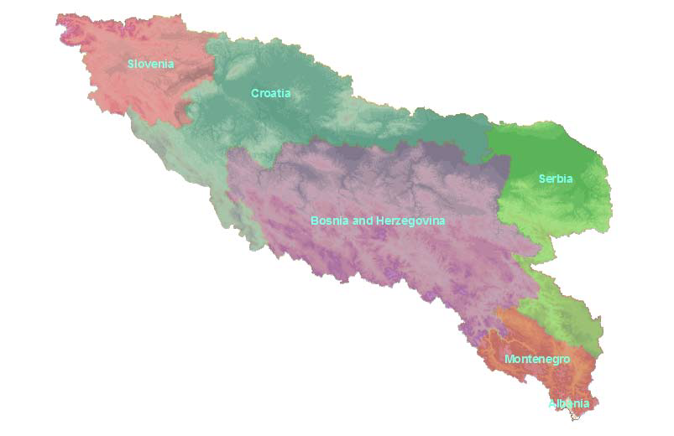
Picture 03: Country share of the Sava River Basin
Total country area of Sava River Basin in Serbia is 88,361 km2 (17.4%).
    - Relief and topography
Terrain in the Sava River Basin is very variable. It significantly changes from the source on the west to its confluence with the Danube River on the east. Rugged mountains (the Alps and the Dinarides) dominate in the upper part of the basin. In the downstream parts, the areas drained by right tributaries in the middle section of the Sava watercourse are also rugged, while the middle and lower part of the Sava watercourse is characterized by flat plains and low mountains as a part of Pannonian Plain, a low-lying, fertile, agricultural region. Generally, elevation of the Sava River Basin varies between approx. 71 m above sea level (m a.s.l.) at the mouth of the Sava River in Belgrade (Serbia) and 2,864 m a.s.l. (Triglav, Slovenian Alps).
    - Soils
According to Harmonized World Soil database, the soils with the largest extent are the Cambisols (weakly to moderately developed soils) that cover 46.4% of the basin. Other important soil groups are the Luvisols (soils with subsurface accumulation of high activity clays and high base saturation), Leptosols (very shallow soils over hard rock or in unconsolidated very gravelly material), Podzoluvisols (leached soils) and Fluvisols (young soils in alluvial deposits)
    - Climate conditions
The Sava River catchment is situated within a wide region where the moderate climate of the northern hemisphere prevails. The cold and hot seasons are clearly distinctive. The winter can be severe with abundant snowfalls, while summer is hot and long. Type of climate conditions within the Sava River basin in Serbia is moderate continental climate,
Average annual air temperature for the whole Sava Basin is estimated to about 9.5°C. Mean monthly temperature in January falls to about -1.5°C, whilst in July it can reach almost 20°C. Average annual rainfall over the Sava River Basin was estimated at about 1,100 mm. The average evapo-transpiration for the whole catchment is about 530 mm/year.
    - Sava River and its main tributaries in Serbia
Drina River is the largest and most important of all tributaries of the Sava River. The confluence of Drina River and Sava River is in Serbia, near the village of Crna Bara. Flowing further downstream, the Sava River receives, near Belgrade, two important tributaries from the right: Kolubara and Topcider River.
    - Ramsar sites in Sava River Basin in Serbia
The Sava River Basin is of high significance due to its outstanding biological and landscape diversity. It hosts the largest complex of alluvial wetlands and large lowlands forest complexes. Some of these floodplains are still intact and support flood alleviation and biodiversity.
Because of the ecological and cultural value of the wetlands, the Sava riparian countries have designated six sites in the Sava River Basin according to The Convention on Wetlands of International Importance especially as Waterfowl Habitat, or so-called Ramsar Convention. Two of them are on Serbian Territory: Obedska Bara (marked as S1 on the picture bellow) and Zasavica (S2).
Picture 04: Protected areas within the Sava River Basin in Serbia
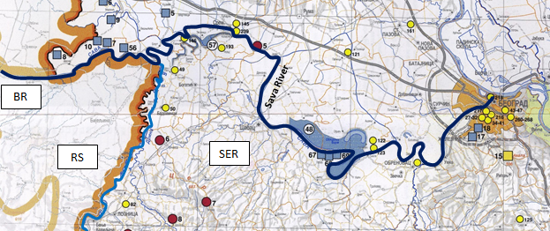
S4

S3

S1

S2

Nature protected areas within the Sava River basin
    - Obedska bara (S1)
The Special Nature Reserve Obedska has the total area of 19 667 ha of which 11 083 ha (55,3%) is located in foreland. This part serves as an important flood retention area that helps to prevent floods downstream in Belgrade.
The mosaic of forests and wetlands are dominated by a mixture of old lowland Pedunculate oak-ash- hornbeam forests, but with much more marshes and waterlogged areas then Morovicko-bosutske forests. Complexes of lowland ecosystems are of outstanding quality due to the natural flooding. Oxbows and mostly overgrown old meanders are the most outstanding landscape features. Grasslands are present both in small patches and in larger complexes, but the succession toward a forest vegetation, caused by insufficient number of wild and domestic herbivores is visible almost everywhere. The site is surrounded by arable land from the north and by the river in the south. The river connects the site with up-and-down-stream natural lowland sites. There are several villages around the site, of which Kupinovo, Grabovci and Klenak are located in a close distance.
More than 95% of the land within the site is in state ownership, predominantly covered by the forests and managed by the forest management company Public Enterprise „Vojvodinasume“. About 1 655 ha (8,4%) of the land covered with forests, pastures and arable land is fenced and primarily managed for needs of Serbian Armed Forces. There are some pastures belonging to the villages. The biggest part of former pastures was afforested through a contract between Public Enterprise “Vojvodinasume” and local communities. The remaining part is agricultural land in private ownership.
The land, that is situated behind the dyke and covers 8 584 ha (44,7%), is never flooded and rarely waterlogged, due to the higher altitude and the water management and drainage system. Regular flooding of the foreland provided particular biodiversity values, which has been recognized and timely protected. Exactly 9 820 ha (49,9%) of the site is protected as Special Nature Reserve Obedska bara, managed by Public Enterprise “Vojvodinasume”.
Dominant land use is forestry on 17 047 ha (86,7%). The land use intensity, according to the agreed land use criteria, is mostly moderate in natural or semi-natural forests and intensive in poplar plantations. 13 097 ha (78,6%) is covered by natural or semi-natural deciduous forests and 3 950 ha (20,1%) of poplar plantations. Small watercourses, fragmented grassland, small wetland patches and forest infrastructure, belonging to forest compartments, are included into „forestry“. Forestry is combined with moderate hunting management.
Within the forest area there is a special hunting area that covers 7 895 ha (40,1%), of which 2 257 ha (11,5%) is fenced and intensively managed. This area is overpopulated by game species.
The management of the arable land is moderately intensive and covers about 970 ha (4,9%). High quality arable land can be found only on higher altitudes. Grasslands are present mostly in mosaic with forest in form of barely used wet meadows, within the area managed for forest production, and covers approximately 405 ha (0,2%). Waterlogged areas cover about 1 255 ha (6,4%), including Obedska bara.
Extensive farming, e.g. pig herding and cattle grazing, used to be common within the area, but during last decades significantly decreased. There are 8 500 pigs, 2 500 sheep and 340 head of cattle herding on the site, regularly registered by forest and protected area manager. The number of pigs, cattle and sheep vary from year to year but the area is not overgrazed.
- Landscape features
The lowland forests dominate the landscape. There is an evident presence and impact of poplar plantations in some parts of the site. The whole area presents a large network of former meanders and oxbows of Sava River. Pastures and meadows are represented with small patches that are unevenly distributed within the forests.
The main threats on this site are the changes in the water regime caused by river regulation activities and natural morphological changes in foreland followed by the succession of wetland vegetation, enhanced by the lack of pasturing. Altered disturbance regime favour spreading of invasive species.
- Cultural historic features
There is a medieval church within the site near the village of Kupinovo. Also, there are several houses that represent traditional architecture.
- Tourist facilities
There is a new hotel within the hunting area, dedicated to hunting tourists. The old ''Obedska bara'' Hotel that is owned by ''Vojvodinasume'' is out of order. There were several plans for renewing the hotel, but due to the lack of finances and interest they have not been realized yet. The rural tourism in the villages is poorly developed.
    - Zasavica (S2)
The site represents a mosaic of natural and agricultural habitats alongside the Zasavica River which is located on the right bank of Sava River near the city of Sremska Mitrovica. The main characteristic feature of the Zasavica Reserve is the wide-open floodplain area with common pastures although these cover only 9,6% of the whole area.
Zasavica River nowadays is a tributary to the Sava, but according to available literature data, centuries ago it was a natural connection between the Sava and its tributary River Drina. Today the connection with the Drina is closed.
There are several underground springs that supply Zasavica with fresh water. The area is well-known as the only natural site in Serbia with Umbra krameri, a fish species protected by national and international legislation. The biggest part of the area is designated in 1997 as Special Nature Reserve “Zasavica”.
The surface of the Reserve is 671 ha or 28,7% of the whole area which is 2 335 ha. The land ownership in the Reserve is: public property (70.3%), state property (20.6%) and private property (9.1%). Private ownership is prevailing on the area as a whole.
The land use on the site is the following: grasslands covers 225 ha (9,6%) - moderately used, moderately used mixed deciduous forest 637 ha (27,3%), intensively managed poplar plantations 108 ha (4,6%), extensively used waterlogged areas including the River Zasavica and tributary watercourses 185 ha (7,9%), moderately to intensively used arable land 1 108 ha (47,4%), intensively used orchards 16 ha (0,7%). Touristic facilities and infrastructure cover approximately 3 ha (0,1%).
The landscape is a mix of natural forests, poplar plantations, forest patches, crop fields, pastures, waterlogged areas and the open water of Zasavica. Dominant landscape feature are the Zasavica River and dyke on the Sava River. The tourist facilities (picnic places) and bird watching tower characterize the vicinity of the Visitors Centre. Dirt roads and small forest patches are present all over the site. Several small illegal garbage dumps were found.
Due to forestry and agriculture there is a well-developed network of dirt roads inside the Reserve. Asphalt roads nearby enable a good accessibility for tourists.
Despite the natural values of this area, there are several threatening factors. The nearby villages are dumping their garbage in the Reserve, or adjacent to the borders of the Special Nature Reserve. Even though these illegal garbage dump sites are cleaned regularly, it is symptomatic that they reappear in a short period of time. The water level in the Zasavica is low during the spring and summer to prevent flooding of arable land. This low water table has a negative impact on the biodiversity of the protected area.
- Cultural historic features
The cultural historic features are represented with a several old churches in villages nearby.
- Touristic facilities
In the vicinity of the area are several villages, which could represent a good basis for the development of eco - and ethno - tourism. Until recently touristic infrastructure such as hotels or bed
& breakfast facilities are not available for potential tourists. Thanks to the Reserve management, the area of Zasavica is well marked. On several places in the Reserve, information signs have been placed. They are mostly beside the walking trail that leads through the Reserve. One of the main attractions is a wooden visitor centre with a high watch tower. There are plans to build several towers for bird watching throughout the Reserve.
    - Other nature protected areas within the Sava River Basin
- Morovicko-bosutske sume (S3)
The area is situated in the lowland on the left bank of Sava and includes several tributaries on the northern edge. The mosaic-like landscape is dominated by mixture of old lowland Pedunculate oak-ash- hornbeam forests, with admixture of marshes and waterlogged areas overgrown with willows, representing a natural mosaic of high biodiversity value. The plants are mostly hygrophilous. Small grassland patches, in different stages of succession, are most often situated within wetland complexes. Accelerated overgrowing of meadows is mostly caused by insufficient number of wild and domestic herbivores and by the lack of natural flooding. The site is surrounded by arable land from north and east. A few villages are in the vicinity.
Total area of the site is 21 852 ha. More than 95% of the area is in state ownership, predominantly covered by the forests and managed by Public Enterprise “Vojvodinasume”. Some land in state ownership is managed by water manager Public Enterprise “Vode Vojvodine”, and there is also an area for hunting and fishing tourism - VU Morovic, managed by Serbian Armed Forces. Other is private agricultural land.
Dominant land use is forestry. Natural or semi-natural mixed deciduous forests covers 17 700 ha (81%), mostly moderately managed, according to the agreed land use criteria. 830 ha (4%) of the site is covered by intensively managed poplar plantations. Strip of waterlogged autochthonous willow and poplar forests in foreland are managed extensively by the Public Enterprise for Water Management “Vode Vojvodine”.
Forests belong to several hunting areas with moderate game management. Within the site there are two plots specially dedicated for intensive hunting and angling, that covers 3 530 ha.
Arable land, moderate in land use intensity, covers 1 680 ha (8%). Grassland fragments are scattered in the lowland forests, in form of wet meadows within the area managed for forest production and are barely used. There is also one moderately managed fishpond in the area that covers 61 ha (0,3%). Extensive farming, e.g. traditional pig herding and cattle grazing is developed, but in decreasing trend. Within the site there are still dozen pig and cattle herders, using forests and dykes for grazing, just like their ancestors. It is regulated by contract with the state forest and dyke managers.
Lowland forests are dominating the landscape. On the border of the site the tributaries to the Sava including the Bosut River are flowing adding to the landscape and biodiversity of the site. Within the site are also a few smaller watercourses. The dyke along the Sava is another significant object in the space. Besides, there are also temporary or permanent gravel depositories on the riverside of the Sava. Due to developed forestry there is a well-developed network of dirt roads. Local asphalt roads crossing the site or passing by enable a good accessibility. Various hunting towers are scattered over the site. Garbage dump are rare. Shallow ditches are well presented on the site, along the dirt roads. A few ameliorative ditches are traced across the forests, connecting bogs and marshes to ameliorative network.
- Cultural historic features
Within the area there is Memorial monument from the Second world war – Domu skela, with representative model of bridge symbolizing connection between people across the Sava. There is also a medieval church in the village of Morovic, nearby the site. The site is rich in archaeological localities.
- Tourist facilities
Hotel and few bungalows, primarily dedicated for hunting and fishing tourism, are available within the hunting and fishing area VU Morovic. Other tourist infrastructures like hotels or bed & breakfast facilities are not available. The nearby villages are suitable for rural tourism which is not organized yet. Hunting tourism used to be important source of income until 1990’s, but afterward it decreased. There are generally great potentials for sustainable fishing and hunting tourism.
Usce Drine
The site covers area of about 19km alongside the River Drina up to its discharge into the river Sava and extends to the right bank of the Sava River (about 4km). It is located in the north-western part of fertile Macva plain and is bordered by the River Drina in the West and by the River Sava in the North. The total size of the site is 1 967 ha.
The River Drina is also the state border between Bosnia and Herzegovina and the Republic of Serbia. The area belongs to Bogatic municipality in Macva County.
At the confluence with the Sava and within the dykes the Drina is a free meandering river with many flow paths and small islands where gravel is deposited. The site consists of two parts: Southern part located along banks of the River Drina and the northern part near the confluence with the River Sava and along the banks of the River Sava. The southern part is mainly under agricultural use with the area that is frequently flooded under forest vegetation, while northern part that is protected from flooding by a dyke represent mixed leaf forests. Approximately 15% (300 ha) of the whole site is located outside of the dyke and frequently flooded.
A characteristic biological feature of this area is the occurrence of a rare bird (Sterna albifrons) that nests on islands in the river Drina.
One part, which is in foreland, is managed by Public Enterprise “Srbijavode”, while the other (protected part) is managed by Public Enterprise “Srbijasume” (approximately 200 ha – 10%). The rest of the site is in private ownership. Approximately 50% of the site is under agriculture land use. Agricultural plots are surrounded by trees, so that they have kept certain biodiversity of flora and fauna. Plots are small to medium and mainly under agricultural cultures. Semi-intensive agriculture is present here with no melioration works. Fertile land and favorable weather conditions provide good yields. Almost a half of this site is covered by forest vegetation (840 ha - 42%). Most of these forests are mixed stands with characteristic species for lowlands (ash-tree, poplar-tree and willows). Forestry is not intensive in this area but there are some plots planted with poplars for commercial use. These plantations are relatively young so this business is in the developing phase. The total area under poplar plantations is approximately 6% (120 ha) of the whole site. The forests in private ownership are in a bad condition. Grazing and mowing is very important for the maintenance of the biodiversity of the small number of natural grasslands.
Alongside the Drina River gravel depositories exist covering a total area of approximately 1% of the whole site. The gravel depositories along the Drina are negatively impacting the landscape and river characteristics. Gravel mining is still ongoing but there are also numerous deserted excavations. There is a well-developed network of dirt and asphalt roads used to transport the gravel. Small garbage dumps are present at numerous locations, mainly positioned by the dirt roads. Ditches are dug along the roads.
The site is characterized by a mosaic landscape. It is a complex of small plots, divided by small forest strips and shrubs. The existing dike protects most of the arable land. Small houses are scattered over the area that is in agriculture land use.
Intensive vegetable production develops with use of plastic covers and melioration on small plots.
- Cultural historic features
Within the area there is Memorial monument from the Second World War. There are also a numerous of churches in surrounding villages.
- Touristic facilities
There are a lot of beaches along the Drina riverside. A few small restaurants and mini cottages are present at the riverside of the Drina River. Because of proximity of the state border there are only limited opportunities for boating.

Baseline information for Drina River basin
    - Geographic characterization
The Drina River is 346 km long and is the largest tributary of the Sava River Basin, which in turn is the largest tributary by volume of water of the Danube River Basin that drains into the Black Sea. The Drina River Basin makes one fifth of the Sava River basin, and even one third of the Sava River water arrives through the Drina River. The Drina River Basin has a surface area of 19,680 km2 and spreads over territory within principally three riparian states: Bosnia Herzegovina (BiH), which is subdivided into two entities (Republika Srpska (RS) and Federation of Bosnia-Herzegovina (FBiH); the Republic of Montenegro and Serbia. In addition, Albania accounts for a very small part of the Drina River Basin (<1%).
The Drina originates between the slopes of the Maglic and Pivska planina mountains, between the villages of Scepan Polje (in Montenegro) and Hum (Bosnia and Herzegovina). The lowest point in the Drina River Basin is at 82.3 m.a.s.l. at the confluence of Drina River and Sava River near the village of Crna Bara.
The major tributaries of the Drina River in Serbia are Lim River with Uvac River, Rzav River, Ljubovidja River and Jadar River.
    - Climate and hydrology
Climate of the Drina River Basin is complex and influenced by general atmospheric circulation, its elongate shape along a meridian, local orography and proximity of the Adriatic Sea. The Southernmost part of the basin has a Mediterranean and a maritime temperate and humid climate. Moderately cold and humid continental climate can be found at the altitudes above 1000 m. Mediterranean influence, although mild, can be found in the upper part of the basin, up to Foca (BIH). From that point downstream a temperate continental climate prevails with warm summers and moderately cold winters.
Generally, from south to north, along the altitude decline, accumulated annual precipitation also decreases, from about 2100 mm measured in Kolasin (MNE) to 820 mm in Loznica (SER). In the same direction annual mean temperature increases, from 4.6 °C in Zabljak (MNE) to 11 °C in Loznica (SER). Annual distribution of precipitation differs throughout the Drina River Basin. Northern parts receive the most rain in the late spring, mainly in May and June, while winter is dry with the lowest precipitation in February. Due to the influence of the Mediterranean climate in the southern parts, maximum rain falls in the late autumn and the minimum during the summer months. The warmest month is July and the coldest is January
Relative humidity in the Drina River Basin is rather uniform, and is at its lowest in the period June-August and the highest in the December-January period. Snow cover significantly impacts the Drina River water regime due to large amounts of water accumulated in it, with the highest flows recorded in spring time, in April and May.
Snow depth in some sections of the lower middle part of the Drina River Basin can be as high as 1.20 m (corresponding to a maximum of 200 mm of water) with frequent snow-drifts and in upper sections it can even exceed 5 m.
Fogs constitute a characteristic feature of the Drina River valley and can occur throughout the year, but are most frequent in spring and autumn. Complex local topography in the upper course of Drina River significantly affects and modifies wind direction and speed. Despite this, strong winds are quite rare and are generally of low intensity.
    - Biodiversity
Wetlands and alluvial forests are amongst of the most important habitats in Drina River Basin. Even though they are not covering large surfaces along the Drina River and its tributaries above the level of 140m a.s.l, they are still an important factor in habitat diversity and they are providing conditions and shelter for a large variety of species and habitats that would be otherwise absent from the region.
Downstream from the city of Zvornik, and especially from Loznica, all the way to the Drina confluence into Sava, wetlands are vast, old and more recent meanders dominate the landscape. These areas host some of the most important habitats on a continental level, they form freshwater supply, provide food and building materials, biodiversity. The wetlands help also in flood control, mitigate groundwater recharge, correcting the irregular discharge of dams, and the climate change. However, these precious ecosystems are insufficiently protected in the three countries of Drina River Basin.
Drina River Basin is a region rich in biodiversity and is a home to many endemic species, as well as many species that have become rare or endangered locally and on continental level. Considering the large surface it covers, as well as the diversity of expositions and altitudes, Drina River Basin has very diverse flora and fauna. The Drina basin holds a high number of endemic species, many of them of European importance. The most famous endemic species in the Drina River Basin is the Serbian spruce (Picea omorika) but there are many others, including Campanula secundiflora, a Balkan stenoendemic species, whose populations are threatened by planned developments on the Lim River.
Drina River offers a variety of different habitats and ecosystems and is inhabited by more than 50 fish species. Drina River represents one of key fish diversity locations within the Balkans. The upper parts of the basin are primarily inhabited by Salmonid fish, mostly Danube Salmon (Hucho hucho) and Brown trout (Salmo labrax). Bullhead (Cottus gobio) and Brook barbel (Barbus caninus) are also common in these regions. These species are mostly affected by overfishing, especially Brown trout.
Regarding birds and mammals, the Drina River Basin shows exceptional richness. Indeed, there is a presence of over 230 species of birds and a large variety of mammal species. Otherwise, there are the rare elsewhere such as Brown bear (Ursus arctos), the Eurasian wolf (Canis lupus), the chamois (Rupicapra rupicapra), the wild cat (Felis silvestris), the Eurasian Lynx (Lynx lynx) and the European otter (Lutra lutra), as well as two endemic species, the Blind Mole (Talpa caeca) and the Balkan Snow Vole (Dinaromys bogdanovi). Bats are exceptionally diverse in the Drina River Basin with a probable number of species ranging between 30 to 32. The Drina River has been confirmed as a corridor for the migration of bats.
    - Natural resources
Territory of the Drina River Basin is rich in natural resources, which are distributed among the region in a specific manner. Agricultural land dominates in the Lower Drina Region (Republic of Srpska and Serbia), while the forestland and forests can be found in the Upper Drina Region. In the area of Upper Drina, agricultural land is less common and mostly consisted of meadows and pastures. There are also mineral resources spread over the area of the Drina River Basin.
Important natural resource is the gravel from the riverbed of the Drina River which extraction is an important economic activity and significant source of income for small private companies. It should be regulated by the state but the data on the quantities of excavated sediments are unavailable. There is a strong lack of a cooperative management of the gravel extraction in the Drina River Basin, integrating the environmental and security components.
Furthermore, the Drina River is very important resource for the development of tourism. For now, there are two main touristic manifestations in Middle Drina: “Drina Regatta” and “Drina-Praca New touristic paths”. The Drina Regatta is the oldest event of tourist - recreational character in the Drina River region, which is organized in memory of the ancient tradition of the Drina rafters. The regatta is the most visited event in Western Serbia and central summer event on water that attracts with a variety of amenities tens of thousands of visitors from Serbia and abroad. Rafting Drina is organized by Municipality of Ljubovija in the length of approximately 40 km from Ljubovija town to the village of Rogatica.
    - Demography
The total area of Drina River Basin is divided into three main administrative units, so that the participation of Serbia is 34%, Montenegro 30% and BiH 36%. However, from total population of the Drina River Basin in Montenegro live only 14% inhabitants, while in Serbia live 47% and in BiH live 39%. The highest population density is in the Serbian part of Drina River Basin, approximately 63 inhabitants/km².
Observing the level of the states in the Drina River Basin, highest average age of the population is characteristic for Serbia (41.9 years). In all three countries, average age of female population is greater than for male population. Population growth rates are negative in all three countries (Serbia -0.46, BiH -0.11 and Montenegro -0.49).
The main problems in Drina River Basin are unfavorable demographic structures and distribution of the population. Drina River Basin is facing complex demographic problems that manifest by constant reduction in the birth rate and negative population growth, by reducing the number of pupils in primary schools, by processes of de-population, the disappearance of villages, aging population, and emigration of fertile and working population abroad.
    - Cultural heritage and monuments
Cultural and historical capital of Drina River Basin is heterogeneous, including cultural goods created in a wide range, from prehistoric and ancient to medieval, Ottoman and modern times. They were created, because of its geographical position, by participation in four major civilization of Europe: Mediterranean, Central European, Byzantine and Oriental-Islamic.
There are 258 protected cultural heritage sites in the Drina River Basin (138 in Serbia, 258 in BiH and 38 in Montenegro). The most important are two UNESCO World Heritage Sites (Mehmed Pasha Sokolovic Bridge in Visegrad (BiH) and Djurdjevi stupovi – Monastery in Berane (MNE). There is no UNESCO sites in Serbian part of Drina River basin.

Nature protected areas within the Drina River basin
Only 5.5% of the Drina River Basin in Serbia is protected, that is far under the European average.
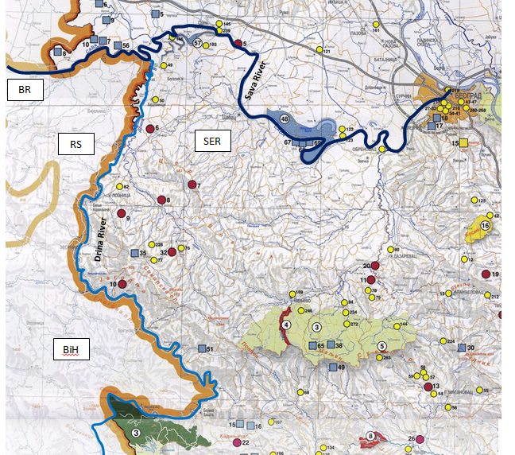
D4
D3
D1
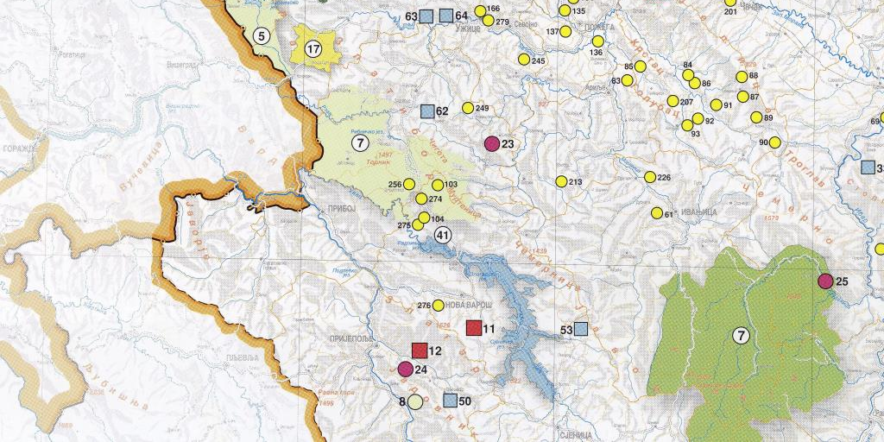
D7
D5
D6

D2
Picture 05: Protected areas within the Drina River Basin

Table 1: Protected Areas of Serbia in the Drina River Basin
Nr. | Name and type of Protected Area in Serbia | Size (km²) | Date Formed
D1 | Tara: NP, Emerald site, IUCN: II | 191.7 | 1981
D2 | Sargan – Mokra Gora: PP | 108.14 | 2005
D3 | Part of the area of the village of Trsic and Tronosa Monastery: MNM |  | 1965
D4 | Tresnjica River Gorge: SNR Tresnjica River Gorge | 5.95 | 1995
D5 | Milesevka: RNP | 4.57 | 1976
D6 | Uvac: SNR Canyon of the Uvac River | 74.53 | 2006
D7 | Slapovi Sopotnice: MoN Waterfalls of Sopotnica River, Lim tributary |  | 2005
 | Many other MoN (small objects)

Legend: MNM: Memorial Nature Monument; MoN: Monument of Nature; NP: National Park; RNP: Regional Nature Park; RP: Regional Park; SNR: Special Nature Reserve.
    - National Park Tara
The Tara National Park in the mountainous region of western Serbia was designated a national park in 1981. The 19,200-hectare park, with administrative offices in Bajina Basta, is spread out over a group of mountain peaks in the Tara, Crni vrh, Stolac and Zvezda ranges, the Canyon of Drina with Perucac and outskirts of Bajina Basta. National park covers a large bend in the Drina River bordering Bosnia.
Due to its climate and isolation Tara preserved ancient species of trees such as Panic spruce and other almost fossil species of plants. Tara is mostly made of limestone and its average height is 1000-1200m. The highest point is Kozji Rid -1591m and the lowest 291m is at the lake Perucac. Vrelo River is the strongest fountain in the national park, which runs into river Drina after 365 meters. Summers are fresh and winters are cold with lots of snow. Most rainfall is in May. Driest months are July and August. Autumn is sunny and warmer then spring.
NP Tara is 80% covered with forests. There are 34 forest and 19 meadow communities. 75% of forests are mixed spruce-fir, fir and beech.
A unique endemic plant Panciceva Omorika - Pancic Spruce (Picea omorika) is, according to many experts, the most beautiful European species of all larches. It represents the unique endemic species of the Balkan Peninsula and its natural habitat is in Veliki Stolac ( 1540 meters of altitude) in the territory of Mitrovac at Tara Mountain. It grows in the downhill and rigid rocks of the northern area.
Besides Pancic spruce significant plants are hazel, yew, holly, jeremicak, knapweed of derventa, peony and blechnum spicant
There are 53 species of mammals. The most interesting are bear (Ursus arctos), and chamois (Rupicapra rupicapra) which lives even on elevation of 291m. There are 135 species of birds. 43 of them are migrating species. The most interesting are endangered species such are golden eagle (Aquila chryssetos), peregrine falcon and others. There are more than 251 species of mushrooms. Three of them are poisonous. Amanita phalloides is the most dangerous mushroom in Europe.
Fishing on rivers and lakes within the NP is a real pleasure. There are about 40 species of fish. (mladica (Hucho – hucho), lipljan (Thumallus thumallus), gull, carp, jez (Leuciscus idus)…
In the NP Tara there are many archaeological sites dating from neolith to middle ages. There are stecaks in Perucac, remnants of medieval fortress Solotnik and monastery Raca, built by king Dragutin Nemanjic in the 13th century.
There are 18 mountain foot paths with total length of 120km. When using those paths you should consult maps which can be bought at information points in the park.
TAROCYKL project defined 27 cycling paths with total length of about 420km creating opportunity for a new kind of tourism with no side effects on environment.
Hunting in the NP Tara is always organized according to plans. There are about 40 bears, 300 chamois, 320 does and 40 wild boars. Hunting licenses, guides and transportation are authorized by service for protection and improvement on hunting and fishing of NP Tara
The location of Tara allows development of tourism and visits to variety of different tourist locations. Richness and variety of tourist attractions, preserved natural environment, mountain relief with height between 800-1500 m, winter sports facilities, richness and variety of plant and animal life, pleasant climate, river Drina and artificial lakes Perucac and Zaovine make this mountain one of the most beautiful in our country. Tara is situated in the vicinity of places such are town of Uzice, Mokra Gora, town of Visegrad with numerous cultural and historical sights which can be easily visited by people who are staying on Tara. This gives them opportunity for more interesting vacations. Tara gives excellent opportunities for development of sustainable tourism with minimal impact on its environment and cultural heritage, which helps economic development of local community at the same time.
The best chutes are in the region of Predov krst. They are between 3 and 5 km long. Mild steeps of Tara are good for walking, horse riding, using trim traces and other sport activities.

Environmental and Social Baseline on national / state level
    - Water
Republic of Serbia abounds in waters that are its great natural wealth and has a dense river network, numerous lakes and numerous sources of hot and mineral water. Water quality in Serbia differs significantly from one region to next. Some data, obtained through monitoring, has shown the presence of: ammonia, nitrates, sulfides, iron and mineral oils in the Tisa River Basin; evaporable phenols and manganese in wells in the area of Backa; and, in some cases, suspended solids – for example, in the South Morava Basin. Throughout Serbia, the most problematic physicochemical water quality parameters are turbidity, iron, manganese, nitrates. In Central Serbia the main problem is bacteriological contamination.
The Sava River is an international waterway Class IV, a standard that mandates the provision of safe navigation conditions for vessels up to 1,500 tons in capacity, with a least available depth (LAD) of 2.5 meters for 300 days per year. Thus the Project triggers the WB OP 7.50 on international waterways requiring the beneficiary state, if it has not already done so, formally to notify the other riparians of the proposed project and its Project/Program Details. At present, however, these conditions are not met. Specifically, the Sava meets Class IV standard only through approximately the last 103 river km of its fairway—i.e., at its most downstream and busiest section, between Sabac and Belgrade, all within Serbia. Upstream from Sabac, the Sava river is generally considered Class III standard or below, consistent with navigation of vessels up to 700 tons in capacity, and, as noted earlier, only for approximately 160 days per year in some sections.
The Drina River basin, with total surface area of 19,680 km2, covers the northern half of Montenegro (31.6% out of total watershed), Bosnia and Herzegovina (37.1%) and Serbia (30.5%), while less than 1% of the basin belongs to Albania. With its high flow volume (about 12 billion m³ annually) and good water quality, the Drina River Basin scores high on the list of areas with high endowments of natural resources and development opportunities in the region. It also has a significant hydropower generation potential (of which about 60% is reported to be still untapped) as well as tourist attractions, and it is a source of abundant biodiversity. Mining, manufacturing, tourism and agriculture create other significant economic opportunities. Almost one million people live in the Drina River basin, their settlements being concentrated along the Drina and its major tributaries.
    - Main environmental pressures in Sava River Basin and Drina River Basin in Serbia
Environmental pollution within the Sava River Basin and Drina River Basin may occur from: on-going human activity (e.g. farming, industry), historic human activity (e.g. contaminated sites) and a new development (e.g. future infrastructure projects). Point sources of pollution are: Settlements, Industry, and Agriculture.
      - Organic pollution
Organic pollution can cause significant changes in the oxygen balance of surface water. As a consequence, it can impact the composition of aquatic species/populations and therefore also the water status. Organic pollution is mainly caused by the emission of partially treated or untreated wastewater from agglomerations, industry and agriculture.
Many agglomerations in the Sava and Drina River Basin have no, or insufficient, wastewater treatment and are therefore key contributors of organic pollution. Direct and indirect discharges of industrial wastewaters are also important. Industrial wastewater is frequently insufficiently treated or is not treated at all before being discharged into surface water (direct emission) or public sewer systems (indirect emission).

      - Nutrient pollution
Nutrient pollution – particularly nitrogen (N) and phosphorus (P) - can cause the eutrophication of surface water. Nutrient pollution is a priority challenge for the freshwater. Drina is the largest Sava River tributary and Sava River is the third longest tributary of the Danube and discharges the largest volume of water into the Danube of all its tributaries. With regard to nutrients, it discharges into the Danube approx. 1.79 – 6.89 kt/a of total P and 37.86 – 85.59 kt/a of total N2.
      - Hazardous substances pollution
Hazardous substances include man-made chemicals, naturally occurring metals, oil and its compounds and numerous emerging substances, e.g. endocrine disruptors, personal care products and pharmaceuticals.
Significant sources of hazardous substance pollution are industrial activities, such as energy production (thermo and hydro power stations), mining (coal, lead, zinc, bauxite), production of aluminum oxide, metallurgy, engineering, glass production, chemical industry, pharmaceutical, textile, pulp and paper industry, tannery and leather industries, pesticides and other chemicals applied in agriculture in addition to animal breeding and the food industry – dairies, breweries, etc.
      - Hydromorphological alterations
Hydrological alterations refer to pressures resulting from impoundment, water abstraction and hydropeaking / altered flow regime. Hydrological alterations are of local importance and do not necessarily result in basin-wide trans-boundary effects. However, the cumulative effect of water abstractions may become significant in a transboundary context. The key driving forces causing river and habitat continuity interruption in the Sava RB are primarily hydropower (78%), water supply (10%), and flood protection (6%).
Longitudinal continuity interruptions are dams, weirs, ramps, sills, etc. There is no barriers in the Sava River in Serbia, but 6 barriers are placed on its tributaries (Drina, Kolubara, Lim and Uvac). Two barriers are equipped with the fish aid (HPP Zvornik on the Drina River and TE Veliki Crljeni on the Kolubara River)
Picture 06 provide information on longitudinal continuity interruptions on the Sava River, Drina River and its tributaries.
      - Future Infrastructure projects
In addition to the present degradation of the Sava River and its tributaries caused by existing hydromorphological alterations, a number of future infrastructure projects are at different stages of planning and preparation. Those projects may provoke significant pressures on water status.
Serbia has reported on construction of two hydropower plants on the Lim River (HPP Brodarevo 1 and Brodarevo 2).
Picture 07 provide information on future infrastructure projects in Serbia on the Sava – Drina Basin.
      - Invasive species
Alien (non-indigenous, exotic) species are all those that are non-native for particular region, that are introduced by human action. Recently, invasive alien species (IAS) has become an emerging issue in environmental management, including water management. Therefore, the subject should be properly included in important water management documents at all spatial scales, including the River Basin Management planning.
Non-native fish species in the River Sava catchment and their status were recently and partially assessed, where for waters of the most downstream, Serbian section, the Prussian carp was assigned the most invasive alien fish species, followed by brown bullhead.
Out of 14 non-indigenous macroinvertebrate species recorded within the Sava River Basin, seven are considered as invasive, while 14 out of 16 fish species is considered as invasive. The consideration of alien algae and macrophites (both, aquatic and riparian) in the SRB is important job to be done.
Picture 06: Overview of the longitudinal habitat continuity interruptions in the Sava / Drina River Basin
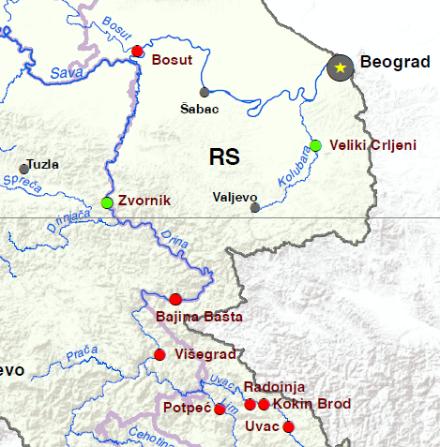

Picture 07: Future infrastructure projects in Sava – Drina River Basin in region
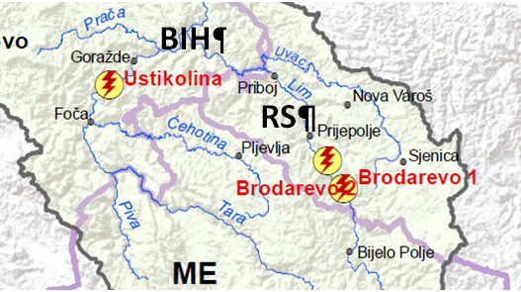

    - Climate change and Floods
According to the World Meteorological Organization, the estimated effects of climate change on Serbia will be the medium range. Serbia, as well as south-east Europe, is likely to have hotter summers, decreased precipitation and, therefore, an increased risk of summer drought. According to data trend over the last 35 years an increase of yearly air temperature by 1°C is noted on Serbian territory in the last 100 years. Shorter periods have greater positive values which mean that the increase of temperature at yearly level has intensified over the last couple of decades. Although there are periods with positive and negative trends, since 1982 negative trends ceased and only an increase in temperatures was noted and it lasts still today.
Global warming is increasing moisture in the atmosphere, making storms wetter, bringing more rainfall to the region. The storms are also moving slower, so they drop more rain over river catchments, causing massive floods more frequently comparing to previous period. Floods are caused or amplified by both weather- and human-related factors. Major weather factors include heavy or prolonged precipitation, snowmelt and thunderstorms. Human factors include altered drainage and poor maintenance of hydraulic and flood protection infrastructure.
The Sava and Drina have a proclivity for both dry spells and devastating floods—most recently occurring in 2010 and 2014. The trends and changes in mean values of precipitation, evapotranspiration, and discharges are well documented and clearly indicate that climate change is expected to cause more intense flood and drought episodes, greater both in scope and duration. Current climate change projections for the Sava River Basin foresee a rise of flood peaks of up to 8 percent, while droughts are also anticipated to become more frequent, and the latter are especially unfavorable for navigation. Floods and droughts create risks for livelihoods and impose constraints on trade, food security, and productive investment. Although the hydraulic infrastructure in the basin is extensive, it has been poorly maintained and not modernized since the Balkans War (1995), hampering regional economic integration and suppressing growth.
The 2014 flood event of the Sava and Drina rivers have been analyzed with respect to loss of life and economic losses and damages. It is estimated that in Serbia, Bosnia-Herzegovina, and Croatia, the May 2014, 1/100-year flood in the Sava Basin affected 2.98 million people, caused the evacuation of 137,000 people, incurred 79 casualties, and total damage and losses exceeded3.8 billion euro. In addition, smaller floods in 2013, 2010, and in years prior also cause considerable damage to infrastructure, homes, and economic losses. The economic evaluation will study how high flood risk levels affects investments along the river corridor, preventing it from achieving its full economic potential particularly related to the tourism industry. The total area protected from floods was 1 442 379 ha, which is by 9.2% less than in 2017. The utilized agricultural area accounts for 66.3% of the total defended area. The length of the constructed embankments for protection against surface water is 3 411 km. The Danube basin (73.7%), followed by the Sava (20.3%) and Morava (6%) have the largest share in the area defended.
25 843 ha of surface flooded with surface water, 75.2% of which is agricultural land used. In the Morava basin, 16 693 ha of agricultural land were flooded, representing 86% of the total utilized agricultural area.
Groundwater flooded 1 222 ha of land, of which 85.8% is agricultural land used. The utilized agricultural area was flooded mostly in the Morava basin and amounted to 972 ha.
The drainage system covered 0.3% more surface area than in 2017. The Danube basin with 1 942 thousand hectares has the largest area covered by the drainage system, followed by the Sava basin with 427 thousand hectares and Morava with 150 thousand hectares. The length of the drainage canal is 6.3% higher than in the previous year. In 2018, the area of ​​land affected by erosion was 3 834 km2, down 0.5% from the previous year. Of these, 1 177 km2 are settled.

    - Waste
The general state of waste management in Serbia is still inadequate, posing public health and environmental hazards. The most acute problem is hazardous waste, which is not separately collected and disposed of – currently it is processed in regular waste disposal sites. In general, over 50% of disposal sites do not meet the technical requirements of sanitary landfills, and are actually just fenced and mapped dump areas. There are also hundreds of illegal dump sites of various sizes in rural areas. Moreover, leakage from these dump sites poses a threat to groundwater, surface water and soil, due to the high content of organic matter and heavy metals. It is, however, important to mention adoption of the new Law on Waste Management, which is fully harmonized with the EU acquis communautaire, and the numerous sub-laws that are currently being developed.
Untreated municipal and industrial waste waters are still the greatest source of pollution. The response of pollutants is still unsatisfactory for fulfilment of their legal obligations and reporting about emissions in waters.
According to a report by the Serbian Environmental Protection Agency (SEPA) on waste management in the 2011-2017 period, a total of 2.15 million metric tons of waste was generated, of which 1.80 million metric tons, or 83.7%, was collected by municipal public utilities. The median daily amount of municipal waste landfilled per capita was 0.84 kg, and the annual figure was 0.30 metric tons. This does not include some 20% of generated municipal waste which ends up in illegal dump sites.
In the waste management sector, the most visible and probably the most complex problems concern municipal waste management, where Serbia lags seriously behind comparable countries in Central and Eastern Europe in virtually all stages of the process – from collection to disposal, while municipal waste treatment hardly even exists. Statistics in Serbia is devastating – the percentage of municipal waste recycled, according to official data, was about 3% in 2016, while the bulk of the generated waste ended up in landfills.
    - Biodiversity, flora, fauna
In general, Serbia has rich and diverse biodiversity, flora and fauna, a number of different types of ecosystems of particular environmental importance, but it is important to mention that specific diversity in Serbia is under-researched or documented. According to available data, specialists estimate that around 60000 taxa (species and subspecies). These includes: forest ecosystems representing different types of forests ; high mountain regions with characteristic mountain ecosystems well-represented or preserved, some of which are found on borders and would require trans-boundary management efforts; mountain regions in which traditional human activities have maintained and even increased biodiversity through centuries of maintaining the open pastures of mountain meadows; gorges and canyons that have been identified as important centers for relict and endemic species; steppe and sands of Vojvodina, as well as lakes, wetlands swamps, marshes, ponds which provide key habitat for migratory birds from elsewhere in Europe and have been identified as wetlands of the Ramsar Convention; karst regions in parts of Serbia, with their numerous caves and pits, supporting a rich fauna; and mountain bogs around mountain and glacial lakes.
It is estimated that in Serbian territory over 1000 species of flora are endangered, according to the Red list of Serbian flora (2002). Most of the endangered plants in Serbia is in the IUCN category of “rare plants”. The most endangered part in Serbia’s biodiversity considers the forest ecosystems and especially sensitive ecosystems (e.g. wetland habitats, prairie habitats, continental salt marshes, sandy terrains, mountain habitats) some of which are refugee habitats for relict and endemic species.
The Sava corridor nourishes expansive wetlands and riverine forests. Seven Ramsar sites cover a total 85,000ha. The Drina corridor features vast pristine mountainous forests and nature parks; its Tara Canyon is a UNESCO Biosphere Reserve (MNE).
List and maps of protected areas within the Sava River Basin (Serbian part) is provided within the section 3.3 of this ESMF document. All relevant data and maps for protected areas in Drina River Basin (Serbian part) is provided within the section 3.5.

    - Social baseline and background
- Socio Economic Trends in the Republic of Serbia
On January 1, 2018, a total of 7,001,444 inhabitants lived in the Republic of Serbia. Demographically, Serbia is characterized by a strong depopulation trend (between January 1, 2014 and January 1, 2018, the Republic of Serbia lost 147,736 persons), low fertility, relatively high (in European terms) specific mortality rates, high average age population (43 years) and unfavorable age structure.
The year 2017 is the twenty-sixth consecutive year that there has been a negative demographic trend in the Republic of Serbia. Relative to one thousand inhabitants, the rate of natural negative increase was -5.5 ‰. The true magnitude of negative population growth can be seen at the municipal level. In 2017, a negative natural increase was recorded in as many as 163 of 169 cities and municipalities.
The trend of increasing life expectancy at birth for both sexes continued. The achieved value of this indicator is 77.9 years for women and 73 years for men in 2017. Despite the historical maximum reached, life expectancy in the Republic of Serbia is shorter than the EU average by over five years. The elderly dependency index in 2017 was 29.7% with projections of reaching a value of 36.3% in 2041.
Rough estimates based on data from different statistical sources indicate an average annual negative external migration balance of at least 15,000 persons (data from countries that most often accept migrants from the Republic of Serbia, the Statistical Office of the Republic and the Commissariat for Refugees and Migration).
According to data from the Labor Force Survey, employment in the Republic of Serbia increased by 75,300 (+ 2.8%) in 2017, which is half the growth recorded in 2016 (by 145,200 and +5, respectively), 6%). The decrease in the unemployment rate, started in 2013, continued into 2017. The unemployment rate was 13.5%, which is a decrease of 1.8 percentage points compared to 2016. An increase in employment and a decrease in unemployment during 2017 was accompanied by a slight decrease in inactivity. The inactivity rate was 46.0%, down 0.7p on the previous year.
Poverty remains significant, both in absolute terms (the share of persons whose consumption is below the threshold needed to meet their existential needs - 7.3% in 2016), and relatively high (the share of persons at risk of poverty is 25.5% in 2016). The at-risk-of-poverty rate by most common status in the labor market (lasting more than six months) indicates that the unemployed are in the worst position (48.0%, ie almost every other unemployed is at risk of poverty). Employment significantly reduces the risk of poverty, but the quality of employment remains a key factor in ending poverty (the self-employed have a significantly higher at-risk-of-poverty rate than employees at the employer, 32.4% vs. 9.0%). Retirees are in the most favorable position, after employees with employers, with a risk of poverty which is approximately at the level of total employees (15.4%). Education is a decisive factor for a person's economic status and ability to generate income, and it is therefore not surprising that lower-educated people are above average at risk of poverty. The highest at-risk-of-poverty rate in 2016 - 2018 period was in the population with primary education and lower than primary school (39.1%), and the lowest in the at-risk-of-poverty population with high school or university education (10.3%). This distribution of the population at risk of poverty by level of education clearly indicates that education is important, since the labor market rewards highly educated people.
Particular categories exposed to poverty are young people and women living in rural areas, especially in the southern and eastern parts of the country. It is stated that farmers in the southern and eastern Serbia have smaller land holdings, and thus a real income much smaller.
- Education and skills
According to data from the Statistical Office of the Republic of Serbia from the 2011 census, there are 164,884 or 2.68 percent of illiterate residents in Serbia. The results of the 2011 census showed that the number of illiterate people in Serbia was halved compared to the 2002 census. In Serbia, 850,000 inhabitants, 14 percent of the population, is without school or with a few elementary school grades. The incomplete elementary school have 677,000 residents of Serbia, or 11 percent.
In the Republic of Serbia, 51% of persons aged 15 and over are computer illiterate, that is, 34.2% of persons are computer literate, while 14.8% are partially computer literate (May 2019).
- Gender and gender equality
Out of the total population of Serbia, 51.3% are female and 48.7% are male inhabitants. The Constitution of the Serbia proclaims principles of gender equality (Art. 15), all internationally recognized human right (Art. 18), and prohibition of any form of discrimination (Art. 21), gender equality in marriage (Art. 62): Although the Constitution fails to mention gender pay equality, articles of The Labor Law treats rights of men and women equally, including right of equal pay. Additionally, according to provisions of this Law, a working woman has the right of absence from work due to pregnancy and childbirth, maternity leave, and absence from work for child care, for a total of 365 days. This length of maternity leave is usually used in full, making it one of the lengthiest in the world. The right of employment is also proclaimed equal, but because of maternity leave provisions young women in certain cases will be discriminated in employment possibility, although it is illegal to ask questions about maternity plans during job interviews. This particularly applies to employment in small and moderate private enterprises.
Despite principles however, many women in Serbia face challenges combining paid work and child care responsibilities. This could be an additional cause for Serbia’s low fertility rate, which is one of the lowest in European countries, and average in the region at 1.46 percent in 2014. The employment rate of women in Serbia (38.3%) is significantly lower than the EU-27 average (58.5%).
- Ethnicity
The Constitution of RoS proclaims principles of ethnic equality and protection of all ethnic minorities (Art. 14), all internationally recognized human rights (Art. 18), prohibition of any form of discrimination (Art. 21), and protection of minority rights (Art. 22). Serbia is home to many different ethnic groups. According to the 2011 census, Serbs are the largest ethnic group in the country and constitute 83.3% of population. Hungarians are the largest ethnic minority in Serbia, concentrated predominately in northern Vojvodina and representing 3.5% of the country's population (13% in Vojvodina). Roma nationals constitute 2% of the total population but unofficial estimates put their actual number to be twice or three times as high. Bosniaks are the third largest ethnic minority mainly inhabiting Raska region in southwestern part of the country. Other minority groups include Croats (0.9%), Slovaks (0.8%), Albanians, Montenegrins (0.5%), Romanians (0.4%), Macedonians (0.3%), and Bulgarians (0.3%). The Chinese and Arabs are the only two significant immigrant minorities.
The official language is Serbian and is native to 6,330,919 or 88% of the population. Recognized minority languages are: Hungarian (mother tongue to 243,146 people or 3.4% of population), Slovak, Albanian, Romanian, Bulgarian and Rusyn as well as Bosnian and Croatian which are completely mutual intelligible with Serbian language. All these languages are in official use in municipalities or cities where more than 15% of population consists of national minority. In Vojvodina, provincial administration uses, besides Serbian, five other languages (Hungarian, Slovak, Croatian, Romanian and Rusyn).
- Economy and livelihood
Serbia is considered to be an emerging market economy. The economy was tipped into the latest recession primarily by the May 2014 floods. The floods are estimated to have caused around euro 864 million in damages and euro 648 million in losses. This translates into, respectively, 2.7 percent of GDP in damages and 2 percent of GDP in losses in 2014. The energy sector was most severely hit as two major lignite mines that serve as a source of fuel for thermal plants were flooded. Between May and December 2014, energy sector output was one third lower than in the same period in 2013.

POLICY, LEGAL AND ADMINISTRATIVE FRAMEWORK

Foreword
Republic of Serbia, having acquired the EU candidate country for membership status, is taking a huge effort to reach environmental standards in line with the EU acquis. A set of environmental legal framework adopted during the last decade contributed to Serbia coming closer to desired environmental standards. However, a negotiating Chapter 27, Environment and Climate change, still remains technically, financially and administratively the most complex and challenging one, with more than 750 different legal acts needed to be produced and adopted and over 10 billion euros of investments needed to be undertaken.
The standards of good environmental practice are applied throughout the country, and progress is particularly visible within the energy and transport sector.
The legal, legislative and institutional framework for environment and society i.e. social considerations in Serbia is founded on the Constitution of Serbia, which stipulates the right to a healthy environment and the duty of all, in line with the law, to protect and enhance the environment. Health and environment is also supported by many governmental strategies, international agreements and the Millennium Development Goals.
Environmental legislation in Serbia has over 100 laws and regulations. Currently, the majority of these are harmonized with EU directives and other legislation.

Reaching environmental standards in Serbia
Republic of Serbia is taking a huge effort to reach good environmental standards. A set of environmental laws adopted during the last two decades contributed to Serbia coming closer to desired environmental standards. The standards of good environmental practice are applied throughout the country, and progress is particularly visible within the energy and transport sector, also due to the fact that several large projects were financed by different International Financing Institutions (IFI), which implemented a strict environmental systems. However, there is still a lot of work to be done regarding environmental protection in Serbia and this chapter is focused on issues most commonly present in these fields, which lead to environmental degradation.

Relevant Government Policies, Acts, Rules, Strategies and Guidelines
Environmental protection in Republic of Serbia is regulated by several national and municipal laws and by-laws. Main environmental legislation in force in Serbia is summarized in Annex 07. Full List of regulations in the field of environmental protection in the Republic of Serbia is placed on following website: https://www.ekologija.gov.rs/wp-content/uploads/inspekcija/List_of_regulations.pdf
Serbia had adopted, in 2015, a Post-screening Document for the transposition and implementation of Chapter 27 - Environment and Climate Change, containing preliminary plans and deadlines, as well as the assessment of the necessary financial resources needed for achieving full implementation of the pertinent EU legislation.
    - The Constitution of Serbia
Passed in 2006 (the constitution was approved in the constitutional referendum of 2006, held from the 28-29th of October. It was officially proclaimed by the National Assembly of Serbia on November 8, 2006), Constitution of RoS proclaims the rule of law and social justice, principles of civil democracy, human and minority rights and freedoms, and commitment to European principles and values.
    - The Law on Public property
Published in "Official Gazette of the RoS, No 72/2011, 88/2013, 105/2014, 104/2016 - other law, 108/2016, 113/2017 and 95/2018, it stipulates fundamental provisions on public ownership and other proprietary rights of the State, autonomous provinces and local self-government units.
    - The Law on foundations of property law relations
The Law on foundations of property law relations ("Official Gazette of the SFRY", No. 6/80, 36/90,"Official Gazette of the FRY", No. 29/96 and "Official Gazette of the RoS", No.115/2005) stipulates fundamental provisions of property relations, including ownership rights substance, subjects of ownership rights, co-ownership and joint ownership rights, acquiring the right of ownership, right on yields emanating from owned thing, possession rights, ownership acquired by adverse possession, ownership relations deriving in situations when structures was built on someone else's land, protection of ownership rights, protection of possession, cessation of ownership rights, etc. Most important provisions of this Law that are of considerable influence on the resettlement process and application of WB standards are the provisions regarding ownership rights acquired by construction (for informally constructed structures), provisions on the legal institute of joint spouse property on property acquired during marriage etc.
    - The National Strategy for Sustainable Development
The National Strategy for Sustainable Development contains chapters that cover public health and environmental risk factors, including climate change, waste, chemicals, accidents, radiation, noise and natural disasters, such as floods, landslides, fires and earthquakes
    - Law on Water
The Law on Water (“Official Gazette of RoS” No. 30/10, 93/12), which incorporates the EU Water Framework Directive, covers water regimes, water management areas, responsibilities for water management (including sub-law water management legislation), water management activities, limitation of owners’ and beneficiaries’ rights, water cooperatives, financing of water management activities, and administrative inspection to enforce the Law. The legislation provides for various water management sub-laws on water resource conditions, water resource compliance and water resource permits.
    - Law on Environmental Protection
Law on Environmental Protection (LEP) is adopted in 2004. The LEP is currently the main legislation relating to environment protection in Serbia. The Law on Environmental Protection is fully harmonized with Council Directive 2003/105/EC, which amends Council Directive 96/82/EC on the control of major-accident hazards involving dangerous substances (Seveso II Directive).
The main objectives of LEP are:
- Conservation and improvement of the environment; and
- Control and mitigation of pollution of the environment.
The main focuses of LEP are:
- Declaration of ecologically critical areas and restriction on the operations and processes, which can or cannot be carried out/ initiated in the ecologically critical areas;
- Environmental Approval;
- Promulgation of standards for quality of air, water, noise and soil for different areas for different purposes;
- Promulgation of a standard limit for discharging and emitting waste; and
- Formulation and declaration of environmental guidelines.
To implement the Law on Environmental Impact Assessment, a government decree determines the list of projects for which an impact assessment is mandatory or may be required in accordance with the relevant EU directives 97/11/EC and 337/85/EEC. Public participation is also envisaged in all environmental impact assessment stages. All subsidiary regulations were adopted in 2005.
    - Law on Environmental Impact Assessment
The Law on EIA (LOEIA) provides categorization of industries and projects and identifies types of environmental assessment required against respective categories of industries or projects.
The Law covers, among others:
- Declaration of ecologically critical areas;
- Classification of industries and projects into 2 categories;
- Procedures for issuing the Final Environmental Approval (FEA); and
- Determination of environmental standards.
LOEIA also contains the procedures for obtaining FEA from the Department of EIA for different types of proposed industries or projects.
    - The Law on Waste Management
The Law on Waste Management, which is harmonized with all relevant EU directives, has been adopted in 2009. The Law regulate: types and classification of waste; waste management planning; waste management entities; responsibilities and obligations in waste management; organization of waste management; managing special waste streams; conditions and procedure for permit issuance; transboundary movement of waste; reporting on waste and database; financing of waste management; supervision, and other issues relevant for waste management.
Serbian Rulebook on Waste Categories defines list of waste categories by activities in which it is generated.
    - The Law on Protection against Environmental Noise
The Law on Protection against Environmental Noise, adopted in May 2009, transposed EU Directive 2002/49/EC. The Law has the following main goals: establishment, maintenance and improvement of the system of noise protection on Serbian territory; and determination and realization of measures in the field of noise protection that avoid, prevent or decrease the harmful effects of noise on human health and the environment. The limit levels of noise are covered by the Regulation on permitted level of noise in the environment.
    - The Law on Occupational Health and Safety
The Law on Occupational Safety and Health regulates the occupational safety and health system in Serbia. By harmonizing this law with the ratified International Labor Organization conventions and EU Framework Directive 89/391/EEC, as well as special directives derived from the Framework Directive, all guidelines originating from them have been accepted in a form adjusted to national conditions. Apart from this Law, the regulatory framework of the occupational safety and health system is integrated by several sub-acts.

    - Regulation on Labor, Working Conditions and Gender equality
The below represent the core laws relevant to Labor in general and the Project workers.
- Labor Law (2005 as amended in 2018)
- Law on Civil Servants (2005 as amended in 2018)
- The Law on Peaceful Settlement of Labor Disputes (2018)
- Law on Employment and Unemployment Insurance (2009)
- Law on Employment of Foreign Citizens 2014 (as amended in 2019)
- Law on Retirement and Disability Insurance (2019)
- Law on Health Insurance (2019)
- Law on the Prohibition of Discrimination (2009)
- Law on the Prevention of Harassment at the Workplace (2010)
- Rulebook on Conduct of Employers and Employees in Relation to Prevention and Protection from Harassment at Work (2009)
- Law on Protection of Whistle Blowers (2019)
- Law on Gender Equality (2009)
The Republic of Serbia is a signatory of a number of important and binding international documents, which guarantee the equality of women and men and prohibit gender-based discrimination. Among these documents, the most important are documents of the United Nations (Universal Declaration of Human Rights, the Convention on the Elimination of All Forms of Discrimination against Women — CEDAW), the Council of Europe (European Conventions for the Protection of Human Rights and Fundamental Freedoms, the European Social Charter and the Council of Europe Convention on preventing and combating violence against women and domestic violence) and the European Union (EU Charter of Fundamental Rights).
NOTE> Full List of regulations in the field of environmental protection in the Republic of Serbia is placed on following website: https://www.ekologija.gov.rs/wp-content/uploads/inspekcija/List_of_regulations.pdf

    - Planning and construction law
The planning and construction law was published in "Official Gazette of the RoS", No. 72/09 of September 3, 2009, corrected "Official Gazette No. 81/09 (Corrigendum), changed by Constitution Court of RoS ruling 64/10 (CC), 24/11, 121/12, 42/13 (CC), 50/13 (CC), 98/13 (CC), 132/14 145/14, 83/2018, 31/2019 and 37/2019 (CC) and it governs the following issues: the conditions and modalities of spatial planning and development, the development of general and detailed regulation plans, the development and use of construction land and the construction of facilities, predominant use of land when the land has multiple uses, public use of land and other issues of significance in the development of space, landscaping and use of construction land and the construction of facilities.
    - Building legalization law
Building legalization law, published in "Official Gazette of the RoS ", No. 96/15 dated November 26, 2015 and 83/18 regulates the conditions, procedure and manner for legalizing buildings, parts of buildings, auxiliary buildings and other buildings constructed without a building or construction permit. The custom of constructing complete buildings (houses, shops, even apartment buildings), or adding auxiliary buildings to existing, legal building (garage, additional floors on houses or rooms) without a construction permit became quite usual during the past 30 years. The governments over the years always maintained the intention to legalize all illegally constructed buildings, if constructed on own land and/or with consent of the owner, but most of the buildings have not yet been legalized. It is without any doubt that if the Project will have any resettlement impact, some of the assets will be buildings without building permits so provisions of this law can be important, but in those cases, the RPF, in terms of eligibility, shall prevail if more stringent. This law now imposes restrictions to title transfer for structures constructed without building permits. In line with Article 28, all structures subject to the formal process of legalization shall within 6 months be registered as such by the relevant cadastral authority together with the note that any commercial transaction in terms of transfer of title is forbidden. This SSS experience on FERP WB financed project proves that the practice of building structures or part of structures is very common on publicly owned plots that are part of riversides and riverbeds in urban communities, so it can be expected that these kind of cases of impacts arise in this Project too, on river Sava and Drina.
    - The Law on Extra-Judicial Proceedings
The Law on Extra-Judicial Proceedings ("Official Gazette of SRS", No. 25/82 and 48/88, amended "Official Gazette of the RoS" No 46/95, 18/2005, 85/2012, 45/2013, 55/2014, 6/2015 and 106/2015) defines the rules by which courts decide on personal, family, property-related and other rights and legal interests, which are resolved in extra-judicial proceedings, pursuant to the Law. In accordance with this Law, the court in extra-judicial proceedings determines compensation for an expropriated property after it establishes the important facts and approves a decision which defines the type and amount of compensation. According to this Law, participants may conclude an Agreement about type and amount of compensation, and the court will then base its decision on their agreement, if the court finds that the agreement is not contrary to mandatory regulations. Following ESS5 proclaimed standards and principles of resettlement, endorsed by this RPF in Chapter 1.4, RoS institution in charge of the land acquisition process will be obliged to strive to reach a negotiated settlement with previous owners of property, in accordance with the Expropriation law prior to the administrative proceedings (as will be described in the next Chapter 2.2) or pursuant to this Law.
    - The Law on Administrative procedures
The law in effect was adopted in 2016 ("Official Gazette of RoS No18/16 and authentic interpretation of the law - 95/2018”) defines the rules and procedures to be applied by government authorities when deciding on rights, obligations or legal interests of individuals, legal persons or other parties, within the framework of administrative procedures. Decisions by administration bodies are approved in form of a decree, after completing the procedure as prescribed by this Law. The party has the right to appeal against the decision approved in first instance. This Law administratively governs the expropriation process.
    - The Law on State Survey and Cadastre
The Law on State Survey and Cadastre ("Official Gazette of the RoS" No 72/2009, amended on 18/2010, 65/2013, 15/2015, 47/17, 113/17, 27/18, 41/18 ) regulates the professional activities and affairs of the state administration related to land, buildings and other structures survey, real estate cadastre, records and registration of property, registration of possession, registration of illegal buildings and buildings legalized according to provision of the latest Building Legalization Law of RoS, utilities cadastre, basic geodetic works, address register, topographic and cartographic activities, valuation of real estate, geodetic and cadastral information system
    - The Law on Expropriation
Passed in 1995 and enacted on January 1, 1996, amended in March 2001, March 2009, 2013 by the Constitutional Court ruling, and in 2016 – with the authentic interpretation) enables government institutions to acquire property for projects that are deemed to be of public interest, while protecting the interests of all persons with legal title, whose assets are to be expropriated. The Law on expropriation does not use the term "involuntary resettlement”, but instead uses the term "expropriation" and is based on the Governments eminent domain power. The law also enshrines the principle of compensation at "market price" of the property instead of the "replacement cost" used in ESS5

    - National Legal Framework guiding labor and Working Conditions
The legal framework of Serbia guiding Labor and Working Conditions is, with a few minor shortcomings, strongly compliant with the ESS2 as Serbia is signatory to the International Labor Organization (ILO) and United Nations (UN) Conventions informing the ESS2.)
The Labor Law (LL) (passed in 2005 as amended in 2018) is the main legislation that guides labor practices in Serbia. The terms and conditions provided by this Law includes ban to direct or indirect discrimination regarding employment conditions and choice of candidates for performing a specific job, conditions of labor and all the rights deriving from the employment relationship, education, vocational training and specialization, job promotion and cancelling an employment contract for reasons of sex, birth, language, race, colour of the skin, age, pregnancy, health condition, and/or disablement, ethnic origin, religion, marital status, family obligations, sexual orientation, political or other belief, social background, financial status, membership in political organisations, trade unions, or any other personal characteristic. The Law guarantees the employee’s right to corresponding earnings, compensations and refund of expanses, entitlement to training and professional development, provision of safety and health at work, health-care protection, personal integrity protection, personal dignity, and other rights in the event of illness, reduction or loss of work ability and old age, including financial benefits in course of temporary unemployment, as well as the right to other forms of protection. Women in course of pregnancy and childbirth, parents with a child under three years of age or in need of special care and minors (younger than 18) are given special protection. Harassment and sexual harassment are prohibited.

Relevant Institutions
The following is a general description of competences of the various institutions involved in and relevant for the environmental sector. Only main competences are included.
The environmental policy and climate change sector a large number of institutions are active at national, provincial and local level.
The main actors are the following:
- The Ministry of Environmental Protection (MoEP)
- Provincial Secretariat for Environmental Protection – PSEP
- The local self-government authority responsible for environmental protection matters
- Serbian Environmental Protection Agency
- the Ministry of Agriculture, Forestry and Water Management,
- the Ministry of Construction, Transport and Infrastructure
- the Ministry of Health,
- the Ministry of Construction, Transport and Infrastructure,
- the Ministry of Mining and Energy,
- the Provincial Secretariat for Urban Planning and Environmental Protection,
- the local self-government units, and
- Public Utility Companies.
Additionally, PMUs established within the MAFWM and MCTI will be responsible for conducting early environmental and social screening of SDIP subprojects to be used for defining eligibility criteria.

    - The Ministry of Environmental Protection (MEP)
MEP is in charge for the development, review and monitoring of the implementation of the National Programme for the Adoption of the Acquis for chapter 27, for the follow-up of European Union environmental regulations, and preparation of proposals for the planning of communication activities for Chapter 27. MEP is responsible for the development of the policy and regulatory framework which is largely driven by the EU accession process.

MEP is responsible for the following areas relevant for the EU Acquis in environment:
- - Horizontal environmental issues (EIA, SEA, public participation, etc.),
- air quality,
- chemicals management,
- climate change (excluding technical demands to vehicles and fuel quality),
- ozone layer protection,
- waste management excluding radioactive waste,
- protection from major chemical accidents and participation in response on chemical accidents,
- industrial pollution,
- nature and biodiversity,
- water quality (water pollution protection to prevent quality deterioration of surface and underground water),
- waste and wastewater infrastructure,
- protection from environmental noise.
    - The Environmental Protection Agency – SEPA
It is an administrative body within the MEP. It is responsible for:
- management of the national Environmental Protection Information System and Register of Polluters,
- state monitoring of water and air quality and management of the national laboratory,
- implementation of established and compliance programmes for the quality control of air, surface and groundwater from first aquifer and precipitations,
- monitoring, analysis and forecasts of quality of air and water
- collection and integration of environmental data, and processing of data in order to prepare annual reports on the state of the environment and implementation of environmental policy in Serbia,
- as focal point, for co-operation with the EEA and EIONET.
    - The Ministry of Agriculture, Forestry and Water Management (MAFWM)
MAFWM is generally responsible for the strategy and policy of development of agriculture and food industry, for rural development, agricultural policy, a system of market information in agriculture; production, certification and quality control of seed and planting material. Within the MAFWM this managed by the Directorate for Agriculture Land.
    - The Ministry of Construction, Transport and Infrastructure (MCTI)
MCTI is generally responsible for road transport, roads and traffic safety, railways and intermodal transport, air traffic and transport of dangerous goods, waterways transport and navigation safety, construction affairs, implementation of consolidated procedures and legislation, spatial and urban planning, international cooperation and European integration, inspection supervision and housing and architectural policy, communal activities and energy efficiency.
    - The MAFWM - Water Directorate (DfWM),
It is an administrative body within the Ministry of Agriculture, Forestry and Water Management, and in the field of environment its competences are:
- water management policy,
- water supply (excluding distribution),
- rational consumption of water,
- monitoring and maintenance of national and trans-boundary water flows,
- implementation of water protection measures,
- regulation of water regimes,
- monitoring the implementation of water management and protection policies, and
- monitoring the work of public utility companies.
    - Public Water management Company “Srbijavode”
This is the Public Water Management company at the national level responsible for:
- operational management of water infrastructure,
- distribution of water to users,
- licensing of water resources,
- hydrological monitoring and
- flood protection.
    - The MAFWM - Forestry Directorate
Within the MAFWM, the Directorate is responsible for:
- forest and forestry policy,
- forest conservation,
- promotion and use of forests and wildlife (hunting),
- implementation of measures for the protection of forests and wildlife,
- control of seeds and planting material in forestry,
- inspections in the field of forestry and hunting.
    - Republic Hydro-Meteorological Service
It is a specialized institution that performs technical tasks related to:
- systematic meteorological, climatological, agro-meteorological and hydrological measurements and observations,
- database of observed and measured hydrological and meteorological data,
- monitoring, analysis and forecasts of weather, climate and water change
- development of methods, operating observations, and warnings about adverse atmospheric and hydro-spheric conditions,
- research in atmospheric and hydrosphere processes and developing methods and models for weather, climate and water forecasts,
- weather modification,
- designing proposals for using the energetic capacities of sun and wind,
- hydro-meteorological support for river transport,
- establishing and preserving benchmarks and calibration of hydrological and meteorological information systems,
- performing international duties in the field of meteorology and hydrology, and
- other affairs specified by law.
    - Republic Geodetic Authority
It is a special organization that carries out professional affairs and affairs of the state administration related to:
- Geodetic Affairs
- Real Estate and Utility Cadaster
- Geospatial Data Management
- Mass Valuation,
- Information and Communication Technology related to Geodetic and Cadastre Information system,
- Administrative Support, Strategic Development, Legal Affairs and Supervision and Control.
    - Ministry of Health
The Ministry of Health is responsible for:
- the implementation of sanitary regulations pertaining to environmental protection and biosafety,
- sanitary inspection,
- water supply for public consumption,
- control and the monitoring of sanitary conditions in and on objects and at the border and other places.
    - The network of the institutes of public health
These institutes cover:
- monitoring of ambient air quality in local urban networks
- monitoring of the quality of surface bathing waters and surface water as sources for water supply
- monitoring of drinking water safety and quality
- monitoring of food safety according to Law on food safety (baby food, salt, special food, etc.)
- monitoring of wastewater quality
    - The Ministry of Health - Sanitary Inspection
Within the Ministry of Health, the Sanitary Inspection is responsible for inspection and supervision:
- water quality of public water supply service
- health control of objects of general use in production, trade and import, including general use of chemicals and products on the market,
- the application of restrictions and prohibition of production, placing on the market and use of chemicals and products intended for general use.
- other tasks in sanitary control.
    - Ministry of Finance - Customs Administration
The Customs Administration in the Ministry of Finance is responsible for the border controls of imports and exports. In the environmental sector it includes the border controls of international trade in protected wild species and whether trade is in line with protection requirements, rules and regulations.
    - The Institute for Nature Conservation in Serbia
The Institute is a professional institution that generally carries out activities on protection and improvement of the natural heritage of Serbia. At national level the Institute is:
- contributes to the implementation of EU nature protection Directives with corporation of Ministry of Environmental Protection,
- is the scientific authority with regard to Implementation CITES in cooperation with the CITES unit in the MEP.
    - Relevant Institutions on Provincial level
The Government of the Autonomous province of Vojvodina has the responsibility for administration and control on its own territory. The responsibilities of AP of Vojvodina, according to the Law on Establishment of Responsibilities of AP Vojvodina, (O.G. 99/2009, 67/2012) include following sectors, relevant to the EU environmental and climate change acquis:
- urban planning, construction and land use,
- veterinary,
- agriculture,
- water management,
- forestry,
- environmental protection (art 16, 25, 28) including nature resources management;
- environmental program in line with national programmes.
- inspections and enforcement,
- collection of charges for the protection and improvement of the environment.
Local self-government units – municipalities and cities
Serbia has three levels of government consisting of the State level and the municipalities at the local self-government level. A conglomeration of two or more municipalities can have the status of a city.
The functions, powers, structures, and procedures of local self-government is set out in the Law on Local Self-Government, O.G. 83/2014. Municipalities have their own elected assemblies and the power to tax. They are responsible for planning, implementation, and enforcement in their territory. Responsibilities of municipal level cover following sectors: horizontal legislation, waste, water, air quality, noise, civil protection.
Their responsibilities relating to environmental protection include (article 20):
- - Development of plans and programmes;
- - Land use planning and construction;
- - Communal services including water purification and distribution, wastewater collection and treatment, district heating, solid waste management, landfills, spatial planning, parks, nature and other;
- - Environmental protection, environmental planning, in accordance with (higher level) strategic documents;
- - Charges for environmental protection and improvement;
- - Inspections and enforcement.
- - Regulation, support and supervision of the operation and development of municipal services (treatment and distribution of drinking water, disposal and treatment of waste and wastewater);
- - Regulation and definition of procedures for the use and management of springs, public water wells and public taps, including water quality standards;
- - Permitting and authorisation of water abstraction and use; and
- - Organisation of protection against natural and other major disasters, e.g. floods, erosion.

EIA procedure in the Republic of Serbia
In the juridical system of the Republic of Serbia, the Environmental Impact Assessment procedure is regulated by the Law on Environmental Impact Assessment, which is completely in line with European EIA Directive (85/337/EEC, 97/11/EC, 2003/35/EC and COM 2009/378).
Serbian Law on EIA regulates the impact assessment procedure for projects that may have significant effects on the environment, the contents of the Environmental Impact Assessment (EIA) Study, the participation of authorities and organizations concerned, the public participation, transboundary exchange of information for projects that may have significant impact on the environment of another state, supervision and other issues of relevance to impact assessment.
The subjects of the impact assessment are planned projects and projects being implemented, changes in technology, reconstruction, the extension of capacity, the termination of operations, and the removal of projects that may have significant impact on the environment. Impact assessments shall be elaborated for projects in the fields of industry, mining, energy production, transport, tourism, agriculture, forestry, water management, waste management and utility services, as well as for all the projects that are planned in areas with protected natural resources of special value and within the protected zones of immobile cultural resources.
The Government of the Republic of Serbia (GoS) prescribed:
1) LIST I - A list of projects for which an impact assessment is mandatory (Annex 05). Those are the projects with significant environmental and social impacts.
2) LIST II - A list of projects for which an impact assessment may be required (Annex 06). Such subprojects could be eligible for financing under SDIP project after obtaining a Decision from relevant institution confirming there is no need for Environmental Impact Assessment for proposed subproject. As a first step, PMU is obliged to submit Request for Decision about Need for Environmental Impact Assessment” to the relevant institution. Interested Public will be informed by relevant institution about subject Request and will be invited to provide its remarks and suggestions. Finally, a Decision will be issued to project developer by relevant Institution.
Both list on Serbian are placed on following website: https://www.paragraf.rs/propisi/uredba_o_utvrdjivanju_liste_projekata_za_koje_je_obavezna_procena_uticaja_i_liste_projekata_za_koje_se_moze_zahtevati_procena_uticaja_na_zivotnu_sredinu.html
Finally, if any project is found to be adjacent or within the nature/cultural protected area the EIA could be required for this project in accordance with the Serbian legislation, depending strictly on the opinions obtained from the relevant institutions (INP), Provincial Institute for the Nature Protection (PINP), Institute for Protection of Cultural Monuments (IPCM), In such case Project Developer should submit request to the INP/PINP and/or IPCM in order to obtain preconditions under which proposed project should be implemented.

RELEVANT WB ENVIRONMENTAL AND SOCIAL STANDARDS

Environmental and Social Management Framework
This Section describes key requirements of the World Bank relevant for the Project. Applicability of these requirements to specific subproject should be assessed after detailed information on such subprojects are made available.
The World Bank (Bank) adopted Environmental and Social Framework (2016) which became effective in October 2018. The Framework specifies the Bank's commitment to sustainable development through Bank's policies and number of Environmental and Social Standards designed to support the Borrower's projects, aimed to alleviate extreme poverty and promote shared prosperity. The Bank's Environmental and Social Framework consists of three parts:
- A Vision for Sustainable Development
- The Environmental and Social Standards (ESS 1-10)
- The WB Environmental and Social Policy for Investment Project Financing
The World Bank’s Environmental and Social Management Framework (ESMF) includes the Environmental and Social Policy for Investment Project Financing, which describes the requirements the Bank must follow for projects it supports through Investment Project Financing, and 10 Environmental and Social Standards (ESSs), which establish requirements for Borrowers and grantees such as Sava and Drina River Corridors Integrated Development Program to identify, assess, and control environmental and social risks and impacts of Bank-supported projects.
The standards will: (a) support Borrowers/Clients in achieving good international practice relating to environmental and social sustainability; (b) assist Borrowers/Clients in fulfilling their national and international environmental and social obligations; (c) enhance non-discrimination, transparency, participation, accountability and governance; (d) enhance the sustainable development outcomes of projects through ongoing stakeholder engagement.

Risk Classification
The Bank classifies all projects into four major categories, depending on the type, location, sensitivity, scale of the project and the nature and magnitude of its potential environmental impacts:
- High risk
- Substantial risk
- Moderate risk
- Low risk.
To determine appropriate risk classification, the Bank takes into account relevant issues such as: Type, location, sensitivity and scope of the project, Nature and magnitude of potential environmental and social risks and impacts, as well as Borrower's (including any other agency responsible of project implementation) capacity and commitment to manage environmental and social risks and impacts in the manner consistent with ESSs.
Other areas of risk can be also relevant for implementation of measures, as well as for results of environmental and social impacts mitigation measures, depending on specific project and context. These can include legal and institutional framework, nature of mitigation and the proposed technology, managerial structures and legislation, as well as considerations related to stability, conflict or security. The Bank discloses project classification and basis for such classification at its website and in the project documentation.

Project Consisting of Multiple Smaller Subprojects
For projects comprising several smaller subprojects under the auspices of a Bank supported Project, the World Bank requirements involve mandatory review of adequacy of local environmental and social requirements relevant for the subprojects, as well as assessment of the Borrower's capacity to manage the environmental and social risks and impacts of such subprojects, particularly, Borrower's capacity to (a) perform subprojects screening; (b) ensure necessary specialties for conducting environmental and social assessment; (c) review findings of environmental and social assessment for individual subprojects; (d) implement mitigation measures; and (e) monitor environmental and social impact during project implementation. If necessary, the project may envisage measures to strengthen Borrower's capacities.
For the projects which involve multiple smaller subprojects, identified, prepared and implemented during the Project, the Borrower must conduct appropriate environmental and social assessment of the subprojects, and prepare such subprojects in the following manner:
- High-risk subprojects, as SDIP, in compliance with ESSs;
- Substantial, moderate and low-risk subprojects, in compliance with local legislation and requirements of ESSs which the Bank finds relevant for such subprojects.
In case that risk ranking of certain project is increased, the Borrower is obliged to apply relevant ESSs requirements as agreed with the Bank.

Overview of relevance Environmental and Social Standards for SDIP Project
The Bank is committed to support Borrowers to design and implement environmentally and socially sustainable projects, as well as to strengthen Borrower's capacity to assess and manage projects' environmental and social risks and impacts. The below applicable Environmental and Social Standards establish the standards that the Borrower and the project will meet through the project life cycle, as follows:
 | E & S Standards | Relevance
ESS1 | Assessment and Management of Environmental and Social Risks and Impacts | Relevant
ESS2 | Labor and Working Conditions | Relevant
ESS3 | Resource Efficiency and Pollution Prevention and Management | Relevant
ESS4 | Community Health and Safety | Relevant
ESS5 | Land Acquisition, Restrictions on Land Use and Involuntary Resettlement | Relevant
ESS6 | Biodiversity Conservation and Sustainable Management of Living Natural Resources | Relevant
ESS7 | Indigenous Peoples/Sub-Saharan African Historically Underserved Traditional Local Communities | Not Relevant
ESS8 | Cultural Heritage | Relevant
ESS9 | Financial Intermediaries | Not Relevant
ESS10 | Stakeholder Engagement and Information Disclosure | Relevant
 | Legal Operational Policies
OP 7.50 | Projects on International Waterways | Yes
OP 7.60 | Projects in Disputed Areas | No

These ESSs are accompanied by unbinding Guidelines, Best Practice Notes, Templates and Checklists'"· Standards applicable to this Project are described in more details below.
OP 7.50 Projects on International Waterways. The policy is triggered since some of the proposed activities encompass international waters including the Sava and Drina Rivers. In accordance with OP 7.50, on October 28th, 2019, the International Commission for the Protection of the Danube River (ICPDR) notified riparian states on behalf of the Governments of Bosnia and Herzegovina, Montenegro, and Serbia (Phase I countries) and requested comments no later than November 28th, 2019. By the stated deadline, no comments nor objections were received from any of the riparian states. To conclude this process, a memorandum to the Regional Vice President summarizing the results of the Riparian Notification has been submitted by the World Bank task team prior to negotiations. The Project is not expected to cause appreciable harm to any of the riparian states through water deprivation, pollution or otherwise. Neither is it anticipated that the implementation of the Project activities will adversely change the overall quantity or quality of water flowing to or from any of the riparian states of the concerned international waterways.
    - ESS1 Assessment and Management of Environmental and Social Risks and Impacts
The Standard of Assessment and Management of Environmental and Social Risks and Impacts applies to all projects supported by the Bank through Investment Project Financing. The objective is to identify, evaluate and manage environmental and social risks and impacts associated with each stage of project, in order to achieve environmental and social outcomes consistent with Bank requirements. ESS 1 is also applied to all Associated Facilities/ Activities which must meet ESSs requirements to the extent that the Borrower has control or influence over such Associated Facilities/ Activities. Within ESS 1, the Borrower is obliged to:
- Conduct environmental and social assessment of the propose project, including stakeholder engagement,
- Undertake stakeholder engagement and disclose appropriate information in accordance with ESS10,
- Develop an Environmental and Social Commitment Plan (ESCP) and implement all measures and actions set out in the legal agreement including the ESCP,
- Conduct monitoring and reporting on the environmental and social performance of the project against the ESSs.
The environmental and social assessment will be proportionate to the risks and impacts of the project and will assess in an integrated way all relevant direct, indirect and cumulative environmental and social risks and impacts throughout project life cycle, including those specifically identified in the ESS2-10. Environmental and social assessment process shall apply mitigation hierarchy according to which: (a) risks and adverse impacts needs to be anticipated and to the extent possible avoided, while positive impacts and benefits for the community and physical environment need to be maximized, (b) where avoidance is not possible, minimize or reduce risks and impacts to acceptable levels; (c) residual adverse impacts and risks need to be removed or mitigated to the acceptable level; (d) where significant residual impacts remain, compensate where technically and financially feasible.
The Project is classified as High Risk by the WB during Project preparation phase taking into accounts possible environmental and social impacts and nature of the interventions. Since the Project involve multiple smaller subprojects, identified, prepared and implemented during the Project, the Borrower must conduct appropriate environmental and social assessment of the subprojects, and prepare such subprojects in the following manner:
- High-risk projects, as SDIP, in compliance with ESSs;
- Substantial, moderate and low-risk subprojects, in compliance with local legislation and requirements of ESSs which the Bank finds relevant for such subprojects.
    - ESS2 Labor and Working Conditions
ESS2 regulates labor and working conditions of project workers. Borrowers can promote sound worker-management relationships and enhance the development benefits of a project by treating workers in the project fairly and providing safe and healthy working conditions.
ESS2 applies to project workers including fulltime, part-time, temporary, seasonal and migrant workers.
The term "project worker" is related to:
- people employed or engaged directly by the Borrower (including the project proponent and the project implementing agencies) to work specifically in relation to the project (direct workers);
- people employed or engaged through third parties to perform work related to core functions of the project, regardless of location (contracted workers); (c)people employed or engaged by the Borrower's primary suppliers (primary supply workers); and (d) people employed or engaged in providing community labor (community workers).
Given the risk attributable to labor and working conditions a self-standing Labor Management Procedures (LMP) was developed to manage labor and working conditions risks under the Project.
    - ESS3 Resource Efficiency and Pollution Prevention and Management
ESS3 recognizes that economic activity and urbanization often generate pollution to air, water, and land, and consume finite resources that may threaten people, ecosystem services and the environment at the local, regional, and global levels. The current and projected atmospheric concentration of greenhouse gases (GHG) threatens the welfare of current and future generations. At the same time, more efficient and effective resource use, pollution prevention and GHG emission avoidance, and mitigation technologies and practices have become more accessible and achievable. This ESS sets out the requirements to address resource efficiency and pollution1 prevention and management throughout the project life cycle consistent with GIIP.
The ESMF includes sections on resource efficiency and pollution prevention and management. Assessment of risks and impacts and proposed mitigation measures related to relevant requirements of ESS3, including raw materials, water use, air pollution, hazardous materials, and hazardous waste are included within scope of the ESMF, and ESMPs as relevant.
    - ESS4 Community Health and Safety
ESS4 recognizes that project activities, equipment, and infrastructure can increase community exposure to risks and impacts. In addition, communities that are already subjected to impacts from climate change may also experience an acceleration or intensification of impacts due to project activities. ESS4 addresses the health, safety, and security risks and impacts on project-affected communities and the corresponding responsibility of Borrowers to avoid or minimize such risks and impacts, with particular attention to people who, because of their particular circumstances, may be vulnerable.
    - ESS5 Land Acquisition, Restrictions on Land Use and Involuntary Resettlement
ESS5 recognizes that project-related land acquisition and restrictions on land use can have adverse impacts on communities and persons. Project-related land acquisition or restrictions on land use may cause physical displacement (relocation, loss of residential land or loss of shelter), economic displacement (loss of land, assets or access to assets, leading to loss of income sources or other means of livelihood), or both. The term “involuntary resettlement” refers to these impacts. Resettlement is considered involuntary when affected persons or communities do not have the right to refuse land acquisition or restrictions on land use that result in displacement. This ESS applies to permanent or temporary physical and economic displacement resulting from the following types of land acquisition or restrictions on land use undertaken or imposed in connection with project implementation: (a) Land rights or land use rights acquired or restricted through expropriation or other compulsory procedures in accordance with national law; (b) Land rights or land use rights acquired or restricted through negotiated settlements with property owners or those with legal rights to the land, if failure to reach settlement would have resulted in expropriation or other compulsory procedures; (c) Restrictions on land use and access to natural resources that cause a community or groups within a community to lose access to resource usage where they have traditional or customary tenure, or recognizable usage rights. This may include situations where legally designated protected areas, forests, biodiversity areas or buffer zones are established in connection with the project; (d) Relocation of people without formal, traditional, or recognizable usage rights, who are occupying or utilizing land prior to a project specific cut-off date; (e) Displacement of people as a result of project impacts that render their land unusable or inaccessible; (f) Restriction on access to land or use of other resources including communal property and natural resources such as marine and aquatic resources, timber and non-timber forest products, fresh water, medicinal plants, hunting and gathering grounds and grazing and cropping areas; ) Land rights or claims to land or resources relinquished by individuals or communities without full payment of compensation;10 and (h) Land acquisition or land use restrictions occurring prior to the project, but which were undertaken or initiated in anticipation of, or in preparation for, the project.
5.4.6 ESS6 Biodiversity Conservation and Sustainable Management of Living Natural Resources
ESS6 recognizes that protecting and conserving biodiversity and sustainably managing living natural resources are fundamental to sustainable development. Biodiversity is defined as the variability among living organisms from all sources including, inter alia, terrestrial, marine and other aquatic ecosystems and the ecological complexes of which they are a part; this includes diversity within species, between species, and of ecosystems. Biodiversity often underpins ecosystem services valued by humans. Impacts on biodiversity can therefore often adversely affect the delivery of ecosystem services. ESS6 recognizes the importance of maintaining core ecological functions of habitats, including forests, and the biodiversity they support. Habitat is defined as a terrestrial, freshwater, or marine geographical unit or airway that supports assemblages of living organisms and their interactions with the non-living environment. All habitats support complexities of living organisms and vary in terms of species diversity, abundance and importance. This ESS also addresses sustainable management of primary production and harvesting of living natural resources. ESS6 recognizes the need to consider the livelihood of project-affected parties, including Indigenous Peoples, whose access to, or use of, biodiversity or living natural resources may be affected by a project. The potential, positive role of project affected parties, including Indigenous Peoples, in biodiversity conservation and sustainable management of living natural resources is also considered.
    - ESS7 Indigenous Peoples/Sub-Saharan African Historically Underserved Traditional Local Communities
This standard is not applicable to this Project given the fact that in Serbia, there are no any social or cultural groups of specific characteristics defined in ESS 7.
    - ESS8 Cultural Heritage
ESS8 recognizes that cultural heritage provides continuity in tangible and intangible forms between the past, present and future. Cultural heritage, in its many manifestations, is important as a source of valuable scientific and historical information, as an economic and social asset for development, and as an integral part of people’s cultural identity and practice. ESS8 sets out measures designed to protect cultural heritage throughout the project life cycle. This ESS sets out general provisions on risks and impacts to cultural heritage from project activities.
    - ESS9 Financial Intermediaries
ESS9 does not apply since Bank funding is not being provided to financial institutions for further on-lending.
    - ESS10 Stakeholder Engagement and Information Disclosure
This ESS recognizes the importance of open and transparent engagement between the Borrower and project stakeholders as an essential element of good international practice. Effective stakeholder engagement can improve the environmental and social sustainability of projects, enhance project acceptance, and make a significant contribution to successful project design and implementation. In consultation with the Bank, the Borrower has developed a Stakeholder Engagement Plan (SEP) proportionate to the nature and scale of the project and its potential risks and impacts.

Other Criteria and Guidelines
The World Bank developed Environmental, Health, and Safety Guidelines which present technical reference documents with general and industry-specific examples of Good International Industrial Practice.
The Borrower is obliged to apply appropriate level of performance or measures referred to in the Environmental, Health and Safety Guidelines. In case of double compliance standards (when country legislation is different from the requirements and measures specified in the Guidelines), the more stringent one shall be applied.

Comparison between ESF objectives and national requirements

ESF Objectives | National Laws and Requirements | Gaps | Recommended Actions
ESS 1: Assessment and Management of Environmental and Social Risks and Impacts
Objectives of ESS 1 are: to identify, evaluate and manage the environment and social risks and impacts of the project in a manner consistent with the ESSs. | Law on EIA  Decrees and lists | Public consultations  Social impact assessment  Small scale activities that may not require activities as per Serbian law but require an ESMP as per Bank ESF | Stakeholder engagement and public consultations in accordance with SEP.  Conduct Social Impact Assessment  Prepare ESMPs as per Bank’s ESF for small scale activities
ESS 2: Labor and Working Conditions
The Objectives of ESs 2 are: To promote safety and health at work. To promote the fair treatment, non-discrimination and equal opportunity of project workers. To protect project workers, including vulnerable workers such as women, persons with disabilities, children (of working age, in accordance with this ESS) and migrant workers, contracted workers, community workers and primary supply workers, as appropriate. | Various laws, policies and code of practices are applicable to the implementation of this LMP. These laws and policies are aligned with the international standards, namely ILO Conventions and EU Directives, as the terms, conditions and instruments proposed in the international conventions and directives are incorporated into the Labor Law of Serbia | There are no major Gaps but the requirement for a Labor Grievance Mechanism to be made available. | Grievance mechanism for project workers shall be established  Sub-component activities will direct and contracted workers.  Both groups will be subject to the Project LMP, GRM and will apply the World Bank Group Environment, Health and Safety Guidelines. These are all in compliance with ESS 2.  .
ESS 3: Resource Efficiency and Pollution Prevention and Management
The Objectives of ESS 3 are: To promote the sustainable use of resources, including energy, water and raw materials. To avoid or minimize adverse impacts on human health and the environment by avoiding or minimizing pollution from project activities’ avoid or minimize project-related emissions of short and long-lived climate pollutants. To avoid or minimize generation of hazardous and non-hazardous waste. To minimize and manage the risks and impacts associated with pesticide use. | Law on Environmental Protection ("Official Gazette of RoS 135/04,. 95/18)  Law on integrated environmental pollution prevention and control ("Official Gazette of RoS 135/04 and 25/15)  Law on waters ("Official Gazette of RoS 30/10,., 95/18)  Law on protection and sustainable use of fisheries ("Official Gazette of RoS 28/14 and 95/18)  Law on Plant Protection Products ("Official Gazette of RoS 41/09).  Law on Energy Efficiency (25/13) | There are no significant gaps between ESS 3 and national laws | The Project aims for resource efficiency in the restoration of communal infrastructure. It will therefore improve the previous conditions
ESS 4: Community Health and Safety
The Objectives of ESS 4 are to anticipate and avoid adverse impacts on the health and safety of project-affected communities during the project life-cycle from both routine and non-routine circumstances.  To promote quality and safety, and considerations relating to climate change, in the design and construction of infrastructure, including dams.  To avoid or minimize community exposure to project-related traffic and road safety risks, diseases and hazardous materials.  To have in place effective measures to address emergency events.  To ensure that the safeguarding of personnel and property is carried out in a manner that avoids or minimizes risks to the project-affected communities. | Planning and building act ("Off. Herald of RoS", Nos. 72/2009, 81/2009 - correction, 64/2010 - decision of the CC, 24/2011, 121/2012, 42/2013 -  Decree on health and safety and OHS at construction sites  Law on Roads (“Official Gazette RoS” nr 41/2018 and 95/2018)  Law on Road Safety (“Official Gazette RoS” nr 41/2009)  Rulebook on technical standards for universal access (“Official Gazette RoS 22/2015)  Fire protection act ("Official Gazette of RoS", Nos. 111/2009, 20/2015, 87/2018 and 87/2018 - other law | In substance the gaps between the national requirements and the ESS are not substantial. However, mitigation and prevention measures shall be required in the form of site-specific Contractor management plans. In case double standards are detected within the ESF and national requirements the more stringent will prevail. | Although the Project aims to improve the lives of previously affected communities, it needs to be ensured that Project activities do not pose any unintended negative consequences on communities.  The Contractors will develop pertaining parts of the plans such as but not limited to:  - Health and Safety Policy (HSP);  - Relevant procedures and references to Method, preparation of all pertaining parts of Construction H&S Management Plan (OHS, community safety plan, traffic management plan, hazardous materials safety plan, training programme, emergency preparedness and response etc.)  - H&S training requirements and plan(s).  - Risk assessments;  - H&S operational control;  - Security of the Construction worksites,  - Traffic Management Plans etc.  to address the impacts on local communities of moving construction equipment; measures and actions developed to assess and manage specific risks and impacts outlined in the ESMF and subsequent ESMPs.
ESS 5: Land Acquisition Restrictions on Land Use and Involuntary Resettlement
The Objectives of ESS 5 are: To avoid involuntary resettlement or, when unavoidable, minimize involuntary resettlement by exploring project design alternatives.  To avoid forced eviction.  To mitigate unavoidable adverse social and economic impacts from land acquisition or restrictions on land use by: (a) providing timely compensation for loss of assets at replacement cost and (b) assisting displaced persons in their efforts to improve, or at least restore, their livelihoods and living standards, in real terms, to pre-displacement levels or to levels prevailing prior to the beginning of project implementation, whichever is higher.  To improve living conditions of poor or vulnerable persons who are physically displaced, through provision of adequate housing, access to services and facilities, and security of tenure. | The Law on Expropriation is the main law guiding the land acquisition by the use of Eminent Domain. Compensation is determined based on the market value | Gaps between the national legal provisions are in the domain of site specific resettlement instruments, socio-economic surveys, compensation of informal owners and users, monitoring of social performance and requirements to prepare completion reports verifying implementation of the mitigation measures and providing for corrective measures if needed. | ESS5 shall prevail  RPF shall be prepared  RPs shall be prepared and implemented designed to cover any gap  Informal owners compensated  Informal users compensated  Cutt-odd date announced  GM established  Adequate monitoring in place
ESS 8: Cultural Heritage
The Objectives of ESS 8 are:  To protect cultural heritage from the adverse impacts of project activities and support its preservation.  To address cultural heritage as an integral aspect of sustainable development.  To promote meaningful consultation with stakeholders regarding cultural heritage.  To promote the equitable sharing of benefits from | Cultural property law ("Official Gazette of RoS 71/94, 52/11, 92/11).  This Law regulate the system of the protection and use of cultural property and define conditions for the implementation of activities relating to the protection of cultural property. | There are no significant gaps between ESS 8 and national laws | Different actions will be taken during subprojects preparation and implementation in order to avoid any negative impact on cultural properties. Preconditions of relevant institutions will be obtained during preparation of site specific ESMP documents and mitigation measures will be prescribed. Project supervision will control implementation of subject requirements.
ESS 9 - Financial Intermediaries – Not relevant
ESS 10: Stakeholder Engagement and Information Disclosure
The Objectives of ESS 10 are:  To establish a systematic approach to stakeholder engagement that will help Borrowers identify stakeholders and build and maintain a constructive relationship with them, in particular project-affected parties.  To assess the level of stakeholder interest and support for the project and to enable stakeholders’ views to be taken into account in project design and environmental and social performance. | The Republic of Serbia citizen engagement commitments do not reside under a single self-standing law or regulation. However, the recognition of importance of citizen engagement is embedded in the legal system and clearly recognized by the mandatory procedures provided by individual laws | While all acts spells out right to information held by public bodies, the ESS recognizes the importance of open and transparent engagement vis- à-vis project stakeholders by the borrower | SEP Prepared and implemented  Citizen Engagement

LABOR MANAGEMENT PROCEDURES

Overview of labor use on the project
These Labor Management Procedures (LMP) laying out the Project’s approach to meeting the objectives of World Bank Environment and Social Standard 2: Working and Labor Conditions (ESS2) are adopted as a standalone document. It sets out the terms and conditions for employment or engagement of workers on the project, specifies the requirements and standards to be met and the policies and procedures to be followed, assesses risks and proposes the implementation of compliance measures. The LMP is developed to help avoid, mitigate and manage risks and impacts in relation to project workers and ensure protection of their fundamental rights, fair treatment and provision of safe and healthy working conditions.
The PMUs will incorporate standardized environmental and social clauses in the tender documentation and contract documents, including integration of ESIA/ESMPs and LMPs, in order for potential bidders to be aware of the requirements to be met. The Borrower will also state that adherence to the national legislation regarding labor and employment relations and occupational health and safety and WBG EHS Guidelines is a prerequisite for participation in the project.
The bidders will be required to submit a statement confirming their awareness of WB ESF standards, WBG EHS Guidelines, their firm compliance with the national labor and employment and occupational health and safety laws and labor management procedures in accordance with WB ESS2, and their willingness to refrain from any practice that can be interpreted or perceived as discriminatory or unfair to their employees and in breach of ESS2 requirements. The statement template is presented in Annex 09. The statement should be signed by the bidder’s legal representative. The failure to submit such statement will exclude a bidder from taking part in bidding.

Grievance Mechanism for Workers
The LL does not foresee grievance mechanisms as mandatory practice, but provides for judicial protection of employees in case of unfair or unlawful employment relationship practices instead. Any employee may refer to trade union or other representative labor organization for help in handling any disciplinary or grievance action. The Employer should not prevent any project worker from seeking assistance or advice in such situations. The Law on Peaceful Settlement of Labor Disputes allows for settlement of both individual and collective grievances and claims arising from the employment relationship and work situations without referring to judiciary through mediation of mediators and arbiters and agreement of the parties involved. On the contrary, the Serbian legislation relating to prevention of discrimination, sexual harassment and abuse at work and combating corruption is much more specific and is aligned with the above stated requests laying out clear procedures to be followed in any case of discriminatory actions, unjust treatment or concerns over non-compliance with the law.
The law on civil servants addresses the grievance mechanism in such a way to provide for employment relations and workplace dispute resolution through the Appeals Commission housed within the institution providing employment i.e. the MAFWM. The Appeals Commission (AC) has the authority to decide on all grievances of civil servant related to labor and working conditions disputes including OHS. Details of the Appeals Commission are provided to each civil servant either as part of this/her employment contract or as a separate notification letter informing the civil servant on how to address the AC. It is the responsibility of the AC to decide on any grievance received within 30 days following the day of receipt. Details on the procedure to be followed during submission of grievances and deciding upon them are provided within the Appeals Commissions Guidelines available at the MAFWM.
The above stated mechanisms provided by the Serbian legislation are considered as minimum standard to be achieved in addressing labor dissatisfaction and perceived maltreatment. Any third party employing and engaging contracted workers are expected to design and implement grievance mechanisms that will be aligned or surpass this standard ensuring an easy access to protective measures and effective remedial actions in work situations that may give rise to grievances and disputes.
For direct workers employed or engaged by MCTI, MAFWM or MF (PMUs, CFU) not subjected to the Law on Civil Servants, a special GM should be conceived and housed by the PMUs within MCTI and MAFWM. This GM shall both serve as workplace and dispute resolution instrument for direct workers and contracted workers in case that no GM exists with the third parties employing or engaging them. Grievance mechanisms should address workplace concerns specifying procedures as to whom a project worker should lodge the grievance, the time frame for receiving a response or feedback and steps to refer to a more senior level, while allowing for transparency, confidentiality and non-retribution practices
The mechanism should foresee the procedure that at least:
- Specifies to whom the employee should lodge the grievance;
- Refers to the time frame allowed for the grievance to be dealt with;
- Allows the employee to refer to a more senior level within the organization if the grievance is not resolved at the lower level;
- Includes right to representation;
- Guarantees non-retribution practice;
- Does not impede access to other judicial or administrative remedies that might be available under the law or through existing arbitration/dispute resolution procedures, if the grievance is not resolved within the organization;
- Provides for anonymous complaints to be raised and addressed.
The project worker is entitled to give suggestions, remarks and information regarding health and safety at work. He/she may refuse to work if his/her life or safety is endangered or if appropriate measures for provision of health and safety at work are not in place. The project worker may express his/her concern or raise grievances to the appointed OHS officer or through the workers’ representative in the Health and Safety Council if such exists in the company.
The project workers should be informed on available grievance mechanisms upon their employment or engagement. The information should be made available together with the notification on prohibition of harassment and protection of whistle blowers.
Contracted parties should demonstrate their willingness to implement these mechanisms, even if such requirement is not prescribed by any law of the domicile country.
The direct workers, as civil servants, are subject to the terms and conditions of the national legislation regulating their status. The grievance mechanism provided for by this legislation will be applicable to them.

Third party’s management
The implementation of the LMP begins with the tender procedure.
The Borrower will incorporate standardized environmental and social clauses in the tender documentation and contract documents, in order for potential bidders to be aware of the requirements to be met. The Borrower will also state that adherence to the national legislation regarding labor and employment relations and occupational health and safety is a prerequisite for participation in the project.
It should be made clear in tender documents that forced labor, child work or disguised employment are unacceptable and may be the ground for exclusion from the project. The requirements should also include ban to discrimination, harassment and gender-based violence.
The bidders will be required to submit a statement confirming their awareness of WB ESF standards, their firm compliance with the national labor and employment and occupational health and safety laws and labor management procedures in accordance with WB ESS2, and their willingness to refrain from any practice that can be interpreted or perceived as discriminatory or unfair to their employees and in breach of ESS2 requirements. The statement template is presented in Annex 08 if this ESMF document. The statement should be signed by the bidder’s legal representative. The failure to submit such statement will exclude a bidder from taking part in bidding.
The Borrower will make reasonable efforts to ensure that the third parties awarded with the contract are reliable law-abiding entities who do not have history of disrespect for labor law, unresolved labor disputes or frequent work-related accidents. The Borrower’s Procurement Department should exercise due diligence in evaluating the reliability of the third parties.
The contract to be made with the selected third party will incorporate terms and conditions of this LMP as the minimum standard provided for the project workers employed or engaged by the third party.
During the implementation of the contract, the third parties engaging/employing project workers will have to submit quarterly reports presenting their compliance with the LMP. The report should include the number and status of project workers, the number of hired and terminated employees in the given period, the number of hours worked, overtime, regularity of payment, OHS issues (injuries and fatalities, if any), safety measures, grievances raised and resolved, training provided/attended, incidents of non-compliance with the law or the LMP.
In case of any inconsistencies or departure from the required standards and practice, the contracted parties will be asked to present a detailed report. Depending on the gravity of a situation or malpractice, the Borrower may decide to inform the Labor Inspectorate on suspected transgressions.
The Head of PMUs and the Environment and Social Impact Manager will monitor the performance of third parties to ensure their compliance with the LMP.

Community workers
No community workers will be engaged for this project.

Primary supply workers
Primary suppliers are those suppliers who, on an ongoing basis, provide directly to the project goods or materials essential for the core functions of the project. Core functions of a project constitute those production and/or service processes essential for a specific project activity without which the project cannot continue The extent in which the Projects procurement will rely on suppliers supplying goods and materials on an ongoing basis is currently only estimated. However, for any supply chain adequate management systems and controls must be in place to ensure compliance with the National law and the requirements of ESS1, ESS2 (in the area of child labor, forced labor and serious safety issues which may arise in relation to primary suppliers).
Third parties i.e. Contractors will be required to ensure their Suppliers comply with the national law and to ensure that Employees of any Suppliers or subcontractors are adequately trained on the requirements covered in the law. This will be ensured by having the Primary suppliers sign a statement of compliance confirm that they adhere to the national requirements regarding labor and working conditions and these LMP as applicable. The selection process of primary Suppliers will ensure that they are reputable companies with evidenced positive track record in social performance including zero tolerance for child and forced labor. They will further need to be able to prove and provide evidence of the procedures in place to assess and manage OHS related risks.
The PMUs reserve the rights to verify compliance with the requirements set by a combination of mechanisms including but not limited to self-assessments, surveys, site-visits or audits. Relevant Records must therefore maintain relevant records to demonstrate compliance and if necessary, allow access to their own and their Suppliers’ and subcontractors’ premises for authorized representatives of the PMUs and/or the supervision consultant.
Once the Project advances the provisions of the LMP covering management of labor and working condition risk of Primary Suppliers shall be expanded and updated and based on the findings of the assessment detailed procedures established and included in the revised document.

POTENTIAL ENVIRONMENTAL AND SOCIAL IMPACTS AND RISKS

The project is classified as High Risk by the WB during Project preparation phase taking into accounts possible environmental and social impacts and nature of the interventions. However, considering the list of subproject in Serbia proposed for financing under the SDIP project (Annex 01), it is expected that during the project implementation different environmental impacts are expected on locations with different environmental / social sensitivity, and therefore different Risk categories (Low, Moderate, Substantial and High) will be assign to particular subproject during the project screening procedure. Most of environmental / social impacts will be a consequence of works related to riverbed training, dredging, construction of new dykes, and rehabilitation of existing dykes on Sava and Drina River and its tributaries. Impacts on environment will be also a consequence of human presence and construction machines, and the nature of construction works at a location. The Project will not finance any of the activities listed in the World Bank Group -IFC Exclusion List given in Annex 03.
The overall SDIP project impacts are considered positive as the project actions will strengthen the preparedness of countries of Sava and Drina river basins for potential and possible climate change impacts on water resource use and management, as well as mitigate or prevent risks pose by climate change to environment, humans and property. The project activities will have positive impact on three levels:
- On cross-border/regional level the project impacts will be through: strengthening cooperation and coordination among relevant authorities in Sava River and Drina River basins countries, thus leading to more efficient and integrated water resource management, strengthening data gathering relevant hydro-meteorological data, which shall lead to more efficient monitoring of trends and provide base for effective resource management, preparedness for climate impacts, prevention and impact mitigation.
- On national level, the project will finance activities that will support the national preparedness for more effective water resource management and environmental protection from potential and actual climate change impacts and activities facilitating trade and transport including reduction of operating costs for port operators, leading to lower handling fees, as well as in faster vessel turnaround times. in the long run the project is expected to contribute to improved regional trade across countries; `
- On local level – Project will contribute to rising awareness on climate change impact to water and environmental resources, and the actions that could minimize negative impact and/or foster resilience to it.
Pollution that can occur in various stages of construction, reconstruction, rehabilitation and/or repair is temporary in its scope and nature - and can be mitigated through the application of standard mitigation measures and good practices in engineering design, application of the code of good construction practice, and regular operation and maintenance.
In addition to the relevant WB standards, the Serbian national legislation will be observed and taken into consideration in preparation of site-specific EMPs. Where the national and WB requirements differ, the more stringent will apply.
The primary labor risk is the risk of informal work. The risks of unpaid and underpaid work, work overload, poor terms and conditions of engagement, lack of occupational health and safety measures, and denied access to social security, pension or health insurance are associated with informal work. Through this ESMF a Labor Screening and Compliance checklist and Monitoring and Evaluation procedures have been developed to be included as mandatory in each call for proposal providing compliance of third parties i.e. beneficiaries of the Project to the ESS2 requirements.
Capacity on ESF implementation: Environmental and Social Experts will be engaged through the Project to perform ES screening of proposed subprojects and to assign adequate Risk Category in line with classification given in the a WB Environmental And Social Framework (ESF).
PMU within the MAFWM will be responsible for obtaining preconditions of relevant institutions (Institute for Nature Protection of Serbia and Institute for Protection of Cultural Monuments) and obtaining of Decision issued by Ministry of Environmental Protection regarding the need of EIA for each particular subproject, except for the subproject 1.3.1 “Expansion and modernization of port of Sremska Mitrovica” where subject activities will be performed by PMU established within the MCTI. Also this document will be used by Environmental and Social Consultants during the subproject’s screening procedures.
Environmental Specialist will be responsible for preparation of site specific ESMP documents, consultations with PAPs and other project stakeholders. During project implementation Environmental Specialist will conduct site visits and control of fulfillment of Contractor’s environmental obligations. Environmental specialist will be also responsible for timely preparation and delivery to the WB project progress reports – status of mitigation measures taken, monitoring results.
Social Specialist will be responsible for preparation of Resettlement Plans, if needed by the subproject. Permanent consultations with PAPs and addressing social issues arising during the project implementation are also responsibility of Social Specialist on this project. Finally, regular reporting to WB regarding compliance with project social requirements is obligation of Social Specialist on this project.

  - Environmental and Social Impacts during Project implementation

Project activities in Serbia for the Phase I of project implementation are presented within the Annex 01 of this ESMF document. Respecting the possibility that some new subproject can be proposed during the 10 years long SDIP Program, this ESMF provides environmental and social protection general guidelines, which would help identify all project activities, as well as environmental and social risks associated to such activities. Due to the nature of currently proposed SDIP subprojects, the focus will be on land acquisition and resettlement issues, construction activities and in river works.
Some of basic types of pollution that can occur during the works execution, linked to subproject actions are:
    - Land acquisition, Restriction on land use and involuntary resettlement
During years, communities have gravitated towards river bodies in Serbia including rivers. Majority of the river embankments and protective belts attract leisure structures, weekend houses and other structures. Both formal and informal occupation of public land is anticipated, but also impacts to private land. AS adaptive design management procedures will be implemented it is highly unlikely that physical displacement induced impacts will occur. Avoidance as the preferred approach in accordance with the mitigation hierarchy in ESS1 will be implemented. Land acquisition required for project implementation, will be subject to ESS5. Land is often either not utilized in productive activities but cases of subsistence production and even commercial oriented might be identified. The nature of works will limit the impacts scale at the level of individual household within minor to moderate impacts, unlikely causing disruption of livelihood streams.
These impacts might differ in the case of implementation of Component 1.3 Enhancement of ports facilities, services and logistics. For the expansion and modernization of port in Sremska Mitrovica the early screening and due diligence activities identified impacts related to loss off land and assets on the left bank of the Sava River rkm136+600 to rkm135+800, on cadastral parcels 5835 5836, 5837, 5839, 5840, 5841, 5842, 5843, 5852, 5853, 5880/6, 5880/7 and 5880/8, C.M. Sremska Mitrovica and parts of cadastral parcels 5825, 5834 and 5854 C.M. Sremska Mitrovica, with the total available surface of 1386 ha. More details of impacts from land acquisition are provided in Annex 17: Summary of potential land acquisition impacts stemming from development of Component 1.3 Specific features of this project requires the Borrower to utilize specialized methods and tools for assessment, such as a Resettlement Plan and Livelihood Restoration Plan, as relevant. The scope of requirements and level of detail of the resettlement plan will be commensurate to magnitude and complexity of resettlement and will comply with the RPF . The plan is based on up-to-date and reliable information about (a) the proposed project and its potential impacts on the displaced persons and other adversely affected groups, (b) appropriate and feasible mitigation measures, and (c) the legal and institutional arrangements required for effective implementation of resettlement measures.

    - The primary labor risk is the risk of informal work.
Construction activities tend to have shadow workforce. The risks of unpaid and underpaid work, work overload, poor terms and conditions of engagement, lack of occupational health and safety measures, and denied access to social security, pension or health insurance are associated with informal work. Through this ESMF a Labor Screening and Compliance checklist and Monitoring and Evaluation procedures have been developed to be included as mandatory in each call for proposal providing compliance of third parties i.e. beneficiaries of the Project to the ESS2 requirements. To safeguard workers’ rights and labor conditions for project workers a Labor Management Plan (LMP) has been prepared in line with the national legislation and ESS2. The LMP shall be applicable and enforceable to both PMUs employing or engaging worker directly and to any third party who has been contracted by the PMUs to provide works, services or goods required for the core functions of the project. Community workers will not be involved while primary suppliers are expected to support the project , to the extent currently unknown, for which adequate management systems and controls must be in place to ensure compliance with the National law and the requirements of ESS1 and ESS2 as applicable. Third parties will be required through the provisions of the ESMF to ensure their Suppliers and subcontractors comply with the national law and to ensure that Employees of any Suppliers or subcontractors are adequately trained on the requirements covered in the law. The PMUs reserve the rights to verify compliance with the requirements set by a combination of mechanisms including but not limited to self-assessments, surveys, site-visits or audits. Relevant Records must therefore maintain relevant records to demonstrate compliance and if necessary, allow access to their own and their Suppliers’ and subcontractors’ premises for authorized representatives of the PMUs and/or the supervision consultant.
    - Pollution of soil and agricultural land
- Soil degradation.
- Contamination of surrounding soil with emission of gases, dust or heavy metals from transportation vehicles /construction machines.
- Contamination caused by temporary construction sites, temporary roads or disposing of waste.
- Contamination from discharging used waters from the construction site into soil.
- Opening of new borrow pits for materials to be used during works,
- Certain construction materials including concrete, greases and motor oils, formwork stripping products and paints for various uses during expansion and modernization of ports. The risk from soil pollution from this source is substantial relative to the quantities, scope and duration of the works,

    - Water pollution
- Discharging diverse waste products from construction site process and construction site complex (liquids, particles and solid waste) on banks or directly into river beds leads to spread of pollution along the watercourse.
- Discharging used waters from the construction site (technological and hygienic) into watercourses.
- Excavations in the field can cause the cutting – opening of aquifers, i.e. disruption of groundwater (water cycle).
- Fine fractions can be washed away during the execution of construction works under influence of material falls from temporary landfills. This will make surface courses turbid.
- Waste material, mechanical oil, fuel etc. can be disseminated by malfunctioning construction machines and vehicles or negligent personnel.
- Location of machines, temporary construction material depots near rivers or surface watercourses.
- During the works on expansion and modernization of ports, hazardous products such as hydrocarbons, lubricants and waste oils may be accidentally or deliberately discharged into the water. The risk from water pollution from this source is substantial relative to the quantities, scope and duration of the works,
- During the operational phase of the expanded and modernized ports, due to the presence of ships, there is a risk, albeit a less probable one, of discharge or spillage of pollutants that could degrade the quality of river waters, resulting from: (i) washing of containers holding organic waste, detergents, plastics, wood and other solid wastes; and (ii) accidental oil spills (diesel fuel, oils, lubricants).
    - Waste
The Project interventions will inevitably cause the waste and wastewater generation. Several types of waste will be produced on the construction site which can be categorised as: (i) inert waste – mainly concrete, soil from earthworks, rubble (tile, brick, plaster, sand from the demolitions, etc.); (ii) non-hazardous waste (wood, plastics, paper and cardboard, ferrous and non-ferrous metals, tapestries, carpets, plants, glass, electrical wires and cables, PVC pipes, tyres, etc.); and (iii) hazardous wastes (paint, mastic, varnish, sprays, solvents, oils, etc.). However, once the subproject’s activities are implemented in the proper way and under the procedures defined by the World Bank and in line with the national legislation, the impact of these interventions to overall environmental status can be considered as minor to none. Serbian Law on waste prescribes all procedures related to waste collection, separation, reuse and disposal procedure. Special attention is given to hazardous waste, its path and final disposal. Hazardous waste and dredging waste collected during project activities will be treated in line with subject regulations and controlled by PMUs, Project Supervision Consultant and Inspection Officers.
Sub-projects envisaging expansion and modernization of ports might have waste issues in varying scales. The usual risks are that common waste is dumped cars, machinery, tires, fuel drums, old containers and similar that are no longer useable, batteries, and other items. This waste can cause environmental, health and safety risks for port users and the environment. Port land is very valuable and therefore the storage of waste becomes an issue insofar as the land is no longer available and cannot be used for normal port activities. Secondly, as with oil spills, the waste can result in the release of lubricants etc. that could both wash off into the river environment, and/or be leaking through the substrate that could then impact groundwater.
The waste also becomes a significant health and safety issue where port users; and in some cases, the public access the ports.

    - Oil Spills
Numerous ports indicate that an existing impact is alleged illegal oil disposal and bilge dumping from ships especially at night at the anchorage.. Leaking oil is often observed in ports associated with the port workshops, and moreover, the waste that was observed throughout ports in general. Even in cases when oil leaks within the port areas are not significant, it is a risk; and can contribute to contamination of the sites. Depending on the substrate, these oil leaks could both wash off into the river environment, and/or be leaking through the substrate that could then impact groundwater.
    - Air
- Construction works might result with increased concentration of polluting substances, primarily dust and exhaust gases from vehicles (machines engaged in the works execution).
- Suspended particles (dust) that will rise from transport roads when used for machinery transportation or trucks passing.
- The installation and operation of the site, including the presence of workers, equipment and materials will result in gaseous emissions of which oxides of carbon (COx), nitrogen (NOx) and sulphur (SOx) as well as aerosols and noise. However, these impacts will be localised, given the number of construction vehicles involved and the duration of the work. Furthermore, in view of the current traffic level, very limited local navigation, constant winds in the project area and wave noise, these emissions are not likely to significantly degrade ambient air quality and noise parameters.
    - Noise levels
- Human presence and execution of works at the location, and movement of vehicles and construction mechanization.
    - Flora and fauna
- Increased noise levels might cause temporary disturbance of wildlife.
- Emissions from trucks and construction machines might have negative impacts on vegetation around the construction site.
    - Impacts on habitats and biodiversity
With envisioned reconstruction and/or rehabilitation actions on current infrastructure, facilities and equipment, loss of habitat, fragmentation of habitat and thereby a significant negative impact on biodiversity is not envisioned. With potentially new infrastructure/equipment envisioned, which could lead to the occupation of new land or best available location, the loss and/or fragmentation of habitat might have potentially negative impact on biodiversity, which are envisioned to be of a local significance if the works are taken place in the protected areas. Information on the protected areas in the general project area are given within the sections 3.3 and 3.5 of this ESMF document.
    - Impacts on settlements and population
No significant impact on local population quality of life is envisioned as no major construction is envisioned. Temporary impact during the reconstruction/construction works through increased noise, vibrations, dust could be experienced.
In the vicinity of the area various possibly sensitive receptors might be identified. The receptors are composed essentially of human population living in houses located throughout the area of site access roads, and next to the ports, Potential impacts from transport will include increased congestion, noise and vibration, reduced access and safety, increased pollutant emissions from truck, exhausts, and inordinate road wear and tear (because of the large size and weight of the trucks), especially on minor roads that constitute the truck route. Poor driving habits by the truck drivers could result in considerable stress if not risk to pedestrians and other vehicles in communities through which the truck route will pass. Access by pedestrians and local vehicles may also be restricted due to the increased truck traffic. Dust, grit and mud may be spilled from the trucks or carried by truck tires and chassis.

    - Impacts on cultural and historic heritage
.
The expansion and modernization project of port in Sremska Mitrovica is located in wider zone of Sirmium. Sirmium (Latin Sirmium [1]) was an ancient city and one of the four capitals of the Roman Empire. It was located in the area of today's Sremska Mitrovica. It is mentioned for the first time in the 4th century BC and originally settled by Illyrians and Celts. In the 1st century BC it was conquered by the Romans and in the time of the empire it became the capital of the Roman province of Pannonia. In 294, Sirmium was proclaimed one of the four capitals of the Roman Empire. It was also the capital city of the prefectures of Illyrians and the province of Pannonia Secondo. In 1990, the Government of the Republic of Serbia proclaimed Sirmium an archaeological site of great importance. Due to the envisaged scope of work, occasional archaeological surveillance is required during the construction of the drainage system and infrastructure connections
No other cultural and historic values are located in the zone of works of the remaining Sub-projects. However, if they are found by chance, the obligation is to stop the works and notify relevant national institutions responsible for protection of cultural and historic heritage (in all Drina River Basin countries mainly the Institutes for Protection of Cultural and Historic Heritage are responsible for these activities and undertake measures to prevent damage of the findings.
    - Impacts on climate
Subprojects implementation will have no negative impact on climate.

  - Potential Negative Impacts and Recommended Mitigation Measures
The potential negative Project impacts, risks and recommended mitigation measures are described below as well as a subprojects characteristic impacts and mitigation measures. During the course of implementation of the Project, once more details on the specific subprojects are known the risk assessment will be updated and refined to adequately reflect the actual impacts.
Table 7.3: Summary of key environmental and social impacts and risks
IMPACT | RISK | MITIGATION - COMMENT
Impacts on land use and settlements | substantial | It is expected that land acquisition issues will be unavoidable. It will be mitigated in accordance with provisions prescribed in ESS5
Ground and surface water | substantial | Full ESIA and ESMP will prescribe mitigation measures. Adequate project supervision will be established and no long term water disturbance or similar activities will be allowed
Air quality | moderate | Temporary impact during construction works. Site specific ESMPs shall envisage working/construction method that reduces air emissions and the emission mitigation plan;
Flora and fauna (protected areas and species) | moderate | Technical documentation will be developed in line with Institute for Nature Protection (INP) preconditions. Project supervision will ensure implementation of prescribed mitigation measures. However, during the construction phase, noise and particulate emissions from moving machinery as well as disturbances to the fauna (noise) and flora (reduction in primary productivity due to particle deposition) in areas adjacent to the project zone must also be considered as a negative impact.
Cultural Assets | substantial | Under the terms of the Institute for Protection of Cultural Monuments. Special care to be taken during implementation of Sub-Project in Sremska Mitrovica
Noise | moderate | Temporary impact during construction works. The works are to be conducted only in daylight, in order to mitigate adverse effects on the population. Noise levels will be monitored on sensitive receptors (if any) and if needed additional mitigation measures (mobile noise buffers etc.) will apply.
Access/crossing points of the main road and local roads | moderate | Moderate impact on existing crossing and access points as the expansion and modernization of port in Sremska Mitrovica will provide direct road and rail connections between the port and an adjacent inland rail intermodal terminal, Potential damages will be repaired by Contractors as its regular obligation under contract.
Soil | moderate | Storage and handling of fuels, oils and other hydrocarbons in a controlled process; In the event that soil is contaminated by spillage, the affected layer should be removed and disposed of at approved dump sites, in accordance with the Contractor’s waste management plans (WMP);
Waste | low | Ensured through environmental management – waste and wastewater management plan will be prepared and implemented. All activities strictly performed in accordance with Law on Waste Management  For subprojects related to modernization and expansion of ports emergency response plan will be implemented. The plan will cover waste and effluent management, including accidental spills. All these measures will be detailed in the documents to be submitted by the contractor engaged and approved by the PMU housed by MCTI prior to works commencement, namely: the waste management plan; (ii) all site protection measures with their implementation schedules; (iii) methods for avoiding and reducing pollution, fires and road accidents during works; (iv) health infrastructure and community access in case of emergency; and (v) construction site regulations pertaining to environmental protection and safety
Health and safety | Substantial | The arrival of employees from diverse backgrounds to the project area is likely to increase the prevalence of communicable diseases. This in particular raises concerns in light of the evolving situation with COVID 19. The assessment on risk to exposure shall be assessed at the time of actual implementation of each subproject. Moreover, the organisation of work could generate certain health risks for workers operating noisy machinery (hearing disturbances) that emit gases. Workers may be subject to accidents as they move around or handle/operate their work tools.
Risks form disruption of port operation during expansion and modernization of ports | moderate | Given the likely volume of materials and equipment needed for the works, the duration of the works and the cargo movement conditions in Sremska Mitrovica, moderate risk from disruption in the normal functioning of the port is expected
Ballast water pollution risk during operational phase of the ports | moderate | There is the risk of discharge of ballast water from ships that could contaminate the local environment with pollutants, exotic species, harmful organisms, etc.
Cumulative impacts | Moderate/low | The environmental and social assessment will be conducted in accordance with ESS1, and will consider all cumulative environmental and social risks and impacts of the proposed subprojects, including those specifically identified in ESS1–10.
Risk categories given in the table above are elaborated within the next section of this ESMF document.

ENVIRONMENTAL AND SOCIAL RISK MANAGEMENT

  - Risk classification according to the WB ESMF
As part of the environmental and social procedures, the Client will adopt the WB’s categorization system for subprojects with clearly defined risk categories under the new ESF. The risk categorization will inform the scope and nature of the Implementing Agency’s environmental and social due diligence and risk management of its subprojects.
The Bank classifies all projects in one of four groups, namely projects with:
- High risk
- Substantial risk
- Moderate risk
- Low risk.
To determine appropriate risk classification, the Bank takes into account relevant issues such as:
- Type, location, sensitivity and scope of the project,
- Nature and magnitude of potential environmental and social risks and impacts, as well as
- Borrower's (including any other agency responsible of project implementation) capacity and commitment to manage environmental and social risks and impacts in the manner consistent with ESSs.
Other areas of risk can be also relevant for implementation of measures, as well as for results of environmental and social impacts mitigation measures, depending on specific project and context. These can include legal and institutional framework, nature of mitigation and the proposed technology, managerial structures and legislation, as well as considerations related to stability, conflict or security. The Bank discloses project classification and basis for such classification at its web site and in the project documentation.
The project is classified as High Risk by the WB during Project preparation phase taking into accounts possible environmental and social impacts and nature of the interventions. However, considering the list of subproject in Serbia proposed for financing under the SDIP project (Annex 01), it is expected that during the project implementation different environmental impacts are expected on locations with different environmental / social sensitivity, and therefore different Risk categories (Low, Moderate, Substantial and High) will be assign to particular subproject during the project screening procedure.
  - World Bank Environmental and Social risk management
    - ESS 1 - Assessment and Management of Environmental and Social Risks and Impacts
Overview of the relevance of the Standard for the Project:
Towards addressing the risks, following instruments have been prepared: (i) Environment and Social Management Framework (ESMF), (ii) Stakeholder Engagement Plan (SEP); and (v) Labor Management Procedures (LMP)prepared as a self-standing document proportionate to the risk associated with Labor The ESMF covers applicable ESF Standards and the World Bank Group’s Environmental Health and Safety Guidelines. The ESMF has checklists for determining where and when site specific Environment and Social Impact Assessments (ESIAs)/Management Plans (ESMPs) are required. The ESMF also contains generic ESMP checklists for each type of small-scale construction envisaged by the project.
For subprojects related to modernization and expansion of ports emergency response plan will be implemented. The plan will cover waste and effluent management, including accidental spills. All these measures will be detailed in the documents to be submitted by the contractor engaged and approved by the PMU prior to works commencement, namely: the waste management plan; (ii) all site protection measures with their implementation schedules; (iii) methods for avoiding and reducing pollution, fires and road accidents during works; (iv) health infrastructure and community access in case of emergency; and (v) construction site regulations pertaining to environmental protection and safety.
.
Number | ESS WB relevant to the SDIP Project | Y | N | Level
1 | ESS1 Assessment and Management of Environmental and Social Risks and Impacts | √ |  | Moderate
Environmental Risks |  | Social risks
Construction phase:  - Impact on soil and agricultural land  - Possible Water pollution  - Air pollution  - Noise  - Flora and fauna  Chance finds  Waste management  Water pollution  Operation phase:  - Waste generation  - Soil pollution, degradation and erosion  - Air pollution  - Water use, pollution and wastewater  - Biodiversity and habitats |  | - Social risks and impacts, including: (ii) risks that project impacts fall disproportionately on individuals and groups who, because of their particular circumstances, may be disadvantaged or vulnerable; (iii) any prejudice or discrimination toward individuals or groups in providing access to development resources and project benefits, particularly in the case of those who may be disadvantaged or vulnerable; (iv) negative economic and social impacts relating to the involuntary taking of land or restrictions on land use; (v) risks or impacts associated with land, impacts on the health, safety and well-being of workers and project-affected communities; and (vii) risks to cultural heritage

    - ESS 2 – Labor and Working Conditions
The Construction sector bears historically a significant risk of informal work including unpaid and underpaid work, work overload, poor terms and conditions of engagement, lack of occupational health and safety measures, and denied access to social security, pension or health insurance are associated with informal work. To mitigate such risks a standalone document in the form of an LMP has been prepared for Project workers enforceable and applicable to all third parties and the PMUs, providing terms and conditions of employment, minimum age requirements, wage, leave and Grievance mechanism provisions. The LMP shall be enforced through incorporation in the tender documents for all selective procedures competitive or otherwise, including the Compliance Statement, Labor Screening and Compliance, Monitoring & Evaluation templates developed to ensure compliance of third parties i.e. to the ESS2 requirements. The checklist and templates are appended to the ESMF and presented in Annex 13 and Annex 16: Compliance Report.
Number | ESS WB relevant by the SDIP Project | Y | N | Level
1 | ESS2 LABOR AND WORKING CONDITIONS | √ |  | Moderate
Environmental Risks |  | Social risks
Construction phase:  - Impact on soil and agricultural land  - Possible Water pollution  - Air pollution  - Noise  - Flora and fauna  Operation phase:  - Waste generation  - Soil pollution, degradation and erosion  - Air pollution  - Water use, pollution and wastewater  - Biodiversity and habitats |  | - Impacts on employment and labor, including identification of additional labor risks (working conditions and rights) in the;  - potential gender risks and opportunities related to access to project benefits  - OH&S issues  - Possible adverse health impacts on workers, facility users and general population in the community due to:  Possible injury to people and facility users due to ongoing works  Non - compliance with local community safety regulations  Non - compliance with local community safety regulations

    - ESS 3 – Recourse and Efficiency, Pollution Prevention and Management
Pest Management
The Bank uses various means to assess pest management in the country and support integrated pest management (IPM) and the safe use of pesticides: economic and sector work, sectorial or project-specific environmental assessments, participatory IPM assessments, and investment projects and components aimed specifically at supporting the adoption and use of IPM.
In Bank-financed operations, pest populations are normally controlled through IPM approaches, such as biological control, cultural practices, and the development and use of crop varieties that are resistant or tolerant to the pest.
Number | ESS WB relevant to the SDIP Project | Y | N | Level
1 | ESS3 Resource Efficiency and Pollution Prevention and Management | √ |  | Moderate
Environmental Risks |  | Social risks
- Raw materials efficiency in terms of waste generation  - PMC, including IPM and PMP  - Overuse of chemicals and biocides  - Energy efficiency  - Land and soil usage efficiency |  | - N/A

    - ESS 4 – Community Health and Safety (CHS)
The major risks tied to Community health and Safety relate to potential traffic and road safety risks to workers, affected communities and road users throughout the project life. These risks mainly stem from increased traffic on haulage routes from and to potential borrow and deposit areas to be used by the Contractors during construction works. The haulage routes shall be inspected and to the extent feasible as a rule use alternative routes avoiding the vicinity of schools, hospitals and other areas frequently accessed by the community members. This risk is followed by the risk from activities on and off each construction site. Adequate public safety provisions (demarcation of site, access to site, inadequate traffic management measures, unprotected excavations etc.) will be screened as part of the environmental and social screening process and results of such screening including the mitigation, measures incorporated in the subproject specific ESMP to be further incorporated in the tender documents to become binding upon contract award. Any unanticipated incident involving and arising from either man-made or natural hazard such as spills, leaks, fire, etc. will be addressed by the Emergency preparedness and response plan. Even though the river Sava in the Serbian part is not confirmed to be host to unexploded ordnances, neither from the 1995-1999 conflicts nor from previous periods, it is still suspected that at some locations UXOs, mines and mine-exploding devices might be found. The site specific ESMPs will ensure specific site security and safety measures, and procedures for monitoring of works in these areas (including “Unexploded ordnance and mines chance finds procedure”) and its implementation before the commencement of works should be included in the construction contract and site-specific management plans

The civil works will need strong supervision of including potential community health and safety impacts from worker influx.
Number | ESS WB relevant to SDIP Project | Y | N | Level
1 | ESS4 Community Health and Safety | √ |  | Moderate
Environmental Risks |  | Social risks
Traffic and road safety
Damage to community infrastructure
Security personnel
Steep eroded riverbanks work
Noise and Vibration
Construction activities of vegetation clearing, excavation, materials delivery may generate dust that will pollute the air and this may affect the respiratory system.
Site and of site traffic may pose risk. Schools in proximity to haulage routes shall be engaged in extensive awareness campaign regarding road safety during construction. Training shall be conducted adequate and commensurate to children’s age.
Risks from UXOs shall be managed through Unexploded ordnance and mines chance finds procedure

    - ESS 5 – Land Acquisition, Restrictions on Land Use, and Involuntary Resettlement
In general civil works at the river banks and within the river bed in general do not require massive permanent land acquisition. Flood protection works per their nature and intended objective follow the natural flow of the river which. Although works are prevalently within the right of way and within the boundaries of public total avoidance of impacts whatsoever although the preferred measure in the case of this Project is not possible. The development of the Project will require Land acquisition, result in loss of assets (trees, perennials, crops, auxiliary structures etc. and will unlikely have impacts to housing structures causing physical displacement. Only two Subprojects were identified at appraisal stage Embankment stabilization of left Sava River dyke in Popova Bara and Rehabilitation of left Sava riverbank in Jarak Serbia. For each of those two a specialized method and tool for assessment of specific impacts in the form of site specific Resettlement Plans were prepared based on information available at this stage covering the proposed project and its potential impacts on the displaced persons and other adversely affected groups, appropriate and feasible mitigation measures, and the legal and institutional arrangements required for effective implementation of resettlement measures. For all other individual project components not yet defined for which necessary information was unavailable, a Resettlement Policy Framework was prepared to be expanded into specific plans proportionate to potential risks and impacts. Project activities that will cause physical and/or economic displacement will not commence until such specific plans have been finalized and approved by the Bank.
Based on initial screening this is considered relevant
Number | ESS WB relevant to SDIP Project | Y | N | Level
1 | ESS5 Land Acquisition, Restrictions on Land Use and Involuntary Resettlement | √ |  | High
Social risks
-physical displacement (relocation, loss of residential land or loss of shelter) although not likely
-economic displacement (loss of land, assets or access to assets, leading to loss of income sources or other means of livelihood),
- Project-related land acquisition, restrictions on land use causing physical displacement (relocation, loss of residential land or loss of shelter), economic displacement (loss of land, assets or access to assets, leading to loss of income sources or other means of livelihood) are mitigated through the specific mitigation tools in the form of the project level Resettlement policy Framework for components of the project unknown while for those components known the framework was expanded into project specific Resettlement Plan i.e. for Subproject Jarak and Popova Bara.

    - ESS 6 – Biodiversity Conservation and Sustainable Management of Living Natural Resources.
The project area includes several nationally and internationally recognized natural and critical habitats, protected areas, wetlands and Ramsar sites as well as hundreds of locally designated nature sites. The environmental and social screening criteria, to be developed during the project implementation will screen for the relevant risks and apply mitigation hierarchy. The environmental screening criteria will ensure that no activities with potential negative impact are eligible for funding in natural or critical habitats. In case of activities to be funded by the project and to be implemented in modified habitats (like mushrooms harvesting and honey production), the project-level ESMF will present requirements for the Borrower to avoid or minimize the respective impacts on biodiversity and implement mitigation measures as appropriate. Where the activities in modified habitats are considered, the project will incorporate consultations with protected area sponsors, national and local guardian institutions and relevant stakeholders, including local communities, and NGOs. Where necessary, a site-specific biodiversity management plans will be reviewed, updated and/or developed. Where the above plans are not existing, development of a site-specific ESMPs will be considered as a part of the screening and approval procedure.
Number | ESS WB relevant to the SDIP Project | Y | N | Level
1 | ESS6 Biodiversity Conservation and Sustainable Management of Living Natural Resources | √ |  | Moderate
Environmental Risks |  | Social risks
- potential negative impact in natural or critical habitats  - potential activities in modified habitats and/or protected areas in various stage of protection in line with the Serbian national legislation |  | - consultations with protected area sponsors, national and local guardian institutions and relevant stakeholders, including local communities, and NGOs

    - ESS7 Indigenous Peoples/Sub-Saharan African Historically Underserved Traditional Local Communities
Serbia does not have distinct social and cultural groups as covered by ESS7. Thus, this standard is not applicable.
Number | ESS WB relevant to the SDIP Project | Y | N | Level
1 | ESS7 Indigenous Peoples/Sub-Saharan African Historically Underserved Traditional Local Communities |  | √

    - ESS 8 – Cultural Heritage
As the project will not contribute to land use change, and the project will support only a very limited construction or rehabilitation of buildings within already existing complexes, it is very unlikely that there will be any interaction with the known cultural heritage sites.
However, in the event of chance finds, the Borrower will deal with it taking into account national legal requirements that are fully consistent with UNESCO and good international practice.
Number | ESS WB relevant to the SDIP Project | Y | N | Level
1 | ESS8 Cultural Heritage |  | √ | Low
Environmental Risks |  | Social risks
- it is very unlikely that there will be any interaction with the known cultural heritage sites; however, if such event would occur, immediately disrupt works and notify the Republic Institution for Protection of Cultural Monuments |  | - N/A

    - ESS9 Financial Intermediaries
The project will provide technical support to producers for using private loans for financing part of the business plans, to commercial banks for the use of existing public guarantee funds to de-risk investments in small and medium producers, and to the Ministry on the needs assessment for a public guarantee fund to ensure financial sustainability of these investments. The project will not finance the on-lending/risk sharing activities of the funds, therefore this standard is not applicable.
Number | ESS WB relevant to the SDIP Project | Y | N | Level
1 | ESS9 Financial Intermediaries |  | √

    - ESS 10 – Stakeholder Engagement and Information Disclosure
Direct beneficiaries are the direct flood affected communities and the broader communities and various sectors. i.e. agriculture, trade, commerce subproject specific and country wide. The project will launch a public awareness campaign to present the features of the program. A Grievance Redress Mechanism will provide the opportunity for continued feedback and resolution of individual grievances during implementation. Procedures related to complaints handling will be posted on the MAFWM website to ensure full transparency. The Borrower will initiate a stakeholder engagement processes to identify additional project stakeholders as designed by the Stakeholder Engagement Plan (SEP) that outlines the timing and methods of engagements with different stakeholders, including hard to reach groups (e.g., women, elderly, disadvantaged, absentees).

Number | ESS WB relevant to the SDIP Project | Y | N | Level
1 | ESS10 Stakeholder Engagement and Information Disclosure | √ |  | Moderate
Environmental Risks |  | Social risks
- low level of information and awareness of the final beneficiaries regarding the environmental BAT/BAP, network of waste management operators, providers of services and technologies  - unfamiliarity of environmental enforcement institutions and organizations in relations to potential environmental risks and mitigation measures |  | - lack of communication, information and awareness of the Project affected persons and communities of Project regarding the existence of the various mechanisms (Grievance mechanism) and other relevant data and information sources needed by the end users  -opposition to project activities

    - OP 7.50 – Projects on international waterways
This Policy applies to various international waterways, such as: any river, lake, canal or similar water body that forms the border between two units; any river or surface water body that flows through two or more countries; any tributary or other surface water body that is a component of any waterway and any creek, bay, gorge or canal connecting two or more countries. Or, if within one state, that is recognized as a necessary communication canal between the open sea and other states and any river that flows into such waters. Required action involves respecting the notification procedure. The project details attached to the notification letter usually relies on environmental impact assessment and/or environmental assessment, to make determination that the Bank financed Project will not cause damage to riparian countries. For the purposes of this project the activities will be communicated to the riparians through The International Commission for the Protection of the Danube River (ICPDR), upon request of the borrower countries, as noted in the session of the Sava River Commission.

  - Projects Consisting of Multiple Smaller Subprojects
For the projects involving several smaller subprojects identified, prepared and implemented during the projects, the World Bank requirements involve mandatory review of adequacy of local environmental and social requirements relevant for the subprojects, as well as assessment of the Borrower’s capacity to manage the environmental and social risks and impacts of such subprojects, particularly, Borrower’s capacity to (a) perform subprojects screening; (b) ensure necessary specialists for conducting environmental and social assessment; (c) review findings of environmental and social assessment for individual subprojects; (d) implement mitigation measures; and (e) monitor environmental and social impact during project implementation. If necessary, the project may envisage measures to strengthen Borrower’s capacities.
PMUs within the MAFWM and MCTI will ensure, on a case-by-case basis, that environmental management will be an integral part of the subproject planning, design, implementation, and operation and maintenance. PMUs will screen and monitor the environmental issues in both rehabilitation works and in subsequent operation & maintenance phases and ensure efficient application of environmentally-related measures, as shall be defined in site-specific EMPs.

  - Environmental and Social Screening and Project Approval
All the subprojects to be financed under the Project must undergo environmental and social screening in the manner described in this ESMF. PMU would perform this process when reviewing and evaluating subprojects in order to be able to implement them in environmentally and socially acceptable manner.
Screening is the first step in the process of thorough analysis of subprojects, and its purpose is to identify potential impacts of the proposed subprojects and define measures aimed to prevent or minimize negative impacts. Specifically, the screening would identify environmental and social risks related to the proposed subproject and determine type of impact assessment documentation needed for subproject implementation. Subprojects unacceptable due to the nature of the proposed activities would be rejected.

    - Environmental and Social Screening Process (Step-by-Step}
Step 1. PMU prepares necessary documentation for subproject implementation
PMUs shall be responsible to prepare the required designs, documentation and necessary permits for the proposed subprojects obtained from responsible authorities as prescribed by appropriate local legislation and in line with the World Bank procedures, as described in this paper.
PMU environmental and Social Specialists should fill the Environmental Screening Questionnaire (Check-List) presented in Annex 04 of this ESMF document for each particular subproject. The Checklist presents simple tool for identification of Project-related potential environmental and social impacts. At this time, it is the responsibility of the PMUs to initiate discussions with the MoEP in order to fulfill any local and national environmental review requirements. It will be the responsibility of the PMUs to obtain the appropriate permits and licenses as required by national law in order to facilitate the clearance process with the MoEP. As important step in subproject screening PMUs will obtain a Ministry Decision that full EIA is needed or not for the project.
Step 2 PMU performs screening
PMU’s Environmental and Social Specialists evaluate the subproject based on the Environmental and Social Checklist (Annex 04), IFI Exclusion list and Decision obtained from MoEP regarding the need for full EIA on proposed project. This would also help simplify decision-making process whether the project can be financed or it is on Exclusion Lists (Annex 03), as well as whether ESMP is needed.
PMU also determines subproject category depending on its type, location, sensitivity and scope, nature and intensity of environmental and social risks and impacts.
According to the New World Bank Environmental and Social Framework (ESF), the subprojects shall be categorized as follows:
- Category 1- Low risk projects (subprojects expected to have negligible environmental and social impacts with no need of environmental impact assessment); In such cases no EA would be required. No further due diligence is needed.
- Category 2- Moderate risk project (subprojects with impacts which can be identified easily and for which standard preventive and/or corrective measures can be prescribes without environmental impact assessment. Mitigation measures are standard and usually involve only good maintenance measures or good engineering practices); ESMP document is required for subprojects that belongs to this Category. This category includes subprojects which may have intermediate levels of environmental and social impacts and typical simple construction related impacts. There might include:
  - all construction of buildings or any infrastructure not included in List II of the national EIA regulation (see Annex 06 of this document), or
  - subprojects included in List II of the Serbian EIA regulation but Ministry decision is that EIA is not required for the subproject, or
  - all physical investments (rehabilitation, refurbishing, etc.) on existing buildings
In any of above cases ESMP document is required for the subprojects.
- Category 3 - Substantial risk projects (subprojects which may have potential and significant or irreversible environmental and social impacts, scope of which is very difficult to determine in project identification phase); This category include projects listed in List II of Serbian EIA regulation. Respecting provisions of the new ESF, for this type of subprojects Management of Environmental and Social Risks and Impacts (ESS1) is required for such subprojects, as well as other subproject relevant ESSs. Environmental Assessment Report should be prepared by PMU and delivered to the Bank on approval. ESMP document is required for the subprojects too.
- Category 4- High risk projects (subprojects or enterprise engaged in manufacturing or use of hazardous or illegal material). A proposed subproject is classified in this category, if it is likely to have highly significant, diverse, and/or long term adverse impacts on human health and natural environment, the magnitude of which is difficult to determine at the subproject identification stage. These impacts may also affect an area broader than the subproject sites. Measures for mitigating such environmental risks may be complex and costly. These projects coincide with List I of the national Regulation on EIA (Annex 05 of this ESMF document). In such cases full EA procedure is needed, EIA Study including Public Consultations is mandatory for subprojects of this type. Environmental Assessment Report should be prepared by PMU and delivered to the Bank on approval. ESMP document is required for the subprojects too.
For subprojects with many aspects assessed as "moderate impact", or PMU assesses that they present potential environmental and social risk, development of full and comprehensive ESMP is recommended. However, in case of simpler subprojects with only one or two items assessed as "moderate impact", PMU may assess that concise or simplified ESMP would be sufficient.
Step 4 Subproject approval and Monitoring
PMU shall be responsible of review and approval of environmental documentation. For subprojects subject to ESMP as a result of limited and site-specific impacts, ESMP shall be approved by WB. Subproject shall be eligible for financing only after ESMP approval. ESMP approval shall follow public disclosure and completion of public consultations, as described in details in the Chapter 9 of this document.
PMU would include in each subproject contract agreement, the Contractor's obligation to comply with the requirements specified in the ESMP. The Contractor shall prepare a Contractor’s ESMP prior to commencing works. C-ESMP shall be reviewed by PMU and Bank E&S Specialists. The Contractors would be required to invest all efforts to ensure subproject implementation in environmentally and socially acceptable manner.

    - Environmental and Social Screening Checklists
Environmental and Social Checklist shall, be filled out by the PMU Environmental and Social Specialists who will make a decision on the category of the proposed subproject.
The Environmental and Social Checklist comprises four parts:
PART l -Administrative and institutional data: includes a descriptive part that characterizes the project, including administrative and institutional data, and a brief description of technical contents of the project, as well as the location of the subproject. This part can contain up to two pages of text. Annexes for all additional information can be supplemented if necessary.
PART II- Project elimination criteria: includes two questions that should assist the ESE in determining whether the project in question is suitable for funding. The ESE should check whether the project is included in the Elimination List. It is necessary to check the corresponding Yes/No field attached to each question. If the answer is "Yes", the subproject cannot be approved for financing. In such a case the ESE should move to the final part of the List and record that the project is "not eligible for financing".
PART III - Basic information on proposed project
PART IV- Project impacts and risks: includes a series of questions on potential adverse environmental and social impacts and risks of the project, to which two answers are possible: "yes" or "no". The level of risk, i.e. the project category shall be determined on the basis of the number of responses (see table below):
- If answers to all questions are "no", the subproject shall be classified as category 1 subproject (Low risk).
- If "yes" is the answer to one or two questions, the subproject shall be classified as category 2 subproject (“Moderate risk”).
- If "yes" is the answer to three of more than three questions, the subproject shall be classified as category 3 subproject (“Substantial risk”).
- Projects involving manufacturing or use of hazardous or illegal substances shall be classified as “High risk” projects – category 4.
NOTE: The PMU reserves the right to assign a different (higher) category based on the information received beyond the yes/no evaluation, and also reserves the right to increase the project risk category following further assessment and consultations with the World Bank team.
After reviewing the Checklist, the screening will result in the project being classified in one of the following categories:
Category | Risk Level | Decision
1 | Low risk project (with negligible environmental and social impacts for which an environmental impact assessment is not necessary) | Eligible for financing. No additional environmental and social assessment necessary
2 | Moderate risk project (with impacts that can be easily identified and for which standard preventive and/or corrective measures can be prescribed without an environmental impact assessment | Eligible for financing. It is necessary for PMU to develop ESMP. Public Consultations are mandatory.
3 | Substantial risk project (with potential and very significant or irrevocable environmental and social impacts, whose size is difficult to determine in the project identification phase) | Eligible for financing. It is necessary for PMU to develop ESMP and EA Report for WB. Public Consultations are mandatory.
4 | High risk project (or enterprises involved in manufacturing or use of hazardous or illegal substances). | Eligible for financing. It is necessary for PMU to develop ESIA Study, EA Report for WB and ESMP. Public Consultations are mandatory.
- | Project belongs to IFI Exclusion List (Annex 03) | Subproject is not eligible for financing

Environmental Screening Questionnaire is enclosed as Annex 04 to this ESMF document.

PMU and Env/Soc Expert perform subproject SCREENING.
Does this activity require a full EIA Study?
YES, requires a full EIA Procedure and ESIA Study
Subproject belongs to IFI Exclusion List
STOP!
This Project or activity is NOT eligible for financing

Category 4
“High Risk”

PMU prepares:
ESIA Study
EA Report for WB
ESMP document
Public Consultations
NO, there is no requirement for full EIA

PMU and Env/Soc Expert conducts Screening Categorization of Project or activity.
Project is:

Category 3
“Substantial Risk”
EA Report for WB needed
Category 2
“Moderate risk”
Category 1
“Low Risk”

No further environmental documents or processes required.
Keep Screening list records and visually inspect for issues occasionally
Applicant prepares ESMP.
PMU and Env/Soc Expert and WB reviews and approves as per RoS laws requirements and WB standards

Public Consultations and disclosure of ESMP

Keep Screening List, ESMP and local permit records on file.
Conduct regular monitoring and reporting activities.

  - Mitigation measures and environmental monitoring activities
    - Standardized Environmental and Social Management Plans (ESMP)
The Environmental and Social Management Plan (ESMP) for the subprojects financed under SDIP will identify the principles, approach, procedures and methods that will be used to control and minimize the environmental and social impacts of all construction activities and further, on the operation phase of the respective investments.
ESMP is an Action Plan that indicates which of the EA report recommendations and alternatives will actually be adopted and implemented. It will ensure incorporation of the relevant environmental factors into the overall project design and will identify linkages to other safeguard policies relating to the project.
ESMP should outline the mitigation, monitoring and administrative measures to be taken during project implementation to avoid or eliminate negative environmental impacts, and may also be an effective way of summarizing the activities needed to achieve effective mitigation of negative environmental impacts.
ESMP identifies feasible and cost-effective measures that may reduce potentially significant adverse environmental impacts to acceptable levels.
The borrower's decision to proceed with a project, and the Bank's decision to support it, are predicated in part on the expectation that the ESMP will be executed effectively. Consequently, the Bank expects the plan to be specific in its description of the individual mitigation and monitoring measures and its assignment of institutional responsibilities, and it must be integrated into the project's overall planning, design, budget, and implementation. Such integration is achieved by establishing the ESMP within the project so that the plan will receive funding and supervision along with the other components.
For subproject 1.3.1 “Expansion and modernization of port of Sremska Mitrovica” ESMP document will ensure that the environmental mitigation measures and their practical monitoring become a legal responsibility of PMU established within the MCTI. For all other subprojects ESMP documents will ensure that the environmental mitigation measures and their practical monitoring become a legal responsibility of PMU established within the MAFWM.
Recommended content of ESMP document is:
- - Executive Summary
- - Project description
- - Policy, legal and administrative framework
- - Baseline conditions assessed during route survey
- - Summary of predicted adverse environmental and social impacts related to project;
- - Description of mitigation measures and plan
- - Description of monitoring activities and plan
- - Institutional arrangements and reporting procedures
- - Stakeholder engagement – information disclosure, public consultations and participation
Institutional arrangements:
The PMUs established within the MAFWM and MCTI will have Environmental and Social specialists at hand, to evaluate and oversee the E&S screening lists and proposed generic or project specific ESMP for each and every subproject, in line with the hiring requirement outlined in section 9.5 of this ESMF document. If there is substantial number of subprojects at once, the PMUs will engage Technical evaluation outsourcing with final verification and approval from the E&S specialists within the PMUs.
Template of an ESMP document - part I & II (Table Mitigation Plan and Table Monitoring Plan) is enclosed as Annex 10 to this ESMF document.
Sample filled out ESMP document - part I & II is enclosed as Annex 11 and Annex 12 to this ESMF document.
Waste management as part of ESMP document
Respecting the expected nature of projects that will be proposed for financing under SDIP project, it can be concluded that, among other project specific impacts, a waste production will be unavoidable for majority of subprojects. Therefore, waste management will be mandatory elaborated within the ESMP documents and Waste Management Plans (WMP) should be developed by subproject Contractors as part of their own Site Specific Implementation Plans. WMP shall contain the following:
- Documentation on the waste generated by the company (origin, type of waste pursuant to waste classification list, composition, volume),
- Measures to be taken to limit waste generation, particularly in case of hazardous waste,
- Segregation of waste, particularly segregation of hazardous waste from other types of waste and from recyclables,
- Waste disposal practices,
- Waste treatment and/or disposal methods.
Serbian Rulebook on Waste Categories defines list of waste categories by activities in which it is generated. Some waste categories which may be generated as a result of activities potentially included in this Project and mitigation measures according the Law and regulations, as well as related ESMP requirements must apply during subproject implementation.
    - Disclosure and Public Consultations on ESMP document
For all projects that would require an ESMP should be organized local public consultations. For that purpose, it is necessary to disclose in advance the ESMP document (about two weeks) in on the Ministry website. Placing notification in the local media is not necessary unless required by PMU, depending on subproject Category. During the consultations, PMU will register all comments and suggestions on improving the ESMP documents and will prepare relevant reports to be included in the final version of the ESMP documents. Public consultations can be done virtually receiving relevant questions/proposals on-line and taking them into consideration while finalizing the ESMPs.
    - Generic ESMP
Generic ESMP has been prepared for the purpose of this ESMF and it is provided in the Annex 11 and Annex 12 of this ESMF document. The generic ESMP provides mitigation measures and monitoring structure for construction works, and or analyses that might take place within project implementation. In addition, legislative requirements on the need for environmental impact assessment of project encompassing works and/or analyses in environment shall be respected (relevant opinion on the need for undertaking the EIA shall be sought, where applicable and needed), as well as relevant permits obtained.
    - Integration of the ESMPs into project documents
The ESMPs provisions will form part of the design documents for the project, and, will be included in construction contracts for selected subprojects, both into specifications and bills of quantities.
Respectively the Contractors will be required to include the cost of ESMP requirements in their financial bids and required to comply with them while implementing the project activities. The bidding documents for selecting the contractors will include specifications that would ensure effective implementation of environmental, health and safety performance criteria by the winning bidder and in particular: (i) preventing/limiting disturbance of soils and vegetation removal to the minimum; (ii) prevent soil compaction as well as other potential impacts; (iii) ensuring that all ground disturbing activities are conducted consistent with the construction requirements; (iv) if the case may be, developing a traffic management plan that include measures to ensure work zone safety for construction workers and the travelling public; (v) conducting all activities on installing new electrical equipment, implementing civil works, etc., will be done with due care, ensuring labor safety; etc. The contract with winning bidder will include an obligation to inform the communities representatives and PMU of any incidents involving community members, all significant accidents and events involving contract and subcontract workers.
    - Monitoring and Reporting
PMU would report on regular basis to the World Bank on subprojects screening, approval and monitoring results

No | ESS applicable | Group | Sub-group | Concern/Issue | Mitigation measure
1 | ESS1 Assessment and Management of Environmental and Social Risks and Impacts | Construction phase | Impact on soil and agricultural land | - Physical damages to soil,  - Soil degradation,  - Emission of gases, dust, heavy metals from construction machines and transportation vehicles leads to the contamination of surrounding soil,  - Using land for illegal waste disposal,  - Soil contamination from the overuse of chemicals and biocides. | 1) Careful selection of location for and planning of the project  2) To minimize construction site’s size and design work to  minimize land affected,  3) Where possible, to execute construction works during dry season to avoid excessive contaminated runoff Properly arranged waste disposals  4) Cleaning of construction site, replacing lost trees, boundary structures, re-vegetation of work area  5) During interior demolition use debris-chutes above the first floor;  6) Keep demolition debris in controlled area and spray with water mist to reduce debris dust;  7) Suppress dust during pneumatic drilling/wall destruction by ongoing water spraying and/or installing dust screen enclosures at site;  8) Keep surrounding environment (side-walks, roads) free of debris to minimize dust;  9) There will be no open burning of construction / waste material at the site;  10) There will be no excessive idling of construction vehicles at sites;  11) Construction noise will be limited to restricted times agreed to in the permit;  12) During operations the engine covers of generators, air compressors and other powered mechanical equipment should be closed, and equipment placed as far away from residential areas as possible;  13) The site will establish appropriate erosion and sediment control measures such as e.g. hay bales and / or silt fences to prevent sediment from moving off site and causing excessive turbidity in nearby streams and rivers.  14) Waste collection and disposal pathways and sites will be identified for all major waste types expected from demolition and construction activities.  15) Mineral construction and demolition wastes will be separated  from general refuse, organic, liquid and chemical wastes by on-site sorting and stored in appropriate containers.  16) Construction waste will be collected and disposed properly by licensed collectors  17) The records of waste disposal will be maintained as proof for proper management as designed.  18) Whenever feasible the contractor will reuse and recycle appropriate and viable materials (except asbestos).  18) Minimize loss of natural vegetation/ Protection of vegetation during construction activities  19) Consideration of alternative locations, where possible  20) Careful timing of works and work seasonally, as appropriate: no construction during breeding season  21) Where possible, to fence the area under construction to lessen even occasional disturbance on habitats and biodiversity  22) Inform personnel about importance of adjacent environmentally important area, if any
 |  |  | Possible Water pollution | - Filling/backfilling of riverbeds with construction material due to contractor's lack of care can cause bed silting up, water contamination, water level rise in the upstream part or even complete clogging of the bed with stone material with watercourse continuing underground movement.  - Discharging diverse waste products from construction site process and construction site complex (liquids, particles and solid waste) on banks or directly into river beds leads to water pollution and pollution spreading along the watercourse.  - Discharging used waters from the construction site (technological and hygienic) into watercourses, or into soil leads to hazardous polluters and biological agents' diffusion.  - Excavations in the field can cause the cutting – opening of aquifers, i.e. disruption of groundwater (water cycle).  - Fine fractions can be washed away during the execution of construction works under influence of material falls from temporary landfills. This will make surface courses turbid. Material is washed away under the same conditions during transport.  - Waste material, mechanical oil, fuel etc. can be disseminated by malfunctioning construction machines and vehicles or negligent personnel.  - Location of heavy machines, temporary construction material depots near rivers or surface watercourses. | 1) For small rural enterprises: to install local wastewater treatment facilities (e.g., septic tanks) b. For big enterprises: not to exceed established limits of pollutants in effluents  2) To minimize water and mud collection  3) Renovation of existing sewerage system/ connection to municipal sewerage system  4) Properly arranged waste disposals  5) Where possible, to plant at least bush vegetation down slope to reduce pollutants runoff into surface water bodies
 |  |  | Air pollution | - exhaust gases from trucks and mechanization that will be engaged in the works execution,  - suspended particles (dust) that will rise from the construction site, transport roads when trucks and mechanization pass,  - suspended particles from temporary landfills of stone aggregates.  Dust, as a consequence of transport and execution of works | 1) Use of approved methods and techniques to prevent and control emissions (e.g. absorption)  2) Where possible, enclosure of dust producing equipment, and use of local exhaust ventilation  3) Arrange barriers for wind protection (if raw material is stored in open piles  4) Where possible, use of fuels with a low sulphur content, such as natural gas or liquefied petroleum gas and use of low-sulphur raw material  5) Where possible, installation of dedicated filtration systems, etc.  6) Selection of materials or processes with no or low demand for VOC-containing products  7) Where possible, to install and modify equipment to reduce solvent use in manufacturing process  8) To execute strict primary and secondary control of air emissions, etc.
 |  |  | Noise | - execution of works at the location,  - activity of construction workers and  - movement of vehicles and heavy construction mechanisation. | In sensitive areas (schools, nature parks, hospitals) special care regarding noise emission will be taken by the Contractor, strictly respecting the ESMP requirements. In case of noise disturbance with noise emissions which are above permitted level, temporary noise barriers should be considered as appropriate mitigation measure. Awareness building and administrative measures should be taken to ensure proper maintenance of vehicles. In case of exceeded noise limits for sensitive areas the Contractor should erect temporary shields to prevent a free noise spreading to the sensitive receptors.
 |  |  | Flora and fauna | - Emissions of polluters from trucks and construction machines have negative impacts on vegetation around the construction site;  - Disturbance of wildlife and other animals due to increased noise and human presence.  - Use of chemicals and biocides potentially can disturb the biodiversity | 1) Where possible, to plant (or maintain) green corridors to ensure movement of terrestrial fauna  2) Where possible, to avoid introduction of alien species  3) In case of use of already introduced alien species to ensure their non-coming into natural ecosystems, e.g., during water discharge from ponds, etc.  4) Not to exceed established limits of pollutants in effluents and emissions  5)To avoid or minimize construction and operational activities during breeding and migration periods, etc.
 |  |  | Waste generation | - Solid waste generation during primary agriculture practices that is non-hazardous (metal wires, wood sticks, plastic foils for shadings, irrigation pipes after usage, organic biodegradable waste, livestock manure, waste from machinery such as old tires, etc.)  - Waste generation during primary agriculture production that is hazardous (packaging of the chemicals and biocides after the substance has been used, oils and lubricants from machinery, etc.)  - Waste generation in the processing technologies that is not hazardous (packaging materials – paper, plastic, metal, glass, organic non-hazardous waste, biodegradable waste, organic non-hazardous sludge, etc.)  - Waste generation in the processing technologies that is hazardous (chemicals, industrial sludge, packaging waste, containers for various substances, etc.) | 1) Locate the garbage pit/waste disposal site min 500 m away from the residence so that peoples are not disturbed with the odor likely to be produced from anaerobic decomposition of wastes at the waste dumping places. Encompass the waste dumping place by fencing and tree plantation to prevent children to enter and play with. All solid waste will be collected and removed from the work camps and disposed in approval waste disposal sites.  2) In case oil and grease are trapped for reuse in a minimum 60cm thick lined pit, care shall be taken to ensure that the pit should be located at the lowest end of the site and away from the residential areas.  3) In case of filling of low-lying areas with wastes, it needs to be ensured that the level matches with the surrounding areas. In this case care should be taken that these low lying areas are not used for rainwater storage.  4) In case of hazardous waste coming from the packaging materials of pesticides and herbicides, apply the following measures:  5) Clearly marking toxic wastes on the project site as hazardous material and securely enclose them inside closed containments, as well as label them with details of composition, properties and handling information;  6) Disposal on special toxic wastes disposal sites.  7) Usage of specially licensed carriers for transportation and disposal of toxic wastes  8) Ensure containers with hazardous substances are placed in an leak-proof container to prevent spillage and leaching;  9) Ensure the asbestos is not reused.
 |  |  | Gender Based violence | -Gender Based violence is not assessed to be a high project risk. This is risk is almost non-existent due to the local context and cultural environment | - Direct and meaningful participation of, and consultation with, women in decision making is needed to ensure that management, assistance and service delivery prevents and responds to GBV, and provides protection for the groups most at risk.  - The LMP includes the codes of conduct for contracted workers
2 | ESS 2 Labor and Working Conditions | Construction phase | Risks to safety and health at work  Fair treatment and non-discrimination  Protection of Project workers  Prevention of child labor  Risk from unformal and unpaid work | Multiple contractors will engage a moderately high number of workers scattered across multiple subprojects. The risk is assessed as moderate, as the LMP and strong but requires strong and firm implementation monitoring | Enforcement of LMP at Tender Stage including code of conduct  Mandatory Compliance Statement  Mandatory Compliance Labor Screening and Compliance, Monitoring & Evaluation templates  Monitoring of labor, workplace and OHS issues  Engage with reputable companies with solid track record in labor management  Regular monitoring and enforcement of penalty clauses for severe breach of LMP provisions  Provide onsite rest facilities, lavatories.  Provide and monitor use of personal protective equipment  Detailed Accident Report (DAR) to be prepared in cases of serious injuries
3 | ESS3 Resource Efficiency and Pollution Prevention and Management | Construction and Operational phase | Raw materials efficiency in terms of waste generation  PMC, including IPM and PMP  Overuse of chemicals and biocides  Energy efficiency  Land and soil usage efficiency | - Inadequate of water resources in various agriculture practices, such as irrigation, washing and purification, both in the primary agriculture production and in the food processing technologies  - Inadequate use of input materials for the development of agriculture production, food processing technologies and lack of use, reuse and recycling practices  - Inadequate use of chemicals and biocides, together with the lack of the proper pest management control mechanisms  - Overuse of energy, both as an electricity power, or fuel consumption  - Inadequate use of the land surface in a non-efficient agriculture practices | Please consult the mitigation measures listed above and apply where necessary.
 | ESS4 Community Health and Safety | Construction phase | Major impact identified during site visits and review of documents relate to:  Transport of construction material to /from deposit areas and borrow pits,  Inspection of transport routes,  Diagnostics of local infrastructure,  Unexploded ordnances – removal and chance find procedures,  Railway level crossings during transport,  Proximity of schools,  Public safety provisions (demarcation of site, access to site, inadequate traffic management measures, unprotected excavations etc.).  Emergency preparedness and response  Traffic and road safety  Damage to community infrastructure  Security personnel  Steep eroded riverbanks  Noise and Vibration  general public will be exposed to safety hazards arising from construction activities with respect to the various construction activities.  Construction activities of vegetation clearing, excavation, materials delivery may generate dust that will pollute the air and this may affect the respiratory system. | - Emissions of air pollutants can occur from a wide variety of  activities during the construction, operation, and decommissioning phases of a project. These activities can be categorized based on the spatial characteristic of the source including point sources, fugitive sources, and mobile sources and, further, by process, such as combustion, materials storage, or other industry sector specific processes.  - Energy management at the facility level should be viewed in the context of overall consumption patterns, including those associated with production processes and supporting utilities, as well as overall impacts associated with emissions from power sources.  - For Wastewater, water conservation, hazardous material management, waste management, noise and land, please take into consideration what has been stated above. | Project specific H&S Management Plan and construction and supervision contracts should include, but not be limited to, following specific requirements: Contractor having in place H&S management system in line with OHSAS 18001/ISO 45001, preparation of Construction H&S Management Plan In particular, the spatial scope of the Plan will include but not limited to: All Project construction sites; All Project construction camps and facilities therein; All borrow pits and quarries used for the project All access roads and all transportation routes to be used by the Project; Other construction, auxiliary or temporary sites used by the Contractor or subcontractors, as applicable.  The pertaining parts of the plans such as but not limited to:  - Health and Safety Policy (HSP);  - Relevant procedures and references to Method,  - Monitoring and reporting requirements and plan(s) in particular to incidents, accidents fatalities and near misses;  - preparation of all pertaining parts of Construction H&S Management Plan (OHS, community safety plan, traffic management plan, hazardous materials safety plan, training programme, emergency preparedness and response etc.)  - Traffic Management Plan  Following emergency preparedness and response plans will be prepared, as a minimum:  - Spill Response Plan,  - Fire Response Plan (fire and explosion hazards, identify evacuation routes;  - Traffic Accident Response Plan  - Structure Collapse Preparedness and Response Plans  - Flooding preparedness and response plan  - Unexploded ordnance preparedness and Response Plan (which will include Unexploded Ordnance Chance Finds Procedure;  Minimum content of plans - Organisational structure, Responsibilities, Communication, Procedures, Training, Resources.  When required by the National Legislation, Contractor is obliged to consult relevant Institutions/Ministries and obtain approval for these plans.  - Security personnel Code of Conduct and awareness training  - Avoid night time construction when noise is loudest. Avoid night-time construction using heavy machinery, from 22:00 to 6:00 near residential areas.  - No discretionary use of noisy machinery within 50m of residential areas and near institutions, manual labor can be used at this point.  - Good maintenance and proper operation of construction machinery to minimize noise generation.  - Where possible, ensure non-mechanized construction to reduce the use of machinery  - Undertake regular maintenance of generator
5 | ESS 5 Land Acquisition, Restriction on Land Use and Involuntary Resettlement | Pre-construction phase  Construction Phase | Economic displacement  Loss of access to assets  Loss of assets  Physical displacement | - Loss of livelihood  - Damages to assets | - Implement RPF  - Implement site specific RPs  - Implement SEP  - Access to site only upon RP is in place, compensation and R&R assistance paid or secured in the escrow account.
6 | ESS6 Biodiversity Conservation and Sustainable Management of Living Natural Resources |  | - potential negative impact in natural or critical habitats  - potential activities in modified habitats and/or protected areas in various stage of protection in line with the Serbian national legislation | The project area is the whole country, which includes several nationally and internationally recognized natural and critical habitats, protected areas, wetlands and Ramsar sites as well as hundreds of locally designated nature sites. | The environmental and social screening criteria, l screen for the relevant risks and apply mitigation hierarchy. The environmental screening criteria will ensure that no activities with potential negative impact are eligible for funding in natural or critical habitats. In case of activities to be funded by the project and to be implemented in modified habitats (like mushrooms harvesting and honey production), the project-level ESMF will present requirements for the Borrower to avoid or minimize the respective impacts on biodiversity and implement mitigation measures as appropriate. Where the activities in modified habitats are considered, the project will incorporate consultations with protected area sponsors, national and local guardian institutions and relevant stakeholders, including local communities, and NGOs. Where necessary, a site-specific biodiversity management plans will be reviewed, updated and/or developed. Where the above plans are not existing, development of site-specific ESMPs will be considered as a part of the screening and approval procedure.
7 | ESS10 Stakeholder Engagement and Information Disclosure | Pre-construction phase  Construction Phase  Operation Phase | low level of information and awareness of the final beneficiaries  inadequate engagement  vulnerable and disadvantaged groups unable to be part of engagement  weak interest of stakeholder to engage in project activities | - loss of social support to implement project  - socially disadvantaged or vulnerable groups including women, Roma communities might be hindered in accessing project benefits | - Implement SEP and differentiated measures to allow effective participation of individual affected by the project that may be disadvantaged  - Launch public awareness campaign to present features of the project and each subproject  - A Grievance Redress Mechanism will provide the opportunity for continued feedback on resolution of individual grievances during implementation. Procedures related to complaints handling will be posted on the MAFWM website to ensure full transparency.  - The PMU will initiate a stakeholder engagement processes to identify additional project stakeholders and prepare a Stakeholder Engagement Plan (SEP) that outlines the timing and methods of engagements with different stakeholders, including hard to reach groups (e.g., women, older ). Trainings, training manuals and capacity building specific programs will be designed and implemented.  - Women sensitive engagement activities shall be nurtured

- ESMF IMPLEMENTATION ARRANGEMENTS

  - ESMF Process Flow at the Project Level
Overall, activities for the SDIP will be predicated on the principles of transparency, inclusiveness and responsive citizen engagement throughout the Process cycle. Citizen engagement values the right of citizens to have an informed say in the decisions that affect their lives. It is based on a two-way interaction and dialogue with government and emphasizes the sharing of power, information, and a mutual respect between government and citizens.
The SDIP project, as Phase I of SDIP Program will be implemented over 7 years with a proposed closing date of December 31, 2027. The following section captures the institutional arrangements for ESMF implementation by concerned officials of PMUs established within the MCTI and MAFWM, their consultants and working contractors. An organizational structure shall be developed at the corporate and site level to aid effective implementation of the ESMF document.
Institutional arrangements and responsibilities of the different institutions are outlined below.
- SDIP will be implemented by participating countries in a coordinated manner through two levels of coordination. At the regional level, a regional committee consisting of the existing ISRBC members and senior officials from key sectors such as water, transport, energy and tourism will facilitate dialogue and cooperation in the region. This committee will also provide strategic oversight and guidance for the implementation of regional activities in addition to national subprojects, ensuring stronger dialogue, integration and knowledge sharing. During implementation, other sectors will be coopted as and when the need arises.

Figure 2. Institutional and Implementation Arrangements
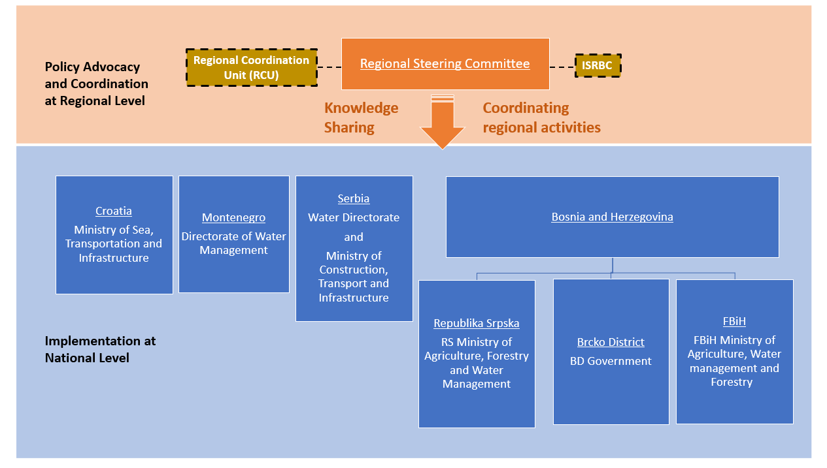

At the national level, implementation will be undertaken by project implementation units within line ministries of each country/entity. In each country/entity, PMUs will be established comprising of the required technical and managerial expertise to support project implementation. In Serbia, two new PMUs will be established, one within the Ministry of Construction, Transport and Infrastructure and the other in the Directorate for Water Management of the Ministry of Agriculture, Forestry and Water. In Montenegro, a PMU will be established under the Ministry of Agriculture and Rural Management. In Croatia, a PMU will be established within the Ministry of Sea, Transport and Infrastructure.

Each PMU will be responsible for the implementation of the assigned national project activities, carry out procurement and supervision/monitoring of contracts, maintain effective internal control procedures, account for expenditures in their existing budgetary accounting systems, receive funds, make payments and provide the documentation and information related to use of the loan/grant proceeds, statement of expenditures (SOE) documentation of the eligible expenditures, project reporting and monitoring. The ISRBC will have the same responsibilities as national PMUs but only for the regional activities.

  - Results Monitoring and Evaluation Arrangements
While the PMUs will be primarily responsible for M&E in Serbia, the ISRBC will be responsible for overall M&E implementation and coordination between the riparian countries and will serve as a liaison with the WB at the regional level and PMUs in each of the riparian countries/entities. An integrated Management Information System (MIS) system will be developed and implemented as part of the program to support implementation and reporting. ISRBC and PMUs will monitor activities and report project progress by reporting on pre-selected project indicators, as presented in the Results Framework. The M&E reports will be presented as part of the regular progress reports. The ISRBC and PMUs will collect and present data and reports for semi-annual reviews by the Regional Committee and respective National institutions responsible for project implementation, in conjunction with Bank missions.
A mid-term review will be conducted to evaluate implementation progress and identify potential issues in need of attention and resolution.

  - Sustainability
The borrower’s commitment is ensured by the strong alignment between the Project’s (and Program’s) investments with national- and regional- level strategies. The Project is also supporting the implementation of the Framework Agreement on the Sava River Basin (FASRB) signed on December 2002 among the signatory States (Bosnia and Herzegovina, Republic of Croatia, Republic of Slovenia, and the Republic of Serbia). FASRB aims to collectively establish the international navigation regime, sustainable water management, manage water related risks, and protection of ecosystems. Subprojects were identified from participating countries’ national priority investments including single project pipeline investments for EU candidate countries, which supports their EU accession progress.
Governments’ actions to finance sub-activity preparation speak to their commitment to achieving the expected results and sustaining the project outcomes. The selected subprojects have been identified and for some prepared by the respective government institutions. The same implementing / government institutions do have the overall mandate for ensuring sustained operations and maintenance for the infrastructure that will be supported through this project. The training, knowledge sharing, and improved monitoring schemes will also ensure stronger institutional sustainability.
With regards to ESMF implementation, MAFWM / MCTI PMUs will: (i (ii) environmental and social screening and evaluation of grant proposal eligibility from the E&S point of view; (iii) communication and coordination with ESA competent authorities (Committee on Environmental Protection); (iv) ensuring proper implementation of the ESMP and ESMP Checklist requirements as well as social due diligence tasks during the subprojects’ realization; (v) addressing complaints and feedback from project stakeholders and the public, including grievances regarding environmental/social impacts of subprojects; (v) supervising (independently or jointly with the State Ecological Inspectorate) environmental protection and mitigation measures stipulated in the ESMPs; (vi) monitoring of environmental impacts as part of overall monitoring of the subproject implementation; and (vii) reporting on environmental and social impacts originated during implementation of subprojects and analysing the efficiency of mitigation measures applied to minimize negative consequences. Together with subproject implementers and beneficiaries, MCTI / MAFWM PMUs and the Grant Manager are responsible for the implementation of above activities
To implement the ESMF the project team will follow the below described Process Cycle by Sectors.

  - Contractor’s Responsibility regarding environmental protection
Construction/Rehabilitation Contractor is responsible for undertaking all activities related to environmental protection during rehabilitation works. During the EMP preparation phase, potential negative environmental impacts will be identified and MCTI/MAFWM PMUs will be obliged to ensure implementation of adequate mitigation measures.
The Contractor will appoint a person responsible for environment protection (B.Sc. environmental engineering) with adequate experience to be responsible for the implementation of all demands of environment protection and the Environment Monitoring Plan implementation.

  - Hiring Requirements - PMU’s Environmental & Social Safeguard Consultant
The PMU within the MAFWM will be responsible for the environmental compliance monitoring and oversight to ensure overall project environmental compliance, except for the subproject 1.3.1 “Expansion and modernization of port of Sremska Mitrovica” where subject activities will be performed by PMU established within the MCTI. The Environmental Specialist and Social Specialist that would be hired by PMUs would assist PMUs to carry out this mandate. Basic Consultants responsibilities are:
- Environmental screening and preparing subproject specific environment screening/assessment report with EMP
- help PMUs in process of obtaining preconditions from relevant institutions (INP/IPCM)
- producing EMP documents for all subprojects
- producing Resettlement Plans for all subprojects where required
- Ensure the implementation of the various mitigation measures proposed for the protection of bio diversity etc., prior to the commencement of SDIP activities at that particular sub-section of the project.
- social interaction, dealing with grievances, communications with PAPs and other project stakeholders
During the period of civil works the environmental and social safeguards specialist will make annual or more frequent mission visits to ensure compliance with project safeguard requirements. Between missions they will review the supervision consultant’s reports to monitor progress and identify issues that may arise. The Safeguards specialists will monitor the implementation in accordance with the Bank safeguard policies, and advise on corrective measures as needed. The implementation of the EMP will be closely monitored, both through reviewing the supervision consultant’s reports and through field visits.

  - Project Supervision Consultants
PMUs are responsible for the supervision of the ESMP implementation in the Project, which will be done through the consulting services – Project Supervision Consultant (PSC).
PSC will review works or contracts believed to have sensitive environmental or social impacts, or those requiring special oversight as determined by the WB. Among other issues, PSC’s review will cover engineering designs and social and environmental safeguard related actions.
In respect to environmental requirements, the specific roles and responsibilities of Project Supervision Consultant shall include, but not limited to the following:
- Supervise the implementation of the ESMP by the Contractors;
- Monitor and review the screening and categorization process for each subproject;
- Review and approve site specific environmental enhancement/mitigation designs worked out by the Contractor;
- Hold regular meetings with the Environmental and Social Specialists
- Review the Contractors Environmental Implementation Plans to ensure compliance with the Environmental Management Plan (EMP);
- Develop good practice construction guidelines to assist the contractors in implementing EMPs;
- Prepare and submit regular environmental monitoring and implementation progress reports;
- Ensure that proper environmental safeguards are being maintained at all ancillary sites such as brick fields, borrow areas, brick crushing area, materials storage yards, worker's camps etc. from which the contractor procures material for rehabilitation works;
- Supervise the proper construction and maintenance of the facilities for the labor camps, including the provisions for the safety and health of workers and their families;
- producing the Monthly Progress Reports and submitting them to PMU

Table 7. Process Cycle by Sectors, for the implementation of ESMF
 | Activity | Primary | Secondary
1. | Capacity building of the  PMUs (within the MAFWM and MCTI) and implementing partners on the new ESF  standards application | WB staff  External E&S specialists | MAFWM PMU
2 | EIA Licenses / Permits | PMU | PMU
3 | Borrow pits exploitation and Landfills deposit , | The Contractor | The Contractor
4. | Incorporation of E&S  requirements and guidelines | PMU | PMU
5 | Preparation, internal approval, Clearance and approval of the Project Operational Manual | PMU  WB SDIP TTLs | PMU  E&S Specialist
6. | Incorporation of the E&S  requirements and guidelines into the Tender Packages | PMU | PMU,  Procurement Specialists
7. | Stakeholder Engagement Plan  Implementation | PMU | E&S Specialists
8. | Establishing GRM | PMU | Local Municipalities
9. | Environmental and Social Screening of Subprojects | PMU | PMU E&S Specialists
10. | Final screening of grant  proposals received for eligibility, including E&S requirements | Grant Committee
11. | ESMP Checklist and Social  Screening completion for Subprojects | PMU | PMU E&S Specialists
12. | ESMP Checklist and Social Screening Checklists verification | MAFWM PMU E&S Specialists | WB
13. | Development of ESS  instruments (site specific  ESIA/ESMP, RPs if needed) | PMU  Borrowers | PMU  E&S Specialists
14. | Quality control and submission  of ESS instruments to the WB | PMU | E&S Specialists
15. | Review and approval of ESS  instruments | WB E&S  Specialists | Project TTLs
16. | Implementation of ESMPs | Contractor | Subcontractors
17. | Monitoring and reporting on  ESMP implementation | PMU | Project Supervision  E&S Specialists
18. | Supervision of ESMP/ RAP  implementation | PMU | Project Supervision  GM  E&S Specialists

The ESMF has checklists for determining where and when site specific Environment and Social Impact Assessments (ESIAs)/Management Plans (ESMPs) will be necessary.
The Environmental and Social Management Plan (ESMP) will identify feasible and cost-effective measures that may reduce potentially significant adverse environmental and social impacts to acceptable levels. The ESMP divides the project cycle into three phases: construction, operation and decommissioning. For each phase, the project team identifies any significant environmental and social impacts. For each impact, mitigation measures are to be identified and listed. Estimates are made of the cost of mitigation actions broken down by estimates for installation (investment cost) and operation (recurrent cost). The ESMP format (enclosed in Annex 10) also provides for the identification of institutional responsibilities for "installation" and operation of mitigation devices and methods. To keep track of the requirements, responsibilities and costs for monitoring the implementation of ESMP, a Monitoring Plan will be applied.

- PROJECT GRIEVANCE MANAGEMENT

A Project level grievance mechanism (GM) will consist of a Central Feedback Desk (CFD) administered by the PMUs and Subproject specific Grievance Desks (LGD) (collectively referred to as Grievance Mechanism (GM)) established and administered by the local Governments with representatives from the key three stakeholders PMUs representative, Municipal representative and representative of the PAPs.
To ensure GM access, potential beneficiaries, communities and other stakeholders may submit grievances through channels as outlined below. The GM will provide the opportunity for continued feedback on the Subprojects and resolution of individual grievances during implementation. Procedures related to complaints handling will be posted on the MAFWM’s website to ensure full transparency.
The GM shall serve as both Project level information center and grievance mechanism, available to those affected by implementation of all Project sub-components and be applicable to all Project activities and relevant to all local communities affected by project activities. The GM shall be responsible for receiving and responding to grievances and comments of the following two groups:
- A person/legal entity directly affected by the project, potential beneficiaries of the Project,
- A person/legal entity directly affected by the project through land acquisition and resettlement,
- Stakeholders - people with interest in the project, and
- Residents/communities interested in and/or affected by project activities.
The Central Feedback Desk (CFD) shall be effective immediately after appraisal of the Project, in order to manage and appropriately answer complaints during its different phases while the LGD shall be effective upon decision on each new Subproject has been taken. In addition to the GM, legal remedies available under the national legislation are also available (courts, inspections, administrative authorities etc.).
However, the grievance mechanism for project workers required under ESS2 will be provided separately with details to be provided in the Labor Management Procedures.
MAFWM and the Local Governments respectively are responsible for establishing functioning GM and informing stakeholders about the GM role and function, the contact persons and the procedures to submit a complaint in the affected areas. Information on the GM will be available:
- on the website of the MAFWM (http://www.minpolj.gov.rs/.)
- on the notice boards and websites of Local Governments
- through social media campaigns.

  - Raising grievances
Effective grievance administration strongly relies on a set fundamental principle designed to promote the fairness of the process and its outcomes. The grievance procedure shall be designed to be accessible, effective, easy, understandable and without costs to the complainant. Any grievance can be brought to the attention of the GM personally or by telephone or in writing by filling in the grievance form by phone, e-mail, post, fax or personal delivery to the addresses/numbers to be determined. The access points and details on local entry points shall be publicized and shall be part of the awareness building once further micro locations of the Subprojects are known. So far two Subprojects have been identified as mature, the Flood Protection Works On the left River Bank of Sava in Popova Bara and Jarak. Within the RP prepared for these two Subprojects details on the GM shall be provided.

  - Grievances administration
Any grievance shall follow the path of the following mandatory steps: receive, assess and assign, acknowledge, investigate, respond, follow up and close out.
Once logged, the GM shall conduct a rapid assessment to verify the nature of grievances and determine on the severity. Within 3 days from logging it will acknowledge that the case is registered and provide the grievant with the basic next step information. It will then investigate by trying to understand the issue from the perspective of the complainant and understand what action he/she requires. The GM will investigate the facts and circumstances and articulate an answer. The final agreement should be issued and grievant be informed about the final decision not later than 30 days after the logging of the grievance. Closing out the grievance occurs after the implementation of the resolution has been verified. Even when an agreement is not reached, or the grievance was rejected, is the results will be documented, actions and effort put into the resolution. If the grievance could not be resolved in amicable endeavor, the grievant can resort to the formal judicial procedures, as made available under the Serbian national legal framework. Logging a grievance with the GM does not preclude or prevent seeking resolution from an official authority, judicial or other at any time (including during the grievance process) provided by the Serbian legal framework.
In case of anonymous grievance, after acknowledgment of the grievance within three days from logging, the GM will investigate the grievance and within 30 days from logging the grievance, issue the final decision that will be disclosed on the PMU’s website.
Each GM shall keep a grievance register log, which will include grievances received through all admission channels, containing all necessary elements to disaggregate the grievance by gender of the person logging it as well as by type of grievance. However, the personal data of each Grievant shall be protected under the Data Protection Law. Each grievance will be recorded in the register with the following information at minimum:
- description of grievance,
- date of receipt acknowledgement returned to the complainant,
- description of actions taken (investigation, corrective measures),
- date of resolution / provision of feedback to the complainant,
- verification of implementation, and
- closure.
To avoid multiple Grievances by the same person on the same subject simply because different admission channels exist, the LGD and the CGD shall weekly exchange information on grievances received and compare the Grievance logs. The centralized log at the level of the CGD will contain notes on potentially duplicated submissions. Multiple submissions, on same events, by same grievant shall be resolved by one decision, which will be stated and the grievant appropriately informed.

  - Grievance and beneficiary feedback reporting
The role of the GM, in addition to addressing grievances, shall be to keep and store comments/grievances received and keep the Central grievance log administered by the PMUs established within the MAFWM and MCTI. In order to allow full knowledge of this tool and its results, quarterly updates from the GM shall be available on the MAFWM website. The updates shall be disaggregated by gender, type of grievances /complaints and updated regularly.

    - Grievance Log
The PMUs will maintain grievance log to ensure that each complaint has an individual reference number and is appropriately tracked and recorded actions are completed. When receiving feedback, including grievances, the following is defined:
- Type,
- Category,
- Deadline for resolving the appeal, and
- Agreed action plan.
Each complaint should be assigned with an individual reference number and is appropriately tracked and recorded actions are completed. The log should contain the following information:
- Name of the grievant, location and details of the grievance.
- Date of submission.
- Date when the Grievance Log was uploaded onto the project database.
- Details of corrective action proposed,
- Date when the proposed corrective action was sent to the complainant (if appropriate).
- Date when the grievance was closed out.
- Date when the response was sent to the grievant.
    - Grievance admission channels
Any grievance can be brought to the attention of the GM by filling the grievance form in hard copy or on-line, or in any other format as chosen by the grievant. The Grievance form is provided in Annex 16.
Any type of grievance can be submitted by mail, fax, phone, e-mail or in person using the below access details:
Ministry of Agriculture, Forestry and Water Management
PMU
To the attention of the CGD
Address TBD
11000 Beograd
And
Access details of each LGD to be known at later stages and to be disseminated at later stages
    - Monitoring and Reporting on Grievances

The CFD will be responsible for:
  - Collecting data from LGD serving as local admission points on the number, substance and status of complaints and uploading them into the single regional database;
  - Maintaining the grievance logs on the complaints received at the regional and local level
  - Monitoring outstanding issues and proposing measures to resolve them;
  - Disclosing quarterly reports on GM mechanisms.
  - Summarizing and analyzing the qualitative data received from the local Grievance Admission points on the number, substance and status of complaints and uploading them into the single project database;
  - Monitoring outstanding issues and proposing measures to resolve them;

The monthly social monitoring reports to the WB shall be submitted through the PMU, which shall include a section related to GM which provides updated information on the following:
- Status of GM implementation (procedures, training, public awareness campaigns, budgeting etc.);
- Qualitative data on number of received grievances (applications, suggestions, complaints, requests, positive feedback) and number of resolved grievances;
- Quantitative data on the type of grievances and responses, issues provided and grievances that remain unresolved;
- Level of satisfaction by the measures (response) taken;
- Any corrective measures taken.

  - World Bank Grievance Redress System
Communities and individuals who believe that they are adversely affected by a World Bank (WB) supported project may submit complaints to existing project-level grievance redress mechanisms or the WB’s Grievance Redress Service (GRS). The GRS ensures that complaints received are promptly reviewed in order to address project-related concerns. Project affected communities and individuals may submit their complaint to the WB’s independent Inspection Panel which determines whether harm occurred, or could occur, as a result of WB non-compliance with its policies and procedures. Complaints may be submitted at any time after concerns have been brought directly to the World Bank’s attention, and Bank Management has been given an opportunity to respond. For information on how to submit complaints to the World Bank’s corporate Grievance Redress Service (GRS), please visit http://www.worldbank.org/en/projects-operations/products-and-services/grievance-redress- service. For information on how to submit complaints to the World Bank Inspection Panel, please visit www.inspectionpanel.org.

- STAKEHOLDER ENGAGEMENT

In response to the commitment of the GOS to comply with the ESF, the Ministry of Agriculture, Forestry and Water Management (MAFWM) has developed a Stakeholder Engagement Plan (SEP) for the Subprojects known at this stage and as a framework approach for Subprojects where the design and location of the project since it has multiple subprojects that will only be designed during project implementation, to guide the project’s stakeholder engagement in line with ESS 10 - Stakeholder Engagement and Information Disclosure, from the early stages and throughout the Project cycle focusing on gender gaps and tailored approaches.
The Republic of Serbia citizen engagement commitments do not reside under a single self-standing law or regulation. However, the recognition of importance of citizen engagement is embedded in the legal system and clearly recognized by the mandatory procedures provided by individual laws. The specific nature of the Project yet leaning on to completed and on-going sector interventions within the water agenda required a broad engagement with various project stakeholders and is ongoing since early 2019.
Various stakeholder engagement activities are proposed to ensure awareness and meaningful consultations about Project activities. The outreach and stakeholder engagement will be gender appropriate, taking into consideration the after-hour chores of women. Targeted messaging will encourage the participation of women, those living in areas with risks from flooding and highlight Project characteristics that are designed to respond to their needs and increase their access to Project benefits. Citizen engagement and feedback survey shall be part of the engagement agenda.
All ESF instruments shall be subject to adequate disclosure and public consultations in line with the SEP, and ESS1.

- STAKEHOLDER CONSULTATIONS

As required by WB Environmental and Social Standard 10 (ESS10) – Stakeholder Engagement and Information disclosure, during preparation of Draft ESMF, ESCP, RPF, SEP and LMP documents the Borrower carried out public consultations with relevant stakeholders.
Starting from 19 December 2019, MAFWM disclosed the Draft ESMF, ESCP, RPF, SEP and LMP documents on its web site and announced invitation for Public Consultations for the public, bodies and organizations interested in subject documents prepared for SDIP Project. Same announcement was published in the daily newspaper with national coverage “Politika” on 26 December 2019. Public and other interested parties and organizations were invited to participate in process of public consultation on draft ESMF, ESCP, RPF, SEP and LMP documents.
Draft documents and invitation to the Public Consultations were also available on the web site of the MAFWM: http://www.rdvode.gov.rs/aktuelno.php.
On 30 December 2019, at 12:00 AM (local time), public consultations and presentation of the Draft ESMF, ESCP, RPF, SEP and LMP documents were organized at the premises of the Ministry of Agriculture, Forestry and Water Management - Serbian Directorate for Water Management, Room 301, III floor, Bulevar umetnosti 2a, 11000 Belgrade. The meeting was attended by a diverse group of 21 stakeholders, namely representatives of MAFWM – Directorate for water management, Public Water Management Company “Srbijavode”, Citizen Association “Akademija inzenjerskih nauka Srbije - The Academy of Engineering Sciences of Serbia”, non-formal Citizen Group “Pravo na vodu – Right2water” and NGO Coalition “Save the Blue Heart of Europe” and Association “Jugo Cikling Kampanja – Yugo Cycling Campaign”.
Project screening procedure and risk classification are explained, as well as legal and administrative framework for Project.
Special focus was given to project description, implementation arrangements, potential environmental and social impacts, grievance redress procedures, labor management, screening forms and development of environmental and social management plans during Project implementation.
Consultation ended at 3:30 PM, local time.

Full Report on public consultations is attached as Annex 15 of this ESMF document.

REFERENCES:

- Project Appraisal Document (PAD) for the first phase of the Sava and Drina River Corridors Integrated Development Program
- Drina River Basin Roof Report, COWI & Jaroslav Cerni Institute, 2017
- Sava River Basin Analysis Summary, International Sava River Basin Commission, 2010
- Protection of Biodiversity of the Sava River Basin Floodplains, Orbicon & Institute for nature Conservation of Serbia
- Output Report on the Sava and Drina Corridor Integrated Development Program, World Bank Group, 2018
- Environment Technical Assistance for the Preparation of the GEF SCCF West Balkans Drina River Basin Management Project and Social Management Framework for West Balkans Drina River Basin Management Project, 2016

ANNEX 01: PROJECT ACTIVITIES

Component 1: Integrated Management and Development of the Sava River Corridor | Readiness | Costs (€ Million)
1.1 Flood protection and environmental management
1.1.1 Raising right Sava dyke in Šabac City, Serbia | Design and ESF documents by September 2020 | 5.5
1.1.3 Rehabilitation of left Sava dyke in Progar-Kupinovo for flood protection in Serbia | Design and ESF documents by September 2020 | 3.6
1.1.4 Rehabilitation of left Sava dyke in Klenak, Serbia for flood protection | Design and ESF documents by September 2020 | 0.4
1.1.5 Raising Sava River dykes at Macvanska Mitrovica (right dyke) for flood protection in Serbia |  | 1.5
1.1.6 Rehabilitation of left Sava riverbank in Jarak Serbia | Design and ESF documents ready | 10.0
1.1.7 Embankment stabilization of left Sava River dyke in Popova Bara, Serbia | Design and ESF documents ready | 6.8
1.1.13 Design and Reconstruction of Kolubara dykes to protect Obrenovac City in Serbia | Design and ESF documents by March 2021 | 14
1.1.14 Design and Raising dykes in Novi Beograd to protect Belgrade City (Serbia) from flood | Design and ESF documents by March 2021 | 7
1.1.18 Construction and rehabilitation of embankment and dykes in Republika Srpska |  | 18.7
1.1.20 Reforestation in Vrbanja, Vrbas and Sava River basin |  | 2.2
1.1.21 Protection of ecological environment and biodiversity of Una River |  | 0.2
1.1.22 Purchase of equipment in Republika Srpska |  | 0.8
1.2 Waterway improvements
1.2.1 Demining right bank of Sava River |  | 8
1.3 Enhancement of ports facilities, services and logistics
1.3.1 Expansion and modernization of port of Sremska Mitrovica |  | 17
Component 2: Integrated Management and Development of along the Drina River Corridor
2.1 Flood protection and environmental management
2.1.1 Flood protection in the Lim River in Serbia | Design and ESF documents by September 2020 | 4.1
2.1.2 River training in Gorazde city within the Federation of Bosnia and Herzegovina |  | 8.4
2.2 Integrated development of lower Lim watershed
2.2.1 Integrated development of Lower Lim River in Montenegro | Design and ESF documents by September 2020 | 15
Component 3: Project preparation and management
3.1 Phase II Preparation
3.1.1 Project Preparation for Phase II Activities |  | 8.1
3.2 Institutional strengthening and project management
3.2.1 PMU and project management, Phase I |  | 5.2
3.2.2 Implementation and Operations Cost, Phase I |  | 5.2
Component 4: Regional activities
4.1 Regional Dialogues and Studies
4.1.1 Preparation of the 2nd Sava RBMP |  | 1.0
4.1.2 Hydrological Study for Sava River Basin |  | 2.0
4.1.3 Study on sediment, water and biota in Sava River Basin |  | 1.4
4.1.4 Climate Change Adaptation Strategy for the Sava River Basin |  | 1.0
4.1.5 Design of a Master Plan for Sustainable Tourism Development in Sava River Basin |  | 1.2
4.1.6 Advanced flood monitoring, forecasting and management system |  | 1.5

ANNEX 02: DETAILED MPA PROGRAM FRAMRWORK FOR THE SDIP PROGRAM

Program Development Objective | Facilitate integrated transboundary water resources management and development along the Sava and Drina river corridors.
Total Duration | 10 years
Phase | Phase I  BiH, Montenegro and Serbia | Phase II  BiH, Croatia, Montenegro, Serbia and Slovenia
Phased development objective | Improve flood protection, and transboundary water resources management in selected catchment areas of the Sava and Drina river corridors. | Improve flood protection, navigability, and transboundary water resources management and development in selected catchment areas of the Sava and Drina river corridors.
Overall Risk | H | H
Components | Phase I | Phase II
Component 1: Integrated Management and Development of the Sava River Corridor | Works on flood protection and environmental management will be implemented throughout the five years. | Works on flood protection and environmental management, with a growing focus on nature-based solutions following various Phase I studies and capacity building activities, will be implemented throughout the five years and be expanded to RoS and FBiH of BiH.
 | In first year, detailed design for the port of Brcko and the port of Gradiska enhancement will be completed. Equipment purchase and installation and works for the Port of Brcko will be implemented subsequently. | Enhancement for Port of Sremska Mitrovica in Serbia will be implemented during this phase.
 | Demining of the right bank of Sava River in BiH will be implemented during the first two years subject to availability of WBIF investment grants. | Subject to completion of demining of the right bank of Sava waterway, additional improvement and maintenance works will be implemented in BiH and Croatia.
Component 2: Integrated Management and Development of the Drina River Corridor | Flood protection and environmental management works will be implemented in the Lim river basin of Serbia and Montenegro. | Scale up flood protection and environmental management works based on priorities identified from the GEF-SCCF Drina project and the ESMAP hydropower project studies.
 | Integrated development of lower Lim watershed in Montenegro. | Integrated development of lower Lim watershed in Montenegro. Building on capacity building activities and lessons learned from Phase I, similar interventions will be scaled up to other watersheds facing similar challenges in the region.
Component 3: Enabling regional economic integration, institutional strengthening and project management | Project preparation for phase I activities that will be implemented in year 4-5 in this phase and phase II activities identified during phase I.
 | Development of the 2nd Sava River Basin Management Plan and conduct hydrological studies for the Sava River. | Scale up regional dialogue and studies including the alluvial aquifers study and development of climate change adaptation strategy for the Sava River Basin.
 | Establishing platforms in support of Regional Dialogue | Operationalize platforms developed in Phase I to promote regional cooperation. Design of a Master Plan for sustainable eco-tourism in Sava and Drina River Basin. Setup of pontoon networks for anchoring touristic vessels.

ANNEX 03: EXCLUSION LIST OF PROJECT / ACTIVITIES

Each project which falls under list A or list B will not be eligible for financing under SDIP Project
The IFC Exclusion List defines the types of projects that IFC does not finance.
IFC does not finance the following projects:
- Production or trade in any product or activity deemed illegal under host country laws or regulations or international conventions and agreements, or subject to international bans, such as pharmaceuticals, pesticides/herbicides, ozone depleting substances, PCB's, wildlife or products regulated under CITES.
- Production or trade in weapons and munitions.
- Production or trade in alcoholic beverages (excluding beer and wine).¹
- Production or trade in tobacco.¹
- Gambling, casinos and equivalent enterprises.¹
- Production or trade in radioactive materials. This does not apply to the purchase of medical equipment, quality control (measurement) equipment and any equipment where IFC considers the radioactive source to be trivial and/or adequately shielded.
- Production or trade in unbounded asbestos fibers. This does not apply to purchase and use of bonded asbestos cement sheeting where the asbestos content is less than 20%.
- Drift net fishing in the marine environment using nets in excess of 2.5 km. in length.
A reasonableness test will be applied when the activities of the project company would have a significant development impact but circumstances of the country require adjustment to the Exclusion List.
All financial intermediaries (FIs), except those engaged in activities specified below*, must apply the following exclusions, in addition to IFC's Exclusion List:
- Production or activities involving harmful or exploitative forms of forced labor/harmful child labor.³
- Commercial logging operations for use in primary tropical moist forest.
- Production or trade in wood or other forestry products other than from sustainably managed forests.
* When investing in microfinance activities, FIs will apply the following items in addition to the IFC Exclusion List:
- Production or activities involving harmful or exploitative forms of forced labor²/harmful child labor.³
- Production, trade, storage, or transport of significant volumes of hazardous chemicals, or commercial scale usage of hazardous chemicals. Hazardous chemicals include gasoline, kerosene, and other petroleum products.
- Production or activities that impinge on the lands owned, or claimed under adjudication, by Indigenous Peoples, without full documented consent of such peoples.
* Trade finance projects, given the nature of the transactions, FIs will apply the following items in addition to the IFC Exclusion List:
- Production or activities involving harmful or exploitative forms of forced labor²/harmful child labor.³

ANNEX 04: ESQ - ENVIRONMENTAL SCREENING QUESTIONNAIRE - TEMPLATE

Title of the Project:
Project IF ID:
City/Municipality:
Contact email address:
CRITERIA |  |  |  | ANSWER YES or NO  (unless otherwise stated)
Does the proposed activity require a FULL Environmental Impact Assessment as
per the Serbian Law on Environmental Impact Assessment (list of projects for which full EIA is mandatory/decided)? If yes, this activity cannot be financed.
Does the existing enterprise have valid operating permit, licenses, approvals
etc.? If not, please explain. Permits to screen for include: construction permit,
operational/use permit, urban permit, water management permit…

If not, will the grant financing be used to correct this condition?
Does the existing enterprise have a valid environmental permit (or is in the
procedure of obtaining an environmental permit as per the Serbian laws) and does the proposed activity fall under those for which this permit was issued?
Does the existing enterprise have a valid water management permit that calls
for special investments or measures for the enterprise’s wastewater releases (or
is in the procedure of obtaining this permit as per the Serbian laws)?
Does the existing enterprise need to follow specific Serbian environmental regulations regarding air emissions, water use or wastewater discharge and solid waste management?
Are there any significant outstanding environmental fees, fines or penalties or
any other environmental liabilities (e.g. pending legal proceedings involving environmental issues etc.)
If so, will the grant financing be used to correct this condition and please explain?
Have there been any complaints raised by local affected people or groups or
NGOs regarding conditions at the facility?
If so, will the grant financing be used to remedy these complaints?
Does the existing enterprise take care about primary suppliers’ environmental
and social performance or practice Socially Responsible Public Procurement?
If possible, explain the answer
Does the existing enterprise take care about associated facilities (if applicable)
relevant environmental and social performance?
If possible, explain the answer

Proposed Activity
CRITERIA |  |  | ANSWER YES or NO  (unless otherwise stated)
Will the activity generate water effluents (wastewater) that may require special
treatment, control or the water management permit?
Will the activity air emissions which would require special controls in order to
ensure compliance with the Serbian standards?
Will the activity generate noise levels that would require control measures to
ensure compliance with the Serbian standards?
Will the noise levels impact particularly sensitive receptors (natural habitats, hospitals, schools, local population centers)?
Will the activity consume, use or store, produce hazardous materials that:

• require special permits or licenses
• require licensed or trained personnel
• are outlawed or banned in EU or Western countries
• are difficult, expensive, or hard to manage
• are inconsistent with PPAH recommendations
• may cause soil and water pollution or health hazards if adequate control measures are not in place
Will the activity generate solid waste that may be considered hazardous, difficult
to manage, or may be beyond the scope of regular household waste?

(This may include, but not be limited too, animal carcasses, toxic materials, pesticides, medical waste, cleaning materials, flammables etc.)
Will the activity be located within or close to officially protected areas or areas
under consideration by the Government for official protection status? And will the activity potentially impact areas of known significance to local, regional or national cultural heritage?
Will the activity involve import of living organisms, e.g. saplings, insects, animals, etc. or works that can impact sensitive environmental receptors?
Has the local population or any NGOs expressed concern about the proposed
activity’s environmental aspects or expressed opposition?

Is there any other aspect of the activity that would – through normal operations or under special conditions – cause a risk or have an impact on the environment, the population or could be considered as a nuisance?

 | SOCIAL SCREENING FORM AND TRIGGERS FOR SUB PROJECTS
 | Screening indicators related to Land acquisition, assets and access to resources
 |  | Type of activity – Will the sub project:
 |  | Require that land (private) to be acquired (temporarily or permanently) for its development
 |  | Use land that is currently occupied or regularly used for productive purposes (e.g. gardening, farming, pasture, fishing locations, forests
 |  | Physically displace individuals, families or businesses
 |  | Result in the temporary or permanent loss of crops, fruit trees or household infrastructure
 |  | Result in the involuntary restriction of access by people to legally designated parks and protected areas
 |  | Result in loss of livelihood
 |  | Have negative impact to any vulnerable individuals or groups
 |  | Have negative impact to informal side road shops, traders or any nomadic type of commercial activity

Form checked by
(PMU Social Specialist)

Project category is: H_ ,S_ , M_ L
Date
Name
Title
Signature

Form checked by
(PMU Environmental Specialist)

Project category is: H_ ,S_ , M_ L
Date
Name
Title
Signature

ANNEX 05 LIST I – PROJECTS REQUIRING A MANDATORY ENVIRONMENTAL IMPACT ASSESSMENT

LIST I  Projects Requiring a Mandatory Environmental Impact Assessment  1. Plants for:  1) Refining oil, oil derivatives and natural gas;  2) Gasification and melting of coal or oil seal shale, heavy crude oil residues.  2. Plants:  1) For the production of electricity, water steam, hot water, technological steam or  heated gases, by using all types of fuel, as well as plants for driving working  machinery (thermal power plants, heating plants, gas turbines, internal  combustion engine plants and other devices for combustion, including steam  boilers) with 50 MW or more power;  2) Nuclear reactors, including the disassembly or removal from operation of such  Reactors¹, other than scientific research plants for the production and  conversion of fission and enriched materials with a total power not exceeding 1  kW of constant thermal load.  3. Plants:  1) For the treatment of spent nuclear fuel;  2) Envisaged:  - For the production or enrichment of nuclear fuel;  - For the treatment of spent nuclear fuel or highly radioactive nuclear waste;  - For the permanent disposal of spent nuclear fuel;  - For the permanent disposal of nuclear waste;  - For the treatment, storage and disposal of radioactive waste.  4. Plants:  1) For roasting or sintering metal ore (including sulphide ore);  2) For the production of raw iron or steel (primary or secondary melting) including  continuous casting, with a capacity exceeding 2.5 t/h;  3) For processing in ferrous metallurgy:  - Hot rolling mills with a capacity of over 20 t/h of raw steel;  - Forges with automatic hammers with energy exceeding 50 kJ per single  hammer, where the used heat power exceeds 20 MW;  - Plants for the application of metal protective layers to metallic surfaces using  molten baths, with an input exceeding 2 t/h of raw material;  4) Foundry for ferrous metals with a production capacity of over 20 t per day;  5) Plants:  - For the production of non-ferrous raw metals from ore, concentrates or secondary raw materials through metallurgic and/or chemical processes, and/or electrolytic processes;  - For melting including the production of alloys from non-ferrous metals, as well as the production of by-products (refining, casting, etc.), with a melting capacity of over 4 t per day for lead and cadmium, or 20 t per day for all other  metals; 6) For the surface processing of metals and plastic materials using electrolytic or  chemical processes, where the volume of the treatment tubs exceeds 30 m3.  5. Plants for:  1) Extraction, production, refining and processing of asbestos and products  containing asbestos;  2) Production of cement clinker, cement and lime in rotational or other furnaces with capacities over 500 t per day for the production of cement clinker or lime with a capacity of over 50 t per day in rotational furnaces.  6. Combined chemical plants, i.e. plants for the industrial production of substances where chemical change procedures are applied and where individual plants are located next to one another and are functionally connected, intended for the production of:  - Basic organic chemicals;  - Basic non-organic chemicals;  - Phosphorus, nitrogen or potassium-based artificial fertilizers (simple or complex  fertilizers);  - Basic plant protection products, as well as biocides;  - Basic pharmaceutical products with the application of chemical or biological  procedures;  - And/or refining and/or processing of explosives.  7. Construction of:  1) Main railway lines including ancillary facilities (bridges, tunnels and stations);  2) Main highways and roads with four or more lanes, or the reconstruction and/or  expansion of an existing road with two lanes or fewer, with the aim of producing  a road with four or more lanes, in case such a new road or a reconstructed  and/or expanded section has a continuous length of over 10 km or more,  including ancillary facilities, other than the supporting content of the main road;  3) Airports for engaging in public air transport² with a take-off runway longer than  2,100 m.  8. Interior waterways whereupon the international or interstate navigational regime  is in force, as well as ports and docks located on an interior waterway whereupon  the international or interstate navigational regime is in force, regulation works on  interior waterways enabling the passage of vessels over 1350 t.  9. Plants for the treatment of hazardous waste by burning, thermal and/or physical,  physical-chemical, chemical procedures, as well as central storage and/or landfills for  depositing hazardous waste.³  10. Plants for the treatment of non-hazardous waste by burning or chemical  procedures⁴ with a capacity exceeding 70 t per day; communal waste landfills for  over 200,000 population equivalent.  11. Exploitation of ground water or enrichment of ground water where the annual  volume of exploited or enriched water is equal to the amount of 10 million m3 or  more.  12. Facilities:  1) Hydro-technical facilities for transferring waters between river basins intended to  prevent potential water shortages where the amount of transferred water  exceeds 100 million cubic metres annually;  2) In all other cases, facilities intended for transferring waters between river basins where the multi-annual average of the flow in the basin where the water is captured exceeds 2,000 million m3 per year and where the amount of transferred water exceeds 5% of this flow, except in case of transfer of potable water by pipelines.  13. Plants for cleaning waste water in settlements with populations over 100,000.  14. Extraction of oil and natural gas.  15. Dams and other facilities intended for holding and accumulating waters where  the water arriving, or additionally retained, or accumulated exceeds the amount of  10 million m3.  16. Pipelines for the transport of gas, liquid gas, oil and oil derivatives or chemicals  with a diameter exceeding 800 mm and a length exceeding 40 km.  17. Facilities for the intensive breeding of poultry or pigs with a capacity exceeding:  - 85,000 places for the production of broilers;  - 40,000 places for poultry in breeding and exploitation;  - 2,000 places for the production of pigs (over 30 kg of weight);  - 750 places for sows.  18. Industrial plants for the production of:  1) Cellulose from wood pulp, hay or similar fibrous materials;  2) Paper and cardboard with a production capacity exceeding 20 t/day.  19. Open pit mines for mineral resources with a surface exceeding 10 ha, or the  extraction of peat when the surface area of the exploitation terrain exceeds 100 ha.  20. Construction of overhead power lines with voltages amounting to 200 kV or more  and lengths exceeding 15 km.  21. Facilities intended for the storage of oil, petrochemical or chemical products,  natural gas, flammable liquids and fuels with a capacity of 100,000 t or more.  22. Activities and plants that are issued integrated permits in accordance with the  Regulation on the types of activities and plants that are issued an integrated permit  (”Official Gazette of RoS”, no. 84/05).  ___________________________________________________________________  1 Nuclear reactors cease to be such plants once the entirety of the nuclear fuel and  other radioactively polluted elements are permanently removed from the place where  the plants have been built.  2 An “airport” involves airports corresponding to the definition envisaged by the  Chicago Convention of 1944 whereby the International Civil Aviation Organization  was founded (Annex 14).  3 Plants defined in Annex IIA with Directive 75/442/EEC, under heading D9, as well  as landfills for disposing of hazardous waste where Directive 91/689/EEC applies.  4 Plants defined in Annex IIA with Directive 75/442/EEC under heading D9. | LISTA I  Projekti za koje je obavezna procena uticaja na zivotnu sredinu  1. Postrojenja za:  1) preradu nafte, naftnih derivata i prirodnog gasa;  2) gasifikaciju i topljenje uglja ili bitumenskih skriljaca, teskih ostataka sirove nafte.  2. Postrojenja:  1) za proizvodnju elektricne energije, vodene pare, tople vode, tehnoloske pare ili zagrejanih gasova, upotrebom svih vrsta goriva, kao i postrojenja za pogon radnih masina (termoelektrane, toplane, gasne turbine, postrojenja sa motorom sa unutrasnjim sagorevanjem i ostali uredjaji za sagorevanje ukljucujuci i parne kotlove) sa snagom od 50 MW ili vise;  2) nuklearni reaktori, ukljucujuci demontazu ili iskljucenje iz pogona takvih reaktora¹,izuzev naucnoistrazivackih postrojenja za proizvodnju i konverziju fisionih i obogacenih materijala, cija ukupna snaga ne prelazi 1 kW stalnog termalnog opterecenja.  3. Postrojenja:  1) za preradu istrosenog nuklearnog goriva;  2) predvidjena:  - za proizvodnju ili obogacenje nuklearnog goriva;  - za preradu istrosenog nuklearnog goriva ili visoko radioaktivnog nuklearnog otpada;  - za trajno odlaganje istrosenog nuklearnog goriva;  - za trajno odlaganje nuklearnog otpada;  - za preradu, skladistenje i odlaganje radioaktivnog otpada.  4. Postrojenja:  1) za pecenje ili sinterovanje metalne rude (ukljucujuci sulfidnu rudu);  2) za proizvodnju sirovog gvozdja ili celika (primarno ili sekundarno topljenje) ukljucujuci kontinualno livenje, sa kapacitetom koji prelazi 2,5 t/h;  3) za preradu u crnoj metalurgiji:  - tople valjaonice sa kapacitetom iznad 20 t/h sirovog celika;  - kovacnice sa automatskim cekicima cija energija prelazi 50 kJ po jednom cekicu, kod kojih upotrebljena toplotna snaga prelazi 20 MW;  - postrojenja za nanosenje metalnih zastitnih slojeva na metalne povrsine pomocu topljenih kupki, sa ulazom koji prelazi 2 t/h sirovog materijala;  4) Livnica crne metalurgije sa proizvodnim kapacitetom preko 20 t na dan;  5) Postrojenja:  - za proizvodnju obojenih sirovih metala iz rude, koncentrata ili sekundarnih sirovina putem metalurskih i/ili hemijskih procesa i/ili elektrolitickih procesa;  - za topljenje ukljucujuci i izradu legura od obojenih metala, kao i izradu korisnih nusproizvoda (rafinacija, livenje, itd.), sa kapacitetom topljenja od preko 4 t dnevno za olovo i kadmijum ili 20 t dnevno za sve ostale metale;  6) za povrsinsku obradu metala i plasticnih materijala koriscenjem elektrolitickih ili hemijskih procesa, gde zapremina kada za tretman prelazi 30 m3.  5. Postrojenja za:  1) ekstrakciju, proizvodnju, preradu i obradu azbesta i proizvoda koji sadrze azbest;  2) proizvodnju cementnog klinkera, cementa i kreca u rotacionim ili drugim pecima kapaciteta preko 500 t dnevno za proizvodnju cementnog klinkera ili kreca kapaciteta preko 50 t dnevno u rotacionim pecima.  6. Kombinovana hemijska postrojenja, tj. postrojenja za industrijsku proizvodnju supstanci kod kojih se primenjuju postupci hemijske promene i u kojima se pojedini pogoni nalaze jedan pored drugog i funkcionalno su povezani, a namenjeni su za proizvodnju:  - osnovnih (baznih) organskih hemikalija;  - osnovnih (baznih) neorganskih hemikalija;  - vestackih djubriva na bazi fosfora, azota ili kalijuma (prosta ili slozena djubriva);  - osnovnih (baznih) proizvoda za zastitu bilja, kao i biocida;  - osnovnih (baznih) farmaceutskih proizvoda uz primenu hemijskih ili bioloskih postupaka;  - i/ili preradu i/ili obradu eksploziva.  7. Izgradnja:  1) magistralnih zeleznickih pruga ukljucujuci pripadajuce objekte (mostove, tunele i stanice);  2) magistralnih autoputeva i puteva sa cetiri ili vise traka, ili rekonstrukcija i/ili prosirenje postojeceg puta sa dve trake ili manje, sa ciljem dobijanja puta sa cetiri ili vise traka, u slucaju da takav novi put ili rekonstruisana i/ili prosirena deonica imaju neprekidnu duzinu od preko 10 km ili vise, ukljucujuci pripadajuce objekte, osim pratecih sadrzaja magistralnog puta;  3) aerodromi za obavljanje javnog avio-transporta2 cija je poletna pista duza od 2.100 m.  8. Unutrasnji plovni putevi na kojima vazi medjunarodni ili medjudrzavni rezim plovidbe, kao i luke i pristanista koje se nalaze na unutrasnjem plovnom putu na kojem vazi medjunarodni ili medjudrzavni rezim plovidbe, regulacioni radovi na unutrasnjim plovnim putevima kojim se omogucava prolaz plovnim objektima od preko 1350 t.  9. Postrojenja za tretman opasnog otpada spaljivanjem, termickim i/ili fizickim, fizicko-hemijskim, hemijskim postupcima, kao i centralna skladista i /ili deponije za odlaganje opasnog otpada.³  10. Postrojenja za tretman otpada koji nije opasan spaljivanjem ili hemijskim postupcima⁴ kapaciteta vise od 70 t na dan; deponije komunalnog otpada za preko 200.000 ekvivalent stanovnika.  11. Eksploatacija podzemnih voda ili obogacivanje podzemnih voda kod kojih je godisnja zapremina eksploatisane ili obogacene vode jednaka kolicini od 10 miliona m³ ili vise.  12. Objekti:  1) hidrotehnicki objekti za prebacivanje voda izmedju recnih slivova, namenjeni sprecavanju mogucih nestasica vode kod kojih kolicina prebacene vode prelazi 100 miliona kubnih metara godisnje;  2) u svim drugim slucajevima, objekti namenjeni za prebacivanje voda izmedju recnih slivova kod kojih visegodisnji prosek protoka u slivu iz kog se voda zahvata prelazi 2.000 miliona m³ godisnje i gde kolicina prebacene vode prelazi 5% od ovog protoka, osim u slucaju prenosa vode za pice cevovodima.  13. Postrojenja za preciscavanje otpadnih voda u naseljima preko 100.000 stanovnika.  14. Vadjenje nafte i prirodnog gasa.  15. Brane i drugi objekti namenjeni zadrzavanju i akumulaciji vode kod kojih voda koja dotice, ili dodatno zadrzana, ili akumulirana voda prelazi kolicinu od 10 miliona m³.  16. Cevovodi za transport gasa, tecnog gasa, nafte i naftnih derivata ili hemikalija precnika veceg od 800 mm i duzine koja prelazi 40 km.  17. Objekti za intenzivan uzgoj zivine ili svinja sa kapacitetom preko:  - 85.000 mesta za proizvodnju brojlera;  - 40.000 mesta za zivinu u uzgoju i eksploataciji;  - 2.000 mesta za proizvodnju svinja (preko 30 kg tezine);  - 750 mesta za krmace.  18. Industrijska postrojenja za proizvodnju:  1) celuloze iz drvne mase, slame ili slicnih vlaknastih materijala;  2) papira i kartona sa proizvodnim kapacitetom koji prelazi 20 t/dan.  19. Povrsinski kopovi mineralnih sirovina cija povrsina prelazi 10 ha, ili vadjenja treseta kad povrsina terena za eksploataciju prelazi 100 ha.  20. Izgradnja nadzemnih dalekovoda cija voltaza iznosi 220 kV ili vise i cija duzina prelazi 15 km.  21. Objekti namenjeni skladistenju nafte, petrohemijskih ili hemijskih proizvoda, zemnog gasa, zapaljivih tecnosti i goriva ciji kapacitet iznosi 100.000 t ili vise.  22. Aktivnosti i postrojenja za koje se izdaje integrisana dozvola u skladu sa Uredbom o vrstama aktivnosti i postrojenja za koje se izdaje integrisana dozvola ("Sluzbeni glasnik RoS", broj 84/05).  ___________________  1 Nuklearni reaktori prestaju da budu ovakva postrojenja kada se celokupno nuklearno gorivo i drugi radioaktivno zagadjeni elementi trajno uklone sa mesta na kome su postrojenja izgradjena.  2 Pod "aerodromom" se podrazumevaju aerodromi koji odgovaraju definiciji predvidjenoj Cikaskom konvencijom iz 1944. godine, kojom je osnovana Medjunarodna organizacija civilnog vazduhoplovstva (Aneks 14).  3 Postrojenja definisana u Aneksu IIA uz Direktivu 75/442/EEZ, pod zaglavljem D9, kao i deponije za odlaganje opasnog otpada na koje se primenjuje Direktiva 91/689/EEZ.  4 Postrojenja definisana u Aneksu IIA uz Direktivu 75/442/EEZ pod zaglavljem D9.

ANNEX 06 LIST II – PROJECTS FOR WHICH AN IMPACT ASSESSMENT MAY BE REQUIRED

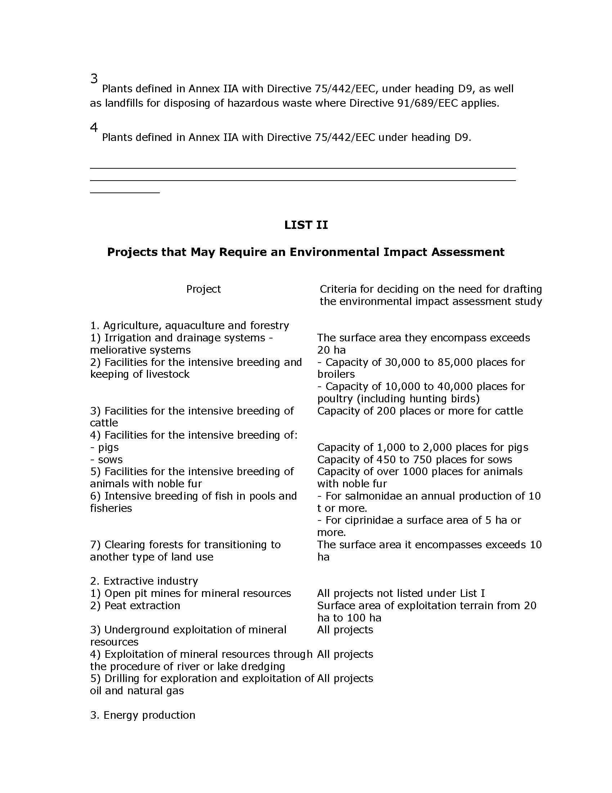

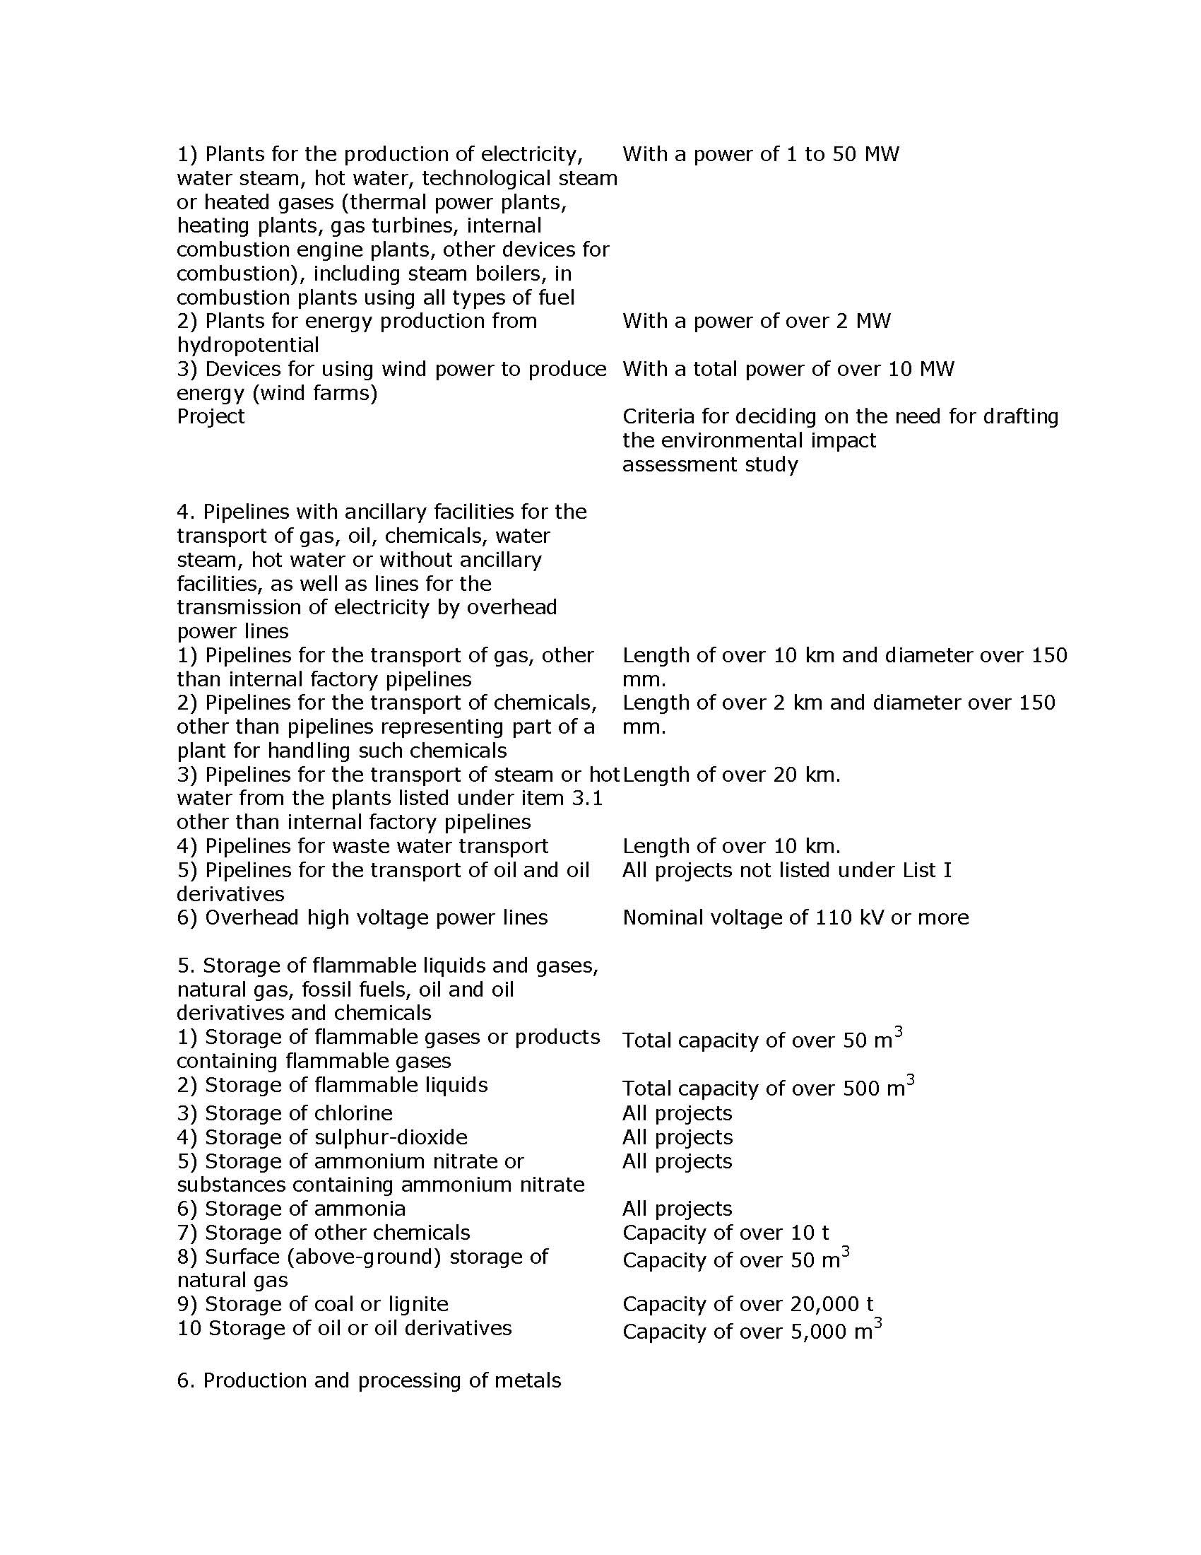

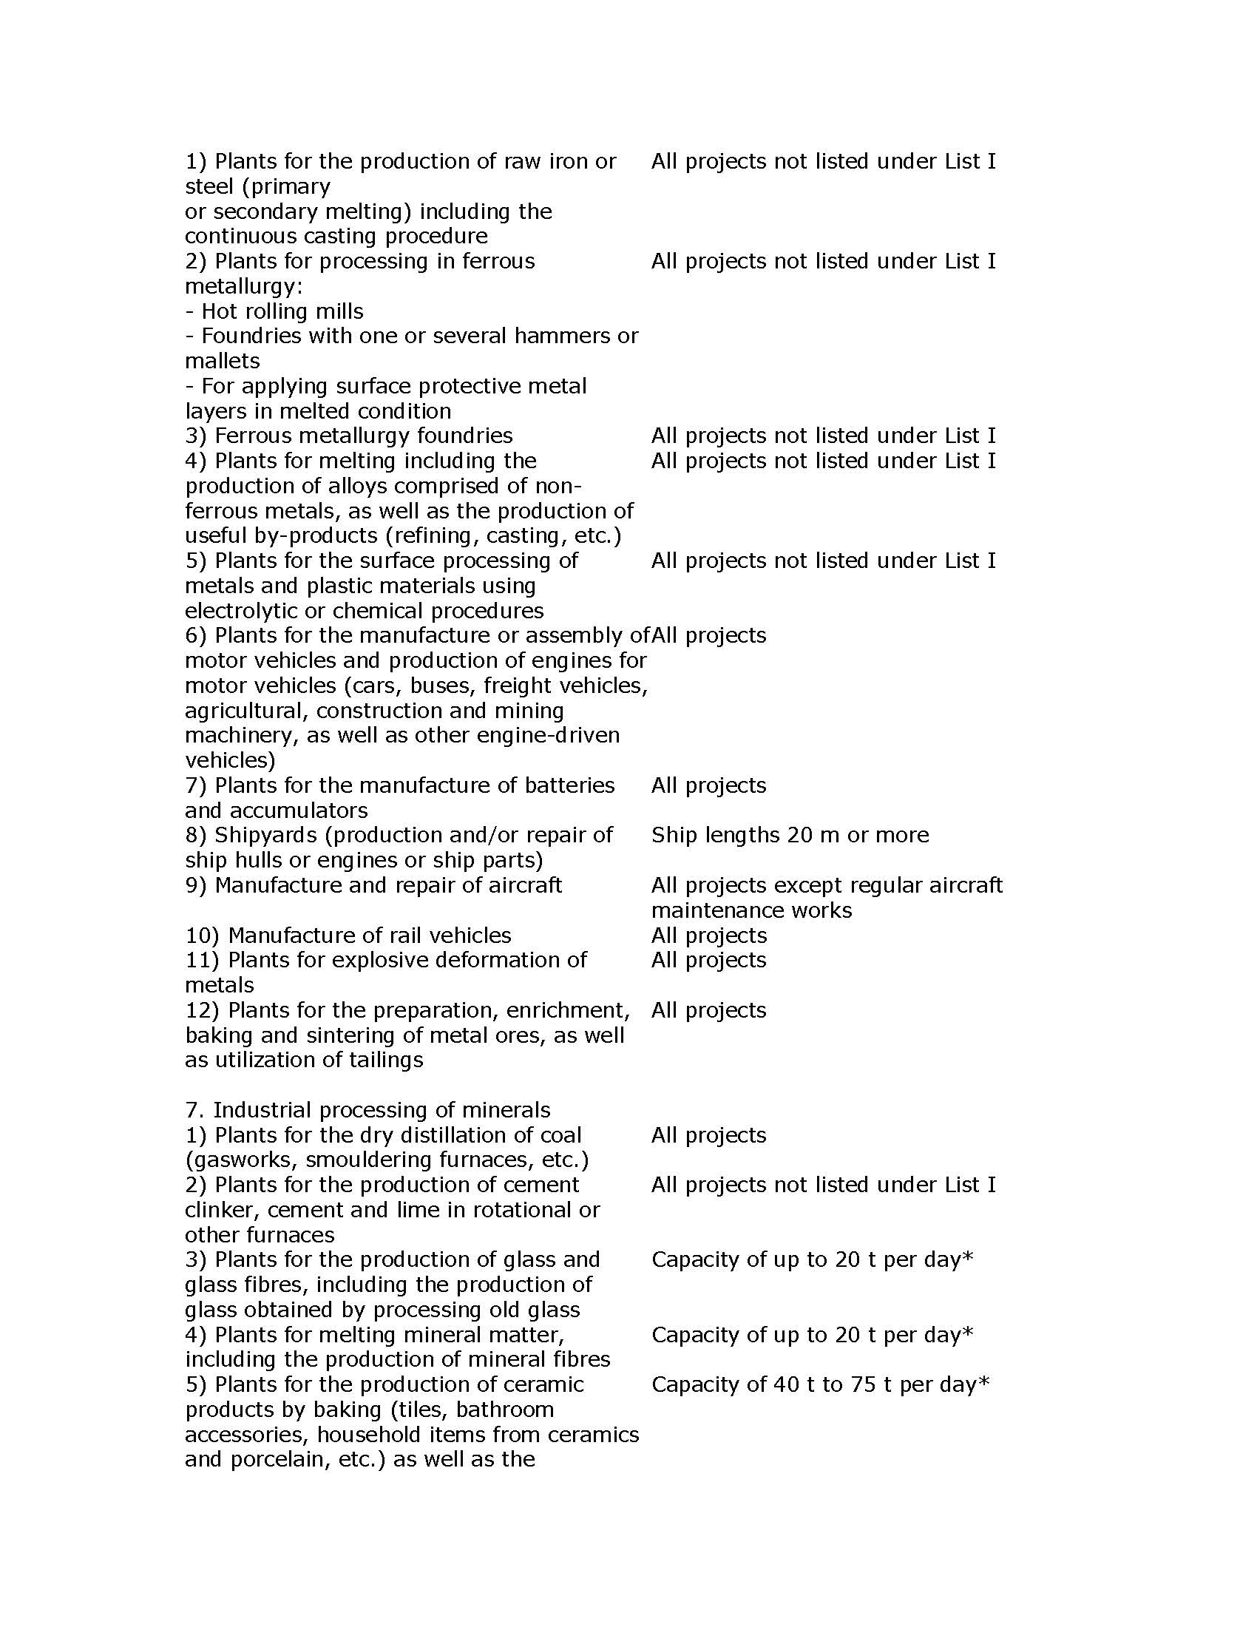

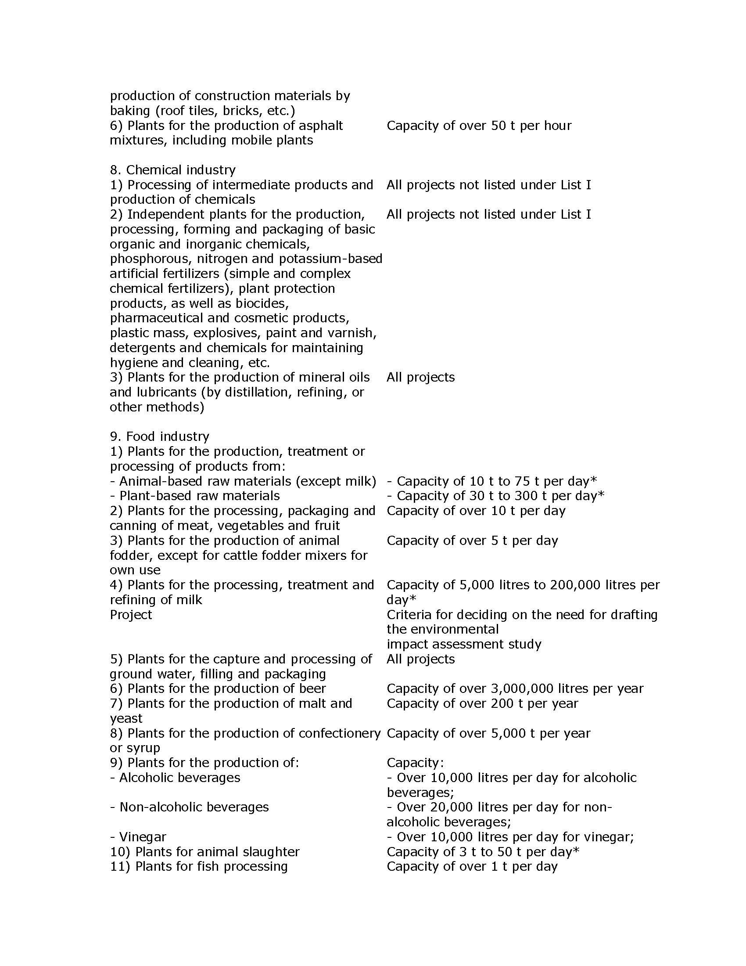

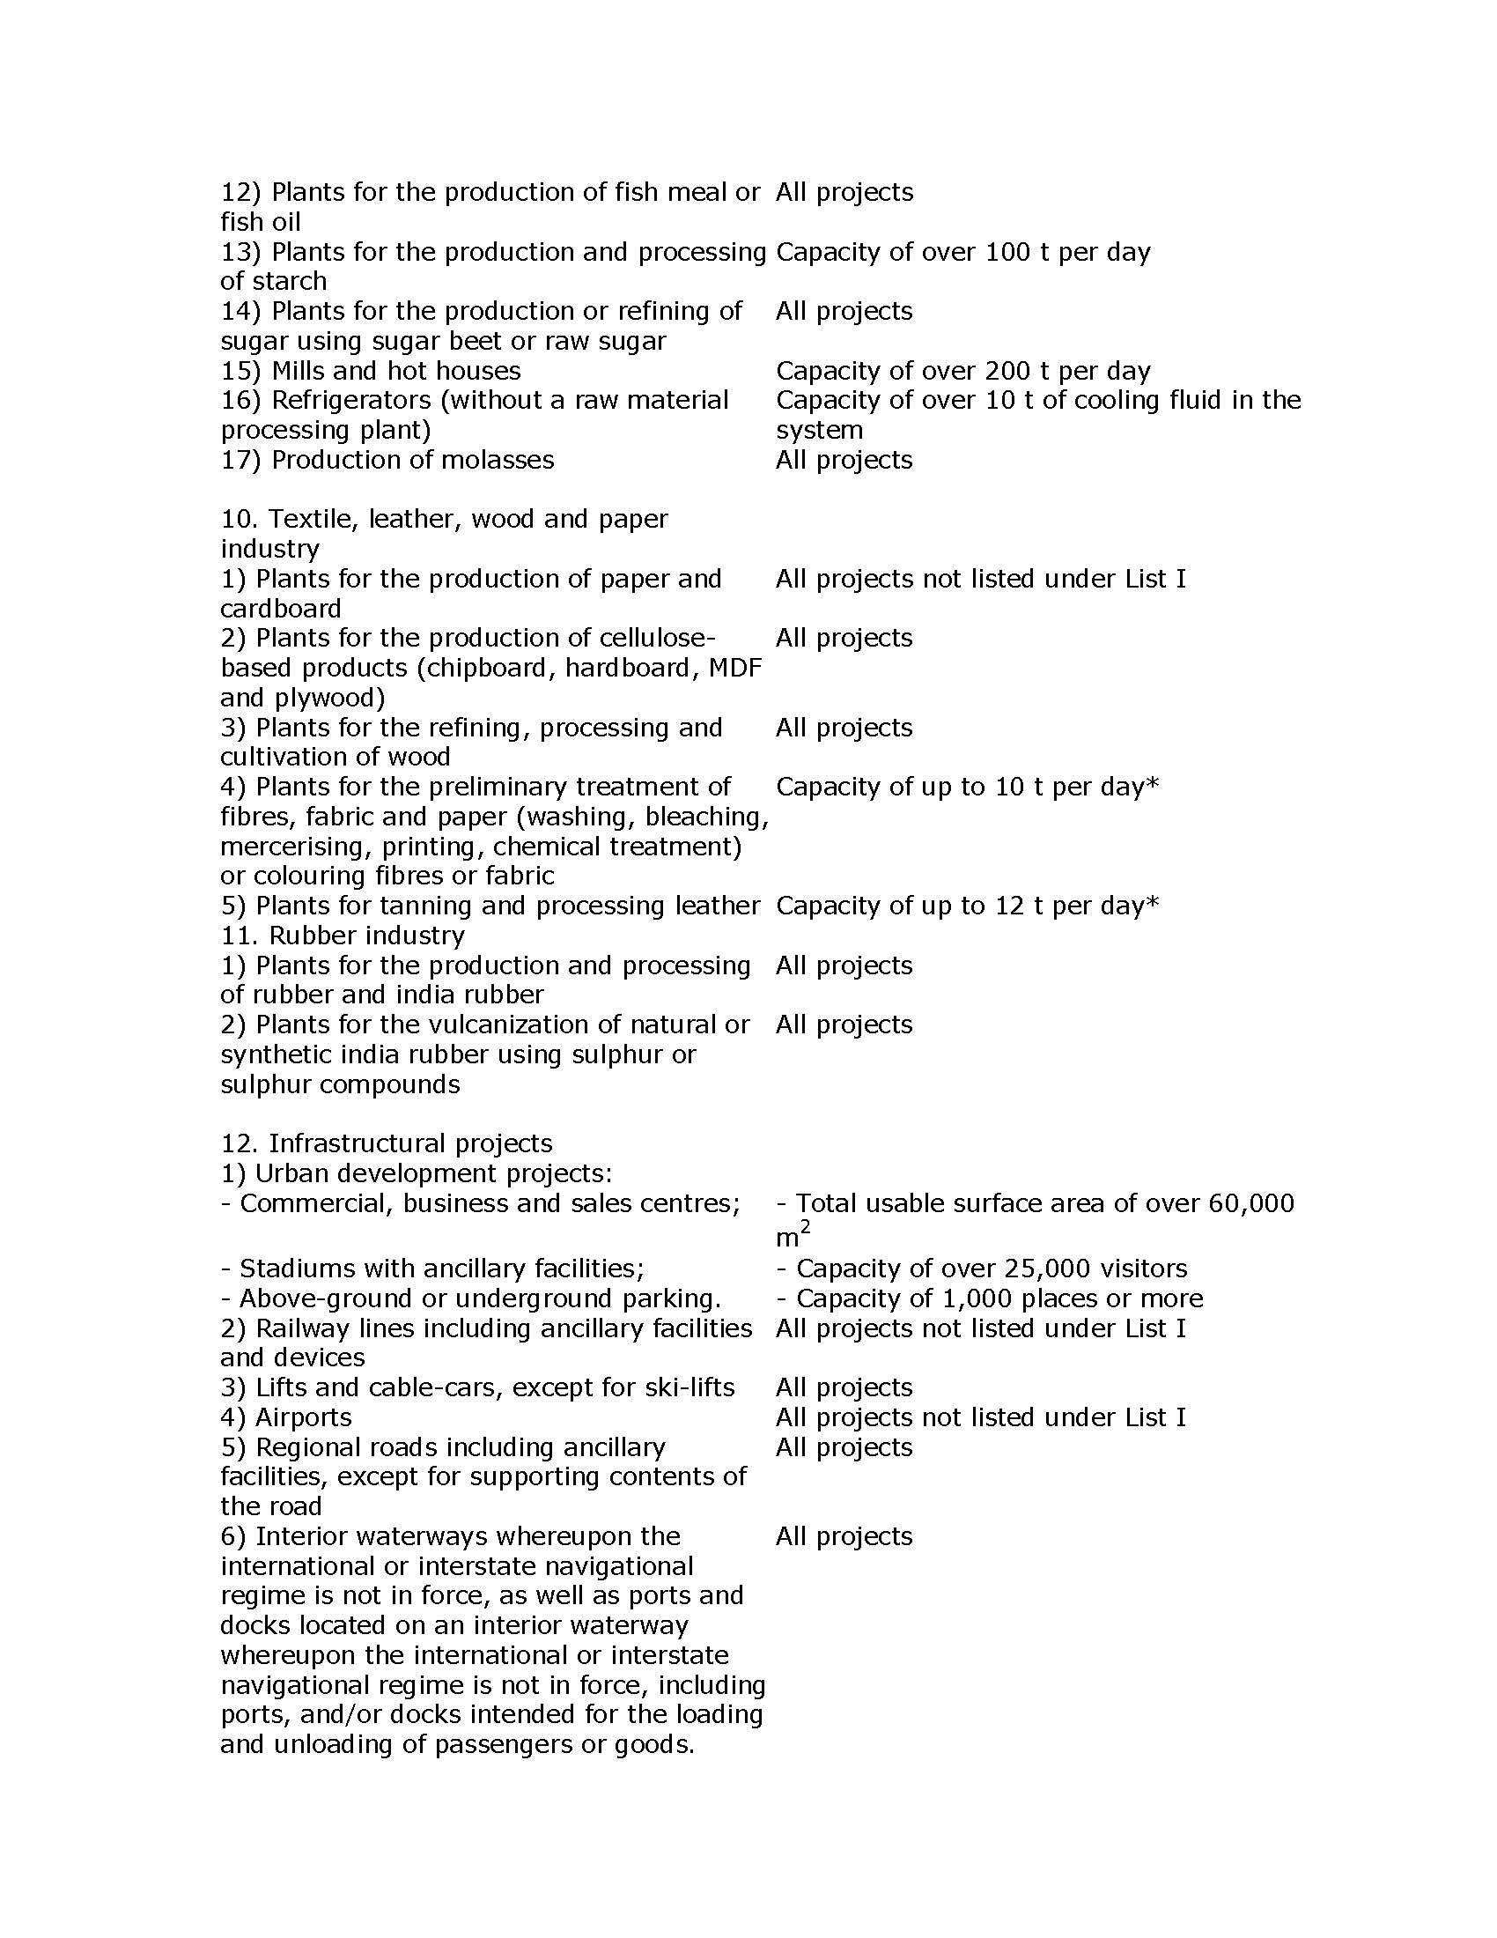

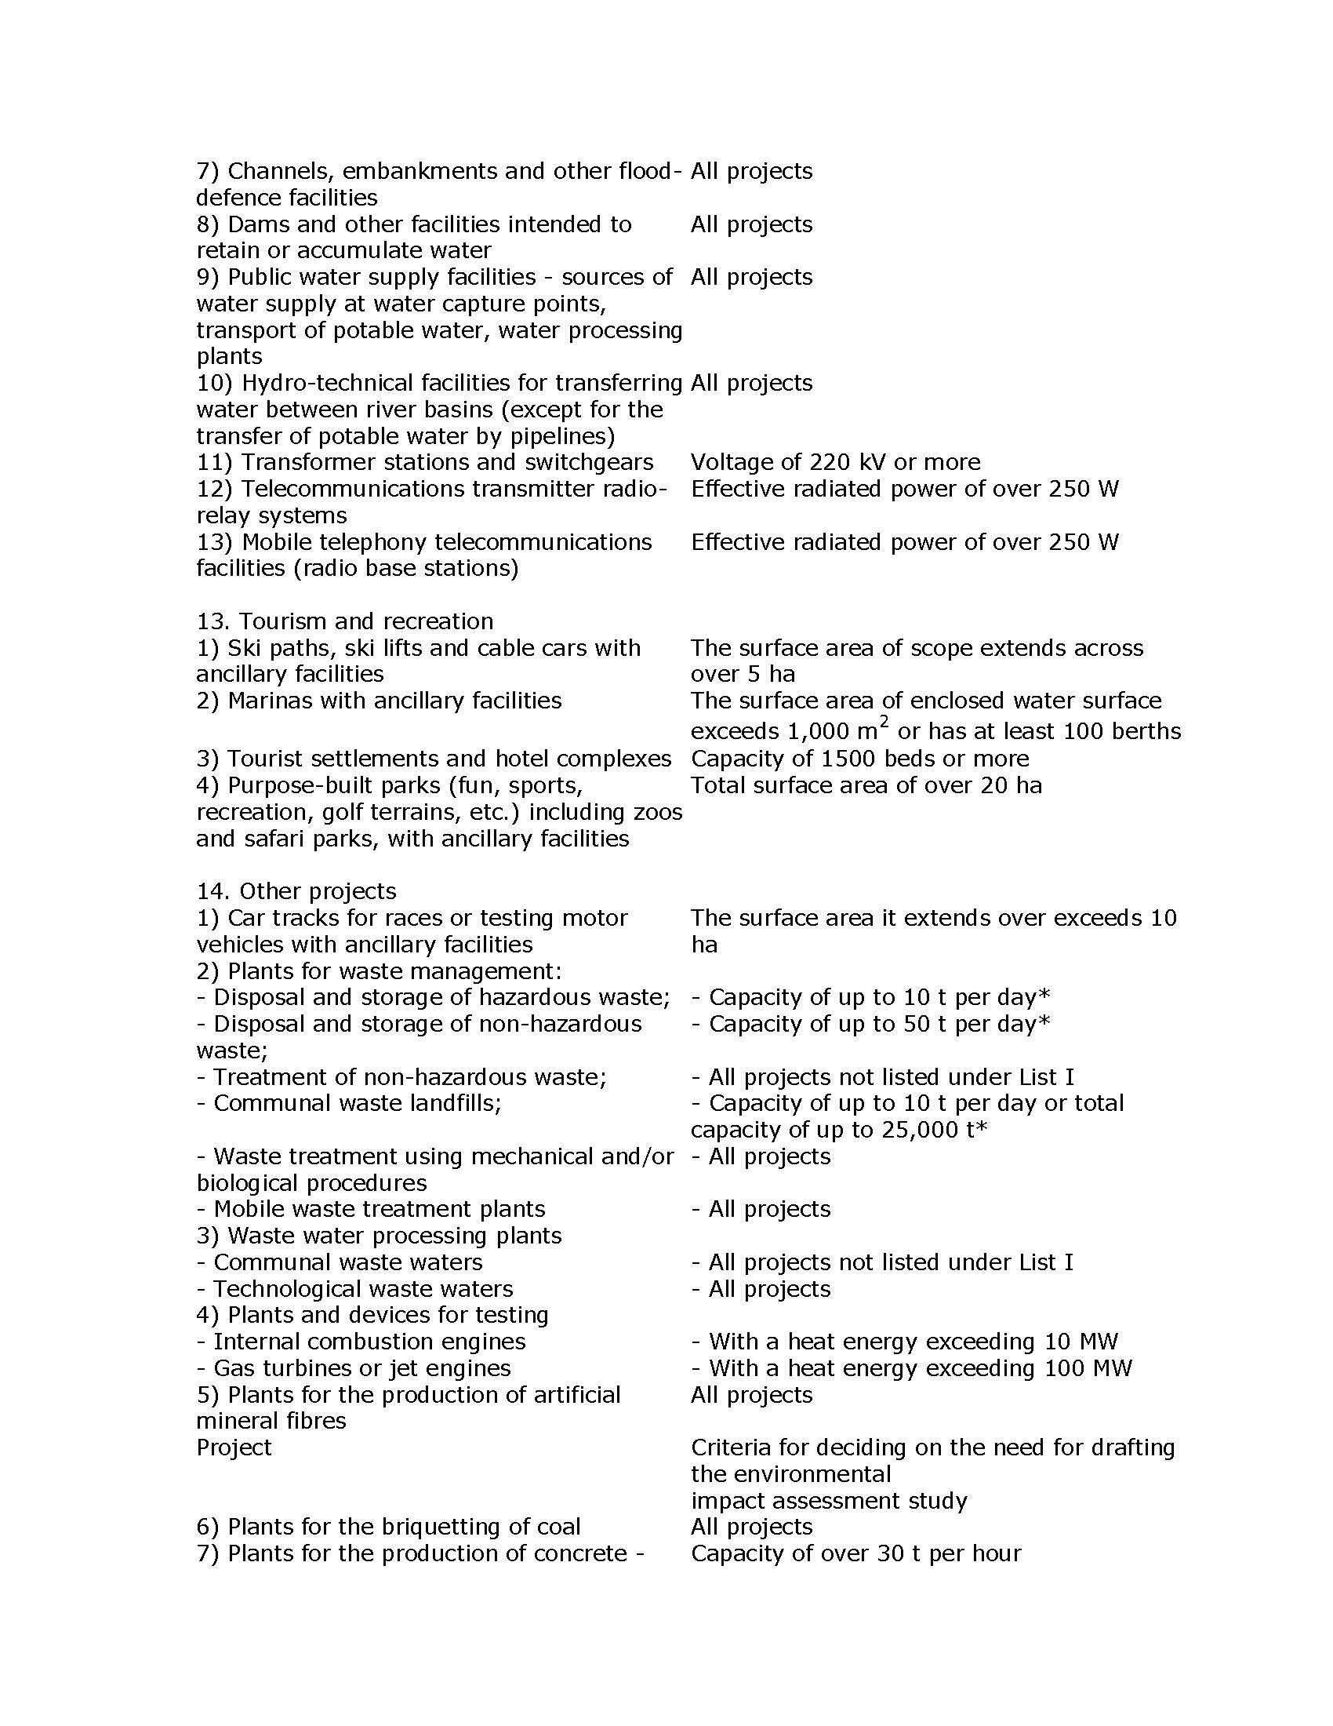

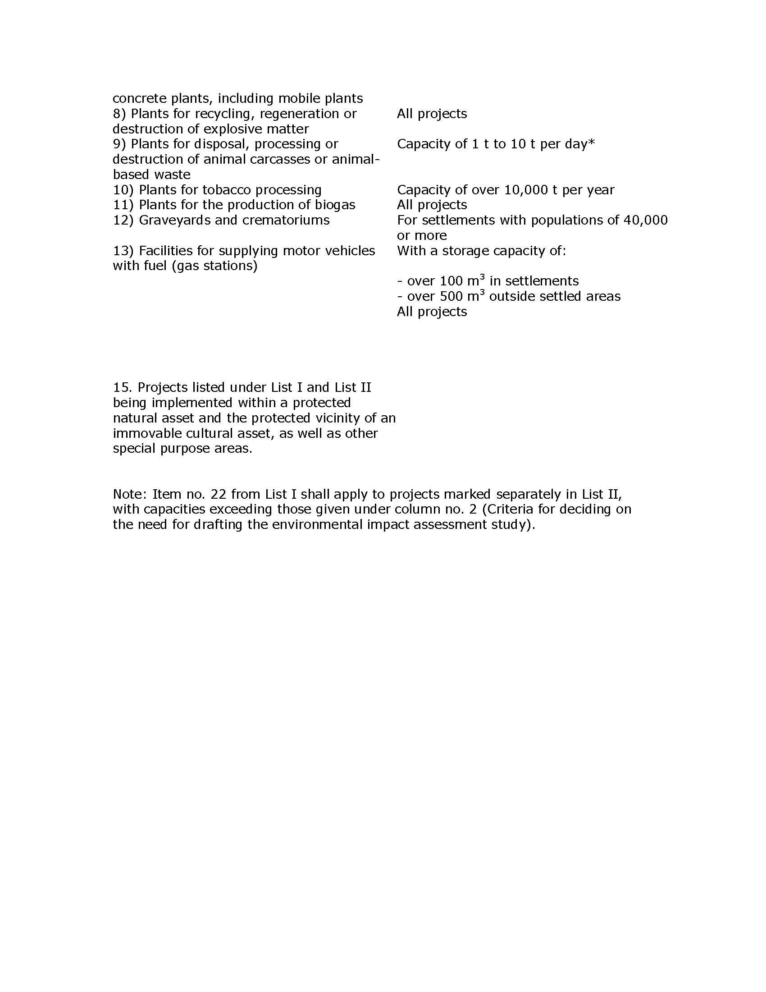

ANNEX 07: RELEVANT NATIONAL LEGISLATION AS OF OCTOBER 2019

The main laws and regulations currently in force in Republic of Serbia which are relevant to the environmental protection during planning, design, construction and operating of this Project are listed below:
The main legal documents are:
- The Constitution of Serbia (“Official Gazette of RoS” No. 98/06).
- The National Strategy for Sustainable Development (“Official Gazette of RoS” No. 72/09, 81/09)
- The Law on Water (“Official Gazette of RoS” No. 30/10, 93/12)
- Law on Planning and Construction (“Official Gazette of RoS” No. 72/09, 81/09)
- Law on Strategic EIA (“Official Gazette of RoS” No. 135/2004
- Law on nature protection (“Official Gazette of RoS”, 36/09, 88/10, 91/10, 14/16)
- Law on environmental protection (“Official Gazette of RoS” No. 135/04, 36/09, 72/09, 43/11, 14/16)
- Law on EIA (“Official Gazette of RoS” No. 135/2004, 36/2009)
- Law on waste management (“Official Gazette of RoS”, 36/09, 88/10, 14/16)
- Law on noise protection (“Official Gazette of RoS”, 36/09, 88/10)
- Law on water (“Official Gazette of RoS”, 30/10, 93/12, 101/16)
- Law on forest (“Official Gazette of RoS”, 30/10, 93/12, 89/15)
- Law on air protection (“Official Gazette of RoS”, 36/09, 10/13)
- Law on Occupational Health and Safety (“Official Gazette of RoS”, 101/05, 91/15)
- Agricultural Land Law, (“Official Gazette of RoS” No. 62/06, 65/08, 41/09, 112/2015)
- Animal Welfare Law, (“Official Gazette of RoS” No. 41/09)
- Regulation on welfare of animal intended for experimental purposes(''Official Journal of. RoS'', No 39/10).

- Regulations established on the basis of the Law on EIA include the following:
- Law on confirmation of convention on information disclosure, public involvement in process of decision making and legal protection in the environmental area (“Official Gazette of RoS”, 38/09)

- Decree on establishing the List of Projects for which the Impact Assessment is mandatory and the List of projects for which the EIA can be requested (“Official Gazette of RoS” No. 114/08)
- Rulebook on the contents of requests for the necessity of Impact Assessment and on the contents of requests for specification of scope and contents of the EIA Study (“Official Gazette of RoS” No. 69/05)
- Rulebook on the contents of the EIA Study (“Official Gazette of RoS” No. 69/05)
- Rulebook on the procedure of public inspection, presentation and public consultation about the EIA Study (“Official Gazette of RoS” No. 69/05)
- Rulebook on the work of the Technical Committee for the EIA Study (“Official Gazette of RoS” No. 69/05)
- Regulations on permitted noise level in the environment (“Official Gazette of RoS” No. 72/10)
- Decree on establishing class of water bodies (“Official Gazette of SRS” No. 5/68)
- Regulations on dangers pollutants in waters (“Official Gazette of SRS” No. 31/82)
- Law on confirmation of convention on information disclosure, public involvement in process of decision making and legal protection in the environmental area (“Official Gazette of RoS”, 38/09)
- European Environment and Health Committee. Serbia. Copenhagen, WHO Regional Office for Europe, 2006 (http://www.euro.who.int/eehc/implementation/20061010_9 accessed 29 December 2009).
- National Assembly. Law on Protection against Environmental Noise. Official Gazette of the Republic of Serbia, No. 36/09, 88/10.
- National Assembly. Law on Waste Management. Official Gazette of the Republic of Serbia, 2009, No. 36/09, 88/10, 14/16.
- National Assembly. Constitution of the Republic of Serbia. Official Gazette of the Republic of Serbia, 2006, No. 98/06.
- National Assembly. Law on Environmental Protection. Official Gazette of the Republic of Serbia, 2004, No. 135/04, 36/09, 72/09, 43/11, 14/16.
- National Assembly. Law on Air Protection. Official Gazette of the Republic of Serbia, 2009, No. 36/09, 10/13.
- National Assembly. Law on Chemicals. Official Gazette of the Republic of Serbia, 2009, No. 36/09. 88/10, 92/11, 93/12, 25/15
- National Assembly. Law on Biocidal Products. Official Gazette of the Republic of Serbia, 2009, No. 36/09, 88/10, 92/11, 25/15
- National Assembly. Law on Occupational Safety and Health. Official Gazette of the Republic of Serbia, 2005, No. 101/05, 91/15
- National Assembly. Law on Environmental Impact Assessment. Official Gazette of the Republic of Serbia, 2004, No. 135/04, 36/09
- Federal Assembly. Regulation on permitted level of noise in the environment. Official Gazette of the Republic of Serbia, 2010, No. 72/10.
- National Assembly. Law on Integrated Pollution Prevention and Control. Official Gazette of the Republic of Serbia, No. 135/04 (http://www.basel.int/legalmatters/natleg/serbia-04e.pdf, accessed 11 January 2010).
- Regulation (EC) No 1907/2006 of the European Parliament and of the Council of 18 December 2006 concerning the Registration, Evaluation, Authorisation and Restriction of Chemicals (REACH), establishing a European Chemicals Agency, amending Directive 1999/45/EC and repealing Council Regulation (EEC) No 793/93 and Commission Regulation (EC) No 1488/94 as well as Council Directive 76/769/EEC and Commission Directives 91/155/EEC, 93/67/EEC, 93/105/EC and 2000/21/EC. Official Journal of the European Union, 2006, L396:1–849.
- Directive 2003/35/EC of the European Parliament and of the Council of 26 May 2003 providing for public participation in respect of the drawing up of certain plans and programmes relating to the environment and amending with regard to public participation and access to justice Council Directives 85/337/EEC and 96/61/EC. Official Journal of the European Union, 2003, L156:17–24.
- Council Directive 91/271/EEC of 21 May 1991 concerning urban waste water treatment. Official Journal of the European Communities, 1991, L135:40–52 (http://eur-lex.europa.eu/LexUriServ/LexUriServ.do?uri=CELEX:31991L0271:EN:HTML, accessed 25 January 2010).
- Council Directive 98/83/EC of 3 November 1998 on the quality of water intended for human consumption. Official Journal of the European Communities, 1998, L330:32–33 (http://eur-lex.europa.eu/LexUriServ/LexUriServ.do?uri=OJ:L:1998:330:0032::EN:PDF, accessed 25 January 2010).
- Directive 2002/49/EC of the European Parliament and of the Council of 25 June 2002 relating to the assessment and management of environmental noise – Declaration by the Commission in the Conciliation Committee on the Directive relating to the assessment and management of environmental noise. Official Journal of the European Communities, 2002, L189:12–25 (http://eur-lex.europa.eu/LexUriServ/LexUriServ.do?uri=OJ:L:2002:189:0012::EN:PDF, accessed 25 January 2010).
- Federal Assembly. Regulation on permitted level of noise in the environment. Official Gazette of the Republic of Serbia, 2010, No. 72/10.
- National Assembly. Law on Integrated Pollution Prevention and Control. Official Gazette of the Republic of Serbia, No. 135/04 (http://www.basel.int/legalmatters/natleg/serbia-04e.pdf, accessed 11 January 2010).
- Council Directive 1999/30/EC of 22 April 1999 relating to limit values for sulphur dioxide, nitrogen dioxide and oxides of nitrogen, particulate matter and lead in ambient air. Official Journal of the European Communities, L163:41–60.

ANNEX 08 FORMAT FOR REPORT ON COMPLIANCE WITH CONDITIONS OF WORK WITH ESS2
for third parties engaging contracted workers

Assignment name:
Contract ref. No:
Contract period: Start date (M/D/Y) End date (M/D/Y)
Contractor/Service Supplier:
Reported period:
Date of report:
Signature of authorized person:

LABOR AND WORKING CONDITIONS COMPLIANCE REPORT
Company employees* statistics:
Total number of employee’s gender disaggregated1: M______F_______
Number of employees with an employment contract out of total number of employees
Number of employees without an employment contract out of total number of employees Number of employees with access to social security, pension and health insurance out of total number of employees Number of employees who receives wages/salaries at least once a month out of total number of employees
Number of employees who left the company in the reported period out of total number of employees
Number of employees hired in the reported period
Number of hours worked per employee (monthly average)
Total overtime (monthly average per employee)
- Number of injuries at work (in reporting period and cumulative since contract start) out of total nr. of employees
- Number of fatalities at work (in reporting period and cumulative) out of total nr. of employees
- Number of reported violence out of total nr. of employees
- Number of reported harassment/ abuses out of total nr. of employees
Availability of an accessible and functioning employee grievance mechanism (Y/N)
Number of grievances raised with the GM (in reporting period and cumulative since contract start)
Number of grievances resolved by GM (in reporting period and cumulative since contract start)
Number of suits filed with regard to labor, employment and OHS issues
Number of disputes brought to peaceful settlement/ voluntary arbitration procedure
Number of visits by labor/ OHS inspection
*The employee is any natural person employed or engaged to work or perform service for the employer
1 The number of employees refers to the actual number/headcount on the date of the report.
2 The numbers imply the total number of incidents in the reported period.
Project workers statistics:
- Total number of project workers**:
- Number of project workers with an employment contract:
- Number of project workers without an employment contract:
- Number of project workers with access to social security, pension and health insurance verified by confirmation from registry:

Working and Labor Conditions Screening Check List
 | Terms and conditions | Yes / No | Notes
1 | All project workers have an employment contract or engagement agreement in writing. | Yes  No | If “No” please specify and explain
2 | All project workers are paid at least once a month | Yes  No | If “No” please specify and explain
3 | All project workers worked 8 hours a day, 40 hours a week | Yes  No | If “No” please explain and specify the hours worked
4 | All project workers had a regular daily and weekly rest | Yes  No | If “No” please specify and explain
5 | Number of project workers were terminated from employment with termination in line with national labor law and ESS2 | Yes  No | If “Yes” please specify number and explain conditions of termination
6 | Number of project workers attended OHS related training programme | Yes  No | If “Yes” please specify number and explain
7 | Project workers were granted leaves they are entitled to | Yes  No | If “Yes” Please specify the type and number of leaves
8 | Project workers were involved in accidents at work resulting in injuries or fatalities | Yes  No | If “Yes” please specify and explain
9 | Project workers reported on cases of discrimination, harassment, sexual harassment or non-compliance with law | Yes  No | If “Yes” please specify and explain
10 | 1Project workers raised grievances or started voluntary arbitration / legal proceedings to settle a dispute | Yes  No | If “Yes” please specify and explain
11 | In the reported period there were some incidents on noncompliance with the LMP | Yes  No | If “Yes” please specify and explain

ANNEX 09 STATEMENT OF LEGAL AND REGULATORY COMPLIANCE

This STATEMENT is to be submitted as part of bidding documents by prospective Service/Works providers

Date and place of issuance: ________________________
Name and address of the issuer:________________________

STATEMENT OF LEGAL AND REGULATORY COMPLIANCE

Hereby we declare that
- We are aware of, and comply with, the standards laid down in World Bank Environment and Social Framework;
- We are aware of, and comply with, the standards laid down in the Labor Management Procedures;
- We are aware of, and comply with, the standards laid down in WBG HSE Guidelines;
- We conform to all national laws* and applicable regulations concerning employment, labor and employee relations, and labor and working conditions;
- We are committed to providing a safe and healthy environment for our employees and to implementing all occupational health and safety requirements as stipulated by national legislation;
- We do not tolerate any form of child, forced or slavery work.
- We prohibit any form of harassment, abuse and violence at work and forbid direct or indirect discrimination against any employee or groups of employees on any ground and for whatever reason.
- We confirm that a worker GM is available
- We confirm that no worker GM is available but will be established by the time the contract is signed or will inform all contracted workers of the GM available

We hereby state that should we be awarded with the contract; we shall adopt the Labor Management Procedures applicable to the project and incorporate them in our practice.
We understand that the failure to respect any of the above stated commitments could lead to termination of the contract and exclusion from the project.

Signature:
Name:
Position:

*National Laws refers both to the Laws of Republic of Serbia and the domicile Law of the country in case the Bidder is foreign

ANNEX 10 SAMPLE MITIGATION PLAN AND MONITORING PLAN FOR ESMP

ANNEX 10A MITIGATION PLAN

Phase | Issue | Mitigating  Measure | Cost of  Mitigation  (If Substantial) | Responsibility* | Supervision observation  and comments  (to be filled out during supervision)
Project Preparation | •  •  •
Project  Execution /  operate | •  •  •
* Items indicated to be the responsibility of the contractor shall be specified in the bid documents

ANNEX 10B MONITORING PLAN

Phase | What  parameter is to be monitored? | Where  is the parameter to be monitored? | How  is the parameter to be monitored/ type of monitoring equipment? | When  is the parameter to be monitored- frequency of measurement or continuous? | Monitoring  Cost  What is the cost of equipment or contractor charges to perform monitoring? | Responsibility | Supervision  observation and comments  (to be filled out during supervision with reference to adequate measuring reports)
Project preparation
Project Execution / Operate

ANNEX 11: SAMPLE FILLED OUT ESMP – MITIGATION PLAN

EXAMPLE ONLY: reconstruction of flood protection barrier

Phase | Problem/activity impact | Mitigating measure | Institutional responsibility | Comment
PRE-CONSTRUCTION | ESIA Procedure and preparation of Bidding documents
 | Bidding documents prepared with access to or use of the this ESMP in a translated version | No bid documents will be prepared without incorporated a (Serbian) copy of the mitigation and monitoring plan ESMP, which shall be included in the safeguard clauses of the Technical Specifications in the contracts and commitment to comply with Lender Requirements | PMU on behalf of the Investor PWMC “Srbijavode” – VPC “Sava – Dunav”, except for subproject 1.3.1 “Expansion and modernization of port of Sremska Mitrovica” where PMU within the MCTI is responsible for implementation of subject mitigation measure
CONSTRUCTION | Material supply
 | Sand and gravel borrow pit. Disturbance of Sava River bed, water quality, ecosystem disturbance | Use existing borrow pits or buy material at licensed separations; requirement for official approval or valid operating license. | Sand and gravel Contractor or Separation  Construction Contractor | to be specified in bid documents -Conditions for selection of subcontractors for material supply
CONSTRUCTION | Material transport
 | Dust, fumes | All trucks are to be covered | Truck operator | a)-d) to be specified in bid documents-Technical Specifications for realization of works
 | Stone, Dust | wet or cover truck load | Truck operator
 | Sand and gravel,  Dust | wet or cover truck load | Truck operator
 | Dust emissions from the site may impact air quality and pose a health threat to workers and neighbors | In case of disposal of dredged or excavated materials the debris shall be kept in controlled area and sprayed with water mist to reduce debris dust  During pneumatic drilling/compaction dust shall be suppressed by ongoing water spraying and/or installing dust screen enclosures at site  The septic tank (in case of reconstruction of existing ones) installed at toilet should be enclosed in quite hermetic manner to avoid unpleasant smells.  The surrounding environment (sidewalks, roads) shall be kept free of debris to minimize dust  There will be no open burning of construction / waste material at the site  There will be no excessive idling of construction vehicles at sites  All materials will be supplied/transported in a manner which minimizes dust – including covered truck loads or closed off truck loads, with dust suppressing measures through water spraying | Construction Contractor
CONSTRUCTION | Construction site
 | Potential damage of cultural property during the earth works | If archaeological sites or artefacts are found during the execution of construction and other works, the Contractor is to immediately and without delay, cease the works and inform IPCM Sremska Mitrovica, as well as take necessary measures as to not destroy or damage the site and preserve it the same way as it was found. | Construction Contractor | Construction Supervision and Archaeological Supervision will be responsible on this project to prevent damage to cultural properties
 | Excavation works may  uncover archaeological or other significant findings | Stop all works on site in case of chance finding and notify proper authorities. | Construction Contractor | Project implementation delay
 | Potential water and soil pollution from improper material storage, management and usage | organize and cover material storage areas; isolate concrete, works from watercourse by using sealed formwork or covers; isolate wash down areas of concrete trucks and other equipment from watercourse by selecting areas for washing that are not free draining directly into watercourse | Construction Contractor
 | Water and soil pollution from improper disposal of waste materials | dispose waste material at location protected from washing out, should be marked in the site plan; if not on site, then at authorized landfill / depot | Construction Contractor
 | Water and soil pollution from improper disposal of waste materials | Storage of wastes according to international best practice (IFC EHS General Guideline). Apply additional measures for storage of hazardous wastes (such as use of secondary containment, access restriction, provision of PPE etc.) as necessary to prevent harm to construction staff, environment and public. Use and labelling of designated waste collection containers and storage areas for different kinds of wastes. | Construction Contractor
 | Potential contamination of soil and water from improper maintenance and fueling of equipment | apply best engineering practice in safe storage and handling of lubricants, fuel and solvents by secured storage; ensure proper loading of fuel and maintenance of equipment; collect all waste and dispose to permitted waste recovery facility | Construction Contractor
 | Improper material storage and use may cause pollution of air, soil or water | Store all materials in original containers in adequate locations, which allow for leak-proof storage  Do not dispose of paint and other waste containers except through adequate handling procedures  Ensure workers are familiar with safety regulations and storage requirements for each product. | Construction Contractor
 | Water and soil pollution from improper disposal of waste materials | Transport of waste in marked vehicles designed to the type of waste to minimise the risk of release of materials (hazardous and non-hazardous materials) and windblown debris. Training of drivers in handling and disposal of their cargo and the documentation of the transport describing the nature of the waste and its degree of hazard. | Construction Contractor
 | Improper waste management may cause pollution of soil and groundwater or cause scattering by wind/animals and pose a health risk | Designated waste disposal areas will be allocated on site, including waste collection bins for smaller waste, and designated areas for bulkier waste  All waste, including construction debris and excavated materials will be regularly and timely transported off site and managed through an authorized agency or disposed of at a site that was officially designated by the local authorities – Sremska Mitrovica Municipality  Waste collection and disposal pathways and sites will be identified for all major waste types expected from demolition and construction activities.  Mineral construction and demolition wastes will be separated from general refuse, organic, liquid and chemical wastes by on-site sorting and stored in appropriate containers.  The records of waste disposal will be maintained as proof for proper management as designed.  Whenever feasible the contractor will reuse and recycle appropriate and viable materials  Removed vegetation may best be composted on site, at a designated and managed area.  All oily wastes will be separately collected, in bins which are leak- proof, and will be handled over to the authorized management and Disposal Company, receipts for which shall be kept. | Construction Contractor
 | Construction works on site may impact the quality of surface waters(small natural ponds) and subsequently ground water | The site will establish appropriate water and sediment control measures such as e.g. silt fences to prevent water sediment from moving off site and causing pollution.  Collectors will be provided to avoid surface water dispersion in case of watering of sand or gravel to control the dusts  Construction vehicles and machinery will be washed only in designated areas where runoff will not pollute natural surface water bodies, and will be adequately collected and managed  Before starting the painting activity, the bottom will be covered by plastic paper to ensure collection of colors drops in the soils. After finalization of work this plastic will be removed and disposed at places defined by local authorities. | Construction Contractor
 | Possibility of encountering an archaeological site | if an archaeological site is encountered, Contractor will immediately suspend the Works and inform IPCM Sremska Mitrovica | Construction Contractor (Periodical IPCM monitoring)
 | Workers safety | provide workers with safety instructions and protective equipment; safe organization of bypassing traffic | Construction Contractor
 | Community safety | regulate traffic and pedestrian circulation in instances of increased risk; put up signs visualizing construction site boundaries; | Construction Contractor
 | Contamination of territory or ground waters by using or treatment of un appropriate building materials | Prepare mixed cement etc. in isolated space. Pave with cement a surface of 20m2 in appropriate distance and into the warehouse territory, avoiding penetration in ground layers of several building material components.  Avoid repair, refueling or any interventions on equipment on unpaved areas with inadequate leak control trays.  Information of workers and operators in the importance of respecting the preventions to avoid possible contamination | Construction Contractor
 | The overall worker safety, and risks of unauthorized and un desired access to construction site | The inhabitants leaving close to construction site will be notified of the works, objectives and temporary expected negative impacts through appropriate communication; public meetings, etc.  All legally required permits will be acquired for construction and/or rehabilitation. Contractor formally agrees that all work will be carried out in a safe and disciplined manner designed to minimize impacts on neighboring residents and environment. Including organization of transport to minimize impacts on neighborhood, and washing of vehicle tires to minimize spreading of debris on the roads.  Workers will comply with international good practice (always hardhats, as needed masks and safety glasses, harnesses etc.). Workers also will be contracted respecting Serbian legislation, and the developer should respect all hygienic and safety rules conditioned by Serbian legislation. Life insurance of workers etc. will be provided by the employer. Technical security measures will be provided by the employer.  Emergency safety kit should be placed close to the working place for intervention in case of accidents. Emergency contacts and numbers should be clearly posted on site.  In case of contact with polluted waters of channels or sediments the workers should have safety clothes.  Appropriate warning signposting of the working sites, visual barriers etc., will be used to prevent accidents. | Construction Contractor
 | Accidents during construction works may cause unintentional damage to the local infrastructure or power supply net | Ensure all adequate permits from local utilities have been obtained  Ensure familiarity with networks in the proximity of the site  In case of accidental disruption, immediately stop all works, notify proper authorities in Sremska Mitrovica and emergency remediation of damaged network in line with the legal requirements | Construction Contractor | Temporary delay the Project implementation
 | Use of raw materials may pose an additional stress on the natural environment | Use raw materials (sand, gravel, stone) only from suppliers that have valid licenses issued by the Relevant Institution. | Construction Contractor
 | Noise generated during works may pose a threat and risk to the workers on site, animals and neighboring properties | Construction noise will be limited to restricted times agreed to in the permit in respect with Serbian Environmental Legislation  During operations the engine covers of generators, air compressors and other powered mechanical equipment shall be closed, and equipment placed at station territory. | Construction Contractor
 | Works done on site may  damage or permanently remove vegetation | Ensure no damage to vegetation occurs on site.  In case of unavoidable damage, re-plant same species on site.  Ensure visually the same appearance as before works started. | Construction Contractor | Temporary decrease of green cover efficiency
 | Use of heavy-duty  transport vehicles for materials on site can cause local traffic disturbances | Ensure local community is aware of any major transport requirements and disruptions to the regular traffic pattern.  Adequately manage traffic and use postings to warn others of possible congestion. | Construction Contractor | Temporary noise and dust generation
 | Improper material storage and use may cause pollution of air, soil or water | Store all materials in original containers in adequate locations, which allow for leak-proof storage  Do not dispose of paint and other waste containers except through adequate handling procedures  Ensure workers are familiar with safety regulations and storage requirements for each product. | Construction Contractor
MAINTENANCE | Construction site
 | Obligation of publishing the results of archaeological excavations | It is necessary to provide funding for storing, publishing and presenting for goods which will be discovered, archaeologically excavated and researched, documented and conserved for the sake of permanent scientific and professional presentation encompassed in an investment project | Investor PWMC “Srbijavode”
 | Possible air, water and soil pollution / dust, vehicle exhaust, fuel and lubricants spills | apply best engineering practice in safe storage and handling of lubricants, fuel and solvents by secured storage; ensure proper loading of fuel and maintenance of equipment; collect all waste and dispose in line with the Law on waste management (“Official Gazette of RoS” No. 36/09, 88/10, 14/16);  Organize and cover material storage areas; selecting areas for washing that are not free draining directly or indirectly into watercourse (Sava River);  dispose waste material at location protected from washing out | Maintenance Contractor
Operation | Improper waste water management may cause contamination of ground waters | Avoid any activities that may leak hazardous constituents into the ground | Operator of warehouse and Sremska Mitrovica Municipality
Operation | Improper solid waste collection and management may pose a threat to soil and water quality | Set up proper waste management procedures, including separation of waste into oily and hazardous waste, regular municipal and green waste which can be composted  Ensure sufficient waste collection bins are available on site and that regular collection of wastes is ensured  Isolate the space of collection been and ensure frequent sanitation from authorized entities. | Operator of warehouse with local waste collection utility
Operation | Leaks and spills in station  can pollute the surface water | Have in place leak control action plan  Provide leak proof bins for collection of oily wastes or equipment which can drip oil  Ensure waste is adequately managed | Operator of warehouse and authorized company for management of such wastes
Planning/ Designing | Assure compliance with relevant construction field legislation | Acquire construction permit Provide Water management guidelines if subprojects are executed near surface watercourses. | PMU
Planning/ Designing | Potential damages to the existing infrastructure and facilities, especially underground installations (water supply and sewerage pipeline etc.) which cause obstacles in the provision of services to consumers. | Precisely situate the position of infrastructural facilities and underground installations at the location of works in cooperation with relevant institutions at all levels of authority. | Project Designer in cooperation with designers and representatives of relevant institutions of local authority.
Planning/ Designing | Increased possibility of employment and gaining income in the local community. | Prioritise qualified local population in employment. | Contractor | Problems should be regulated through tender documentation.
Reconstruction/ | Supply of material | Use the existing quarries and concrete bases for the supply of material.  Use licensed suppliers for other materials | Contractor | Borrow pits from which materials and concrete base are supplied must have valid environmental permits.
Reconstruction/ | Transport of material. | Using trucks with awning and special vehicles depending on the type of material. | Contractor | When transporting material, drivers must observe speed limitations
Reconstruction/ | Violation of vegetation cover | Replant or re-seed vegetation. Apply measures of good construction practice. | Contractor | Problems should be regulated through the Works execution contract.
Reconstruction/ | Emissions of dust from the landfill of earth material. due to vehicles' movement  on macadam roads and construction works execution. | Compact deposited earth material.  Sprinkle dust sources with water in order to reduce impacts on the surrounding population and vegetation. Control the speed of vehicles in order to reduce dust rising.  Prepare and implement a Plan for construction site organisation that includes good construction practices. | Contractor | Problems should be regulated through the Works execution contract.
Reconstruction/ | Emission of gases and particles from vehicles, mechanisation and generators. | Regular equipment maintenance.  The contractor is obliged to submit evidence of vehicle roadworthiness in line with the regulations on hazardous gases emission. Prepare and implement the Construction Site Organisation Plan that incorporates good construction practice measures. | Contractor | Problems should be regulated through the Works execution contract.
Reconstruction/ | Noise in the operation of heavy mechanisation and generators. | Observe law-defined working hours at the construction site.  Make the generator casings sound proof if they are located near residential units. Ensure mufflers for heavy machinery. Prepare and implement the Construction Site Organisation Plan that incorporates good construction practice measures. | Contractor | Problems should be regulated through the Works execution contract.
Reconstruction/ | Increased water turbidity as a consequence of the works. | Construction works should be executed in a way that surfaces and natural contents outside the project are not damaged and that works are performed so that watercourses are not unnecessarily made tumid and watercourses discontinued.  Works should be executed in dry weather. Prepare and implement a Construction Site Organisation | Contractor | Contractor
Reconstruction/ | Soil groundwater and surface water pollution.  with oils and lubricants  due to equipment poor maintenance and repairs and refueling at the  Construction site. | Avoid servicing and refueling at the site.  Use protective foils during possible vehicle refueling and maintenance at the construction site. Provide absorbing material in case of fuel spills. Used oiled materials and agents should be managed in l line with the Waste management report. Procedure for actions in case of incidental oil and lubrication spills.  Prepare and implement the Construction Site Organisation Plan that incorporates good construction practice measures. Measures from water management documents and measures from the Waste management report. | Contractor | Problems should be regulated through the Works execution contract.
Reconstruction/ | Water and soil pollution due to inadequate disposal of communal, inert and hazardous waste. | Typical containers for solid Communal waste are placed at the construction site locations;  Acceptance of collected Communal waste and its disposal by authorised institutions;  Hazardous waste fractions (used waste oils, oiled packaging. bitumen agents waste, waste transformer oils, waste asbestos-cement pipes etc.) are separately collected into typical containers or metal barrels; they are to be consigned to entities authorised for hazardous waste management;  Re-usage and recycle of waste whenever possible.  It is prohibited to incinerate waste in the open and at the location.  Actions in line with the waste management report. | Contractor | Problems should be regulated through the Works execution contract.
Reconstruction/ | Reconstruction et  damaged brides | Avoid driving on the Sava River banks;  Ensure streambed and bank in the zone of bridges, upstream and downstream from bridges, as to ensure their protection from erosion processes. | Contractor | Problems should be regulated through the Works execution contract.
Reconstruction/ | Decommissioning and dismantling of old, existing pedestrian path at quay zone:  Dismantling and removing (in whole or in part) the existing structure together with salvaging,  cleaning, handling and storing of all usable or valuable parts and materials, and disposing of non-salvable  materials and debris; | The existing structure shall be dismantled and removed in a careful and workmanlike manner and the use of equipment or facilities that might damage portions of the structure to be salvaged shall not be permitted. Salvable material shall be cleaned, sorted and stored as to size and length for purposes of checking and preparing lists.  Removal and Disposal of Non-Salvable Materials:  Any debris that falls off the structures onto the underlying ground, roadway right-of-way shall be immediately cleaned up by the Contractor. The Contractor shall remove all non-salvable materials and debris from the site as soon as possible. All material shall be deemed non-salvable unless noted otherwise on the Drawings or Special Provisions. Demolition debris shall be properly disposed of at an approved location, in accordance with the applicable Regulations and Acts.  Storage of non-salvable materials and debris will not be allowed on site without the written approval of the Engineer. | Contractor  The Contractor shall submit to the Engineer, a detailed plan and schedule clearly illustrating the method and sequence by which the Contractor proposes to dismantle and remove the existing structures (in whole or in part), including a description of the measures that will be implemented to meet the environmental  requirements. | This requirements as part of ESMP document will become part of Works execution contract.
Reconstruction/ | Reduced mobility through the area where the works are executed. | Plan the relocation of equipment at times when daily traffic is not jammed; Provide alternative passage for pedestrians and vehicles in cooperation with local authorities or provide a safe passage through the construction site;  Avoid roads through inhabited areas especially near schools and hospitals; Prepare and implement the Construction Site Organisation Plan that incorporates good construction practice measures. | Contractor | Problems should be regulated through the Works execution contract.
Reconstruction/ | Potential pollution of soil and water due to the discharge of waste sanitary waters from the construction site | Installation of ecological toilettes for workers | Contractor | Problems should be regulated through the Works execution contract.
Reconstruction/ | Population at increased risks of traffic accidents and construction works to population. | Assure adequate warning signs, lighting, protective fencing etc.  Observe traffic rules.  Clean construction waste from the construction site both in the construction phase and after works completion, when closing the construction site.  Assure medical supplies and aid through institutional and administrative arrangements with municipal hospitals at the construction site.  Implement the Construction Site Organisation Plan. | Contractor | Problems should be regulated through the Works execution contract.
Reconstruction/ | Risk of injuries at work. | Demand from all workers to abide by the Protection at work measures;  Provide protective equipment;  Install warning signs at the construction site;  Prepare and implement the Construction Site Organisation Plan and Protection at work measures plan. | Contractor | Problems should be regulated through the Works execution contract.
Reconstruction/ | Construction material leftovers after the closure of temporary construction sites | All shivers and material that remain after the closure of temporary construction sites are to be removed from the location and reused/recycled where possible.  All remains are to be disposed of in a manner that will not be harmful to environment; this is to be done by companies that have permits to perform such works | Contractor | Problems should be regulated through the Works execution contract.

ANNEX 12: SAMPLE FILLED OUT ESMP – MONITORING PLAN

EXAMPLE ONLY: reconstruction of flood protection barrier

Phase | What is the parameter to be monitored? | Where the parameter should be monitored? | How the parameter should be monitored? / type of monitoring equipment | When the parameter should be monitored? (frequency of measurement or continuous) | Why the parameter should be monitored? (optional) | Institutional responsibility
 |  |  |  |  |  | Operate
CONSTRUCTION |  |  | Material transport
Stone | truck load covered or wetted | job site | supervision | unannounced inspections during work, at least once per week | and safety requirements and enable as | Supervision Contractor
Sand and gravel | truck load covered or wetted | job site | supervision | unannounced inspections during work, at least once per week | little disruption to traffic as it is possible | Supervision Contractor
Traffic management | hours and routes selected | job site | supervision | unannounced inspections during work, at least once per week |  | Supervision Contractor
CONSTRUCTION |  |  | Construction Site
Cultural goods and archaeological findings | Presence of archaeological findings in the soil | at and near the Construction site | Continuous supervision of earthworks and  Archaeological supervision during earthworks | During earthworks. | For the sake of preservation of cultural heritage | Contractor Supervision and Archaeological Supervision  (Monitoring).
During construction | Chance findings | On site | Through site log | Regularly through construction works | To ensure adequate management of chance findings | Contractor to implement, Supervisor to review and report on
Dust | air pollution (solid particles) | at and near job site | inspection and visual observation | unannounced inspections during material delivery and construction | health and safety requirements and enable as little disruption to traffic as it is possible | Supervision Contractor
During construction | Air and Soil quality | On construction site and surrounding areas | Visually inspect dust generation and control.  Inspect presence and if any smell is emitted from the septic tank on site. Visually inspect presence of clandestine waste on site and in surroundings.  Visually inspect for leaks of oily materials.  Keep proof of waste being collected by authorized company.  Visually inspect signs of open burning  of wastes. | Continuously during construction works | To ensure works are conducted as per the utmost safety and environmental protection standards | Contractor to implement, Supervisor to review and report on
Workers safety | protective equipment; organization of bypassing traffic | job site | inspection | Unannounced inspections during work. It is recommended to use H&S template for this purpose (next table) |  | Supervision Contractor
During construction | Notification, information of workers for the importance of environmental and hygienic protection, Worker and safety and health | On construction site | Maintain a log of workers and neighbor notification, all information efforts, permits obtained, supervisor will provide regular reports on ESMP compliance, worker safety, and on possible complaints  Appropriate signs will be inspected visually | Continuously during construction works | To ensure works are conducted as per the utmost safety and environmental protection standards | Contractor to implement, Supervisor to review and report on
During construction | Noise levels | On construction site and surrounding areas | Ensure compliance with permit as per Serbian law. Measurements on complaints from neighbors. | Continuously during construction works | To ensure noise levels do not exceed permissible | Contractor to implement, Supervisor to review and report on
During construction | Water Quality | On construction site and surrounding areas | Visually and upon complaints of increased turbidity, waste materials in small ponds, spills or leaks. | Continuously during construction works | To ensure there is no pollution caused to the waters | Contractor to implement, Supervisor to review and report
Before/during construction | Isolation of septic tank | On construction site | Visually or by penetration | In the reconstruction | To ensure there is not risk of contamination by waste waters | Contractor to implement, Supervisor to review and report on
During construction | Waste management | On construction site and surrounding areas | Visually for separation of wastes, review receipts from the collection company, or notification from the commune on the proper site of the disposal | Continuously during construction works | To ensure there is no risk of environmental pollution caused by construction works | Contractor to implement, Supervisor to review and report on
During construction | Damage to vegetation or other specific habitats | On construction site | Site log and visual inspection | Continuously during construction works | To ensure no damage to vegetation and specific habitats | Contractor to implement, Supervisor to review and report on
During construction | Storage of paint, oil or other hazardous materials | On site | Visually ensure proper storage, and no leaks or spills | Continuously during construction works | To minimize risks of pollution of hazardous materials | Contractor to implement, Supervisor to review and report on
OPERATION
Increased vehicle speed | condition of traffic signs; vehicle speed | Approach roads to the construction site | visual observation; speed detectors | unannounced | enable safe traffic flow | Traffic Police
Erosion, rockfall, hazardous conditions | section included in project | condition of hazard signs | visual observation | during maintenance activities |  | Contractor
During operation/  maintenance | Waste collection and management | On site | Visually for separation of wastes, review receipts from the collection company, or notification from the municipality on the proper site of the disposal | Continuously during construction works | To ensure there is no risk of environmental pollution from improper waste  management | Warehouse operator
During operation/  maintenance | Septic tank maintenance  – clearing and adequate disposal of wastes | On site | Visually, or through measuring flow. | Continuously | To ensure that no contamination occurs from waste waters | Warehouse operator
During operation/  maintenance | Respecting of worker safety measures | On site | Visually, and ensure compliance with plan | Continuously | No life risk for workers and operators | Warehouse operators
During operation/  maintenance | Leaks and spills in station | On site | Visually, and ensure compliance with plan | Continuously | To ensure no leaks of oils or other materials pollute the environment | Warehouse operator

Phase | Monitoring parameter | Location | How / equipment | When / frequency | Responsibility
Supply of material | Possession of environmental permits for plants of quarries and concrete bases from which material is supplied | Legal entities that own the plants | Insight into the documentation | During material supply | Supervision  body
Transport of material | If trucks are covered during powdered material transport | At the construction site and transport roads | Visual supervision | During material transport | Supervision  body
Reconstruction/ | Degradation and soil pollution | At the construction site and directly around the construction site | Visual supervision | Weekly | Supervision  body
Reconstruction/ | Does the construction site meet the criteria from the guidelines for good construction practice | At the construction site | Visual supervision. Insight into the documentation. | During the works execution | Supervision  body
Reconstruction/ | Occurrence of noise and air pollution | AI the works execution location | Standard air quality and noise level measurement equipment. | Upon receipt of grievances | Contractor - Company that has license to perform environment monitoring works
Reconstruction/ | Destruction of crops, woods, meadows etc. | At the works execution location and in the vicinity | Visually | Upon receipt of grievances | Supervision  body
Reconstruction/ | Working hours control. | At the works execution location | Visually and comparison with the construction site organisation plan. | Upon receipt of grievances | Supervision  body
Reconstruction/ | Waste management during the works execution | At the cons1ruction site | Visually and by comparison with the waste management report. | Permanently | Supervision  body
Reconstruction/ | Number of registered accidents Existence of hygienic Conditions for workers, Protective equipment application | At the construction site | Visually and insight into the register | Permanently during the works execution | Contractor Supervision  body
Reconstruction/ | Impact on population due to the limitation of business activity and right to use land | Local community | Insight into the register | Upon receipt of grievances | PMU
Reconstruction/ | Quality of executed works Quality of material that is installed | At the construction site | Visual monitoring and through register | Permanently during the works execution and construction site removal | Supervision  body
Construction site closure | Waste remnants and soil degradation | At the project location | Visually | After the works completion | Contractor Supervision  body
Pollution of water and soil because of improper disposal of excavated materials and construction wastes | Existence of zones/sites for preliminary accumulation of wastes | At and near work site | Inspection | During construction works | Contractor, Supervisor Engineer
Loss of top soil due to temporary access roads and work areas, Landscape degradation | Clear delineation of access roads and work sites to prevent their expansion | At access roads and work sites | Inspection, Observation | During construction works | Contractor, Supervisor Engineer
 | Cleaning of access roads and work sites after construction works completion | At access roads and work sites | Inspection, Observation | After construction works | Contractor, Supervisor Engineer
 | Restoration of landscape to quasi-original condition after completion of works and after use of quarries | At work site and quarries | Unannounced Inspection | After works completion. | Contractor
Temporary air pollution (dust) related to the transportation of construction materials and truck traffic | Sprinkling of water to suppress the dust | At access roads and work sites | Inspection, Observation | During construction works | Contractor, Supervisor Engineer
Noise and vibration disturbances | Termination of construction works at the established time (e.g. work on daylight hours) | At access roads and work sites | Inspection, Observation | During construction works | Contractor, Supervisor Engineer
 | Measure noise levels (Db) | At and near the work site | Inspection | During construction works | Contractor, Supervisor Engineer
Staff safety | Use of protective equipment, organization of by-passing traffic | At work site | Inspection | During construction works | Contractor, Supervisor Engineer

ANNEX 13: Grievance registration form

Reference No:
Full Name
Note: you can remain anonymous if you prefer, or request not to disclose your identity to the third parties without your consent. In case of anonymous grievances, the decision will be disclosed at the Projects website www.minpolj.rs
First name _____________________________________

Last name _____________________________________

❏ I wish to raise my grievance anonymously
❏ I request not to disclose my identity without my consent Contact Information Please mark how you wish to be contacted (mail, telephone, e-mail).
❏ By Post: Please provide mailing address: _________________________________________________________________ ________________________________________________________________ __________________________________________
❏ By Telephone: _______________________________________________
❏ By E-mail _______________________________________________
❏ I will follow up on the resolution at the website as I want to remain anonymous
Preferred Language for communication ❏ Serbian ❏ Other (indicate)
Description of Incident or Grievance (What happened? Where did it happen? Who did it happen to? What is the result of the problem? Date of Incident/ Grievance)

❏ One-time incident/grievance (date _______________)
❏ Happened more than once (how many times? _____)
❏ On-going (currently experiencing problem) What would you like to see happen to resolve the problem?

Signature: _______________________________ Date: _______________________________
Please return this form to: The Ministry of Agriculture Forestry and Water Management, PMU,

c) Template for Grievance redress log

# | Priority | Date Feedback Received | Feedback  Channel | Category of feedback | Summary  Description | Anonymous  (Yes/No) | Person  assigned  to address feedback | Status  (resolved, pending,  escalated) | Date of resolution of feedback | Communication about resolution
1
2
3
4
5
6

ANNEX 14: Sample ES Questionnaire to be used for regular reporting to PMU and WB

1. Contractor’s Details
Company Name:
Company Address:
Country:
Town/Location:
Company authorized representative
Title: Date:, 201
Contact Details
Telephone:
Mobile:
E-mail:

2. General
Is the project materially compliant with all relevant WB Safeguard policies (taking account of agreed action plans, exemptions or derogations)? | Yes  No | If No, please provide details of any material non-compliances:
Is the project materially compliant with all applicable environmental and social laws and regulations? | Yes  No | If No, please provide details of any material non-compliances:
Have there been any accidents or incidents that have caused damage to the environment, brought about injuries or fatalities, affected project labor or local communities, affected cultural property, or created liabilities for the company? | Yes  No | If yes, please describe, including details of actions to repair and prevent reoccurrence:
Have there been any changes to environment, social, labor or health and safety laws or regulations that have materially affected the company? | Yes  No | If yes, please describe:
How many inspections did you receive from the environmental authorities during the reporting period? | Number: | Please provide details of these visits, including number and nature of any violations found
How many inspections did you receive from the health and safety authorities during the reporting period? | Number: | Please provide details of these visits, including number and nature of any violations found
How many inspections did you receive from the labor authorities during the reporting period? | Number: | Please provide details of these visits, including number and nature of any violations found:
Have these visits resulted in any penalties, fines and/or corrective action plans? | Yes  No | If yes, please describe, including status of implementing corrective actions to address any violations found:
Has the Company engaged any Applicants for project-related work in the reporting period? | Yes  No | If yes, please state for which types of work, and how the company has monitored the compliance of Applicants with WB Safeguard Policies and the Environmental and Social Management Plan:
Were any of the violations stated above the responsibility of Applicants? | Yes  No | If yes, please provide details, including how the Company is ensuring that corrective actions are implemented by the Applicant?
Have any operations been reduced, temporarily suspended or closed down due to environmental, health, safety or labor reasons? | Yes  No | If yes, please describe:
Please describe any environment or social programmes, initiatives or subprojects undertaking during the reporting period to improve the company’s environmental or social performance and/or management systems:
.
Please indicate the level of associated expenditure (capital expenditure and operating expenditure), and whether this relates to the requirements of the Environmental and Social Management Plan, or to any other initiative:

3. Status of the Environmental and Social Management Plan
Please provide information on the status of each item in the Environmental and Social Management Plan (ESMP) agreed with WB. If the ESMP has been updated during the reporting period, please attach a copy of the new plan.

4. Environmental Monitoring Data
Please provide the name and contact details for your environmental manager:
Comments:

5. Resource Usage and Product Output
Parameter | Value | Unit | Comments
Fuels used
Oil (diesel) |  | l
Gas |  | m3
Coal |  | t
Lignite |  | t
Grid Electricity |  | KW
Heat Purchased
Feedstocks and raw materials consumed
Name 1
Name 2
Product output
Product 1
Product 2

6. Human Resources Management
Please provide the name and contact details for your Human Resources manager:
 | Total |  |  | Recruited in this reporting period | Dismissed in this reporting period
Number of direct employees:
Number of contracted workers:
Were there any collective redundancies during the reporting period? |  | Yes  No | If yes, please describe the redundancy plan, including reasons for redundancies, number of workers involved, how they were selected, consultation undertaken, and measures to mitigate the effects of redundancy:
Are there any planned redundancies to the workforce in the next year? |  | Yes  No | If yes, please describe the redundancy plan, including reasons for redundancies, number of workers involved, and selection and consultation process:
Were there any changes in trade union representation at Company facilities during the reporting period? |  | Yes  No | If yes, please provide details, and summarise engagement with trade unions during reporting period:
Were there any other worker representatives (e.g. in the absence of a trade union)? |  | Yes  No | If yes, please provide details and summarise engagement with them during reporting period:
Were there any changes in the status of Collective Agreements? |  | Yes  No | If yes, please provide details:
Have employees raised any grievances with the project during the reporting period? |  | Yes  No | If yes, please state how many, split by gender, summarise the issues raised in grievances by male and female staff and explain how the Company has addressed them:
Have employees raised any complaints about harassment or bullying during the reporting period? |  | Yes  No | If yes, please state how many, split by gender, summarise the issues raised by male and female staff and explain how the Company has addressed them:
Have there been any strikes or other collective disputes related to labor and working conditions at the Company in the reporting period? |  | Yes  No | If yes, please summarise nature of, and reasons for, disputes and explain how they were resolved
Have there been any court cases related to labor issues during the reporting period? |  | Yes  No | If yes, please summarise the issues contested and outcome:
Have there been any changes to the following policies or terms and conditions during the reporting period in any of the following areas:  - Union recognition  - Collective Agreement  - Non-discrimination and equal opportunity  - Equal pay for equal work  - Gender Equality  - Bullying and harassment, including sexual harassment  - Employment of young persons under age 18  - Wages (wage level, normal and overtime)  - Overtime  - Working hours  - Flexible working / work-life balance  - Grievance mechanism for workers  - Health & safety |  | Yes  No | If yes, please give details, including of any new initiatives:

7. Occupational Health and Safety Data
Please provide the name and contact details for your Health and Safety manager:
 | Direct employees | Contracted workers |  | Direct employees | Contracted workers
Number of man-hours worked this reporting period: |  |  | Number of Fatalities:
Budget spent on OHS in this period (total amount and currency): | RSD |  | Number of disabling injuries:
OHS training provided in this period in person-days: |  |  | Number of Lost Time Incidents (including vehicular):
Number of lost workdays resulting from incidents: |  |  | Number of cases of occupational disease:
Number of sick days:
Accident causes (falling, heavy loads, struck by object, contact with energy source etc.):
Please provide details of any fatalities or major accidents that have not previously been reported to WB, including total compensation paid due to occupational injury or illness (amount and currency):

Please summarise any emergency prevention and response training that has been provided for company personnel during the report period:

8. Stakeholder Engagement
Please provide the name and contact details for your external relations or community engagement manager:
Please provide information on the implementation of the stakeholder engagement plan agreed with WB and summarise interaction with stakeholders during the reporting period, including:
- Meeting or other initiatives to engage with members of the public or public organisations during the report period,

- information provided to members of the public and other stakeholders during the report period relating to environmental, social or safety issues

- coverage in media,

- and interaction with any environmental or other community groups.

Please describe any changes to the Stakeholder Engagement Plan agreed with WB:

How many complaints or grievances did the project receive from members of the public or civil society organisations during the reporting period? Please split by stakeholder group. Summarise any issues raised in the complaints or grievances and explain how they were resolved:

10. Community Interaction and Development
Please summarise any social or community development initiatives undertaken by the company during the reporting period, and any associated expenditure:

ANNEX 15: REPORT ON PUBLIC DISCLOSURE AND PUBLIC CONSULTATION ON ESMF

Republic of Serbia
Ministry of Agriculture, Forestry
and Water Management
Nemanjina 22-26, 11000 Belgrade

SAVA AND DRINA RIVER CORRIDORS INTEGRATED DEVELOPMENT PROGRAM (SDIP)

REPORT ON PUBLIC CONSULTATIONS
held for:
Environmental and Social Management Framework (ESMF)
Environmental and Social Commitment Plan (ESCP)
Resettlement Policy Framework (RPF)
Stakeholder Engagement Plan (SEP) and
Labor Management Plan (LMP)

FINAL DOCUMENT
B E L G R A D E, January 2020
REPORT ON PUBLIC DISCLOSURE AND PUBLIC CONSULTATION

As required by WB Environmental and Social Standard 10 (ESS10) – Stakeholder Engagement and Information disclosure, during preparation of Draft ESMF, ESCP, RPF, SEP and LMP documents the Borrower carried out public consultations with relevant stakeholders.
Starting from 19 December 2019, MAFWM disclosed the Draft ESMF, ESCP, RPF, SEP and LMP documents on its web site and announced invitation for Public Consultations for the public, bodies and organizations interested in subject documents prepared for SDIP Project. Same announcement was published in the daily newspaper with national coverage “Politika” on 26 December 2019. Public and other interested parties and organizations were invited to participate in process of public consultation on draft ESMF, ESCP, RPF, SEP and LMP documents.
Draft documents and invitation to the Public Consultations were also available on the web site of the MAFWM: http://www.rdvode.gov.rs/aktuelno.php.
On 30 December 2019, at 12:00 AM (local time), public consultations and presentation of the Draft ESMF, ESCP, RPF, SEP and LMP documents were organized at the premises of the Ministry of Agriculture, Forestry and Water Management - Serbian Directorate for Water Management, Room 301, III floor, Bulevar umetnosti 2a, 11000 Belgrade. The meeting was attended by a diverse group of 21 stakeholders, namely representatives of MAFWM – Directorate for water management, Public Water Management Company “Srbijavode”, Citizen Association “Akademija inzenjerskih nauka Srbije - The Academy of Engineering Sciences of Serbia”, non-formal Citizen Group “Pravo na vodu – Right2water” and NGO Coalition “Save the Blue Heart of Europe” and Association “Jugo Cikling Kampanja – Yugo Cycling Campaign”.
The attendees were:
- Mr. Milan Boric Citizen Association “Jugo Cikling Kampanja”
- Ms. Ana Petrovic Serbian Directorate for Water Management
- Mr. Branislav Djordjevic Citizen Association “Akademija inzenjerskih nauka Srbije”
- Ms. Aleksandra Smiljanic Citizen Association “Akademija inzenjerskih nauka Srbije”
- Mr. Zoran Bukvic UZB
- Mr. Dmitar Zakula Serbian Directorate for Water Management
- Mr. Zoran Kresojevic Serbian Directorate for Water Management – FERP PIU
- Ms. Milica Pavlovic Serbian Directorate for Water Management
- Ms. Jasmina Pejcic Serbian Directorate for Water Management
- Ms. Mila Udarevic Serbian Directorate for Water Management
- Ms. Maja Jeremic Serbian Directorate for Water Management
- Mr. Uros Suberic Serbian Directorate for Water Management
- Ms. Zorica Jankovic Serbian Directorate for Water Management
- Ms. Milica Mrenkolic Serbian Directorate for Water Management
- Ms. Dijana Ivanov Serbian Directorate for Water Management
- Mr. Milan Njegovan Serbian Directorate for Water Management
- Ms. Biljana Vasic Public Water Management Company “Srbijavode”
- Mr. Oliver Ilic Non-formal Citizen Group “Savski Nasip”
- Mr. Sasa Petrovic Citizen Group “Pravo na vodu”
- Mr. Sasa Kulic Serbian Directorate for Water Management
- Ms. Iva Markovic NGO Coalition “Save the Blue Heart of Europe”

The consultation consisted of two parts. The first presentational were participants were informed in general of the ESF and the purpose of ESMF, ESCP, RPF, SEP and LMP documents during implementation. In addition, it was emphasized that all activities supported under the Project shall be environmentally and socially sound, sustainable, and consistent with WB ESS and Serbian national legislation.
Project screening procedure and risk classification are explained, as well as legal and administrative framework for Project.
The meeting started according to schedule at 12:00 AM. The Social Specialist Ms. Nina Valcic presented all project documents in details to the interested attendees.

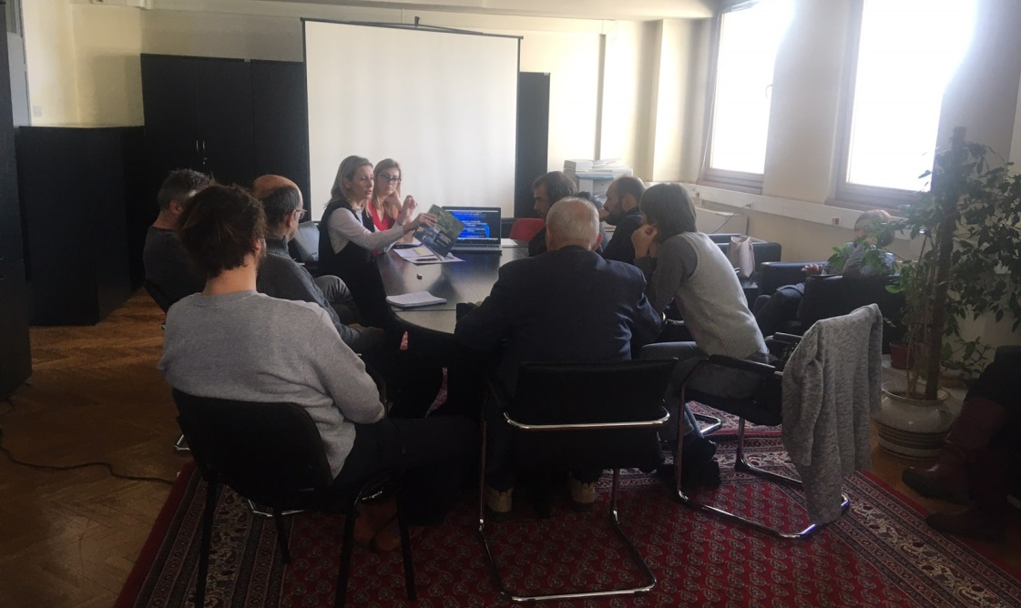
Picture 1: Public consultation in Belgrade, 30 December 2019
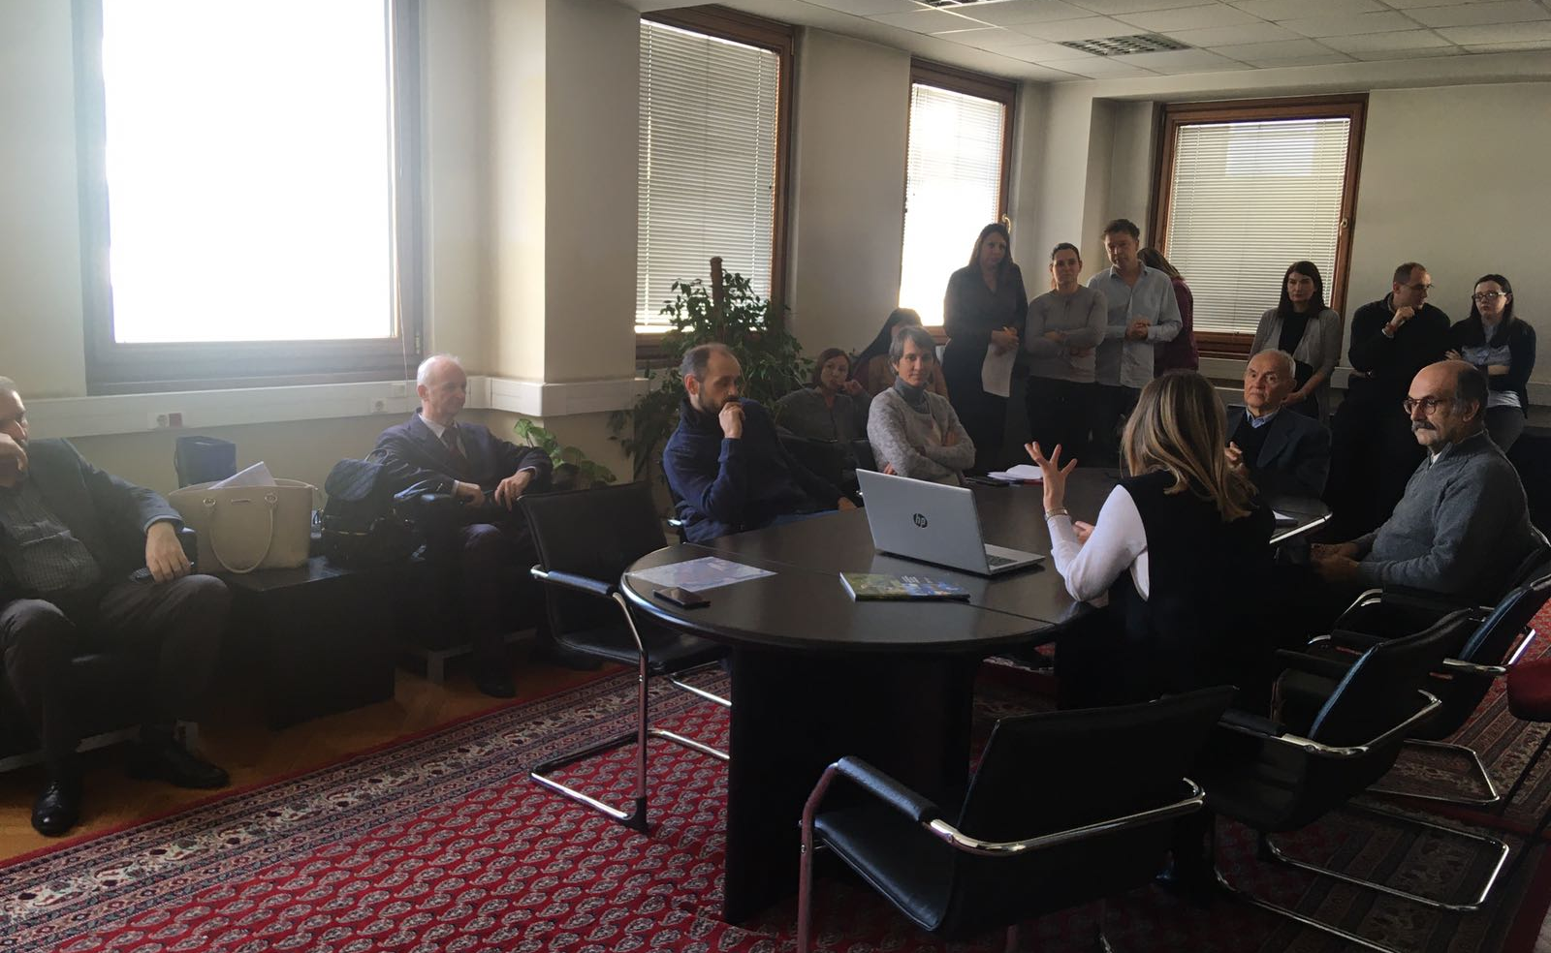
Picture 2: Public consultation in Belgrade, 30 December 2019
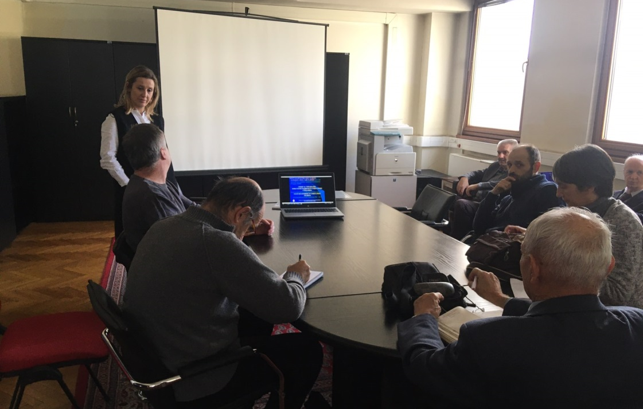
Picture 3: Public consultation in Belgrade, 30 December 2019
Special focus was given to project description, implementation arrangements, potential environmental and social impacts, grievance redress procedures, labor management, screening forms and development of environmental and social management plans during Project implementation.
The importance of Labor management and most important provisions of WB Environmental and Social Standard ESS2 (Labor and Working Conditions) are also explained to the public during presentation of ESMF document.
Before starting with questions of participants, institutional responsibilities and monitoring and reporting procedure on Project were presented and explained. However, the whole consultation have taken a participatory form and turned into a very interactive discussion with participation of all present Stakeholders very early before the moderator handed over the floor to the participants. This
Consultation started at 12:00 AM and ended at 3:30 PM, local time.

Questions and Answers during public presentation and consultations:

Q1: Has the MAFWM and/or the Government defined all Sub-projects at this stage?
A1 Nina Valcic, Social Specialist: Only a couple of Sub-project were identified at the preparation stage. These are Sub-projects Jarak, Popova Bara and Surcin Warehouse. One of the aims of these public consultations and the whole Stakeholder engagement activities relate inter alia to better understand the needs and provide the Stakeholders with an opportunity to directly contribute to the project architecture.
.................................................
Q2: What is the rationale of the World Bank to support compensation even for informal structures constructed without valid permits on land designated as river protection belt?
A1 Nina Valcic, Social Specialist: Any Project developed with financial support of the World Bank, here and anywhere in the World are subjected to the Banks social standards. As already highlighted as of October 2018 any new Project is subject to the Environmental and Social Framework =. Adverse impacts attributable to the Project stemming from Land acquisition are in detailed covered by the ESS 5 on Land Acquisition, Restrictions on Land Use and Involuntary Resettlement. The requirements of these standards are very specific when it comes to informal owners and users and formal and informal economic activities and between these two categories there are no differences in their eligibility. In the aim to prevent opportunistic claims, which indeed, are not eligible the Borrow is requested to announce the Cut-off date.
.................................................
Q3: How are the specific Stakeholder engagement activities designed? What will the methods of engagement be and what frequency will they take?
A1 Nina Valcic, Social Specialist: .As presented today this Project has a standalone Stakeholder Engagement Plan (SEP) applicable throughout the Project lifecycle, to be updated as needed following the procedure set out in the plan itself. The method of engagement is phase sensitive and will be continued and ongoing carefully following the development of the Project and the need to consult and inform the identified Stakeholders. Stakeholders are encouraged to follow announcements on the website of the MAFWM and newspapers as the Project information will be available there. Following these consultations and the Appraisal by the World Bank the engagement shall be intensified as outlined in the plan. For more details please again refer to the disclosed Stakeholder Engagement plan.
.................................................
Q4: Will the Project have a specific Grievance Mechanism? As we understand this is a requirement of many IFIs?
A1 Nina Valcic, Social Specialist: This as all other Projects financially supported by the World bank will have a Project Specific Grievance Mechanism to serve both persons directly affected by land acquisition and persons affected by other Project`s activities ( throughout the cycle). At this moment given the preparation phase of the project the Central mechanism within the MAFWM is operational to be followed by local entry points. Subsequently as the selection of Sub-projects continues and progresses. This points and function of the GM shall be locally publicized and information material distributed.

Opinions and remarks provided in written form:

O1 Branislav Djordjevic, Citizen Association “Akademija inzenjerskih nauka Srbije”, by his letter dated 03 January 2020:
- All hydro technical project activities on the rivers and in the Sava and Drina corridors should be done exclusively with new hydrological studies and with new hydrological analyzes, since the previously prepared studies are obsolete. Recommended experts to be involved in the new design team.
- Detailed environmental impact analysis is required. The Ramsar Convention on the Protection of Wetlands should also be kept in mind.
- In the case of construction of a new embankment on the left bank of the Sava River in the New Belgrade area, a Spatial Plan of Detailed Regulation with clearly defined Land use should be developed.
- The planned settlements in the remaining Sava river bank areas of New Belgrade, in the hinterland of the regulated part of the river banks, should be carefully reviewed in sense of the population density of that particular city zone (density of buildings, floors), as it is already extremely densely populated, which is reflected in very difficult traffic, as well as to air pollution resulting from excessive occupancy of remaining land.
- Since the Program also includes the Drina corridor, regardless of which facilities will be financed in that corridor, the integral solution of the water management system on that river, which is now official, should be mentioned, as it is in the Water Management Base of Serbia and the Spatial Plan of the Republic of Serbia , as well as in the Republika Srpska Water Management Strategy.
- During the consultation, I and several other attendees were unpleasantly surprised by the explanation of the World Bank's position that all facilities for which displacement and demolition are needed - are in the same legal position in terms of compensation, regardless of when and how investors built the property to be removed. Therefore, in view of the legal regulations relating to water land, as well as the zone of protection of springs, the World Bank in Serbia must use the only possible - selective approach. He implies that the position on the legal position of those whose property will be expropriated and compensated for the construction of shorelines does not apply to those owners who have committed the crime of building in prohibited zones.
- It would be completely illogical and dangerous to require a high degree of flood protection in the new coastal zones regulated under this Program, while allowing the already existing embankment upstream of the settlement in block 45 to be physically destroyed by unintended use as a road, even for the heaviest traffic. Such loads have a very unfavorable effect on the deformations of the foundation zone of the embankment, which therefore becomes unsafe and prone to collapse. The World Bank should therefore explicitly restrict its loan for the construction of new fortifications on the left bank of the Sava by requiring that physical barriers be completely prevented from accessing motor vehicles on the embankment, in all places where it occurs, and preventing the opening of some new approaches.
- In order to re-design the New Belgrade embankment project, it should be borne in mind that the owners of illegally constructed houses in the river side area have constructed transverse embankments to block the large water (river inundation) trough so that they can reach their homes, not only by cars, but by heavy construction machines. These transverse structures during periods of high Sava waters completely impede the flow in the high water trough and drastically aggravate the modes of propagation of large water waves, drastically increasing the risk of breakage of the embankment. Therefore, it is necessary for the World Bank to make the loan for new works in the Sava Corridor conditional on the removal of these transverse structures (access roads to residential buildings, rem.aut.), as well as all other facilities in the large water basin and to enable unhindered mode of transmission of large-water waves. Here, too, the principle must be that these works should be done at the expense of those persons who performed those dangerous works.
- Raft owners cut deep embankments through deep trenches to push plumbing to their rafts. The embankment is thus damaged in several places, which compromises its safety. Therefore, as one of the priorities of this Program, the World Bank should require the rehabilitation of an already existing embankment and prevent its further damage by enforcing a traffic ban on it, except for the official purpose of maintaining the embankment.
- The World Bank should also be aware of the very serious endangering of Belgrade Water Supply springs by illegal construction in the protection zones of the springs.

O2 Aleksandra Smiljanic, Citizen Association “Akademija inzenjerskih nauka Srbije”, by her letter dated 03 January 2020, related to SDIP Project Potential Procurement Packages - : Nr. 1.1.14 Design and Raising dykes in Novi Beograd to protect Belgrade City from flood:
- Several hundred illegal cottages between the embankment and the water were built on the Sava embankment. They threaten the embankment itself, which protects New Belgrade with over 200,000 inhabitants from flooding, as well as Belgrade's water supply, because they are located in the middle of Belgrade's water source
- The owners of illegal cottages drive cars along an embankment that is not designed for traffic but only for service vehicles
- The owners of illegal rafts along the Sava Quay have drilled the embankment in several places with water pipes to bring water to their rafts.
- Although no funds have been allocated for specific projects, investment is being considered for coastal fortification along the planned settlement in New Belgrade, downstream of Block 70a, on land owned by the private companies Comtrade and Zepter. The owners of these companies benefit most from such a project, which is not in line with the World Bank policy that everyone has equal access to World Bank funds
- New planned settlements along the Sava River in New Belgrade do not need to be built, because New Belgrade is already too densely populated and traffic congestion is unbearable.
- If the World Bank wants to provide embankments on the Sava River, it must first start with the existing, already built part of the embankment, which is most vulnerable to the misuse of infrastructure by irresponsible citizens.
- I request that my statement and the accompanying articles be forwarded to the World Bank:
- http://savskinasip.com/analize/group-of-irresponsible-people-endanger-belgrade/1469/
- http://savskinasip.com/analize/stance-of-serbian-academy-of-engineering-sciences/1463/
- http://savskinasip.com/analize/story-about-insolent-people-and-powerless-system/1439/

LIST OF PARTICIPANTS - PRELIMINARY CONSULTATIONS WITH KEY STAKEHOLDERS, 30 DEC 2019

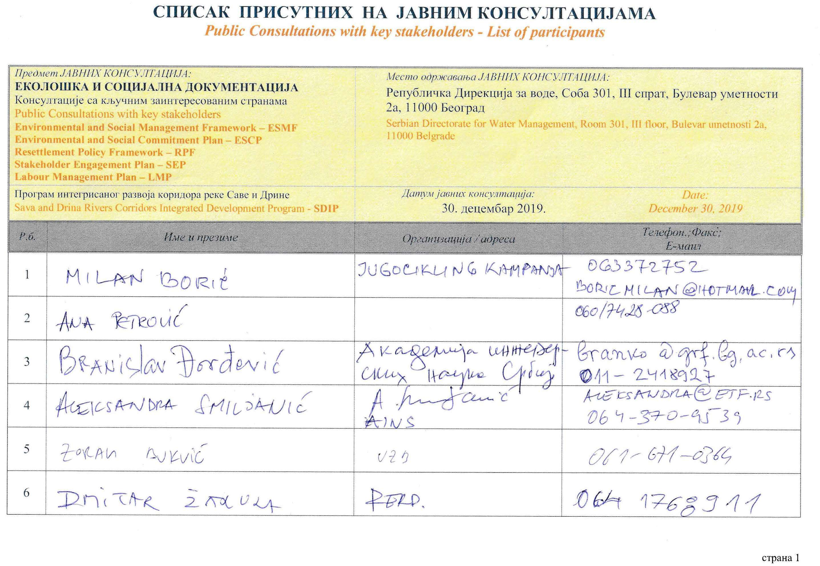
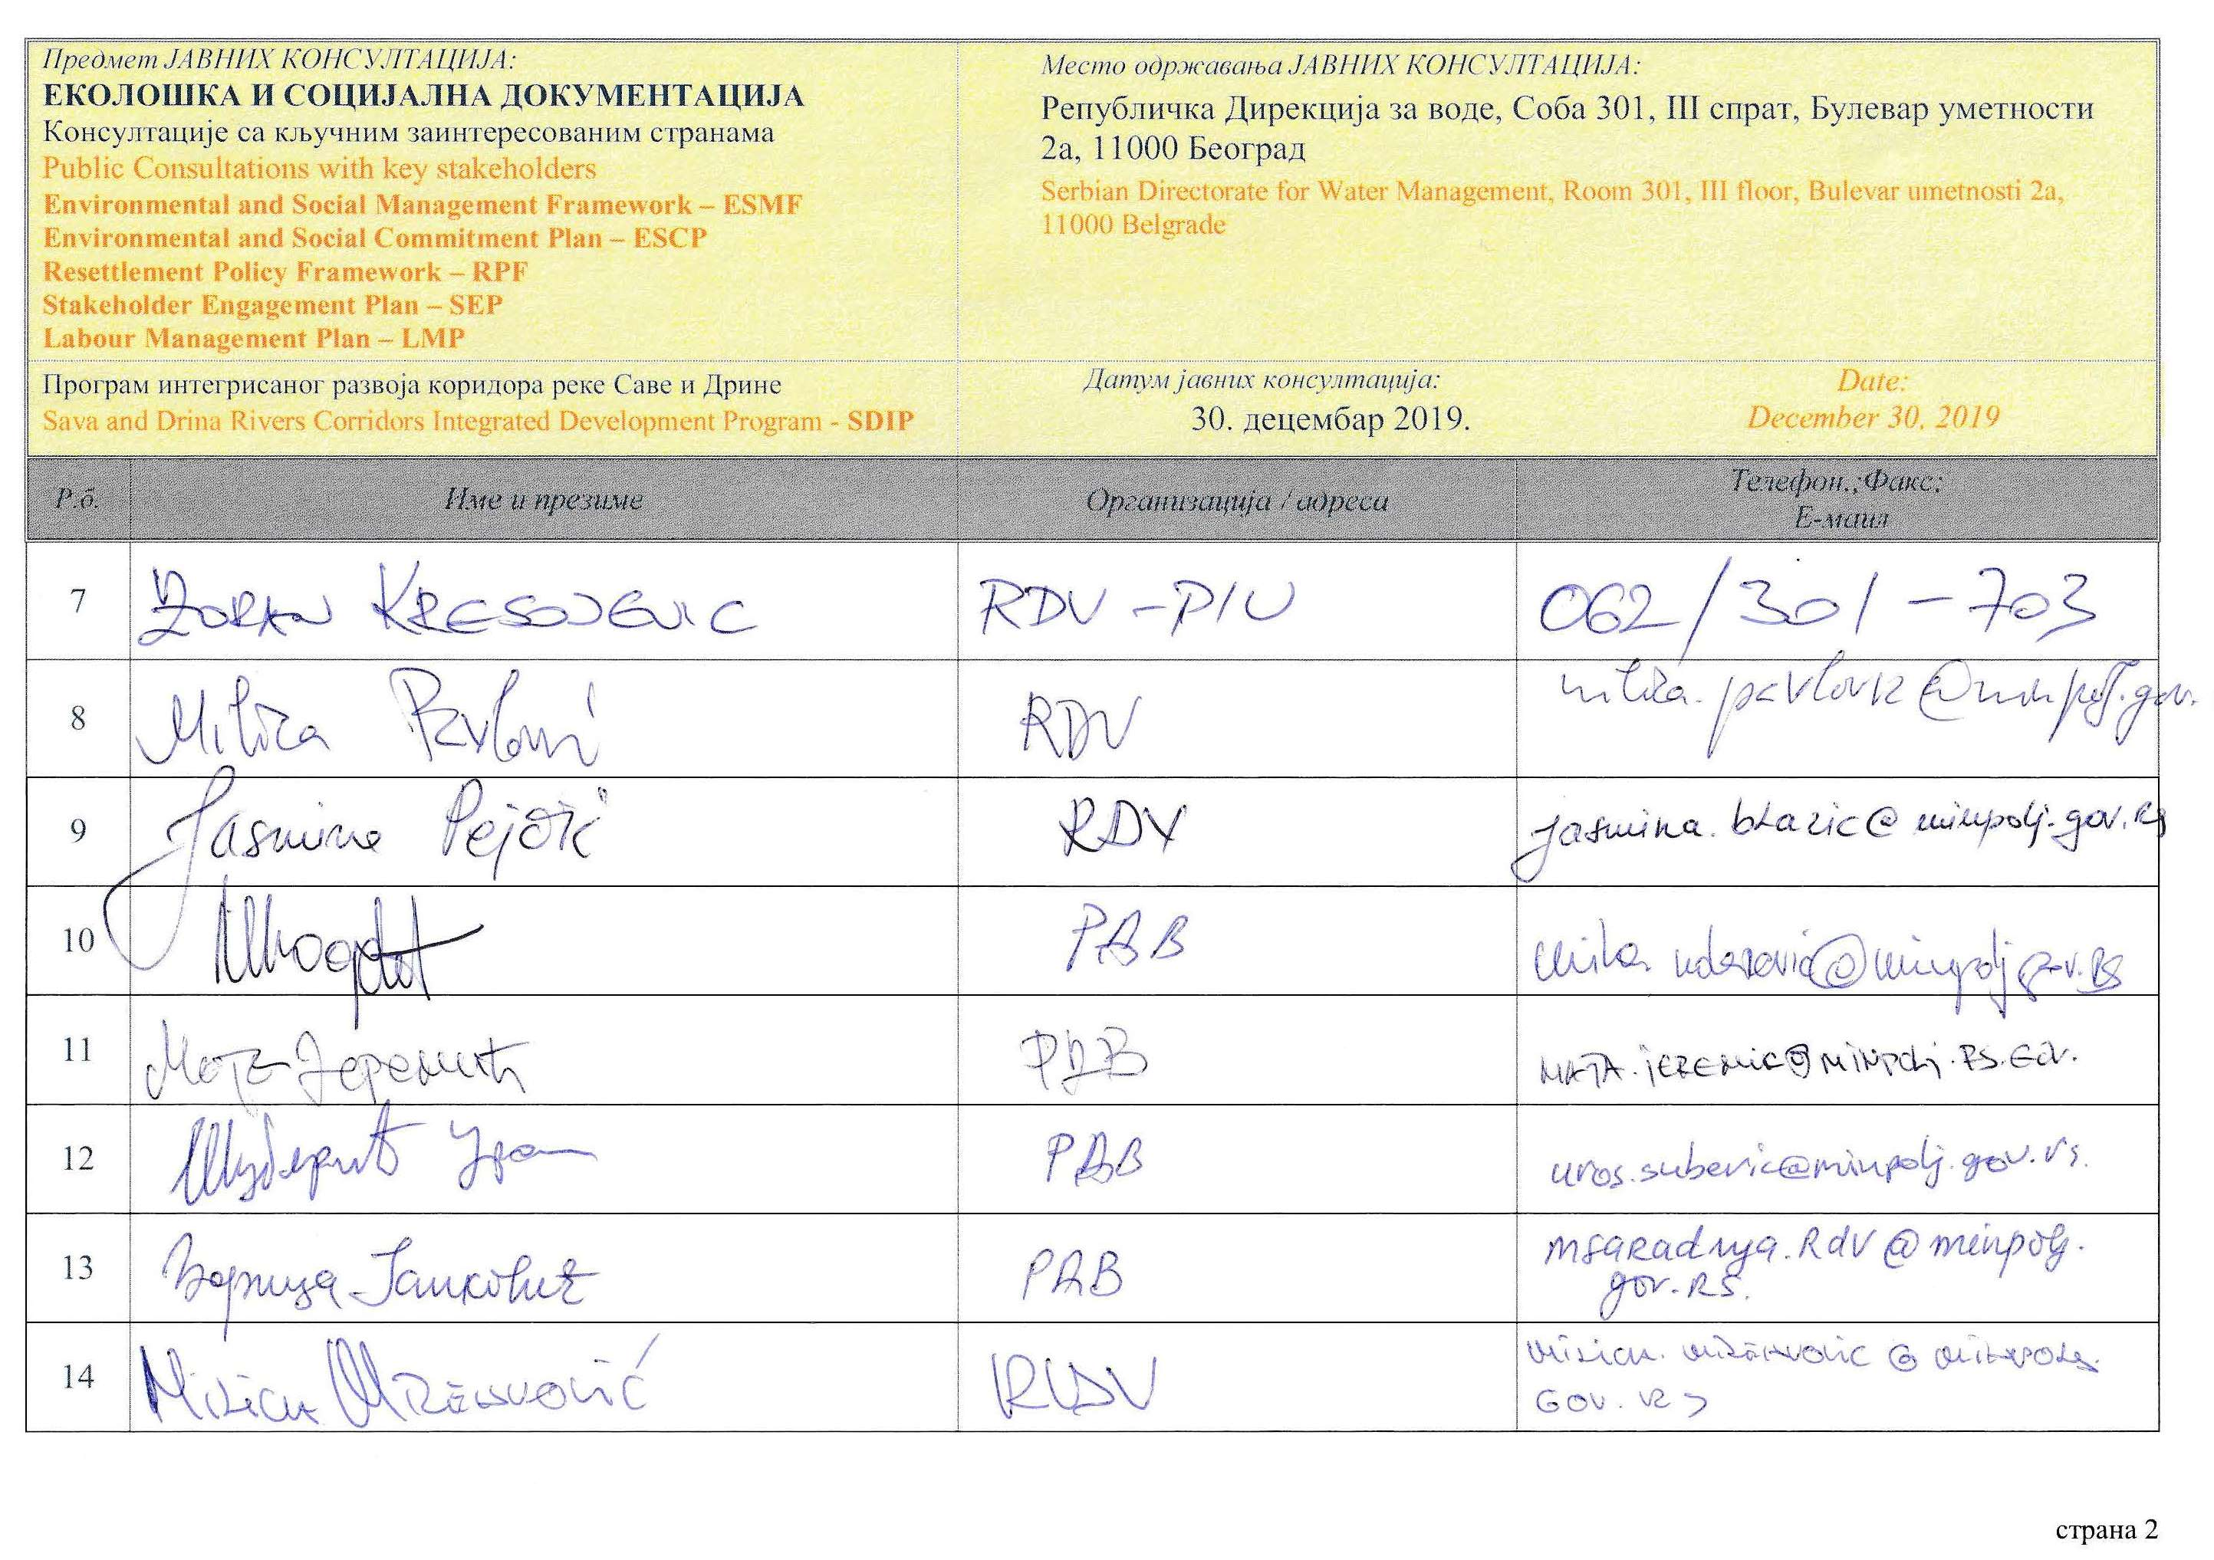
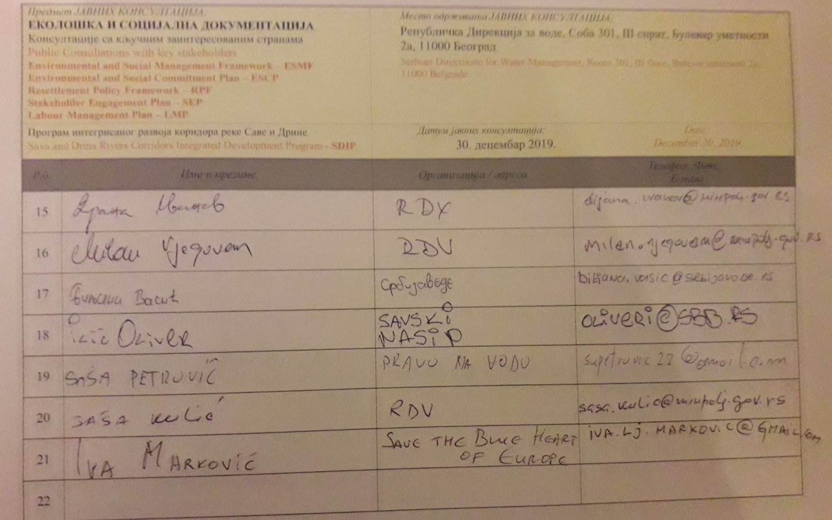

DOCUMENTATION

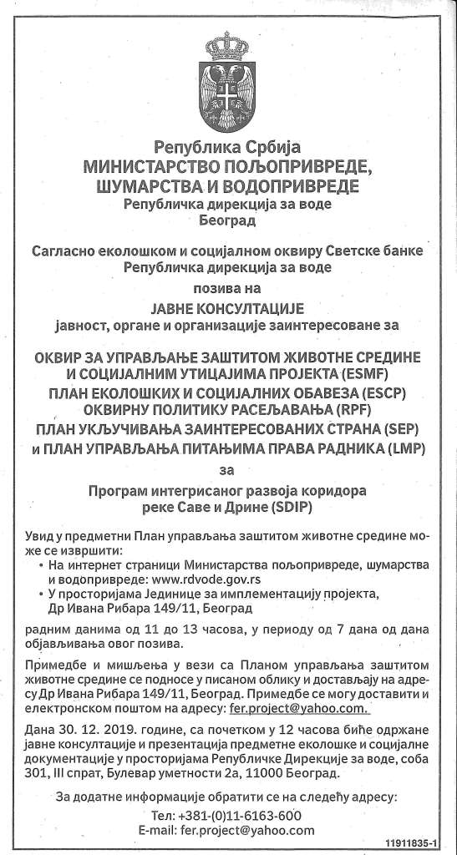
Picture 4: Announcement of public consultation in daily newspaper, (“Politika”, 26 Dec 2019)

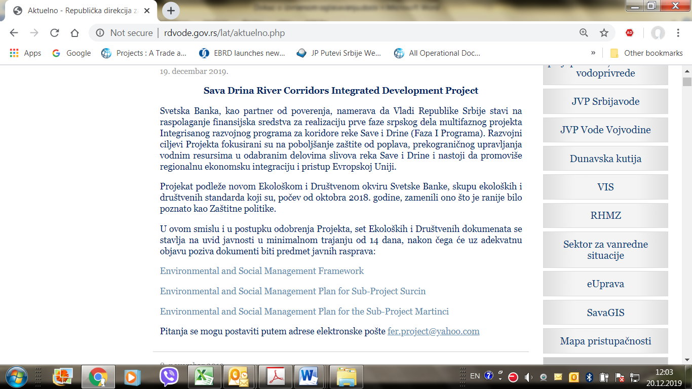
Picture 5: Announcement of public consultation on SDIP Environmental documents on Ministry web site

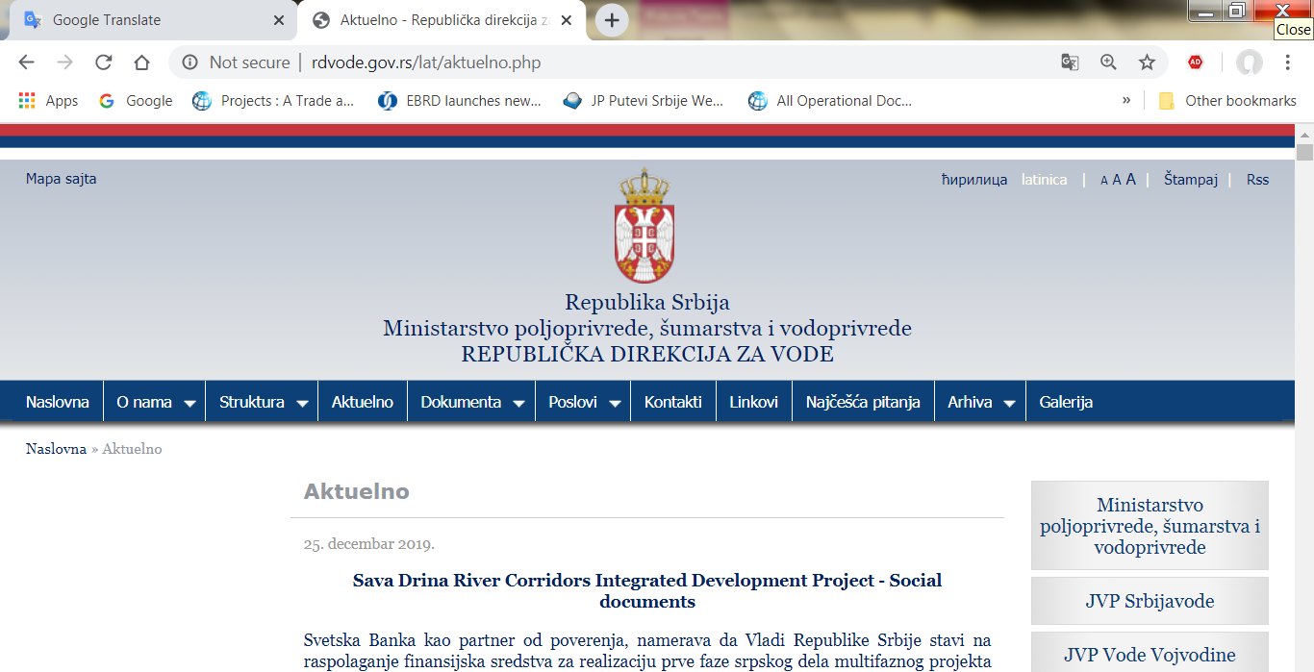
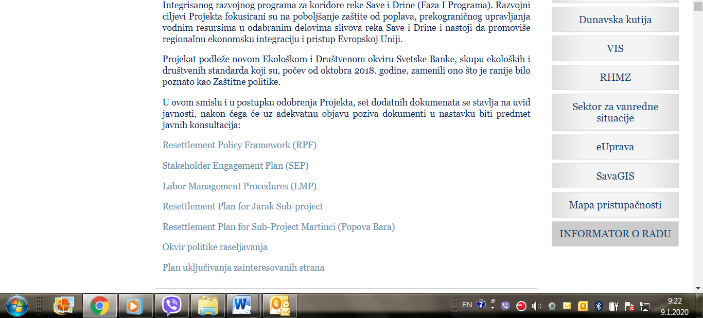
Picture 6: Announcement of public consultation on SDIP Social documents on Ministry web site

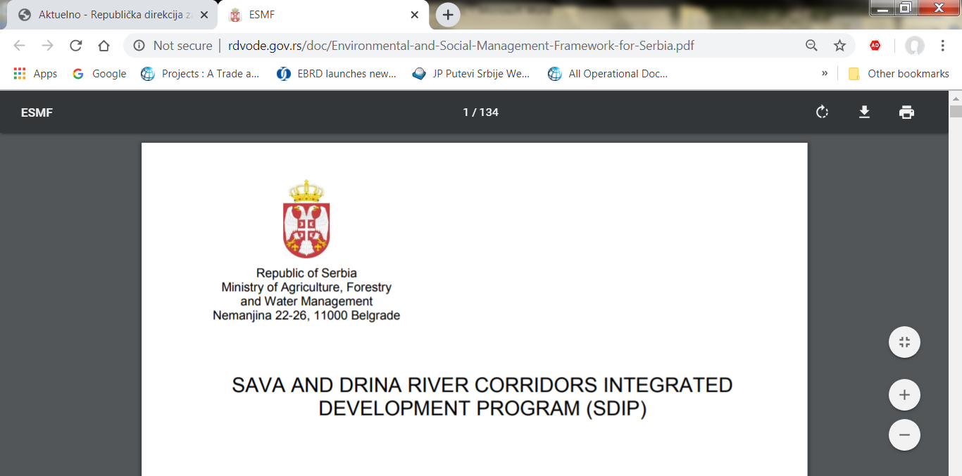
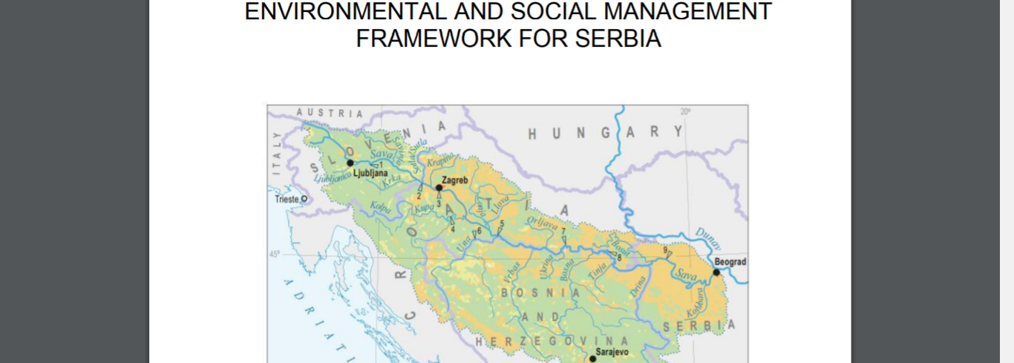
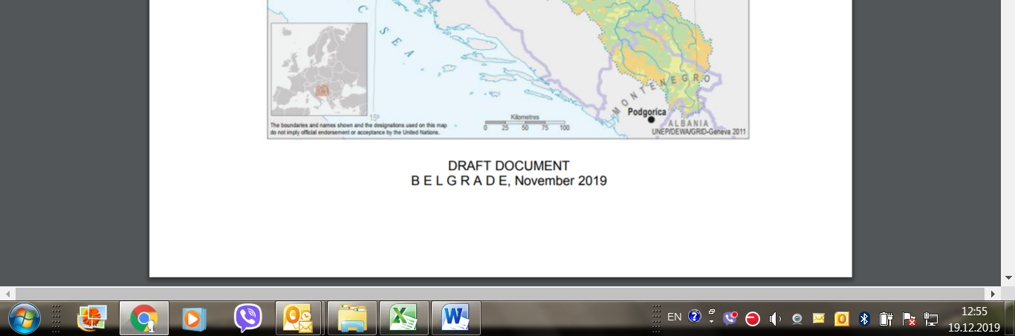
Picture 7: Public disclosure of DRAFT ESMF document, English language, Ministry web site

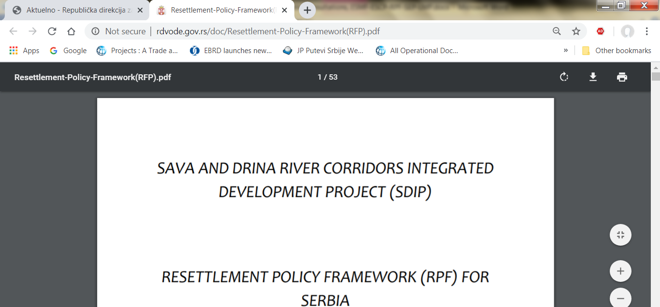
Picture 8: Public disclosure of DRAFT RPF document, English language, Ministry web site

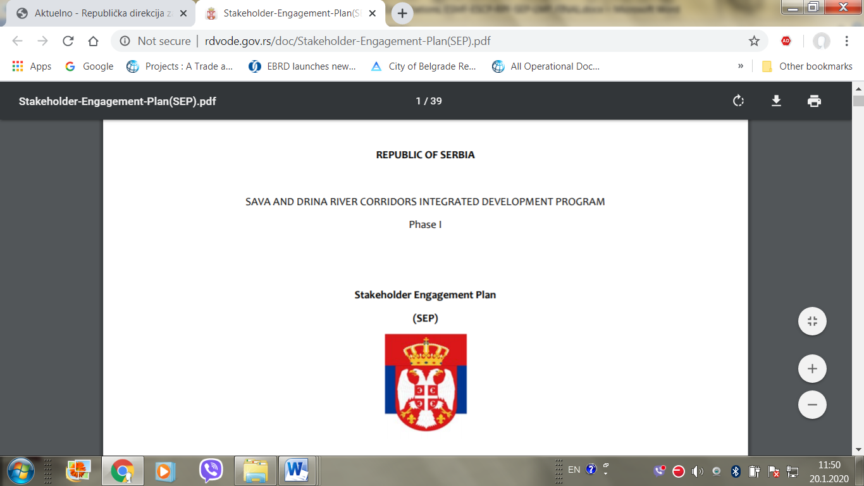
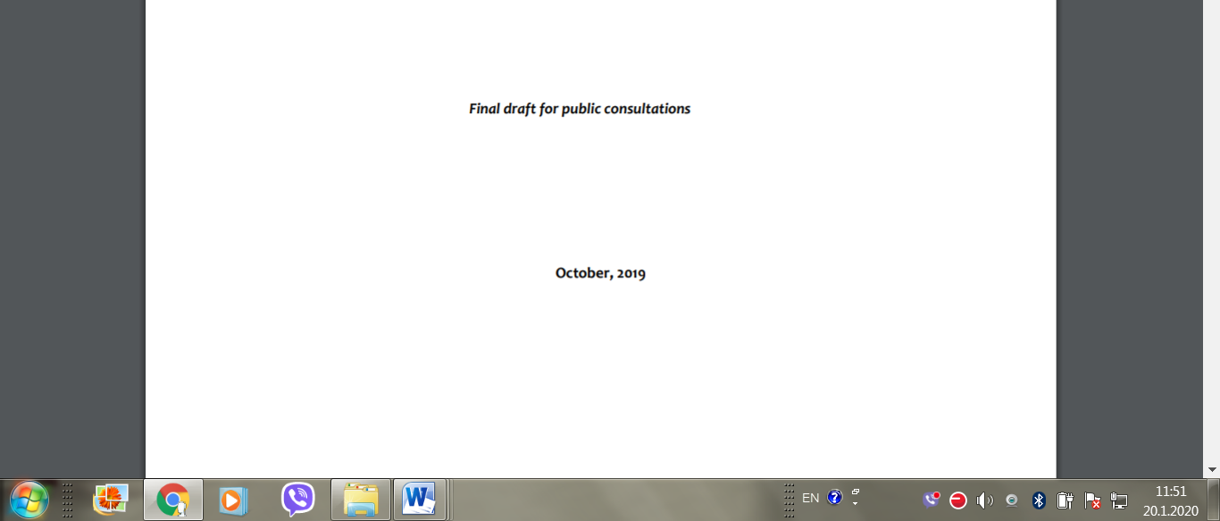
Picture 9: Public disclosure of DRAFT SEP document, English language, Ministry web site

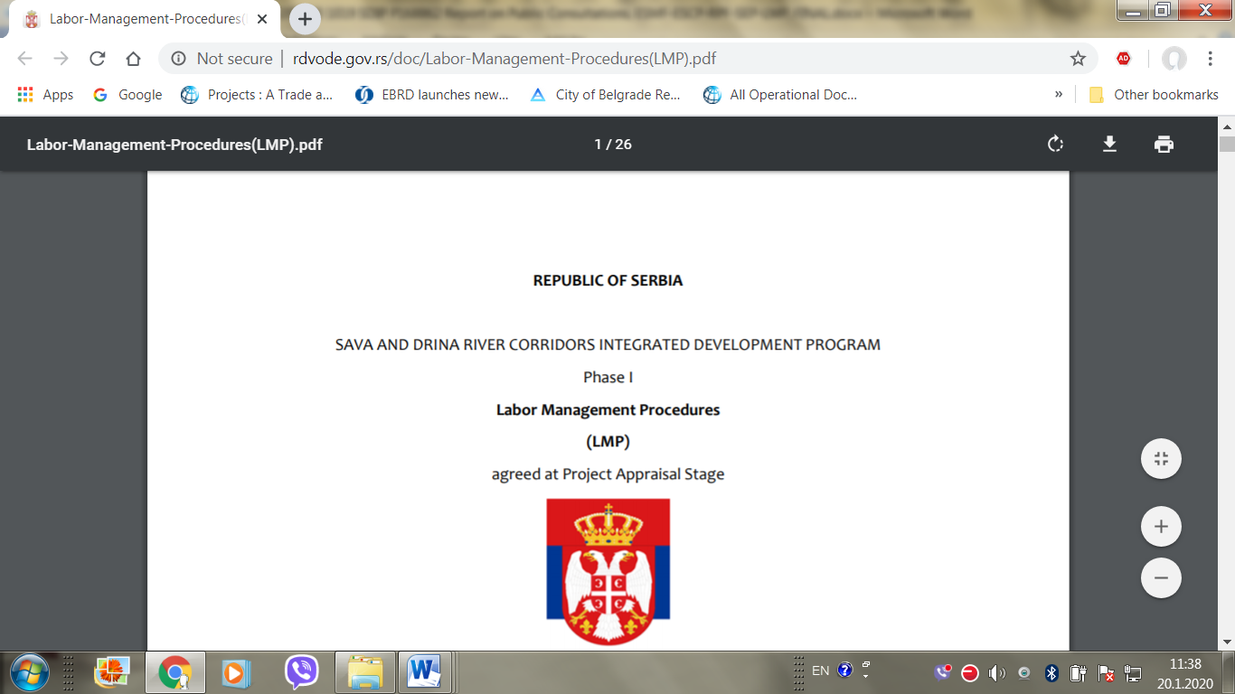
Picture 10: Public disclosure of DRAFT LMP document, English language, Ministry web site

ANNEX 16: COMPLIANCE REPORT

Contract:
Contractor/Service Supplier:
Reported period:
Date of report:

COMPLIANCE REPORT

Company employees* statistics:
Total number of employees¹: _________________
Number of employees with an employment contract | Number of employees outside the employment relationship | Number of employees with access to social security, pension and health insurance | Number of employees who receives wages/salaries at least once a month
Number of employees who left the company in the reported period | Number of employees hired in the reported period | Number of hours worked per employee (monthly average) | Total overtime (monthly average)
Number² of injuries at work | Number of fatalities at work | Number of reported violence | Number of reported harassment/ abuse
Number of reported discriminations | Number of grievances raised | Number of grievances resolved
Number of suits filed with regard to labor, employment and OHS issues | Number of disputes brought to peaceful settlement/ voluntary arbitration procedure | Number of visits by labor/ OHS inspection
*The employee is any natural person employed or engaged to work or perform service for the employer
¹ The number of employees refers to the actual number/headcount on the date of the report.
² The numbers implies the total number of incidents in the reported period.

Project workers statistics:
Total number of project workers**: | Number of project workers with an employment contract: | Number of project workers outside the employment relationship | Number of project workers with access to social security, pension and health insurance

Working and Labor Conditions Screening Check List
 | Terms and conditions | Yes | No | Notes
1 | All project workers have an employment contract or engagement agreement in writing |  |  | If “No” please specify and explain
2 | Project workers are paid at least once a month |  |  | If “No” please specify and explain
3 | Project workers worked 8 hours a day, 40 hours a week |  |  | If “No” please explain and specify the hours worked
4 | Project workers had a regular daily and weekly rest |  |  | If “No” please specify and explain
5 | Project workers were terminated from employment |  |  | If “Yes” please specify and explain
6 | Project workers attended a training programme |  |  | If “Yes” please specify and explain
7 | Project workers were granted leaves they are entitled to |  |  | If “Yes” Please specify the type and number of leaves
8 | Project workers were involved in accidents at work resulting in injuries or fatalities |  |  | If “Yes” please specify and explain
9 | Project workers reported on cases of discrimination, harassment, sexual harassment or non-compliance with law |  |  | If “Yes” please specify and explain
10 | Project workers raised grievances or started voluntary arbitration / legal proceedings to settle a dispute |  |  | If “Yes” please specify and explain
11 | In the reported period there were some incidents on noncompliance with the LMP |  |  | If “Yes” please specify and explain
** Project workers are natural persons assigned to the project by the contractor/ service provider.

This questionnaire should be part of a report on involvement/results achieved in the project

ANNEX 17: Summary of potential land acquisition impacts stemming from development of Component 1.3

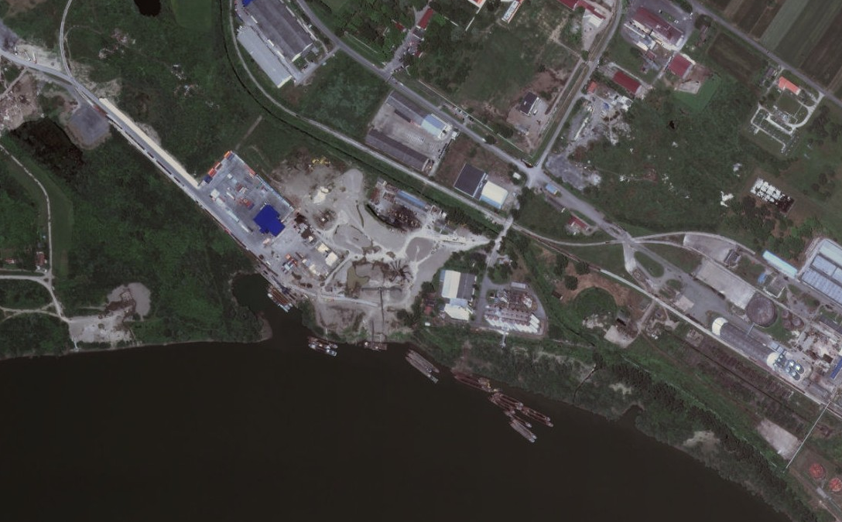
Construction of Sremska Mitrovica Port is planned on the left bank of the Sava River rkm136+600 to rkm135+800, on cadastral parcels 5835 5836, 5837, 5839, 5840, 5841, 5842, 5843, 5852, 5853, 5880/6, 5880/7 and 5880/8, C.M. Sremska Mitrovica and parts of cad. parcels 5825, 5834 and 5854 C.M. Sremska Mitrovica, with the total available surface of 1386 ha.
The Port is designed as an open port with the possibility of expanding the existing basin and accommodating certain terminals in this part of the operational quay. Planned technical productivity should enable transhipment of approximately 1.5 million tonnes of various types of bulk, liquid and general cargo, namely: grain, petroleum products, finished products and semi-finished products of the steel industry (billets, concrete steel, etc.), construction material (gravel, sand and aggregates), old iron, coal, biomass pellets, palletized goods and other packaged products and containers.
The table below depicts potential anticipated impacts to land affected by the expansion activities. Detailed in depth screening and application of relevant mitigation measures and development of resettlement instruments shall follow once the detailed engineering designs are available:
Cadastral Parcel | Total area m2 | Title holder /Type of ownership | Comment
5835/1 Sremska Mitrovica | 391 | Radosevic (Petar) Ivan /private | Structure Residential
5835/2 Sremska Mitrovica | 9 | Radosevic (Petar) Ivan /private
5835/3 Sremska Mitrovica | 391 | Radosevic (Petar) Ivan /private
5836 Sremska Mitrovica | 3854 | Archers’ Club "Zivko Relic " / private | Owner of land Republic of Serbia
5837 Sremska Mitrovica | 2293 | RTC PORT LEGET a.d/ private
5839 Sremska Mitrovica | 11.146 + 392 | GАSСОМ ВАLКАN DОО ВЕОGRАD/private
5840 Sremska Mitrovica | 8.297 | GАSСОМ ВАLКАN DОО ВЕОGRАD
5841 Sremska Mitrovica | 1.982 | GАSСОМ ВАLКАN DОО ВЕОGRАD
5842, Sremska Mitrovica | 1.985 | GАSСОМ ВАLКАN DОО ВЕОGRАD
5843 Sremska Mitrovica | 468 | GАSСОМ ВАLКАN DОО ВЕОGRАD
5852 Sremska Mitrovica | 110 | RTC PORT LEGET a.d/ private | Residential Structure
5853 Sremska Mitrovica | 18 | RTC PORT LEGET a.d/ private | Auxiliary Structure
5880/6 Sremska Mitrovica | 14.007 | RTC PORT LEGET a.d/ private | Structure of 11 m2 with unknown use
5880/7 Sremska Mitrovica | 54.345 | RTC PORT LEGET a.d/ private
5880/8 Sremska Mitrovica | 31.678 | RTC PORT LEGET a.d/ private

This is part of a multiphase programmatic approach with an overall financing envelope of EUR225.4 million US$250.2 million equivalent)
The World Bank’s ESF came into effect on October 1, 2018
In August 2016, the World Bank’s Board of Executive Directors approved the Environmental and Social Framework (ESF), which have come into effect in August 2018
The term “project worker” refers to: (a) people employed or engaged directly by the Borrower (including the project proponent and the project implementing agencies) to work specifically in relation to the project (direct workers); people employed or engaged through third parties to perform work related to core functions of the project, regardless of location (contracted workers); (c) people employed or engaged by the Borrower’s primary suppliers (primary supply workers); and (d) people employed or engaged in providing community labor (community workers). ESS2 applies to project workers including fulltime, part-time, temporary, seasonal and migrant workers.
The boundaries, colors, denominations and any other information shown on this map do not imply, any judgement on the legal status of any territory, or any endorsement or acceptance of such boundaries.
Detailed MPA Program Framework for SDIP Program is enclosed as Annex 02 to this ESMF document
The boundaries, colors, denominations and any other information shown on this map do not imply, any judgement on the legal status of any territory, or any endorsement or acceptance of such boundaries.
The enrichment of water by nutrients, especially compounds of nitrogen and/or phosphorus, causing an accelerated growth of algae and higher forms of plant life to produce an undesirable disturbance to the balance of organisms present in the water and to the quality of the water concerned [Directive 91/271/EEC].
General Poverty Assessment in the Republic of Serbia for 2017, Statistical Office of the Republic of Serbia report, 2017 - http://socijalnoukljucivanje.gov.rs/wp-content/uploads/2018/10/Ocena_apsolutnog_siromastva_u_Srbiji_u_2017_godini_lat.pdf
"Official gazette of RS" 24/2005, 61/2005, 54/2009, 32/2013 i 75/2014
The current situation of gender equality in Serbia – Country Profile - study that was financed by, and prepared for the use of the European Commission, Directorate-General Justice, Unit D2 “Gender Equality” in the framework of the service contract managed by Roland Berger Strategy Consultants GmbH in partnership with ergo Unternehmenskommunikation GmbH & Co. KG.
Source: WikiMedia - all data came from Statistical office of Serbia and article was written by Serbian government representatives, based on Statistical office surveys. Taken from an article within the scope of WikiProject Serbia, a collaborative effort to improve the coverage of Serbia on Wikipedia.
Ibid.
The Acquis Communautaire is the accumulated body of European Union (EU) law and obligations from 1958 to the present day. It comprises all the EU's treaties and laws (directives, regulations, decisions), declarations and resolutions, international agreements and the judgments of the Court of Justice.
http://eukonvent.org/wp-content/uploads/2018/07/Izve%C5%A1taj-o-napretku-Srbije-2018_engleski.pdf
https://www.paragraf.rs/propisi/zakon_o_javnoj_svojini.html, last accessed October 9, 2019
https://www.paragraf.rs/propisi/zakon_o_osnovama_svojinskopravnih_odnosa.html, ibid
http://www.pregovarackagrupa27.gov.rs/?wpfb_dl=109
http://www.subotica.rs/documents/zivotna_sredina/Propisi/Pokate.pdf
https://www.paragraf.rs/propisi/zakon_o_planiranju_i_izgradnji.html, ibid
https://www.paragraf.rs/propisi/zakon_o_ozakonjenju_objekata.html, last accessed October 9, 2019
Serbia Flood Emergency and Recovery Project which closed on October 31, 2019
https://www.paragraf.rs/propisi/zakon_o_vanparnicnom_postupku.html, last accessed October 9, 2019
https://www.paragraf.rs/propisi/zakon-o-opstem-upravnom-postupku.html, ibid
https://www.paragraf.rs/propisi/zakon_o_drzavnom_premeru_i_katastru.html, last accessed October 9, 2019
https://www.paragraf.rs/propisi/zakon_o_eksproprijaciji.html, ibid
These include: • ILO Convention 87 on Freedom of Association and Protection of the Right to Organize • ILO Convention 98 on the Right to Organize and Collective Bargaining • ILO Convention 29 on Forced Labor • ILO Convention 105 on the Abolition of Forced Labor 2 Guidance Note – ESS2: Labor and Working Conditions • ILO Convention 138 on Minimum Age (of Employment) • ILO Convention 182 on the Worst Forms of Child Labor • ILO Convention 100 on Equal Remuneration • ILO Convention 111 on Discrimination (Employment and Occupation
MEP is responsible for: EIA, SEA, Public Participation, Access to Information, Environmental Liability, Waste Framework, Packaging, Landfill, WEEE, Batteries, PCB/PCT, POPs, ELVs, RoHS (recast), Shipments of Waste, AAQ, 4th daughter, VOCs petrol, Stage II VOCs petrol, NEC, Standards on good environmental status, Groundwater, Habitats, Wild Birds, CITES, NAGOYA PROTOCOL, Zoo, Trade in seal products, Importation of skins of certain seal pups, Leg-hold Traps, IED, CHAPTER II – IPPC, LCP, Waste Incineration, VOC solvents, SEVESO III, VOCs paints, Eco-label, EMAS, Titanium – Dioxide, MCP, REACH, CLP, Mercury, Asbestos, Biocidal products, PIC REGULATION, MMR, Consumer Information, ODS, F – GASES, Environmental Noise.
SEPA is in charge for Quality Assurance/Quality Control
DAL in charge for Sludge management
DfWM is responsible for Water Framework, Nitrates, UWWT, Floods, Marine Strategy Directive.
FD is in charge for EUTR and FLEGT Directive
RGA is the responsible for transposition and coordinating the implementation and monitoring of the INSPIRE directive
MoH is in charge for Bathing Water Directive and Drinking Water Directive.
INC deals with, Habitats Directives: Directive 92/43 / EEC as amended by Directive 97/62 / EC, 2006/105 / EC and Regulation (EC) 1882/2003.
Such notification is the employer's obligation stipulated by Law on the Prevention of Harassment at the Workplace (2010), Rulebook on Conduct of Employers and Employees in Relation to Prevention and Protection from Harassment at Work (2010) and Law on Protection of Whistle Blowers (2014),
PMU within the MCTI for subproject 1.3.1 “Expansion and modernization of port of Sremska Mitrovica” and PMU within the MAFWM for other subprojects
http://www.subotica.rs/documents/zivotna_sredina/Propisi/Pokate.pdf
For subproject 1.3.1 “Expansion and modernization of port of Sremska Mitrovica” relevant institution is Ministry of Construction, Transport and Infrastructure
This does not apply to project sponsors who are not substantially involved in these activities. "Not substantially involved" means that the activity concerned is ancillary to a project sponsor's primary operations.
Forced labor means all work or service, not voluntarily performed, that is extracted from an individual under threat of force or penalty.
Harmful child labor means the employment of children that is economically exploitive, or is likely to be hazardous to, or to interfere with, the child's education, or to be harmful to the child's health, or physical, mental, spiritual, moral, or social development.
The Applican should mark adequate commitment
For subproject 1.3.1 “Expansion and modernization of port of Sremska Mitrovica” relevant institution is Ministry of Construction, Transport and Infrastructure
In addition to any other relevant comments, please indicate whether the measurements reported apply to all or only some process operations at the facility Please include any relevant fuel quality parameters (e.g. calorific value)
If you have not already done so, please provide a separate report detailing the circumstances of each fatality.
Incapacity to work for at least one full workday beyond the day on which the accident or illness occurred.
Lost workdays are the number of workdays (consecutive or not) beyond the date of injury or onset of illness that the employee was away from work or limited to restricted work activity because of an occupational injury or illness.

