REPUBLIC OF SERBIA

SAVA AND DRINA RIVER CORRIDORS INTEGRATED DEVELOPMENT PROGRAM
Phase I
Labor Management Procedures
(LMP)
agreed at Project Appraisal Stage

October 12, 2019

Contents
1. INTRODUCTION 3
2. SCOPE AND STRUCTURE OF THE LMP 4
3. OVERVIEW OF LABOR USE ON THE PROJECT 4
3.1 Number of Project Workers 5
3.2 Timing of labor requirements: 5
4. ASSESSMENT OF KEY POTENTIAL LABOR RISKS 6
5. BRIEF OVERVIEW OF LABOR LEGISLATION: TERMS AND CONDITIONS 7
6. BRIEF OVERVIEW OF LABOR LEGISLATION: OCCUPATIONAL HEALTH AND SAFETY (OHS) 9
7. RESPONSIBLE STAFF 9
8. POLICIES AND PROCEDURES 10
9. AGE OF EMPLOYMENT 13
10. TERMS AND CONDITIONS 14
11. GRIEVANCE MECHANISM 15
12. CONTRACTOR MANAGEMENT 17
13. PRIMARY SUPPLIERS 18
ANNEX 01 FORMAT FOR REPORT ON COMPLIANCE WITH CONDITIONS OF WORK WITH ESS2 for third parties engaging contracted workers 20
ANNEX 02 THIRD PARTIES STATEMENT (POTENTIAL CONTRACTORS AND SERVISE PROVIDERS) ON COMPLIANCE WITH PROVISIONS OF LABOR LEGISLATION and THE PROJECT`S LMP 23
ANNEX 03 PRIMARY SUPPLIERS STATEMENT OF COMPLIANCE WITH PROVISIONS OF LABOR LEGISLATION and THE PROJECT`S LMP RELATED TO CHILD LABOR, FORCED LABOR AND OHS 24

List of Abbreviations and Acronyms
CMU | Country Management Unit of the WB
EHS | Environmental, Health and Safety
ESF | Environmental and Social Framework
ESMF | Environmental and Social Management Framework
ESS | Environmental and Social Standards
FY | Fiscal Year
GM | Grievance Mechanism
GoRoS | Government of Serbia
GRS | Grievance Redress System
IDA | International Development Association/ World Bank
IFIs | International Financial Institutions
LMP | Labour Management Procedures
M&E | Monitoring and Evaluation
MAFWM | Ministry of Agriculture, Forestry and Water Management of the Republic of Serbia
MCTI | Ministry of Construction, Transport and Infrastructure
MLVSA | Ministry of Labor, Veteran and Social Affairs
MoF | Ministry of Finance of the Republic of Serbia
NGO | Non-Governmental Organization
PDO | Project Development Objective
PMU | Project Management Unit

INTRODUCTION
The World Bank (WB) as a trusted partner aims to provide financing through a multiphase program approach to the Government of Serbia (GoRoS) for the implementation of the Serbian part of the first phase of the Sava and Drina river corridors integrated development program (hereinafter referred to as: The Project). The Development Objective of the Sava Drina River Corridors Integrated Development Project (Phase 1 of the Program) is to improve flood protection, and transboundary water resources management in selected catchment areas of the Sava and Drina river corridors and aims to promote regional economic integration and EU accession within a challenging political environment. The Project is aligned with Serbia CPF 2016-2020 and with the World Bank’s twin goals, with the priorities set out by the national government and with EU policy goals for the region.
The project is designed as an Investment Project Financing (IPF) and as such needs to comply with the World Bank’s Environmental and Social Framework (2016) (ESF) comprising, inter alia, the Environmental and Social Standards (ESS). In response to the commitment of the GOS to comply with the ESF, the Ministry of Agriculture, Forestry and Water Management (MAFWM) has developed these Labor Management Procedure (LMP), laying out the Project’s approach to meeting the objectives of World Bank ESS 2: Labor and Working Conditions (ESS2). It sets out the terms and conditions for employment or engagement of workers on the project, specifies the requirements and standards to be met and the policies and procedures to be followed, assesses risks and proposes the implementation of compliance measures and promotes fair treatment, nondiscrimination and equal opportunity of project workers. The LMP is developed to help avoid, mitigate and manage risks and impacts in relation to project workers and set out the way in which project workers will be managed, in accordance with the requirements of national law and the ESS2. The procedures address the way in which both standards will apply to different categories of project workers including direct workers, and the way in which third parties will manage their workers compliant to this document.

The LMP applies to project workers as defined by ESS2. The focus of this LMP is on workers engaged by potential work and service providers (contracted workers) and consultants engaged directly by MAFWM i.e. the PMU to perform project related tasks (direct workers) as other labor of other workers (such as community workers are not expected). The extent in which primary supply workers will contribute in the projects pool of workers, including the assessment whether supply of goods and/or materials will be on an ongoing basis to the project essential to the core function of the project to qualify as primary suppliers is at this point at a best estimate considering the type of supply needs for construction/rehabilitation works. The labor management procedures set out the procedures how potential risks of child labor, forced labor and serious safety issues which may arise in relation to primary suppliers will be identified and assessed including roles and responsibilities for monitoring primary suppliers.
The legal framework of Serbia guiding Labor and Working Conditions is, with a few minor shortcomings, strongly compliant with the ESS2 as Serbia is signatory to the International Labor Organization (ILO) and United Nations (UN) Conventions informing the ESS2.)

SCOPE AND STRUCTURE OF THE LMP
The scope of the LMP shall be as outlined in the World Bank’s ESS 2. The engagement will be
Planned as an integral part of the project’s environmental and social assessment and project design and implementation. This document has 10 chapters. This chapter viz., chapter 1 served as introduction. An overview of labour use in the project is presented in chapter 2. Key potential labor risks are listed in chapter 3. Legislative framework governing labour employment in Serbia and a gap analysis with that of the World Bank’s ESS 2 is discussed in chapter 4. Implementation Arrangements, age requirement, policies and procedures and timing of labour requirements follows in the subsequent chapters. Grievance mechanism, contractor management are presented in the last chapters.

OVERVIEW OF LABOR USE ON THE PROJECT
It is expected that Project will engage the following categories of project workers as defined by ESS2:
Direct workers. Direct workers will be independent consultants hired specifically to work in relation to the project and be integrated into the project implementation unit (PMU) yet to be established housed by the Ministry of Forestry and Water Management (MFWM) its Directorate for Water (DfW) namely. These workers will be engaged through the standard form of Contracts for Consultancy services provided by the World Bank with standard wording. The PMU will have managerial, administrative and coordination roles. The number of PMU personnel and the requirements in terms of their qualifications, experience and competences is yet to be defined, along with the job positions and responsibilities but will be along the line of the following: Project Management, Environmental and Social Specialists, Sub-Project Coordinators, Financial Specialist, Procurement Specialists, Administrative services etc. In a limited number of cases government civil servants will be working in connection with the project, whether full-time or part-time, they will remain subject to the terms and conditions of their existing public sector employment agreement or arrangement, unless there has been an effective legal transfer of their employment or engagement to the project. Such transfer, if any, will be conducted in accordance with all legal requirements and transferred workers will be subject to all requirements of these LMP.
Contracted workers: Contracted workers will be engaged or employed by third parties’ i.e. contractors, sub-contractors and service providers/consultants needed for project implementation and these imply professionals and support staff provided by the Contractor or Consultants or by any Sub-Contractor or Sub-Consultants assigned to perform the Services or any part thereof.
The contractual and legal relationship between the third parties and the MAFWM will be established through contracts awarded in line with the standard procurement procedures and bidding documents of the World Bank for specific project activities which have a standard wording for labor and working conditions requirements. Each Sub-Project will be subject to a competitive open tendering procedure both for works and supervision services (although the scope of one supervision service contract may cover multiple construction contracts.) Due to the size of the contract, their scattered locations, relatively low value of the construction/rehabilitation works (relative to mobilization, operation and overhead costs) and required qualification to carry out design and construction activities, it is expected that contracts will be awarded to well-known reputable predominantly national companies or international companies who have already established their operation in Serbia and obey by and operate under the Serbian regulatory framework including Labor and Occupational Health and Safety (OHS) laws. Should Contracts be awarded to multiple entities forming a Joint Venture or association alike each company shall be bound by these LMP.

Primary supply workers might be engaged on the project as certain supply of materials (i.e. aggregate and crushed stone, geotextile, gravel, sand etc.) will be required within the project. However, these impacts are not subject to ESS2 but will be looked through the lens of ESS1 and ESS4 and the area covered by relevant management plans (i.e. the Project level ESMF, Sub-Project specific ESMPs and any Contractors management plan as required by the ESMF).
Community workers will not be engaged on the project.

3.1 Number of Project Workers
At appraisal time only a tentative list of Sub-Projects has been agreed, with the exception of three Sub-projects for which engineering designs have been completed. The list will be further refined during negotiation and implementation stage. Assessment of the number of project workers to be engaged in the project is based on the anticipated labor scale of these three Sub-Project informed by records and experience in flood protection, river regulation and related works in the recent past in Serbia. The MAFWM implemented in the past two Flood Protection Projects supported by the World Bank (The Irrigation and Drainage Rehabilitation Project (IDRP) which closed on March 31, 2013 and the Flood Emergency Response Project (FERP) which closed on October 31, 2019 to which the Operational Policies of the WB had applied.

Based on recent experience It is estimated that the total number of workers would be between 250-350 (being the absolute highest number) engaged in civil works in total including another 3-10 persons engaged in the supervision of works activities under each construction site.

3.2 Timing of labor requirements:
It is expected that the first Contract for Construction works will be awarded by February 2020. Each Sub-Section will be subject to separate tendering procedures and separate Contracts. Each Contract will be managed separately in term of labor and working condition. Under each contract teams responsible for the construction the transmission line, and each made up of teams to complete specific jobs, such as land-clearing, foundation excavation, foundation installation, land restoration, wire cage assembly, gabion filling and tree-cutting. About fifty percent of the workers will be unskilled laborers, with semiskilled and skilled positions such as managers, engineers, forepersons, drivers and equipment operators. Majority of skilled and unskilled labor is likely to come from local communities, while managerial and technical staff from the either the contractor’s home country or their representatives in Serbia.
It is expected that Project will engage the following categories of project workers as defined by ESS2:

Direct workers: Direct workers will include PMU Staff. The estimated number of direct workers would not likely exceed 20 including the management unit, technical unit, social, environmental, financial, procurement, administrative. Direct workers will be hired independent consultants, who are specialized in the required disciplines These consultants are hired under individual contracts, with different tijme inputs (full time for the positions i.e. Management, procurement, technical, financial etc while others like environmental and social specialist shall be engaged part time) with specific definition of the assigned tasks and responsibilities.

Contracted Workers: Contracted workers would be hired under the Standard form of Contract for Construction. The number of Sub-Project will correspond to the number of Contractors with the possibility of one contractor being awarded multiple Sub-Projects. Each contractor might need engagement of multiple subcontractors. The subcontractors’ workforce will be also considered as contracted workers. It is estimated that the Project would engage between 250 and 350 contracted workers overall.

Primary supply workers: The extent in which the Projects procurement will rely on suppliers supplying goods and materials on an ongoing basis is currently only estimated as possible and they might be engaged on the project as certain supply of materials (i.e. aggregate and crushed stone, geotextile, gravel, sand etc.) will be required within the project. The potential number is not possible to be provided as this will depend of the sourcing strategy and management by the Contractors However, in case third parties qualifying as primary supply workers are to be engaged risks of potential child labor, forced labor ad serious safety issues which may arise in relation to primary suppliers shall be assessed.

Community workers: Community workers will not be employed in relation to this Project.

Taking into account the nature of the project workforce (mostly unskilled and semiskilled construction labor) and characteristics of labor force market in Serbia, it is not expected that the number of female workers will be high. It is estimated that women would represent about 5-10 percent of the workforce, and those would likely be technical (engineering) and/or staff working in the operation offices and camps (maids, cooks, cleaners etc.). Given the local Context Gender Based Violence is not assessed to have a high risk.

ASSESSMENT OF KEY POTENTIAL LABOR RISKS
Project activities
The majority of Sub –Projects will be implemented on the Rivers Sava and Drina. Construction of this type of projects typically includes the following activities:
- clearance of right of way;
- construction of access roads (wherever required),
- laying of crushed stone over geotextile layer,
- land-clearing and construction of foundation;
- soil stabilization;
- embankment stabilization,
- dredging,
- cutting trees and high vegetation;
- demolition of buildings; and
- working over high waters,
- Reinstatement and revegetation of impacted areas.

Key Labor Risks
It is assessed that key labor risks would be associated with health and safety risks related to the construction activities such as exposure to physical hazards during construction activities such as: use of heavy equipment, works on river banks with high speed currants, trip and fall hazards, exposure to noise and dust, falling objects, exposure to hazardous materials and exposure to electrical hazards from the use of tools and machinery. As the construction activities will involve hazardous work, persons under the age of 18 will not be employed by the Project. Many workers will be exposed to occupational health and safety hazards, primarily including but not limited to:
- Stringing works
- Working at height
- Chain saws and treefall during timber cutting
- Movement and working on steep and treacherous terrain.
- Traffic accidents.
- Excavations hazards
- Lifting of heavy structures
- Exposure to construction airborne agents (dust)
- Ergonomic hazards during construction
- Welding hazards (fumes, burns and radiation)
- Steel erection (towers) hazards.

No other labor risks are considered to be significant. The Project is assessed as Low on gender-based violence (GBV) risk. Should the labor risks deviate significantly from the area as described above these procedures shall be amended to cover further impacts.

BRIEF OVERVIEW OF LABOR LEGISLATION AND ASSESSMENT OF THE NATIONAL FRAMEWORK: TERMS AND CONDITIONS
Various laws, policies and code of practices are applicable to the implementation of this LMP. The Borrowers Labor Legal Framework is strongly compliant to the ESS2. The laws and procedures are aligned with the international standards, namely the ILO Conventions and EU Directives, as the terms, conditions and instruments proposed in the international conventions and directives are incorporated into the national labor legislations. The Republic of Serbia has ratified all ILO standards which inter alia informed the Bank`s Labor and Working Condition standards. The umbrella Labor laws are enforced through various decrees, by-laws and rulebooks passed by the Ministry of Labor, Employment Veteran and Social Affairs (MLEVSA), which includes effective labor, working conditions and OHS inspections across the country. The main focus area of the Inspectorate to decrease the informal work rate and increase workplace health and safety. Remedial measure for identified non-conformities range from monetary fines to criminal prosecution which, in most severe cases, can result in operation and business ban, subject to a Court`s ruling. The institutional capacity to address the labor and working condition risks attributable to the project are assessed as adequate. This type of Projects, and supported by the WB have already been implemented in the recent past with positive track record of social performance. There are clear delegation of responsibilities within and among the respective institutions which places assurance that the mechanism to enforce the laws are in place.
The Constitution of the Republic of Serbia (2006) guarantees the right to work, free choice of occupation, availability of work positions under equal conditions, respect of person’s dignity at work, safe and healthy working conditions, necessary protection at work, limited working hours, daily and weekly interval for rest, paid annual holiday, fair remuneration for work done and legal protection in case of termination of working relations.
The Labour Law (LL) (passed in 2005 as amended in 2018) is the main legislation that guides labour practices in Serbia. The terms and conditions provided by this Law includes ban to direct or indirect discrimination regarding employment conditions and choice of candidates for performing a specific job, conditions of labour and all the rights deriving from the employment relationship, education, vocational training and specialization, job promotion and cancelling an employment contract for reasons of sex, birth, language, race, colour of the skin, age, pregnancy, health condition, and/or disablement, ethnic origin, religion, marital status, family obligations, sexual orientation, political or other belief, social background, financial status, membership in political organisations, trade unions, or any other personal characteristic. The Law guarantees the employee’s right to corresponding earnings, compensations and refund of expanses, entitlement to training and professional development, provision of safety and health at work, health-care protection, personal integrity protection, personal dignity, and other rights in the event of illness, reduction or loss of work ability and old age, including financial benefits in course of temporary unemployment, as well as the right to other forms of protection. Women in course of pregnancy and childbirth, parents with a child under three years of age or in need of special care and minors (younger than 18) are given special protection. Harassment and sexual harassment are prohibited. The Law sets out the conditions for employment (including the minimum age for employment), specifies what information an employment contract must contain, and defines fixed term (definite period of time) employment, part time employment, remote work (outside the Employer’s premises) and work without established employment relationship (service supply contract, temporary and seasonal work, supplementary work). It stipulates maximum hours of work, overtime, break during working day, daily and weekly rest and leave entitlements (annual leave, sick leave, and maternity leave). The Law lays out the framework for retrenchment and termination of the employment relationship, provides for freedom of association and collective bargaining and guarantees the right to judicial protection.
Employment relationship is also regulated by the Law on Employment and Unemployment Insurance (2019, 2010, 2015, 2017) and the Law on Employment of Foreign Citizens (2014, 2017, 2018, 2019).
The rights stemming from the employment relationship are further elaborated by the Law on Mandatory Social Security Insurance Contribution (2004 as amended in 20019), the Law on Retirement and Disability Insurance (2003 as amended in 2019) and the Law on Health Insurance (2019). These laws specify contributions, benefits and entitlements covering all employees and extending the entitlement to social security, retirement, disability, injury and health insurance to those who work without the established working relationship.
The following laws specifically address the issues of discrimination, harassment and equal opportunities at work: Law on the Prohibition of Discrimination (2009), Law on the Prevention of Harassment at the Workplace (2010), Rulebook on Conduct of Employers and Employees in Relation to Prevention and Protection from Harassment at Work (2010), Law on Protection of Whistle Blowers (2014), Law on Gender Equality (2009). They lay out the grievance mechanisms and legal procedures in relation to perceived maltreatment and infringement of the employee’s right.
The Law on Peaceful Settlement of Labour Disputes (2014 as amended in 2018) regulates the method and procedures of settlement of collective and individual labour disputes. A dispute can be initiated on a voluntary basis in relation to the collective agreement, strike, termination of employment contract, working hours, annual leave, disbursement of salary, compensation of costs, discrimination and abuse at work, etc.
The above legislation applies to all who work or provide services in Serbia, patriates or expatriates workers or employers and is in line with ESS 2 requirements.

BRIEF OVERVIEW OF LABOR LEGISLATION: OCCUPATIONAL HEALTH AND SAFETY (OHS)
Health and safety at work is the right guaranteed by the Serbian Constitution (2006).
The Law on Safety and Health at Work (LSHW, 2005, 2015, 2017) is the key legislative act in this area. It regulates the implementation and improvement of occupational safety and health for persons involved in working processes or found in work environments, in order to prevent injuries at work, occupational diseases and work-related illnesses. The employer must ensure that measures have been taken to provide a safe and healthy workplace and work environment for any employee (any person working or undertaking training at the employer, regardless of their employment status) to work. The Law stipulates the obligations and responsibilities of the employer in relation to ensuring safety and health at work (general obligations, special obligations and training for employees) and assessing and mitigating labour-related risks and hazards, provides for appointment of persons (licensed OHS officers or legal entities) responsible for ensuring labour compliance and creating a safe working environment, and determines preventive measures for ensuring occupational safety and health. It also regulates the rights and obligations of employees, the way of organizing the task of occupational safety and health, provision of the first aid at the workplace, the possibility of selecting representatives among the employees for occupational safety and health, obligations of the employer related to keeping records, information exchange and cooperation with relevant institutions, the issue of the professional exam and licensing, the competence of the Occupational Safety and Health Administration. The provisions of the LSHW are further elaborated in numerous by-laws, for the purpose of regulating the specific implementation procedures.
The LSHW is applicable to all domestic and foreign employers regardless of their size and to all domestic and foreign employees regardless of their employment status. The law has been harmonised with the ratified ILO Conventions and the EU Directives and complies with WB ESS2.

RESPONSIBLE STAFF
The Head of PMU will be responsible for direct workers labour management and implementation of these LMP.

The Supervision Consultant will be assigned responsibility to responsible to:
• Implement this labour management procedure with third parties.
• Ensure that civil works contractors comply with these labor management procedures, and also prepare occupational health and safety plans before mobilizing to the field.
• Ensure the contracts with the contractors are developed in line with the provisions of this LMP and the project’s ESMF, as detailed in the Project Operations Manual.
• Monitor to verify that contractors are meeting labour and OHS obligations toward contracted and subcontracted workers as required by Serbian law and respective contracts between MAFWM and the contractors.
• Monitor contractors and subcontractors’ implementation of labor management procedures.
• Monitor compliance with occupational health and safety standards at all workplaces in line with Serbian occupational health and safety legislation.
• Monitor and implement training on LMP and OHS for project workers.
• Ensure that the grievance redress mechanism for project workers is established and implemented and that workers are informed of its purpose and how to use it.
• Have a system for regular monitoring and reporting on labor and occupational safety and health performance.
• Monitor implementation of the Worker Code of Conduct.

The Supervision Consultant will oversee labor and safety performance on a daily basis, on the behalf of the Employer (MAFWM). The ESMP for each Sub-Project will require the Supervision Consultant to employ qualified experts for such oversight and to report on performance to the PMU on a monthly basis.

The Contractors will be responsible for the following:
- Employ or appoint qualified social, labor and occupational safety experts to prepare and implement project specific labor management procedure, occupational health and safety plans, and to manage subcontractor performance
- Develop labor management procedure and occupational health and safety plan which will apply to contracted and sub-contracted workers. These procedures and plans will be submitted to the Supervision Consultant for review and approval before the contractors mobilize for the design stage
- Contractors will supervise their subcontractors’ implementation labor managements procedures and occupational health and safety plans
- Maintain records of recruitment and employment process of contracted workers
- Communicate clearly job description and employment conditions to contracted workers
- Develop, and implement workers’ grievance mechanism and address the grievance received from the contracted and sub-contracted workers
- Have a system for regular review and reporting on labor, and occupational safety and health performance
- Deliver regular induction (including social induction) and HSE training to employees.
- Ensure that all contractor and sub-contractor workers understand and sign the Code of Conduct prior to the commencement of works

After the bidding process is completed and the Contractors are known, this labor management procedure can be updated to include additional details about companies, as necessary.

POLICIES AND PROCEDURES
This section outlines main policies and procedures to be followed during construction phase of the project. This section will be updated and amended as needed, after construction contracts have been awarded.
The policies adopted for the project will contribute to the achievement of ESS2 objectives and are in line with the MAFWM HR Policies.
All Employers of direct or contracted workers, in the project must ensure safety and health at work. Strict adherence to the legal provisions, notably the LHSW, is required It is the responsibility of the MAFWM, MF and third parties as Employers (both civil servants and consultants regardless of their employment status) to fulfil all the obligations stipulated by the law. This includes assessment of the OHS risks and hazards, informing and training of project workers on the occupational health and safety issues, and taking preventive measures prior and during the work process in order to mitigate or diminish risks for project workers’ health and safety. The third party should adapt work processes, work stations and work environment in such a manner to make them safe and hazard free. If any protective equipment is needed, MAFWM, MF and the third party will provide project workers with it at the third party’s expense. The third party must keep records prescribed by the national legislation regarding health and safety at work, and duly report work-related injuries, near misses, fatalities and diseases, in compliance with the law. As for the risks relating to transportation and traffic and residual risks of the workplace, the third party will take reasonable precautionary measures as part of normal work routine.
The project promotes fair treatment, non-discrimination and equal opportunity of project workers. Any and every Employer to direct or contracted workers, will ensure that the selection process for project workers is bias-free, and that the requirements set are not directly or indirectly discriminatory. The project workers will be recruited and assessed on the basis of their competence and professional achievements. Gender, birth, language, race, colour of the skin, age, pregnancy, health condition, and/or disablement, ethnic origin, religion, marital status, family obligations, sexual orientation, political or other belief, social background, financial status, membership in political organisations, trade unions, or any other personal characteristic unrelated to inherent job requirements cannot be ground for making any decision regarding employment and the employment relationship. However, third parties are encouraged to take a gender sensitive approach and make reasonable accommodation to make it possible for persons with disabilities to take part in the project. Provided that project workers are expected to be established experts, no person under the age of 18 years will be employed or engaged for work on the project.
All project workers will perform work or provide services under conditions set in their engagement/employment contract or agreement in return for remuneration. Their status must be clearly defined in line with the national law. Any form of disguised employment will not be acceptable. For short term and part time workers, the agreement on work should foresee the possibility of providing some rights typical of the employment relationship (refund of travel expenses, leaves, etc.).
All project workers are entitled to fair treatment and protection from harassment and sexual harassment and abuse at work. The contracted party must install mechanisms that will protect the proaject worker from incidence of mistreatment. If it happens anyway, the grievance mechanism should be in place to enable the project worker to file grievances to a competent person within the company/institution and be informed on the actions taken subsequently in relation to his grievances, without prejudice to his/her right to seek judicial protection. If a third party does not have an affective grievance mechanism, they may follow the guidelines in section 9 to design and install such mechanism.
In no way any project worker will be prevented from joining a trade union or any other worker organization. The principle of free association and collective bargaining will be strictly respected. The third party must not condition the participation of a project worker in the project, his/her status, remuneration or entitlements on the project worker’s membership or activity in any organization.
Adherence to law and good practice and a high level of integrity is expected from all participants in the project. The Borrower should make it clear in tender documentation that non-compliance with the national legislation, particularly the legislation regarding terms and conditions of employment, labor rights and occupational health and safety, may constitute the ground for termination of the contract with a contracted party and exclusion of that party from the project.
The Contractors will prepare labor management procedures in line with this labor management procedure and national labor code. The principles and procedures presented below represent minimum requirements, but are not an exhaustive list of requirements.
The following measures will be developed by the contractors and monitored by PMU and supervision consultant to ensure fair treatment of all employees:

- As per Labor Code requirements, recruitment procedures will be transparent, public and non-discriminatory with respect to ethnicity, religion, sexual orientation, disability, gender, and other grounds included in the Labor Code
- Applications for employment will be considered in accordance with the application procedures established by the contractors.
- Clear job descriptions will be provided in advance of recruitment and will explain the skills required for each post.
- All workers will have written contracts describing terms and conditions of work and will have the contents explained to them. Workers will sign the employment contract. Terms and conditions of employment will be available at work sites.
- Unskilled labor will be preferentially recruited from the affected communities, settlements and municipalities.
- Employees will be informed at least two months before their expected release date of the coming termination. If more than 50 workers will be terminated within any three month period, the Contractor will prepare a retrenchment plan for review and approval by the Supervision Consultant
- The contracted workers will not pay any hiring fees. If any hiring fees are to be incurred, these will be paid by the Employer (‘Contractor’).
- Depending on origin of the employer and employee the contracts will be developed in corresponding language understandable for both parties.
- In addition to written documentation, an oral explanation of conditions and terms of employment will be provided to workers who may have difficulties with understanding the documentation.
- While communication language related problems are not expected, attention should be given to ensuring coordination between different contractors and means to address any language differences.
- Foreign workers will require residence permit, which will allow them to work in Serbia.
- will include in contracts that all contractor (and subcontractor) personnel must be of the age of 18 years or more.

If accommodations, other than collective work camps are provided for workers, Contractors will ensure that they are provided in good hygiene standards, with fresh drinking water, clean beds, restrooms and showers, clean bedrooms, good illumination, lockers, proper ventilation, safe electrical installation, fire and lightening protection, separate cooking and eating areas. There will be separate facilities provided for men and women.

Supervision Consultant (on behalf of the PMU) will conduct periodic supervision of contractor’s OHS performance, including site visits, at least monthly. These supervisions will cover compliance with above mentioned standards, accidents, violations of golden rules, recommendations, and progress of ongoing corrective actions. The PMU will include in the contract(s) as requirement for contractors to report on issues such as number of accidents rates, near misses, severity rates, number of recurring non-compliances, violations of Golden rules, fatalities and serious injuries; and penalties for non-compliance.

The supervision consultant will review and approve contractors’ safety plans and procedures.

The PMU will inform the Bank promptly about any incident or accident related to the project which has, or is likely to have a significant adverse effect on the environment, the affected communities, the public or workers (labor, health and safety, or security incident, accident or circumstance) as soon as reasonably practicable, but no later than five calendar days after the occurrence of the event. Such events can include strikes or other labor protests, serious worker injuries or fatalities, project-caused injuries to community members or property damage the PMU will prepare a report on the event and the corrective action and submit to the Bank within 30 calendar days of the event.
The construction contractor will develop and implement its Code of Conduct. The contractor should also submit the Code of Conduct to supervision consultant for review and approval. The Code of Conduct will reflect the company’s core values and overall working culture. The content of the Code of Conduct is included in the World Bank Standard Bidding Documents and will include provisions relating to GBV.

The contractors will be required to provide the periodic information on the performance in terms of labor, occupational health and safety issues. The information will be included in the construction contractor’s monthly report and will be reviewed by the supervision consultant’s team.
In addition, the contractor shall report to PMU about any inspections and audits carried out by the respective ministries – Labour, Health and Social Affairs of Serbia. The findings of the labor audits will be presented to PMU and the Bank at request.

AGE OF EMPLOYMENT
Serbia has adopted ILO conventions on child labour and incorporated them in the legal system. The minimum age of employment is 15, but the employment relationship with persons under the age of 18 can be established with a consent in writing of a parent provided that work to be performed does not put at risk their health, integrity or education. A person under 18 years of age must present a medical certificate attesting that he/she is capable of performing the activities related to the specific job, and that such activities do not harm his/her health.
As contractors are expected to employ or engage highly qualified, experienced and competent project workers, it is understood that no one under the age of 18 will be employed or engaged. If any contractor employs or engages a person under the age of 18 years, that contractor will not only be terminated and excluded from the project but will also be reported to the authorities (Labour Inspectorate).
No other restrictions regarding the age of employment will be imposed. The age of workers will not be used as a criterion in deciding on hiring and promoting project workers or terminating their contracts. The contractors will be required to verify the identify and age of all workers. This will require workers to provide official documentation, which could include a birth certificate, national identification card, passport, or medical or school record.

TERMS AND CONDITIONS
The terms and conditions of employment in Serbia are governed by the provisions of the LL, while occupational health and safety is guided by the LHSW.
A project worker may be employed or engaged for work on the project only after negotiating, signing, and receiving a copy of an employment contract or engagement agreement which contains information required by the provisions of the LL.
The project worker can be employed on a permanent (open-ended contract) or temporary (fixed-term contract) basis, or can be engaged without establishing the employment relationship on the basis of an agreement. In either case, the project worker will be registered in the Central Registry of Compulsory Social Insurance, in accordance with the national legislation of the Republic of Serbia. If the project worker is employed / engaged in his/her domicile country other than Serbia, he/she will be registered in accordance with the national legislation of that country. In case of self-employed project workers, the evidence of registration in the Central Registry of Compulsory Social Insurance or a corresponding foreign body has to be presented.
The terms and conditions of employment or engagement of the project worker must meet the inter alia the following standards:
- The project worker should in advance be clear about the job he/she is going to do and the wage/salary/fee he/she is going to receive.
- The project worker will be paid on a regular basis, at least once a month, or, if so agreed, upon the completion of specific activities, in accordance with the employment contract or engagement agreement.
- The project worker will work 8 or fewer hours a day, with payment of overtime.
- Any work longer than 8 hours is considered overtime work and the project worker should receive extra payment for the hours of overtime work. In any case, the project worker cannot work more than 12 hours a day.
- The project worker is entitled to a daily rest of at least 11 hours within 24 hours.
- The project worker is entitled to a weekly rest of at least 24 consecutive hours.
- Average weekly hours of work in a six-month period cannot exceed 40 hours.
- The project worker is entitled to annual, sick, maternity and family leave, as required by the national legislation. Where the national legislation does not stipulate entitlement to leaves on any ground (i.e. temporary or seasonal work), the contracted party will provide the project worker, at his/her request, with a reasonable period of leave taking into consideration all the circumstances.
- An employment contract or engagement agreement, except in case of permanent employment, ends on the date of its expiry, unless both parties have agreed otherwise. In case of an early termination, a written notice will be submitted at least 15 days in advance. The termination of employment contract and payment of any related entitlements will be done in compliance with the national legislation.
- The third party will assess the risk related to specific jobs. In conformity with the national legislation (LHSW), the third party will be responsible for taking preventive and protective measures to ensure a safe and healthy work environment and informing the project worker on all the relevant issues and conditions affecting his/her health and safety at work. The project worker will respect regulations relating to safety and protection of life and health at work in order not to put in danger his life and health or life and health of others.
- The third party will make effort to establish mechanisms that will prevent discrimination, harassment, sexual harassment and abuse at work and ensure equal treatment and equal opportunity for all. The service providers working in Serbia should follow the procedure laid out by the national legislation regulating the area of discrimination, harassment and equal opportunity.
- Project workers have the right to form or join union or other organizations of their choosing and to bargain collectively, in accordance with the national legislation. The employer (third party) will not interfere with the worker’s right to choose the organization or opt for an alternative mechanism to protect their rights regarding working conditions and terms of employment.
- The project worker will be able to raise his/her grievances using the grievance mechanism defined in section 10.

GRIEVANCE MECHANISM
The LL does not foresee grievance mechanisms as mandatory practice, but provides for judicial protection of employees in case of unfair or unlawful employment relationship practices instead. Any employee may refer to trade union or other representative labor organization for help in handling any disciplinary or grievance action. The Employer should not prevent any project worker from seeking assistance or advice in such situations. The Law on Peaceful Settlement of Labor Disputes allows for settlement of both individual and collective grievances and claims arising from the employment relationship and work situations without referring to judiciary through mediation of mediators and arbiters and agreement of the parties involved. On the contrary, the Serbian legislation relating to prevention of discrimination, sexual harassment and abuse at work and combating corruption is much more specific and is aligned with the above stated requests laying out clear procedures to be followed in any case of discriminatory actions, unjust treatment or concerns over non-compliance with the law.
The above stated mechanisms provided by the Serbian legislation are considered as minimum standard to be achieved in addressing labour dissatisfaction and perceived maltreatment. Any third party employing and engaging contracted workers are expected to design and implement grievance mechanisms that will be aligned or surpass this standard ensuring an easy access to protective measures and effective remedial actions in work situations that may give rise to grievances and disputes.
For direct workers employed or engaged by MAFWM, excluding civil servants, a special GM shall be conceived and housed by the PMU within MAFWM. This GM shall both serve as workplace and dispute resolution instrument for direct workers and contracted workers in case that no GM exists with the third parties employing or engaging them. Grievance mechanisms should address workplace concerns specifying procedures as to whom a project worker should lodge the grievance, the time frame for receiving a response or feedback and steps to refer to a more senior level, while allowing for transparency, confidentiality and non-retribution practices
The mechanism should foresee the procedure that at least:
- Specifies to whom the employee should lodge the grievance;
- Refers to the time frame allowed for the grievance to be dealt with;
- Allows the employee to refer to a more senior level within the organization if the grievance is not resolved at the lower level;
- Includes right to representation;
- Guarantees non-retribution practice;
- Does not impede access to other judicial or administrative remedies that might be available under the law or through existing arbitration/dispute resolution procedures, if the grievance is not resolved within the organization;
- Provides for anonymous complaints to be raised and addressed.
The project worker is entitled to give suggestions, remarks and information regarding health and safety at work. He/she may refuse to work if his/her life or safety is endangered or if appropriate measures for provision of health and safety at work are not in place. The project worker may express his/her concern or raise grievances to the appointed OHS officer or through the workers’ representative in the Health and Safety Council if such exists in the company.
The project workers should be informed on available grievance mechanisms upon their employment or engagement. The information should be made available together with the notification on prohibition of harassment and protection of whistle blowers.
Contracted parties should demonstrate their willingness to implement these mechanisms, even if such requirement is not prescribed by any law of the domicile country. The Supervision Consultant will monitor the contractors’ recording and resolution of grievances, and report these to PMU in their monthly progress reports.
The workers grievance mechanism will be described in staff induction trainings, which will be provided to all project workers. The mechanism will be based on the following principles:
- The process will be transparent and allow workers to express their concerns and file grievances.
- There will be no discrimination against those who express grievances and any grievances will be treated confidentially.
- Anonymous grievances will be treated equally as other grievances, whose origin is known.
- Management will treat grievances seriously and take timely and appropriate action in response.
Information about the existence of the grievance mechanism will be readily available to all project workers (direct and contracted) through notice boards, the presence of “suggestion/complaint boxes”, and other means as needed.
The Project workers’ grievance mechanism will not prevent workers to use conciliation procedure provided in the LL.
The law on civil servants addresses the grievance mechanism in such a way to provide for employment relations and workplace dispute resolution through the Appeals Commission housed within the institution providing employment i.e. the MAFWM. The Appeals Commission (AC) has the authority to decide on all grievances of civil servant related to labor and working conditions disputes including OHS. Details of the Appeals Commission are provided to each civil servant either as part of this/her employment contract or as a separate notification letter informing the civil servant on how to address the AC. It is the responsibility of the AC to decide on any grievance received within 30 days following the day of receipt. Details on the procedure to be followed during submission of grievances and deciding upon them are provided within the Appeals Commissions Guidelines available at the MAFWM.

CONTRACTOR MANAGEMENT
The PMU will use the Bank’s 2017 Standard Procurement Documents for solicitations and contracts, and these include labor and occupational, health and safety requirements.

As part of the process to select build contractors who will engage contracted workers, PMU and/or the supervision consultant may review the following information:
• Information in public records, for example, corporate registers and public documents relating to violations of applicable labor law, including reports from labor inspectorates and other enforcement bodies;
• Business licenses, registrations, permits, and approvals;
• Documents relating to a labor management system, including OHS issues, for example, labor management procedures;
• Identification of labor management, safety, and health personnel, their qualifications, and certifications;
• Workers’ certifications/permits/training to perform required work;
• Records of safety and health violations, and responses;
• Accident and fatality records and notifications to authorities;
• Records of legally required worker benefits and proof of workers’ enrollment in the related programs;
• Worker payroll records, including hours worked and pay received;
• Copies of previous contracts with contractors and suppliers, showing inclusion of provisions and terms reflecting ESS2.

The contracts with selected contractors will include provisions related to labor and occupational health and safety, as provided in the World Bank SPD and Serbian law.
The Supervision Consultant will manage and monitor the performance of Contractors in relation to contracted workers, focusing on compliance by contractors with their contractual agreements (obligations, representations, and warranties). This may include periodic audits, inspections, and/or spot checks of project locations or work sites and/or of labor management records and reports compiled by contractors. Contractors’ labor management records and reports may include: (a) a representative sample of employment contracts or arrangements between third parties and contracted workers; (b) records relating to grievances received and their resolution; (c) reports relating to safety inspections, including fatalities and incidents and implementation of corrective actions; (d) records relating to incidents of non-compliance with national law; and (e) records of training provided for contracted workers to explain labor and working conditions and OHS for the project.
The Conditions of Contract for each Contractor shall include the right to terminate the Contract should the Contractor fail, within the reasonable time given, to comply with any Notice to Correct related inter alia to compliance with the National LL, OHS laws and regulations and this LMP.

PRIMARY SUPPLIERS
The extent in which the Projects procurement will rely on suppliers supplying goods and materials on an ongoing basis is currently only estimated. However, for any supply chain adequate management systems and controls must be in place to ensure compliance with the National law and the requirements of ESS1, ESS2 (in the area of child labor, forced labor and serious safety issues which may arise in relation to primary suppliers).
Third parties i.e. Contractors will be required to ensure their Suppliers comply with the national law and to ensure that Employees of any Suppliers or subcontractors are adequately trained on the requirements covered in the law. This will be ensured by having the Primary suppliers sign a statement of compliance confirm that they adhere to the national requirements regarding labor and working conditions and these LMP as applicable. The selection process of primary Suppliers will ensure that they are reputable companies with evidenced positive track record in social performance including zero tolerance for child and forced labor. They will further need to be able to prove and provide evidence of the procedures in place to assess and manage OHS related risks.
The PMU reserves the rights to verify compliance with the requirements set by a combination of mechanisms including but not limited to self-assessments, surveys, site-visits or audits. Relevant Records must therefore maintain relevant records to demonstrate compliance and if necessary, allow access to their own and their Suppliers’ and subcontractors’ premises for authorized representatives of the PMU and/or the supervision consultant. In case the Primary Supplier fails to demonstrate conformance and compliance to the national law and this LMP in the area of child and forced labor and serious safety risks, the PMU will submit through the Contractor a Notice -to-correct the non-compliance with immediate effect. Should the Primary Supplier fail to comply within the time specified in the Notice or should the PMU assess that such remedy is not possible, the project s primary suppliers shall be shifted to those that can demonstrate compliant labor management and performance.
Once the Project advances the provisions of the LMP covering management of labor and working condition risk of Primary Suppliers shall be expanded and updated and based on the findings of the assessment detailed procedures established and included in the revised document.

ANNEX 01 FORMAT FOR REPORT ON COMPLIANCE WITH CONDITIONS OF WORK WITH ESS2 for third parties engaging contracted workers

Assignment name:
Contract ref. No:
Contract period: Start date (M/D/Y) End date (M/D/Y)
Contractor/Service Supplier:
Reported period:
Date of report:
Signature of authorized person:

LABOR AND WORKING CONDITIONS COMPLIANCE REPORT
Company employees* statistics:
Total number of employee’s gender disaggregated1: M______F_______
Number of employees with an employment contract out of total number of employees
Number of employees without an employment contract out of total number of employees
Number of employees with access to social security, pension and health insurance out of total number of employees
Number of employees who receives wages/salaries at least once a month out of total number of employees
Number of employees who left the company in the reported period out of total number of employees
Number of employees hired in the reported period
Number of hours worked per employee (monthly average)
Total overtime (monthly average per employee)
- Number of injuries at work (in reporting period and cumulative since contract start) out of total nr. of employees
- Number of fatalities at work (in reporting period and cumulative) out of total nr. of employees
- Number of reported violence out of total nr. of employees
- Number of reported harassment/ abuses out of total nr. of employees
Availability of an accessible and functioning employee grievance mechanism (Y/N)
Number of grievances raised with the GM (in reporting period and cumulative since contract start)
Number of grievances resolved by GM (in reporting period and cumulative since contract start)
Number of suits filed with regard to labor, employment and OHS issues
Number of disputes brought to peaceful settlement/ voluntary arbitration procedure
Number of visits by labor/ OHS inspection
*The employee is any natural person employed or engaged to work or perform service for the employer
1 The number of employees refers to the actual number/headcount on the date of the report.
2 The numbers imply the total number of incidents in the reported period.
Project workers statistics:
- Total number of project workers**:
- Number of project workers with an employment contract:
- Number of project workers without an employment contract:
- Number of project workers with access to social security, pension and health insurance verified by confirmation from registry:
Working and Labor Conditions Screening Check List
 | Terms and conditions | Yes / No | Notes
1 | All project workers have an employment contract or engagement agreement in writing. | Yes  No | If “No” please specify and explain
2 | All project workers are paid at least once a month | Yes  No | If “No” please specify and explain
3 | All project workers worked 8 hours a day, 40 hours a week | Yes  No | If “No” please explain and specify the hours worked
4 | All project workers had a regular daily and weekly rest | Yes  No | If “No” please specify and explain
5 | Number of project workers were terminated from employment with termination in line with national labor law and ESS2 | Yes  No | If “Yes” please specify number and explain conditions of termination
6 | Number of project workers attended OHS related training programme | Yes  No | If “Yes” please specify number and explain
7 | Project workers were granted leaves they are entitled to | Yes  No | If “Yes” Please specify the type and number of leaves
8 | Project workers were involved in accidents at work resulting in injuries or fatalities | Yes  No | If “Yes” please specify and explain
9 | Project workers reported on cases of discrimination, harassment, sexual harassment or non-compliance with law | Yes  No | If “Yes” please specify and explain
10 | 1Project workers raised grievances or started voluntary arbitration / legal proceedings to settle a dispute | Yes  No | If “Yes” please specify and explain
11 | In the reported period there were some incidents on noncompliance with the LMP | Yes  No | If “Yes” please specify and explain

ANNEX 02 THIRD PARTIES STATEMENT (POTENTIAL CONTRACTORS AND SERVISE PROVIDERS) ON COMPLIANCE WITH PROVISIONS OF LABOR LEGISLATION and THE PROJECT`S LMP

Date and place of issuance: ________________________
Name and address of the issuer (Bidder): ________________________

STATEMENT OF LEGAL AND REGULATORY COMPLIANCE

Hereby we declare that
- We are aware of, and comply with, the standards laid down in the Labor Management Procedures;
- We conform to all national laws* and applicable regulations concerning employment, labor and employee relations, and labor and working conditions;
- We are committed to providing a safe and healthy environment for our employees and to implementing all occupational health and safety requirements as stipulated by national legislation;
- We do not tolerate any form of child, forced or slavery work.
- We prohibit any form of harassment, sexual harassment, abuse, violence, including Gender Based Violence (GBV) at work and forbid direct or indirect discrimination against any employee or groups of employees on any ground and for whatever reason.
- We confirm that a worker GM is available
- We confirm that no worker GM is available but will be established by the time the contract is signed.

We hereby state that should we be awarded with the contract; we shall adopt the Labor Management Procedures applicable to the project and incorporate them in our practice.
We understand that the failure to respect any of the above stated commitments could lead to termination of the contract and exclusion from the project.

Signature:
Name:
Position:

*National Laws refers both to the Laws of Republic of Serbia and the domicile Law of the country in case the Bidder is foreign

ANNEX 03 PRIMARY SUPPLIERS STATEMENT OF COMPLIANCE WITH PROVISIONS OF LABOR LEGISLATION and THE PROJECT`S LMP RELATED TO CHILD LABOR, FORCED LABOR AND OHS

Date and place of issuance: ________________________
Name and address of the Supplier : ________________________

STATEMENT OF LEGAL AND REGULATORY COMPLIANCE

Hereby we declare that
- We conform to all national laws* and applicable regulations concerning employment, labor and employee relations, and labor and working conditions;
- We are committed to providing a safe and healthy environment for our employees and to implementing all occupational health and safety requirements as stipulated by national legislation;
- We do not tolerate any form of child, forced or slavery work.
- We prohibit any form of harassment (including sexual) abuse, violence and Gender Based Violence at work and forbid direct or indirect discrimination against any employee or groups of employees on any ground and for whatever reason.
- We shall maintain records related to labor, occupational injuries, illness, near misses and incidents.

We hereby acknowledge our understanding that our company may be subjected to announced and unannounced visits, site checks and labor and working condition audits by the Contractor through which materials and good are supplied to the Project, PMU staff and independent third parties with the aim to verify compliance with the above statement.
We understand that the failure to respect any of the above stated commitments could lead to termination of the contract and exclusion from the project.

Signature:
Name:
Position:

*National Laws refers both to the Laws of Republic of Serbia and the domicile Law of the country in case the Suppliers are expatriates

ANNEX 04 – REPORT ON PUBLIC CONSULTATIONS
Republic of Serbia
Ministry of Agriculture, Forestry
and Water Management
Nemanjina 22-26, 11000 Belgrade

SAVA AND DRINA RIVER CORRIDORS INTEGRATED DEVELOPMENT PROGRAM (SDIP)

REPORT ON PUBLIC CONSULTATIONS
held for:
Environmental and Social Management Framework (ESMF)
Environmental and Social Commitment Plan (ESCP)
Resettlement Policy Framework (RPF)
Stakeholder Engagement Plan (SEP) and
Labour Management Plan (LMP)

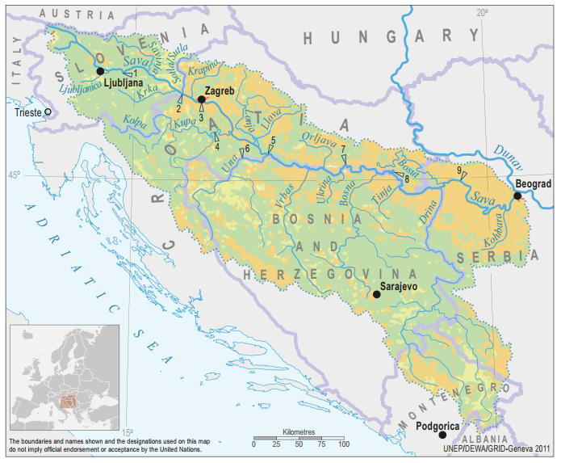

FINAL DOCUMENT
B E L G R A D E, January 2020

Table of contents

1. REPORT ON PUBLIC DISCLOSURE AND PUBLIC CONSULTATION 3
2. LIST OF PARTICIPANTS - PRELIMINARY CONSULTATIONS WITH KEY STAKEHOLDERS, 30 DEC 2019 8
3. DOCUMENTATION 11

REPORT ON PUBLIC DISCLOSURE AND PUBLIC CONSULTATION

As required by WB Environmental and Social Standard 10 (ESS10) – Stakeholder Engagement and Information disclosure, during preparation of Draft ESMF, ESCP, RPF, SEP and LMP documents the Borrower carried out public consultations with relevant stakeholders.
Starting from 19 December 2019, MAFWM disclosed the Draft ESMF, ESCP, RPF, SEP and LMP documents on its web site and announced invitation for Public Consultations for the public, bodies and organizations interested in subject documents prepared for SDIP Project. Same announcement was published in the daily newspaper with national coverage “Politika” on 26 December 2019. Public and other interested parties and organizations were invited to participate in process of public consultation on draft ESMF, ESCP, RPF, SEP and LMP documents.
Draft documents and invitation to the Public Consultations were also available on the web site of the MAFWM: http://www.rdvode.gov.rs/aktuelno.php.
On 30 December 2019, at 12:00 AM (local time), public consultations and presentation of the Draft ESMF, ESCP, RPF, SEP and LMP documents were organized at the premises of the Ministry of Agriculture, Forestry and Water Management - Serbian Directorate for Water Management, Room 301, III floor, Bulevar umetnosti 2a, 11000 Belgrade. The meeting was attended by a diverse group of 21 stakeholders, namely representatives of MAFWM – Directorate for water management, Public Water Management Company “Srbijavode”, Citizen Association “Akademija inzenjerskih nauka Srbije - The Academy of Engineering Sciences of Serbia”, non-formal Citizen Group “Pravo na vodu – Right2water” and NGO Coalition “Save the Blue Heart of Europe” and Association “Jugo Cikling Kampanja – Yugo Cycling Campaign”.
The attendees were:
- Mr. Milan Boric Citizen Association “Jugo Cikling Kampanja”
- Ms. Ana Petrovic Serbian Directorate for Water Management
- Mr. Branislav Djordjevic Citizen Association “Akademija inzenjerskih nauka Srbije”
- Ms. Aleksandra Smiljanic Citizen Association “Akademija inzenjerskih nauka Srbije”
- Mr. Zoran Bukvic UZB
- Mr. Dmitar Zakula Serbian Directorate for Water Management
- Mr. Zoran Kresojevic Serbian Directorate for Water Management - PIU
- Ms. Milica Pavlovic Serbian Directorate for Water Management
- Ms. Jasmina Pejcic Serbian Directorate for Water Management
- Ms. Mila Udarevic Serbian Directorate for Water Management
- Ms. Maja Jeremic Serbian Directorate for Water Management
- Mr. Uros Suberic Serbian Directorate for Water Management
- Ms. Zorica Jankovic Serbian Directorate for Water Management
- Ms. Milica Mrenkolic Serbian Directorate for Water Management
- Ms. Dijana Ivanov Serbian Directorate for Water Management
- Mr. Milan Njegovan Serbian Directorate for Water Management
- Ms. Biljana Vasic Public Water Management Company “Srbijavode”
- Mr. Oliver Ilic Non-formal Citizen Group “Savski Nasip”
- Mr. Sasa Petrovic Citizen Group “Pravo na vodu”
- Mr. Sasa Kulic Serbian Directorate for Water Management
- Ms. Iva Markovic NGO Coalition “Save the Blue Heart of Europe”

The consultation consisted of two parts. The first presentational were participants were informed in general of the ESF and the purpose of ESMF, ESCP, RPF, SEP and LMP documents during implementation. In addition, it was emphasized that all activities supported under the Project shall be environmentally and socially sound, sustainable, and consistent with WB ESS and Serbian national legislation.
Project screening procedure and risk classification are explained, as well as legal and administrative framework for Project.
The meeting started according to schedule at 12:00 AM. The Social Specialist Ms. Nina Valcic presented all project documents in details to the interested attendees.

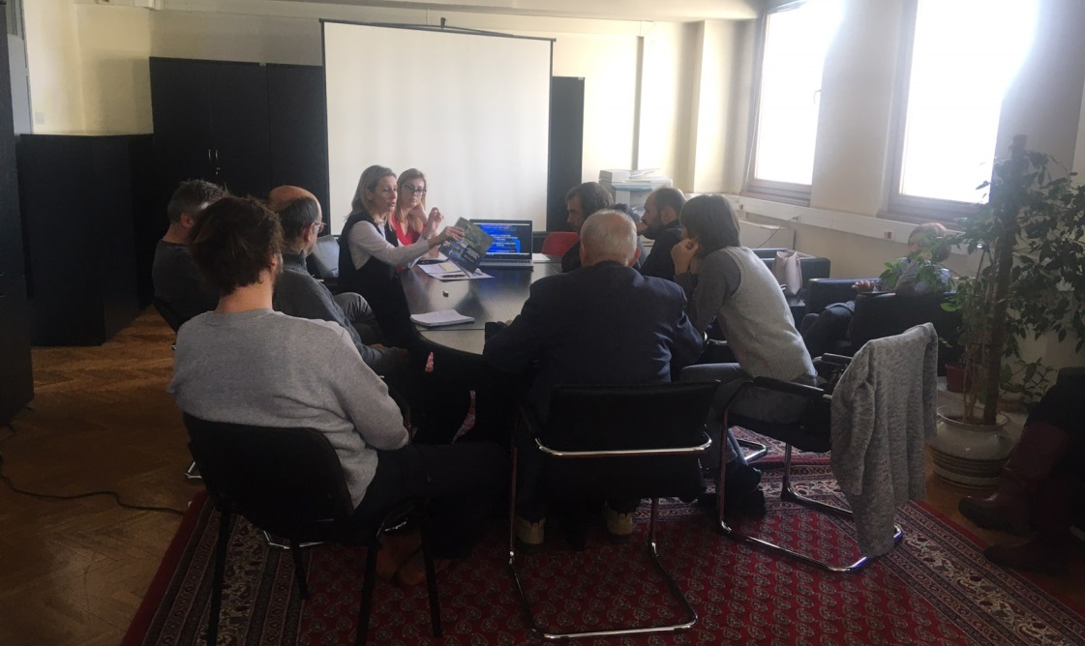
Picture 1: Public consultation in Belgrade, 30 December 2019
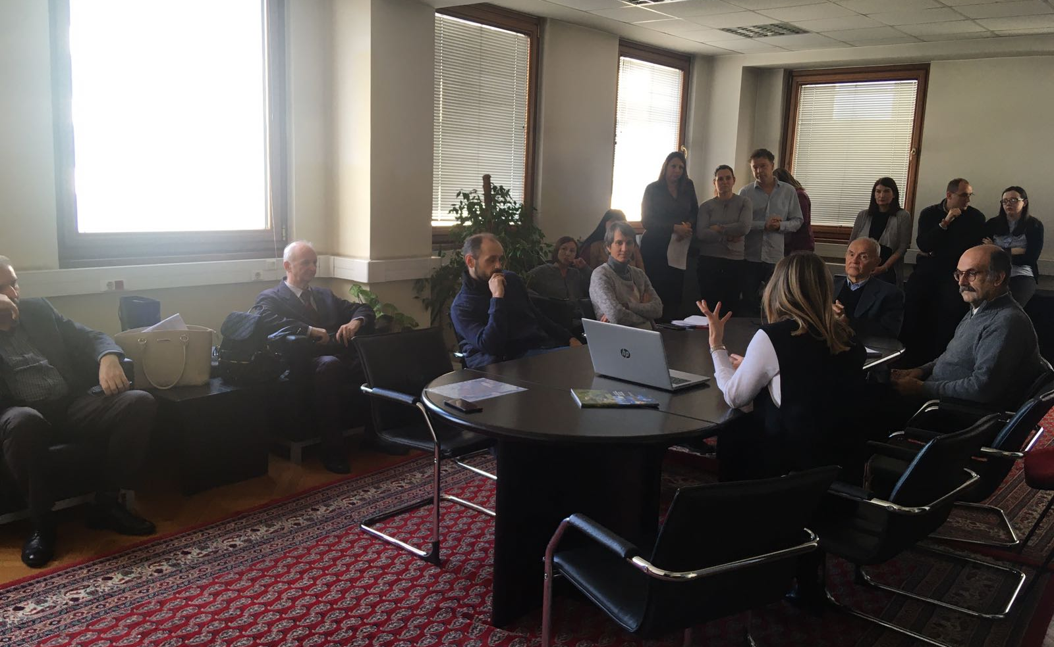
Picture 2: Public consultation in Belgrade, 30 December 2019
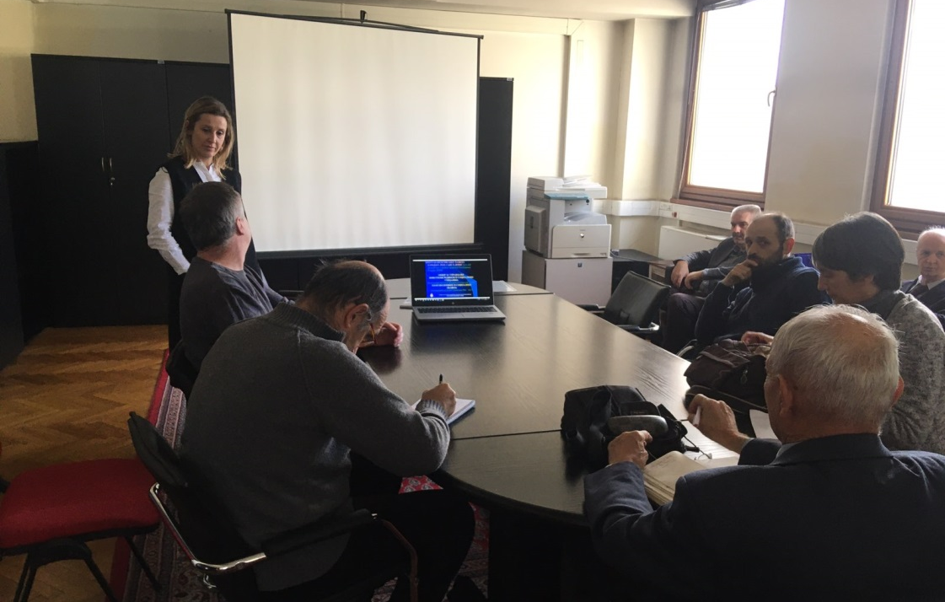
Picture 3: Public consultation in Belgrade, 30 December 2019
Special focus was given to project description, implementation arrangements, potential environmental and social impacts, grievance redress procedures, labor management, screening forms and development of environmental and social management plans during Project implementation.
The importance of Labor management and most important provisions of WB Environmental and Social Standard ESS2 (Labor and Working Conditions) are also explained to the public during presentation of ESMF document.
Before starting with questions of participants, institutional responsibilities and monitoring and reporting procedure on Project were presented and explained. However, the whole consultation have taken a participatory form and turned into a very interactive discussion with participation of all present Stakeholders very early before the moderator handed over the floor to the participants. This
Consultation started at 12:00 AM and ended at 3:30 PM, local time.

Questions and Answers during public presentation and consultations:

Q1: Has the MAFWM and/or the Government defined all Sub-projects at this stage?
A1 Nina Valcic, Social Specialist: Only a couple of Sub-project were identified at the preparation stage. These are Sub-projects Jarak, Popova Bara and Surcin Warehouse. One of the aims of these public consultations and the whole Stakeholder engagement activities relate inter alia to better understand the needs and provide the Stakeholders with an opportunity to directly contribute to the project architecture.
.................................................
Q2: What is the rationale of the World Bank to support compensation even for informal structures constructed without valid permits on land designated as river protection belt?
A1 Nina Valcic, Social Specialist: Any Project developed with financial support of the World Bank, here and anywhere in the World are subjected to the Banks social standards. As already highlighted as of October 2018 any new Project is subject to the Environmental and Social Framework =. Adverse impacts attributable to the Project stemming from Land acquisition are in detailed covered by the ESS 5 on Land Acquisition, Restrictions on Land Use and Involuntary Resettlement. The requirements of these standards are very specific when it comes to informal owners and users and formal and informal economic activities and between these two categories there are no differences in their eligibility. In the aim to prevent opportunistic claims, which indeed, are not eligible the Borrow is requested to announce the Cut-off date.
.................................................
Q3: How are the specific Stakeholder engagement activities designed? What will the methods of engagement be and what frequency will they take?
A1 Nina Valcic, Social Specialist: .As presented today this Project has a standalone Stakeholder Engagement Plan (SEP) applicable throughout the Project lifecycle, to be updated as needed following the procedure set out in the plan itself. The method of engagement is phase sensitive and will be continued and ongoing carefully following the development of the Project and the need to consult and inform the identified Stakeholders. Stakeholders are encouraged to follow announcements on the website of the MAFWM and newspapers as the Project information will be available there. Following these consultations and the Appraisal by the World Bank the engagement shall be intensified as outlined in the plan. For more details please again refer to the disclosed Stakeholder Engagement plan.
.................................................
Q4: Will the Project have a specific Grievance Mechanism? As we understand this is a requirement of many IFIs?
A1 Nina Valcic, Social Specialist: This as all other Projects financially supported by the World bank will have a Project Specific Grievance Mechanism to serve both persons directly affected by land acquisition and persons affected by other Project`s activities ( throughout the cycle). At this moment given the preparation phase of the project the Central mechanism within the MAFWM is operational to be followed by local entry points. Subsequently as the selection of Sub-projects continues and progresses. This points and function of the GM shall be locally publicized and information material distributed.

Opinions and remarks provided in written form:

O1 Branislav Djordjevic, Citizen Association “Akademija inzenjerskih nauka Srbije”, by his letter dated 03 January 2020:
- All hydro technical project activities on the rivers and in the Sava and Drina corridors should be done exclusively with new hydrological studies and with new hydrological analyzes, since the previously prepared studies are obsolete. Recommended experts to be involved in the new design team.
- Detailed environmental impact analysis is required. The Ramsar Convention on the Protection of Wetlands should also be kept in mind.
- In the case of construction of a new embankment on the left bank of the Sava River in the New Belgrade area, a Spatial Plan of Detailed Regulation with clearly defined Land use should be developed.
- The planned settlements in the remaining Sava river bank areas of New Belgrade, in the hinterland of the regulated part of the river banks, should be carefully reviewed in sense of the population density of that particular city zone (density of buildings, floors), as it is already extremely densely populated, which is reflected in very difficult traffic, as well as to air pollution resulting from excessive occupancy of remaining land.
- Since the Program also includes the Drina corridor, regardless of which facilities will be financed in that corridor, the integral solution of the water management system on that river, which is now official, should be mentioned, as it is in the Water Management Base of Serbia and the Spatial Plan of the Republic of Serbia , as well as in the Republika Srpska Water Management Strategy.
- During the consultation, I and several other attendees were unpleasantly surprised by the explanation of the World Bank's position that all facilities for which displacement and demolition are needed - are in the same legal position in terms of compensation, regardless of when and how investors built the property to be removed. Therefore, in view of the legal regulations relating to water land, as well as the zone of protection of springs, the World Bank in Serbia must use the only possible - selective approach. He implies that the position on the legal position of those whose property will be expropriated and compensated for the construction of shorelines does not apply to those owners who have committed the crime of building in prohibited zones.
- It would be completely illogical and dangerous to require a high degree of flood protection in the new coastal zones regulated under this Program, while allowing the already existing embankment upstream of the settlement in block 45 to be physically destroyed by unintended use as a road, even for the heaviest traffic. Such loads have a very unfavorable effect on the deformations of the foundation zone of the embankment, which therefore becomes unsafe and prone to collapse. The World Bank should therefore explicitly restrict its loan for the construction of new fortifications on the left bank of the Sava by requiring that physical barriers be completely prevented from accessing motor vehicles on the embankment, in all places where it occurs, and preventing the opening of some new approaches.
- In order to re-design the New Belgrade embankment project, it should be borne in mind that the owners of illegally constructed houses in the river side area have constructed transverse embankments to block the large water (river inundation) trough so that they can reach their homes, not only by cars, but by heavy construction machines. These transverse structures during periods of high Sava waters completely impede the flow in the high water trough and drastically aggravate the modes of propagation of large water waves, drastically increasing the risk of breakage of the embankment. Therefore, it is necessary for the World Bank to make the loan for new works in the Sava Corridor conditional on the removal of these transverse structures (access roads to residential buildings, rem.aut.), as well as all other facilities in the large water basin and to enable unhindered mode of transmission of large-water waves. Here, too, the principle must be that these works should be done at the expense of those persons who performed those dangerous works.
- Raft owners cut deep embankments through deep trenches to push plumbing to their rafts. The embankment is thus damaged in several places, which compromises its safety. Therefore, as one of the priorities of this Program, the World Bank should require the rehabilitation of an already existing embankment and prevent its further damage by enforcing a traffic ban on it, except for the official purpose of maintaining the embankment.
- The World Bank should also be aware of the very serious endangering of Belgrade Water Supply springs by illegal construction in the protection zones of the springs.

O2 Aleksandra Smiljanic, Citizen Association “Akademija inzenjerskih nauka Srbije”, by her letter dated 03 January 2020, related to SDIP Project Potential Procurement Packages - : Nr. 1.1.14 Design and Raising dykes in Novi Beograd to protect Belgrade City from flood:
- Several hundred illegal cottages between the embankment and the water were built on the Sava embankment. They threaten the embankment itself, which protects New Belgrade with over 200,000 inhabitants from flooding, as well as Belgrade's water supply, because they are located in the middle of Belgrade's water source
- The owners of illegal cottages drive cars along an embankment that is not designed for traffic but only for service vehicles
- The owners of illegal rafts along the Sava Quay have drilled the embankment in several places with water pipes to bring water to their rafts.
- Although no funds have been allocated for specific projects, investment is being considered for coastal fortification along the planned settlement in New Belgrade, downstream of Block 70a, on land owned by the private companies Comtrade and Zepter. The owners of these companies benefit most from such a project, which is not in line with the World Bank policy that everyone has equal access to World Bank funds
- New planned settlements along the Sava River in New Belgrade do not need to be built, because New Belgrade is already too densely populated and traffic congestion is unbearable.
- If the World Bank wants to provide embankments on the Sava River, it must first start with the existing, already built part of the embankment, which is most vulnerable to the misuse of infrastructure by irresponsible citizens.
- I request that my statement and the accompanying articles be forwarded to the World Bank:
- http://savskinasip.com/analize/group-of-irresponsible-people-endanger-belgrade/1469/
- http://savskinasip.com/analize/stance-of-serbian-academy-of-engineering-sciences/1463/
- http://savskinasip.com/analize/story-about-insolent-people-and-powerless-system/1439/

LIST OF PARTICIPANTS - PRELIMINARY CONSULTATIONS WITH KEY STAKEHOLDERS, 30 DEC 2019

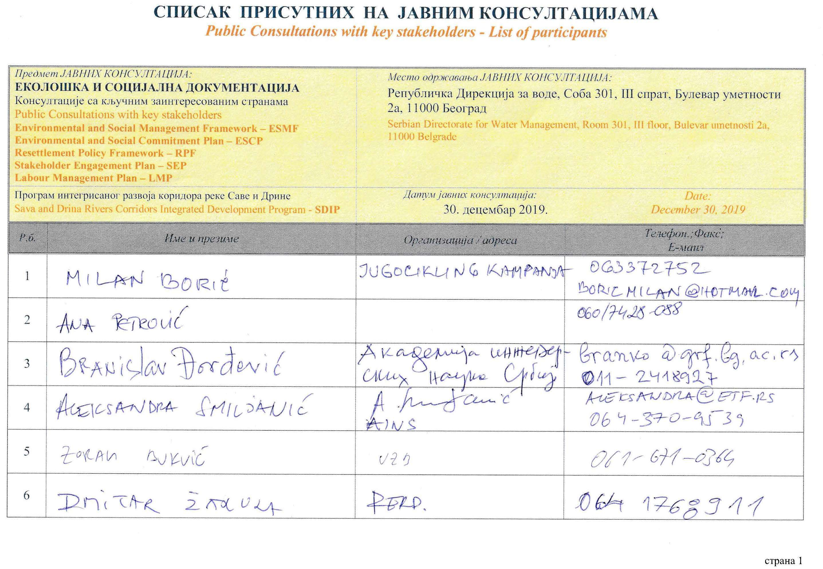
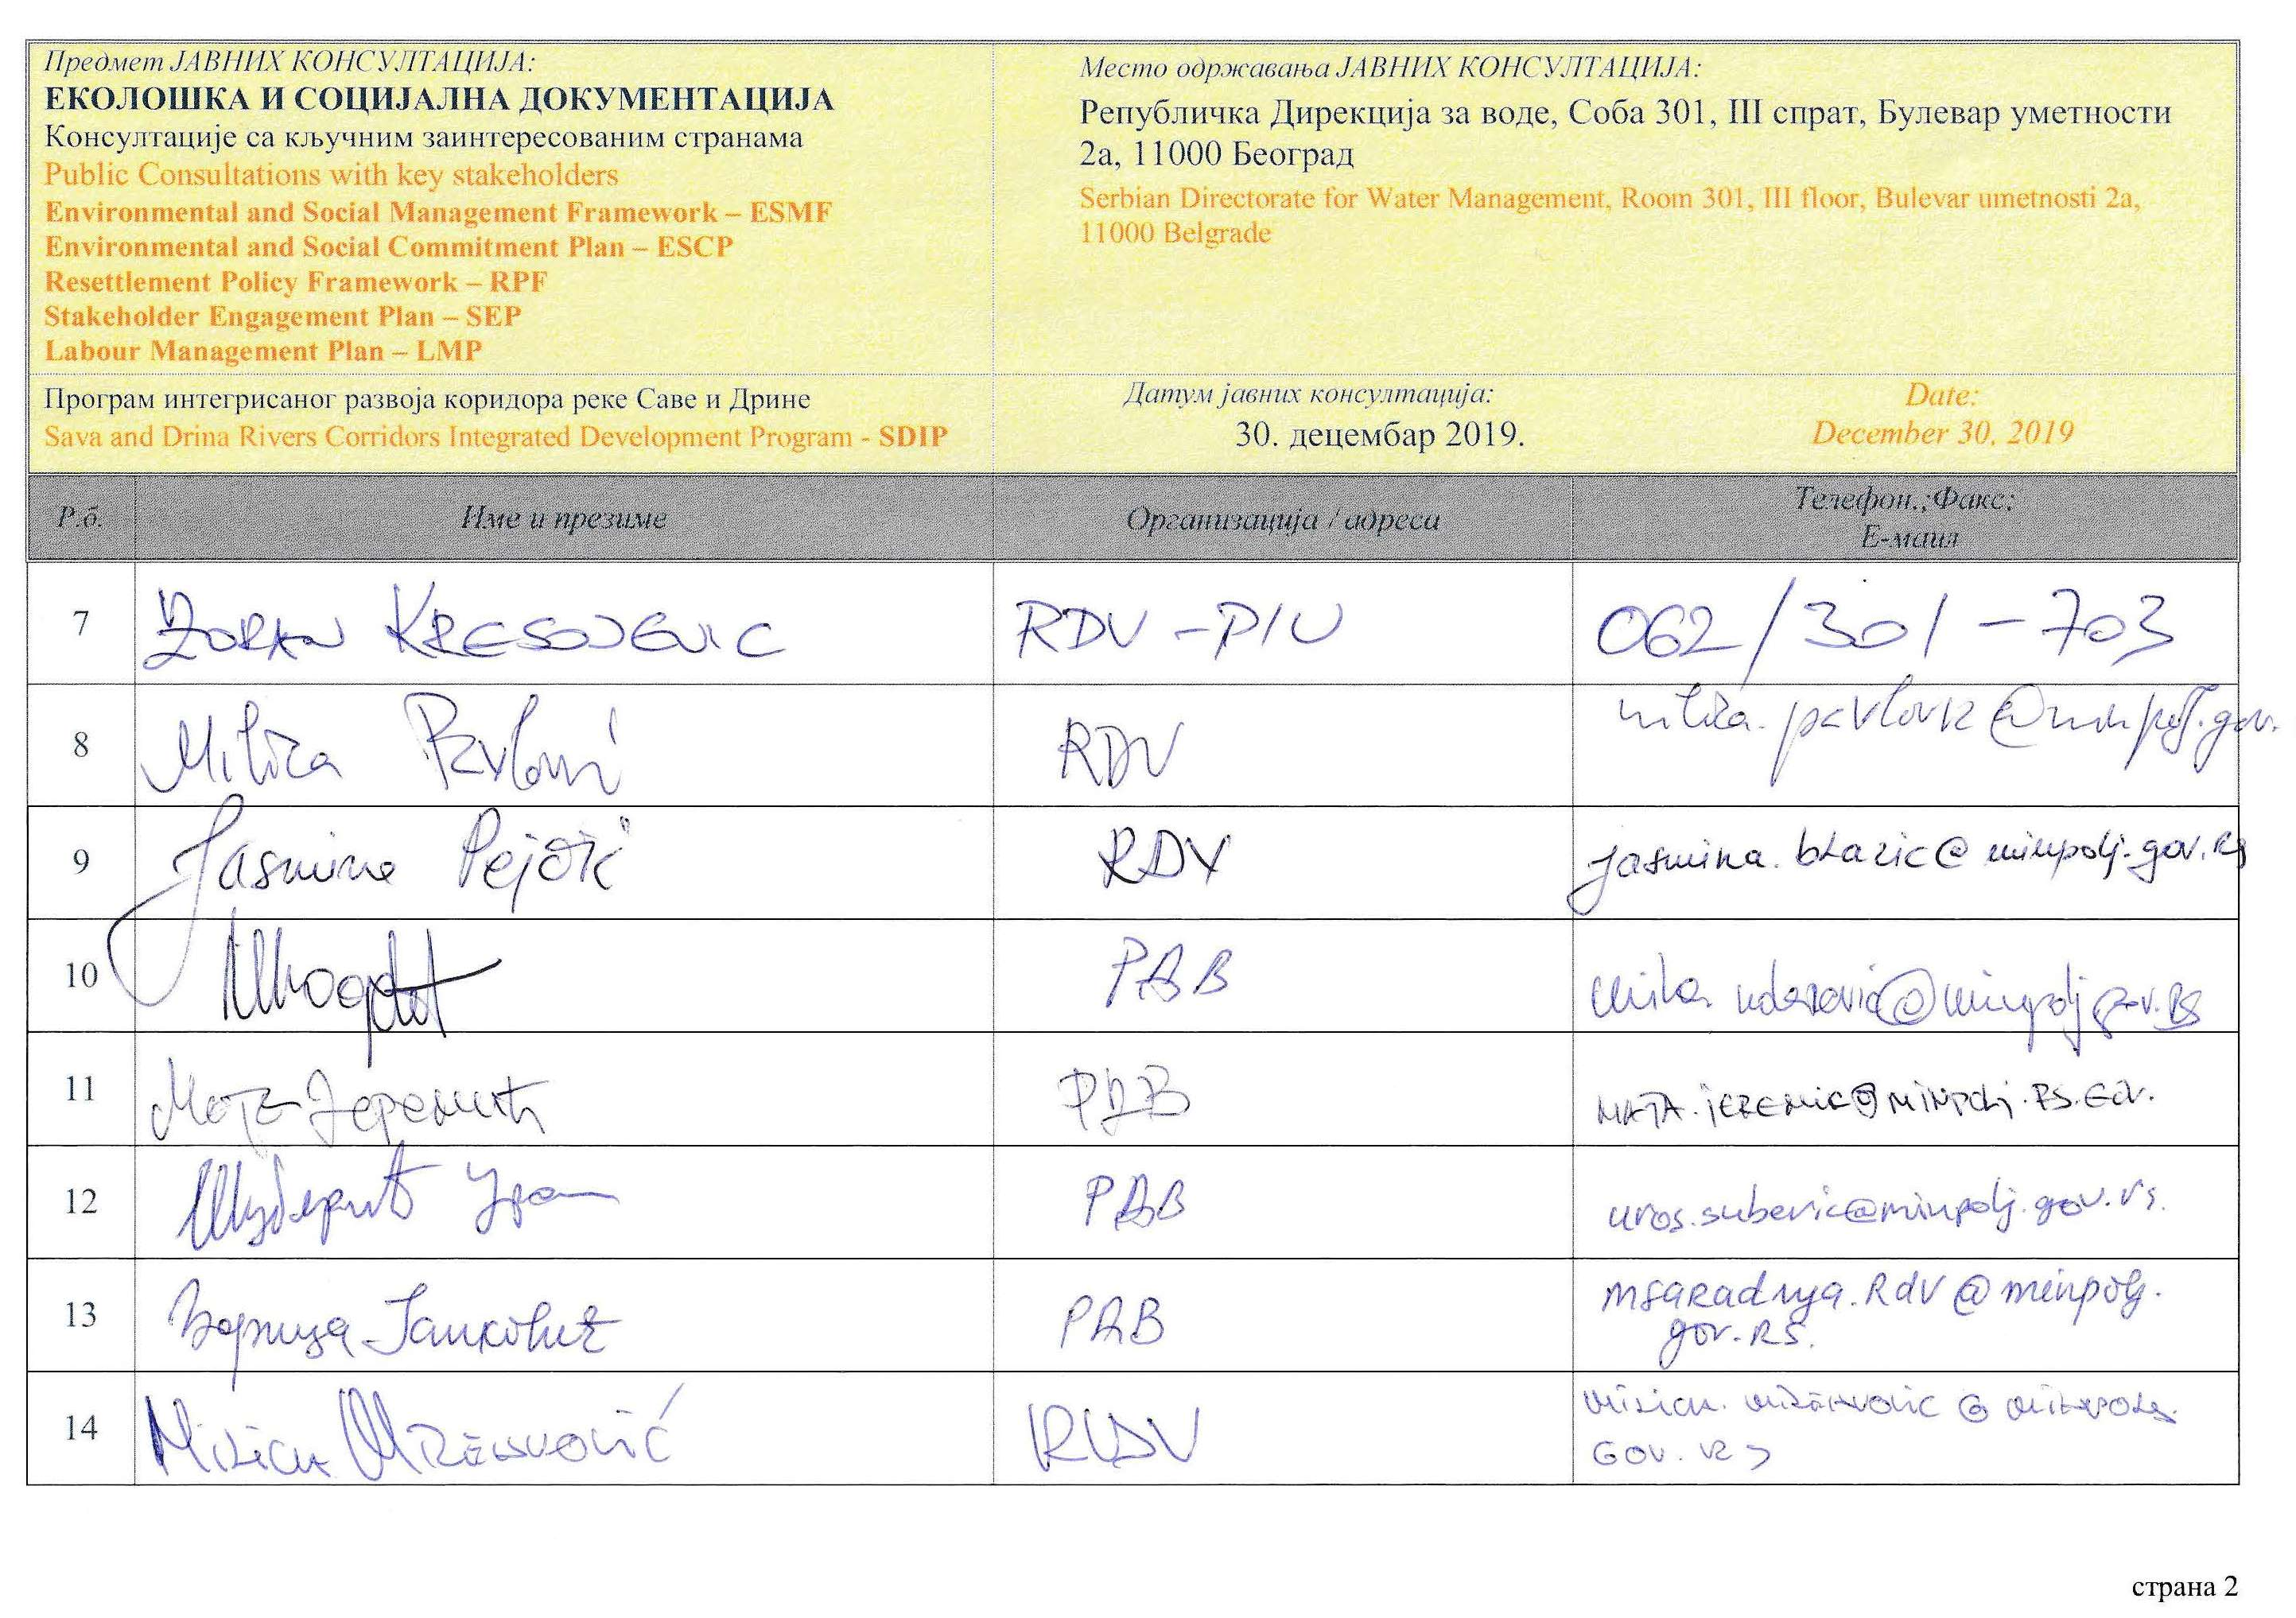
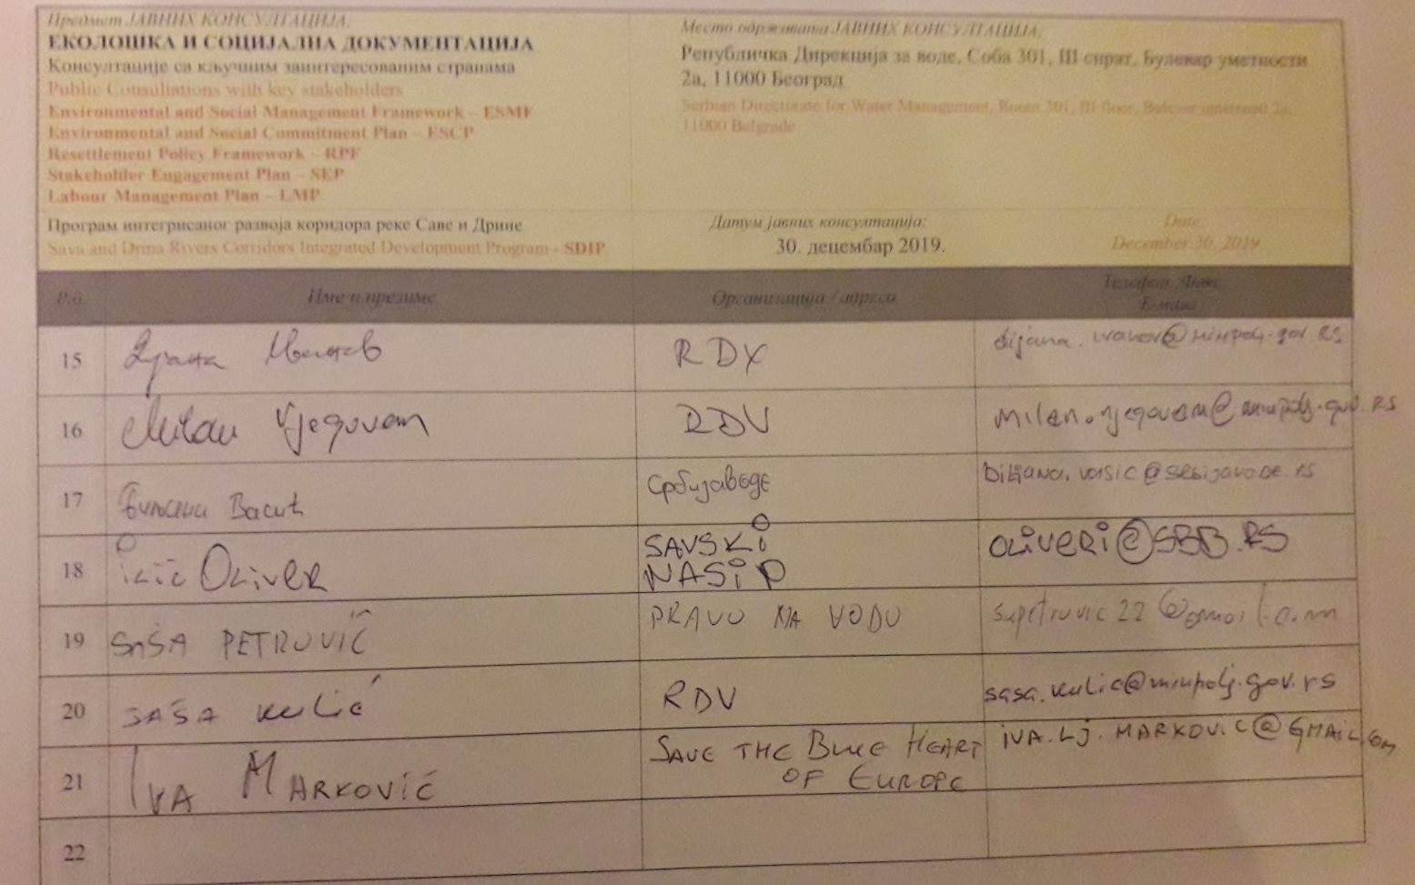

DOCUMENTATION

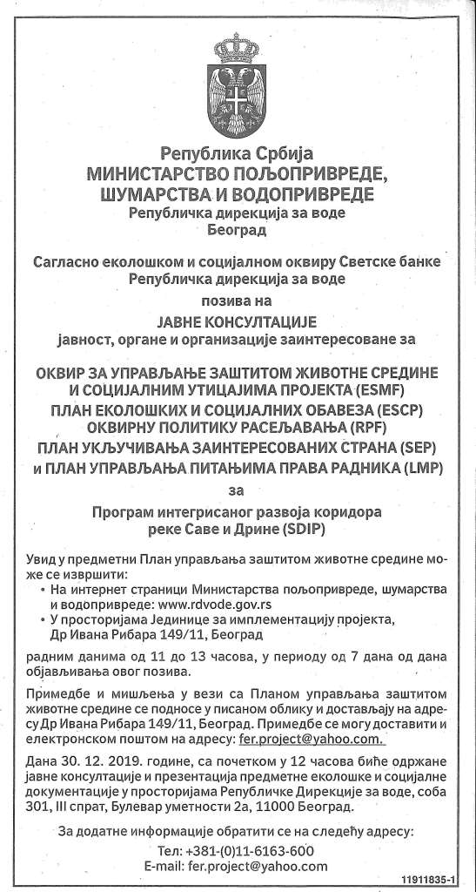
Picture 4: Announcement of public consultation in daily newspaper, (“Politika”, 26 Dec 2019)

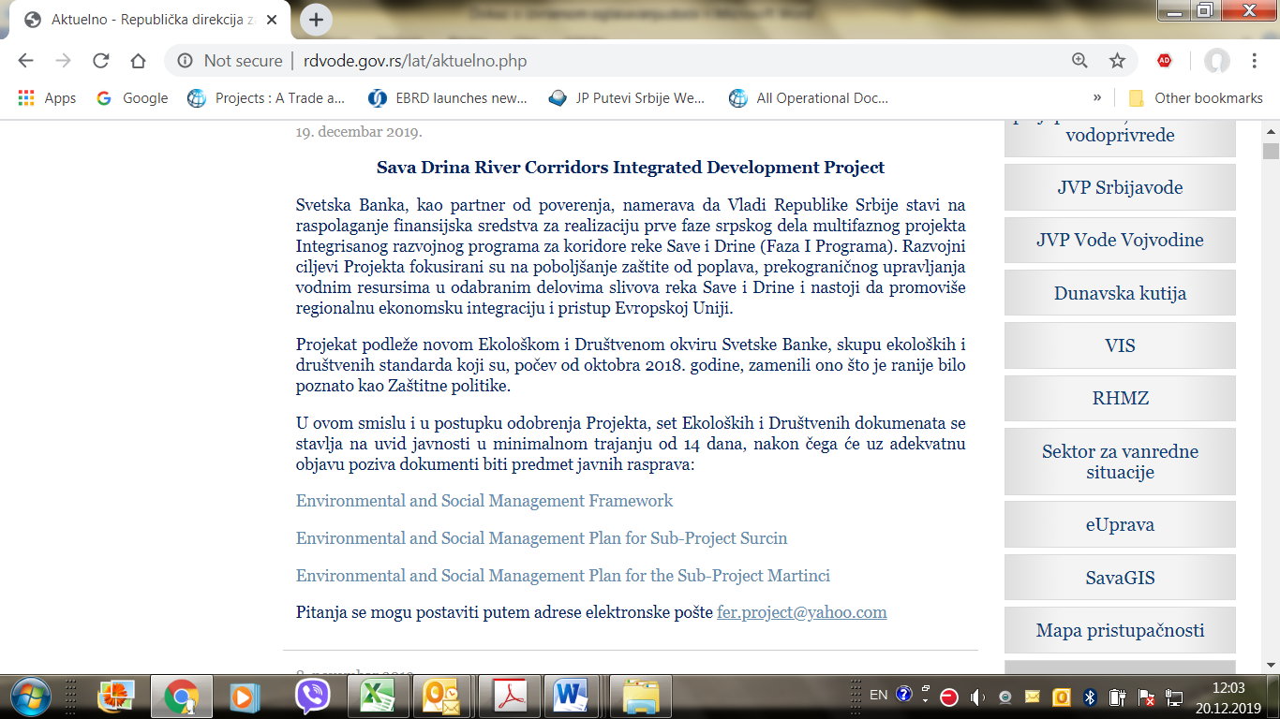
Picture 5: Announcement of public consultation on SDIP Environmental documents on Ministry web site

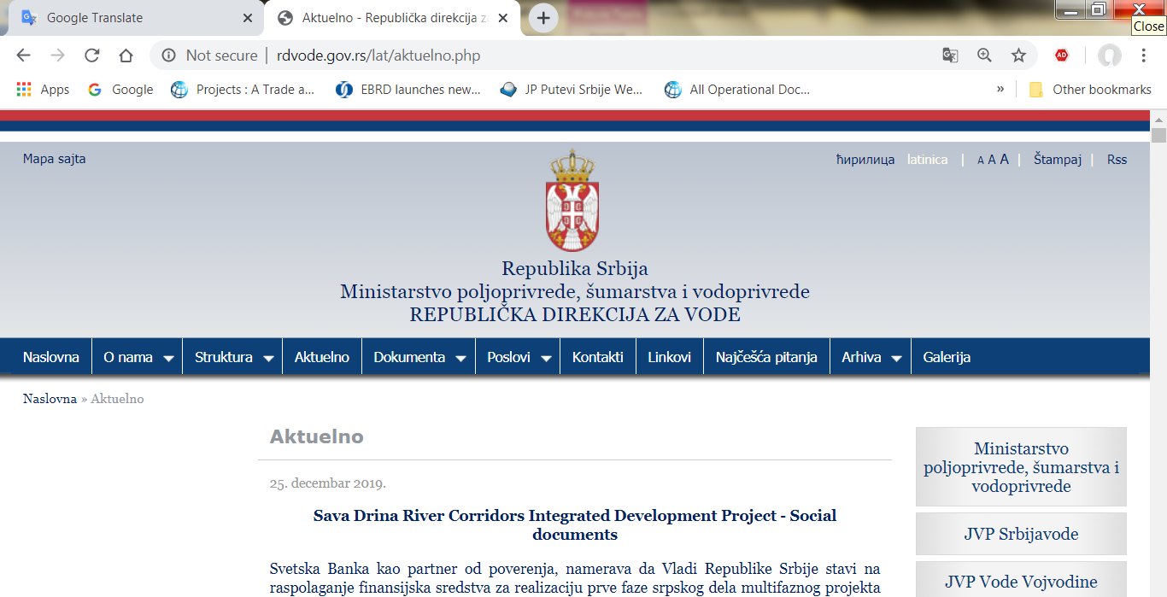
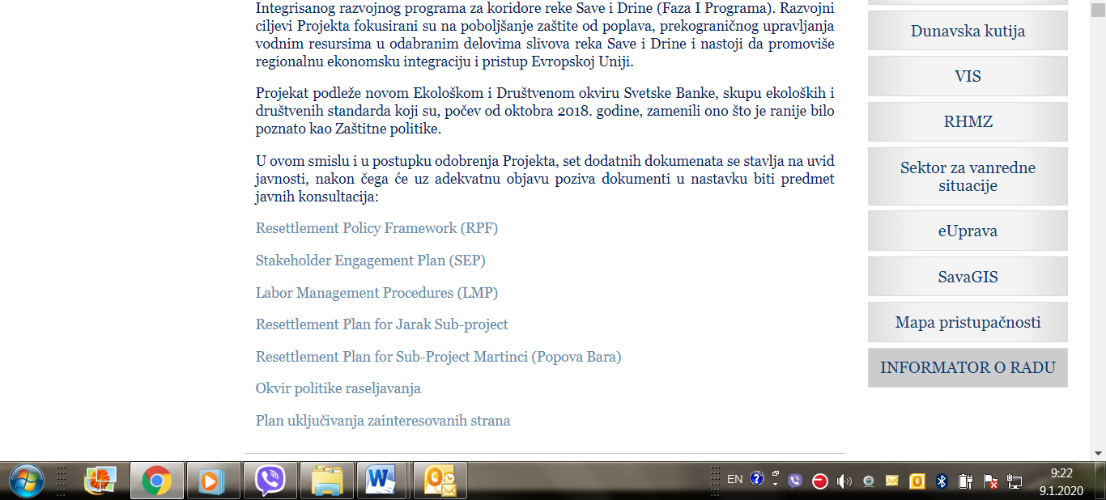
Picture 6: Announcement of public consultation on SDIP Social documents on Ministry web site

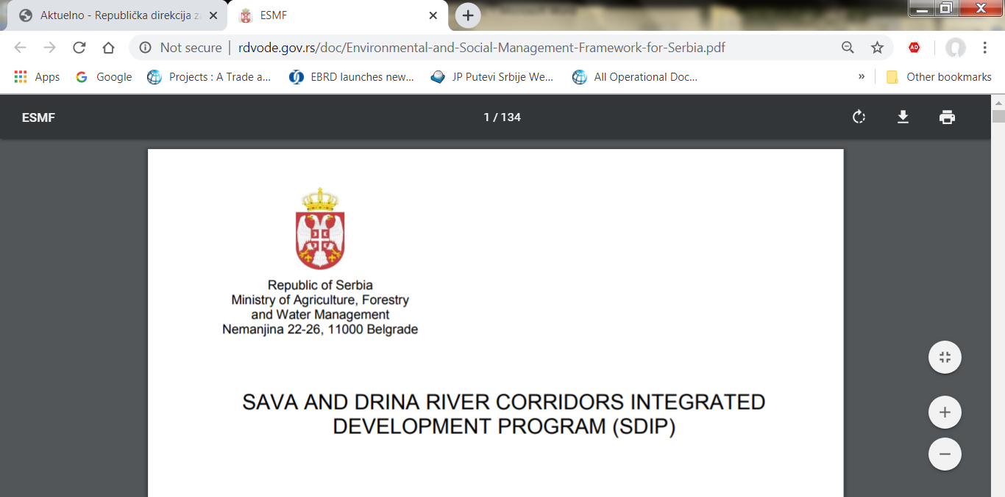
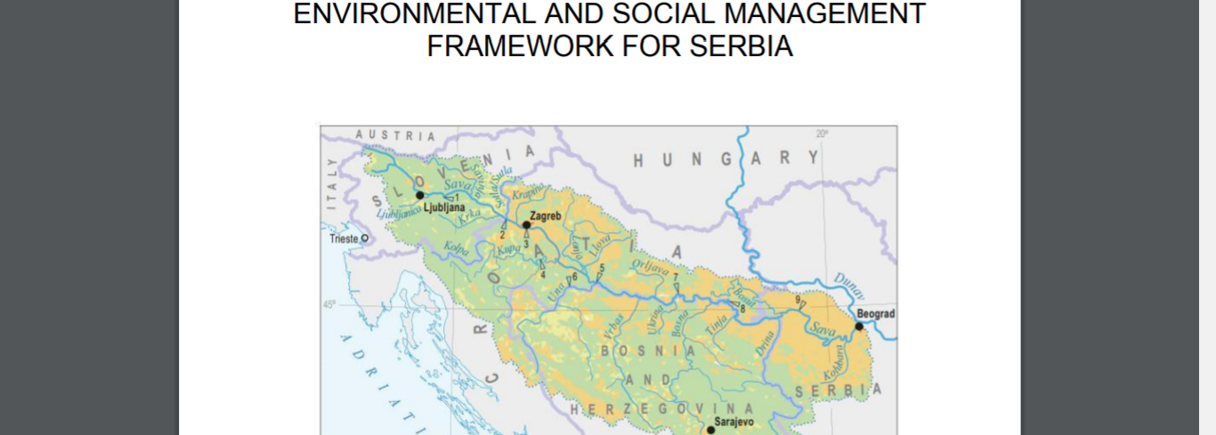
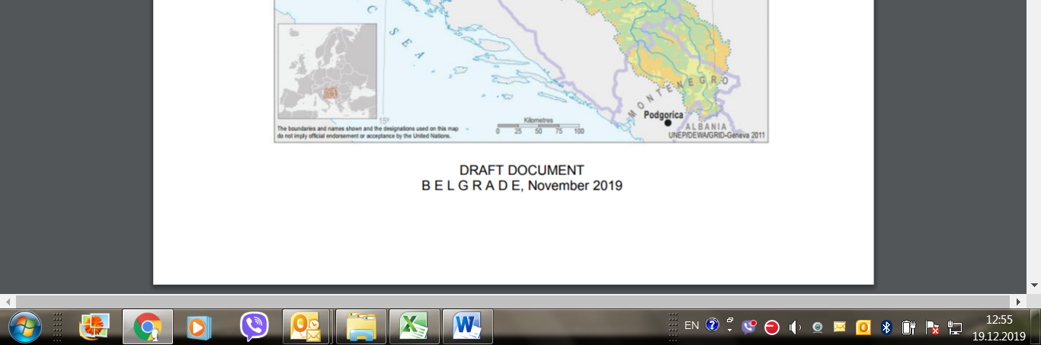
Picture 7: Public disclosure of DRAFT ESMF document, English language, Ministry web site

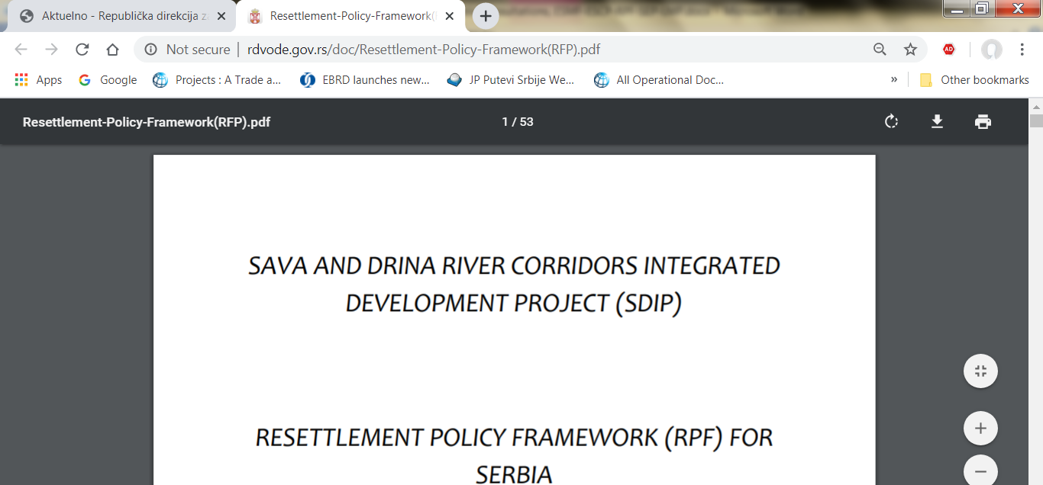
Picture 8: Public disclosure of DRAFT RPF document, English language, Ministry web site

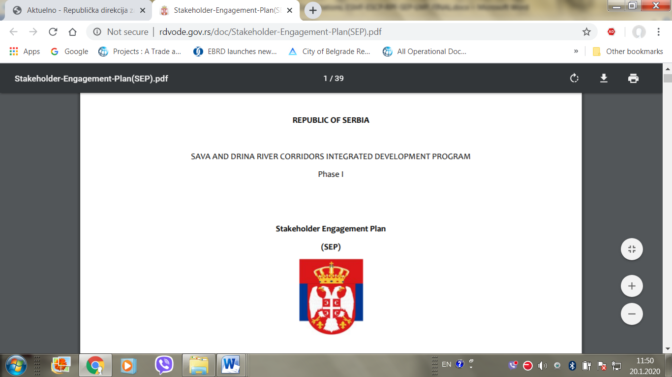
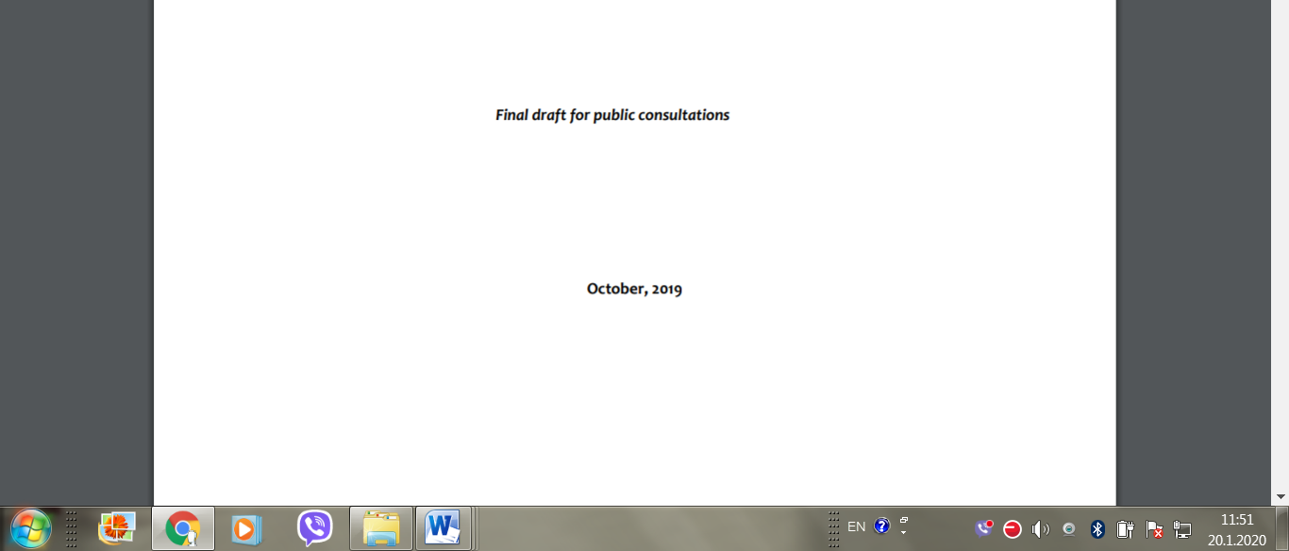
Picture 9: Public disclosure of DRAFT SEP document, English language, Ministry web site

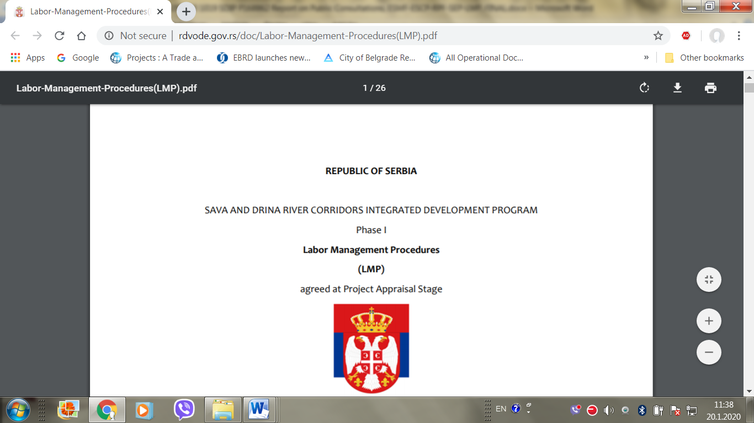
Picture 10: Public disclosure of DRAFT LMP document, English language, Ministry web site

This is part of a multiphase programmatic approach with an overall financing envelope of EUR225.4 million US$250.2 million equivalent)
In August 2016, the World Bank’s Board of Executive Directors approved the Environmental and Social Framework (ESF), which have come into effect in August 2018
The term “project worker” refers to: (a) people employed or engaged directly by the Borrower (including the project proponent and the project implementing agencies) to work specifically in relation to the project (direct workers); people employed or engaged through third parties3 to perform work related to core functions4 of the project, regardless of location (contracted workers); (c) people employed or engaged by the Borrower’s primary suppliers5 (primary supply workers); and (d) people employed or engaged in providing community labor6 (community workers). ESS2 applies to project workers including fulltime, part-time, temporary, seasonal and migrant workers.
These include: ILO Convention 87 on Freedom of Association and Protection of the Right to Organize, ILO Convention 98 on the Right to Organize and Collective Bargaining , ILO Convention 29 on Forced Labor ,ILO Convention 105 on the Abolition of Forced Labor 2 Guidance Note – ESS2: Labor and Working Conditions • ILO Convention 138 on Minimum Age (of Employment) • ILO Convention 182 on the Worst Forms of Child Labor • ILO Convention 100 on Equal Remuneration • ILO Convention 111 on Discrimination (Employment and Occupation
Sub-Consultant/Contractor means any person or entity to whom/which the Contractor or Consultant subcontracts any part of the Works or Services.
Flood Emergency Response Project
The term used in this context refers to professionals, skilled workers, or artists taking positions outside their home country, either independently or sent abroad by their employers, which can be companies, universities, governments, or non-governmental organization.
There are 8 legal acts and 55 rulebooks related to the area of occupational health and safety.
The term „employee “is defined as any domestic or foreign natural person who is employed by an employer, works on any basis for an employer or trains for work for an employer.
The Serbian Labor Law recognizes two categories of workers: Employees with established employment relations ( fixed term and open-ended employment contract) and persons engaged outside employment relations (seasonal works, service contracts, additional work engagement).
Such notification is the employer's obligation stipulated by Law on the Prevention of Harassment at the Workplace (2010), Rulebook on Conduct of Employers and Employees in Relation to Prevention and Protection from Harassment at Work (2010) and Law on Protection of Whistle Blowers (2014),
The Bidder should mark the appropriate commitment

